**Unity3D Terrain Excavation Function Request Form**

**Project outline:**

- We would like to outsource some functions of SW during the work for upgrading the functions of our heavy equipment simulator.

- Some functions refer to the soil algorithm to be expressed in the simulator similar to the physical characteristics of the soil (soil) in the real world, and should be installed so that it can interact with the existing heavy equipment simulator in the process of upgrading without difficulty.

**Development Environment:**

- Language used: C#

- Development and operating environment: Windows 10, Unity3D 2021.2.13 (

Editor version can be negotiated)

**Outputs :**

- Development original source code and user manual

- Complete transfer of intellectual property rights

**Requirements :**

1. Frame drap during soil simulation should not be severe.

Soil particles don't need to depend on Unity's physics engine, you can implement them yourself in other ways.

2. Friction force by friction between soil particles should be implemented, and the friction force value should be able to be modified in the Unity editor.

3. Cohesion between soil particles (viscosity: cohesion) must be implemented, and the value of cohesion must be able to be modified in the Unity editor.

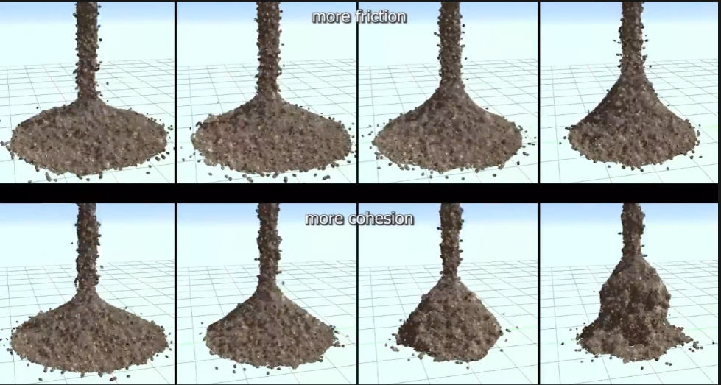

4. Soil accumulated or moved by external action is converted back to Terrain, so additional external action (movement and work of heavy equipment) should be possible.

-> Negotiable on how to convert from soil particles to Terrain.

-> Example of requirement 4

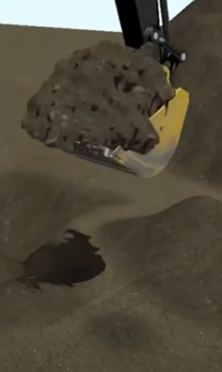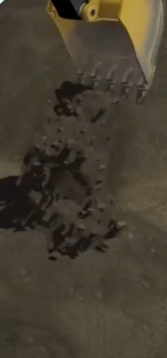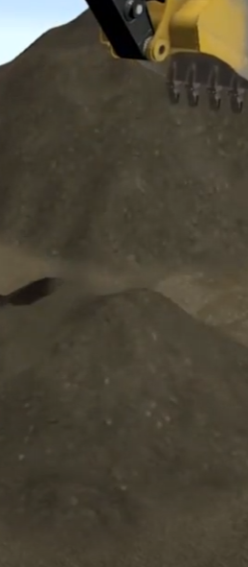

5. When the excavator's bucket is driven into the Terrain, as a repulsive action, a resistance force must be generated. At this time, the output of the excavator must be increased (setting the limit range) in proportion to the area and depth where the bucket is embedded in the Terrain to enable excavation, and the corresponding resistance value must be editable in the editor.

-> The shape of the bucket can be changed.

6. The shape of the soil excavated should be similar to the shape and depth of the bucket inserted into the soil.

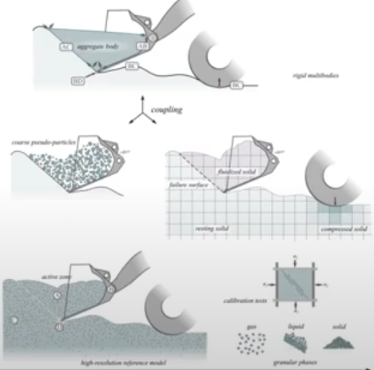

<https://www.youtube.com/watch?v=TkiekFf5970>

<https://www.youtube.com/watch?v=RNwFJrj-ao0>

<https://www.youtube.com/watch?v=TCytUa9C708>

<https://www.youtube.com/watch?v=XCm0kT6NSs4>

<https://www.youtube.com/watch?v=eLT5zAzyGQY>