VNUHCM-UNIVERSITY OF SCIENCE
FACULTY OF INFORMATION TECHNOLOGY
──────── ────────

COURSE NAME: INTRODUCTION TO SOFTWARE ENGINEERING
SOFTWARE DESIGN
Supervisor: Ph.D. Trần Duy Hoàng
M.Sc. Phạm Hoàng Hải
Class: 24C08
Student group: Group 5
Cao Hải Vy  Nguyễn Lâm Thảo Trang  Nguyễn Thanh Nguyên  Huỳnh Mai Trâm | 24127598  24127566  24127468  24127562

Ho Chi Minh City, July 28, 2026
SOFTWARE DESIGN
Table of Contents
1. Member Contribution Assessment 2
2. Conceptual Model 3
3. Architectural Design 4
3.1. Architecture Diagram 4
3.1.1. System decomposition tree diagram 4
3.1.2. System architecture diagram 5
3.1.3. Special Aspects of the Architecture 6
3.2. Class Diagram 8
3.3. Class Specifications 9
3.3.1. Class User 9
3.3.2. Class Property 10
3.3.3. Class PropertyImage 11
3.3.4. Class Favorite 12
3.3.5. Class Notification 13
3.3.6. Class Lead 14
3.3.7. Class LeadClaim 15
3.3.8. Class AgentProfile 16
3.3.9. Class AgentRegion 17
3.3.10. Class Region 18
3.3.11. Class AuthService 19
3.3.12. Class AdminService 20
3.3.13. Class FavoritesService 21
3.3.14. Class ClaimingGateway 22
3.3.15. Class LeadsService 23
3.3.16. Class PropertiesService 24
4. Data Design 25
4.1. Data Diagram 25
4.1.1. Logical Data Diagram 25
4.1.2. Physical Data Diagram 26
4.2. Data Specification 27
4.2.1. User Data 27
4.2.2. AgentProfile Data 28
4.2.3. Region Data 28
4.2.4. AgentRegion Data 28
4.2.5. Property Data 29
4.2.6. PropertyImage Data 30
4.2.7. PropertyStatusHistory Data 30
4.2.8. Favorite Data 30
4.2.9. Lead Data 31
4.2.10. LeadClaim Data 31
4.2.11. Notification Data 32
4.2.12. Enum Values 32
5. User Interface and User Experience Design 33
5.1. Screen Diagram 33
5.2. Screen Specifications 34
5.2.1. Sign-in Screen 34
5.2.2. Sign-up Screen 35
5.2.3. Set New Password Screen Screen 36
5.2.4. Verify OTP Code Screen 37
5.2.5. Public Catalog Screen 38
5.2.6. Property Detail Screen 39
5.2.7. Favorite Property Screen 41
5.2.8. Admin Account Approval Dashboard Screen 42
5.2.9. Agent Lead-Claiming Screen 43
5.2.10. Property Creation & Modification Screen 44
5.2.11. Sales Agent Directory Screen 46
5.2.12. Shared Component Specification: Navigation Bar 47

List of Tables
Table 1. Design Patterns Implementation 7
Table 2. Class User Attributes Specification 9
Table 3. Class User Operations Specification 9
Table 4. Class Property Attributes Specification 10
Table 5. Class Property Operations Specification 10
Table 6. Class PropertyImage Attributes Specification 11
Table 7. Class PropertyImage Operations Specification 11
Table 8. Class Favorite Attributes Specification 12
Table 9. Class Favorite Operations Specification 12
Table 10. Class Notification Attributes Specification 13
Table 11. Class Notification Operations Specification 13
Table 12. Class Lead Attributes Specification 14
Table 13. Class Lead Operations Specification 14
Table 14. Class LeadClaim Attributes Specification 15
Table 15. Class LeadClaim Operations Specification 15
Table 16. Class AgentProfile Attributes Specification 16
Table 17. Class AgentProfile Operations Specification 16
Table 18. Class AgentRegion Attributes Specification 17
Table 19. Class AgentRegion Operations Specification 17
Table 20. Class Region Attributes Specification 18
Table 21. Class Region Operations Specification 18
Table 22. Class AuthService Attributes Specification 19
Table 23. Class AuthService Operations Specification 19
Table 24. Class AdminService Attributes Specification 20
Table 25. Class AdminService Operations Specification 20
Table 26. Class FavoritesService Attributes Specification 21
Table 27. Class FavoritesService Operations Specification 21
Table 28. Class ClaimingGateway Attributes Specification 22
Table 29. Class ClaimingGateway Operations Specification 22
Table 30. Class LeadsService Attributes Specification 23
Table 31. Class LeadsService Operations Specification 23
Table 32. Class PropertiesService Attributes Specification 24
Table 33. Class PropertiesService Operations Specification 24
Table 34. User Data Specification 27
Table 35. AgentProfile Data Specification 28
Table 36. Region Data Specification 28
Table 37. AgentRegion Data Specification 28
Table 38. Property Data Specification 29
Table 39. PropertyImage Data Specification 30
Table 40. PropertyStatusHistory Data Specification 30
Table 41. Favorite Data Specification 30
Table 42. Lead Data Specification 31
Table 43. LeadClaim Data Specification 31
Table 44. Notification Data Specification 32
Table 45. Enum Values 32
Table 46. Screens Overview 33

List of Figures
Figure 1. An Extended Entity-Relationship diagram 3
Figure 2. A system decomposition tree diagram 4
Figure 3. A system architecture diagram 5
Figure 4. A class diagram 8
Figure 5. Logical Data Diagram 25
Figure 6. Physical Data Diagram 26
Figure 7. Screen Diagram 33
Figure 8. Sign-in Screen 34
Figure 9. Sign-up Screen 35
Figure 10. Set New Password Screen 36
Figure 11. Verify OTP Code Screen 37
Figure 12. Public Catalog Screen 38
Figure 13. Property Detail Screen for Customer 39
Figure 14. Property Detail Screen for Admin and Sales Agent 40
Figure 15. Favorite Property Screen 41
Figure 16. Admin Account Approval Dashboard Screen 42
Figure 17. Agent Lead-Claiming Dashboard Screen 43
Figure 18. Property Creation & Modification Screen 45
Figure 19. Property Creation & Modification Screen 46

Member Contribution Assessment
ID | Name | Contribution (%) | Signature
24127598 | Cao Hải Vy | 26,67% | 
24127566 | Nguyễn Lâm Thảo Trang | 26,67% | 
24127468 | Nguyễn Thanh Nguyên | 26,67% | 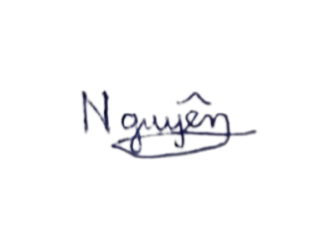
24127562 | Huỳnh Mai Trâm | 20% | 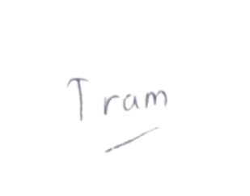

Conceptual Model
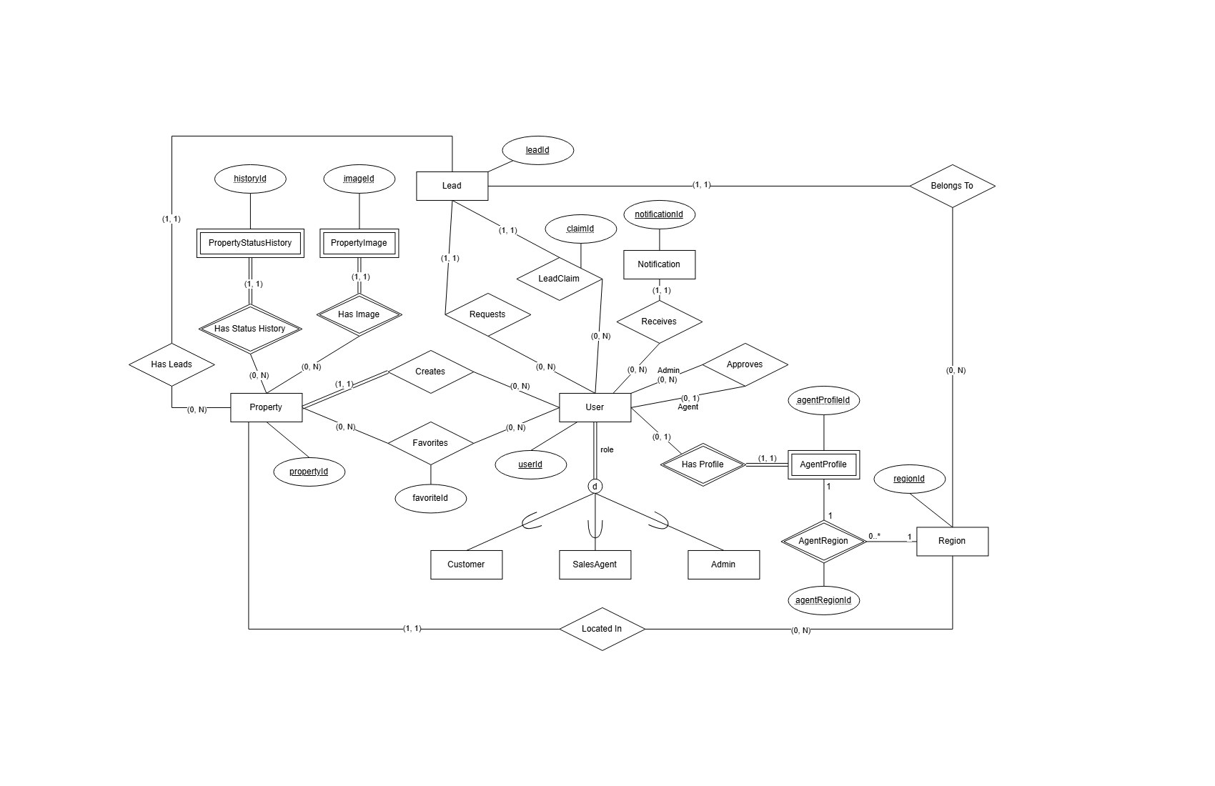
Figure 1. An Extended Entity-Relationship diagram
Link: An Extended Entity-Relationship diagram

Architectural Design

Architecture Diagram
- System decomposition tree diagram
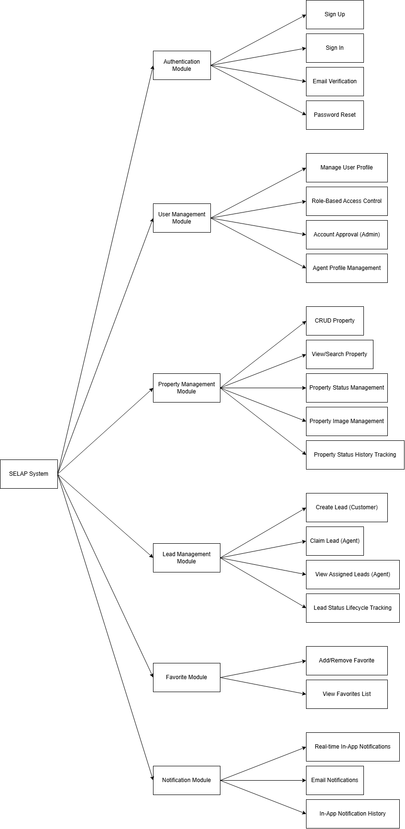
Figure 2. A system decomposition tree diagram
Link: A system decomposition tree diagram
- System architecture diagram
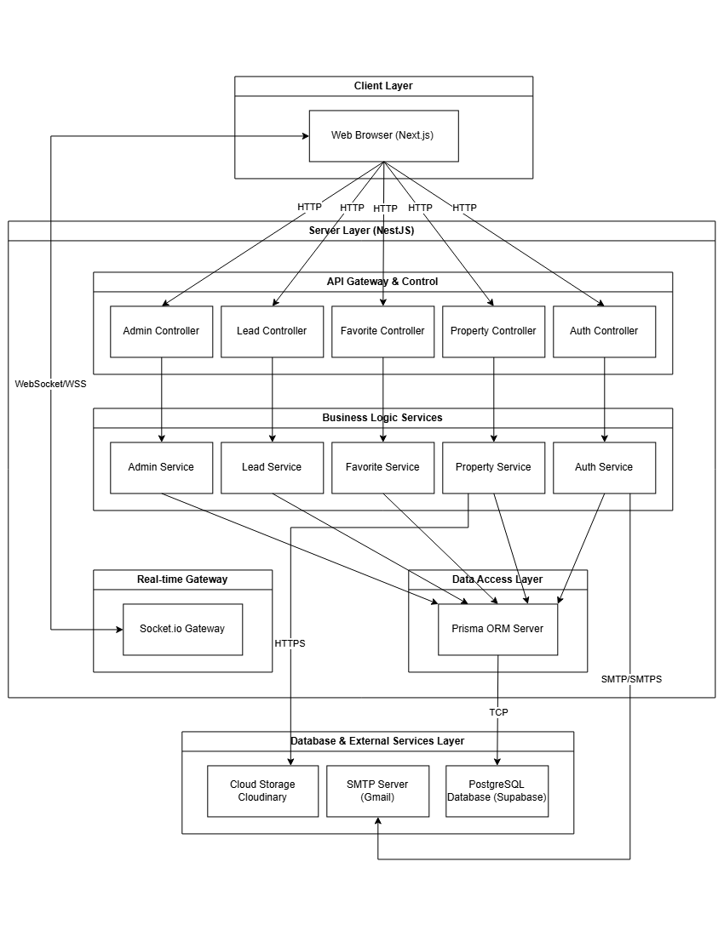
Figure 3. A system architecture diagram
Link: A system architecture diagram

- Special Aspects of the Architecture
Key architectural styles, design patterns, and structural mechanisms applied within the system include:
- Multilayered Client-Server Architecture: Divided into 4 clear functional tiers
- Client Tier: A Next.js Web application interacting with the backend via RESTful APIs and WebSocket channels.
- API Gateway & Controller Tier: NestJS Controllers (AuthController, PropertiesController, LeadsController, AdminController, FavoritesController) serving as API entry points, handling route mapping, request validation via DTOs, and guard-based authorization.
- Business Logic Tier: NestJS Services (AuthService, PropertiesService, LeadsService, AdminService, FavoritesService) encapsulating core business rules, transactional logic, and security workflows.
- Data Access & Persistence Tier: Powered by Prisma ORM (PrismaService) bridging domain models with the PostgreSQL database, supplemented by external integration services (MailService via SMTP and Cloudinary via HTTPS).
- Modular Monolithic Architecture: Although the backend is deployed as a single monolithic application, it is structured as a Modular Monolith
- Auth Module: User registration, login, OTP verification, password reset.
- Property Module: CRUD operations, filtering, status history management.
- Lead Module: Consultation requests, atomic lead claiming, agent assignment.
- Favorite Module: Managing user favorites
- Admin Module: Agent approval, region management.
- Claiming Module: WebSocket gateway for real-time lead notifications.

- Design Patterns Implementation:
Table 1. Design Patterns Implementation
Design Pattern | Application | Benefit
Dependency Injection | NestJS DI Container | Loose coupling, easy testing
Singleton | Prisma Client Instance | Efficient database connection reuse
Repository | Prisma ORM | Abstracts data access, centralizes queries
- Event-Driven & Real-Time Communication Mechanism:
- WebSocket Gateway (ClaimingGateway): Built on Socket.io, maintaining bi-directional, persistent WSS connections with authenticated clients.
- Room-Based Pub/Sub Pattern: Clients join specific WebSocket rooms (region_{regionId} for Sales Agents or user_{userId} for Customers). When a customer submits a consultation request, LeadsService triggers ClaimingGateway to broadcast the new_lead event instantly to all agents assigned to that region.

Class Diagram
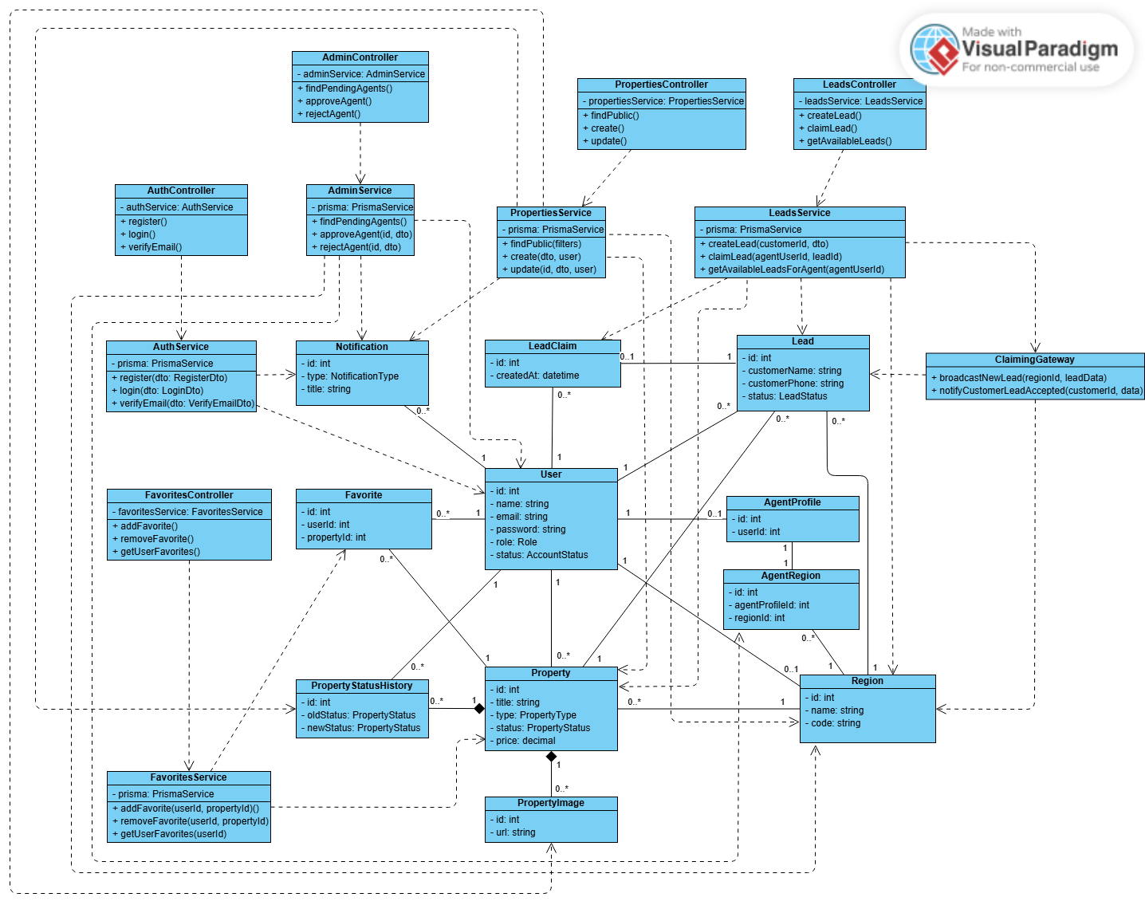
Figure 4. A class diagram
Link: A class diagram

Class Specifications
- Class User
- Inheritance: Class User does not inherit from any class.
- Attributes:
Table 2. Class User Attributes Specification
Seq | Property | Modifier | Constraint | Description
1 | id: int | private | Generated by system | Identifies a user object in the system
2 | name: string | private | Must not be empty | Full name of the user
3 | email: string | private | Must follow valid email format | Email used for login and communication
4 | password: string | private | Must be encrypted | Password used for authentication
5 | role: Role | private | Must be a valid Role value | Defines the user role such as admin, customer, or agent
6 | status: AccountStatus | private | Must be a valid AccountStatus value | Shows the current status of the user account
- Operations:
Table 3. Class User Operations Specification
Seq | Operation | Modifier | Constraint | Description
1 | register() | public | Registration information must be valid | Creates a new user account
2 | login() | public | Email and password must be correct | Authenticates the user
3 | verifyEmail() | public | Verification information must be valid | Confirms the user email address

- Class Property
- Inheritance: Class Property does not inherit from any class.
- Attributes:
Table 4. Class Property Attributes Specification
Seq | Property | Modifier | Constraint | Description
1 | id: int | private | Generated by system | Identifies a property object
2 | title: string | private | Must not be empty | Title of the property listing
3 | type: PropertyType | private | Must be a valid PropertyType value | Type of property, such as house, apartment, or land
4 | status: PropertyStatus | private | Must be a valid PropertyStatus value | Current status of the property listing
5 | price: Decimal | private | Must be greater than 0 | Selling or renting price of the property
- Operations:
Table 5. Class Property Operations Specification
Seq | Operation | Modifier | Constraint | Description
1 | findPublic(filter) | public | Only visible properties are returned | Searches and displays public property listings
2 | create(dto, user) | public | User must be authenticated | Creates a new property listing
3 | update(id, dto, user) | public | User must have permission to update | Updates information of an existing property

- Class PropertyImage
- Inheritance: Class PropertyImage does not inherit from any class.
- Attributes:
Table 6. Class PropertyImage Attributes Specification
Seq | Property | Modifier | Constraint | Description
1 | id: int | private | Generated by system | Identifies a property image object
2 | url: string | private | Must be a valid image URL | Stores the location of the property image
- Operations:
Table 7. Class PropertyImage Operations Specification
Seq | Operation | Modifier | Constraint | Description
1 | addImage(propertyId, url) | public | Property must exist and URL must be valid | Adds an image to a property
2 | removeImage(imageId) | public | Image must exist | Removes an image from a property

- Class Favorite
- Inheritance: Class Favorite does not inherit from any class.
- Attributes:
Table 8. Class Favorite Attributes Specification
Seq | Property | Modifier | Constraint | Description
1 | id: int | private | Generated by system | Identifies a favorite object
2 | userId: int | private | User object must exist | Identifies the user who saves the property
3 | propertyId: int | private | Property object must exist | Identifies the property saved by the user
- Operations:
Table 9. Class Favorite Operations Specification
Seq | Operation | Modifier | Constraint | Description
1 | addFavorite(userId, propertyId) | public | User must be authenticated | Adds a property to the user’s favorite list
2 | removeFavorite(userId, propertyId) | public | Favorite item must exist | Removes a property from the user’s favorite list
3 | getUserFavorites(userId) | public | User must be authenticated | Returns the list of favorite properties of a user

- Class Notification
- Inheritance: Class Notification does not inherit from any class.
- Attributes:
Table 10. Class Notification Attributes Specification
Seq | Property | Modifier | Constraint | Description
1 | id: int | private | Generated by system | Identifies a notification object
2 | type: NotificationType | private | Must be a valid NotificationType value | Type of notification sent to the user
3 | title: string | private | Must not be empty | Title or short content of the notification
- Operations:
Table 11. Class Notification Operations Specification
Seq | Operation | Modifier | Constraint | Description
1 | broadcastNewLead (regionId, leadData) | public | Region and lead data must be valid | Sends new lead notification to agents in a region
2 | notifyCustomerLeadAccepted (customerId, data) | public | Customer and notification data must be valid | Notifies customer when a lead is accepted

- Class Lead
- Inheritance: Class Lead does not inherit from any class.
- Attributes:
Table 12. Class Lead Attributes Specification
Seq | Property | Modifier | Constraint | Description
1 | id: int | private | Generated by system | Identifies a lead object
2 | customerName: string | private | Must not be empty | Name of the customer who is interested in a property
3 | customerPhone: string | private | Must be a valid phone number | Phone number of the customer
4 | status: LeadStatus | private | Must be a valid LeadStatus value | Current status of the lead
- Operations:
Table 13. Class Lead Operations Specification
Seq | Operation | Modifier | Constraint | Description
1 | createLead(customerId, dto) | public | Customer information must be valid | Creates a new lead for a property
2 | claimLead(agentUserId, leadId) | public | Lead must be available | Allows an agent to accept and handle a lead
3 | getAvailableLeadsForAgent(agentUserId) | public | Agent must be approved | Returns available leads for a specific agent

- Class LeadClaim
- Inheritance: Class LeadClaim does not inherit from any class.
- Attributes:
Table 14. Class LeadClaim Attributes Specification
Seq | Property | Modifier | Constraint | Description
1 | id: int | private | Generated by system | Identifies a lead claim object
2 | createdAt: datetime | private | Must be a valid date and time | Time when the lead is claimed by an agent
- Operations:
Table 15. Class LeadClaim Operations Specification
Seq | Operation | Modifier | Constraint | Description
1 | claimLead(agentUserId, leadId) | public | Agent must be approved and lead must be unclaimed | Creates a claim record for a lead

- Class AgentProfile
- Inheritance: Class AgentProfile does not inherit from any class.
- Attributes:
Table 16. Class AgentProfile Attributes Specification
Seq | Property | Modifier | Constraint | Description
1 | id: int | private | Generated by system | Identifies an agent profile object
2 | userId: int | private | User must have agent role | Identifies the user account linked to the agent profile
- Operations:
Table 17. Class AgentProfile Operations Specification
Seq | Operation | Modifier | Constraint | Description
1 | findPendingAgents() | public | Admin permission is required | Retrieves agents waiting for approval
2 | approveAgent(id, dto) | public | Admin permission is required | Approves an agent account
3 | rejectAgent(id, dto) | public | Admin permission is required | Rejects an agent account

- Class AgentRegion
- Inheritance: Class AgentRegion does not inherit from any class.
- Attributes:
Table 18. Class AgentRegion Attributes Specification
Seq | Property | Modifier | Constraint | Description
1 | id: int | private | Generated by system | Identifies an agent-region assignment
2 | agentProfileId: int | private | Agent profile must exist | Identifies the assigned agent profile
3 | regionId: int | private | Region must exist | Identifies the region assigned to the agent
- Operations:
Table 19. Class AgentRegion Operations Specification
Seq | Operation | Modifier | Constraint | Description
1 | assignRegion(agentProfileId, regionId) | public | Agent profile and region must be valid | Assigns a region to an agent
2 | removeRegion(agentProfileId, regionId) | public | Assignment must exist | Removes a region from an agent

- Class Region
- Inheritance: Class Region does not inherit from any class.
- Attributes:
Table 20. Class Region Attributes Specification
Seq | Property | Modifier | Constraint | Description
1 | id: int | private | Generated by system | Identifies a region object
2 | name: string | private | Must not be empty | Name of the region
3 | code: string | private | Must not be empty | Code used to represent the region
- Operations:
Table 21. Class Region Operations Specification
Seq | Operation | Modifier | Constraint | Description
1 | getAvailableLeadsForAgent(agentUserId) | public | Agent must belong to a region | Finds available leads based on the agent’s region
2 | broadcastNewLead (regionId, leadData) | public | Region must be valid | Broadcasts new lead information to agents in the region

- Class AuthService
- Inheritance: Class AuthService does not inherit from any class.
- Attributes:
Table 22. Class AuthService Attributes Specification
Seq | Property | Modifier | Constraint | Description
1 | prisma: PrismaService | private | Must be available | Provides access to user data
2 | registerDto: RegisterDto | private | Registration data must be valid | Contains user registration information
- Operations:
Table 23. Class AuthService Operations Specification
Seq | Operation | Modifier | Constraint | Description
1 | register() | public | User information must be valid | Registers a new user account
2 | login(dto) | public | Email and password must be correct | Authenticates a user and allows access to the system
3 | verifyEmail(dto) | public | Verification data must be valid | Verifies the email address of a registered user

- Class AdminService
- Inheritance: Class AdminService does not inherit from any class.
- Attributes:
Table 24. Class AdminService Attributes Specification
Seq | Property | Modifier | Constraint | Description
1 | prisma: PrismaService | private | Must be available | Provides access to agent and user data
- Operations:
Table 25. Class AdminService Operations Specification
Seq | Operation | Modifier | Constraint | Description
1 | findPendingAgents() | public | Admin permission is required | Retrieves the list of agents waiting for approval
2 | approveAgent(id, dto) | public | Admin permission is required and agent must be pending | Approves an agent account
3 | rejectAgent(id, dto) | public | Admin permission is required and agent must be pending | Rejects an agent account

- Class FavoritesService
- Inheritance: Class FavoritesService does not inherit from any class.
- Attributes:
Table 26. Class FavoritesService Attributes Specification
Seq | Property | Modifier | Constraint | Description
1 | prisma: PrismaService | private | Must be available | Provides access to favorite, user, and property data
- Operations:
Table 27. Class FavoritesService Operations Specification
Seq | Operation | Modifier | Constraint | Description
1 | addFavorite(userId, propertyId) | public | User must be authenticated and property must exist | Adds a property to the user’s favorite list
2 | removeFavorite (userId, propertyId) | public | Favorite item must exist | Removes a property from the user’s favorite list
3 | getUserFavorites (userId) | public | User must be authenticated | Retrieves all favorite properties of a user

- Class ClaimingGateway
- Inheritance: Class ClaimingGateway does not inherit from any class.
- Attributes:
Table 28. Class ClaimingGateway Attributes Specification
Seq | Property | Modifier | Constraint | Description
1 | server | private | Gateway connection must be active | Handles real-time communication with connected clients
- Operations:
Table 29. Class ClaimingGateway Operations Specification
Seq | Operation | Modifier | Constraint | Description
1 | broadcastNewLead (regionId, leadData) | public | Region and lead data must be valid | Sends real-time notification about a new lead to agents in a region
2 | notifyCustomerLeadAccepted (customerId, data) | public | Customer and notification data must be valid | Notifies a customer when their lead has been accepted by an agent

- Class LeadsService
- Inheritance: Class LeadsService does not inherit from any class.
- Attributes:
Table 30. Class LeadsService Attributes Specification
Seq | Property | Modifier | Constraint | Description
1 | prisma: PrismaService | private | Must be available | Provides access to lead, user, property, and claim data
- Operations:
Table 31. Class LeadsService Operations Specification
Seq | Operation | Modifier | Constraint | Description
1 | createLead(customerId, dto) | public | Customer and property information must be valid | Creates a new lead for a property
2 | claimLead(agentUserId, leadId) | public | Agent must be approved and lead must be available | Allows an agent to accept and handle a lead
3 | getAvailableLeadsForAgent(agentUserId) | public | Agent must have an assigned region | Retrieves available leads suitable for the agent

- Class PropertiesService
- Inheritance: Class PropertiesService does not inherit from any class.
- Attributes:
Table 32. Class PropertiesService Attributes Specification
Seq | Property | Modifier | Constraint | Description
1 | prisma: PrismaService | private | Must be available | Provides access to property, image, user, and region data
- Operations:
Table 33. Class PropertiesService Operations Specification
Seq | Operation | Modifier | Constraint | Description
1 | findPublic(filter) | public | Search filter must be valid if provided | Retrieves public property listings based on filter conditions
2 | create(dto, user) | public | User must be authenticated and property data must be valid | Creates a new property listing
3 | update(id, dto, user) | public | User must have permission to update the property | Updates information of an existing property

Data Design

Data Diagram
- Logical Data Diagram
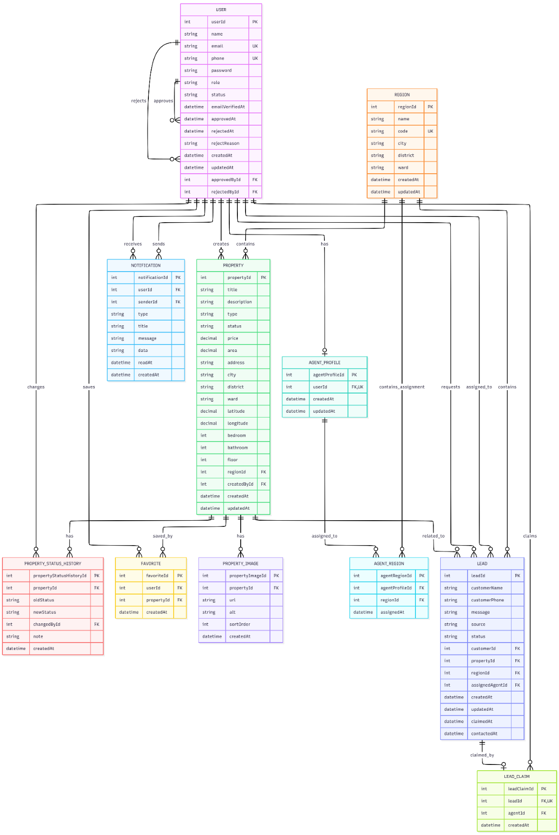
Figure 5. Logical Data Diagram

- Physical Data Diagram
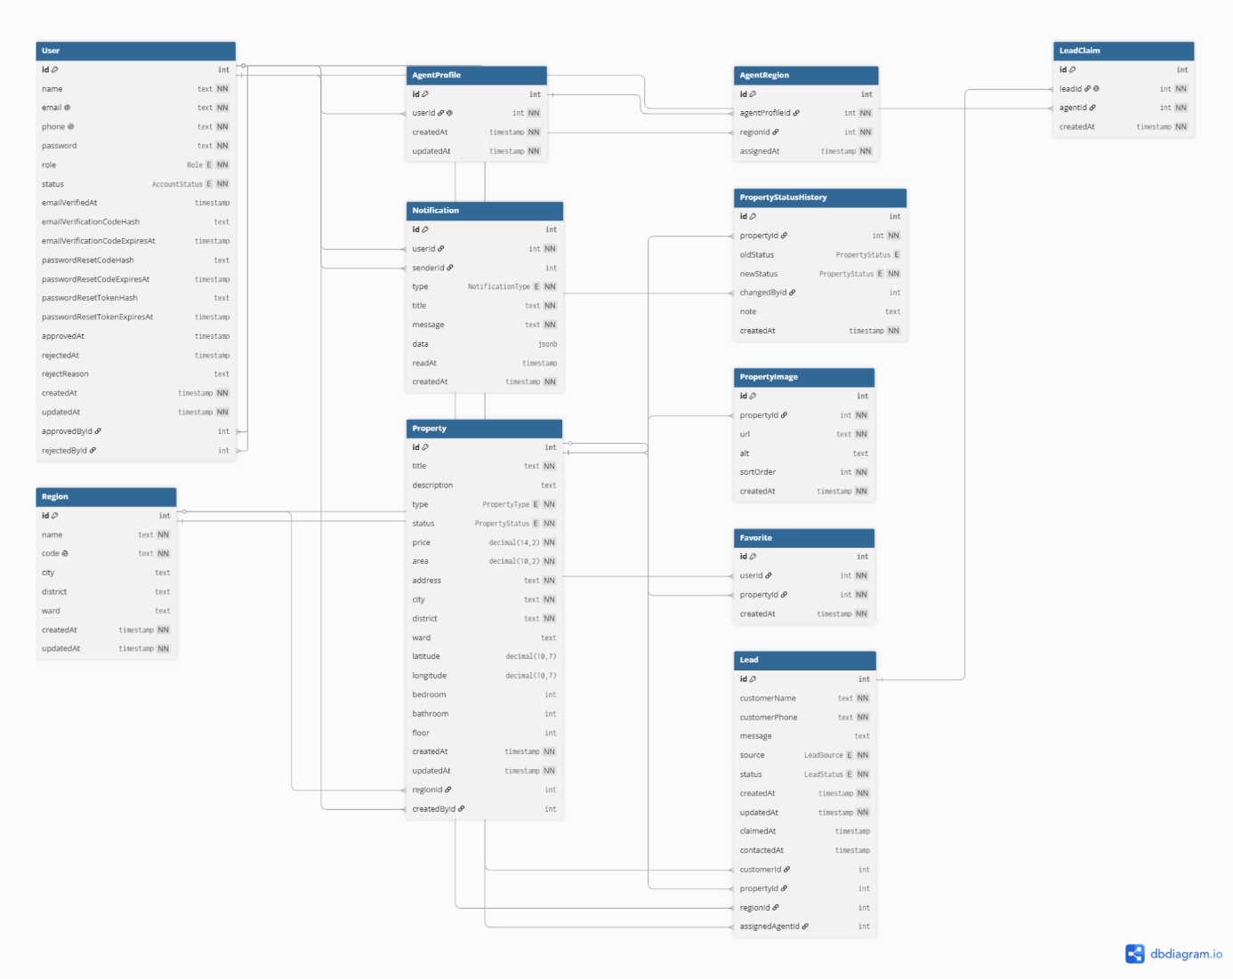
Figure 6. Physical Data Diagram

Data Specification
- User Data
Table 34. User Data Specification
No. | Column Name | Data Type | PK | FK | Not Null | Auto Increment | Default Value | Description
1 | id | INTEGER | ☑ | ☐ | ☑ | ☑ |  | Unique user identifier
2 | name | TEXT | ☐ | ☐ | ☑ | ☐ |  | Full name of the user
3 | email | TEXT | ☐ | ☐ | ☑ | ☐ |  | User email address, must be unique
4 | phone | TEXT | ☐ | ☐ | ☑ | ☐ |  | User phone number, must be unique
5 | password | TEXT | ☐ | ☐ | ☑ | ☐ |  | Encrypted login password
6 | role | Role | ☐ | ☐ | ☑ | ☐ | CUSTOMER | User role
7 | status | AccountStatus | ☐ | ☐ | ☑ | ☐ | ACTIVE | Account status
8 | emailVerifiedAt | TIMESTAMP | ☐ | ☐ | ☐ | ☐ | NULL | Email verification time
9 | emailVerificationCodeHash | TEXT | ☐ | ☐ | ☐ | ☐ | NULL | Hashed email verification code
10 | emailVerificationCodeExpiresAt | TIMESTAMP | ☐ | ☐ | ☐ | ☐ | NULL | Email verification code expiration time
11 | passwordResetCodeHash | TEXT | ☐ | ☐ | ☐ | ☐ | NULL | Hashed password reset code
12 | passwordResetCodeExpiresAt | TIMESTAMP | ☐ | ☐ | ☐ | ☐ | NULL | Password reset code expiration time
13 | passwordResetTokenHash | TEXT | ☐ | ☐ | ☐ | ☐ | NULL | Hashed password reset token
14 | passwordResetTokenExpiresAt | TIMESTAMP | ☐ | ☐ | ☐ | ☐ | NULL | Password reset token expiration time
15 | approvedAt | TIMESTAMP | ☐ | ☐ | ☐ | ☐ | NULL | Account approval time
16 | rejectedAt | TIMESTAMP | ☐ | ☐ | ☐ | ☐ | NULL | Account rejection time
17 | rejectReason | TEXT | ☐ | ☐ | ☐ | ☐ | NULL | Reason why the account was rejected
18 | createdAt | TIMESTAMP | ☐ | ☐ | ☑ | ☐ | CURRENT_  TIMESTAMP | Account creation time
19 | updatedAt | TIMESTAMP | ☐ | ☐ | ☑ | ☐ |  | Last account update time
20 | approvedById | INTEGER | ☐ | ☑ | ☐ | ☐ | NULL | References the user who approved this account
21 | rejectedById | INTEGER | ☐ | ☑ | ☐ | ☐ | NULL | References the user who rejected this account

- AgentProfile Data
Table 35. AgentProfile Data Specification
No. | Column Name | Data Type | PK | FK | Not Null | Auto Increment | Default Value | Description
1 | id | INTEGER | ☑ | ☐ | ☑ | ☑ |  | Unique agent profile identifier
2 | userId | INTEGER | ☐ | ☑ | ☑ | ☐ |  | References the user account, must be unique
3 | createdAt | TIMESTAMP | ☐ | ☐ | ☑ | ☐ | CURRENT_  TIMESTAMP | Profile creation time
4 | updatedAt | TIMESTAMP | ☐ | ☐ | ☑ | ☐ |  | Last profile update time
- Region Data
Table 36. Region Data Specification
No. | Column Name | Data Type | PK | FK | Not Null | Auto Increment | Default Value | Description
1 | id | INTEGER | ☑ | ☐ | ☑ | ☑ |  | Unique region identifier
2 | name | TEXT | ☐ | ☐ | ☑ | ☐ |  | Region name
3 | code | TEXT | ☐ | ☐ | ☑ | ☐ |  | Unique region code
4 | city | TEXT | ☐ | ☐ | ☐ | ☐ | NULL | City name
5 | district | TEXT | ☐ | ☐ | ☐ | ☐ | NULL | District name
6 | ward | TEXT | ☐ | ☐ | ☐ | ☐ | NULL | Ward name
7 | createdAt | TIMESTAMP | ☐ | ☐ | ☑ | ☐ | CURRENT_  TIMESTAMP | Region creation time
8 | updatedAt | TIMESTAMP | ☐ | ☐ | ☑ | ☐ |  | Last region update time
- AgentRegion Data
Table 37. AgentRegion Data Specification
No. | Column Name | Data Type | PK | FK | Not Null | Auto Increment | Default Value | Description
1 | id | INTEGER | ☑ | ☐ | ☑ | ☑ |  | Unique assignment identifier
2 | agentProfileId | INTEGER | ☐ | ☑ | ☑ | ☐ |  | References the assigned agent profile
3 | regionId | INTEGER | ☐ | ☑ | ☑ | ☐ |  | References the assigned region
4 | assignedAt | TIMESTAMP | ☐ | ☐ | ☑ | ☐ | CURRENT_  TIMESTAMP | Time when the agent was assigned to the region

- Property Data
Table 38. Property Data Specification
No. | Column Name | Data Type | PK | FK | Not Null | Auto Increment | Default Value | Description
1 | id | INTEGER | ☑ | ☐ | ☑ | ☑ |  | Unique property identifier
2 | title | TEXT | ☐ | ☐ | ☑ | ☐ |  | Property title
3 | description | TEXT | ☐ | ☐ | ☐ | ☐ | NULL | Detailed property description
4 | type | PropertyType | ☐ | ☐ | ☑ | ☐ |  | Property type
5 | status | PropertyStatus | ☐ | ☐ | ☑ | ☐ | AVAILABLE | Current property status
6 | price | DECIMAL(14,2) | ☐ | ☐ | ☑ | ☐ |  | Property price
7 | area | DECIMAL(10,2) | ☐ | ☐ | ☑ | ☐ |  | Property area
8 | address | TEXT | ☐ | ☐ | ☑ | ☐ |  | Property address
9 | city | TEXT | ☐ | ☐ | ☑ | ☐ |  | City where the property is located
10 | district | TEXT | ☐ | ☐ | ☑ | ☐ |  | District where the property is located
11 | ward | TEXT | ☐ | ☐ | ☐ | ☐ | NULL | Ward where the property is located
12 | latitude | DECIMAL(10,7) | ☐ | ☐ | ☐ | ☐ | NULL | Latitude coordinate
13 | longitude | DECIMAL(10,7) | ☐ | ☐ | ☐ | ☐ | NULL | Longitude coordinate
14 | bedroom | INTEGER | ☐ | ☐ | ☐ | ☐ | NULL | Number of bedrooms
15 | bathroom | INTEGER | ☐ | ☐ | ☐ | ☐ | NULL | Number of bathrooms
16 | floor | INTEGER | ☐ | ☐ | ☐ | ☐ | NULL | Number of floors
17 | createdAt | TIMESTAMP | ☐ | ☐ | ☑ | ☐ | CURRENT_  TIMESTAMP | Property creation time
18 | updatedAt | TIMESTAMP | ☐ | ☐ | ☑ | ☐ |  | Last property update time
19 | regionId | INTEGER | ☐ | ☑ | ☐ | ☐ | NULL | References the region of the property
20 | createdById | INTEGER | ☐ | ☑ | ☐ | ☐ | NULL | References the user who created the property

- PropertyImage Data
Table 39. PropertyImage Data Specification
No. | Column Name | Data Type | PK | FK | Not Null | Auto Increment | Default Value | Description
1 | id | INTEGER | ☑ | ☐ | ☑ | ☑ |  | Unique property image identifier
2 | propertyId | INTEGER | ☐ | ☑ | ☑ | ☐ |  | References the related property
3 | url | TEXT | ☐ | ☐ | ☑ | ☐ |  | Image URL or storage path
4 | alt | TEXT | ☐ | ☐ | ☐ | ☐ | NULL | Alternative image description
5 | sortOrder | INTEGER | ☐ | ☐ | ☑ | ☐ | 0 | Image display order
6 | createdAt | TIMESTAMP | ☐ | ☐ | ☑ | ☐ | CURRENT_  TIMESTAMP | Image creation time
- PropertyStatusHistory Data
Table 40. PropertyStatusHistory Data Specification
No. | Column Name | Data Type | PK | FK | Not Null | Auto Increment | Default Value | Description
1 | id | INTEGER | ☑ | ☐ | ☑ | ☑ |  | Unique status history identifier
2 | propertyId | INTEGER | ☐ | ☑ | ☑ | ☐ |  | References the related property
3 | oldStatus | PropertyStatus | ☐ | ☐ | ☐ | ☐ | NULL | Previous property status
4 | newStatus | PropertyStatus | ☐ | ☐ | ☑ | ☐ |  | New property status
5 | changedById | INTEGER | ☐ | ☑ | ☐ | ☐ | NULL | References the user who changed the status
6 | note | TEXT | ☐ | ☐ | ☐ | ☐ | NULL | Additional note about the status change
7 | createdAt | TIMESTAMP | ☐ | ☐ | ☑ | ☐ | CURRENT_  TIMESTAMP | Time when the status change was recorded
- Favorite Data
Table 41. Favorite Data Specification
No. | Column Name | Data Type | PK | FK | Not Null | Auto Increment | Default Value | Description
1 | id | INTEGER | ☑ | ☐ | ☑ | ☑ |  | Unique favorite identifier
2 | userId | INTEGER | ☐ | ☑ | ☑ | ☐ |  | References the user who saved the property
3 | propertyId | INTEGER | ☐ | ☑ | ☑ | ☐ |  | References the saved property
4 | createdAt | TIMESTAMP | ☐ | ☐ | ☑ | ☐ | CURRENT_  TIMESTAMP | Time when the property was added to favorites
- Lead Data
Table 42. Lead Data Specification
No. | Column Name | Data Type | PK | FK | Not Null | Auto Increment | Default Value | Description
1 | id | INTEGER | ☑ | ☐ | ☑ | ☑ |  | Unique lead identifier
2 | customerName | TEXT | ☐ | ☐ | ☑ | ☐ |  | Name of the potential customer
3 | customerPhone | TEXT | ☐ | ☐ | ☑ | ☐ |  | Phone number of the potential customer
4 | message | TEXT | ☐ | ☐ | ☐ | ☐ | NULL | Customer inquiry message
5 | source | LeadSource | ☐ | ☐ | ☑ | ☐ | CONSULTATION_REQUEST | Source of the lead
6 | status | LeadStatus | ☐ | ☐ | ☑ | ☐ | NEW | Current lead processing status
7 | createdAt | TIMESTAMP | ☐ | ☐ | ☑ | ☐ | CURRENT_  TIMESTAMP | Lead creation time
8 | updatedAt | TIMESTAMP | ☐ | ☐ | ☑ | ☐ |  | Last lead update time
9 | claimedAt | TIMESTAMP | ☐ | ☐ | ☐ | ☐ | NULL | Time when the lead was claimed
10 | contactedAt | TIMESTAMP | ☐ | ☐ | ☐ | ☐ | NULL | Time when the customer was contacted
11 | customerId | INTEGER | ☐ | ☑ | ☐ | ☐ | NULL | References the registered customer account
12 | propertyId | INTEGER | ☐ | ☑ | ☐ | ☐ | NULL | References the related property
13 | regionId | INTEGER | ☐ | ☑ | ☐ | ☐ | NULL | References the related region
14 | assignedAgentId | INTEGER | ☐ | ☑ | ☐ | ☐ | NULL | References the assigned sales agent
- LeadClaim Data
Table 43. LeadClaim Data Specification
No. | Column Name | Data Type | PK | FK | Not Null | Auto Increment | Default Value | Description
1 | id | INTEGER | ☑ | ☐ | ☑ | ☑ |  | Unique lead claim identifier
2 | leadId | INTEGER | ☐ | ☑ | ☑ | ☐ |  | References the claimed lead, must be unique
3 | agentId | INTEGER | ☐ | ☑ | ☑ | ☐ |  | References the sales agent who claimed the lead
4 | createdAt | TIMESTAMP | ☐ | ☐ | ☑ | ☐ | CURRENT_  TIMESTAMP | Time when the lead was claimed

- Notification Data
Table 44. Notification Data Specification
No. | Column Name | Data Type | PK | FK | Not Null | Auto Increment | Default Value | Description
1 | id | INTEGER | ☑ | ☐ | ☑ | ☑ |  | Unique notification identifier
2 | userId | INTEGER | ☐ | ☑ | ☑ | ☐ |  | References the notification receiver
3 | senderId | INTEGER | ☐ | ☑ | ☐ | ☐ | NULL | References the notification sender
4 | type | NotificationType | ☐ | ☐ | ☑ | ☐ |  | Type of notification
5 | title | TEXT | ☐ | ☐ | ☑ | ☐ |  | Notification title
6 | message | TEXT | ☐ | ☐ | ☑ | ☐ |  | Notification content
7 | data | JSONB | ☐ | ☐ | ☐ | ☐ | NULL | Additional structured notification data
8 | readAt | TIMESTAMP | ☐ | ☐ | ☐ | ☐ | NULL | Time when the notification was read
9 | createdAt | TIMESTAMP | ☐ | ☐ | ☑ | ☐ | CURRENT_  TIMESTAMP | Notification creation time
- Enum Values
Table 45. Enum Values
Enum Name | Values
Role | ADMIN, SALES_AGENT, CUSTOMER
AccountStatus | PENDING, ACTIVE, REJECTED, SUSPENDED
PropertyType | APARTMENT, HOUSE, LAND, VILLA, OFFICE, OTHER
PropertyStatus | AVAILABLE, COMING_SOON, DEPOSITED, SOLD, HIDDEN
LeadStatus | NEW, CLAIMED, CONTACTED, QUALIFIED, CONVERTED, LOST, CANCELLED
LeadSource | CONSULTATION_REQUEST, PROPERTY_INQUIRY, MANUAL
NotificationType | ACCOUNT_APPROVED, ACCOUNT_REJECTED, PROPERTY_STATUS_CHANGED, PROPERTY_FAVORITE_CHANGED, LEAD_CREATED, LEAD_CLAIMED, LEAD_ACCEPTED, SYSTEM

User Interface and User Experience Design

Screen Diagram
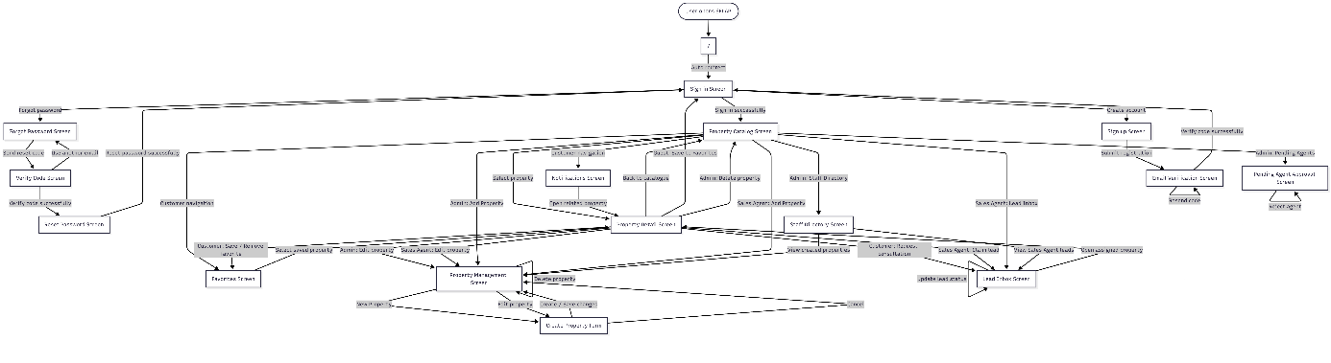
Figure 7. Screen Diagram
Table 46. Screens Overview
Seq | Screen | Description
1 | Sign In Screen | User logs into the system
2 | Sign Up Screen | New user registers an account
3 | Verify Email Screen | User verifies email using an OTP code
4 | Forgot Password Screen | User requests a password reset code by email
5 | Reset Password Screen | User creates a new password after OTP verification
6 | Public Catalog Screen | User browses and searches available properties
7 | Dashboard Screen | User accesses quick actions after signing in
8 | Property Management Screen | Admin or Sales Agent views and manages property inventory
9 | Property Creation and Modification Screen | Admin or Sales Agent adds or edits property information
10 | Pending Agent Approval Dashboard | Admin approves or rejects Sales Agent accounts
11 | Favorites Screen | Customer views and manages favorite properties
12 | Notifications Screen | User views system updates and notifications
13 | Agent Lead Inbox Screen | Sales Agent receives and manages consultation leads
14 | Staff Directory Screen | Admin views or manages staff information

Screen Specifications
- Sign-in Screen
- Presentation Format: Includes
- Input fields (Phone number, Password).
- A “Log In” button.
- Role-switching tab bar (Admin, Sales Agent, Customer) to optimize the user experience.
- Event Handling: The system calls the JWT authentication API.
- If the account belongs to the PENDING group, the system rejects the request and returns the error: “Account not yet activated.”
- Upon success, the system stores the Token/Role and redirects the user to the appropriate page (Admin, Agent, and Customer to the Catalog page).
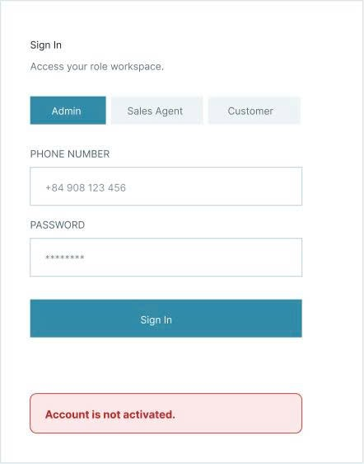
Figure 8. Sign-in Screen

- Sign-up Screen
- Presentation Format: Includes
- Input fields (Username, Phone number, Password).
- A “Register” button.
- A tab bar for role selection (Admin, Sales Agent, Customer) to optimize the user experience.
- Event Handling: The system calls the JWT authentication API.
- Agent Sign-Up Event: When a user selects the “Sales Agent” role and clicks ‘Sign Up”, the system sends data to the backend to create an account with a default status of PENDING. The interface displays a yellow notification: “Your account has been successfully created and is awaiting Admin approval for regional assignment.”
- Customer Sign-Up Event: When a user selects the “Customer"”role and creates a registration account, the system will send the account to the backend with the default status of ACTIVE. Next, the system will send a 4-digit OTP code to the email account for verification. After successful verification, the customer will be redirected directly to the Product Backlog page without requiring administrator authentication.
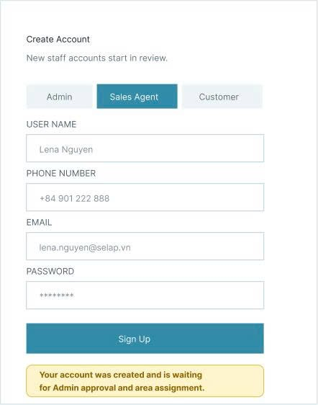
Figure 9. Sign-up Screen
- Set New Password Screen Screen
- Presentation Format: Includes
- Input field for entering new password.
- A “Reset password” button.
- New Password Screen: The user enters a new password. After entering it, the website will redirect to the login page.
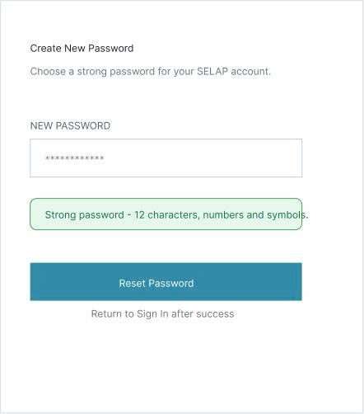
Figure 10. Set New Password Screen

- Verify OTP Code Screen
- Presentation Format: Includes
- An email bar for entering user email.
- A “Verify Code” button.
- A verification code in the user email box(the verification code above is a demo).
- Verify OTP Screen: Users will enter the 4-digit OTP code sent to their personal account. After system verification, users will be redirected to the “Set New Password Screen”.
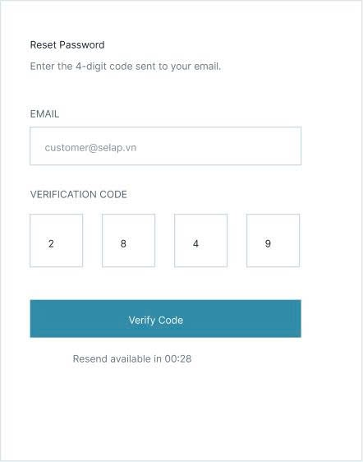
Figure 11. Verify OTP Code Screen

- Public Catalog Screen
- Presentation Format: This is the public-facing interface for all users. The screen features a search bar and smart filters (by area, price range, apartment type, and apartment name), along with a list of apartments displayed as grid cards. Each card shows a representative image, price, area, and status, as well as a heart-shaped button to mark the apartment as a “favorite” (or “interested”).
- Event Handling:
- Page Load Event: Calls an API to retrieve and display the full list of apartments.
- Filter/Search Event: When a user changes options in the Area or Price Range fields, the system immediately sends an API request to filter the data and update the displayed list of apartments according to the selected criteria.
- “Favorite” Click Event: Prompts the user to log in if they have not already done so. If the user is logged in, the system calls an API to add the apartment to the Wishlist table in the database.
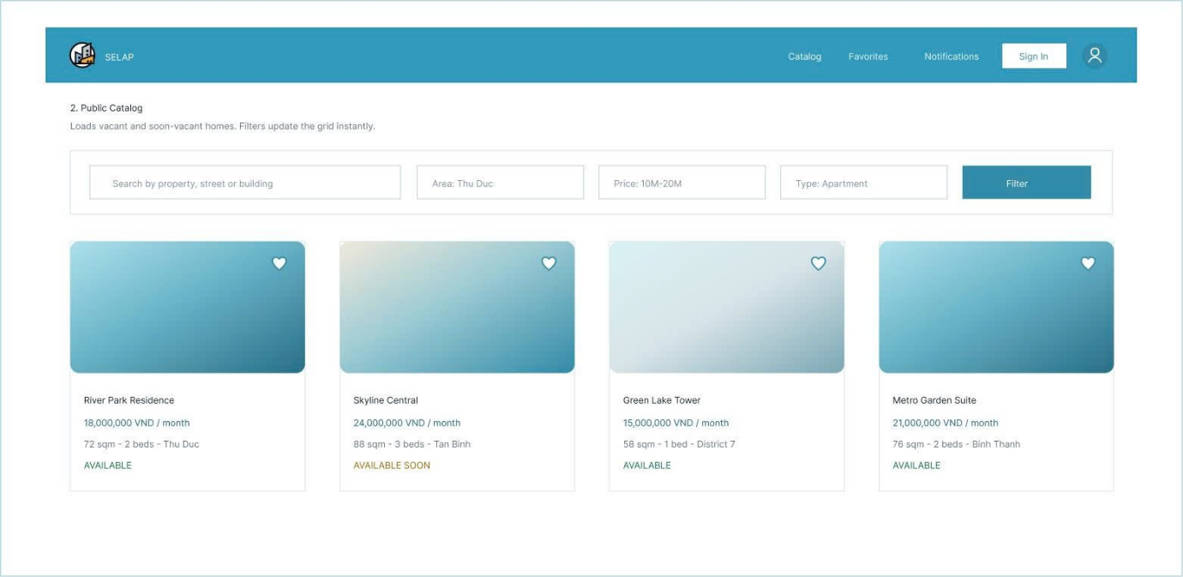
Figure 12. Public Catalog Screen

- Property Detail Screen
Includes two types of screens: one for customers and one for admins/sales agents.
- Property Detail Screen for Customer
- Presentation Format: Displays details of a specific property. Includes: an image slider for the unit; detailed specifications (Name, Price, Area, Address, and features description); and buttons for “Request Consultation” and “Save to Favorites”.
- Event Handling:
- “Request Consultation” Click Event: The system checks whether the customer is logged in. When the customer confirms the request submission, the system performs two actions simultaneously:
- Sends an HTTP POST request to create a new `LeadRequest` record in the database with a status of PENDING.
- Triggers a real-time event via the Real-time Gateway (Socket.io) to the backend server.
- “Save to favorites” Click Event: Only customers who have logged in can use this function. If the customer is not logged in, when clicked, the website will redirect to the Login Screen. If you don't have a favorite yet, send POST /favorites (create record, optimistically update icon '♥' to filled); If you have a favorite, send DELETE /favorites (delete the record, the icon returns to outline) → if the request is an error, roll back the icon to the old state → this change is reflected immediately on the Favorites List page.
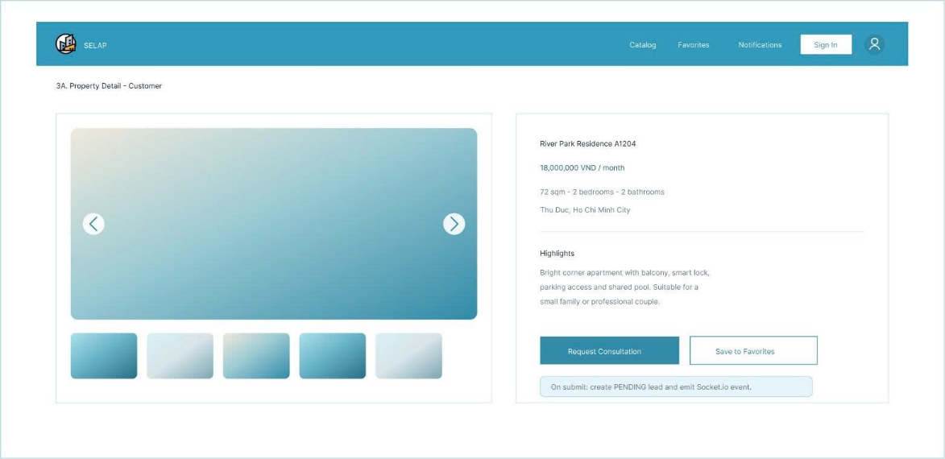
Figure 13. Property Detail Screen for Customer

- Property Detail Screen for Admin and Sales Agent
- Presentation Format: Displays details of a specific property. Includes: an image slider for the property; detailed specifications (Name, Price, Area, Address, and features description); and “Edit” and “Delete” buttons.
- Event Handling:
- The “Edit List” event: Only administrators or sales agents responsible for that area can see it. Click “Edit” → navigate to the form, call GET /properties to pre-fill data → user edits and clicks "Save" → send PATCH /properties → backend validates permissions, updates records, logs to PropertyStatusHistory if the status changes → redirects to Property Detail with a successful toast; if there is an error, an error notice is displayed, no redirect.
- The “Delete List” event: Similar to the edit button, only administrators or property agents responsible for that area can see the property. Click “Delete” → display confirmation modal (Cancel/Confirm) → if Cancel, close the modal without changes → if Confirm, send DELETE /properties/{id} → backend deletes/soft-delete (changes status to HIDDEN) and cascades processing of related Favorites/Leads → redirect to Property Catalog with successful toast; if an error occurs, display an errorNotice in the modal.
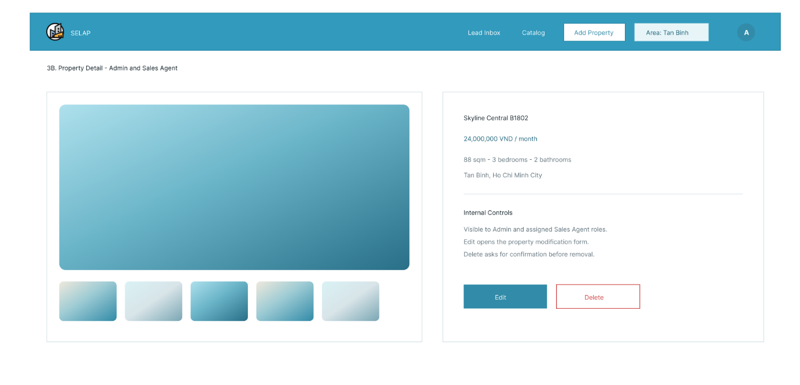
Figure 14. Property Detail Screen for Admin and Sales Agent

- Favorite Property Screen
- Presentation Format: A private interface for logged-in customers. It displays a vertical list of apartments the customer has previously marked as “Interested” (or “Favorite”). Each list item includes “View Details” and “Remove” buttons.
- Event Handling:
- On click of “Remove”: Calls the API to delete the record linking the customer to the apartment and updates the interface to remove the corresponding list item.
- On Page Load: Sends the customer's JWT authentication token to the backend to query and display the specific apartments stored in that customer's “Favorite Property” record.
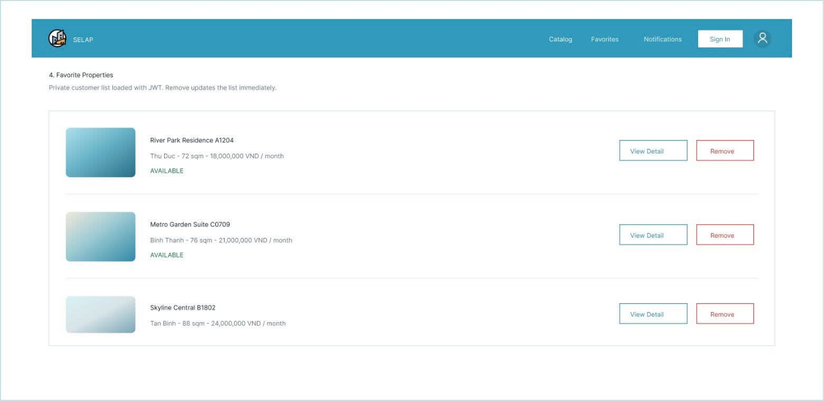
Figure 15. Favorite Property Screen

- Admin Account Approval Dashboard Screen
- Presentation Format: An administration interface designed specifically for Admins. The primary display format is a data table listing newly registered Sales Agents with a “PENDING” status. The final column of the table contains a dropdown menu for selecting “Areas” and two action buttons: “Approve” and “Reject”.
- Event Handling:
- Area Selection Event (On Area Dropdown Select): When the Admin selects an assigned area for a specific agent, the frontend captures the `selectedAreaId` for that row.
- “Approve” Click Event (On Click “Approve”): The system checks a mandatory condition: the Admin must first select an area from the dropdown. Upon approval, the frontend sends both the `userId` and `selectedAreaId` to the backend. The backend updates the account status to “ACTIVE” and assigns the area data to the “Staff Area Assignment” table. The agent's row is then removed from the pending approval table using an animation effect.
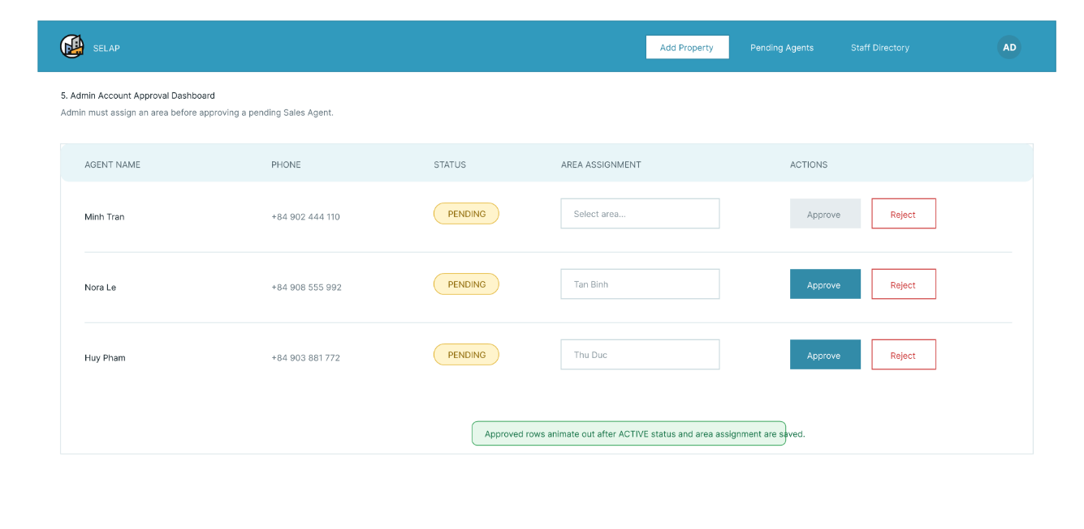
Figure 16. Admin Account Approval Dashboard Screen

- Agent Lead-Claiming Screen
- Presentation Format: This is the primary workspace for sales agents. The center of the screen features an in-app real-time notification box. Whenever a new consultation request arrives from a customer within an agent's assigned area, a yellow notification card automatically appears, displaying details about the apartment of interest and a large “Accept” (or “Claim Lead”) button.
- Event Handling:
- Real-time signal reception (On WebSocket Event `new_lead`): The frontend device maintains a continuous connection via `Socket.io-client`. When a customer clicks “Register for Consultation” on Screen 3, the backend automatically broadcasts a signal to the specific “Room” corresponding to that area. The agent's screen automatically pushes the new notification card to the top of the list, accompanied by a sound or flashing effect, without requiring a page refresh.
- “Accept” button click event (On Click “Accept”): The agent clicks the button to claim the lead. The system sends a `claim_lead` event to the server:
- If the agent is the fastest: The system displays a “Lead successfully accepted!” notification; the notification card turns green and displays the customer's contact information.
- If the agent is slower than someone else: The system displays an error pop-up stating, “This request has already been accepted by another agent!”; the “Accept” button is immediately disabled, and the notification card turns gray to indicate the session has ended.
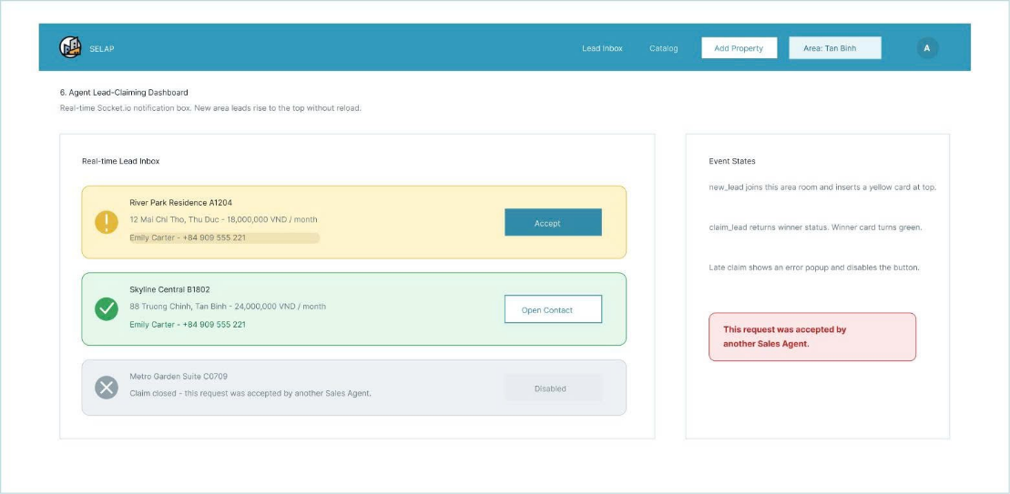
Figure 17. Agent Lead-Claiming Dashboard Screen

- Property Creation & Modification Screen
- Presentation Format: The form interface is clearly and intuitively divided into two columns, with a dynamic title “Add New Project” (or “Edit Project”):
- Left Column - Basic Information: Includes text input fields for Apartment Name/Title, Apartment Code, Type, Address/Area, a dropdown box for Status (with options: Empty, Almost Empty), and a large text area for Description.
- Right Column - Price, Status, and Images: Includes numerical input fields for Price, Area, Number of Bedrooms, Number of Bathrooms, an Apartment Status input field, and a dashed drag-and-drop zone with the text “Drag and drop images or click to upload” for the Photo/Video Library.
- The toolbar below (Footer Actions) contains 3 main action buttons: Cancel (Cancel the operation), Save Draft (Temporarily save), and Save (Confirm pushing data to the system).
- Event Handling:
- Image Upload Event (On Image Drag & Drop / Click Upload): When the user drags and drops an image file or clicks on the upload area, the Frontend activates the device's file selection library. When a file is selected, the system calls the API to connect to Cloudinary to upload the image to the cloud, returning the static image URL and displaying a preview image in the dashed frame.
- Status Selection Event (On Status Dropdown Click): When the Status box is clicked, the system displays a dropdown menu with two values: “Available” and “Not Available” for the user to click to select data.

- On Click “Save” Event:
- The system performs a validation check of the input data: The fields for title, price, area, and unit code cannot be blank.
- The frontend sends an HTTP POST request (if adding a new entry) or HTTP PUT request (if editing an entry) containing all the information from the form along with the image URL to the NestJS backend.
- After Prisma successfully updates the data in PostgreSQL, the system will automatically redirect the user back to the management menu and display a success notification pop-up.
- On the “Cancel” click event: The system displays a confirmation dialog box asking the user to delete the entered information. If the user agrees, the browser will delete all the content in the form and return to the previous page.
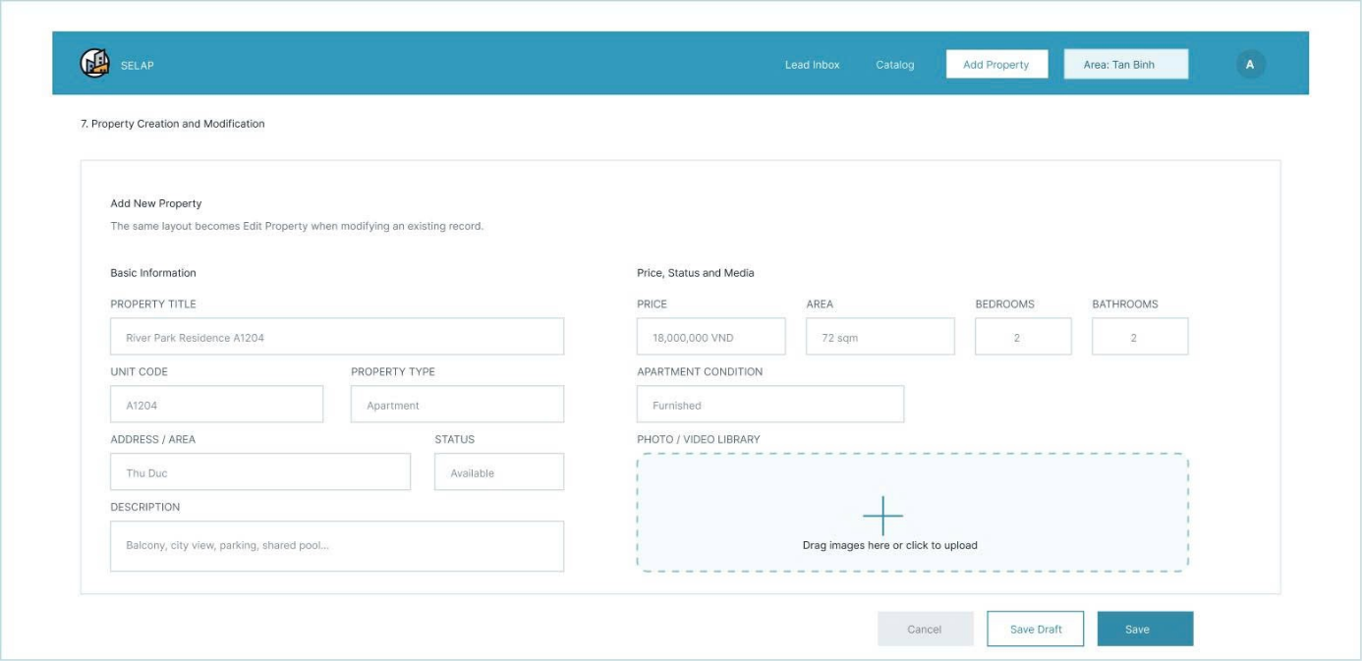
Figure 18. Property Creation & Modification Screen

- Sales Agent Directory Screen
- Presentation Format: This is the admin-specific management page interface displayed when clicking on the menu in the navigation bar. The main display structure is a visual data table including the following columns:
- Employee's Full Name.
- Phone Number.
- Region of Responsibility (displays a list of areas/districts that the employee has been previously assigned to by the Admin).
- Event Handling:
- On-Page Load Event: The system checks the Admin's authentication token. The frontend sends an HTTP GET request to the NestJS backend API to query the entire list of users with the SalesAgent role and an ACTIVE status in the PostgreSQL database. The returned data will be automatically loaded into the corresponding rows of the table.
- Navigation Bar Click Event: When the Admin clicks any button on the top navigation bar (e.g., “Staff Pending Approval” or “Add Apartment”), the system will activate the router to switch screens immediately without losing the login session state.
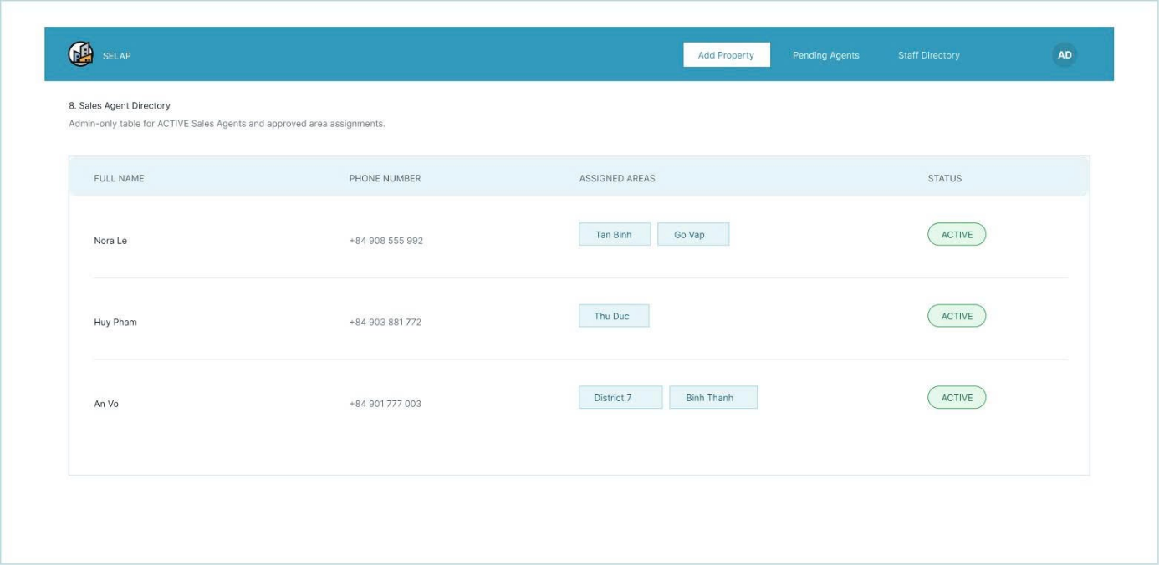
Figure 19. Property Creation & Modification Screen

- Shared Component Specification: Navigation Bar
All screens in the system have a navigation bar at the top (Top Navigation). Depending on the JWT authorization code of the account after login, this navigation bar will display the following dynamic custom components:
- Customer View: Displays the “SELAP” logo, quick link buttons: Login/Register (if not registered or logged in), Account icon (if logged in), Favorites, Catalog, Notifications. The personal account icon in the right corner is displayed according to the Customer standard.
- Sales Agent View: The right-hand corner displays the Sales Agent's account icon. The navigation bar includes:
- A “Lead Inbox” button where the Sales Agent receives contact requests from customers: when a customer views a property and clicks “Contact for Consultation” or “Schedule a Viewing”, the message or request is routed to the Lead Inbox of the Sales Agent assigned to that property.
- An “Add Property” button for quick access to the data entry form.
- A badge indicating the employee's assigned area (e.g., a rounded text box clearly stating: Region: Tan Binh or Region: Thu Duc), taken directly from the area assignment data table.
- Admin View: The right-hand corner displays the Admin's supreme account icon. The navigation bar displays three core management function buttons:
- “Add Property” button.
- “Pending Agent” button.
- “Staff Directory” button (leading to the system's personnel management page).

