SELAP
Final Presentation Content
Centralized real estate management with real-time lead claiming
Source basis: Prepared from PA0, PA1, PA2, PA3 and verified against the current Next.js/NestJS/Prisma implementation. PA4 is not present in the workspace, so Katalon PASS screenshots remain placeholders.

Slide 1. Problem Statement
- Real estate SMEs still manage inventory, customers, and transaction status through scattered files and chat channels.
- Property status is not synchronized in real time, creating duplicated consultations and outdated customer information.
- Manual lead distribution is opaque and easily causes internal disputes between Sales Agents.
- Managers lack structured regional assignment and local performance visibility.
Speaker note: Position the problem as an operations and coordination issue, not merely a listing website issue.

Slide 2. Product Positioning
- SELAP is a centralized real estate management web platform for properties, users, regions, favorites, leads, and notifications.
- Centralized repository: one trusted source for inventory and customer interaction data.
- Real-time lead sharing: Socket.IO broadcasts consultation requests to eligible agents.
- Regional partitioning: agents receive and manage leads/properties only in assigned service regions.
- Positioning statement: SELAP helps real estate teams reduce fragmented data, prevent lead disputes, and respond faster to customers.

Slide 3. Target Users And Value Proposition
User | Main Goals | SELAP Value
Administrator | Approve agents, assign regions, manage staff and properties | Operational control over users, regions, and listings
Sales Agent | Manage listings, receive new leads, claim customers quickly | Fair access to relevant leads and protected contact data after claiming
Customer | Browse properties, save favorites, request consultation | Faster property discovery and direct connection to an available agent

Slide 4. Project Management And Team Structure
Member | Primary Role | Key Responsibilities
Cao Hai Vy | Project Lead / Business Analyst | Sprint planning, requirement analysis, coordination, backend APIs
Nguyen Lam Thao Trang | Backend Developer / QA Tester | Backend APIs, test planning, functional and integration testing
Nguyen Thanh Nguyen | Frontend Developer / Database Designer | Next.js UI, schema design, data relationships, frontend integration
Huynh Mai Tram | Frontend Developer / UI/UX Support | UI screens, user flows, responsive layout, usability refinement

Speaker note: Roles show primary ownership; the team also supported each other across analysis, design, implementation, and testing.

Slide 5. Agile/Scrum Workflow
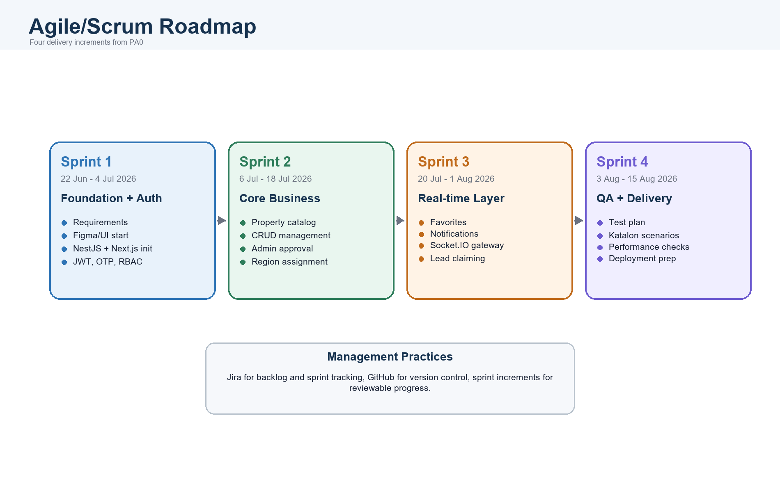
Figure 5. Agile/Scrum Workflow

Slide 6. Software Requirements: Use Case Model
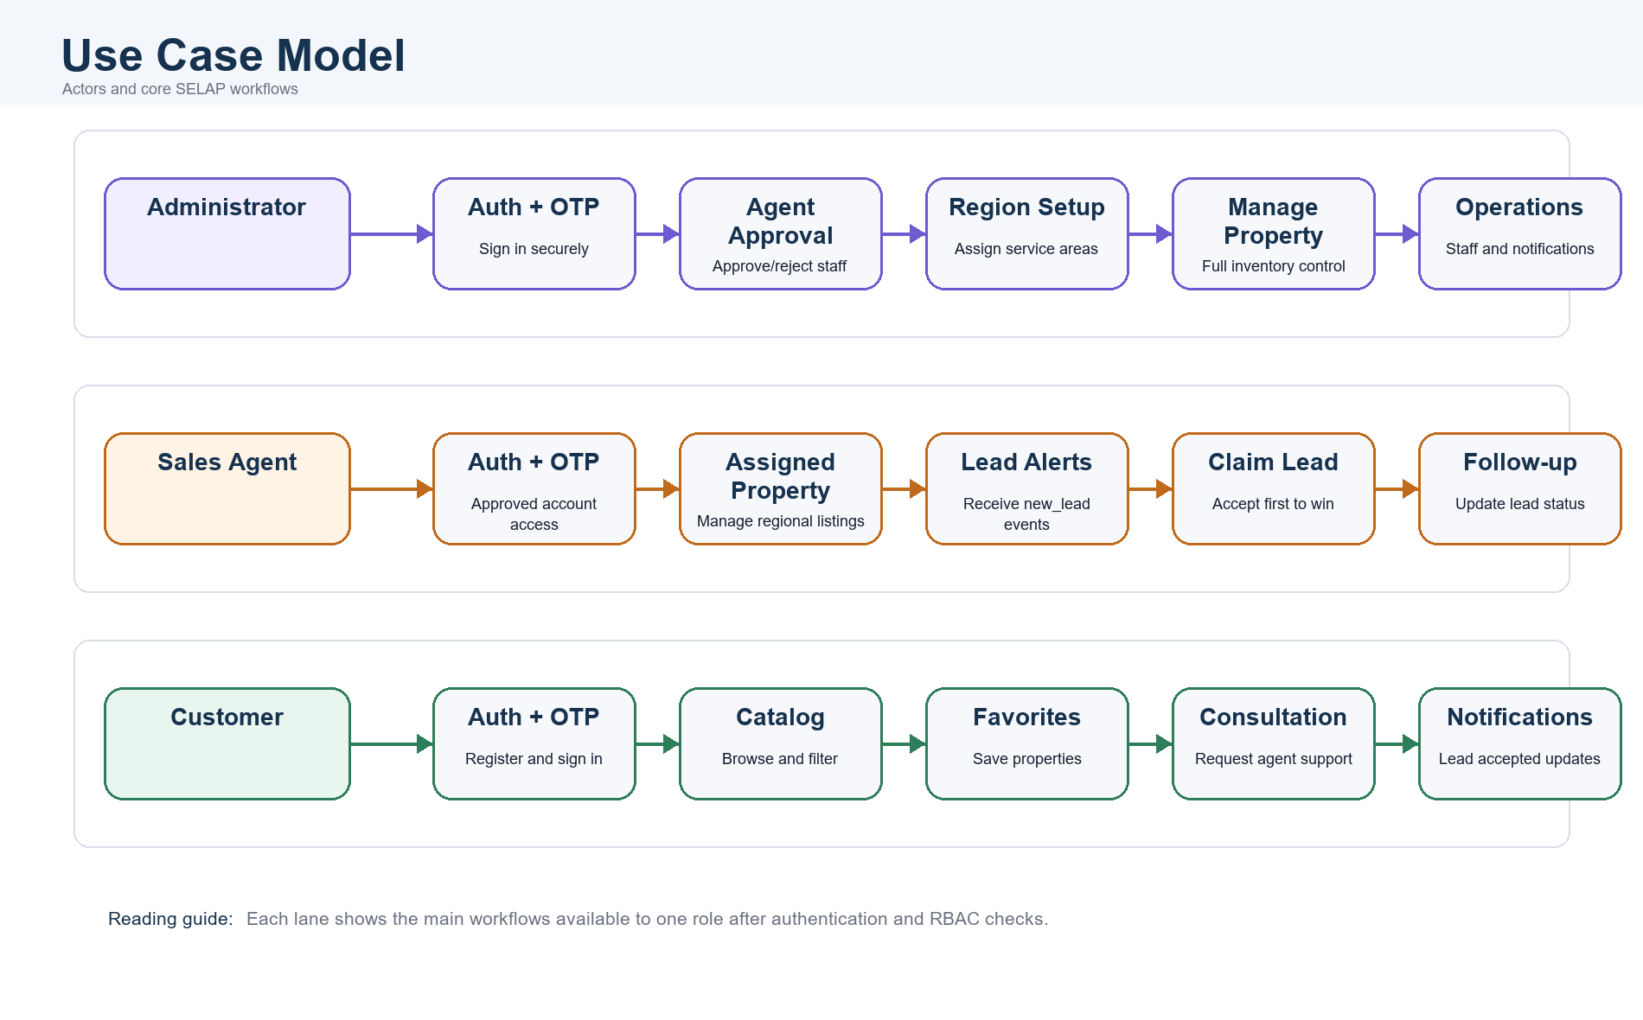
Figure 6. Software Requirements: Use Case Model
- Core PA1 use cases: Sign Up, Sign In, Password Recovery, Browse/Filter Properties, Favorites, Request Consultation, Property CRUD, Real-time Lead Notifications, Claim Lead, Approve Agent Account, Receive Notifications.

Slide 7. Core Functional Requirements
- Authentication: unique email/phone registration, 4-digit OTP email verification, phone-password-role login.
- RBAC and account status: JWT-protected APIs; Sales Agents start as PENDING and require Admin approval.
- Property management: Admins manage all properties; Sales Agents manage only assigned-region properties.
- Public catalog: search and filter by keyword, location, type, price, area.
- Favorites and notifications: saved properties, property status alerts, lead accepted alerts.
- Real-time lead claiming: eligible agents receive regional consultation requests and compete through the Accept action.

Slide 8. Non-Functional Requirements
- Performance target: core API responses below 500 ms under normal conditions.
- Real-time target: lead and notification delivery within 1 second, including the 100 concurrent user test scenario.
- Security: JWT access tokens, role checks, account status validation, email verification, and secure password hashing.
- Data consistency: one lead can only be claimed once under simultaneous Accept actions.
- Maintainability: modular monolithic NestJS backend separated into domain modules.
- Portability: suitable for Vercel, Render/Railway, and Supabase PostgreSQL deployment.
Implementation note: The current backend uses Node.js scrypt password hashing. If the rubric expects bcrypt, present it as secure password hashing with scrypt in the current implementation.

Slide 9. Architecture: Modular Monolithic System
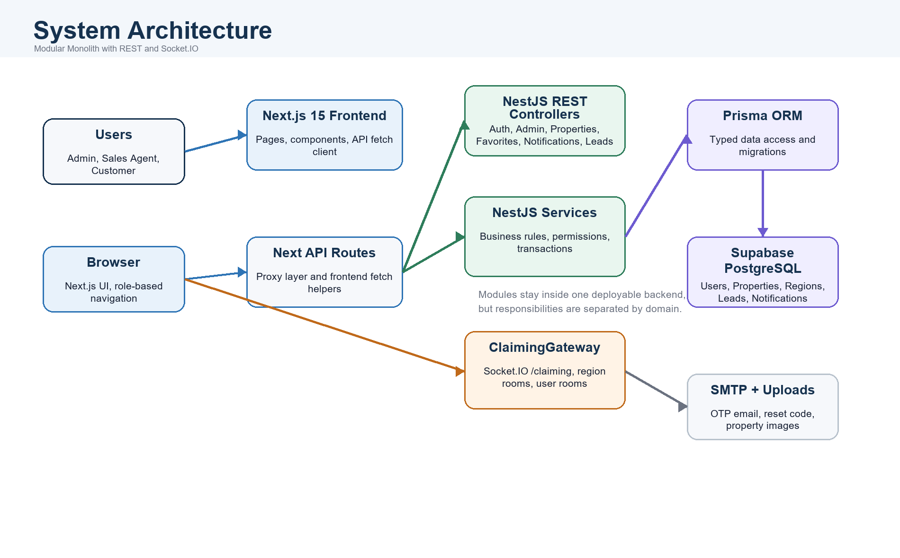
Figure 9. Architecture: Modular Monolithic System
- Frontend: Next.js pages for login, registration, catalog, detail, favorites, notifications, property management, pending agents, staff directory, and lead inbox.
- Backend: NestJS modular monolith with REST controllers and Socket.IO ClaimingGateway.
- Persistence: Prisma ORM maps application models to PostgreSQL.
- Real-time layer: WebSocket rooms segment messages by user and region.

Slide 10. Design Highlight: Real-Time Lead Claiming
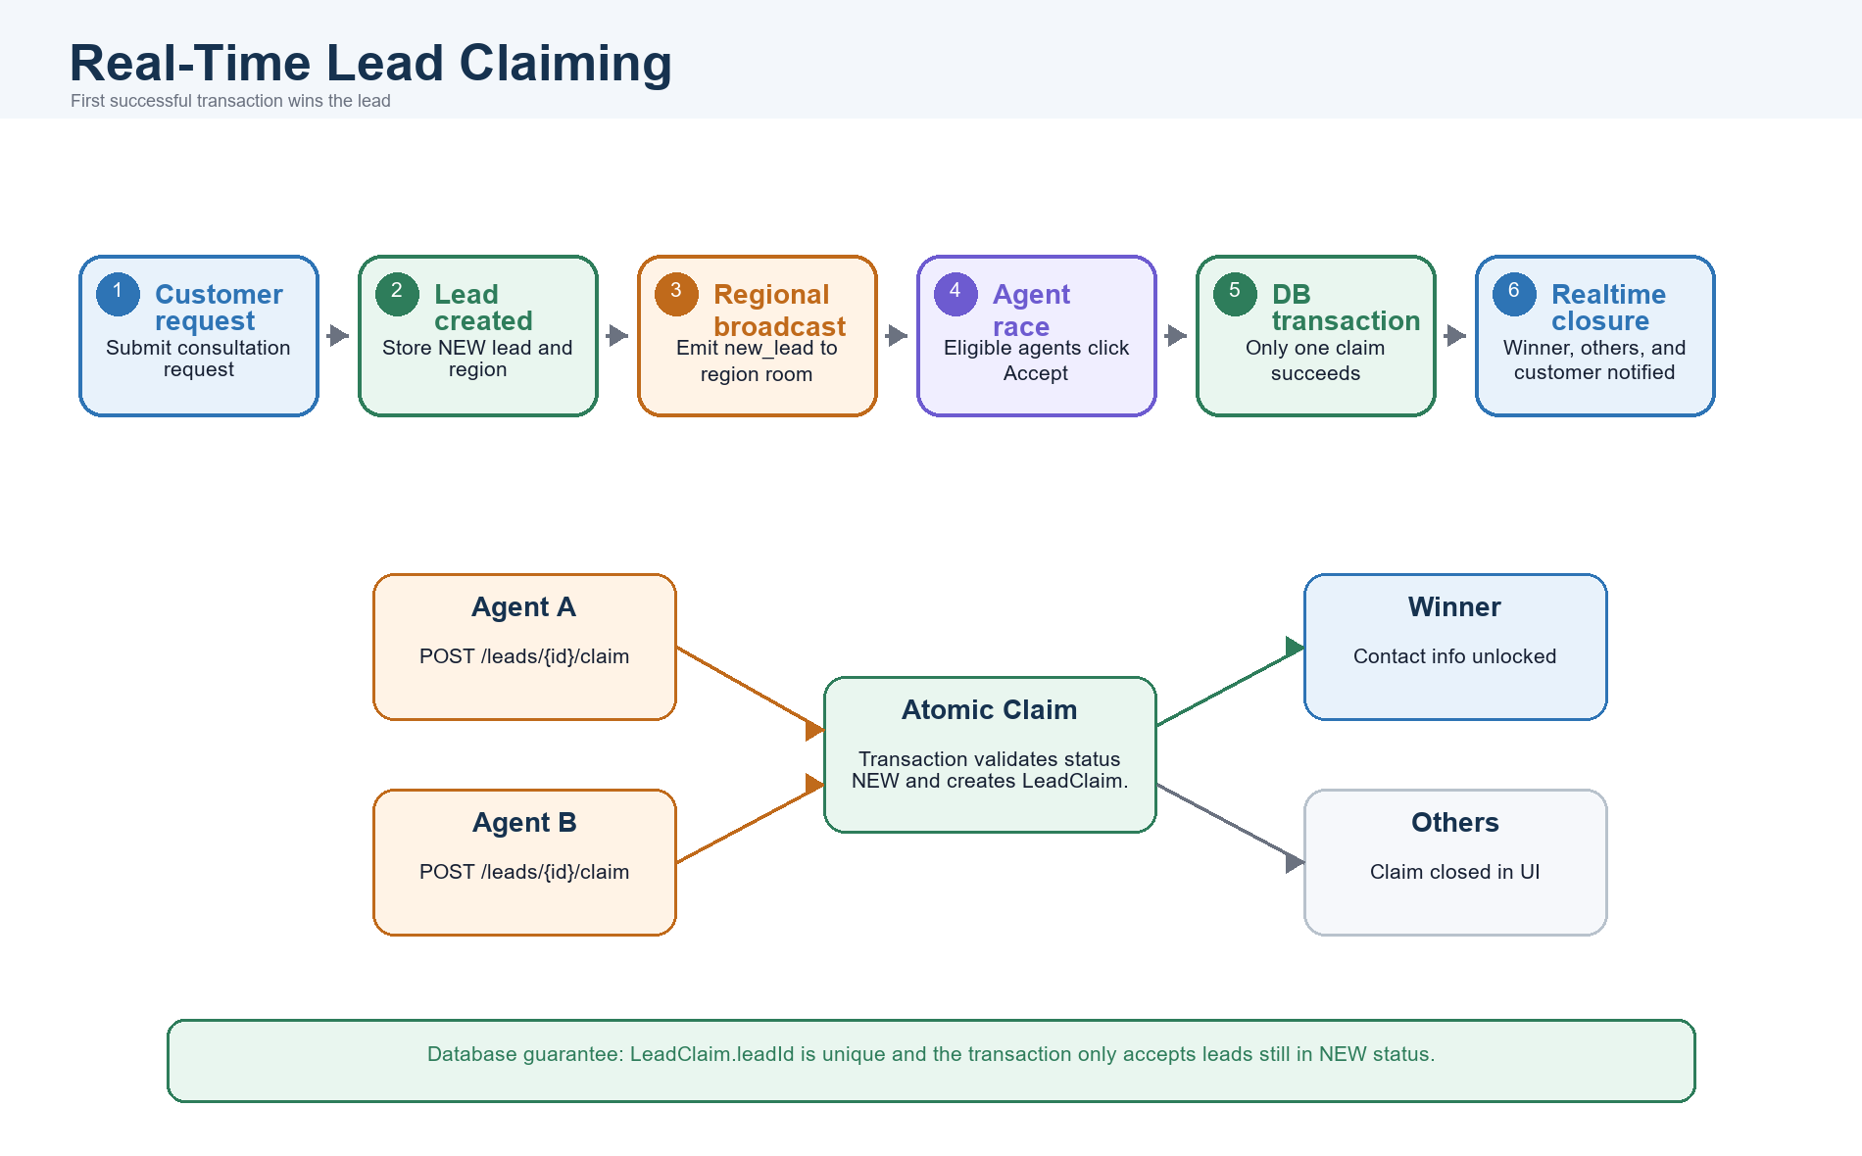
Figure 10. Design Highlight: Real-Time Lead Claiming
- Sales Agents join region rooms such as region_{regionId}; Customers join user rooms such as user_{userId}.
- The first successful claim changes a lead from NEW to CLAIMED and creates a unique LeadClaim.
- Other agents immediately receive lead_claimed so the UI can close the claim action.
- Customer contact information remains hidden until a Sales Agent successfully claims the lead.

Slide 11. Database Schema Overview
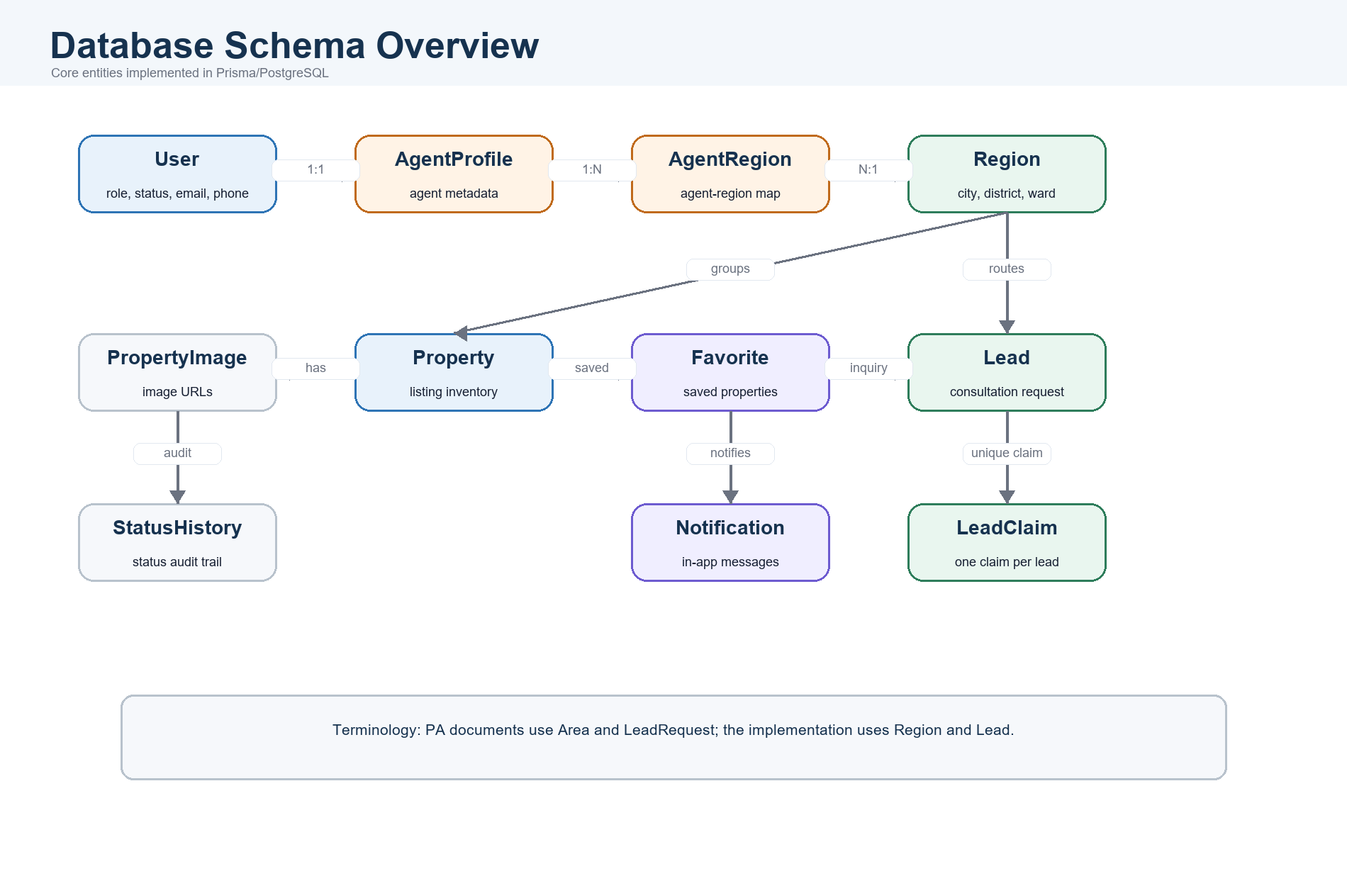
Figure 11. Database Schema Overview
- Main entities: User, AgentProfile, Region, AgentRegion, Property, PropertyImage, PropertyStatusHistory, Favorite, Lead, LeadClaim, Notification.
- LeadClaim.leadId is unique, which supports the one-claim-per-lead rule.
- Terminology note: PA documents sometimes use Area and LeadRequest; the implementation names them Region and Lead.

Slide 12. Implementation Evidence
- Authentication: registration, email verification, login, password recovery, reset token, and /auth/me.
- Admin: pending Sales Agent approval, rejection, region assignment, staff directory.
- Property: public listing, detail view, management view, image upload, filtering, status history, favorite-status notifications.
- Lead: create consultation request, view available leads, claim lead, view assigned leads, update lead status.
- Realtime: Socket.IO /claiming namespace, JWT-authenticated connections, region rooms, user rooms, new_lead, lead_claimed, and lead_accepted events.

Slide 13. Testing Strategy And QA Pyramid
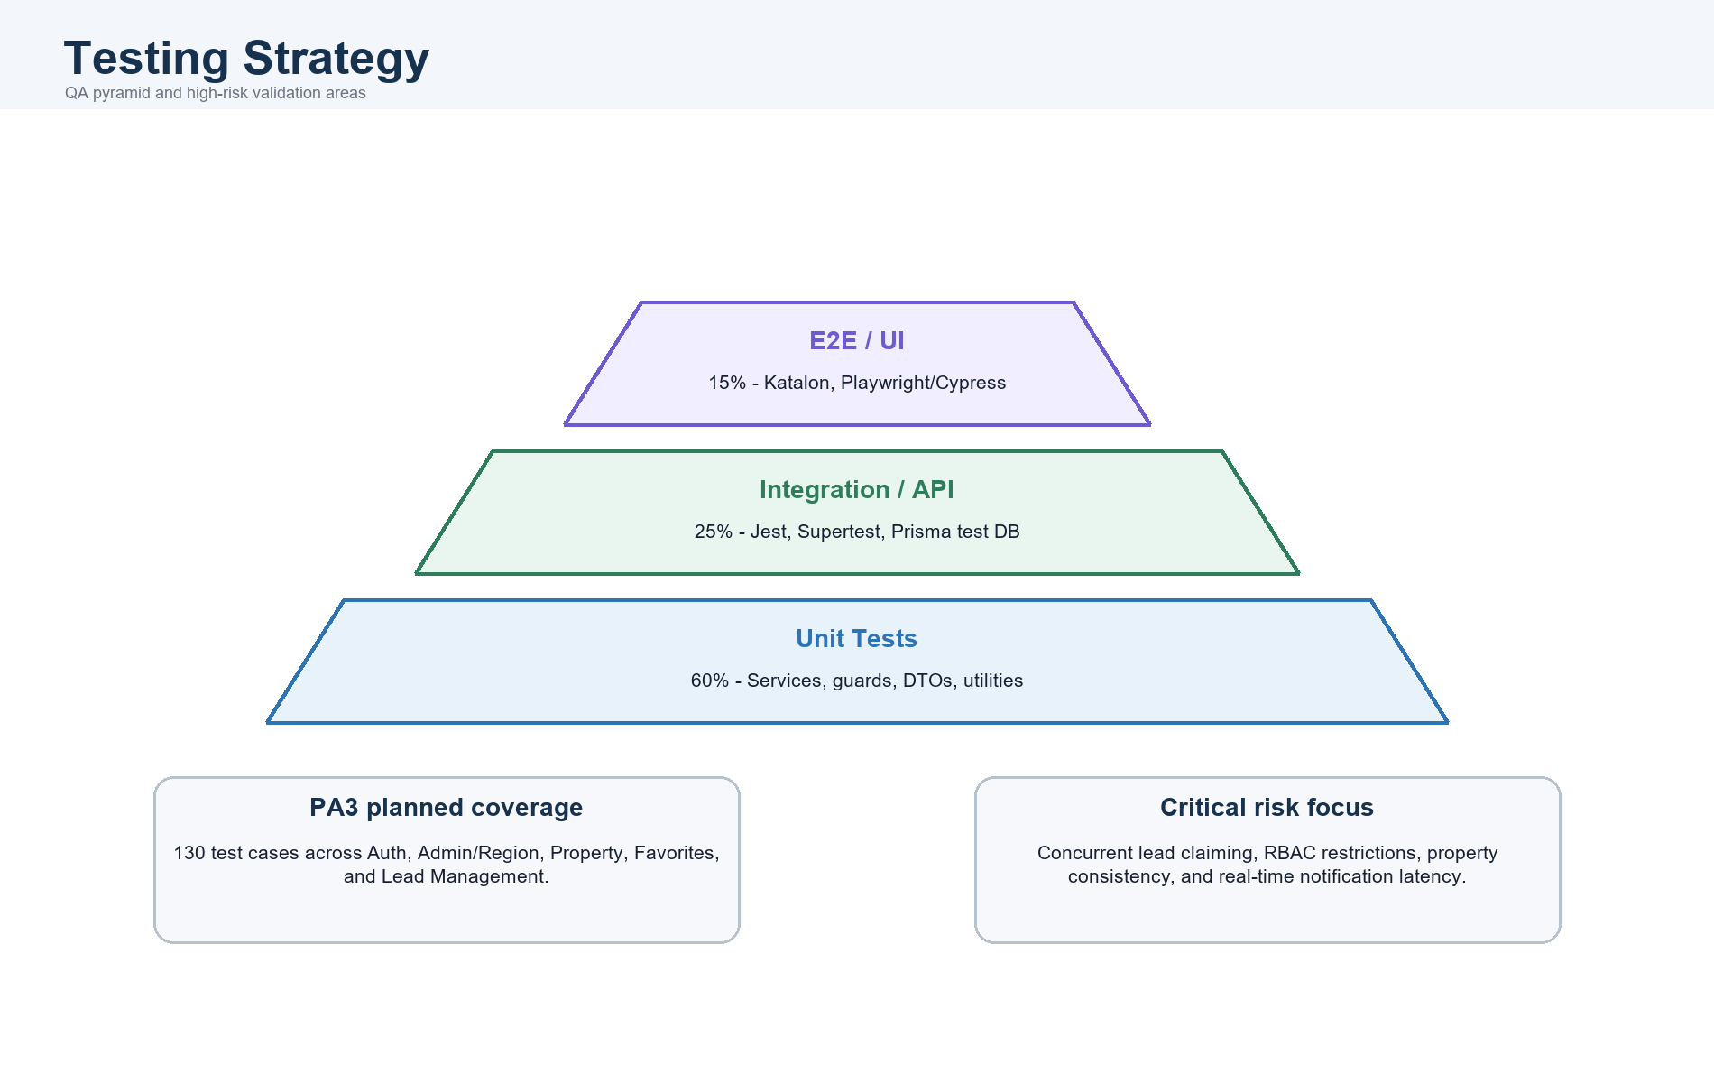
Figure 13. Testing Strategy And QA Pyramid
Test Level | Allocation | Purpose | Tools
Unit Testing | 60% | Validate services, guards, DTOs, utilities, and business rules | Jest
Integration/API Testing | 25% | Validate module interaction, Prisma database behavior, REST endpoints, and lead-claim consistency | Jest, Supertest, Prisma test DB, Postman/Bruno
E2E/UI Testing | 15% | Validate critical browser journeys across frontend, backend, and database | Katalon Studio, Playwright/Cypress
Performance Testing | Targeted | Validate API latency, WebSocket latency, and concurrent lead claiming | k6, Locust, scripted Socket.IO/API clients

Slide 14. Automation Testing With Katalon Studio
Scenario | Business Risk Covered | Evidence
Customer registration and OTP/email verification | Customer onboarding and identity verification | Insert Katalon PASS screenshot
Sales Agent registration and Admin approval with region assignment | Unauthorized access prevention and regional routing | Insert Katalon PASS screenshot
Property creation and catalog filtering | Inventory publishing and property discovery | Insert Katalon PASS screenshot
Consultation request and real-time lead claiming conflict | SELAP core USP: first successful agent claims the lead | Insert Katalon PASS screenshot

Presenter note: PA4 is not present in the workspace. Replace these placeholders with actual Katalon pass images and update the exact pass count after PA4 or screenshots are added.

Slide 15. Test Results And System Stability
- Requirement/test design completion: 130 planned test cases documented in PA3.
- Detailed scenario coverage: 12 high-risk test specifications documented.
- Current repository smoke test: backend Jest smoke test passed, 1 test suite and 1 test case.
- Release quality gate: no unresolved Critical or High severity defects.
- API quality gate: core response time below 500 ms under normal conditions.
- Realtime quality gate: lead claiming and WebSocket notifications below 1 second under 100 concurrent users.
- Consistency gate: concurrent lead claiming records only one successful LeadClaim per lead.

Slide 16. Demo

Slide 17. Closing Message
- SELAP is not just a property listing website; it is an internal operating platform for real estate teams.
- The system connects property data, users, regional assignments, customer requests, and real-time lead ownership in one workflow.
- The strongest product value is transparent, low-latency lead claiming with database-level consistency.
- Future improvements: analytics dashboards, commission calculation, production cloud storage for images, and expanded automated regression coverage.

