# Experiment Design

In order to test the three different implementations of the Index search, a simple experiment conducted by the group is presented here. The three different implementations, simple Index, inverted index using hashmap and inverted index using treemap were compared in terms of the speed it took to build the indexes and retrieve the results of a search.

Beyond that, the searches were conducted using three different files (varying in size) as the website database. The files used were tiny (10 KB), small (510 KB) and medium (9766 KB) for the lookup method and tiny and small for the build method. The large file was not used for the lookup because no query was not completed due to the amount of time it took to execute. Similarly, neither the large or medium file were not used for the build for the same reasons. The results are presented below

|  |  |  |  |
| --- | --- | --- | --- |
| Build | Simple Index | Inverted Hash | Inverted Tree |
| Tiny (nano seconds) | 45 | 60432 | 313274 |
| Small (nano seconds) | 83 | 17735285 | 48917137 |

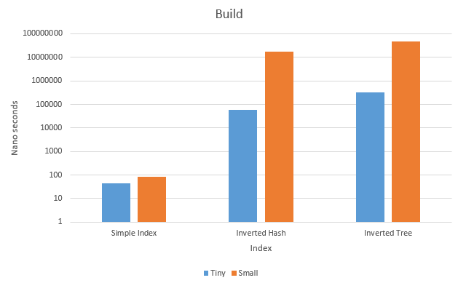

|  |  |  |  |
| --- | --- | --- | --- |
| Lookup | Simple Index | Inverted Hash | Inverted Tree |
| Tiny (nano seconds) | 3506 | 279 | 259 |
| Small (nano seconds) | 261839 | 214 | 628 |
| Medium (nano seconds) | 9836630 | 274 | 423 |

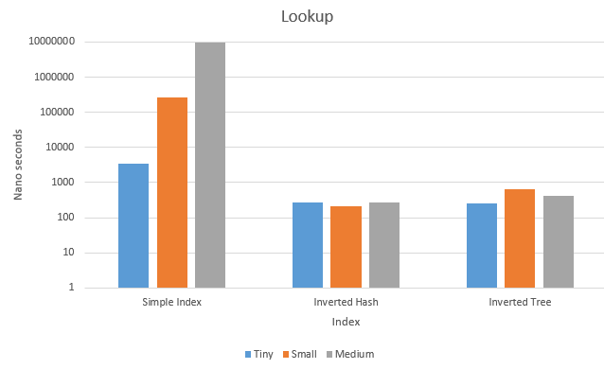

First, the results show that building the Inverted indexes take more time than building the simple index. However, the build function will still be executed only in the initialization of the search engine.

Second, looking at the results from the lookup, is possible to observe that as the file grows the simple index gets slower, whereas the maps remain very similar. Moreover, looking at the difference between the maps, the hashmap remains slightly faster than the treemap as the file size grows.

Therefore, we conclude the experiment by choosing the implementation of the Inverted Index using the Hashmap.