A Brief Tour of Seafile

Seafile is a file management and collaboration platform for teams and organizations. Let's show you how Seafile manages and syncs your files, and how you can share your files.
Libraries
Seafile organizes your files into file libraries. Each library can be synced and shared separately. When you log in to Seafile website for the first time, Seafile creates a personal library for you.
You may have a look at the default library.
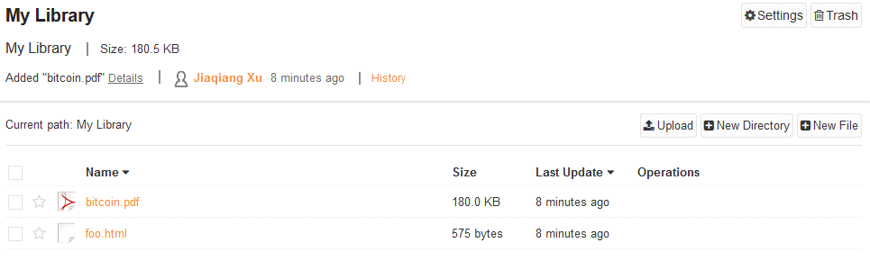
Syncing a Library
You can sync a library to your computer after installing the Seafile client. After installation, you need to login to your Seafile server by entering the server address and your account email address.
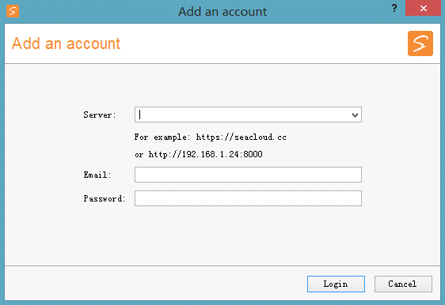
After you successfully login, Seafile client syncs your personal library to your computer. A virtual disk pointing to the downloaded personal library folder will be created. Any files or folders you drop into the virtual disk will be synced to Seafile server.
You can find more libraries in the client's window. You may sync them down to the computer when you need them.
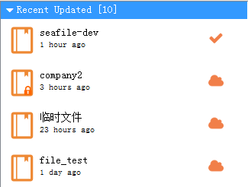

Sharing Libraries
On the Seafile website, you can share libraries or folders in a library to other users. You may share to individual users or to a group.
There're two ways to share a library to a group:
- Create a shared library in a group;
- Click the "share" button next to the library on the "My Home" page.
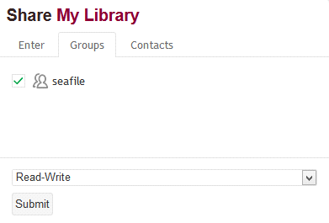
You can fine tune the permission of this share. You may either set "read-write" permission or "read-only" permission.
Mobile Clients
Seafile comes with clients for iOS and Android. From mobile clients you can access and share your files, or participate in group discussions.
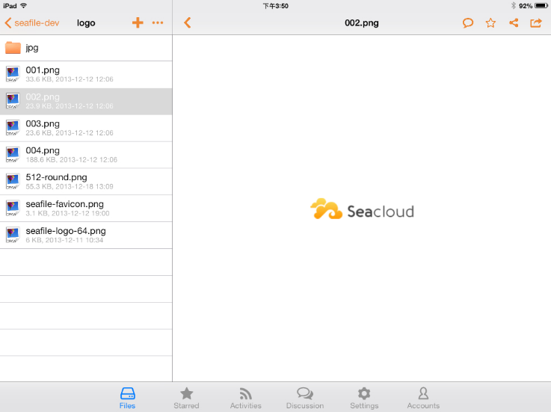
More Features
That's it! Now that you've got started with Seafile, you may want to explore more features. Here is a short list of things you can do with Seafile:
- Create and share a download link from a file or folder;
- Create an upload link to collect files from your friends;
- View older versions of files, and recover a deleted file;
- Sharing a sub-folder inside a library
For more details, please refer to our online help http://www.seafile.com/en/help/.

