**The Interaction Between Self and Emotion: An ERP Study on Implicit Self-Positivity Bias**

Table 1 The reaction time under different conditions(ms)

|  |  |  |  |  |
| --- | --- | --- | --- | --- |
|  | Self-positive | Self-negative | Others-positive | Others-negative |
| Mean | 231.46 | 325.35 | 325.88 | 232.91 |
| SD | 65.06 | 78.56 | 78.61 | 62.87 |

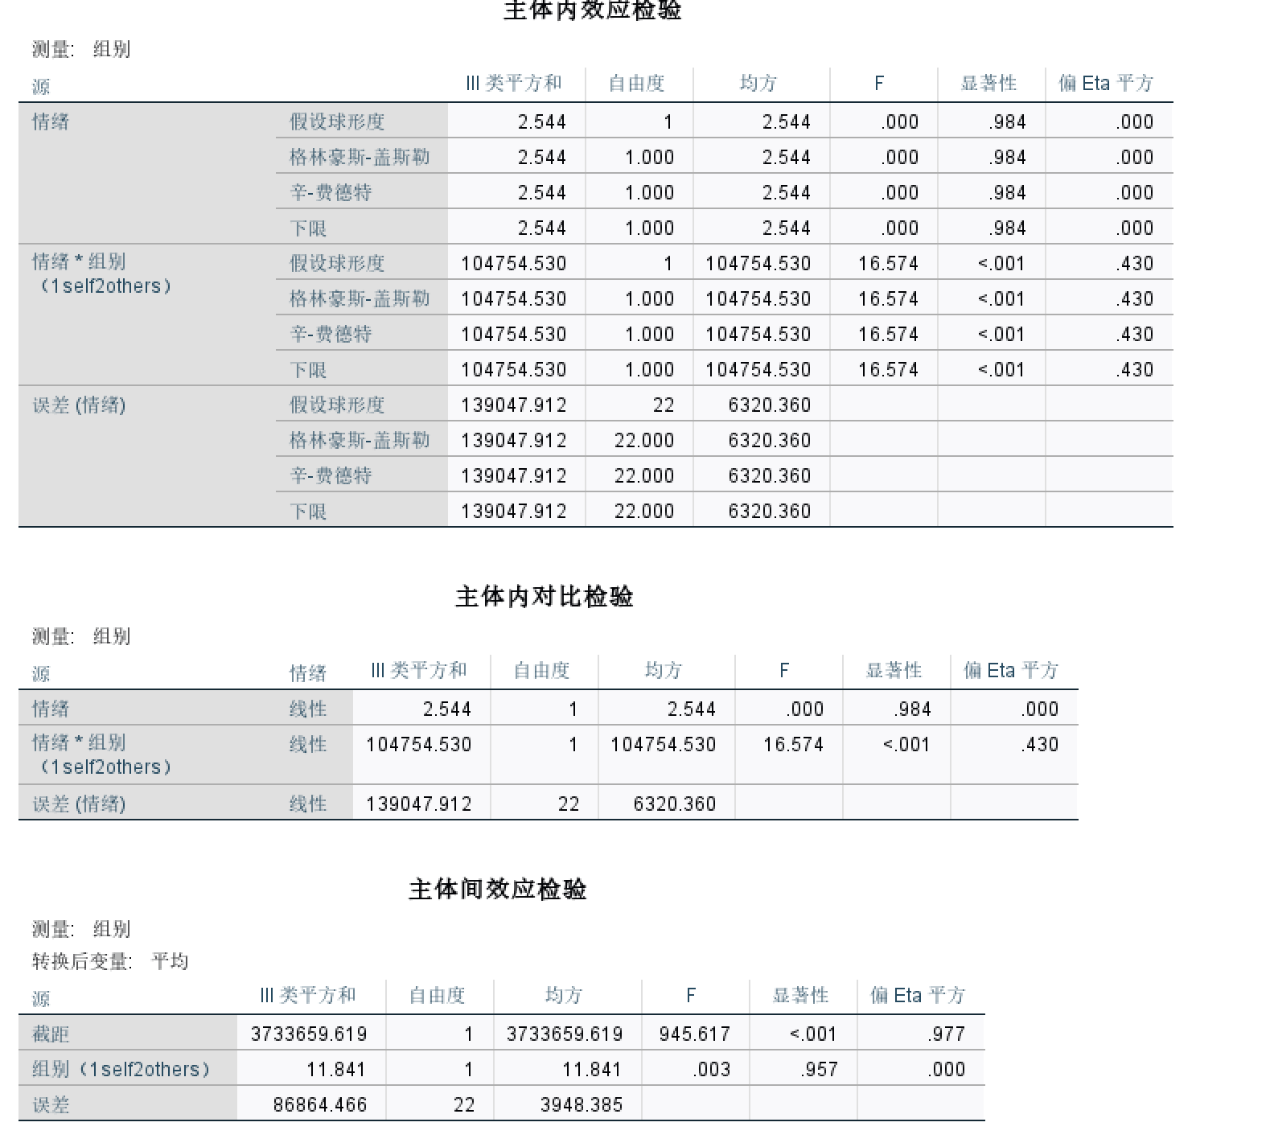

Table 2 Two-way Repeated-measures ANOVA

|  |  |  |  |
| --- | --- | --- | --- |
|  | *F* | *p* | Partial *η2* |
| Prime (main effect) | 0.003 | 0.96 | 0.00 |
| Emotion (main effect) | 0.00 | 0.98 | 0.00 |
| Prime x Emotion | 16.57 | <0.001 | 0.43 |

简单效应图1

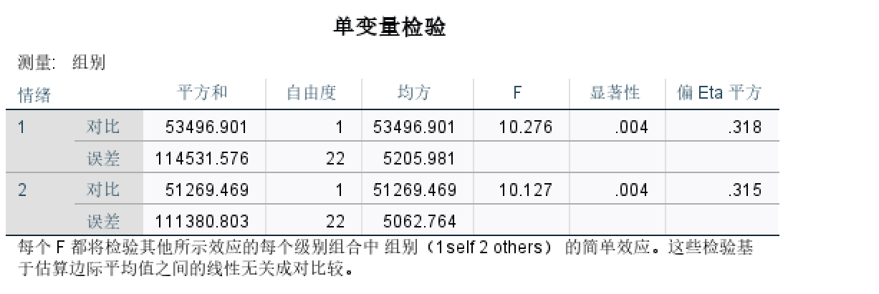

在积极情绪词中，组别的简单效应显著，F=10.27（就是自我词与非自我词的差异显著），p=0.004，偏η2=0.32。

在消极情绪词中，组别的简单效应显著，F=10.13(同上)，p=0.004，偏η2=0.32。

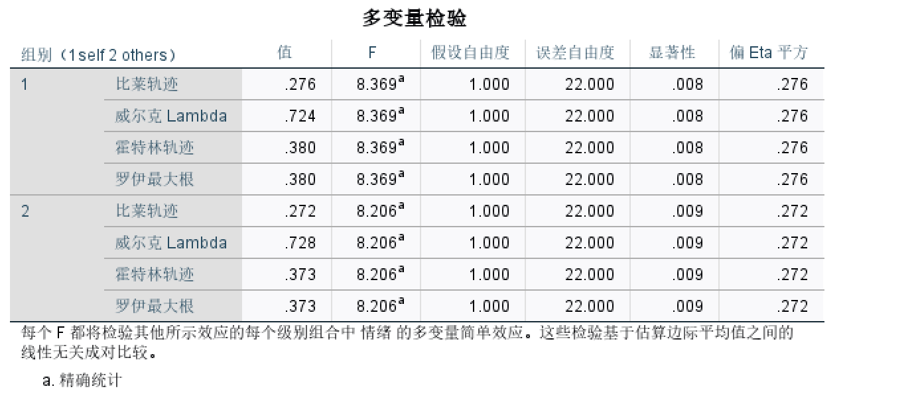

在自我相关组中，词语类型的简单效应显著，F=8.37，p=0.008，偏η2=0.28。

在非自我相关组中，词语类型的简单效应显著，F=8.20，p=0.009，偏η2=0.27。

