This is the instruction of how to execute the project

First, please install the Anaconda, which is a powerful platform to run the code. The install file can be found in the following link:

<https://www.continuum.io/downloads>

After install Anaconda, please install lightgbm and xgboost because they are important for code running. The detail setup process for lightgbm is shown in the following two links:

<https://pypi.python.org/pypi/lightgbm/2.0.2>

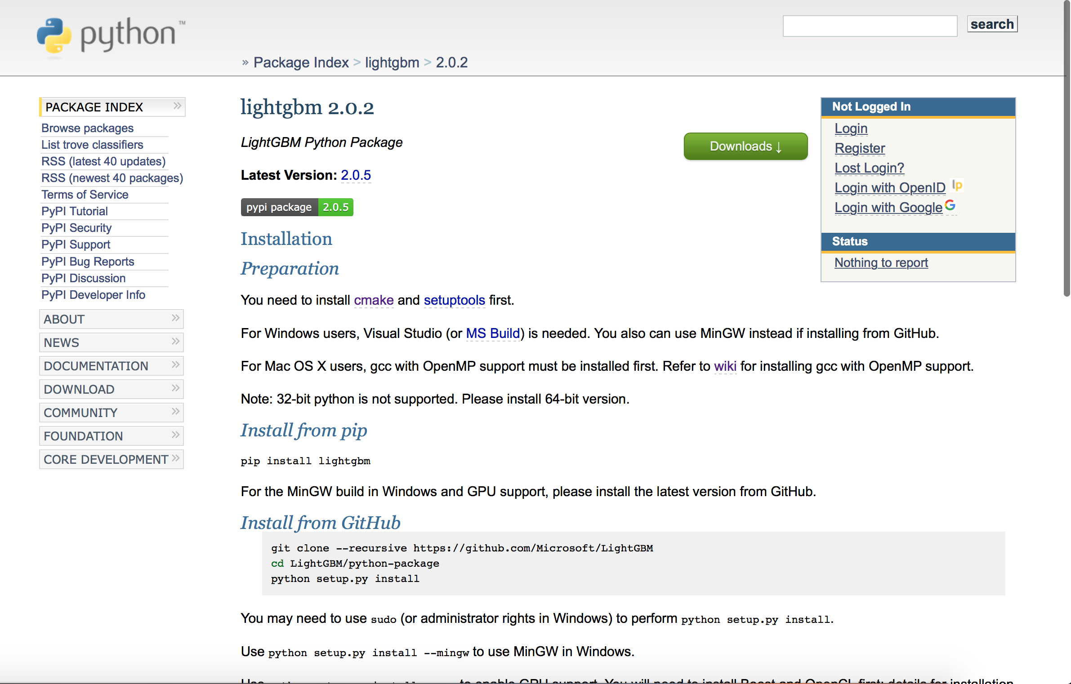

<https://github.com/Microsoft/LightGBM/wiki/Installation-Guide>

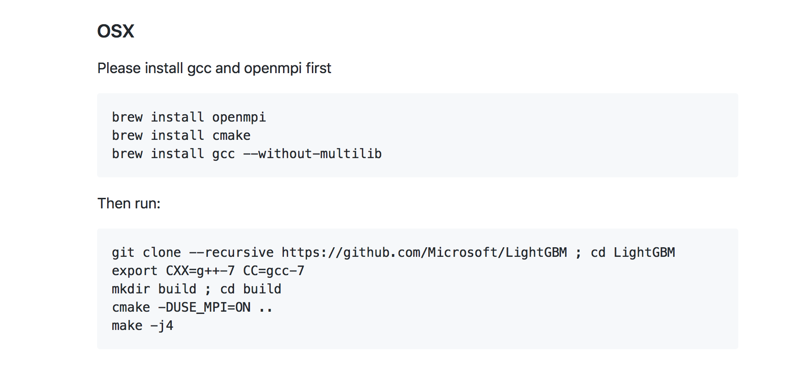

The installation of xgboost is shown in the following link:

<https://stackoverflow.com/questions/36292484/xgboost-installation-issue-with-anaconda>

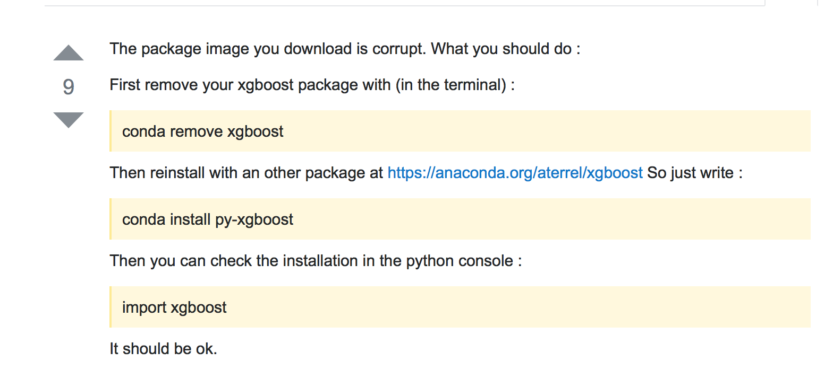

After installing lightgbm and xgboost, please open Anaconda, launch spyder (the third label).

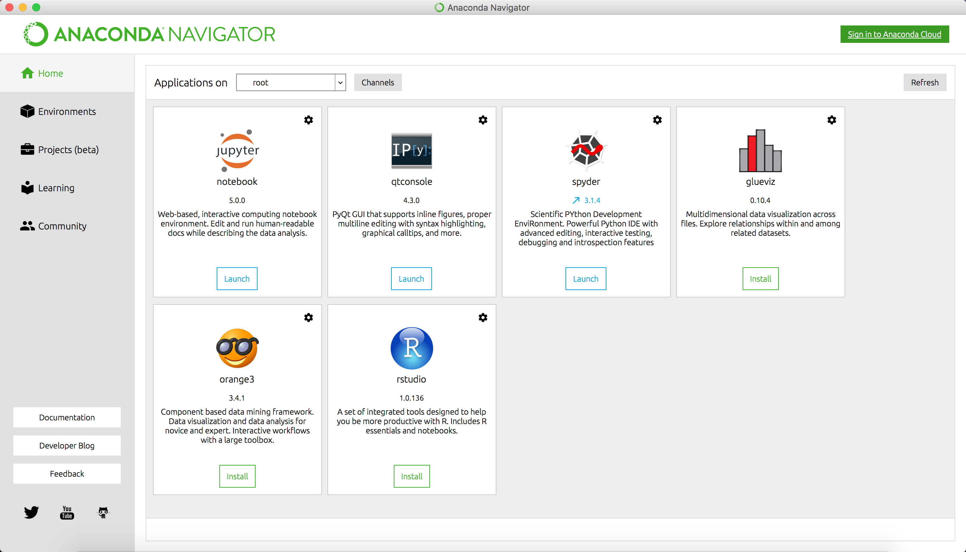

Copy the code attached in the project file, change the directory of file input (there are several places for the input and output directory changing, please make sure you have changed all the directory) and press Run file button (the little green triangle label) to execute. After that, a result document will be stored in the directory where you required.