### A database for global soil health assessment

Jinshi Jian1,2, Xuan Du3, Ryan D. Stewart1\*

1. School of Plant and Environmental Sciences, Virginia Tech, Blacksburg, VA, USA
2. Pacific Northwest National Laboratory-University of Maryland Joint Global Change Research Institute, 5825 University Research Court, Suite 3500, College Park, MD, USA
3. Department of Hydraulic Engineering, Yangling Vocational & Technical College, Yang Ling, Shaanxi, China

\*Corresponding author: Ryan D. Stewart (ryan.stewart@vt.edu)

### Abstract

Field studies have been performed for decades to analyse effects of different management practices on agricultural soils and crop yields, but these data have never been integrated together in a way that can inform current and future cropland management. Here, we collected, extracted, and integrated a database of soil health measurements conducted in the field from sites found across the globe. The database, named *SoilHealthDB*, currently focuses on four main conservation management methods: cover crops, no-tillage, agro-forestry systems, and organic farming. The database includes 5,241 data entries from 281 published studies. These studies represent 324 geographic sites (i.e., locations with unique latitudes and longitudes) in 41 countries around the world. The *SoilHealthDB* includes 42 soil health indicators and 45 background indicators that describe factors such as climate, elevation, and soil type. A primary goal of this effort is to enable the research community to perform comprehensive analyses, e.g., meta-analyses, of soil health changes related to cropland conservation management. The database also provides a common framework for sharing soil health, and the scientific research community is encouraged to contribute their own measurements.

|  |  |
| --- | --- |
| Design Types | Data integration objective |
| Measurement Type(s) | 42 soil health indicators (for details, please see Table 3) |
| Technology Type(s) | Data extracted from published papers |
| Factor Type(s) | Material , temporal\_interval , geographic location |
| Sample Characteristic(s) | Cover crop, no-tillage, organic farm, soil health, soil quality |

### Background & Summary

Cropland soil degradation due to natural vegetation removal, intensive agricultural operations, and erosion are among the main factors causing declines in soil quality and crop yields1–3. According to a recent report from the Food and Agriculture Organization of the United Nations (FAO), one-third of soils in the world are infertile due to unsustainable land-use management practices4. Cropland conservation management practices, including the use of cover crops within rotations and changes from traditional mouldboard or disk tillage to reduced or no-tillage, have been proposed as ways to increase soil carbon and soil health5,6. Many on-site experiments have been conducted to evaluate the effects of conservation management on soil properties, yet there has been little effort to evaluate which indicators should be measured to consistently quantify any resulting soil quality improvements. In addition, studies can differ in their results: as an example, using cover crops during normally fallow seasons can enhance soil organic carbon7, though many short-term studies have not found this same result8–10.

To better address such uncertainties, systematic reviews and meta-analyses have evaluated the effects of cover crops11, no-tillage12,13, organic farm14, and agroforestry systems15 on crop yield and soil properties. These efforts have generated new insights into soil health dynamics, yet there is still limited understanding of whether and how these findings translate to global scales. Historically and newly published data offer a wealth of information that can support global assessments of how conservation agricultural practices may influence soil health, provided that there is an effective mechanism to record and disseminate this information.

To address this gap, we collected studies that compared agricultural production and soil properties under traditional management strategies with those under conservational management practices. Publications that meet a specific criteria were digitized and the data were integrated into a global soil health database that we have named *SoilHealthDB*. This web-based, open source dataset can be continuously updated by including newly published and even provisional data. The dataset can be used to perform statistical analyses (e.g., meta-analyses) on specific soil health indicators or agronomic responses. *SoilHealthDB* provides a common soil health framework for sharing and integrating field measurements and related information, and thereby offers valuable information for farmers, agency personnel, and scientists as they plan and evaluate cropland management.

### Methods

**Data collection**

*SoilHealthDB* currently includes 45 background indicators (Table 2) and 42 soil health indicators (Table 3)16. To identify relevant studies, we conducted a systematic literature search for field comparisons between traditional and conservational management practices. We initially targeted four main conservational management methods: cover cropping (CC), no-tillage (NT), organic farming (OF), and agro-forestry systems (AF) (Table 1).

Publications were searched and collected from three sources: (1) the Soil Health Institute “Research Landscape Tool”, which compiles soil health results into a searchable database and includes publication and research projects ([www.soilhealthinstituteresearch.org](http://www.soilhealthinstituteresearch.org)); (2) cited papers from previous meta-analyses or review papers11,14,17,18; and (3) a literature search using ISI Web of Science, Google Scholar, and the China National Knowledge Infrastructure (CNKI). We used the keywords “soil health” or “soil quality” and “conservation management” (we also replaced the term “conservation management” with “cover crop”, “no-till”, “organic farm”, “agroforestry systems”) when performing the literature search. Papers from peer-reviewed journals, conference collections, theses, and dissertations were included. No other restrictions or filtering criteria were used (e.g., we included eligible papers in all languages and with all publication dates). We collected a total of more than 500 papers; we then used the following criteria to determine whether the publication would be included in this study: (1) experiments were conducted in the field or at a research station; (2) the publications compared controls (i.e., traditional management) and treatments (i.e., conservational management); (3) publications provide at least one comparison of soil health indicators between controls and treatments (Table 3). Within these constraints, 281 papers were extracted and integrated into the *SoilHealthDB*.

Data were digitized from tables and figures. The software Data Thief (version III, http://datathief.org/) was used to read the data from figures. Background information was extracted from the publications and fit into 45 background indicator categories (Table 2). Whenever latitude and longitude were not reported in the literature, they were collected from https://www.findlatitudeandlongitude.com based on the site name. Whenever elevation was missing from the original paper, it was identified by latitude and longitude using https://www.freemaptools.com/elevation-finder.htm. In total, 5241 comparisons were collected from across the globe (Figure 1), for a mean of approximately 20 comparisons per study. As many studies reported multiple comparisons, we needed to identify if those comparisons were independent of one another. We therefore allocated a unique experiment ID to a comparison if the cover crop group, cash crop group, site, tillage, fertilization, soil depth, termination, or rotation were different from other comparisons (Figure 2). This process resulted in a total of 1177 experiments that were assumed to be independent of each other.

**Data processing**

After the location information was carefully checked, the climatic regions for all sites were identified according to climate Koppen classification (http://koeppen-geiger.vu-wien.ac.at/), using the latitude and longitude (please see the supplemental R code). All missing MAT and MAP values were filled by a global air temperature and precipitation dataset provided by the Center for Climate Research at the University of Delaware19. The MAP and MAT were calculated based on the monthly precipitation and temperature between 1961 and 2015. Soil texture was grouped into coarse (sand, loamy sand, and sandy loam), medium (sandy clay loam, loam, silt loam, and silt), and fine (clay, sandy clay, clay loam, silty clay, and silty clay loam) textures based on the Cornell Framework20.

The cash crops were grouped into corn, soybean, wheat, other monoculture, corn-soybean rotation (CS), corn-soybean-wheat rotation (CSW), and other rotation of more than two cash crops (ROT). The cover crops were grouped into broadleaf, grass, legume, mixture of two legumes (LL), mixture of legume and grass (LG), mixture of two cover crops other than LL or LG (MOT), and other mixtures of more than two cover crops (MTT). Soil sampling depths were grouped into 0-10 cm, 0-20 cm, 0-30 cm, and 30-100 cm (Figure 3). It should be noted that the user can regroup the cash crop, cover crop, and soil sampling depth according their research objectives.

The number of replications and standard deviations (SD) were compiled from the publications when possible. When the studies reported standard error (SE), coefficient of variation (CV), or confidence interval (CI) rather than SD, SD was calculated using:

$SD=SE × \sqrt{n}$ (1)

where *n* is the number of observations.

SD was calculated from CV as:

$SD=CV × mean$ (2)

and from the CI as:

$SD=|CI- mean|/(2Z_{a/2}) × \sqrt{n}$ (3)

where $Z_{α/2}$ is the *Z* score for a given level of signiﬁcance, α. $Z_{α/2}$ is equal to 1.96 when α = 0.05 and 1.645 when α = 0.10.

Soil organic carbon (SOC) data was reported as carbon stocks (Mg/ha). When applicable, SOC was calculated based on SOC concentrations (SOC%) and soil bulk density using:

$SOC={SOC}_{\% }×h ×100 ×BD$ (4)

where *h* represents soil sampling depth (meter), and BD represents soil bulk density (Mg/m3).

SOC sequestration rate (SOC*seq*) was calculated in terms of (Mg/ha/yr) using:

${SOC}_{seq}={(SOC}_{cc }- {SOC}_{background })÷y$ (5)

where SOC*cc* is the soil carbon stocks under CC treatments (Mg/ha), SOC*background* is the soil carbon stock either under background conditions or under the no cover crop controls (Mg/ha), and *y* represents years after CCs.

**Code availability**

All the data processing and data visualization were conducted using R (version 3.5.1)21. The source code is available on the Open Science Framework. The code is detailed with instructions for users. The intent of the code is to illustrate how some missing background information was filled in based on other data sources. The code also intends to check data quality, and to explain how some soil health indicators are grouped based on the basic information.

### Data Records

Data records are reported in a single table that currently includes 5241 rows and 268 columns. Each column corresponds to one data point of either background information or soil health indicator, and each row includes as many as 42 comparisons between treatments and controls (if all soil health indicators have data). The names, attributes, and descriptions of the background information and soil health indicators are shown in Tables 1 and 2. It should be noted that different measurements and/or units may be involved in the same soil health indicator (e.g., soil total nitrogen, soil organic nitrogen, or soil inorganic nitrogen are reported in different papers to represent the soil nitrogen indicator, ID 5 in Table 3); therefore, it is important that measurement objectives, units, and other detailed descriptions are recorded in the comments columns. It should also be noted that for some soil health indicators (e.g., CH4 and N2O emission), we were only able to extract limited numbers of comparisons, which may restrain the ability of those data to be used in further analyses.

**Technical Validation**

Quality control was performed to check the fidelity of the data to the original source. Each paper was carefully read at least twice, and special attention was paid to the tables, figures, and method sections, where most of the soil health indicator comparisons and background information were located. Before a new paper was extracted, we first used the bibliography database manager Mendeley to check whether it was a duplicate of previous papers (for details, please see the supplemental reference document). After the data extraction, we compared the digitized data against the tables or figures from the original paper once again to make sure the data were loaded correctly.

After the data extraction, we examined data quality using R (version 3.5.1)21. The formats of each column (numerical or string) were checked to correct any mistyping in the numerical columns (e.g., checking all soil health indicators and some background information columns like latitude and longitude). For each soil health indicator, we calculated the response ratio (RR), which is the value of treatment divided by the value of control, e.g., for cover crop studies RR = ln(*xcc*/*xnc*), where *xcc* is the mean parameter value under cover crops and *xnc* is the mean parameter value under no cover controls. We then plotted the frequency distribution of response ratio for each soil health indicator, and returned to the original articles to verify any extreme values that were identified in this process. We also visualized the data distribution for background columns that contained numeric values (e.g. latitude, elevation) and manually checked the outliers by validating them against the original papers. For the location of each site, we plotted the latitude and longitude by country and checked whether there were sites from a specific country that fell outside its border. For those sites, we checked the extracted latitude and longitude information with location information from the original paper (e.g., site name, country name). For some sites located near to coastal areas, a few sites were reported to exist in the sea, likely due to insufficient precision in reported values. For these sites, we slightly corrected the longitude and latitude to the nearest point on land.

### Usage Notes

In the *SoilHealthDB*, the measurement objectives and units between each comparison (control vs. treatment within same row) will always be the same. However, each soil health indicator may have multiple measurement objectives and therefore involve multiple units (e.g., a researcher may measure soil total nitrogen in one site and measure organic nitrogen in another site). Detailed information about measurement objectives and units are recorded under the comments column. The user should always check the comments before data processing and analysis; otherwise, without data filtration and unit conversion only response ratios should be analysed. We recommend that users download and explore the database using the provided R code, as the code includes explanations and instructions. The user can contact the corresponding author with questions on understanding the code and using the data.

### Acknowledgements

This work is supported by the Natural Resources Conservation Service, U.S. Department of Agriculture, under NRCS Conservation Innovation Grant 69-3A75-14-260. Funding for this work was provided in part by the Virginia Agricultural Experiment Station and the Hatch Program of the National Institute of Food and Agriculture, U.S. Department of Agriculture. Jinshi Jian was partially supported by the U.S. Department of Energy, Office of Science, Biological and Environmental Research as part of the Terrestrial Ecosystem Sciences Program. The code and the *SoilHealthDB* are available on GitHub; those items can be used for individual, academic, research, and commercial usage, but cannot be repackaged or sold without written permission.

### Author contributions

Jinshi Jian and Ryan D. Stewart conceived the design of the data framework. Jinshi Jian and Xuan Du extracted and integrated the data from papers to the *SoilHealthDB*. Jinshi Jian drafted the manuscript, and all authors revised and approved the manuscript.

### Competing interests

The authors declare no competing interests.

### Figures

G:\My Drive\MyResearch\12.SoilHealthDB\SoilHealthDB\SoilHealthDB_R\Figures\Figure 1. site_plot.tiff

**Figure 1.** **The spatial distribution of sites from cover cropping (CC), no-tillage (NT), organic farming (OF), and agro-forestry systems (AF) across the globe.** The numbers in the parentheses represent the number of sites reporting data for each different conservation management method. Symbol sizes represent the number of comparisons in each site.

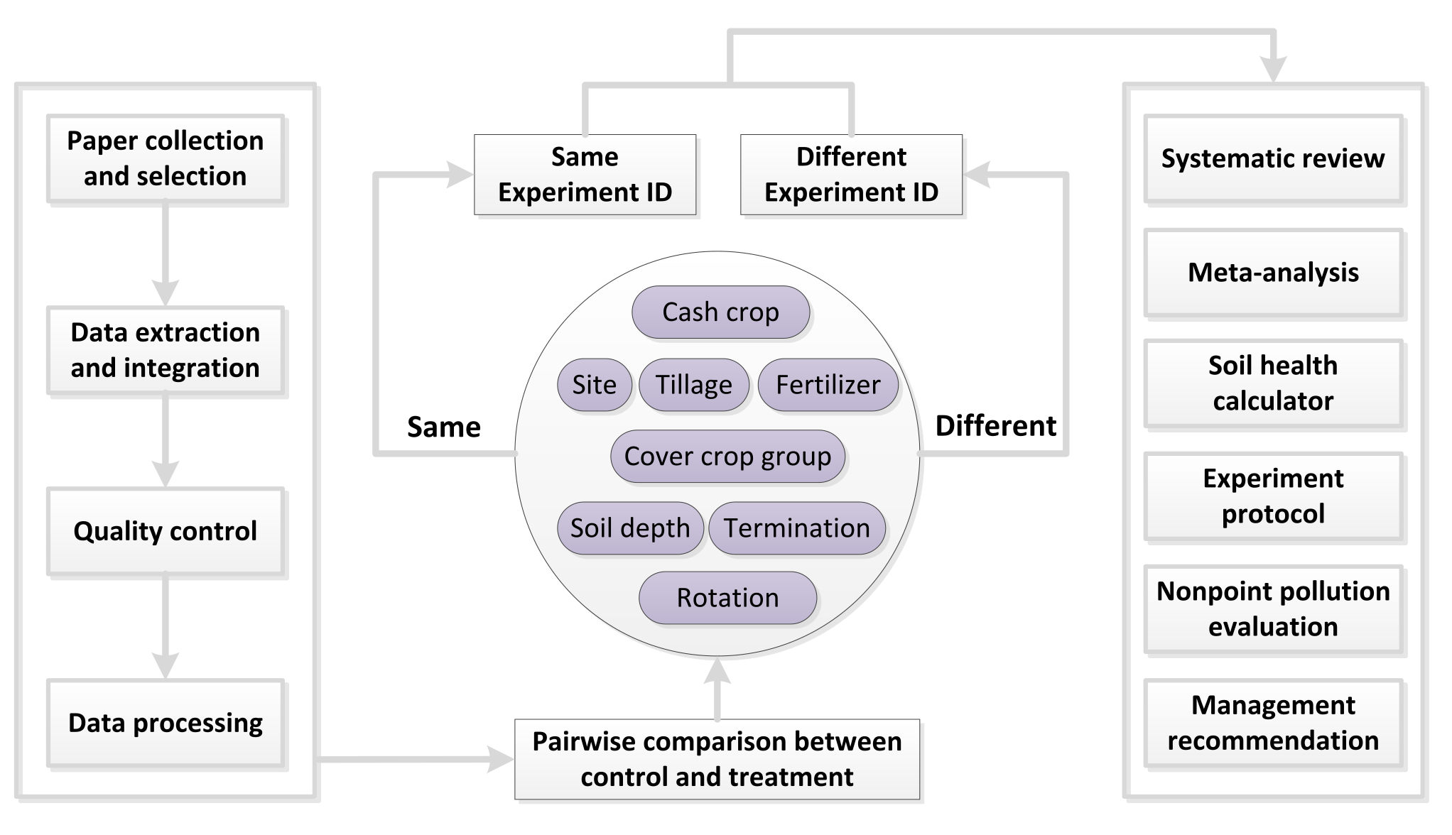

**Figure 2.** **The procedure for data integration (left panel); experiment ID allocation (middle panel); and potential uses that the database can support (right panel).** Unique experiment IDs were given to pairwise comparisons if the cash crop, site, tillage, fertilizer level, cover crop, soil sampling depth, cover crop termination, and cash crop rotation were different from other comparisons; otherwise, comparisons who had the same information for one or more of those categories received the same experiment ID (middle panel).

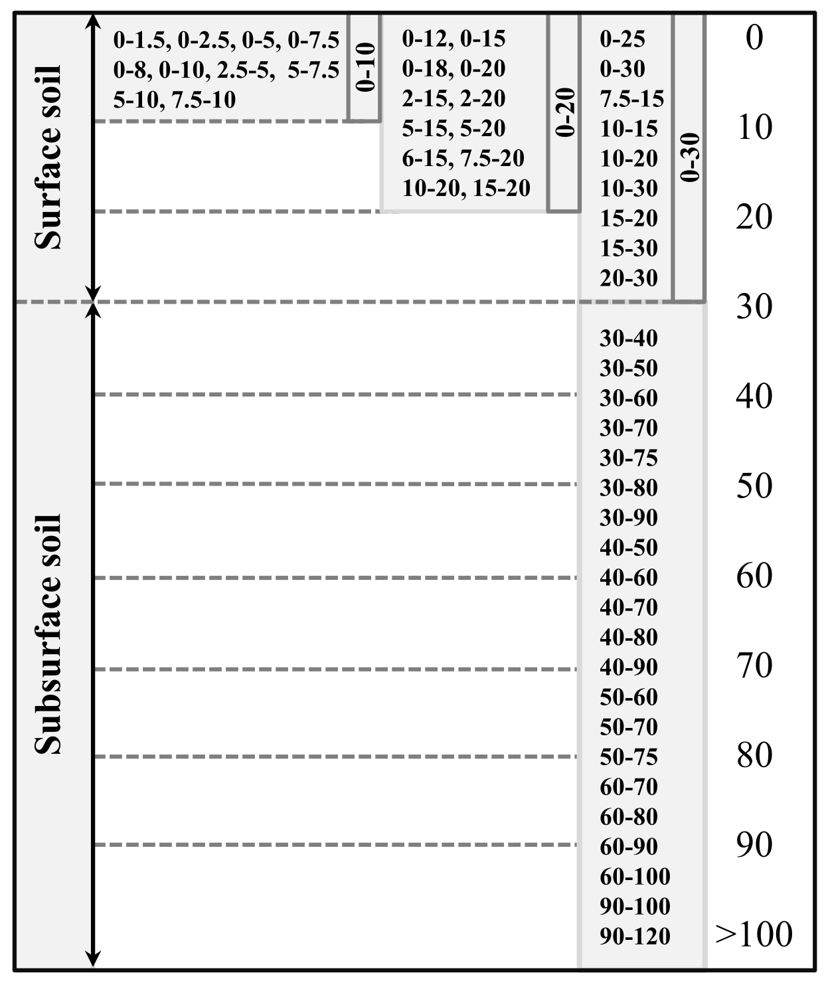

**Figure 3. Diagram detailing how soil sampling depths were separated into 0-10 cm, 0-20 cm, 0-30 cm, and >30 cm groups.**

**Table 1. Conservation type included in *SoilHealthDB*.**

|  |  |
| --- | --- |
| **Conservation type** | **Description** |
| Cover crop (CC) | In traditional no-cover-crop farming system, farm surface are not covered after harvesting and thus may cause soil erosion, leaching, and thus SOC decreasing1–3. A cover crop is a plant grown in the fallowing season. Grasses or legumes are the major cover crops but other green plants such as brassica can also be used as cover crops. Cover crop is grown primarily for the benefit of the soil rather than the crop yield, but before 1990s cover crops were used as green manure to increase yield 22. |
| No-tillage (NT) | No-tillage (also named No-till, zero tillage, and direct drilling) is a way of growing crops without tillage. Benefits of no-tillage including reducing soil erosion, runoff, and leaching, improving soil infiltration and soil organic carbon13. |
| Agriculture forest system (AF) | Agriculture forest system (or called agroforestry) is a farmland management that combines trees or shrubs with crops or pastures. Benefits of agriculture forest system including prevention of soil erosion and increasing of biodiversity. In sub-Saharan Africa and in parts of the United States, agriculture forest system has been successful applied15. |
| Organic farm (OF) | Organic farm using organic fertilizers (e.g., compost manure, green manure, and bone meal) rather than using chemical fertilizers and pesticides in the traditional farming system. Organic farm usually accompany with crop rotation and companion planting. It has been verified that conversion to organic farm contributes to increasing soil carbon concentration and improving food safety 14. |

**Table 2. Descriptions and attributes of background information in *SoilHealthDB*.**

|  |  |  |
| --- | --- | --- |
| **ID** | **Background indicator** | **Description** |
| 1 | ExperimentID | Experiment ID number; please see details in **Figure 2** |
| 2.1 | Author\_F | First author's Family name |
| 2.2 | Author\_G | First author's Given name |
| 3 | YearPublication | Paper publication year |
| 4 | SamplingYear | Sampling year, should be same or earlier than publication year |
| 5 | Journal | Name of journal in which paper was published |
| 6 | SiteInfor | Site name and detailed site information |
| 7 | Country | Country name where the study occurred |
| 8 | Latitude | Latitude of the site |
| 9 | Longitude | Longitude of the site |
| 10 | Elevation | Elevation of the site |
| 11 | Tannual | Annual average air temperature |
| 12 | MAT | Mean annual air temperature reported from paper (time span may differ from paper to paper) or from a global air temperature data19. |
| 13 | Pannual | Annual precipitation from paper |
| 14 | MAP | Mean annual precipitation (time span may differ from paper to paper) or from a global precipitation data19. |
| 15 | ClimateType | Study site's climate type, following Koeppon climate classification system23 |
| 16 | YearsAfterCoverCrop | How many years cover crop applied before taking soil samples (e.g., experiment initiated at 1991, sample take at 1995, then fill with 5) |
| 17 | Duration | How many years the whole experiment lasted for (e.g., if an experiment started in 1990 and ended in 2000, the duration is 11 years) |
| 18.1 | CC\_planting\_date | Time that cover crops were planted |
| 18.2 | CC\_termination\_date | Time that cover crops were terminated |
| 19 | Time\_Comments | Comments about cover crop planting period |
| 20 | SamplingDepth | Soil sampling depth, formatted as top-to-bottom, e.g., 10-to-20. |
| 21.1 | SamplingThickness | Difference between bottom and top sampling depths, e.g., for 10-to-20, the Sample Thickness is 10 |
| 21.2 | SoilDepthGroup | Soil depth grouped based on sampling depth; see **Figure 3** for more details |
| 21.3 | SurfaceSubsurface | Surface or subsurface indicator; see **Figure 3** for more details |
| 22 | SoilBD | Bulk density |
| 23.1 | SandPerc | Percentage of sand |
| 23.2 | SiltPerc | Percentage of silt |
| 23.3 | ClayPerc | Percentage of clay |
| 24.1 | Texture | Soil texture |
| 24.2 | TextureGroup | Soil texture group (coarse, medium, and fine), based on the Cornell Framework of Soil Health Manual20. |
| 25 | SoilpH | Soil pH |
| 26 | BackgroudSOC | Background soil organic carbon; note that this column reports background soil carbon information (Unit is %), which is different than OC\_C\_concentration and OC\_T that are reported in the response columns |
| 27 | SOC\_NaturalVeg | Soil organic carbon of nearby natural vegetation land use (Unit is %) |
| 28 | SoilKsat | Soil saturated conductivity |
| 29 | SoilFamily | Soil family or soil group information; it should be noted that there are many soil classification system in the word, and studies from different countries may use different soil classification system |
| 30.1 | CoverCrop | Cover crop type; also referred to in literature as catch crop or green manure |
| 30.2 | CoverCropGroup | Cover crop grouped by function or family of cover crop; please see more details in **the data file** |
| 31.1 | GrainCrop | Grain crop type, also called cash crop |
| 31.2 | GrainCropGroup | Grain crop grouped by function or family of grain crop; please see more details in **the data file** |
| 32 | Landuse | Landuse type |
| 33.1 | Rotation\_C | Type of rotation/crop sequence for control |
| 33.2 | Rotation\_T | Type of rotation/crop sequence for treatment |
| 33.3 | Rotation\_Diff | Whether the type of rotation/crop sequence differs between control and cover crop: yes or no |
| 34.1 | Tillage\_C | Type of tillage for control |
| 34.2 | Tillage\_T | Type of tillage for cover crop |
| 34.3 | Tillage\_Diff | Whether type of tillage differs between control and cover crop: yes or no |
| 34.4 | TillageGroup\_C | Tillage method grouped to CT, RT, or NT of control; for details please see **the data file** |
| 34.5 | TillageGroup\_T | Tillage method grouped to CT, RT, or NT of treatment; for details please see **the data file** |
| 35.1 | Fertilization\_C | Description about fertilization for control |
| 35.2 | Fertilization\_T | Description about fertilization for treatment |
| 35.3 | Fert\_Diff | Whether control and treatment applied different fertilizer levels: yes or no |
| 36 | ControlDescription | Control description (e.g., winter fallow, summer fallow, no cover crop, bare soil) |
| 37.1 | No\_C | Number of plots in control |
| 37.2 | No\_T | Number of plots in treatment |
| 37.3 | No\_Supsample | Number of subsamples |
| 38 | ExperimentDesign | Experimental design: CRD, RCBD, split-design etc. |
| 39 | CCFreshBiomass | Fresh biomass of cover crop (returned to soil as green manure) |
| 40 | CCDryBiomass | Dry biomass of cover crop (returned to soil as green manure) |
| 41 | CNOfCoverCrop | Carbon to nitrogen ratio of the cover crop dry biomass (determine quality of green manure) |
| 42 | CCTermination | Method of killing cover crop |
| 43 | Conservation\_Type | Type of conservation management: cover crop (CC), no-tillage (NT), organic farm (OF), agro-forestry system (AF) |
| 44 | Conservation\_ Description | More details or descriptions on conservation agriculture method |
| 45 | Other | Other meta/background information about the publication |

**Table 3. Description and attributes of soil health indicators in the *SoilHealthDB*.** Note that in the data sheet, each indicator has 5 columns, recording information for mean of control, mean of treatment, standard deviation (SD) for control, SD for treatment, and comments.

|  |  |  |  |
| --- | --- | --- | --- |
| **ID** | **Indicator** | **Description** | **Comments** |
| 1 | Biomass | Biomass of cash crop excluding yield (e.g., stem, leave, root) | Units vary, but are in kg/ha2 if not otherwise indicated |
| 2 | Yield | Yield of grain (cash) crop | Units vary, but are in kg/ha2 if not otherwise indicated |
| 3 | BD | Soil bulk density | Units = g/cm3 |
| 4.1 | SOC\_Conc | Soil organic carbon concentration (in unit of %) | SOC = SOM/1.72 |
| 4.2 | SOC\_Stock | Soil organic carbon stock | Units = Mg/ha; when not reported, it can be calculated by Equation (4) |
| 4.3 | SOC\_SEQ | Soil organic carbon sequestration rate | Units = Mg/ha/cm/yr; can be calculated by either Equations (5) or (6) |
| 5 | N | Soil Nitrogen | Units vary |
| 6 | P | Soil Phosphorus | Units vary |
| 7 | K | Soil Potassium | Units vary |
| 8 | pH | Soil pH | No units |
| 9 | CEC | Soil cation exchange capability | Units vary |
| 10 | EC | Soil electric conductivity | Units vary |
| 11 | BS | Soil base Saturation | Units vary |
| 12 | Aggregation | Soil aggregation | There are multiple ways to measure and report soil aggregation; units vary |
| 13 | Porosity | Soil porosity | Units vary |
| 14 | Penetration | Soil penetration resistance | Units vary |
| 15 | Infiltration | Soil infiltration rate | Units vary |
| 16 | Ksat | Field saturated hydraulic conductivity | Units vary |
| 17 | Erosion | Soil erosion or wind erosion | Units vary |
| 18 | Runoff | Runoff | Units vary |
| 19 | Leaching | Soil nutrient leaching | Units vary |
| 20 | ST | Soil temperature | ℃ |
| 21 | SWC | Soil water content | Units vary |
| 22 | AWHC | Available water hold capacity | Units vary |
| 23 | Weed | Weeds in the cropland | Units vary |
| 24 | Diseases | Diseases of the cropland | Units vary |
| 25 | Pests | Pests in the cropland | Units vary |
| 26 | SoilFauna | Earthworms, athropods, nematodes | Units vary |
| 27 | Fungal | Bacteria, fungi, mycorrhizi in the soil | Units vary |
| 28 | O-Microbial | Other microbial indicators | Units vary |
| 29 | Enzyme | Enzyme activity | Beta-glucosidase activity and phenol oxidase; units vary |
| 30 | Cmin | Soil mineralizable carbon | Units vary |
| 31 | Nmin | Soil mineralizable nitrogen | Units vary |
| 32 | N2O | Soil N2O efflux | Units vary |
| 33 | SIR | Soil substrate-induced respiration | Units vary |
| 34 | CO2BTest | Soil CO2 burst test respiration | Units vary |
| 35 | CO2 | Soil respiration | Units vary; some literature calls this CO2 efflux or CO2 flux |
| 36 | CH4 | Soil CH4 emission | Units vary |
| 37 | MBC | Microbe biomass carbon | Units vary |
| 38 | MBN | Microbe biomass nitrogen | Units vary |
| 39 | Microelement | Mn, Zn, Cu etc. | We did not record the actual data; instead, we labelled with 9999 if a paper reported microelements |
| 40 | SQI | Soil quality indicator, soil health indicator | We did not record the actual data; instead, we labelled with 9999 if a paper reported SQI |
| 41 | ESS | Ecosystem services indicator | We did not record the actual data; instead, we labelled with 9999 if a paper reported ESS |
| 42 | Texture | Cover crop effect on soil texture compared with control | We do not record the actual data; instead, we labelled with 9999 if a paper reported Texture |
|  | Other\_comments | Other comments about soil health indicators (e.g., notes about indicators which currently not included in above 42 indicators) |  |

### References

1. Cullum, R. F., McGregor, K. C., Mutchler, C. K., Johnson, J. R. & Boykin, D. L. Soybean yield response to tillage, fragipan depth, and slope length. *Trans. ASAE* **43**, 563–571 (2000).

2. Olson, K., Ebelhar, S. A. & Lang, J. M. Long-Term Effects of Cover Crops on Crop Yields, Soil Organic Carbon Stocks and Sequestration. *Open J. Soil Sci.* **04**, 284–292 (2014).

3. Haruna, S. I., Nkongolo, N. V., Anderson, S. H., Eivazi, F. & Zaibon, S. In situ infiltration as influenced by cover crop and tillage management. *J. Soil Water Conserv.* **73**, 164–172 (2018).

4. FAO. *The state of the world’s land and water resources for food and agriculture (SOLAW): managing systems at risk*. (The Food and Agriculture Organization of the United Nations and Earthscan, 2011).

5. Gardner, J. C. & Clancy, S. A. Impact of Farming Practices on Soil Quality in North Dakota. *Methods Assess. soil Qual. methodsforasses* 337–343 (1996). doi:10.1017/S000748530002229X

6. Mbuthia, L. W. *et al.* Long term tillage, cover crop, and fertilization effects on microbial community structure, activity: Implications for soil quality. *Soil Biol. Biochem.* **89**, 24–34 (2015).

7. Kaye, J. P. & Quemada, M. Using cover crops to mitigate and adapt to climate change. A review. *Agron. Sustain. Dev.* **37**, (2017).

8. Bandick, A. K. & Dick, R. P. Field management effects on soil enzyme activities. *Soil Biol. Biochem.* **31**, 1471–1479 (1999).

9. Idowu, O. J. *et al.* Use of an integrative soil health test for evaluation of soil management impacts. *Renew. Agric. Food Syst.* **24**, 214–224 (2009).

10. Ndiaye, E. L., Sandeno, J. M., McGrath, D. & Dick, R. P. Integrative biological indicators for detecting change in soil quality. *Am. J. Altern. Agric.* **15**, 26 (2000).

11. Poeplau, C. & Don, A. Carbon sequestration in agricultural soils via cultivation of cover crops - A meta-analysis. *Agric. Ecosyst. Environ.* **200**, 33–41 (2015).

12. Cooper, J. *et al.* Shallow non-inversion tillage in organic farming maintains crop yields and increases soil C stocks: a meta-analysis. *Agron. Sustain. Dev.* **36**, (2016).

13. Luo, Z., Wang, E. & Sun, O. J. Can no-tillage stimulate carbon sequestration in agricultural soils? A meta-analysis of paired experiments. *Agric. Ecosyst. Environ.* **139**, 224–231 (2010).

14. Gattinger, A. *et al.* Enhanced top soil carbon stocks under organic farming. *Proc. Natl. Acad. Sci.* **109**, 18226–18231 (2012).

15. Shi, L., Feng, W., Xu, J. & Kuzyakov, Y. Agroforestry systems: Meta-analysis of soil carbon stocks, sequestration processes, and future potentials. *L. Degrad. Dev.* (2018). doi:10.1002/ldr.3136

16. Stewart, R. D. *et al.* What we talk about when we talk about soil health. *Agric. Environ. Lett.* 5–9 (2018). doi:10.2134/ael2018.06.0033

17. Alvarez, R., Steinbach, H. S. & De Paepe, J. L. Cover crop effects on soils and subsequent crops in the pampas: A meta-analysis. *Soil Tillage Res.* **170**, 53–65 (2017).

18. Sileshi, G. *Evidence for impact of green fertilizers on maize production in sub-Saharan Africa*. (2009).

19. Willmott, C. J., Matsuura, K. & Legates, D. R. Terrestrial air temperature and precipitation: Monthly and annual time series (1950-1999). *Cent. Clim. Res. version* **1**, (2001).

20. Moebius-Clune, B. N., D.J. Moebius-Clune, B.K. Gugino, O. J. I., R.R. Schindelbeck, A.J. Ristow, H.M. van Es, J.E. Thies, H. A. S. & M.B. McBride, K.S.M. Kurtz, D.W. Wolfe, and G. S. A. *Comprehensive Assessment of Soil Health: The Cornell Framework Manual*. (Cornell University, 2016).

21. R, C. T. *R: A language and environment for statistical computing. R Foundation for Statistical Computing, Vienna, Austria. 2013*. (2014).

22. Chander, K., Goyal, S., Mundra, M. C. & Kapoor, K. K. Organic matter, microbial biomass and enzyme activity of soils under different crop rotations in the tropics. *Biol. Fertil. Soils* **24**, 306–310 (1997).

23. Alvares, C. A. *et al.* Köppen’s climate classification map for Brazil. *Meteorol. Zeitschrift* **22**, 711–728 (2013).