Pfizer Inc
Transmart Data Models and Data Loading Documents
[Type the document subtitle]

Haiyan Zhang
5/3/2013

Contents
- Load study metadata
- Load clinical data
- Load gene expression data
- Load GWAS/eQTL data

Load Study Metadata

Study Metadata Data Model in Transmart

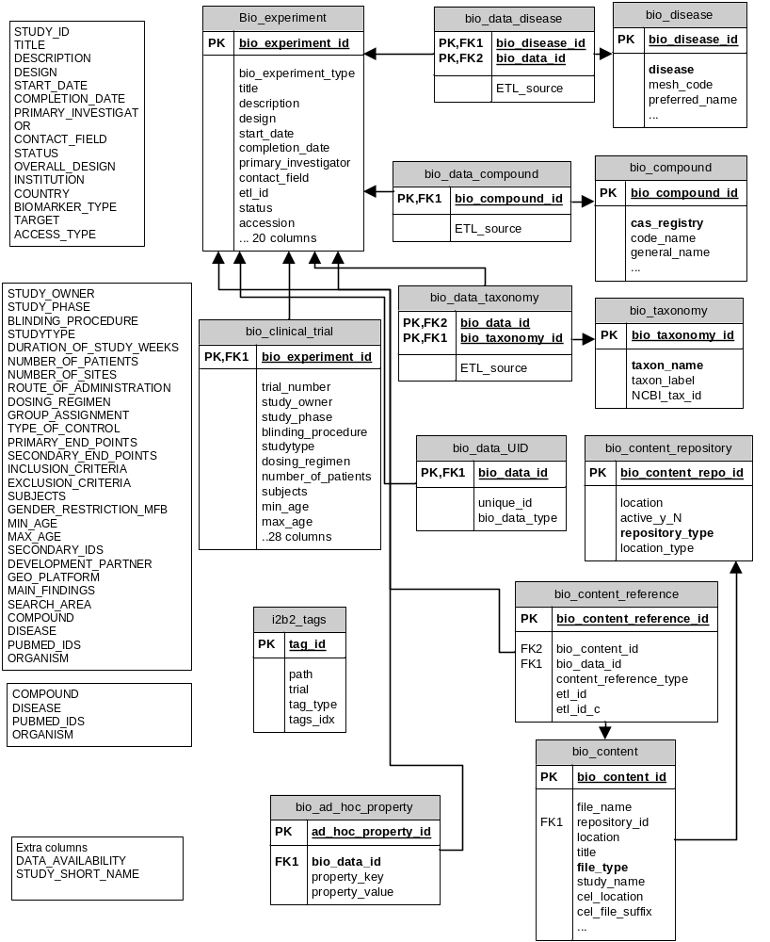
Study_id
Top_node

Input Study Metadata File Example

STUDY_ID Column_name Column_value
TEST2 TITLE This is a test for study metadata loading
TEST2 DESCRIPTION This is a test.
TEST2 START_DATE 20130101
TEST2 OVERALL_DESIGN TESTD
TEST2 INSTITUTION Pfizer
TEST2 COUNTRY USA
TEST2 BIOMARKER_TYPE test
TEST2 PUBMED_IDS 12345
TEST2 STUDY_SHORT_NAME STUDY_TEST
TEST2 STUDY_PHASE Phase 0: Observational study
TEST2 SUBJECTS 30 healthy, 90 patients
TEST2 DATA_AVAILABILITY GWAS
TEST2 DISEASE Diabetes, Type 2;Asthma
TEST2 ORGANISM Homo sapiens
TEST TITLE This is a test for multiple study metadata loading
TEST DESCRIPTION This study is used for testing
TEST STUDY_SHORT_NAME STUDY_TEST
TEST DATA_AVAILABILITY GWAS and Clinical
TEST PRIMARY_INVESTIGATOR John Smith

The Study metadata file is a tab-limited text file, consists of 3 columns: Study_id, Column_name and Column_value. The pre-defined column names are listed in List 1.

- TITLE
- DESCRIPTION
- DESIGN
- START_DATE
- COMPLETION_DATE
- PRIMARY_INVESTIGATOR
- CONTACT_FIELD
- STATUS
- OVERALL_DESIGN
- INSTITUTION
- COUNTRY
- BIOMARKER_TYPE
- TARGET
- ACCESS_TYPE
- STUDY_OWNER
- STUDY_PHASE
- BLINDING_PROCEDURE
- STUDYTYPE
- DURATION_OF_STUDY_WEEKS
- NUMBER_OF_PATIENTS
- NUMBER_OF_SITES
- ROUTE_OF_ADMINISTRATION
- DOSING_REGIMEN
- GROUP_ASSIGNMENT
- TYPE_OF_CONTROL
- PRIMARY_END_POINTS
- SECONDARY_END_POINTS
- INCLUSION_CRITERIA
- EXCLUSION_CRITERIA
- SUBJECTS
- GENDER_RESTRICTION_MFB
- MIN_AGE
- MAX_AGE
- SECONDARY_IDS
- DEVELOPMENT_PARTNER
- GEO_PLATFORM
- MAIN_FINDINGS
- SEARCH_AREA
- COMPOUND
- DISEASE
- PUBMED_IDS
- ORGANISM

List 1. Pre-defined column names for study metadata.

Kettle Jobs and Transformation
Load_Study_Metadata.kjb
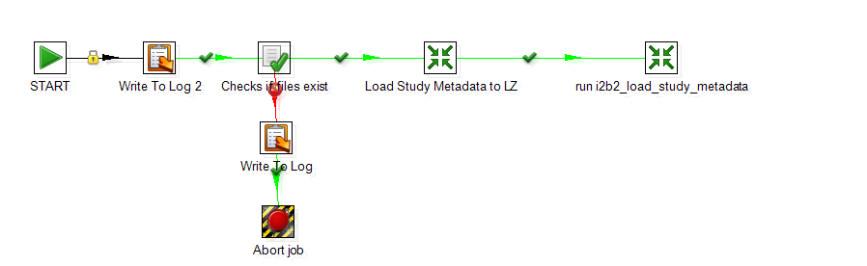
load_study_metadata.ktr
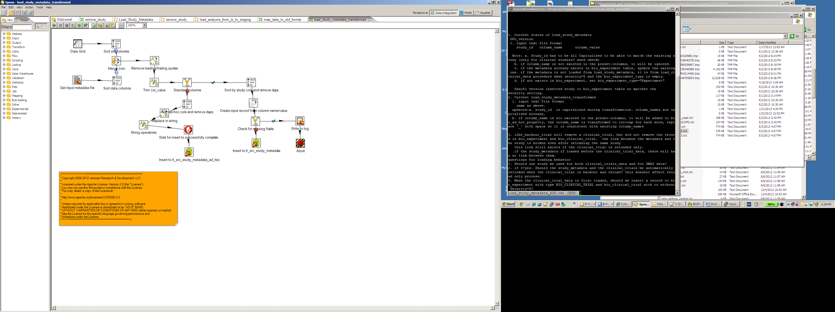
Involved Kettle jobs and transformations
- Load_Study_Metadata.kjb
- load_study_metadata.ktr
- run_i2b2_load_study_metadata.ktr

Command to execute Kettle job

$HOME/data-integration/kitchen.sh -norep=Y -file=$HOME/Kettle-ETL/Load_Study_Metadata.kjb -log=load_study_metadata.log \
-param:METADATA_FILENAME=Test_metadata.txt \
-param:METADATA_LOCATION=$HOME\Test \
-param:METADATA_MAP_FILENAME=x \
-param:SORT_DIR=$HOME

Involved Tables for study metadata loading

  - Tm_lz.Lz_src_study_metadata
  - Tm_lz.lt_src_study_metadata
  - Tm_lz.lt_src_study_metadata_ad_hoc
  - Tm_lz.lz_src_study_metdata_ad_hoc
  - Biomart.bio_experiment
  - Biomart.bio_clinical_trial
  - Biomart.bio_data_uid
  - Biomart.bio_compound
  - Biomart.bio_data_compound
  - Biomart.bio_data_disease
  - Biomart.bio_disease
  - Biomart.bio_data_taxonomy
  - Biomart.bio_taxonomy
  - Biomart.bio_content_repository
  - Biomart.bio_content
  - Biomart.bio_content_reference
  - Biomart.bio_ad_hoc_property
  - I2b2metadata.i2b2_tags

Involved Oracle pl/SQL procedures/functions
- Tm_cz.i2b2_load_study_metadata
- Tm_cz. cz_write_audit
- Tm_cz.cz_end_audit
- Tm_cz.cz_error_handle
- Tm_cz.parse_nth_value

Undefined foreign keys
- Bio_experiment.bio_experiment_id | = bio_clinical_trial.bio_experiment_id
 | = bio_data_taxonomy.bio_data_id
 | = bio_data_disease.bio_data_id
 | = bio_content_reference.bio_data_id
 | = bio_ad_hoc_property.bio_data_id
 | = bio_data_compound.bio_data_id
 | = bio_data_uid.bio_data_id

- Bio_assay_analysis.bio_data_analysis_id | = bio_data_observation.bio_data_id
 | = bio_data_platform.bio_data_id

- bio_clinical_trial.trial_number | = i2b2tags.tag
 | = i2b2_security.sourcesystem_cd
 | = i2b2metadata.i2b2.sourcesystem_cd

Availability
The Kettle transformation script was developed from the GPL version in tranSMART github repositories. The Kettle scripts mentioned in this document, Oracle pl/sql procedures, loading shell scripts can be found in transmart GitHub repository http://github.com/haiyanz/transmart-ETL/.

Notes

Load Clinical Data

Clinical data model in tranSMART
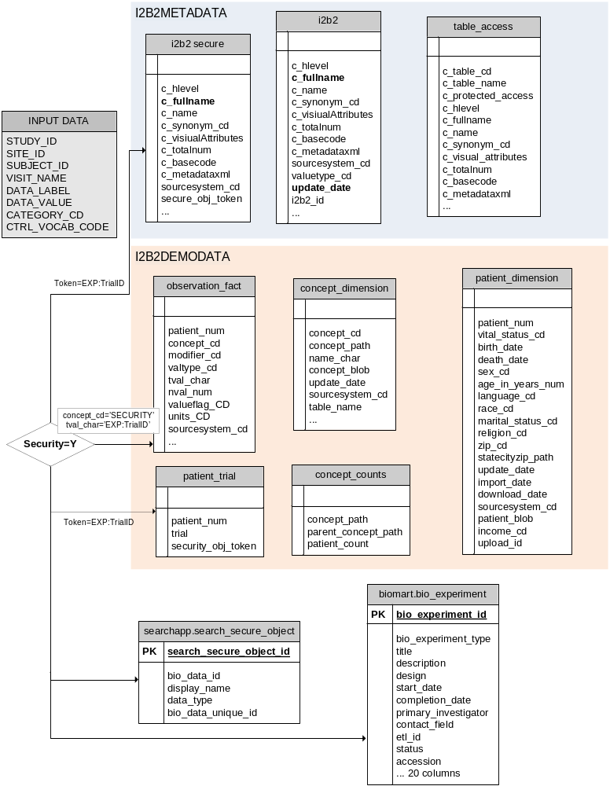

Involved tables for clinical data loading
- tm_lz.lt_src_clinical_data
- tm_lz.lz_src_clinical_data
- tm_wz.wkr_clinical_data
- tm_wz.wt_num_data_types
- tm_wz.wt_trial_nodes
- tm_cz.tmp_subject_info
- i2b2demodata.patient_dimension
- i2b2demodata.patient_trial
- i2b2demodata.concept_counts
- i2b2demodata.concept_dimension
- i2b2demodata.observation_fact
- i2b2metadata.i2b2_secure
- i2b2metadata.i2b2
- i2b2metadata.table_access
- searchapp.search_security_object
- deapp.de_subject_sample_mapping
- biomart.bio_experiment

Involved Oracle pl/SQL procedures/functions
- i2b2_load_clinical_data
- i2b2_creat_security_for_trial
- i2b2_load_security_data
- i2b2_fill_in_tree
- i2b2_delete_1_node
- i2b2_add_root_node
- i2b2_add_node
- i2b2_create_concept_counts
- cz_start_audit
- cz_write_audit
- cz_end_audit
- cz_error_handler

Kettle Jobs and Transformation
create_clinical_data.kjb

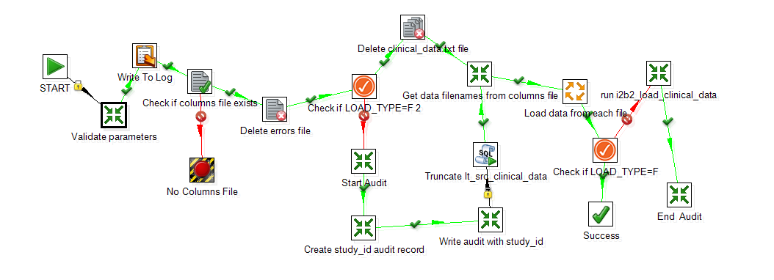
Map_data_to_std_format.ktr

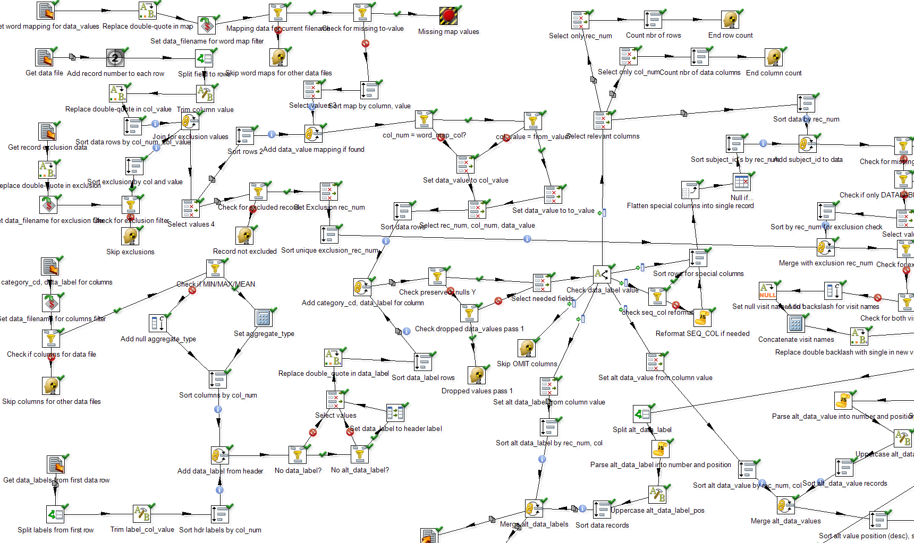

Involved Kettle jobs and transformations
- create_clinical_data.kjb
- load_lt_clnical_data.kjb
- get_data_filenames.ktr
- run_i2b2_load_clinical_data.ktr
- validate_clinical_data_params.ktr
- set_data_filename.ktr
- map_data_to_std_format.ktr
- write_clinical_audit.ktr
- cz_start_audit.ktr
- cz_end_audit.ktr
- write_study_id_to_audit.ktr

Command to execute Kettle job

$HOME/data-integration/kitchen.sh -norep=Y -file=$HOME/Kettle-ETL/create_clinical_data.kjb -log=load_clinical_data.log \
-param:COLUMN_MAP_FILE=test_column_mapping.txt \
-param:DATA_LOCATION=$HOME/TEST/DATA \
-param:LOAD_TYPE=I \
-param:SECURITY_REQUIRED=N \
-param:SORT_DIR=$HOME \
-param:SQLLDR_PATH=$ORACLE_HOME/bin/sqlldr \
-param:STUDY_ID=TEST \
-param:TOP_NODE='\Public Studies\test\' \
-param:WORD_MAP_FILE=test_word_mapping.txt \
-param:RECORD_EXCLUSION_FILE=x

Examples of Input files
- Clinical Data File
Clinical data file(s) is required. The files should be tab-limited text files under DATA_LOCATION directory.
- column mapping file
The column mapping file specifies how the data should be represented in the dataset explorer.
- word mapping file
The word mapping file is optional. This allows data value for a concept node to be transformed to another data value.

Notes
- Data values are loaded to Observation_fact table
- Category_cd are loaded to concept_dimension, i2b2, i2b2_secure

Load Gene Expression Data
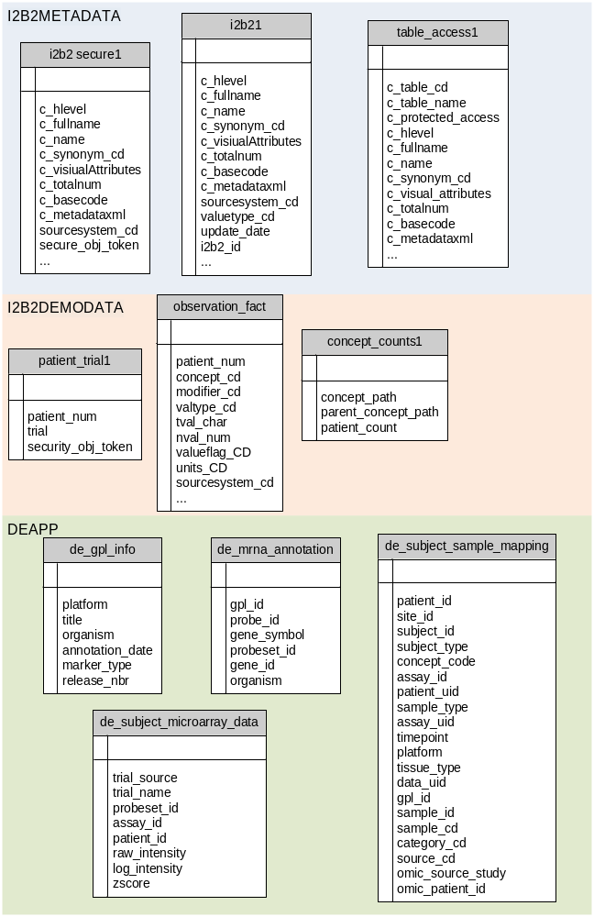

Involved tables
- tm_lz.lt_src_mrna_subj_samp_map
- deapp.de_mrna_annotation
- deapp.de_gpl_info
- i2b2metadata.table_access
- i2b2metadata.i2b2
- i2b2metadata.i2b2_secure
- i2b2demodata.patient_dimension
- i2b2demodata.observation_fact
- deapp.de_subject_microarray_data
- deapp.de_subject_sample_mapping
- tm_wz.wt_mrna_nodes
- tm_wz.wt_mrna_node_values
- tm_wz.wt_subject_mrna_probeset
- tm_cz.probeset_deapp

Involved procedures
- cz_start_audit
- cz_write_audit
- cz_end_audit
- cz_error_handler
- i2b2_process_mrna_data
- parse_nth_value
- i2b2_add_root_node
- i2b2_fill_in_tree
- i2b2_create_security_for_trial
- i2b2_add_node
- i2b2_create_concept_counts
- i2b2_delete_1_node
- i2b2_load_security_data
- i2b2_mrna_zscore_calc
- tm_wz.wt_subject_microarray_logs
- tm_wz.wt_subject_microarray_calcs
- tm_wz.wt_subject_microarray_med

Kettle Jobs and Transformation
Load_gene_expression_data.kjb

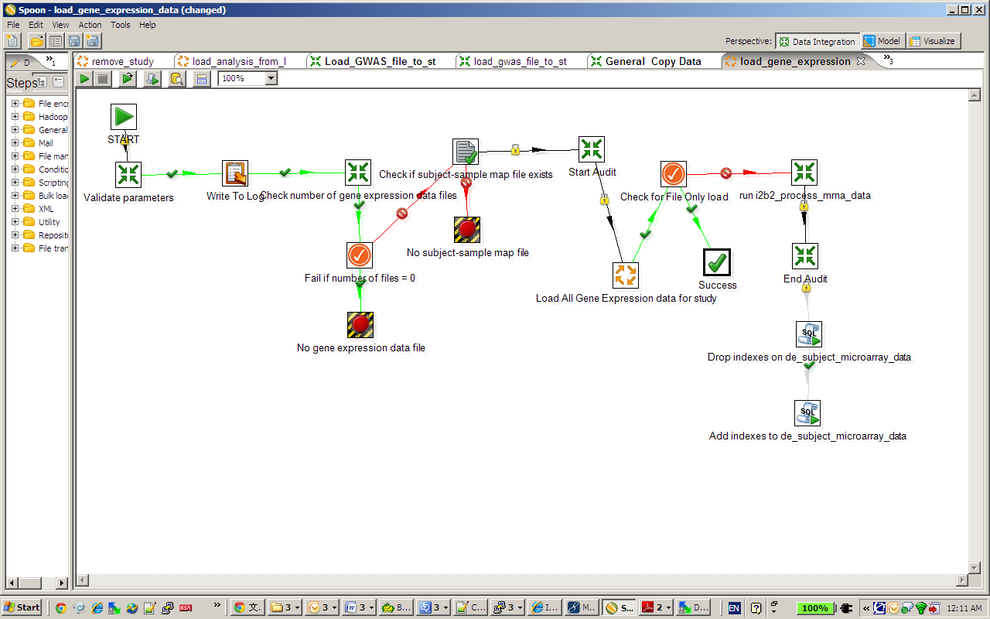
load_gene_expression_data_to_lz.ktr

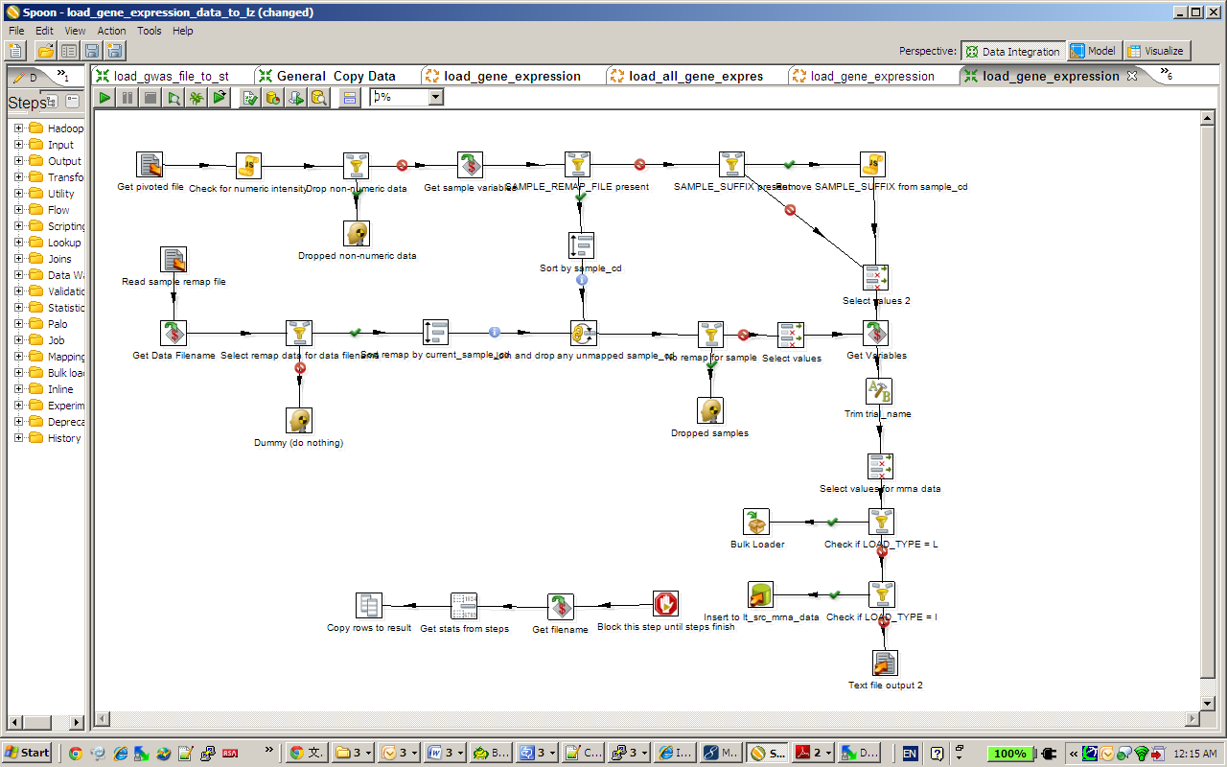
Involved Kettle jobs and transformations

- Load_gene_expression_data.kjb
- load_all_gene_expression_files_for_study.kjb
- load_gene_expression_one_study.kjb
- check_gene_expression_filenames.ktr
- load_subject_sample_map_to_lt.ktr
- get_list_of_gene_expression_filenames.ktr
- run_i2b2_process_mrna_data.ktr
- validate_gene_expression_params.ktr
- validate_gene_expression_columns.ktr
- write_gene_expression_audit.ktr
- load_gene_expression_data_to_lz.ktr
- set_gene_expression_filename.ktr
- write_study_id_to_audit.ktr
- cz_end_audit.ktr
- cz_start_audit.ktr

Examples of input files
- subject sample mapping file
- expression data file

Notes:
- load data type (T, L or R)
dataType=T, values will be loaded to zscore column, values range [-2.5,2.5] if value <-2.5, value=-2.5; if value >2.5 value=2.5. Loading data type as T will cause problem when exporting data.
dataType=R, values loaded to raw_intensity
dataType=L, if log_base=-1 raw_intensity=null, else power(logbase, log_intenisty)
- If the gene expression file does not need pivot, use load_gene_expression_data_nopivot.kjb
- Data from one data source has to be loaded in the same time. (needs verify other conditions)

