Q: How do you handle multi-national and multi-domain cooperation as of today?

R: According to communication standards of the FNM Spiral 4 standards, and based on this, using XML and SOA service definitions.

And with a predefined shared data model between applications.

The different domains must export the schemas and follow the JC3IEDM taxonomy. But structures are not shared between domains.

What are the key challenges for multi-domain cooperation?

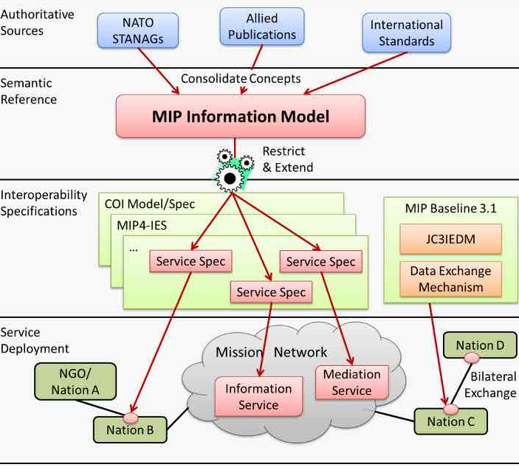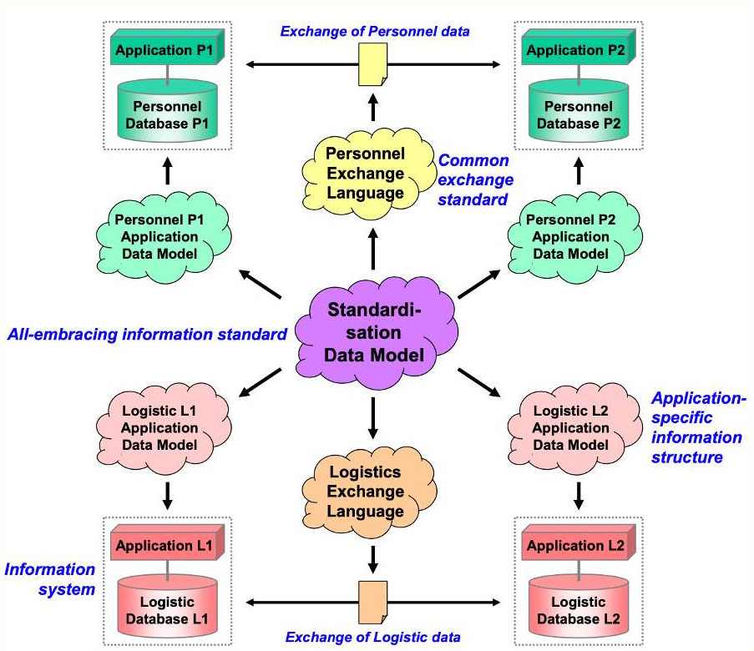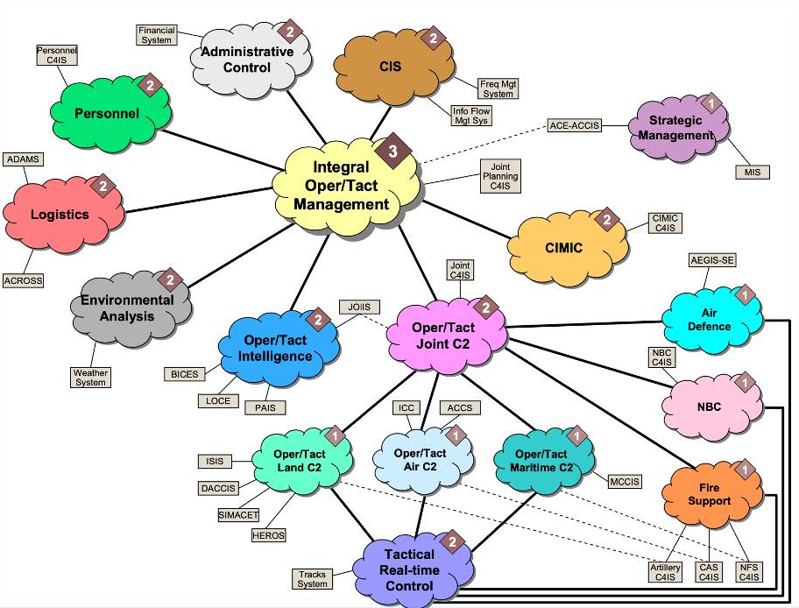

Currently the federated services and the classification of the information help to manage the sending of the data. These are coordinated manually.

The problem is the coordinated management of information in a timely manner:

It could be technically:

- Solve the problem of cryptographic exchange.

- Include concepts of federated events.

- Data Flows associated with Security Circles.

- Data-based security:

Relationship: Mission &CIS:

A definition of the hierarchy of military (Business) / IT technical roles. That this is managed with adaptable workflows...

What are the key challenges for multi-national cooperation?

The above are included but with the ability to define and coordinate cyberspace, and a management of security levels compatible with a clear definition of the responsibilities of each data (classification, reclassification).

And an organizational chart of dynamic roles (role/sub role) with a dated hierarchy.

Sensor language (translatable through harmonization libraries) and accessible resources (Data Mesh paradigms) and OpenLinkData.

Distributed Orchestators.

Where do you see the biggest need for improvements in each of the following areas?

1. multi-national
2. multi-domain
3. Strategic/Operational/Tactical layers

What are your most urgent issues/problems to be solved in the shortest time, in joint or combined mission that should be solved? Can you give a prioritized list?

1. Information colaborational Models - Procedures.
2. Definition of role structures that accompany the hierarchical roles of military command. Transferable to CIS domains.
3. Information digitization and classification procedures.