# Getting Started

1. On my MacBook, install Hyperledger BESU using homebrew. Following the tutorial on <https://besu.hyperledger.org/en/stable/private-networks/get-started/install/binary-distribution/#prerequisites>

* Installation unsuccessful due to no java runtime?
* Tried running **besu –-help** also to no avail.
* Cause of Error: Suspected to be not having Java installed in the system.
* Steps taken to solve the error:
  + Using homebrew to install Java. Command: **brew install openjdk**

* + Creating a symlink for the system Java wrappers to find the JDK but it still fails:
    - Link for reference: <https://developer.apple.com/forums/thread/687489> (Posted by xinnyuan)

* + Trying to upgrade the Hyperledger BESU again then run besu –version but it still fails.
  + Trying another type of java installation under homebrew command: **brew install –-cask adoptopenjdk**

* + The previous method works, java is now detected BUT it is not satisfying the requirement of BESU. BESU need java 17+

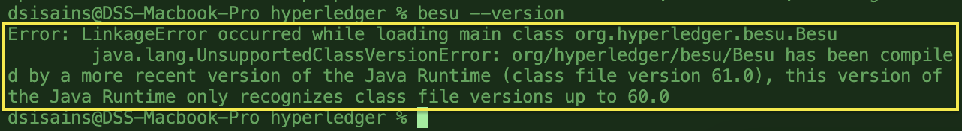

* + Figuring out how to get java 17+. Read the instructions from adoptopenjdk developer themselves here <https://github.com/AdoptOpenJDK/homebrew-openjdk>. Tried installing Temurin and it finally works. BESU can link to the Java as well as shown below:

1. Check BESU version to see if installation is valid.



1. Check if CURL & Java is installed as per requirements.
   1. JAVA check:

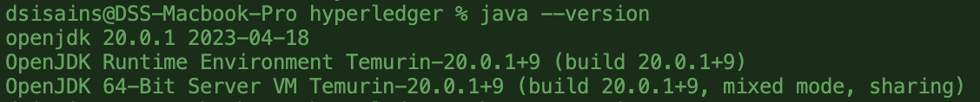

* 1. CURL check:



# IBFT 2.0

Following steps in the tutorial.

**Step 1 & 2**: basic setting up directories and config files for ibft

**Step 3**:

Giving the output where a networkFiles folder is generated.

**Step 4**: Just copy genesis.json to main dir from networkFiles folder

**Step 5**: copy private keys into the node dirs

**Step 6**: Copy the enode url generated.

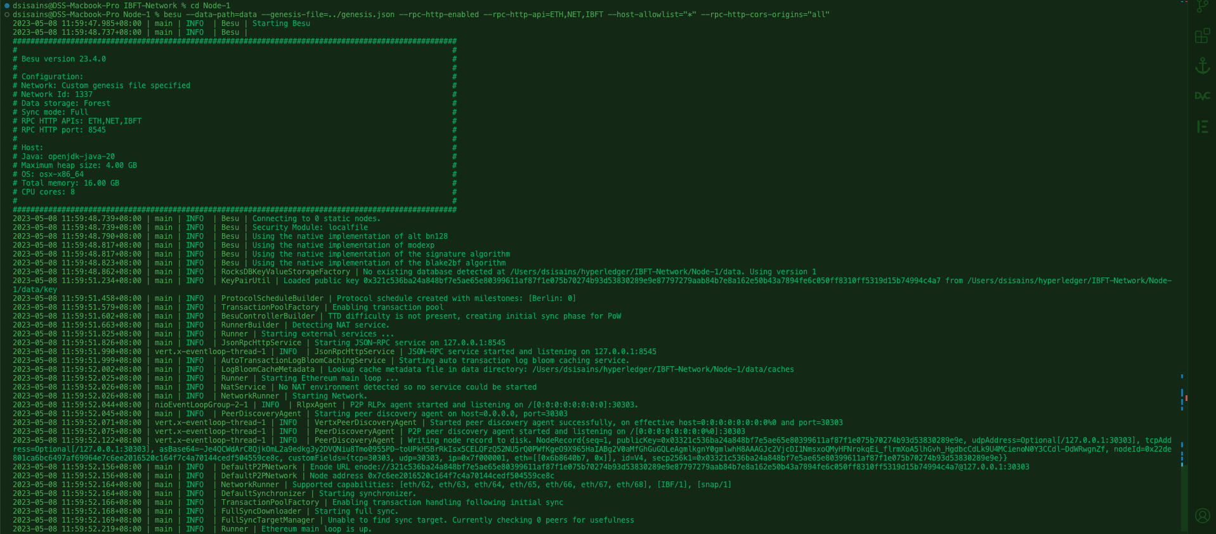

**Enode URL NODE 1:** enode://321c536ba24a848bf7e5ae65e80399611af87f1e075b70274b93d53830289e9e87797279aab84b7e8a162e50b43a7894fe6c050ff8310ff5319d15b74994c4a7@127.0.0.1:30303

**Step 7**: Paste Enode URL from Node 1 into the command.

besu --data-path=data --genesis-file=../genesis.json --bootnodes= enode://321c536ba24a848bf7e5ae65e80399611af87f1e075b70274b93d53830289e9e87797279aab84b7e8a162e50b43a7894fe6c050ff8310ff5319d15b74994c4a7@127.0.0.1:30303 --p2p-port=30304 --rpc-http-enabled --rpc-http-api=ETH,NET,IBFT --host-allowlist="*" --rpc-http-cors-origins="all" --rpc-http-port=8546

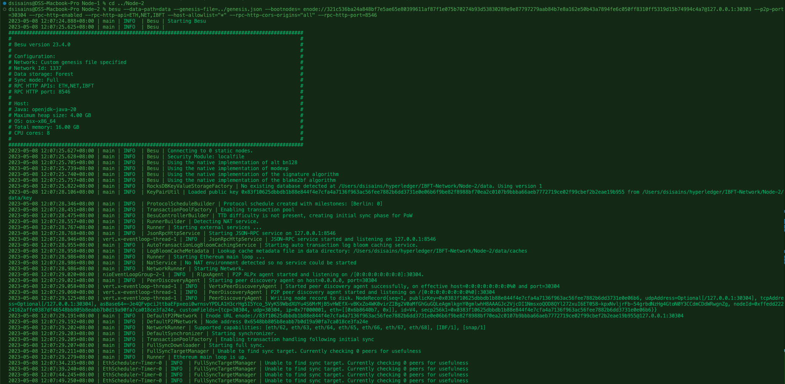

**Step 8**: Start Node-3

besu --data-path=data --genesis-file=../genesis.json --bootnodes= enode://321c536ba24a848bf7e5ae65e80399611af87f1e075b70274b93d53830289e9e87797279aab84b7e8a162e50b43a7894fe6c050ff8310ff5319d15b74994c4a7@127.0.0.1:30303 --p2p-port=30305 --rpc-http-enabled --rpc-http-api=ETH,NET,IBFT --host-allowlist="*" --rpc-http-cors-origins="all" --rpc-http-port=8547

**Step 9**: Start Node 4

besu --data-path=data --genesis-file=../genesis.json --bootnodes= enode://321c536ba24a848bf7e5ae65e80399611af87f1e075b70274b93d53830289e9e87797279aab84b7e8a162e50b43a7894fe6c050ff8310ff5319d15b74994c4a7@127.0.0.1:30303 --p2p-port=30306 --rpc-http-enabled --rpc-http-api=ETH,NET,IBFT --host-allowlist="*" --rpc-http-cors-origins="all" --rpc-http-port=8548

Starting to realize that there is a problem.

**Step 10**: no logs shown for the curl command I was hitting.

Steps taken to find solution:

1. Try run all nodes 1 to 4 in unison then hit curl again – this works.

In conclusion,

1. Create all necessary folders.
2. Write down configuration files in ibftConfigFile.json that will specify all the gas limits, content size etc
3. Specify how many nodes u want in that configuration files. This is under ‘blockchain’ object. Node count for this tutorial is 4.
4. Then run command to generate node keys and its genesis files.
5. Basically we only use ibftConfigFile.json one time and then from then on, use genesis.json that is generated from the command in Step 4 which we then paste to main directory as the default config.
6. Run all nodes from terminal and use curl to get data.
7. Check the logs if it is all connected.

* THE END FOR PART 1 –

# Configuring Free Gas Networks

Following this tutorial: <https://besu.hyperledger.org/en/stable/private-networks/how-to/configure/free-gas/#1-set-the-block-size>

**Roadblocks**:

* The editing on genesis,json file caused it to not be able to run anymore.

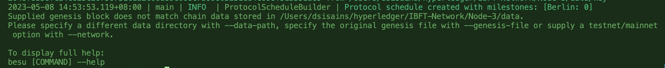

* Need to recreate genesis and their respective node keys? NO

Steps to solve:

* Ask chatGPT how to edit genesis.json without recreating node keys

* Add the **--revert-chain-to=genesis** tag into each of the startup commands for all the nodes.
* Firstly, add in Node 1:
* besu --data-path=data --genesis-file=../genesis.json --revert-chain-to=genesis --rpc-http-enabled --rpc-http-api=ETH,NET,IBFT --host-allowlist="*" --rpc-http-cors-origins="all"
* Whoops, it failed.  
  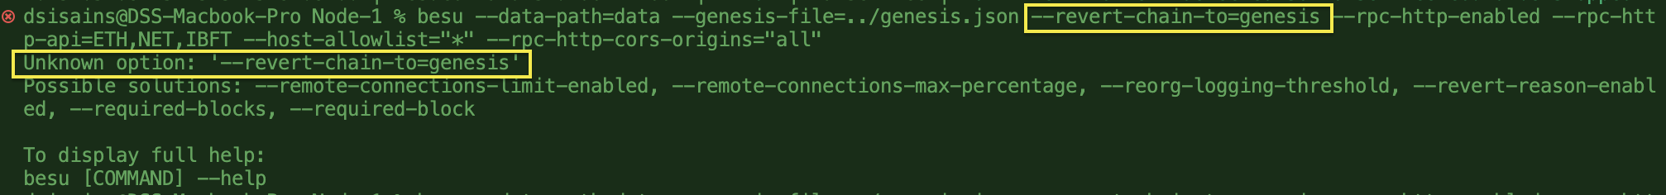
* Asked chatGPT again but solution given which is to add ‘—clear-data’ flag before revert chain flag but it is still not working too:

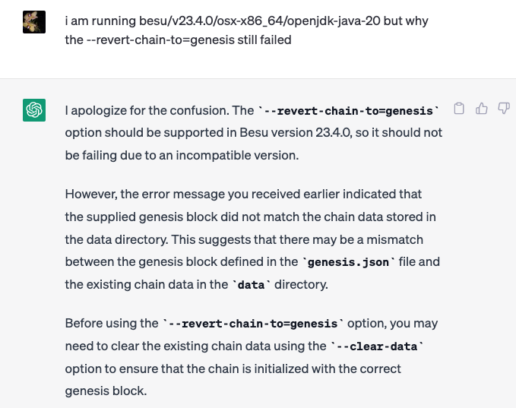

* Finally, I just surrender and manually delete the ‘data’ directory to clear the chain data and re-initialize the chain with the genesis block by using normal linux command ‘rm -rf data’.
* Restart the nodes with the initial command without extra tags.
* Too annoyed with the constant manual work whenever I need to edit genesis.json so I created a shell script to automate the deletion of data files in node folders
* Able to run 4 nodes parallelly.

- THE END FOR PART 2 –

# Configuring Tessera

1. Installing tessera using homebrew based on the guide given by chatGPT
   1. brew tap web3j/web3j
   2. brew install tessera
      1. but brew gave warning saying:

Warning: No available formula with the name "tessera".

I am not doing text extraction, so this way of installing is not viable.

1. Find other ways to install using this link:
   1. <https://github.com/ConsenSys/tessera/releases>
2. Went to tessera-23.4.0 and download tessera-dist-23.4.0.tar (40.5MB)
3. Extract the files in folder and put in my repo.

1. Configuring Tessera config file with 4 nodes specified
2. ROADBLOCK: cannot find tessera-app-23.4.0-app.jar file. According to chatGPT, it is important.
   1. Steps to solve:
      1. Try docker image pull version of tessera installation
      * docker pull quorumengineering/tessera

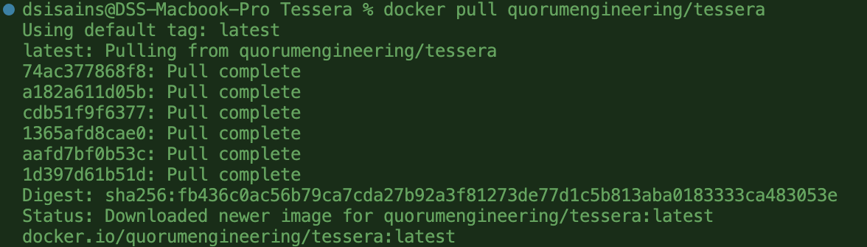

* + 1. Check if the image is not corrupted with the command:
    - “docker run quorumengineering/tessera:latest help”

* + 1. Run the container from Tessera directory with the command:
       - docker run -p 9081:9081 -p 9082:9082 -v /Users/dsisains/hyperledger/besu-ibft2.0/Tessera/:/config quorumengineering/tessera:latest -configfile /config/tessera-config.json -o mode=”orion”
    2. Found out there is such thing as config.toml which is the configuration file for besu & Tessera is a replacement of Orion
    3. Give up in trying to run the docker after it is giving me error.

1. Found another tutorial and trying to set things up based on the steps in: <https://besu.hyperledger.org/en/stable/private-networks/tutorials/privacy/#prerequisites>

* Step 1: Create Tessera directories.

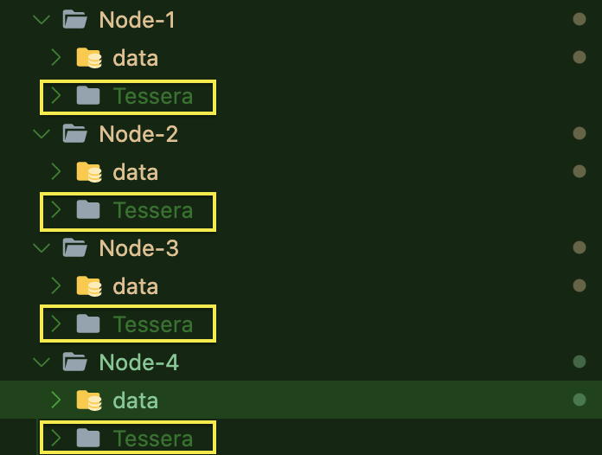

* Run docker run quorumengineering/tessera:latest -keygen -filename nodeKey in each Tessera folders to create keys
* Reinstall tessera using source because it is hard to see files if using docker. Reference: <https://docs.tessera.consensys.net/HowTo/Get-started/Install/Build-From-Source>
* Building tessera with the gradle wrapper gradlew but failed.
* Tried to build with the next command.

* Turns out it was giving error bcs my gradle version s incompatible with my java version. I am choosing to upgrade my gradle bcs I am afraid if I upgrade my java, my Hyperledger besu will gives out problem.
* Realizing I haven’t got libsodium installed in my mac, so I tried installing libsodium first before proceeding to try and upgrade my gradle. But upon finish installing libsodium, the error is still there so I continue to update my gradle
* I finished upgrading my gradle and tried running the build tessera code and it still failed. Asked chatgpt and it told me my gradle too latest. Must downgrade.
* ROADBLOCK: java version cannot run this gradle version. It can only compile and test. This conclusion has been met based on gradle compatibility matrix at <https://docs.gradle.org/current/userguide/compatibility.html>

* After downgrading my gradle, I can’t make it work at all
* Reinstall gradle again following this tutorial: <https://medium.com/@czerwinb/how-to-install-a-specific-gradle-version-on-your-mac-beab35051ee8>
* Finally, after downgrading my jaa to version 18, and using gradle version 7.5.1, I managed to finally build tessera. Took me 8 hours.
* ROADBLOCK: after building tessera, I cannot run the tessera command/
* Trying to figure out why. Found out for tessera installed using source, the tessera-dist/build/install/tessera is actually at ‘tessera-dist/build/distributions’
* So instead of running ./tessera-dist/build/install/tessera/bin/tessera help, I need to run ./tessera-dist/build/distributions/tessera-23.4.0-SNAPSHOT/bin/tessera help. Now it works. Fucking finally.

* + Typing such a long command is so much hassle even when u only need to copy n paste. So I want to create a symbolic link so I can just ype in tessera and be done with it. Command used:
    - ln -s $PWD/tessera-dist/build/distributions/tessera-23.4.0-SNAPSHOT/bin/tessera /usr/local/bin/tessera
  + Continue to create tessera keys inside each of the node folders
  + Create shell script to run tessera for the 4 nodes parallelly
  + Start besu with the updated command in the tutorial
  + The besu failed. Trying to start besu manually using command line
    - Node 1:
    - besu --data-path=data --genesis-file=../../genesis.json --rpc-http-enabled --rpc-http-a
  + Continue to create tessera keys inside each of the node folders

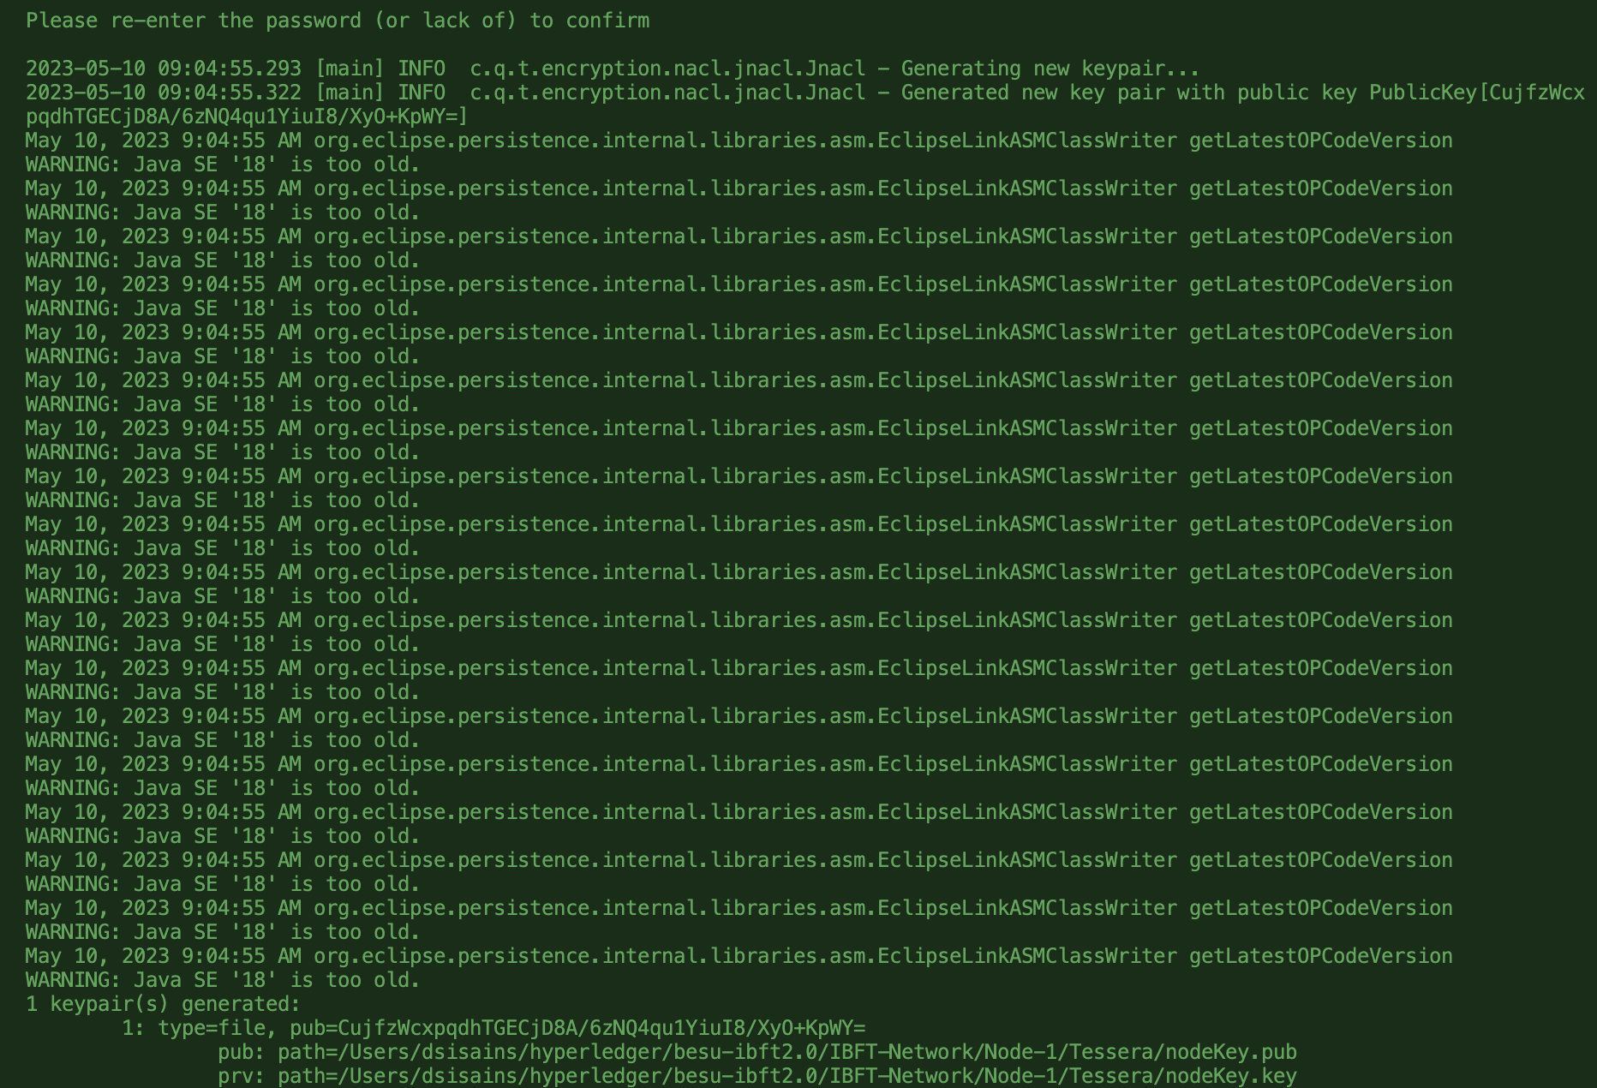

* + Create shell script to run tessera for the 4 nodes parallelly
  + Start besu with the updated command in the tutorial
  + The start up of besu failed. Then try to start it manually by going through each folder which ends up working.
    - Node 1

besu --data-path=data --genesis-file=../../genesis.json --rpc-http-enabled --rpc-http-api=ETH,NET,IBFT,EEA,PRIV --host-allowlist="*" --rpc-http-cors-origins="all" --privacy-enabled --privacy-url=http://127.0.0.1:9102 --privacy-public-key-file=nodeKey.pub --min-gas-price=0

* Node 2

besu --data-path=data --genesis-file=../genesis.json --bootnodes=enode://ff7faffbef8b6a5f089dde9c605eb4535c982dcc442dc7548fb28856bb68896a93b6ac5dea1367b5669d49374852403cb9a8ffab5dccc35e5ab4d454c8e59d4b@127.0.0.1:30303 --p2p-port=30304 --rpc-http-enabled --rpc-http-api=ETH,NET,IBFT,EEA,PRIV --host-allowlist="*" --rpc-http-cors-origins="all" --rpc-http-port=8546 --privacy-enabled --privacy-url=http://127.0.0.1:9202 --privacy-public-key-file=Tessera/nodeKey.pub --min-gas-price=0

* + - Node 3:

besu --data-path=data --genesis-file=../genesis.json --bootnodes=enode://ff7faffbef8b6a5f089dde9c605eb4535c982dcc442dc7548fb28856bb68896a93b6ac5dea1367b5669d49374852403cb9a8ffab5dccc35e5ab4d454c8e59d4b@127.0.0.1:30303 --p2p-port=30305 --rpc-http-enabled --rpc-http-api=ETH,NET,IBFT,EEA,PRIV --host-allowlist="*" --rpc-http-cors-origins="all" --rpc-http-port=8547 --privacy-enabled --privacy-url=http://127.0.0.1:9302 --privacy-public-key-file=Tessera/nodeKey.pub --min-gas-price=0

* + - Node 4:

besu --data-path=data --genesis-file=../genesis.json --bootnodes=enode://ff7faffbef8b6a5f089dde9c605eb4535c982dcc442dc7548fb28856bb68896a93b6ac5dea1367b5669d49374852403cb9a8ffab5dccc35e5ab4d454c8e59d4b@127.0.0.1:30303 --p2p-port=30306 --rpc-http-enabled --rpc-http-api=ETH,NET,IBFT,EEA,PRIV --host-allowlist="*" --rpc-http-cors-origins="all" --rpc-http-port=8548 --privacy-enabled --privacy-url=http://127.0.0.1:9402 --privacy-public-key-file=Tessera/nodeKey.pub --min-gas-price=0

* + But there is syncing problem. The peers have no usefulness. Tried troubleshooting with chatGPT and tessera documentation.
    - I managed to get tessera to work with BESU after following the tutorial and configure the tessera config file to connect with besu using --p2p-port that has been assigned to the besu nodes. @3:05pm. End.
  + Created a shell script that will run tessera & besu in parallel without having to go to each folder and open so many terminals.
  + Code can be obtained from my github.