DEPARTMENT OF INFORMATION AND COMMUNICATION TECHNOLOGY
PROG101: PRINCIPLES OF PROGRAMMING LOGIC AND DESIGN

Title | : | Designing Logical Solutions For Sierra Leone Community Challanges
Issue Date | : | WEEK 2
Due Date | : | WEEK 4
Lecturer/Examiner | : | Mr. Elijah Fullah
Name of Student | : | Haja Memunatu Sesay
Student ID No. | : | 905006570
Class | : | BBIT1101
Semester/Year | : | 1/ 1
I, hereby attest that the contents of this attachment are my own work. Referenced works, articles, art, programs, papers, or parts thereof are acknowledged at the end of this paper. This includes data excerpted from CD-ROMs, the Internet, other private networks, and other people's disks of the computer system.
Student's Signature : | Date:

LECTURER'S COMMENTS/GRADE: | for office use only upon receive  Remark  DATE :  TIME :  RECEIVER'S NAME :

TABLE OF CONTENTS
No. | Section | Page
— | Abstract | 2
— | Executive Summary | 2
— | Report Structure and Methodology | 4
1 | Problem Context and Community Relevance | 4
2 | Computational Thinking and Problem Analysis | 4
3 | Algorithm Design | 5
4 | Pseudocode Design | 6
5 | Flowchart Design | 10
6 | Logical Design | 23
7 | SDG, Open Source and Digital Public Goods | 24
8 | GitHub Repository and Version Control | 24
9 | Logical Test Scenarios and Expected Outputs | 26
10 | Discussion, Recommendations and Future Work | 27
11 | Conclusion | 28
12 | References (Harvard Style) | 28
13 | Appendices | 28

ABSTRACT
Access to reliable community water services depends partly on how faults are reported, prioritised and followed up. This assignment presents a language-independent logical design for a Community Water Supply Monitoring and Reporting System in Sierra Leone. The proposed system allows residents to submit water-supply complaints, validates essential inputs, assigns priority according to severity, generates unique report identifiers, enables status enquiries and restricts status updates to authorised staff. Computational thinking is applied through decomposition, pattern recognition, abstraction and algorithm design. The solution is documented using modular pseudocode, seven flowcharts and fifteen illustrative logical test scenarios. Its intended contribution is improved complaint traceability and communication, with a conceptual alignment to Sustainable Development Goal 6. The assignment does not claim that a functioning application has been developed or field-tested; database persistence, authentication implementation and deployment remain future work.
Keywords: water supply; complaint management; computational thinking; pseudocode; flowcharts; Sierra Leone; SDG 6.

EXECUTIVE SUMMARY
Community challenge. Residents may experience broken public taps, interrupted supply or damaged pipes, while informal reporting can make follow-up difficult. This assignment examines a proposed structured reporting approach rather than an implemented service.
Proposed design. A five-option menu supports complaint submission, status checking, authorised status updating, summary generation and exit. Seven modular flowcharts and corresponding pseudocode explain the system’s sequence, decisions and loops.
Design safeguards. Required fields and severity values are validated; priority follows severity levels 1–3; a sequential report identifier enables lookup; staff-only updates are represented by a conceptual authentication check.
Evidence and limitations. Fifteen logical scenarios illustrate expected outputs, and a public GitHub repository documents the design through three recorded commits. The system has not been coded or deployed, and the sample outputs are not results from live testing.
Expected value. If developed and responsibly operated, the design could improve visibility of reported water problems, support prioritisation and help local maintenance teams communicate progress. It aligns conceptually with SDG 6 (United Nations, n.d.).

REPORT STRUCTURE AND METHODOLOGY
This report follows a design-based academic approach. It begins by defining the community problem and its stakeholders, applies computational thinking, develops a stepwise algorithm and modular pseudocode, then represents the same logic through flowcharts. Logical design tables and hypothetical test cases provide internal checks. Finally, the report discusses SDG 6, open-source and Digital Public Goods considerations, GitHub evidence, limitations and recommendations. No participant data were collected and no software implementation or empirical evaluation is claimed.

1. PROBLEM CONTEXT AND COMMUNITY RELEVANCE

1.1 Background
Reliable access to water is important for public health and community wellbeing. In Sierra Leone, problems such as damaged public taps, faulty pumps, interruptions to supply and slow fault reporting can disrupt daily life. This assignment proposes a logical reporting and tracking system for community water facilities; it does not claim to be an implemented or field-tested application.

1.2 Problem Statement
Informal verbal or telephone complaints can be difficult to record consistently and track to resolution. Without a structured record, the same fault may be reported repeatedly while residents lack a report reference or status information.

1.3 Proposed Solution and Objectives
The proposed system accepts complaint details, validates required fields, assigns a priority based on a three-level severity rating, generates a report ID, records the complaint, permits status lookup, restricts status updates to authorized staff and summarizes complaint statuses.

1.4 Stakeholders and Scope
Beneficiaries include residents, community leaders, maintenance staff and water service authorities. The scope is a language-independent logical design with algorithms, pseudocode and flowcharts. Live databases, authentication services, mobile interfaces and water infrastructure repairs are outside the current assignment.

2. COMPUTATIONAL THINKING AND PROBLEM ANALYSIS
Technique | Application
Decomposition | Separate intake, validation, prioritization, lookup, authorized updates and reporting.
Pattern recognition | Identify recurring fault categories such as broken taps, shortages and pump failures.
Abstraction | Represent each complaint by essential fields and omit unrelated details.
Algorithmic thinking | Define finite, ordered procedures for each menu operation.

2.1 System Inputs and Outputs
Inputs | Processing | Outputs
Name, location, fault type, description, severity | Validate fields; assign priority; generate ID; store record | Acknowledgement, report ID, priority and Pending status
Report ID | Search existing records | Problem, priority and current status or Not Found
Staff credentials, report ID, new status | Authorize; validate status; update record | Status update confirmation
Complaint records | Count by status | Pending, In Progress, Resolved and total counts

3. ALGORITHM DESIGN

3.1 Variables, Constants and Data Types
Name | Type | Purpose
residentName, location, problemType, description | String | Complaint details
severity, reportCount, menuChoice | Integer | Rating, counter and menu choice
priority, reportID, reportStatus | String | Derived and stored values
isValid, found, authorized | Boolean | Control conditions
complaints | List of records | Shared complaint store
Constants: MIN_SEVERITY = 1; MAX_SEVERITY = 3; DEFAULT_STATUS = “Pending”; EXIT_OPTION = 5. Priority mapping: severity 1 = Low; 2 = Medium; 3 = High.

3.2 Step-by-Step Main Algorithm
1. START; initialize an empty complaint list and set reportCount to zero.
2. Display menu options: 1 Submit, 2 Check, 3 Update, 4 Summary, 5 Exit.
3. Read menuChoice.
4. If choice = 1, collect complaint details; repeat until all required text fields are nonempty and severity is an integer from 1 to 3.
5. Map severity to priority; increment reportCount; construct a unique ID such as WSR0001; set status to Pending; append record; display confirmation.
6. If choice = 2, read report ID; search records; display status or Report Not Found.
7. If choice = 3, authenticate staff; if authorized, locate record; repeat until status is Pending, In Progress or Resolved; save change; otherwise deny access.
8. If choice = 4, loop through records and count each status; display totals.
9. If choice is not 1–5, display Invalid Selection.
10. Repeat from menu until choice = 5; display goodbye and END.

3.3 Decisions, Loops and Modules
IF / ELSE IF / ELSE branches handle validation, priority assignment, record lookup and staff authorization. REPEAT UNTIL handles menu selection and correction of invalid inputs; FOR EACH iterates over stored complaints. The seven principal modules are MainMenu, SubmitComplaint, ValidateInput, AssignPriority, CheckStatus, UpdateStatus and GenerateSummary. AuthenticateUser is a supporting function.

4. PSEUDOCODE DESIGN
The following language-independent pseudocode is also supplied as a separate .txt file for the repository. It is a design artifact, not executable software.
COMMUNITY WATER SUPPLY MONITORING AND REPORTING SYSTEM
PROG101 – LANGUAGE-INDEPENDENT PSEUDOCODE

CONSTANT MIN_SEVERITY = 1
CONSTANT MAX_SEVERITY = 3
CONSTANT DEFAULT_STATUS = "Pending"

DECLARE complaints AS LIST OF RECORDS = EMPTY LIST
DECLARE authorizedUsers AS LIST OF STAFF RECORDS
DECLARE reportCount AS INTEGER = 0

PROCEDURE MainMenu()
DISPLAY "1. Submit Complaint"
DISPLAY "2. Check Complaint Status"
DISPLAY "3. Update Complaint Status"
DISPLAY "4. Generate Complaint Summary"
DISPLAY "5. Exit"
END PROCEDURE

FUNCTION ValidateInput(name, location, problemType, description, severity) RETURNS BOOLEAN
IF TRIM(name) = "" OR TRIM(location) = "" OR
TRIM(problemType) = "" OR TRIM(description) = "" THEN
RETURN FALSE
END IF
IF severity IS NOT AN INTEGER THEN
RETURN FALSE
END IF
IF severity < MIN_SEVERITY OR severity > MAX_SEVERITY THEN
RETURN FALSE
END IF
RETURN TRUE
END FUNCTION

FUNCTION AssignPriority(severity) RETURNS STRING
IF severity = 3 THEN
RETURN "High"
ELSE IF severity = 2 THEN
RETURN "Medium"
ELSE
RETURN "Low"
END IF
END FUNCTION

PROCEDURE SubmitComplaint()
REPEAT
INPUT residentName
INPUT location
INPUT problemType
INPUT description
INPUT severity
SET isValid = ValidateInput(residentName, location, problemType,
description, severity)
IF isValid = FALSE THEN
DISPLAY "Invalid information. Please try again."
END IF
UNTIL isValid = TRUE

SET priority = AssignPriority(severity)
SET reportCount = reportCount + 1
SET reportID = "WSR" + FORMAT_WITH_LEADING_ZEROS(reportCount, 4)
SET reportStatus = DEFAULT_STATUS
ADD RECORD(reportID, residentName, location, problemType,
description, severity, priority, reportStatus) TO complaints
DISPLAY "Complaint Submitted Successfully"
DISPLAY "Report ID: ", reportID
DISPLAY "Priority: ", priority
DISPLAY "Status: ", reportStatus
END PROCEDURE

PROCEDURE CheckStatus()
INPUT searchID
SET found = FALSE
FOR EACH complaint IN complaints
IF complaint.reportID = searchID THEN
DISPLAY complaint.problemType, complaint.priority, complaint.reportStatus
SET found = TRUE
EXIT FOR
END IF
END FOR
IF found = FALSE THEN
DISPLAY "Report Not Found"
END IF
END PROCEDURE

FUNCTION AuthenticateUser(username, password) RETURNS BOOLEAN
FOR EACH user IN authorizedUsers
IF user.username = username AND
VerifyPassword(password, user.passwordHash) = TRUE THEN
RETURN TRUE
END IF
END FOR
RETURN FALSE
END FUNCTION

PROCEDURE UpdateStatus()
INPUT username
INPUT password
IF AuthenticateUser(username, password) = FALSE THEN
DISPLAY "Access Denied"
RETURN
END IF

INPUT searchID
SET found = FALSE
FOR EACH complaint IN complaints
IF complaint.reportID = searchID THEN
SET found = TRUE
DISPLAY "Current Status: ", complaint.reportStatus
REPEAT
INPUT newStatus
IF newStatus != "Pending" AND
newStatus != "In Progress" AND
newStatus != "Resolved" THEN
DISPLAY "Invalid Status"
END IF
UNTIL newStatus = "Pending" OR
newStatus = "In Progress" OR
newStatus = "Resolved"
SET complaint.reportStatus = newStatus
DISPLAY "Status Updated Successfully"
EXIT FOR
END IF
END FOR
IF found = FALSE THEN
DISPLAY "Report Not Found"
END IF
END PROCEDURE

PROCEDURE GenerateSummary()
SET pendingCount = 0
SET progressCount = 0
SET resolvedCount = 0
SET totalCount = 0
FOR EACH complaint IN complaints
SET totalCount = totalCount + 1
IF complaint.reportStatus = "Pending" THEN
SET pendingCount = pendingCount + 1
ELSE IF complaint.reportStatus = "In Progress" THEN
SET progressCount = progressCount + 1
ELSE IF complaint.reportStatus = "Resolved" THEN
SET resolvedCount = resolvedCount + 1
END IF
END FOR
DISPLAY "Total Complaints: ", totalCount
DISPLAY "Pending: ", pendingCount
DISPLAY "In Progress: ", progressCount
DISPLAY "Resolved: ", resolvedCount
END PROCEDURE

BEGIN MAIN
REPEAT
CALL MainMenu()
INPUT menuChoice
IF menuChoice = 1 THEN
CALL SubmitComplaint()
ELSE IF menuChoice = 2 THEN
CALL CheckStatus()
ELSE IF menuChoice = 3 THEN
CALL UpdateStatus()
ELSE IF menuChoice = 4 THEN
CALL GenerateSummary()
ELSE IF menuChoice = 5 THEN
DISPLAY "Thank you for using the system"
ELSE
DISPLAY "Invalid Selection"
END IF
UNTIL menuChoice = 5
END MAIN

NOTE: This is design pseudocode, not executable source code.
The authorizedUsers records and VerifyPassword operation represent a proposed
future authentication mechanism; they are not implemented in this assignment.

5. FLOWCHART DESIGN
Standard flowchart notation is used: oval for start/end, parallelogram for input/output, rectangle for processing, diamond for decisions, and predefined-process symbols for modules. The seven diagrams correspond to the main procedure and its major functions.

Figure 1. Main menu and module selection
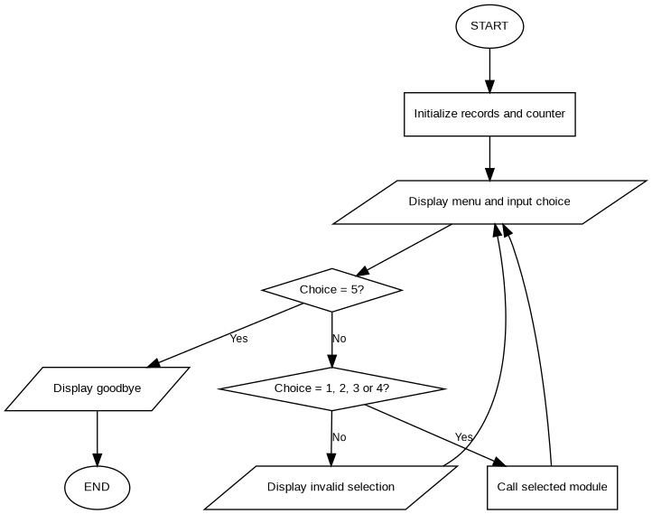

Source: project flowchart created for this assignment; editable diagram available in the accompanying .drawio file.

Figure 2. Complaint submission
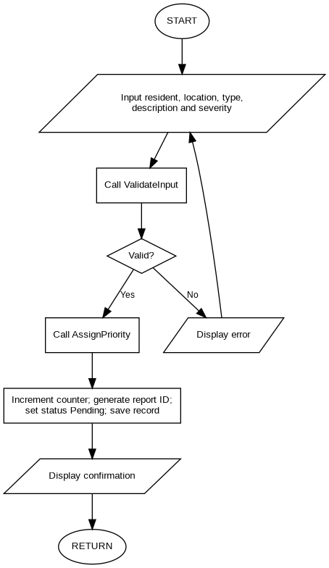
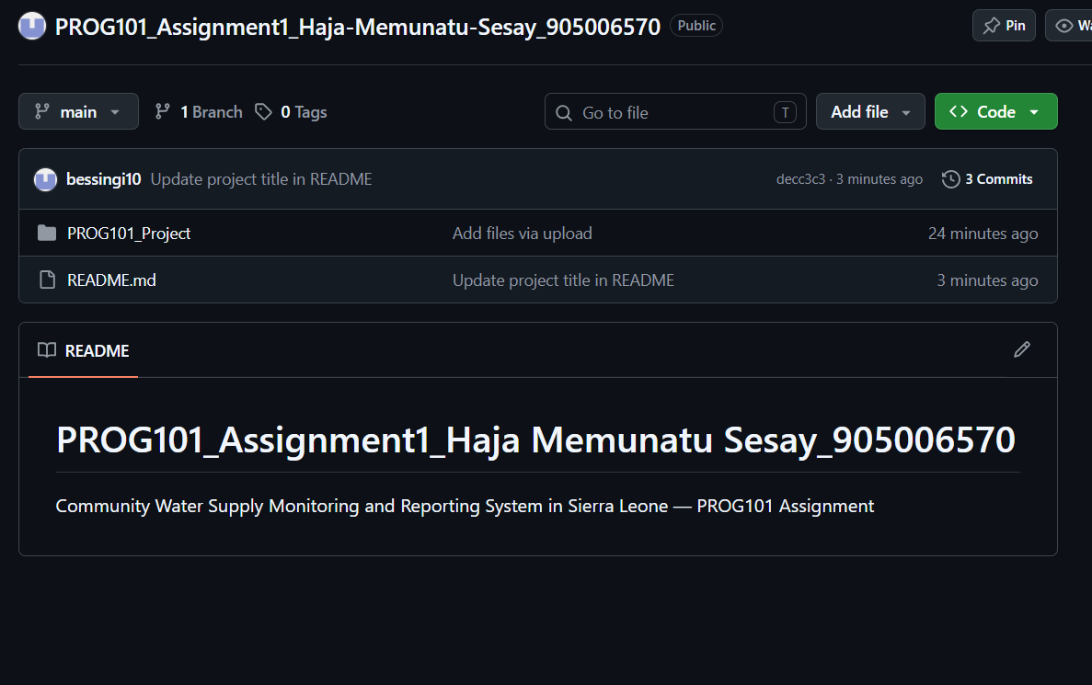
Source: project flowchart created for this assignment; editable diagram available in the accompanying .drawio file.

Figure 3. Input validation
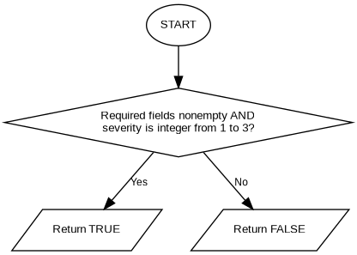
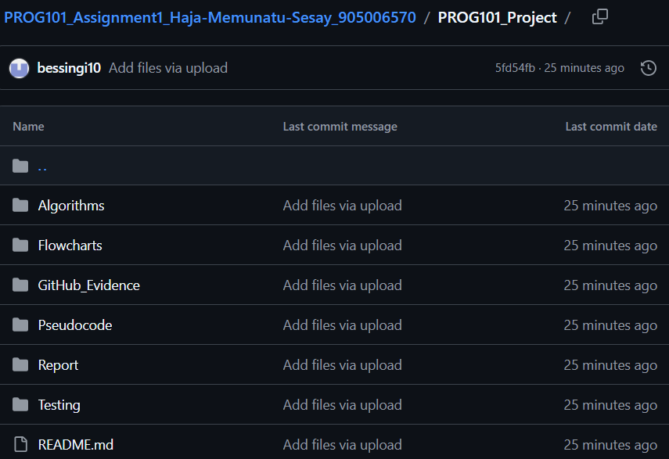
Source: project flowchart created for this assignment; editable diagram available in the accompanying .drawio file.

Figure 4. Priority assignment
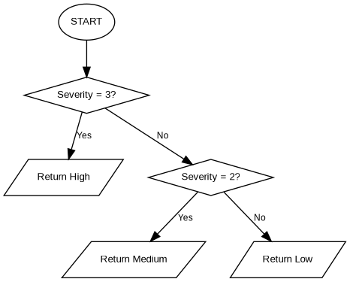
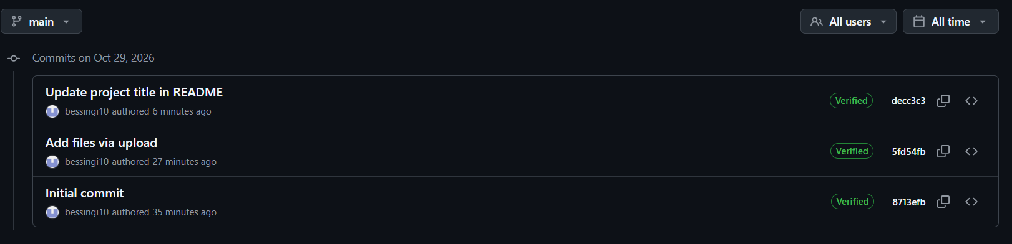
Source: project flowchart created for this assignment; editable diagram available in the accompanying .drawio file.

Figure 5. Complaint status lookup
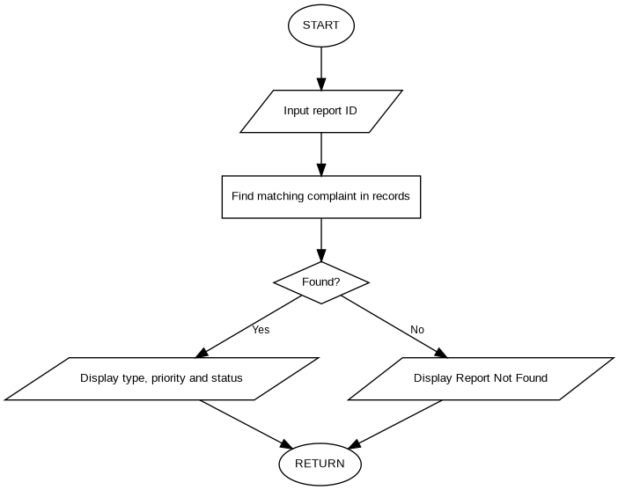
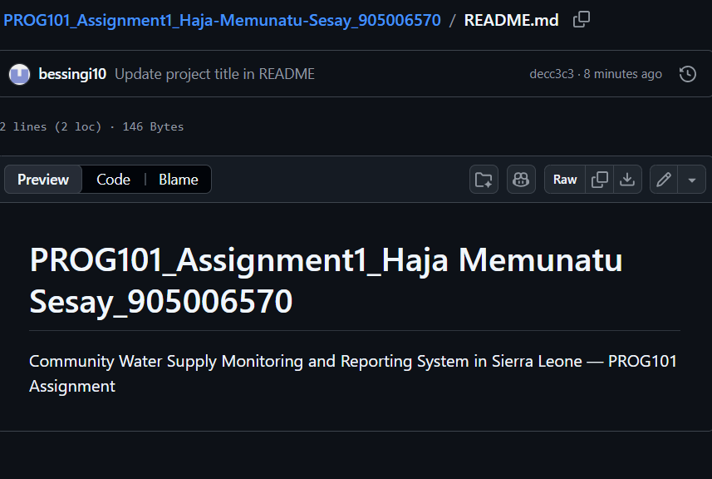
Source: project flowchart created for this assignment; editable diagram available in the accompanying .drawio file.

Figure 6. Authorized status update
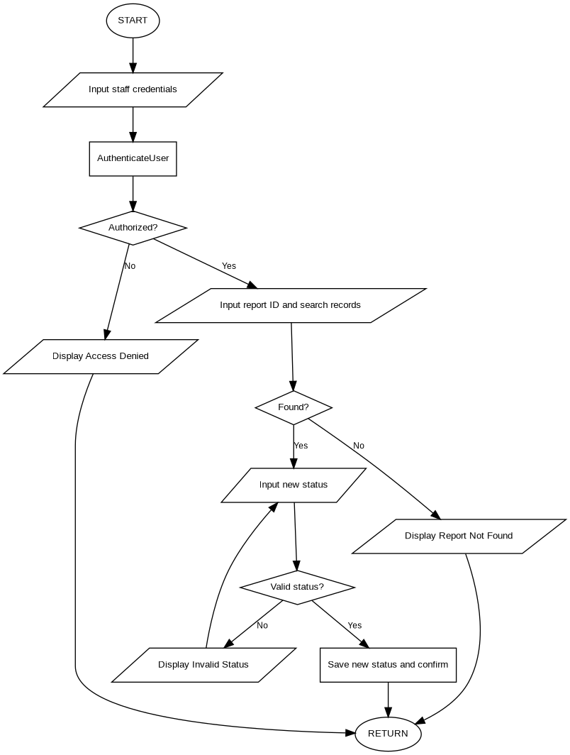
Source: project flowchart created for this assignment; editable diagram available in the accompanying .drawio file.

Figure 7. Complaint summary
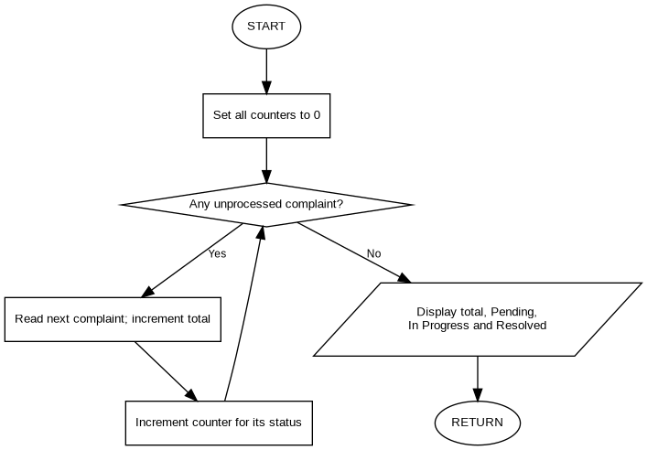
Source: project flowchart created for this assignment; editable diagram available in the accompanying .drawio file.

6. LOGICAL DESIGN

6.1 Sequence, Selection and Iteration
Sequential steps capture data, validate it, assign priority and save a record. Selection branches distinguish valid and invalid inputs, three priority levels, found and missing IDs, and authorized and unauthorized staff. Iteration repeats the menu and invalid-entry prompts and scans records for lookup and summaries.

6.2 Operators and Boolean Conditions
Category | Example | Purpose
Arithmetic | reportCount + 1 | Generate sequential ID suffix
Relational | severity < 1; severity > 3 | Reject out-of-range ratings
AND | name not empty AND location not empty | Require multiple fields
OR | severity < 1 OR severity > 3 | Detect invalid range
NOT | NOT authorized | Deny unauthorized update

6.3 Modular Responsibilities
Module | Responsibility
MainMenu() | Show available operations
SubmitComplaint() | Collect, validate, prioritize and save a report
ValidateInput() | Check nonempty text and integer severity in 1–3
AssignPriority() | Return High, Medium or Low
CheckStatus() | Find report by ID and display its status
UpdateStatus() | Authorize user and validate a status change
GenerateSummary() | Count complaint records by status
AuthenticateUser() (support) | Represent proposed staff verification

6.4 Design Assumptions and Limitations
The complaint list and counter are conceptual in-memory records. Persistence between sessions, concurrent ID generation and actual credential storage would require additional implementation decisions. The sample authentication function assumes a future authorized-user store and secure password verification. Personal data should not be published in the public repository.

7. SDG, OPEN SOURCE AND DIGITAL PUBLIC GOODS

7.1 Sustainable Development Goal 6
The project aligns with SDG 6: Clean Water and Sanitation by proposing a structured way to report and monitor water service faults. It does not itself supply or purify water; its potential contribution is improved documentation, prioritization, follow-up and accountability.

7.2 Open Source Rationale
Publishing future implementation code under an appropriate open-source license could support local adaptation, peer review, student learning and collaborative maintenance. Open-source software can reduce license barriers but still incurs hosting, training and support costs. No software license is claimed for an implementation that has not yet been built.

7.3 Digital Public Goods
The design could be developed toward a Digital Public Good through appropriate licensing, public documentation, privacy protection, accessibility, open standards and demonstrable contribution to sustainable development. It is not currently a certified or registered Digital Public Good.

7.4 Community Impact, Accessibility and Sustainability
Potential beneficiaries include residents, community leaders, water maintenance teams and local authorities. Future accessibility considerations include mobile-friendly design, low-bandwidth support, plain-language instructions and local-language options. Key risks include limited connectivity, digital literacy, staffing, funding and privacy; these require mitigation in any future implementation.
Source verification: The system aligns most directly with SDG 6 targets 6.1 and 6.b, which address drinking-water access and community participation (United Nations, n.d.). Open-source status requires a suitable license rather than public visibility alone (Open Source Initiative, 2024). Recognition as a Digital Public Good requires assessment against the DPG Standard and has not been claimed for this concept (Digital Public Goods Alliance, n.d.).

8. GITHUB REPOSITORY AND VERSION CONTROL
A public GitHub repository was created to document the proposed solution, store the design artifacts and record version-control changes. The screenshots below were captured from the actual GitHub interface on 29 October 2026. The repository and commit history constitute evidence of the uploaded design materials, not of a working software implementation.
Repository: PROG101_Assignment1_Haja-Memunatu-Sesay_905006570
Account shown: bessingi10 | Branch: main | Visibility: Public | Recorded commits: 3
Figure 8.1. Public repository homepage and project description
Figure 8.2. Repository project folder structure
Figure 8.3. Three verified Git commits
Figure 8.4. Root README.md displayed on GitHub
The root README shown in Figure 8.4 is brief; the project folder contains a separate README.md with further documentation. Repository evidence should be rechecked before submission if files or commit history change.

9. LOGICAL TEST SCENARIOS AND EXPECTED OUTPUTS
The following test cases evaluate the expected behavior of the algorithm and pseudocode. They are logical walkthroughs, not tests performed on executable software. WSR0001 assumes the report counter begins at zero.
ID | Scenario | Example input | Expected output
TC01 | Valid complaint | Name: Mohamed Kamara; Wellington; severity 3 | WSR0001; High; Pending
TC02 | Missing required field | Blank resident name | Validation error; retry
TC03 | Severity out of range | 4 | Validation error; retry
TC04 | Non-numeric severity | High | Validation error; retry
TC05 | Low priority | Severity 1 | Low
TC06 | Medium priority | Severity 2 | Medium
TC07 | High priority | Severity 3 | High
TC08 | Existing report | WSR0001 | Matching complaint details
TC09 | Unknown report | WSR9999 | Report Not Found
TC10 | Unauthorized update | Invalid staff credentials | Access Denied
TC11 | Authorized update | WSR0001 → Resolved | Status Updated Successfully
TC12 | Invalid status | Completed | Invalid Status; retry
TC13 | Complaint summary | 5 records: 2 Pending, 1 In Progress, 2 Resolved | Total 5; Pending 2; In Progress 1; Resolved 2
TC14 | Invalid menu choice | 8 | Invalid Selection; return to menu
TC15 | Exit | Menu option 5 | Goodbye; terminate
Sample output — complaint submission: Report ID WSR0001; Priority High; Status Pending. Sample output — complaint summary: Total Complaints 5; Pending 2; In Progress 1; Resolved 2. These are illustrative results dependent on the assumed sample data.

10. DISCUSSION, RECOMMENDATIONS AND FUTURE WORK

10.1 Interpretation of the Design
The principal strength of the proposed system is its traceable complaint workflow: each valid report receives an identifier, severity is mapped to a consistent priority category, and subsequent enquiries use the identifier to retrieve status. Modular decomposition separates validation, prioritisation, authentication, searching and summary calculation, which makes the design easier to explain and review. The design is suitable as a programming-logic exercise but does not demonstrate real-world effectiveness.

10.2 Ethical and Operational Considerations
A future application would handle names, locations and possibly contact details. Its implementation should therefore minimise personal data collection, define access permissions, secure stored records and document retention rules. Staff authorisation and password verification are design assumptions only. Public access to the repository should not expose real resident records or passwords.

10.3 Recommendations for Implementation
Future development should introduce a persistent database; secure role-based authentication; a collision-resistant identifier strategy for multiple simultaneous users; input normalisation; status-change timestamps; accessible mobile-friendly forms; and audit logs. A pilot with local stakeholders would be required to evaluate usability, reporting completeness and practical response times. Such development would need appropriate governance and maintenance resources.

11. CONCLUSION
The proposed Community Water Supply Monitoring and Reporting System demonstrates decomposition, abstraction, sequence, selection, iteration, validation and modular design. Its algorithm, pseudocode, flowcharts and expected outputs describe a structured approach to recording and tracking community water complaints. The design supports the public-interest aims of SDG 6, while implementation, deployment, security validation and DPG recognition remain future work.

12. REFERENCES
Digital Public Goods Alliance (n.d.) Digital Public Goods Standard. Available at: https://www.digitalpublicgoods.net/standard (Accessed: 29 October 2026).
GitHub (n.d.) About commits. Available at: https://docs.github.com/en/pull-requests/committing-changes-to-your-project/creating-and-editing-commits/about-commits (Accessed: 29 October 2026).
Limkokwing University Sierra Leone (2026) PROG101: Designing Logical Solutions for Sierra Leone Community Challenges. Unpublished course assignment brief.
Open Source Initiative (2024) The Open Source Definition. Available at: https://opensource.org/osd (Accessed: 29 October 2026).
United Nations (n.d.) Goal 6: Ensure availability and sustainable management of water and sanitation for all. Available at: https://sdgs.un.org/goals/goal6 (Accessed: 29 October 2026).

