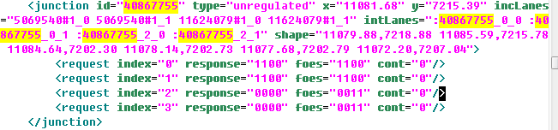

Internal lane 40867755_0_0

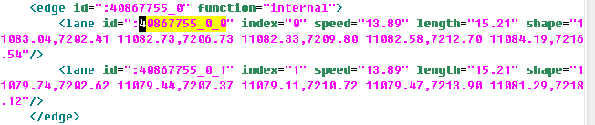

connections

