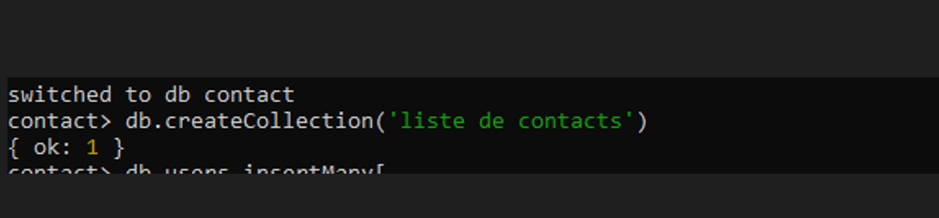

* Insert these documents in "contactlist" :

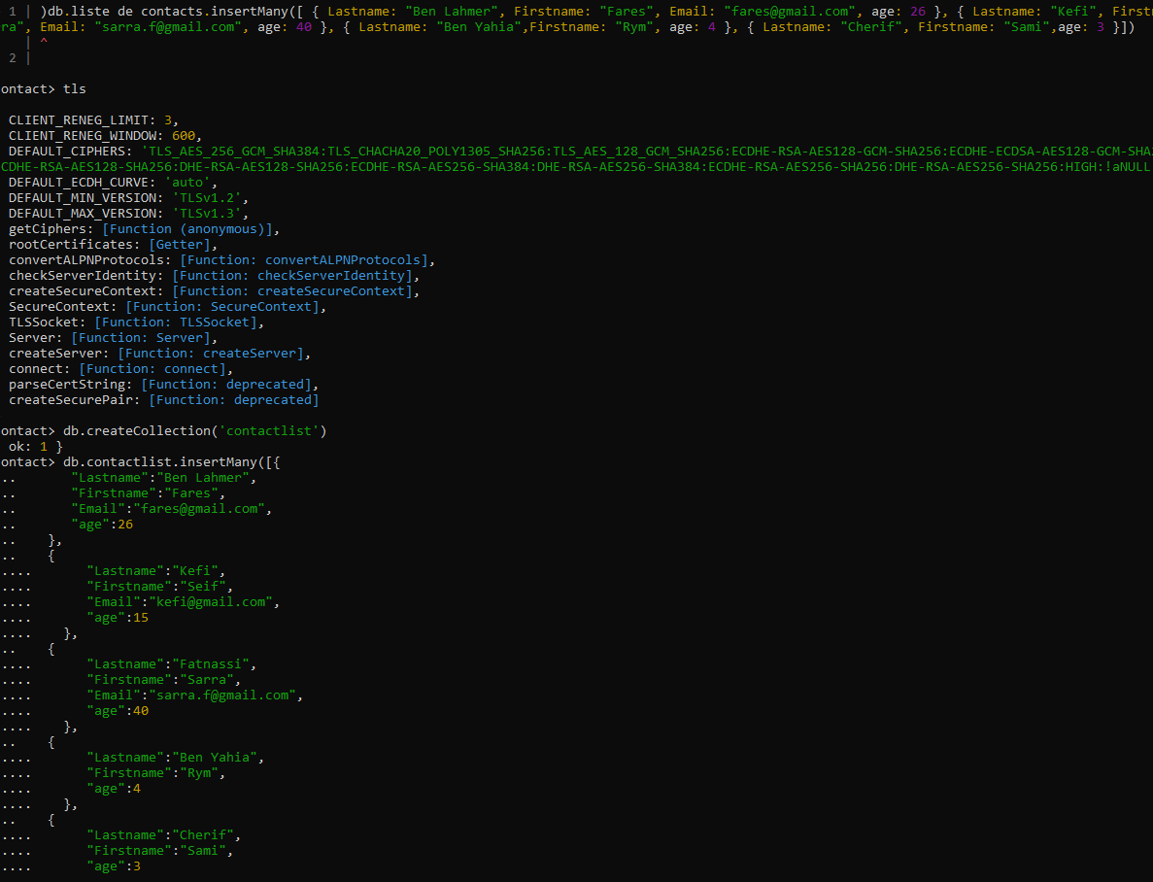

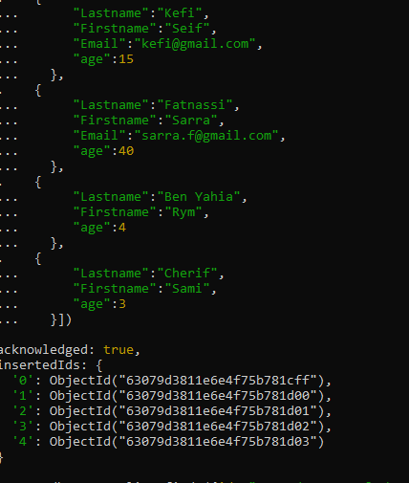

* Display all the information about only one person using his ID.

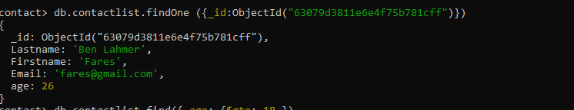

* Display all the contacts with an age>18 and name containing "ah"

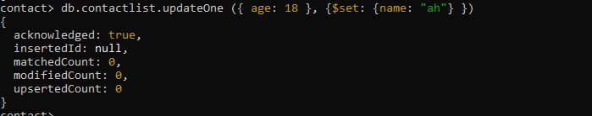

* Change the contact's first name from"Kefi Seif" to "Kefi Anis".
* Delete the contacts that are aged under <18.

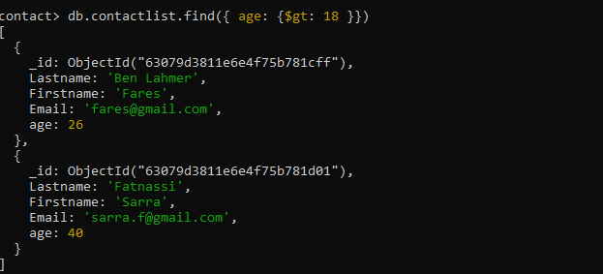

* Display all of the contacts list.

