Generation of Chess Variants
Cell-DEVS Model

Authors: Hajar Assim 101232456, Hasib Khodayar 101225523
Course Name: SYSC 5104/4906 – Methodologies for Discrete Event Modelling and Simulation
Instructor: Dr. Gabriel Wainer
Date Submitted: March 24, 2026

GitHub URL: https://github.com/hajar-assim/GenerationOfChessVariants/tree/main

Table of Contents

Table of Contents 2
1. Introduction 3
2. Background 3
2.1 Overview of the Original CD++ Model 3
3. Model Design Modifications and Extensions 4
3.1 Extended Neighbourhood Scenarios 4
3.2 Experimental Configurations 4
4. Design Specification 5
4.1 Cell State and Initial Values 5
4.2 Transition Rules 5
5. Model Structure and Coupling Scheme 6
5.1 Atomic Cell-DEVS 6
5.2 Coupled Cell-DEVS 8
6. Cadmium v2 Implementation 9
6.1 Project Structure 9
6.2 Source File Descriptions 9
chessVariantState.hpp 9
chessVariantCell.hpp 9
main.cpp 9
6.3 JSON Configuration Format 10
6.4 Build and Execution Instructions 10
7. Simulation Results and Analysis 12
7.1 Baseline Scenario Results 12
7.2 Experimental Variation Results (Moore Neighbourhood) 14
7.3 Chess-Piece Neighbourhood Results 15
Rook Neighbourhood - Complete Extinction 15
Bishop Neighbourhood - Corner Stability and Near-Extinction 16
Knight Neighbourhood - Fixed Point and Rich Patterns 16
Multi-Piece Hybrid - Heterogeneous Topology 17
Key Finding: Neighbourhood Size Determines Viability 17
7.4 Visualization 18
8. Conclusion 19
9. References 20

1. Introduction

This report documents the re-implementation of the Generation of Chess Variants cellular automaton model using the Cadmium v2 Cell-DEVS simulation framework, submitted as Assignment 2 for SYSC 5104.
The original model was implemented in CD++ and generates chess-like spatial patterns by applying a modified Game-of-Life rule set to a two-dimensional grid. The core rule, B23/S23 (a cell is alive if exactly 2 or 3 of its neighbours are alive), produces distinctive interlocking patterns from small seed configurations. This assignment re-specifies the model formally using the TDC and GCC formalisms, re-implements it in Cadmium v2, and extends it with ten additional scenarios.
As a two-person team submission, the extensions explore two directions. The first group varies initial conditions, grid size, and boundary conditions while keeping the standard Moore neighbourhood. The second group, which constitutes the primary contribution of this assignment, substitutes chess-piece-specific movement patterns as the neighbourhood definition, replacing the Moore neighbourhood with bishop, rook, knight, and multi-piece topologies. The results reveal a fundamental insight about the relationship between neighbourhood structure and the viability of the B23/S23 rule.

2. Background

2.1 Overview of the Original CD++ Model
The Generation of Chess Variants model was originally developed by Mikael Fridenfalk (2017) and implemented using the CD++ Cell-DEVS simulator at Carleton University. The model is a two-dimensional cellular automaton that applies a variant of Conway's Game of Life rules to a grid, using the Moore neighbourhood (all 8 surrounding cells plus self). Starting from small seed configurations of live cells, the automaton generates evolving patterns that stabilize into chess-board-like arrangements.
The original CD++ implementation defines the transition rules using the trueCount macro, which counts the number of non-zero cells across the full 9-cell neighbourhood including the cell itself:
rule : 1 100 { (0,0) = 1 and ( trueCount = 3 or trueCount = 4 ) }
rule : 1 100 { (0,0) = 0 and ( trueCount = 2 or trueCount = 3 ) }
rule : 0 100 { t }

Because trueCount includes the cell's own state, these thresholds translate to an effective rule of B23/S23 once self is subtracted: a cell is alive in the next generation if and only if exactly 2 or 3 of its 8 surrounding neighbours are alive. This is distinct from standard Conway's Game of Life (B3/S23); the additional birth condition with 2 neighbours produces the denser, more symmetric chess-like patterns.
The model was retrieved from the course model repository maintained by Dr. Gabriel Wainer's ARSLab group at Carleton University [1].

3. Model Design Modifications and Extensions

The Cadmium v2 implementation preserves all parameters from the original CD++ model and adds two groups of extensions appropriate for a two-person team submission as shown in the assignment instructions.

3.1 Extended Neighbourhood Scenarios
The primary contribution of this assignment is the introduction of chess-piece-specific neighbourhood topologies as a replacement for the standard Moore neighbourhood. While the B23/S23 transition rule is held constant, the neighbourhood N is changed to reflect the movement pattern of each chess piece:
- Knight neighbourhood: The 8 L-shaped moves of a chess knight, plus self (η = 9). This matches the Moore neighbourhood in size, making it the most likely to support viable patterns.
- Bishop neighbourhood: All diagonal squares reachable by a bishop from the cell's position, up to the grid boundary. On an 8×8 non-wrapped grid this gives up to 28 diagonal neighbours plus self (η ≤ 29).
- Rook neighbourhood: The entire row and column, representing all orthogonal squares reachable by a rook. On an 8×8 grid: 7 cells in each of 4 directions plus self (η = 29).
- Multi-piece hybrid: A heterogeneous grid where different cells use different neighbourhoods simultaneously, with designated zones for bishop movement and a default knight movement.

3.2 Experimental Configurations
In addition to the chess-piece neighbourhood extensions, four Moore-neighbourhood experimental variations were introduced to study the sensitivity of the model to initial conditions, boundary conditions, and grid size:
- Glider seed: Tests whether a classic Game of Life glider seed translates under B23/S23 rules.
- Horizontal line seed: Studies evolution from a linear 7-cell initial configuration.
- Non-wrapped boundary: Compares bounded vs. toroidal boundary effects on the same Kernel 1 seed.
- Large grid (20×20): Allows unconstrained expansion before wrap-around interaction occurs.

4. Design Specification

4.1 Cell State and Initial Values
Each cell holds a single integer state value representing its alive/dead status. The configuration JSON files specify the initial state for each scenario by defining a default state and a cell map of positions that override the default.
Field | Values | Description
alive | 0 or 1 | Cell state: 0 = dead/inactive, 1 = alive/active. Default value is 0 for all cells unless overridden by the seed configuration.

All cells begin with alive = 0 except for the seed positions defined in the cell_map section of the JSON configuration file. The seed configurations for each of the 14 scenarios are given in Table 4 in Section 5.

4.2 Transition Rules
The local transition function τ is uniform across all scenarios. Let N_alive denote the number of cells with state 1 among the cell's neighbours, excluding the cell itself:
Rule | Condition | Outcome
Survival | N_alive = 2 or N_alive = 3 | Live cell remains alive in the next generation
Birth | N_alive = 2 or N_alive = 3 | Dead cell becomes alive in the next generation
Death / Stay Dead | N_alive < 2 or N_alive > 3 | Cell is dead in the next generation

This corresponds to rule notation B23/S23. The survival and birth conditions are identical, so the rule simplifies to: a cell is alive if and only if exactly 2 or 3 of its neighbours are alive, regardless of its current state.
What changes across scenarios is the neighbourhood N, the set of cells that qualify as neighbours. For Moore-neighbourhood scenarios, N consists of the 8 surrounding cells. For chess-piece scenarios, N is defined by the movement pattern of the respective piece. The same τ function is applied in all cases.
NOTE: on trueCount in the original CD++ model: the original .ma rules use trueCount, which counts alive cells including the cell itself. The thresholds of 3/4 (alive cell) and 2/3 (dead cell) translate to N_alive = 2 or 3 once self is subtracted. The Cadmium implementation correctly performs this subtraction in localComputation().

5. Model Structure and Coupling Scheme

The system consists of one atomic model (the cell) and one coupled model (the grid). This section defines both following the Cell-DEVS formalism.

5.1 Atomic Cell-DEVS
TDC = ⟨ X, Y, S, θ, I, N, d, τ, δint, δext, λ, D ⟩

X (Input Set):
- X = {0, 1}. Each input event is the state value broadcast by a neighbouring cell: 0 (dead) or 1 (alive).
Y (Output Set):
- Y = {0, 1}. Each output event is the cell's current state value, broadcast to all neighbouring cells.
S (State Set):
- S = {0, 1}. The cell's current state (dead or alive).
θ (State Variable Definition):
- θ = { (s, phase, squeue, σ) } where:
  - s ∈ S: current state value
  - phase ∈ {active, passive}: whether the cell has a pending output
  - squeue: ordered queue of (value, time) pairs for scheduled outputs (transport delay)
  - σ ∈ R₀⁺ ∪ {∞}: time remaining until the next internal transition
  - Initial state: s = 0 (or 1 for seed cells), phase = passive, squeue = empty, σ = ∞.
I (Modular Interface)
- I = ⟨ η, Px, Py ⟩ where η = 9 for Moore and knight neighbourhoods (including self); η ≤ 29 for bishop and rook neighbourhoods on 8×8 grids. m = 0 (no additional ports beyond neighbourhood ports).
N (Neighbourhood):
- N varies by scenario group:

Neighbourhood Type | η | Neighbour Offsets
Moore (baseline) | 9 | {(−1,−1),(−1,0),(−1,1),(0,−1),(0,0),(0,1),(1,−1),(1,0),(1,1)}
Knight | 9 | {(0,0),(−2,−1),(−2,1),(−1,−2),(−1,2),(1,−2),(1,2),(2,−1),(2,1)}
Bishop (8×8) | ≤29 | {(0,0),(−1,−1),(−1,1),(1,−1),(1,1),(−2,−2),(−2,2),(2,−2),(2,2),...,(±7,±7)}
Rook (8×8) | 29 | {(0,0),(−1,0),(−2,0),...,(−7,0),(1,0),...,(7,0),(0,−1),(0,−2),...,(0,−7),(0,1),...,(0,7)}

d (Delay):
- d = 1.0 time unit (transport delay).
- This is a rescaling of the original CD++ delay of 100 time units; each generation takes exactly one delay period. Transport delay means all scheduled state changes are queued and delivered in order with no preemption.
τ (Local Computing Function):
- See Section 4.2. τ(s, N) = 1 if N_alive ∈ {2, 3}, else 0.
- Applied uniformly across all neighbourhood types.
δint (Internal Transition Function):
- Fires when σ expires. Pops the head of squeue and sends it via the output function λ. Updates σ to the time of the next queued event.
- If squeue is empty, the cell enters passive phase with σ = ∞.
δext (External Transition Function):
- Fires when an input arrives from a neighbour. Updates the stored neighbour states in N.
- Computes new_state = τ(s, N). If new_state ≠ s, schedules the output (new_state, clock + d) in squeue and enters active phase.
λ (Output Function):
- λ(s) = s. Broadcasts the cell's current state to all coupled neighbour input ports when the internal transition fires.
D (Duration Function):
- D(s) = 1.0 for all s.
- Constant transport delay; all states have equal lifetime.

5.2 Coupled Cell-DEVS
GCC = ⟨ Xlist, Ylist, I, X, Y, n, {t₁, t₂}, η, N, C, B, Z, select ⟩

Parameter | Value
Xlist = Ylist | {}, No external input or output ports. The model is self-contained.
X = Y | {0, 1}, Binary state alphabet.
n | 2, Two-dimensional cell space.
{t₁, t₂} | Varies by scenario: {9,13} (baseline), {7,7}, {5,9}, {20,20}, {8,8}. See Table 4.
C | {Cᵢᵠ | i ∈ [0, t₁−1], j ∈ [0, t₂−1]}, Full set of atomic TDC instances, one per grid cell.
B | {} (wrapped/toroidal) for most scenarios; fixed edge for non-wrapped and 8×8 chess-piece scenarios. Wrapped: B = {}, top connects to bottom, left connects to right. Non-wrapped: edge cells have truncated neighbourhoods.
Z | Z(Pᵢᵠʸᵱ) = Pₖₗˣᵱ where k = (i+r) mod t₁, l = (j+s) mod t₂ for (r,s) ∈ N. Standard auto-coupling; each cell's output is routed to the input ports of all cells in its neighbourhood.
select | Standard tie-breaking function for simultaneous imminent events.

The following table defines the scenario-specific parameters for all 14 configurations:
Scenario | Grid {t₁,t₂} | Wrapped | Initial Seed
Kernel 1 | {9,13} | Yes | Plus shape: (3,6),(4,5),(4,6),(4,7),(5,6)
Kernel 2 | {9,13} | Yes | Asymmetric cluster: (3,6),(3,7),(4,5),(4,6),(4,7),(5,5),(5,6)
Kernel 1 Small Grid | {7,7} | Yes | Plus centred: (2,3),(3,2),(3,3),(3,4),(4,3)
Kernel 2 Small Grid | {5,9} | Yes | Asymmetric: (1,4),(1,5),(2,3),(2,4),(2,5),(3,3),(3,4)
Glider Seed | {9,13} | Yes | Classic glider: (0,1),(1,2),(2,0),(2,1),(2,2)
Horizontal Line | {9,13} | Yes | 7-cell line in row 4: (4,3) through (4,9)
No-Wrap Boundary | {9,13} | No | Plus shape (same as Kernel 1): (3,6),(4,5),(4,6),(4,7),(5,6)
Large Grid | {20,20} | Yes | Plus centred at (8–10): (8,10),(9,9),(9,10),(9,11),(10,10)
Bishop 8×8 | {8,8} | No | Diagonal cluster: (2,2),(3,3),(4,4),(5,5),(3,5),(5,3)
Bishop 9×13 | {9,13} | Yes | Plus shape (same as Kernel 1): (3,6),(4,5),(4,6),(4,7),(5,6)
Rook 8×8 | {8,8} | No | Dense cluster: (3,2),(3,3),(3,4),(3,5),(4,3),(4,4),(5,3)
Knight 8×8 | {8,8} | No | 2×2 block: (3,3),(3,4),(4,3),(4,4)
Knight 9×13 | {9,13} | Yes | Plus shape (same as Kernel 1): (3,6),(4,5),(4,6),(4,7),(5,6)
Multi-piece 8×8 | {8,8} | No | Knight seed: (3,3),(3,4),(4,3),(4,4). Bishop seeds: (0,1),(0,5),(7,0),(7,6)

6. Cadmium v2 Implementation

6.1 Project Structure
The implementation follows the same structure as the reference Conway's Game of Life Cell-DEVS example provided in the course material. The project is organized as follows:

chess-variants-celldevs/
├── CMakeLists.txt Top-level CMake configuration
├── build_sim.sh Build script (produces bin/chess_variant)
├── main/
│ ├── CMakeLists.txt
│ ├── main.cpp Simulation driver
│ └── include/
│ ├── chessVariantState.hpp Cell state
│ └── chessVariantCell.hpp Transition function (τ)
├── config/ 14 JSON scenario files
├── scripts/ Shell scripts for each scenario
└── logs/ Output CSV logs (generated at runtime)

6.2 Source File Descriptions

chessVariantState.hpp
Defines the ChessVariantState struct, the cell state type consumed by the Cadmium Cell-DEVS framework. Contains a single integer field alive (0 or 1) and implements the three interfaces required by the framework: operator!= for change detection (used by the framework to determine whether a cell needs to broadcast), operator<< for CSV log output (outputs in <N> format), and from_json() for parsing initial cell states from the JSON configuration file.

chessVariantCell.hpp
Defines ChessVariantCell, which inherits from GridCell<ChessVariantState, double>. Implements the two methods required by the Cadmium Cell-DEVS framework:
- localComputation(state, neighborhood): Implements τ. Iterates over all entries in the neighborhood map (which includes the cell's own position), counts alive cells, subtracts the cell's own state to obtain N_alive, and returns alive = 1 if N_alive ∈ {2, 3}, else 0. The self-subtraction is required because Cadmium's GridCell passes the cell's own state as part of the neighbourhood map.
- outputDelay(state): Returns 1.0, specifying the fixed transport delay per generation. This is a rescaling of the original CD++ delay of 100 time units.

main.cpp
The simulation driver. Accepts a JSON configuration file path and an optional simulation time from the command line, constructs a GridCellDEVSCoupled model using the addGridCell factory function (which maps the model name "chessVariant" to ChessVariantCell), attaches a CSVLogger, and runs via RootCoordinator. Output is written to simulation_results/<config_name>_output.csv.

6.3 JSON Configuration Format
Each of the 14 scenarios is defined by a JSON file specifying the Cell-DEVS grid parameters, initial cell states, neighbourhood definition, and visualisation colour mapping. The schema follows the Cadmium v2 Grid Cell-DEVS format:

{
"scenario": {
"shape": [9, 13], // {t1, t2} - grid dimensions [rows, cols]
"origin": [0, 0],
"wrapped": true // toroidal boundary (B = {})
},
"cells": {
"default": {
"delay": "transport", // transport delay
"model": "chessVariant",
"state": { "alive": 0 }, // default initial state
"neighborhood": [{ "type": "moore", "range": 1 }]
},
"seed_pattern": { // overrides for live seed cells
"state": { "alive": 1 },
"cell_map": [[3,6],[4,5],[4,6],[4,7],[5,6]]
}
},
"viewer": [{"colors":[[255,255,255],[0,0,0]],
"breaks":[0,0.5,1],"field":"alive"}]
}

For chess-piece-neighbourhood scenarios, the neighbourhood section uses a "relative" type with explicit offset coordinates instead of "moore":
"neighborhood": [{
"type": "relative",
"neighbors": [[0,0],[-2,-1],[-2,1],[-1,-2],[-1,2],[1,-2],[1,2],[2,-1],[2,1]]
}]

6.4 Build and Execution Instructions
Prerequisites: C++ compiler with C++20 support (g++ 11+ or clang++ 14+), CMake 3.16+, Cadmium v2 with the CADMIUM environment variable pointing to the cadmium_v2/include/cadmium directory.

# 1. Set Cadmium path
export CADMIUM=/path/to/cadmium_v2/include/cadmium

# 2. Build
bash build_sim.sh

# 3. Run a single scenario (example: Kernel 1, 60 generations)
./bin/chess_variant config/chessVariantKernel1.json 60

# 4. Run all 14 scenarios
bash scripts/run_all_scenarios.sh

Output CSV files are written to simulation_results/<scenario_name>_grid_log.csv. Individual run scripts for each scenario are provided in the scripts/ directory. The CSV format is compatible with the Cell-DEVS Web Viewer at https://devssim.carleton.ca/cell-devs-viewer/.

7. Simulation Results and Analysis

All 14 scenarios were executed for 60 time steps (60 generations). The simulation output CSV files are located in simulation_results/ and were uploaded to the Cell-DEVS Web Viewer for visual analysis. Video recordings of all scenarios are included in the submission repository.

7.1 Baseline Scenario Results
The four baseline scenarios faithfully reproduce the behaviour of the original CD++ model. All four sustain active populations across the full 60-generation simulation.
Scenario | Grid | Seed | Gen 1 | Gen 60 | Behaviour
Kernel 1 | {9,13} | 5 | 8 | 52 | Symmetric expansion from plus seed; oscillating chess-like pattern forms across wrapped grid
Kernel 2 | {9,13} | 7 | 12 | 12 | Asymmetric growth; peak of ~50 cells around generation 3 followed by die-back and oscillation
Kernel 1 Small | {7,7} | 5 | 8 | 24 | Rapid wrap-around interaction within first few generations; dense oscillating end state
Kernel 2 Small | {5,9} | 7 | 12 | 10 | Small grid reaches saturation quickly; sparse oscillating end state


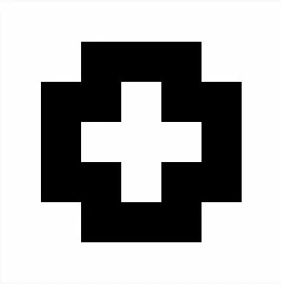


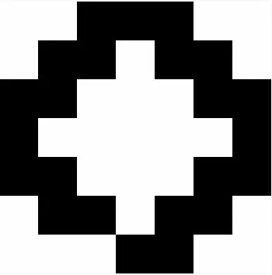
Kernel 1 confirms the characteristic chess-variant behaviour of the original model: the symmetric plus seed expands outward in a diamond-like wavefront and, upon wrapping, interacts with itself to produce the interlocking grid pattern the model is named for. Kernel 2 demonstrates that asymmetric seeds produce more complex trajectories with an early population peak, reflecting the unequal neighbour counts on each side of the asymmetric initial configuration. The small-grid variants show how reduced grid size accelerates wrap-around interaction and compresses the pattern dynamics into fewer generations.



Figure 1: Kernel 1 Small Grid (7×7) evolution in Cadmium v2 (DEVS Web viewer steps 0 - 4) (top) compared with the original results from Fridenfalk (bottom, Figure 8). The patterns match, confirming faithful reproduction of the B23/S23 rule.
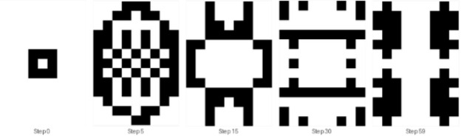

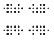
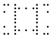
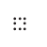
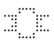

Figure 2: Kernel 1 (9×13) evolution showing the chess-like checkerboard pattern forming from the plus seed. The symmetric expansion and wrap-around interaction produce the interlocking pattern characteristic of this model. Top image from Cadmium implementation viewed using the Cell-DEVS Web Viewer. Bottom image is taken from Fridenfalk's paper (Figure 10) showing the same 9-row by 13-column grid at the relevant generation steps, noted as 13×9 using width×height convention. Notice the similarity.

7.2 Experimental Variation Results (Moore Neighbourhood)
Scenario | Grid | Seed | Gen 1 | Gen 60 | Behaviour
Glider Seed | {9,13} | 5 | 10 | 40 | Glider does not translate; expands aggressively from gen 1 under B23/S23 birth rule
Horizontal Line | {9,13} | 7 | 19 | 25 | Vertical expansion in gen 1 forms rectangular block; evolves to oscillating structure
No-Wrap | {9,13} | 5 | 8 | 50 | Similar to Kernel 1 but contained; boundary cells have fewer neighbours reducing edge births
Large Grid | {20,20} | 5 | 8 | 132 | Unconstrained free expansion; largest population count; reveals natural B23/S23 growth shape

The glider experiment confirms that B23/S23 does not support translating structures from standard Game of Life. Under B3/S23 (Conway), the birth threshold of exactly 3 enables the glider's asymmetric propagation. Under B23/S23, the broader birth condition with 2 neighbours causes the glider seed to expand symmetrically from generation 1, reaching 10 live cells immediately and growing to 40 by generation 59.
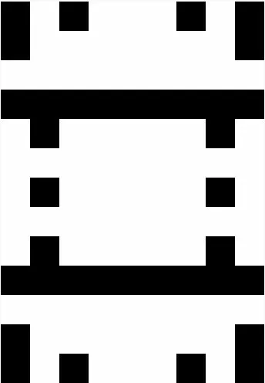
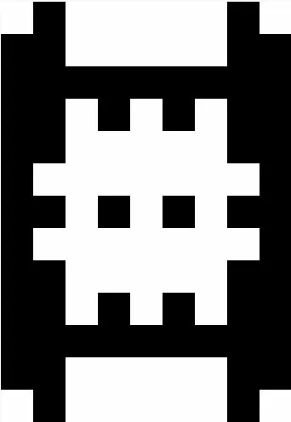
The non-wrapped vs. large grid comparison isolates two distinct effects: boundary conditions and available space. The non-wrapped 9×13 grid (50 cells at generation 59) produces slightly fewer live cells than the wrapped version (52 cells) because border cells have truncated neighbourhoods, reducing birth rates at edges. The 20×20 large grid (132 cells at generation 59) shows the natural unconstrained growth of B23/S23, expanding outward for 8–10 generations before wrap-around interaction occurs.

Figure 3: Wrapped (left) vs non-wrapped (right) boundary at generation 30. The non-wrapped grid shows truncated growth at edges due to reduced neighbour counts at boundaries.

7.3 Chess-Piece Neighbourhood Results
The chess-piece neighbourhood scenarios are the primary extension of this assignment. They demonstrate that the B23/S23 rule is not neighbourhood-agnostic: its viability depends critically on the size and topology of the neighbourhood.

Scenario | Grid | η | Gen 1 | Gen 60 | Outcome
Rook 8×8 | {8,8} | 29 | 26 | 0 | EXTINCT at generation 2. Rook neighbourhood too large for B23/S23.
Bishop 8×8 | {8,8} | ≤29 | 15 | 4 | Stable at 4 corner cells; simulation halts (quiescent) after generation 2.
Bishop 9×13 | {9,13} | ≤29 | 32 | 2 | Near-extinct; oscillates near 0 cells; 2 alive at generation 59.
Knight 8×8 | {8,8} | 9 | 4 | 4 | Perfect stability; 2×2 seed is a fixed point. Unchanged for all 60 generations.
Knight 9×13 | {9,13} | 9 | 24 | 48 | Sustained active growth; rich oscillating patterns comparable to Moore scenarios.
Multi-piece 8×8 | {8,8} | Mixed | 12 | 31 | Sustained activity throughout; complex interaction between knight and bishop zones.
NOTE: Simulation halts early (before generation 60) for the rook 8×8 and bishop 8×8 scenarios. This is correct Cell-DEVS behaviour: when all cells enter the passive phase (quiescent state), no further internal transitions are scheduled and the Cadmium root coordinator stops generating events. Early halt indicates global quiescence, not a simulation error.

Rook Neighbourhood - Complete Extinction
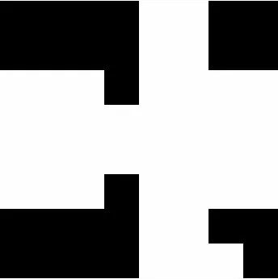
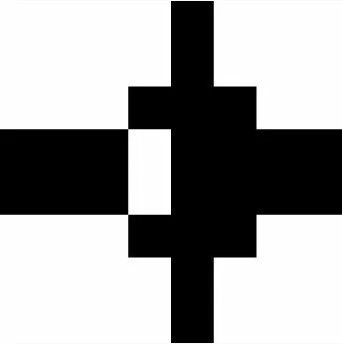

The rook neighbourhood on an 8×8 grid gives each cell up to 28 other cells as neighbours (entire row + column minus self). With up to 28 potential neighbours, the probability of any cell having exactly 2 or 3 alive neighbours is extremely low for any non-trivial configuration. Even as the 7-cell rook seed initially expands to 26 live cells in generation 1 through births at positions with 2–3 alive rook-neighbours, the density of the rook neighbourhood causes the population to collapse by generation 2. No configuration survives: the simulation correctly halts at generation 3 with 0 live cells.

Figure 4: Rook neighbourhood on 8×8 grid (Steps 0, 1, 2). The population expands in generation 1 but collapses to 0 by generation 2 due to the oversized neighbourhood (η = 29).

Bishop Neighbourhood - Corner Stability and Near-Extinction
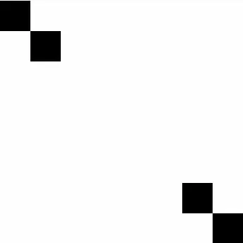
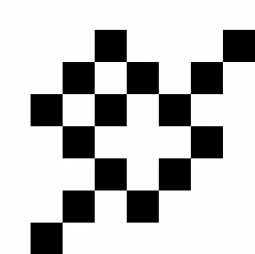
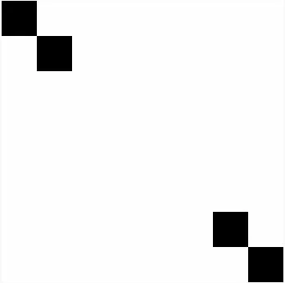
The bishop neighbourhood produces two distinct behaviours depending on boundary conditions. On the non-wrapped 8×8 grid, the simulation collapses to exactly 4 cells at positions (0,0), (1,1), (6,6), and (7,7) by generation 2, then becomes globally quiescent. These four corner cells form a self-sustaining fixed point: each has exactly 2 or 3 diagonal neighbours that are also alive, satisfying B23/S23 survival indefinitely.

Figure 5: Bishop neighbourhood on 8×8 grid (Steps 0, 1, 2). Only 4 corner cells survive as a stable fixed point.
On the wrapped 9×13 grid, the bishop neighbourhood (modified by toroidal wrapping) sustains slow oscillation but undergoes progressive decline, reaching only 2 live cells by generation 59. The toroidal geometry alters the diagonal reach of each cell and prevents the clean corner-collapse seen in the non-wrapped case, instead producing a near-extinct but not fully quiescent trajectory.

Knight Neighbourhood - Fixed Point and Rich Patterns
The knight neighbourhood (η = 9, matching the Moore neighbourhood size) is the only chess-piece topology that sustains behaviour comparable to the baseline scenarios. On the non-wrapped 8×8 grid, the 2×2 block seed is a perfect fixed point: each of the 4 cells has exactly 2 knight-reachable live neighbours within the block (since the block is too compact for the L-shaped offsets to reach outside it). The population remains exactly 4 cells across all 60 generations without change.
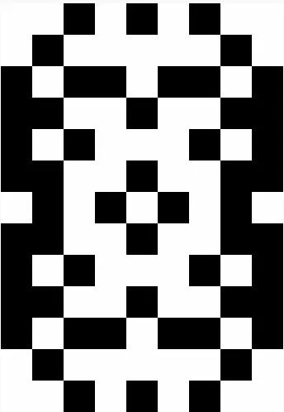

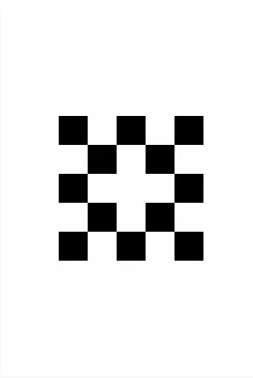
On the wrapped 9×13 grid with the larger Kernel 1 seed (5 cells), the knight neighbourhood with toroidal wrapping produces rich dynamics: the population grows from 5 to 24 in the first generation, reaches a peak of 60 cells by generation 3, and oscillates around 48 cells through generation 59. The oscillating patterns produced are visually distinct from Moore-neighbourhood patterns, the L-shaped neighbourhood creates non-contiguous sparse clusters rather than the solid block-like chess formations seen in the baseline scenarios.

Figure 6: Knight neighbourhood on 9×13 wrapped grid. The L-shaped topology produces sparse, non-contiguous clusters distinct from Moore neighbourhood patterns but sustains active dynamics across all 60 generations.

Multi-Piece Hybrid - Heterogeneous Topology
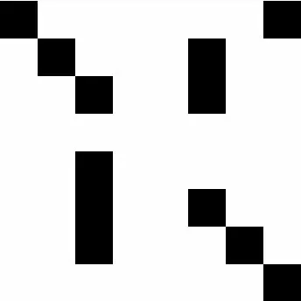
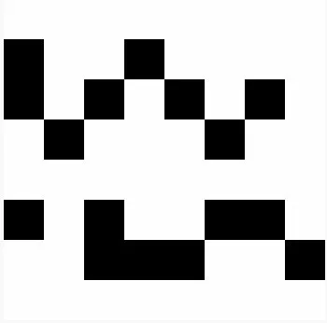
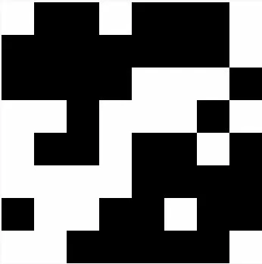
The multi-piece scenario assigns knight neighbourhood to most cells and bishop neighbourhood to designated diagonal-zone cells and bishop seed cells. The result is a sustained population of 31 alive cells at generation 59, with complex interactions between cells under different neighbourhood topologies. Cells in the bishop zone compute their next state from diagonal neighbours, while knight-zone cells compute from L-shaped neighbours, creating a topologically heterogeneous cellular automaton. This scenario demonstrates that the Cadmium v2 JSON configuration format supports per-cell neighbourhood assignment, enabling mixed-topology models that would be difficult to specify in CD++.

Figure X: Multi-piece hybrid with knight (default) and bishop zones on 8×8 grid. The heterogeneous topology produces complex interaction between the two neighbourhood types.

Key Finding: Neighbourhood Size Determines Viability
The results across all 14 scenarios support a single central finding: the B23/S23 rule is calibrated for a neighbourhood of approximately 8 cells. The Moore neighbourhood (η = 9 including self, 8 neighbours) and the knight neighbourhood (η = 9, 8 neighbours) both sustain active populations. The bishop and rook neighbourhoods (η ≤ 29, up to 28 neighbours) cause extinction or near-extinction because B23/S23 requires exactly 2 or 3 alive neighbours, a condition that is probabilistically rare when a cell can see up to 28 neighbours. This is a non-trivial empirical result that connects cellular automaton theory to chess piece movement patterns in a meaningful way.

7.4 Visualization
All 14 simulation output CSV files are compatible with the Cell-DEVS Web Viewer at https://devssim.carleton.ca/cell-devs-viewer/. Each JSON configuration includes a viewer section specifying a black-and-white colour mapping: dead cells (state 0) render white, alive cells (state 1) render black. This mapping makes it straightforward to observe the spatial patterns produced by each scenario.
To view a simulation in the Cell-DEVS Web Viewer:
- Upload the JSON configuration file (e.g., config/chessVariantKernel1_config.json)
- Upload the corresponding CSV output file (e.g., simulation_results/chessVariantKernel1_grid_log.csv)
- Step through generations or play the animation to observe pattern evolution

8. Conclusion

This assignment successfully re-implemented the Generation of Chess Variants Cell-DEVS model from the CD++ simulator to Cadmium v2, reproduced all four original baseline scenarios, and extended the model with ten additional scenarios in two groups.
The formal re-specification using the TDC and GCC formalisms identified and corrected a subtle issue in the original CD++ transition rules: the trueCount macro counts the cell itself, so the effective rule is B23/S23, not the B23/S34 that would result from a naive reading of the thresholds. The Cadmium implementation correctly accounts for this through the self-subtraction in localComputation().
The chess-piece neighbourhood extension, the primary contribution of the two-person team submission, produced a meaningful empirical finding: B23/S23 is viable only for neighbourhoods of approximately 8 cells. The rook neighbourhood (η = 29) causes complete extinction; the bishop neighbourhood causes near-extinction or corner-collapse; the knight neighbourhood (η = 9) sustains dynamics comparable to the Moore baseline. This result connects cellular automaton theory directly to chess piece movement topology in a way that was not explored in the original CD++ model.
The multi-piece heterogeneous scenario demonstrates that the Cadmium v2 JSON configuration format enables per-cell neighbourhood assignment, providing capabilities beyond what was possible in the original CD++ implementation.

9. References

[1] Wainer, G. (n.d.). Generation of Chess Variants (GenerationofChessVariants.zip). Cell-DEVS Model Samples, Department of Systems and Computer Engineering, Carleton University. Retrieved March 2026 from https://www.sce.carleton.ca/faculty/wainer/wbgraf/doku.php?id=model_samples:start
[2] Wainer, G. A. (2009). Discrete-Event Modeling and Simulation: A Practitioner's Approach. CRC Press.
[3] M. Fridenfalk, "Application of Cellular Automata for Generation of Chess Variants," Uppsala University Campus Gotland, Department of Game Design, 2013.

