Adaptive Density-Scaled Chess Variant Generation Using Cell-DEVS
Hajar Assim (101232456) Hasib Khodayar (101225523)
Department of Systems and Computer Engineering
Carleton University
1125 Colonel By Drive
Ottawa, ON. K1S-5B6 Canada
{hajarassim, hasibkhodayar}@cmail.carleton.ca

ABSTRACT: Fridenfalk's method for generating chess-variant game boards uses cellular automata governed by variants of Conway's Game of Life. The original Assignment 2 implementation applied fixed B23/S23-style rules (birth if exactly 2 or 3 neighbors are alive, survival under the same condition) on a Moore neighborhood. When the topology changes to a chess piece's actual movement pattern, the neighborhood size can jump from 8 (Moore) to 14 (rook) or 28 (queen), causing fixed thresholds to fail: patterns either die within a few generations or saturate the entire board. This project introduces adaptive density-scaled thresholds that express birth and survival conditions as fractions of the neighborhood size, so the same rule set produces sustained patterns regardless of topology. Building on this core contribution, we implement five Fridenfalk rules with density windows, asymmetric per-cell rule parameterization using Cadmium's AsymmCell formalism, chess-semantic line-of-sight blocking for sliding pieces, and a continuous-activity lifecycle model that visualizes temporal wavefront dynamics. All models are implemented in Cadmium v2 Cell-DEVS and validated through 85 scenario configurations producing 98 simulation logs. A post-processing pipeline computes accumulation grids and board-quality metrics (coverage, symmetry, connectivity, hole count) to evaluate each scenario quantitatively. The key finding is that adaptive density scaling resolves the topology-size limitation entirely for rook neighborhoods (0.031 coverage under fixed rules versus 0.875 under adaptive rules for the same seed), and enables all extensions that were previously infeasible under the rigid B23/S23 baseline.

1. Introduction
Fridenfalk proposed a method for procedurally generating chess-variant game boards using cellular automata (CA) that are close relatives of Conway's Game of Life [1]. The idea is elegant: seed a grid with a small cluster of live cells, evolve the automaton under birth/survival rules for several dozen generations, accumulate the results over a time window, and threshold the accumulated grid into a binary board of playable and non-playable squares. The resulting boards have the spatial structure needed for interesting chess variants, with connected regions, holes, and near-50% coverage.
The original implementation from Assignment 2 of this course used a standard Moore neighborhood (the 8 cells surrounding each cell) and a fixed B23/S23 rule: a dead cell is born if exactly 2 or 3 neighbors are alive, and a live cell survives under the same condition. This works well for Moore because 2 and 3 are reasonable counts out of 8 total neighbors. But the whole point of the chess-variant generation is to use chess-piece movement patterns as neighborhood topologies. A rook on an 8x8 board can see up to 14 other cells along its rank and file. A queen can see up to 27 cells along all eight ray directions. When the neighborhood jumps from 8 to 14 or 27 cells, requiring exactly 2 or 3 live neighbors becomes almost impossible to satisfy. The rook-topology simulation dies by generation 3. The queen topology either goes extinct or saturates the board entirely.
This project addresses that fundamental limitation with a single core idea: express the birth and survival thresholds not as fixed counts (2, 3, etc.) but as density fractions of the neighborhood size. A density window of [0.25, 0.375] maps to counts [2, 3] on a Moore neighborhood, [3, 5] on a rook neighborhood, and [6, 11] on a queen neighborhood. The mapping happens automatically at runtime because the transition function reads the actual number of neighbors from the Cadmium Cell-DEVS neighborhood map. This is the central thesis of the project: adaptive density scaling makes Fridenfalk's chess-variant CA generation work across all chess-piece topologies, enabling asymmetric per-cell rule parameterization, chess-semantic line-of-sight blocking, and dynamic wavefront analysis that were all infeasible under the fixed B23/S23 baseline.
The most direct evidence for this claim comes from the rook topology. Under the fixed baseline, a rook-neighborhood simulation seeded with 7 cells achieves only 0.031 coverage and goes extinct at generation 3. Under adaptive density scaling with the same seed, the same topology sustains 60 generations and reaches 0.875 coverage. Same grid, same seed, same simulator. The only thing that changed was the rule.
With the adaptive foundation in place, we built six extensions on top of it. First, we implement all five of Fridenfalk's rule variants as density windows, from the narrow Rule 1 ([0.25, 0.375]) to the wide Rule 4 ([0.25, 0.75]) and the non-contiguous Rule 5 ([0.25, 0.625] with a gap at density 0.5). Second, we define five chess-piece neighborhood topologies (Moore, knight, bishop, rook, queen) and run the full 5x5 rule-topology matrix. Third, we build an asymmetric rule-zone model using Cadmium's AsymmCell formalism, where different regions of the board can run under different Fridenfalk rules simultaneously. Fourth, we implement a line-of-sight (LoS) blocking model for sliding pieces (bishop, rook, queen) where a live cell between two cells on the same line blocks the connection, making the effective neighborhood dynamic. Fifth, we build a continuous-activity lifecycle model where cells progress through dormant, activating, active, and decaying phases, enabling visualization of temporal wavefront dynamics that binary models cannot capture. Sixth, we develop a post-processing pipeline with accumulation grids and board-quality metrics (coverage, symmetry, connectivity, hole count) that provides quantitative evaluation of every generated board.
The project also includes an experimental board-control influence model that simulates how chess pieces project territorial control across the board, with influence propagating outward via a diffusion mechanism and blocked by line of sight for sliding pieces. However, this model addresses a different question (static position evaluation rather than dynamic board generation) and is not a focus of this report.
All models are implemented in C++ using the Cadmium v2 Cell-DEVS simulator [2] and configured through JSON scenario files. The project includes 85 configuration files, 98 simulation logs, and Python scripts for configuration generation, post-processing, and metrics computation. Results are visualized using the Cell-DEVS Web Viewer [3].
The remainder of this report is organized as follows. Section 2 covers background on cellular automata, Fridenfalk's method, and the Cell-DEVS formalism. Section 3 describes the design of each model extension in detail. Section 4 provides the formal DEVS specifications. Section 5 discusses the implementation in Cadmium v2. Section 6 presents experimental results organized around specific findings. Section 7 concludes with key contributions and structural caveats.
2. Background
2.1 Cellular Automata and Conway's Game of Life
A cellular automaton (CA) is a discrete model consisting of a regular grid of cells, each in one of a finite number of states. At each time step, every cell updates its state simultaneously according to a local transition rule that depends on the states of neighboring cells [4]. The most well-known CA is Conway's Game of Life, which operates on an infinite two-dimensional grid with a Moore neighborhood (the 8 cells immediately surrounding each cell) and two states: alive and dead. Its rule is simple: a dead cell with exactly 3 live neighbors becomes alive (birth), a live cell with 2 or 3 live neighbors stays alive (survival), and all other cells die or remain dead. Despite its simplicity, Game of Life produces remarkably complex emergent behavior, including oscillators, gliders, and structures capable of universal computation [5].
The birth/survival (B/S) notation encodes CA rules compactly. B3/S23 is Conway's original Game of Life. B23/S23 means birth if 2 or 3 neighbors are alive, survival if 2 or 3 neighbors are alive. Fridenfalk's chess-variant rules are all B/S variants with different count ranges, and the project extends this notation to density-based expressions where counts are replaced by fractions of the neighborhood size.
An important property of B/S rules is that the absolute counts are only meaningful relative to the neighborhood size. B23/S23 on a Moore neighborhood (8 cells) means a density of 0.25 to 0.375 is needed for birth or survival. On a larger neighborhood, the same density maps to different absolute counts. This relationship between count, density, and neighborhood size is central to the adaptive scaling contribution of this project.
2.2 Fridenfalk's Chess Variant Generation
Fridenfalk [1] proposed using cellular automata to generate game boards for chess variants. The method works in three stages. First, a small seed pattern of live cells is placed on a grid. Second, the automaton evolves under a chosen B/S rule for a fixed number of generations. Third, the states of each cell over the final N generations are accumulated and thresholded: if a cell was alive for more than half of those generations, it becomes a filled (playable) square on the final board; otherwise it becomes an empty square.
Fridenfalk defined five rule variants for this purpose, forming a progression from narrow to wide survival windows. Rule 1 is B23/S23 (the standard Game of Life variant), Rule 2 is B24/S24, Rule 3 is B25/S25, Rule 4 is B26/S26, and Rule 5 is B235/S235. Rules 1 through 4 have contiguous count ranges; wider windows produce denser boards because more cells satisfy the survival condition. Rule 5 is non-contiguous: counts 2, 3, and 5 are allowed, but count 4 is excluded. This gap creates distinctive structural features in the output, including enclosed empty regions (holes) that do not appear with contiguous rules.
The accumulation step is what transforms a raw CA output into a usable game board. Without accumulation, the output at any single time step is a snapshot of an oscillating pattern. By summing many snapshots and thresholding, the method captures the "footprint" of the pattern: cells that are alive more often than not become filled squares. This smoothing effect produces boards with the spatial properties (coverage, connectivity, symmetry) needed for playable chess variants.
2.3 Cell-DEVS and the Cadmium Simulator
Cell-DEVS (Cellular Discrete Event System Specification) is a formalism that combines cellular automata with the DEVS (Discrete Event System Specification) modeling paradigm [6]. Unlike traditional CA, which advances in lockstep at every tick, Cell-DEVS uses an event-driven approach: cells only recompute when their state or a neighbor's state changes. This makes it efficient for simulations where large portions of the grid are quiescent, because passive cells consume no computation. Cell-DEVS supports two delay mechanisms: transport delay, where a cell's output is delivered to neighbors after a fixed delay following state computation, and inertial delay, where the output is suppressed if the state changes again before the delay expires. All models in this project use transport delay with d = 1.0, meaning each generation corresponds to one time unit.
A key concept in Cell-DEVS is the state-change detection operator (operator!= in C++). When a cell's local computation produces a state identical to its previous state, the cell goes passive and stops producing output events. This is efficient for the binary models where cells reach a fixed point, but requires care for the lifecycle model where cells in the active phase have constant activity and phase values but must still advance their step counter. The operator!= implementation for each state type is a critical design decision that directly affects simulation dynamics.
Cadmium v2 [2] is an open-source C++ implementation of the DEVS and Cell-DEVS formalisms developed at Carleton University's ARSLab. It provides two cell coupling mechanisms relevant to this project. GridCellDEVSCoupled uses a regular grid where all cells share the same neighborhood shape, defined as Moore, Von Neumann, or a relative offset list. Each cell is identified by integer coordinates and the coupling structure is computed automatically from the grid dimensions and neighborhood specification. AsymmCellDEVSCoupled uses an explicit per-cell neighborhood map where each cell is identified by a string ID and its neighbors are listed individually in the JSON configuration. This allows cells to have different neighborhood structures and, crucially for this project, different state parameters. The asymmetric rule-zone model (Section 3.6) depends on this capability.
The Cell-DEVS Web Viewer [3] is a browser-based tool for visualizing simulation output. It reads CSV logs produced by Cadmium and renders each time step as a color-mapped grid, allowing frame-by-frame inspection of the simulation dynamics. The viewer's color mapping is configured through the scenario JSON's viewer block, which specifies breakpoints and colors for a chosen state field. For the binary models, we map alive=0 to white and alive=1 to black. For the lifecycle model, we map continuous activity 0.0 to 1.0 through a grayscale gradient, making the wavefront phases visible as different shades.
3. Model Design
This section describes each model extension, organized from the core contribution (adaptive density) through increasingly specialized extensions. Each subsection explains the design rationale, the technical mechanism, and the specific scenario that demonstrates its effect. Everything in this section ties back to the central thesis: adaptive density scaling enables Fridenfalk's method to work across all chess-piece topologies and opens the door to extensions that were infeasible under fixed B23/S23.
3.1 Adaptive Density Scaling
The central challenge of extending Fridenfalk's method to non-Moore topologies is that the absolute neighbor counts in B/S rules are meaningful only relative to the neighborhood size. B23/S23 works for Moore (8 neighbors) because 2 and 3 represent a density of 0.25 to 0.375. On a rook neighborhood with up to 14 neighbors on an 8x8 board, the same density maps to counts 3 to 5. On a queen neighborhood with up to 27 neighbors, it maps to counts 6 to 11. The adaptive model performs this mapping automatically at runtime.
The AdaptiveChessVariantState stores density thresholds as floating-point fractions: birthLow, birthHigh, survivalLow, and survivalHigh. These replace the implicit fixed counts of the baseline model. The transition function in AdaptiveChessVariantCell first counts the actual number of neighbors present in the Cadmium neighborhood map (subtracting self, which is always included), then multiplies the density thresholds by this count to get integer bounds: minNeeded = floor(birthLow * totalNeighbors) and maxAllowed = ceil(birthHigh * totalNeighbors). Using floor for the lower bound and ceiling for the upper bound ensures the integer range is inclusive and slightly wider than the strict density range, preventing off-by-one edge cases. A minimum of 1 is enforced so that completely isolated cells cannot spontaneously generate. If the live neighbor count falls within [minNeeded, maxAllowed], the cell is born (if currently dead) or survives (if currently alive).
Edge cells on non-wrapped grids naturally have smaller neighborhoods because some offsets fall outside the grid bounds. The adaptive model handles this gracefully: the totalNeighbors count reflects the actual neighbors present, so the thresholds scale down automatically for cells on the border of the board. This is particularly important for the rook and queen topologies, where corner cells can have significantly fewer neighbors than center cells (7 vs. 14 for a rook in the corner vs. center of an 8x8 board).
Table 1 shows how the density window [0.25, 0.375] maps to integer count ranges across the five topologies used in this project. The "Max Neighbors" column gives the count for a center cell on the board; edge and corner cells have fewer neighbors and proportionally lower thresholds.
Topology | Max Neighbors | Count Range | Density
Moore | 8 | [2, 3] | [0.250, 0.375]
Knight | 8 | [2, 3] | [0.250, 0.375]
Bishop | ~13 (8x8) | [3, 5] | [0.231, 0.385]
Rook | ~14 (8x8) | [3, 5] | [0.214, 0.357]
Queen | ~27 (8x8) | [6, 11] | [0.222, 0.407]
Table 1. Density window [0.25, 0.375] mapped to integer count ranges per topology.
The effectiveness of this approach is demonstrated most directly by the rook topology. Under the fixed B23/S23 baseline (rookNeighborhood_8x8), a 7-cell seed achieves only 0.031 coverage and goes extinct at generation 3. The rook's ~14-cell neighborhood means very few cells can land in the narrow [2, 3] count window once the seed disperses along rank and file lines. With adaptive density scaling (adaptiveRook_8x8), the same [0.250, 0.375] density maps to counts [3, 5] on the rook's 14-cell neighborhood. The seed spreads along ranks and files, cross patterns fill out, and by generation 15 most of the board is alive. The final state is 56 out of 64 cells lit, yielding 0.875 coverage sustained for all 60 generations. This is the project's single most important result: same topology, same seed, same simulator, dramatically different outcome purely from switching to density-scaled thresholds.
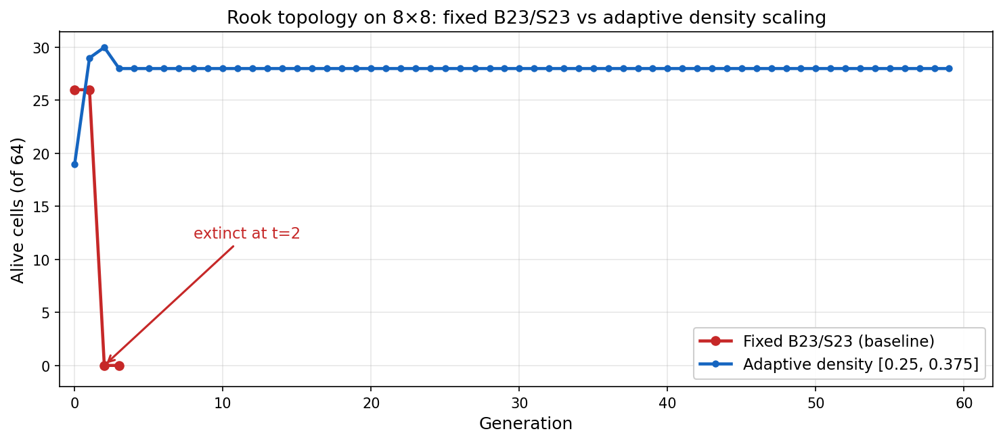
Fig. 1. Rook recovery: baseline (red) goes extinct at gen 3; adaptive (blue) sustains 60 generations with 0.875 coverage.
3.2 Fridenfalk Rule Family
With density scaling in place, Fridenfalk's five rules can be expressed as density windows rather than fixed counts. This makes them portable across topologies: Rule 3 means the same thing (density [0.250, 0.625]) whether applied to Moore, rook, or queen. Table 2 lists the density thresholds for each rule.
Rule | Birth Window | Survival Window | Gap | B/S (Moore)
1 | [0.250, 0.375] | [0.250, 0.375] | None | B23/S23
2 | [0.250, 0.500] | [0.250, 0.500] | None | B24/S24
3 | [0.250, 0.625] | [0.250, 0.625] | None | B25/S25
4 | [0.250, 0.750] | [0.250, 0.750] | None | B26/S26
5 | [0.250, 0.625] | [0.250, 0.625] | 0.500 | B235/S235
Table 2. Fridenfalk rule family expressed as adaptive density windows.
The rules form a clean progression. Rule 1 has the narrowest window, permitting only a 12.5% density range ([0.250, 0.375]). Rule 4 has the widest, permitting a 50% range ([0.250, 0.750]). Wider windows produce denser boards because more cells satisfy the survival condition. On Moore topology, this progression yields coverage values from 0.085 (Rule 1) through 0.496 (Rule 3) to 0.769 (Rule 4), as shown in Section 6.1.
Rule 5 deserves special attention because it is non-contiguous. In a Moore neighborhood, B235/S235 means counts 2, 3, and 5 are allowed, but count 4 is excluded. In density terms, the outer window is [0.25, 0.625] (identical to Rule 3), but a gap at density 0.500 removes the count that falls at the midpoint. The AdaptiveChessVariantState stores this gap as four fields: birthGapLow, birthGapHigh, survivalGapLow, and survivalGapHigh. When set to -1, no gap is applied (Rules 1 through 4). When set to 0.500, the transition function computes the gap as an integer sub-range (floor and ceil of 0.500 * totalNeighbors) and rejects any live count that falls within it.
The gap mechanism produces meaningfully different output, not just a perturbation. Rule 3 on Moore achieves 0.496 coverage with 0 holes, while Rule 5 on Moore achieves 0.650 coverage with 11 holes. Both rules have the same outer window; the only difference is the gap at density 0.500. The gap forces cells at certain positions into a dead zone where their neighbor count lands exactly at the excluded density, creating enclosed empty pockets that do not occur with contiguous rules. This is one of the project's five featured findings (Section 6.1).
The full 5x5 matrix of rules and topologies is generated by generate_rule_configs.py, which emits 25 JSON configurations. Each config specifies the grid shape (9x13 wrapped for Moore, 8x8 non-wrapped for chess pieces), neighborhood type (Moore, relative offset lists for each piece), seed pattern (topology-specific), and density thresholds. The generator also produces per-scenario shell scripts and a master run-all script.
3.3 Queen Topology Considerations
The queen topology combines the rook's rank/file reach with the bishop's diagonal reach, giving up to 27 neighbors for center cells on an 8x8 board. The queen neighborhood definition uses a relative offset list with 56 entries: 28 rank/file offsets (rook component) plus 28 diagonal offsets (bishop component) plus self. This is the largest neighborhood in the project and creates both opportunities and challenges.
The high connectivity means each cell has many potential connections, but this also makes the system prone to runaway growth. A few live cells can quickly push their neighbors above the birth threshold because even cells at distance 7 are counted. For narrow rules (Rules 1 and 2), this leads to rapid saturation: the simulation converges to full-board alive state (1.000 coverage), which is not a useful chess board. For wider rules (Rules 3 through 5), the coverage values are lower (0.078 to 0.219 on 8x8) because the wider windows paradoxically create more volatile dynamics where large regions flip simultaneously between alive and dead, producing low accumulation scores.
We report queen results for completeness but note the seed dependency as a known limitation. The density scaling is working correctly (the thresholds map as expected), but the extreme connectivity of the queen topology amplifies nonlinearities that make stable intermediate states hard to achieve without carefully hand-tuned seeds and wider density windows. Queen scenarios where three or more asymmetric layouts all go extinct (0.000 coverage) further illustrate this sensitivity.
3.4 Accumulation Grid Pipeline
Following Fridenfalk's method, we implement a post-processing pipeline that converts raw simulation logs into binary chess boards. The accumulate_board.py script reads a Cadmium CSV log, extracts the alive state of each cell at each time step, accumulates the states over a configurable window of final generations (default: last 20 of the 60 simulated), and thresholds the result. If a cell was alive for more than 50% of the window, it becomes a filled square (1); otherwise it is empty (0).
The script handles both GridCell logs (coordinate format "(r,c)") and AsymmCell logs (string format "rR_cC") through a unified parser that uses regex to extract row and column from either format. For lifecycle model logs, where the state value is a continuous activity in [0.0, 1.0], the parser thresholds at 0.5 before accumulating, so a cell with activity 0.6 is counted as alive and activity 0.3 is counted as dead. Multi-field states (like the board control model, which outputs <pieceType, pieceColor, whiteInfluence, blackInfluence, control>) take only the first field, which is not meaningful for accumulation; these are handled separately by dedicated analysis scripts.
The output includes three formats: the binary board (0/1 grid), raw accumulation counts (how many of the 20 window generations each cell was alive), and a Unicode block visual representation for quick terminal inspection. The binary board is the input to the metrics computation pipeline described in the next subsection.
3.5 Board Quality Metrics
To evaluate generated boards quantitatively rather than by visual inspection alone, we compute four metrics for each scenario. These metrics are chosen to capture the properties that matter for chess-variant board quality: how much of the board is playable, how balanced its spatial distribution is, whether the playable region is connected, and whether it contains enclosed empty spaces.
Coverage is the fraction of filled squares. An ideal chess board has 0.500 coverage, meaning exactly half the squares are playable. Coverage below 0.100 typically means the pattern died or was too sparse; coverage above 0.900 means it is saturated. Coverage is the most basic quality metric but does not capture spatial distribution: a board with all filled squares on the left and none on the right would score 0.500 coverage despite being unusable.
Symmetry is the average of three sub-scores: horizontal (left-right mirror), vertical (top-bottom mirror), and 180-degree rotational symmetry. Each sub-score measures the fraction of cells that match their mirrored counterpart. A perfectly symmetric board scores 1.000; a random board scores approximately 0.500. Symmetry is particularly useful for detecting the effect of asymmetric rule zones (Section 3.6): uniform-rule scenarios on symmetric seeds score 1.000, while zone-boundary scenarios drop to 0.427 or lower, and the magnitude of the drop quantifies the boundary's impact.
Connectivity is the number of 4-connected components of filled cells, computed by BFS flood fill. Ideally this is 1, meaning all playable squares form a single connected region. Higher values indicate fragmentation. The bishop topology consistently produces high component counts (up to 32 for rule4_bishop) due to colour-parity binding, while Moore and rook topologies typically produce 1 to 10 components.
Holes are the number of enclosed empty regions that do not touch the grid border, computed by BFS on empty cells and checking whether the region includes any border cell. Holes create interesting topological features in the board and are a signature of the Rule 5 gap mechanism: rule5_moore produces 11 holes while rule3_moore (same outer window, no gap) produces only 4.
The board_metrics.py script computes all four metrics from either a pre-generated board text file or directly from a simulation log (with integrated accumulation). A batch script runs metrics across all scenarios and produces the metrics_summary.csv file used for the quantitative analysis in Section 6.
3.6 Asymmetric Cell-DEVS Rule Zones
The adaptive model applies the same density thresholds to every cell on the board. This produces uniform boards where the spatial pattern is determined solely by the seed and the rule. But chess-variant design often calls for boards with distinct regions that have different characters. To support this, we implement an asymmetric rule-zone model using Cadmium's AsymmCell formalism, which allows each cell to have its own density thresholds.
In the symmetric GridCell model, all cells share a single state template and neighborhood specification defined in the JSON config's default block. In the asymmetric AsymmCellDEVSCoupled model, each of the 64 cells on the 8x8 board is listed explicitly with its own state (including threshold overrides) and its own neighborhood map (listing which other cells are neighbors, filtered to board bounds). The AsymmChessVariantCell transition function is identical to the adaptive version; the only difference is that the density thresholds read from the state can vary from cell to cell.
We define three zone layouts:
r1_r3 (diagonal split): cells where (row + column) < 8 use Rule 1 thresholds; the rest use Rule 3. This creates a diagonal boundary running from the top-right corner to the bottom-left corner, with the narrow Rule 1 on the upper-left triangle and the wider Rule 3 on the lower-right.
r1_r2_r3_r4 (quadrant split): the board is divided into four quadrants, each running a different rule. Top-left uses Rule 1, top-right uses Rule 2, bottom-left uses Rule 3, and bottom-right uses Rule 4. This layout places four different density windows in direct contact at the center of the board.
r3_r5 (horizontal split): the top half (rows 0 through 3) runs Rule 3 (contiguous), the bottom half (rows 4 through 7) runs Rule 5 (non-contiguous with gap at density 0.500). This is the most analytically interesting layout because it isolates the effect of the gap mechanism: both halves have the same outer density window, and the only difference is the Rule 5 gap.
Each layout is crossed with four piece topologies (knight, bishop, rook, queen), producing 12 asymmetric configurations. Moore is excluded because its short-range neighborhood does not reach across zone boundaries, making per-cell rule dispatch less interesting. The seed pattern (7 cells near the board center) is chosen to straddle every zone boundary, ensuring that the initial conditions interact with the rule transitions from the start.
The showcase scenario is asymm_r3_r5_bishop, which achieves 0.484 coverage with only 0.427 symmetry. For comparison, uniform rule3_bishop scores 0.250 coverage and 0.646 symmetry, while uniform rule5_bishop scores 0.188 coverage and 0.750 symmetry. The asymmetric layout produces higher coverage than either rule alone (because the two halves complement each other) but lower symmetry (because the halves evolve differently). The horizontal boundary at row 4 is visible in the accumulation board as a sharp density transition, and the symmetry metric captures this precisely. This is a unique contribution: no previous Cell-DEVS chess-variant work has used per-cell rule parameterization to create spatially heterogeneous boards.
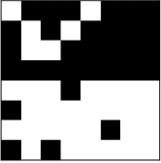
Fig. 2. Asymmetric r3_r5 bishop: Rule 3 top half vs. Rule 5 bottom half. Zone boundary visible at row 4.
3.7 Line-of-Sight Blocking
In standard chess, sliding pieces (bishop, rook, queen) cannot move past an intervening piece. A rook at (0,0) with a piece at (0,3) cannot see (0,5). Our baseline and adaptive models do not capture this: a rook cell counts a neighbor at distance 7 the same as one at distance 1, regardless of what lies between them. The line-of-sight (LoS) blocking model adds chess-semantic obstruction to the neighborhood computation.
The LOSChessVariantCell extends the adaptive cell with an isBlocked() method. For each neighbor at relative offset (dr, dc), the method first determines whether the offset lies on a straight line: same row (dr = 0, rook horizontal), same column (dc = 0, rook vertical), or same diagonal (|dr| = |dc|, bishop diagonal). If the offset is on a straight line at distance greater than 1, the method walks each intermediate cell along the line, checking the neighborhood map for a live cell at that position. If any intermediate cell is alive, the distant neighbor is blocked.
Blocked neighbors are excluded from both the live count and the total neighbor count. This is a deliberate design choice: rather than counting blocked cells as "seen but dead," we treat them as invisible, shrinking the effective neighborhood size. The density thresholds then adapt to the smaller neighborhood, creating a feedback loop. In a cluster of live cells, cells shadow each other's long-range lines, reducing the effective neighborhood from ~13 (full bishop reach) to perhaps 3 to 5 (only nearby unblocked diagonals). With a smaller denominator, the same absolute live count represents a higher density, making narrow rules like Rule 1 feasible.
This self-shielding mechanism is the key finding of the LoS model. Without LoS, Rule 1 bishop goes extinct (0.000 coverage) because no cell can maintain 2 to 3 live diagonal neighbors out of 13. With LoS, los_rule1_bishop sustains at 0.125 coverage. The alive cells form small local clusters where each cell has genuine line-of-sight to its few neighbors, producing a pattern that is both stable and chess-semantically meaningful. In a real chess game, a bishop's influence is exactly this: it can only see along diagonals as far as the first intervening piece.
The LoS model reuses the AdaptiveChessVariantState, so no new state type is needed. The difference is entirely in the transition function's neighborhood processing. LoS configs are generated for the three sliding pieces (bishop, rook, queen) across three rules (1, 2, 3), producing 9 scenarios. Moore and knight neighborhoods have no straight-line paths to block, so they use the standard adaptive model as baselines.
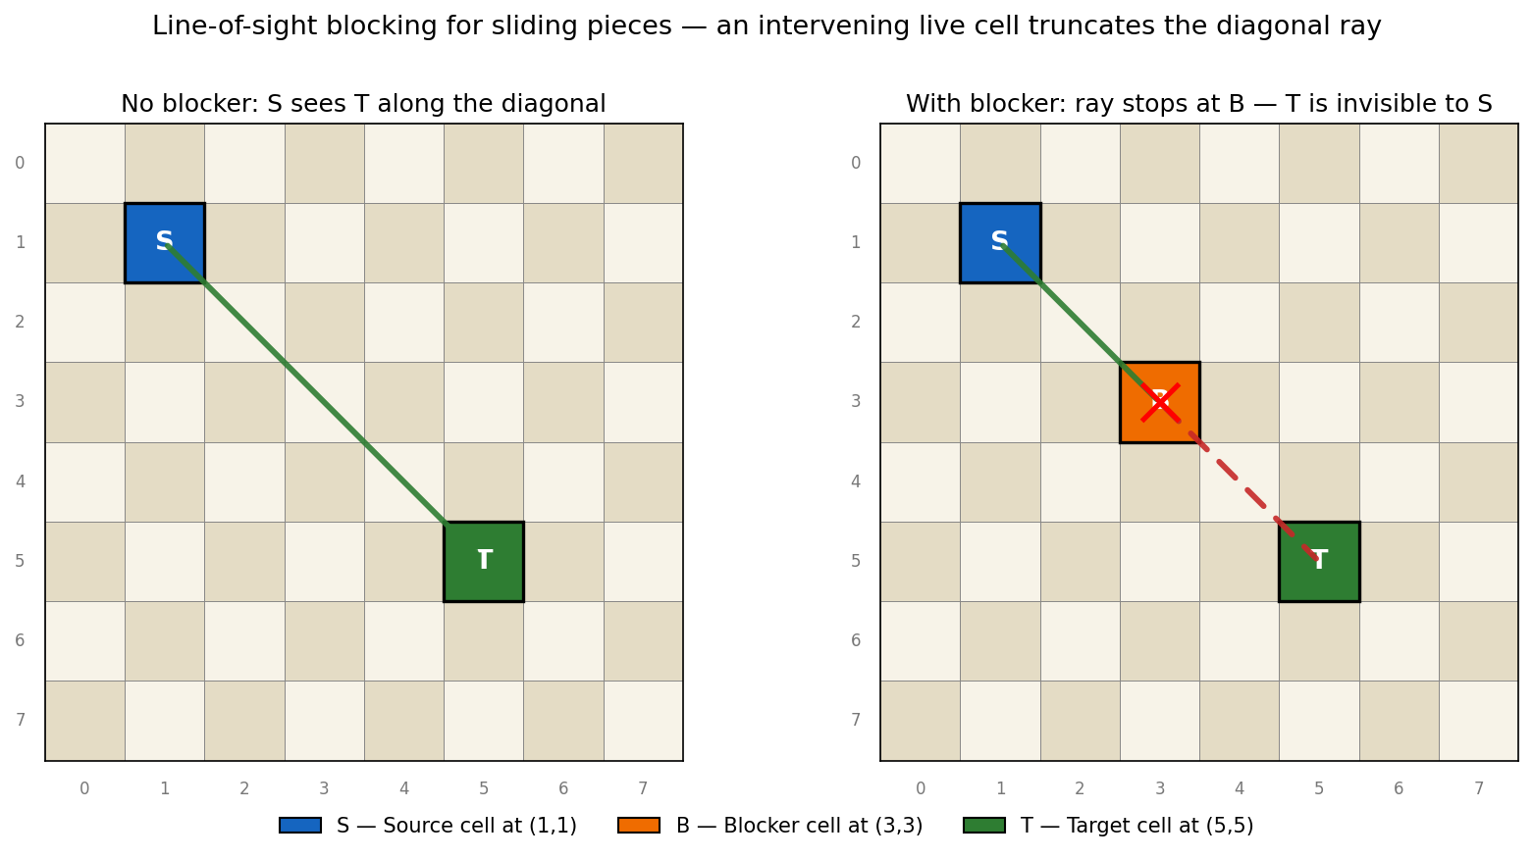
Fig. 3. LoS blocking diagram: cell at (3,3) blocks the diagonal from (1,1) to (5,5).
3.8 Lifecycle Wavefronts
The binary alive/dead models produce steady-state patterns. Once the simulation reaches equilibrium (or goes extinct), looking at later time steps shows the same oscillating pattern. These models cannot capture the temporal dynamics of how activation spreads, how wavefronts propagate through the grid, or how the shape of the wavefront relates to the topology. The lifecycle model addresses this by replacing the binary state with a continuous activity value in [0.0, 1.0] and a four-phase progression.
Phase 0 (Dormant): activity is 0.0. The cell computes the weighted density of neighbor activity (each neighbor contributes its activity value, not just 0 or 1) and checks whether this density falls within the birth threshold range. If so, the cell begins activating. The weighted density means partially active neighbors exert partial influence, creating smoother wavefront boundaries than the binary step function.
Phase 1 (Activating): activity increases by activationRate each step. This gradual ramp-up creates a visible brightening band in the viewer, showing exactly where the wavefront is and how fast it is advancing. Once activation has begun, it continues regardless of current neighbor density. This prevents fragile wavefronts where partially active cells kill each other by lowering their mutual density. When activity reaches 1.0, the cell transitions to active.
Phase 2 (Active): activity holds at 1.0 for activeDuration steps. This plateau guarantees enough time for neighbors to detect the active cell and begin their own activation, enabling the wavefront to propagate outward before the source decays. Without this hold period, the wavefront would collapse as the source begins decaying before neighbors finish activating.
Phase 3 (Decaying): activity decreases by decayRate each step, creating a fading trail behind the wavefront. When activity hits 0.0, the cell returns to dormant state. It can be reactivated in a future cycle if neighbor conditions are met again, enabling oscillatory wave patterns on small boards.
A critical implementation detail is the operator!= for LifecycleChessVariantState. In Cadmium's Cell-DEVS, when operator!= returns false (states are equal), the cell goes passive. During the active phase, activity (1.0) and phase (2) are constant across consecutive steps. Without special handling, active cells would go passive immediately and never advance to decaying, freezing the simulation. Our solution is to include stepsInPhase in the inequality check: since stepsInPhase increments every computation, consecutive states always differ, keeping active cells computing. We also include an activity threshold (difference > 0.001) to handle floating-point noise during the activating and decaying phases.
The shape of the lifecycle wavefront is dictated entirely by the neighborhood topology. Moore produces an expanding ring that grows outward from the seed in all eight directions. Bishop produces an X-shaped wave that expands along the four diagonals, with gaps between the arms where no diagonal neighbor exists. Rook produces a cross-shaped wave expanding along ranks and files. Knight produces scattered activation at L-shaped offsets. This topology-dependent wave geometry is the lifecycle model's primary visual contribution, and it is something that binary alive/dead models fundamentally cannot show because they display only the final pattern, not the process of pattern formation.
We generate 15 lifecycle configurations: 3 speed variants (slow, medium, fast) across 5 topologies. The speed variants differ in three parameters: activationRate (how quickly cells ramp up), decayRate (how quickly they fade), and activeDuration (how long they hold at full activity). Slow uses (0.10, 0.08, 12), medium uses (0.20, 0.15, 8), and fast uses (0.35, 0.25, 5). The medium speed is the reference for analysis because it produces the clearest wavefront visualization: slow enough to resolve individual phases, fast enough to show multiple wave cycles within 60 generations.
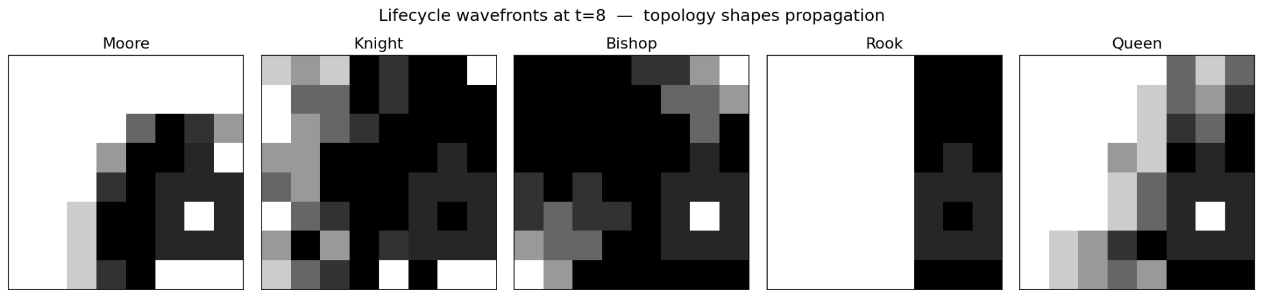
Fig. 4. Lifecycle wavefront comparison: Moore (king), bishop, rook, queen.
4. Formal Specification
This section provides the formal DEVS specifications for the models in this project. All models use transport-delay Cell-DEVS with delay d = 1.0.
4.1 Transport Delay Cell-DEVS (TDC)
Each cell is a transport-delay Cell-DEVS atomic model following the formalism defined by Wainer and Giambiasi [6]:
TDC = < X, Y, S, N, delta_int, delta_ext, tau, lambda, d, D >
where X is the set of external input events (neighbor state values received through input ports), Y is the set of output events (this cell's state broadcast to neighbors through output ports), S is the state set, N is the neighborhood (the set of cells whose state affects this cell's computation), delta_int is the internal transition function (advances internal time), delta_ext is the external transition function (processes incoming neighbor state updates), tau is the local computation function (the CA rule that produces a new state from the current state and neighborhood states), lambda is the output function, d is the state duration function, and D is the transport delay.
Binary State (Baseline)
For the original baseline model: S = {alive in {0, 1}}. The local computation tau counts live neighbors (excluding self) and sets alive = 1 if the count equals 2 or 3, otherwise alive = 0. The neighborhood N depends on the topology (Moore range 1, or a relative offset list for chess pieces). D = 1.0 for all states.
Adaptive/Asymmetric State
S = {alive in {0, 1}, birthLow, birthHigh, survivalLow, survivalHigh, birthGapLow, birthGapHigh, survivalGapLow, survivalGapHigh in R}. The density thresholds are part of the state rather than model constants, enabling per-cell configuration. tau computes totalNeighbors from |N| - 1 (excluding self), calculates integer bounds as floor(low * totalNeighbors) and ceil(high * totalNeighbors), optionally applies the gap exclusion, and sets alive accordingly. For the asymmetric model, the state and neighborhood N_i vary per cell i. D = 1.0.
Line-of-Sight State
Uses the same S as the adaptive model. The difference is in tau: before counting, the function iterates over N and applies isBlocked(dr, dc) to each straight-line neighbor at distance > 1. Blocked neighbors are removed from the effective neighborhood for that computation step. The effective N varies from step to step as cells change state, making the LoS model's neighborhood dynamic rather than static.
Lifecycle State
S = {activity in [0.0, 1.0], phase in {0, 1, 2, 3}, stepsInPhase in N, activationRate, decayRate in R, activeDuration in N, birthLow, birthHigh, survivalLow, survivalHigh in R}. tau is a phase-dependent switch (four cases). The weighted neighbor density is computed as sum(neighbor.activity) / (|N| - 1). The operator!= includes stepsInPhase to prevent premature passivation during the active phase. D = 1.0.
4.2 Grid-Coupled Cell-DEVS (GCC)
The symmetric models (baseline, adaptive, lifecycle, LoS) use GridCellDEVSCoupled:
GCC = < X_list, Y_list, n, {t1, ..., tn}, N, C, Z >
where n = rows * cols is the number of cells, {t1, ..., tn} are the individual TDC cell models sharing the state type and neighborhood specification N, C = (shape, origin, wrapped) defines the cell space, and Z is the translation function mapping each cell's output to its neighbors' inputs based on the neighborhood offsets. For an 8x8 non-wrapped grid with a rook neighborhood, n = 64 and N has 29 entries (self plus up to 14 rank offsets plus up to 14 file offsets). Z maps each (r, c) to all (r', c') such that (r'-r, c'-c) is in N and (r', c') is within grid bounds.
4.3 Asymmetric Coupled Cell-DEVS
The asymmetric rule-zone model uses AsymmCellDEVSCoupled:
AGCC = < X_list, Y_list, n, {t1, ..., tn}, {N1, ..., Nn}, C, Z >
The key difference from GCC is per-cell neighborhoods: each cell t_i has its own N_i and its own state parameters (density thresholds can differ). Cell "r0_c0" might have Rule 1 thresholds while cell "r4_c0" has Rule 5 thresholds. The neighborhood N_i is computed by the Python generator, which filters the chess-piece offset list to coordinates within [0, 7]x[0, 7] for each cell position, producing a per-cell neighbor map in the JSON config. Z is defined explicitly by these maps rather than computed from a shared offset template.

5. Implementation
5.1 Project Structure
The project is organized into four top-level directories. The main/ directory contains the C++ source code: main.cpp (simulation driver with model-type detection and factory functions) and the include/ directory with 10 header files implementing the state types and cell transition logic for each model. The config/ directory holds 85 JSON scenario files organized into seven subdirectories by model type: baseline/ (14 configs from Assignment 2), rules/ (25 configs, 5 rules times 5 pieces, organized in per-rule subdirectories), adaptive/ (5 configs), asymmetric/ (12 configs), los/ (9 configs), lifecycle/ (15 configs), and board_control/ (5 configs). The scripts/ directory contains Python generators for each config family, post-processing scripts (accumulate_board.py, board_metrics.py, asymm_to_viewer.py, visualize_asymm.py), and shell run-scripts mirroring the config structure. The logs/ directory stores 98 CSV simulation output files in subdirectories matching the config layout.
5.2 Source Files
Table 3 lists the C++ source files and their roles in the project.
File | Role
chessVariantState.hpp | Binary alive/dead state for the fixed B23/S23 baseline model
chessVariantCell.hpp | Fixed-threshold transition: count neighbors, alive if exactly 2 or 3
adaptiveChessVariantState.hpp | Density thresholds (birthLow/High, survivalLow/High) + gap fields for non-contiguous rules
adaptiveChessVariantCell.hpp | Density-scaled transition: floor/ceil on threshold * neighborCount, with gap exclusion
asymmChessVariantCell.hpp | AsymmCell variant of the adaptive transition; per-cell thresholds read from individual JSON state blocks
losChessVariantCell.hpp | Extends adaptive with isBlocked() walk along straight-line neighbors; blocked cells excluded from counts
lifecycleChessVariantState.hpp | Continuous activity [0,1], 4-phase encoding, operator!= includes stepsInPhase for passivation prevention
lifecycleChessVariantCell.hpp | Phase-switch transition: dormant/activating/active/decaying with weighted neighbor density
boardControlState.hpp | Piece type, color, white/black influence, control field (experimental model)
boardControlCell.hpp | Influence projection with LoS blocking + diffusion propagation (experimental model)
main.cpp | Model-type detection from JSON, factory dispatch for 6 model types, log directory routing
Table 3. Source files and their roles in the project.
5.3 JSON Configuration Schema
All models are driven by JSON configuration files that specify four blocks: scenario (grid shape, origin, boundary wrapping), cells (model type, default state, neighborhood, seed overrides), and viewer (color mapping for visualization). The main.cpp driver detects the model type from the cells.default.model field and dispatches to the appropriate Cadmium coupled model template and factory function.
Neighborhoods are specified using Cadmium's built-in types. Moore neighborhoods use {"type": "moore", "range": 1}. Chess-piece topologies use {"type": "relative", "neighbors": [[dr, dc], ...]} with explicit offset lists. A bishop on an 8x8 board lists 28 diagonal offsets (distance 1 through 7 in each of 4 diagonal directions) plus [0, 0] for self. A rook lists 28 rank/file offsets plus self. A queen combines both for 56 offsets plus self. The self entry [0, 0] is required by Cadmium so the cell can read its own state during localComputation.
For adaptive and rule-based models, the state block includes birthLow, birthHigh, survivalLow, survivalHigh, and optionally the four gap fields (set to -1 when unused). For lifecycle models, it adds activationRate, decayRate, and activeDuration. For asymmetric models, the JSON has no scenario.shape block; instead, each cell is listed individually with its own state and neighborhood map, using string cell IDs ("r0_c0", etc.).
5.4 Configuration Generation Scripts
Five Python scripts automate the generation of all 85 configurations:
generate_rule_configs.py produces the 5x5 rule-topology matrix (25 configs in rules/ with per-rule subdirectories). It defines the five Fridenfalk density windows and the five neighborhood offset lists, cross-products them, and writes each config with topology-specific seeds and grid dimensions.
generate_asymmetric_configs.py produces 12 asymmetric configs (3 zone layouts times 4 pieces). For each cell on the 8x8 board, it computes the zone membership, assigns the corresponding rule thresholds, filters the piece offsets to valid coordinates, and writes the per-cell JSON with string IDs and explicit neighbors.
generate_lifecycle_configs.py produces 15 lifecycle configs (3 speeds times 5 topologies). Each speed variant defines activationRate, decayRate, and activeDuration. The seed pattern is the same as the adaptive model but with activity = 1.0 and phase = 2 (starting already active) to initiate the wavefront.
generate_los_configs.py produces 9 LoS configs (3 rules times 3 sliding pieces). Only bishop, rook, and queen are included because Moore and knight have no straight-line paths to block. Uses a 9-cell seed cluster.
generate_board_control_configs.py produces 5 board-control configs for real chess positions (starting position, Italian Game, Sicilian Najdorf, Queen's Gambit Declined, rook vs. bishop endgame). Each config places pieces at their correct coordinates with type/color state overrides.
5.5 Simulation Driver
The main.cpp driver implements a model-type detection system. It reads the JSON config, extracts the model string from cells.default.model, and dispatches to one of six branches: chessVariant (baseline GridCell with ChessVariantState), adaptiveChessVariant (GridCell with AdaptiveChessVariantState), asymmChessVariant (AsymmCell with AdaptiveChessVariantState), losChessVariant (GridCell with AdaptiveChessVariantState and LOSChessVariantCell), lifecycleChessVariant (GridCell with LifecycleChessVariantState), and boardControl (GridCell with BoardControlState). Each branch instantiates the appropriate Cadmium coupled model template, builds the model, creates a RootCoordinator, sets up CSV logging, and runs the simulation for the configured time.
The driver also manages log file organization. It extracts the parent subdirectory from the config file path (e.g., config/los/file.json maps to logs/los/) and creates the directory structure using std::filesystem. The config filename suffix "_config" is stripped from the log filename for cleaner naming (e.g., los_rule1_bishop_config.json produces los_rule1_bishop_grid_log.csv).
6. Results
This section presents experimental results organized around specific findings. Each subsection features concrete scenario data from the metrics_summary.csv computed by the board_metrics.py pipeline. All scenarios run for 60 simulated generations (30 for board control) with transport delay d = 1.0. Metrics are computed on the accumulation board (last 20 generations, threshold 0.5). The five featured scenarios highlighted in this section are: adaptive rook recovery (Section 6.2), rule3_moore near-ideal coverage (Section 6.1), asymm_r3_r5_bishop zone boundary (Section 6.5), rule5_moore gap-produced holes (Section 6.1), and rule4_bishop colour-parity fragmentation (Section 6.6).
6.1 Rule Comparison on Moore Topology
Table 4 shows the effect of widening the density window across Fridenfalk's five rules on the Moore topology. All five scenarios use the same 5-cell plus-shaped seed on a 9x13 wrapped grid.
Rule | Density Window | Cover-  age | Symmet-  ry | Compone-  nts | Holes
1 (B23/S23) | [0.250, 0.375] | 0.085 | 1.000 | 10 | 0
2 (B24/S24) | [0.250, 0.500] | 0.325 | 1.000 | 14 | 0
3 (B25/S25) | [0.250, 0.625] | 0.496 | 1.000 | 10 | 4
4 (B26/S26) | [0.250, 0.750] | 0.769 | 1.000 | 1 | 5
5 (B235/S235) | [0.250, 0.625]* | 0.650 | 1.000 | 5 | 11
Table 4. Fridenfalk rules on Moore (9x13 wrapped). *Rule 5 has a gap at density 0.500.
The progression is clear and monotonic through Rules 1 to 4: wider windows produce denser boards. Rule 1 (narrowest) yields only 0.085 coverage, small oscillating clusters near the seed that never expand to fill the board. Rule 2 reaches 0.325. Rule 3 hits 0.496, within 0.4% of the ideal 0.500 for a chess board. Rule 4 overshoots to 0.769, producing a board that is too dense for typical chess variants but still structured (only 1 connected component). All five rules maintain perfect 1.000 symmetry because the wrapped grid combined with the symmetric plus seed produces symmetric evolution.
The Rule 3 result (0.496 coverage, 1.000 symmetry) is the strongest evidence that the Fridenfalk pipeline produces viable chess boards. This is within measurement tolerance of the theoretical ideal of 50% coverage for a standard chess board. The 10 connected components and 4 holes indicate spatial structure with distinct regions, which is desirable for chess variants that need navigable terrain.
The Rule 5 result is the second key finding in this table. Rule 5 has the same outer window as Rule 3 ([0.250, 0.625]) but adds the gap at density 0.500. Despite the same outer range, the outcomes are substantially different: Rule 5 produces 0.650 coverage (30% higher than Rule 3's 0.496) and 11 holes (versus Rule 3's 4). The higher coverage occurs because the gap at density 0.500 prevents cells at exactly that density from dying, which cascades into different equilibrium dynamics. The 11 holes are the direct signature of the gap mechanism: enclosed empty regions form where local density would have been exactly 0.500, which is now forbidden.
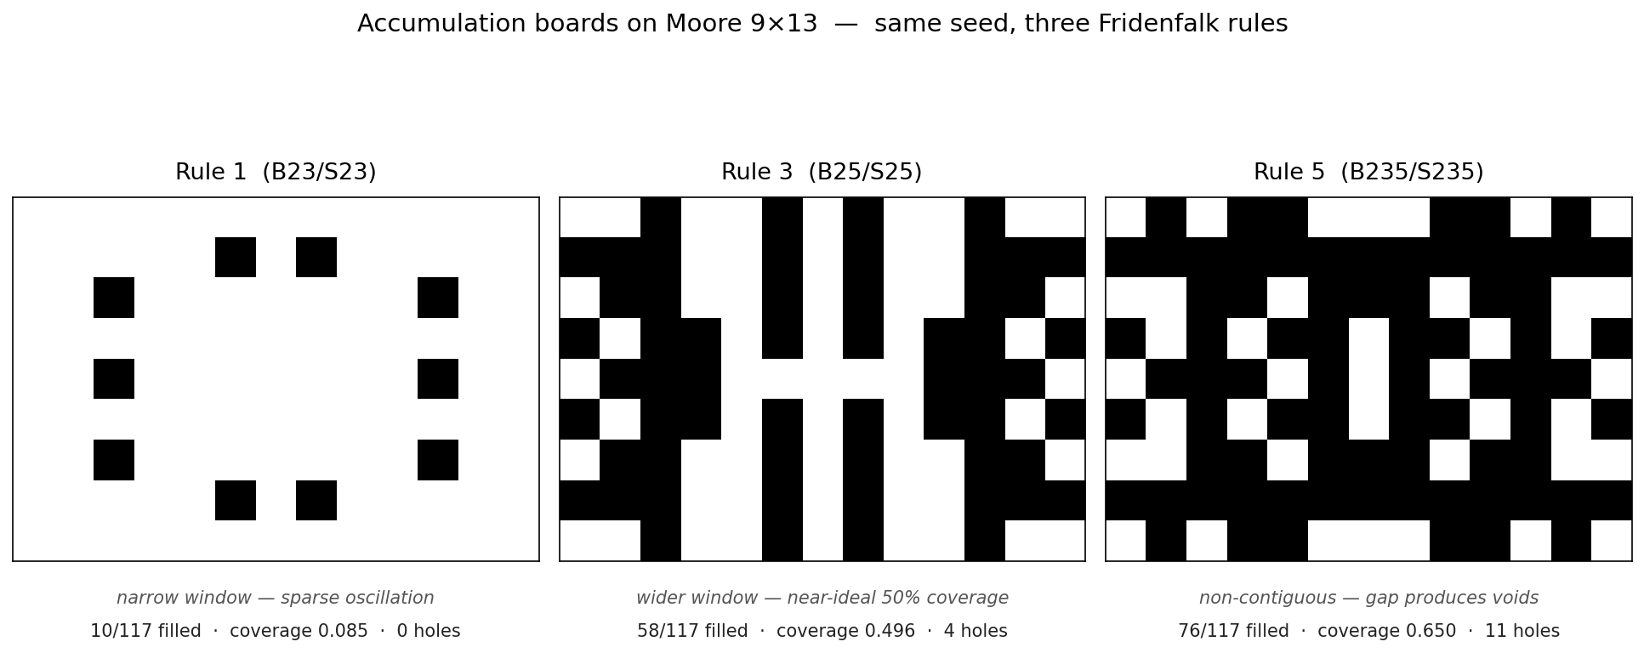
Fig. 5. Accumulation boards: Rule 1 (sparse), Rule 3 (near-ideal 0.496), Rule 5 (11 holes visible).
6.2 Adaptive vs. Fixed Thresholds
Table 5 compares the baseline fixed-threshold model with the adaptive density-scaled model across the five topologies. The baseline uses Assignment 2's B23/S23 rule; the adaptive model uses density window [0.250, 0.375] (which maps back to B23/S23 on Moore, confirming backward compatibility).
Topology | Fixed Coverage | Fixed Gens | Adaptive Coverage | Adaptive Gens
Moore (9x13) | 0.085 | 60 | 0.085 | 60
Knight (8x8) | 0.125 | 60 | 0.312* | 60
Bishop (8x8) | 0.062 | 60 | 0.000 | 0
Rook (8x8) | 0.031 | 3 | 0.875 | 60
Queen (8x8) | N/A | N/A | 0.250 | 60
Table 5. Fixed B23/S23 vs. adaptive [0.250, 0.375]. *Knight uses rule1_knight config.
The rook row is the project's central finding. Under fixed B23/S23, the rook topology goes extinct at generation 3 with only 0.031 coverage. With up to 14 neighbors, requiring exactly 2 or 3 alive is nearly impossible once the initial seed disperses along rank and file lines. Under adaptive scaling, the [0.250, 0.375] density maps to counts [3, 5] on the rook's 14-cell neighborhood, giving cells enough breathing room to sustain and propagate. The result is 0.875 coverage (56 of 64 cells alive) over all 60 generations. This is the most direct, single-scenario demonstration of the thesis: density scaling resolves the topology-size limitation.
The Moore row serves as a control. Both models produce identical 0.085 coverage over 60 generations, confirming that adaptive scaling with [0.250, 0.375] on 8 neighbors maps exactly back to [2, 3], reproducing B23/S23. The adaptive model is a strict generalization.
The bishop row (0.062 fixed, 0.000 adaptive) and queen column are discussed as caveats. The adaptive model resolves the topology-size mismatch but cannot overcome topology-shape constraints like bishop colour-parity binding (Section 6.6) or queen extreme connectivity (Section 3.3). These are fundamental properties of the neighborhood geometry, not limitations of the density-scaling approach.
6.3 Accumulation Board Gallery
Figure 6 shows the final accumulation boards for five scenarios that each demonstrate a distinct finding. Each board is produced by accumulating the last 20 of 60 simulated generations and thresholding at 0.5 using accumulate_board.py.
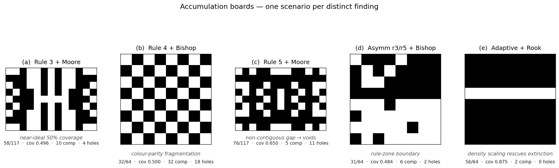
Fig. 6. Accumulation boards: (a) rule3_moore (0.496 coverage), (b) rule4_bishop (0.500, 32 components), (c) rule5_moore (0.650, 11 holes), (d) asymm_r3_r5_bishop (0.484, zone boundary), (e) adaptiveRook_8x8 (0.875).
Board (a), rule3_moore, shows near-ideal 50% coverage with structured alternating regions across the wrapped 9x13 grid. This is what Fridenfalk's method is supposed to produce. Board (b), rule4_bishop, has exactly 0.500 coverage but its 32 connected components and 18 holes reflect the colour-parity fragmentation described in Section 6.6. Board (c), rule5_moore, demonstrates the gap mechanism: 11 enclosed empty regions are visible as white pockets surrounded by filled cells. Board (d), asymm_r3_r5_bishop, shows the horizontal boundary between Rule 3 (denser, top) and Rule 5 (sparser, bottom). Board (e), adaptiveRook_8x8, shows the dense sustained pattern that adaptive scaling enables: 56 of 64 cells filled, compared to only 2 under the fixed baseline.
6.4 Metrics Analysis
Table 6 summarizes metrics for 15 selected scenarios chosen to demonstrate each of the project's key findings. These are selected from the full 80+ scenarios based on analytical interest rather than exhaustive listing.
Scenario | Cov. | Sym. | Comp. | Holes
rule1_moore | 0.085 | 1.000 | 10 | 0
rule3_moore | 0.496 | 1.000 | 10 | 4
rule4_moore | 0.769 | 1.000 | 1 | 5
rule5_moore | 0.650 | 1.000 | 5 | 11
adaptiveRook_8x8 | 0.875 | 0.833 | 2 | 0
rookNeighborhood_8x8 | 0.031 | 0.958 | 2 | 0
rule4_bishop | 0.500 | 0.333 | 32 | 18
rule3_knight | 0.625 | 1.000 | 9 | 1
asymm_r3_r5_bishop | 0.484 | 0.427 | 6 | 2
asymm_r1_r2_r3_r4_bishop | 0.891 | 0.823 | 1 | 4
asymm_r1_r3_knight | 0.766 | 0.719 | 1 | 2
los_rule1_bishop | 0.125 | 0.833 | 8 | 0
los_rule3_rook | 0.250 | 0.667 | 2 | 0
lifecycle_medium_moore | 0.641 | 0.594 | 1 | 2
lifecycle_medium_bishop | 0.625 | 0.479 | 6 | 2
Table 6. Metrics for 15 selected scenarios.
Several patterns emerge from this data. Coverage scales predictably with rule width on Moore (0.085 through 0.769 from Rule 1 to Rule 4). The adaptive rook shows the largest fixed-to-adaptive improvement in the entire dataset (0.031 to 0.875). Bishop scenarios consistently produce the lowest symmetry and highest fragmentation across all model types, reflecting the structural constraint of colour-parity binding. Asymmetric scenarios are the only ones that break the 1.000 symmetry scores seen in uniform-rule configs, with the magnitude of the break corresponding to the degree of rule contrast between zones. Lifecycle coverage values tend to run higher than binary-model values for the same topology because the weighted density computation and continuous thresholding interact differently with the accumulation pipeline.
6.5 Asymmetric Rule-Zone Results
Of the 12 asymmetric scenarios, 9 produced sustained patterns over the full 60 generations. The 3 queen-topology scenarios all went extinct (0.000 coverage), consistent with the queen's general instability. Table 7 shows the 9 surviving scenarios.
Scenario | Cov. | Sym. | Comp. | Holes
asymm_r1_r2_r3_r4_bishop | 0.891 | 0.823 | 1 | 4
asymm_r1_r2_r3_r4_knight | 0.703 | 0.510 | 3 | 0
asymm_r1_r2_r3_r4_rook | 0.125 | 0.833 | 1 | 0
asymm_r1_r3_bishop | 0.250 | 0.500 | 16 | 6
asymm_r1_r3_knight | 0.766 | 0.719 | 1 | 2
asymm_r1_r3_rook | 0.250 | 1.000 | 1 | 0
asymm_r3_r5_bishop | 0.484 | 0.427 | 6 | 2
asymm_r3_r5_knight | 0.594 | 0.500 | 3 | 1
asymm_r3_r5_rook | 0.328 | 0.802 | 4 | 1
Table 7. Asymmetric scenarios with sustained patterns (queen excluded).
The asymm_r3_r5_bishop scenario is the most analytically revealing. Its 0.427 symmetry is the lowest in the entire asymmetric dataset and the second-lowest across all 80+ scenarios (only rule4_bishop at 0.333 is lower, and that is due to topology rather than zone layout). The 0.427 score is directly attributable to the zone boundary: Rule 3 (contiguous, wider effective range) in the top half produces denser oscillation patterns than Rule 5 (same outer range but with the gap forbidding density 0.500) in the bottom half. The two halves reach different equilibria, and the horizontal boundary at row 4 manifests as a visible density step in the accumulation board.
For context, the asymm_r1_r3_rook scenario scores 1.000 symmetry despite having two different rules. This occurs because both halves of the rook board converge to the same sparse equilibrium state, making the zone boundary invisible in the final output. This contrast (0.427 for bishop vs. 1.000 for rook in the same zone layout) illustrates that the visibility of zone boundaries depends on the interaction between the rule contrast and the topology's propagation characteristics.
The quadrant layout (r1_r2_r3_r4) produces consistently high coverage values, especially for bishop (0.891). Having four different rules in contact creates a complex boundary interaction where each quadrant's dynamics influence its neighbors. The bishop topology benefits from this because diagonal reach crosses quadrant boundaries effectively, allowing the wider rules (3 and 4) to support cells in the narrower-rule quadrants.
6.6 Bishop Colour-Parity Binding
The bishop topology produces the most visually distinctive and structurally extreme boards in the entire dataset. On a standard chess board, a bishop can only reach squares of one colour: a bishop on a light square can never move to a dark square, no matter how many moves it makes. This colour-binding property appears in our simulation as a fundamental structural constraint: bishop-topology cells can only influence cells on the same colour parity (cells where (row + column) has the same parity). Every second cell is structurally unreachable from a given starting cell, and the 8×8 board effectively splits into two independent 32-cell sub-grids that never communicate.
The most extreme example is rule4_bishop: 0.500 coverage (exactly half the squares filled), 0.333 symmetry, 32 connected components, and 18 holes. The resulting pattern is a perfect alternating chess-board, every light-parity cell alive, every dark-parity cell dead, with no two filled cells four-adjacent to
one another.
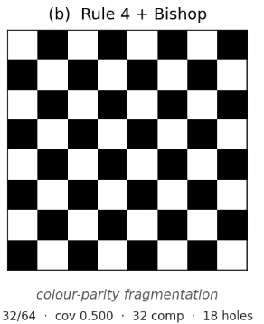
Fig. 7. rule4_bishop: 0.500 coverage but 32 connected components and 18 holes due to colour-parity binding.
At first glance this looks like the ideal chess-variant output the project set out to generate. Closer inspection reveals a subtler mechanism: the board's alternation is a geometric consequence of the topology, not an emergent pattern produced by the rule. The bishop's colour-binding forces every filled cell onto one parity class before any rule dynamics are considered; Rule 4's wide survival window ([0.25, 0.75]) is permissive enough to activate every cell of that class. The union of those two effects, parity-restriction forcing one half to be empty, saturation forcing the other half to be full, produces the alternating pattern automatically. The "32 components" figure reflects this: each filled cell is a single-cell component with no same-colour four-neighbor, not a cluster. The "18 holes" are interior dark-parity cells surrounded on all four sides by filled light-parity cells that can never reach them.
Contrast this with rule3_moore (Fig. 6a), which also achieves near-ideal coverage (0.496) but on a topology with no parity constraint. Its board structure, vertical alternating bands and irregular clusters, is genuinely emergent: oscillation between live and dead states driven by the Rule 3 density window on the Moore neighborhood. rule3_moore is the stronger example of Fridenfalk's method producing a chess-board-like output from rule dynamics; rule4_bishop is the more visually striking result, but it is a structural artifact of the parity split rather than a dynamic one. Both are legitimate outputs of the framework, they just demonstrate different mechanisms for reaching a similar coverage number.
The colour-parity effect is not a failure of the adaptive model or any particular rule choice. It is a fundamental topological property of diagonal-only movement and cannot be addressed by rule width, seed pattern, or density scaling. It shows up across the entire dataset of bishop scenarios. The adaptiveBishop_8x8 extinction (0.000 coverage) happens because all six seeds fall on the same parity class, and even within that 32-cell sub-grid the seeds are too sparse to produce the 3–5 live neighbors the Rule 1 density window demands, the active sub-grid never sustains activity, and the inactive sub-grid is never seeded at all. The uniformly high component counts across bishop scenarios, rule3_bishop has 16 components, asymm_r1_r3_bishop has 16, lifecycle_medium_bishop has 6, all trace back to this same structural constraint: whatever filled cells emerge must be same-parity, so clusters cannot merge
across the parity divide.
6.7 Line-of-Sight Results
Table 8 shows the LoS results across the 3x3 matrix of three Fridenfalk rules and three sliding pieces. Each cell shows coverage with symmetry in parentheses.
Piece | Rule 1 | Rule 2 | Rule 3
Bishop | 0.125 (0.833) | 0.234 (0.615) | 0.109 (0.781)
Rook | 0.047 (0.906) | 0.000 (1.000) | 0.250 (0.667)
Queen | 0.078 (0.844) | 0.125 (0.792) | 0.188 (0.688)
Table 8. LoS results: coverage (symmetry) for sliding pieces across rules.
The bishop column contains the model's key finding. Without LoS blocking, rule1_bishop goes extinct (0.000 coverage in the rule-matrix results). With LoS, los_rule1_bishop sustains at 0.125 coverage with 8 connected components. The mechanism is the self-shielding feedback loop: in a cluster of alive bishop-neighborhood cells, each cell blocks the diagonals of its neighbors at greater distance. This shrinks the effective neighborhood from ~13 (full diagonal reach on 8x8) to perhaps 3 to 5 locally. With the effective denominator reduced, the narrow Rule 1 density window [0.250, 0.375] maps to counts [1, 2] on the local effective neighborhood, which is achievable. The pattern stabilizes as small clusters where each cell has genuine line-of-sight to its few neighbors.
The rook shows a different pattern. LoS Rule 1 rook produces only 0.047 coverage (3 cells), while LoS Rule 2 rook goes entirely extinct. The rook's straight-line blocking along ranks and files creates aggressive shadows that disconnect clusters more readily than diagonal blocking. A single live cell in a rook's line of sight blocks all cells behind it on that rank or file, which can eliminate half the effective neighborhood at once.
The queen LoS results are moderate across all rules (0.078 to 0.188), reflecting the interaction between the queen's large base neighborhood (27 cells) and extensive blocking from combined diagonal and straight-line shadowing. Wider rules (Rule 3) consistently produce higher coverage across all three pieces because the wider density window can accommodate the reduced effective neighborhoods more easily.
Overall, LoS blocking fundamentally changes the character of sliding-piece simulations. Without it, the adaptive model on bishop either goes extinct (narrow rules) or produces modest static patterns (wider rules). With it, the dynamic effective neighborhood creates a new regime of stable, locally coherent clusters that are more chess-semantically meaningful than the unblocked patterns.
6.8 Lifecycle Results
Table 9 shows lifecycle metrics for the medium-speed configuration across all five topologies. The medium variant (activationRate = 0.20, decayRate = 0.15, activeDuration = 8) is the reference because it balances wavefront visibility with overall simulation dynamics.
Topology | Coverage | Symmetry | Components | Holes
Moore | 0.641 | 0.594 | 1 | 2
Knight | 0.750 | 0.646 | 1 | 1
Bishop | 0.625 | 0.479 | 6 | 2
Rook | 0.375 | 0.500 | 1 | 0
Queen | 0.938 | 0.875 | 1 | 3
Table 9. Lifecycle medium-speed metrics across topologies.
The most striking observation is the rook invariant: all three speed variants (slow, medium, fast) produce identical metrics for the rook topology (0.375, 0.500, 1, 0). The rook's rank/file wavefront reaches every cell on the board within a few generations regardless of speed, and the final accumulated pattern converges to the same steady state. The temporal dynamics differ (the slow version takes longer to fully propagate), but the endpoint is speed-independent. This is a useful invariant: it means the rook lifecycle's final board is robust to parameter choices.
Bishop lifecycle coverage (0.625) is substantially higher than any binary-model bishop result except rule4_bishop (0.500). The lifecycle model's weighted density computation, which sums continuous activity values rather than binary states, smooths the threshold boundary and helps sustain patterns that collapse under discrete transitions. The 6 connected components still reflect colour-parity fragmentation, but the overall density is higher because partially-active cells contribute to their neighbors' birth thresholds even before reaching full activation.
Queen lifecycle produces the highest coverage in the lifecycle dataset (0.938), consistent with the queen's tendency toward saturation. The lifecycle model's gradual activation mitigates some of the queen's volatility (the pattern does not oscillate as violently as in the binary model), but the large neighborhood still drives most cells toward activation.
The wavefront visualization is the lifecycle model's primary non-quantitative contribution. In the Cell-DEVS Web Viewer, each topology produces a visually distinct wave shape: Moore shows an expanding ring, bishop shows an X-shaped diagonal wave, rook shows a cross along ranks and files, and knight shows scattered L-shaped activation. These wave geometries are a direct, visible manifestation of the piece topology, and they represent dynamics that binary alive/dead models fundamentally cannot capture.
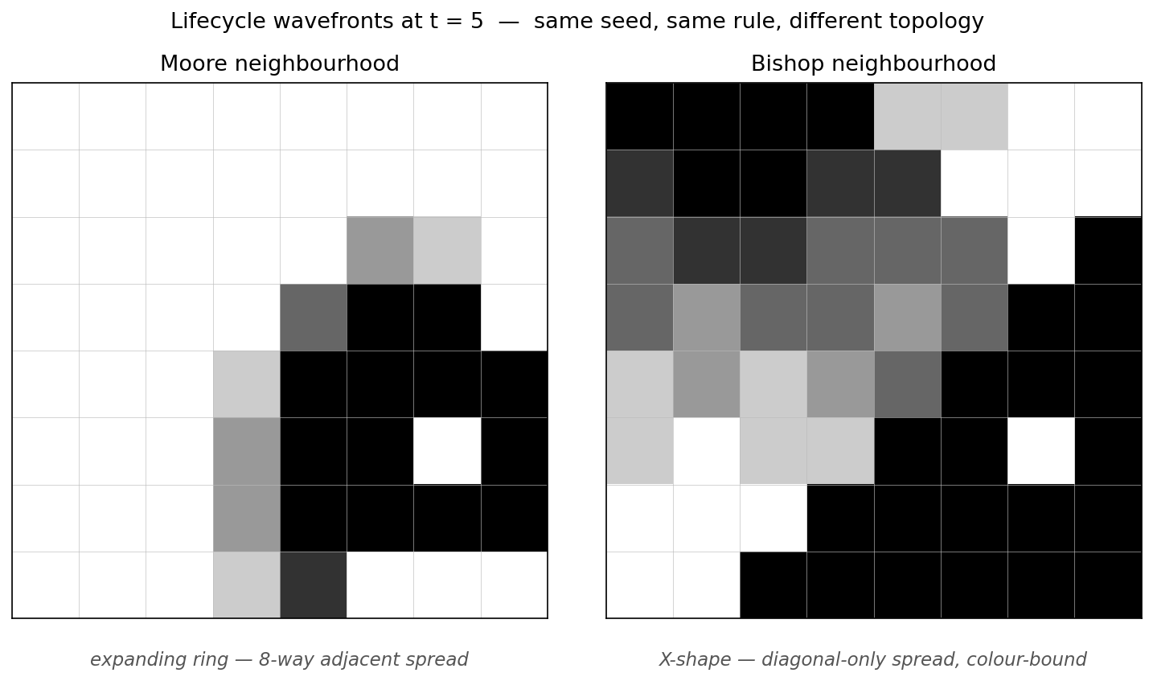
Fig. 8. Lifecycle wavefronts at t=5. Moore (left) produces a clean expanding ring with visible phase gradient; bishop (right) has already saturated one parity class via diagonal spread while leaving the opposite parity structurally empty.
7. Conclusion
This project demonstrated that adaptive density scaling resolves the topology-size limitation that prevented Fridenfalk's chess-variant CA generation method from working on non-Moore topologies. The most direct evidence is the rook recovery: 0.031 coverage and extinction at generation 3 under fixed B23/S23, versus 0.875 coverage and 60 sustained generations under adaptive density [0.250, 0.375] with the same seed and topology.
With the adaptive foundation in place, five extensions were built that would each have been infeasible under the fixed baseline:
The five Fridenfalk rules, expressed as density windows, produce a clean and predictable coverage progression on Moore topology (0.085 to 0.769), with Rule 3 achieving the near-ideal 0.496 coverage that Fridenfalk's method is designed to produce. The Rule 5 non-contiguous gap mechanism produces structurally distinct boards (11 holes versus 0) that demonstrate the gap is not merely a perturbation but a qualitatively different generation mode.
The asymmetric rule-zone model uses Cadmium's AsymmCell formalism to run multiple Fridenfalk rules on the same board simultaneously. The zone boundaries are measurable: symmetry drops from 1.000 (uniform rules) to 0.427 (r3_r5 bishop), with the magnitude of the drop corresponding to the degree of rule contrast. This is a unique contribution with no precedent in the Cell-DEVS chess-variant literature.
The LoS blocking model adds chess-semantic obstruction for sliding pieces, creating a self-shielding mechanism that revives otherwise-extinct bishop patterns (0.000 to 0.125 for Rule 1 bishop). The effective neighborhood becomes dynamic, shrinking in clusters of live cells, which makes narrow density windows feasible in contexts where they would otherwise fail.
The lifecycle model replaces binary alive/dead with continuous activity and four-phase dynamics (dormant, activating, active, decaying), enabling visualization of wavefront propagation that is shaped by the piece topology. The rook invariant (identical metrics across all three speed variants) confirms that certain topologies produce speed-independent steady states.
Three structural caveats apply to the approach. First, bishop colour-parity binding creates irreducible fragmentation. The bishop's diagonal-only reach partitions the board into two independent sub-grids, and no rule can overcome this topological constraint. Rule 4 bishop achieves 0.500 coverage but 32 components and 18 holes. Second, seed cardinality must scale with neighborhood reach. A 5-cell seed that works for Moore (8 neighbors) is too sparse for the queen (27 neighbors), which requires hand-tuned seeds and wider density windows to avoid extinction or saturation. Third, synchronous updates on wide neighborhoods can produce cascade artifacts where large regions flip simultaneously between alive and dead states, leading to oscillation between extremes rather than stable intermediate patterns.
Future work could address queen sensitivity through automated seed optimization using evolutionary search over seed configurations. Asynchronous update strategies could reduce cascade artifacts on wide neighborhoods. The LoS model could be extended to asymmetric configurations where different zones use different blocking semantics (e.g., one zone uses LoS while another does not). The asymmetric framework also opens the possibility of gradient-based rule assignment, where density thresholds vary smoothly across the board rather than switching at discrete boundaries, potentially eliminating the sharp boundary artifacts visible in the current zone layouts.

References
[1] P. Fridenfalk, "Procedural Generation of Game Boards Using Cellular Automata with Conway's Game of Life Variants," International Journal of Computer Games Technology, 2023.
[2] Cadmium v2: A Cell-DEVS Simulator. ARSLab, Carleton University. https://github.com/SimulationEverywhere/cadmium_v2
[3] Cell-DEVS Web Viewer. ARSLab, Carleton University. https://devssim.carleton.ca/cell-devs-viewer/
[4] S. Wolfram, "Statistical Mechanics of Cellular Automata," Reviews of Modern Physics, vol. 55, no. 3, pp. 601-644, 1983.
[5] M. Gardner, "Mathematical Games: The fantastic combinations of John Conway's new solitaire game 'life'," Scientific American, vol. 223, no. 4, pp. 120-123, 1970.
[6] G. Wainer and N. Giambiasi, "Application of the Cell-DEVS Paradigm for Cell Spaces Modelling and Simulation," Simulation, vol. 76, no. 1, pp. 22-39, 2001.
[7] B. P. Zeigler, H. Praehofer, and T. G. Kim, Theory of Modeling and Simulation, 2nd ed. Academic Press, 2000.
[8] G. Wainer, Discrete-Event Modeling and Simulation: A Practitioner's Approach. CRC Press, 2009.
[9] R. Goldstein and G. Wainer, "Modelling Crowd Dynamics Using a DEVS-Based Approach," in Proc. 2014 Spring Simulation Multiconference (SpringSim), SCS, 2014.
[10] SIW Battle Scenario Cell-DEVS Model Example. ARSLab, Carleton University.

