**Dr. Ambedkar Institute of Technology**

((Near Jnana Bharathi Campus, Mallathahalli, Bengaluru – 560056)

Department of Computer Science & Engineering

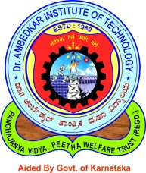

5th Semester

“Environmental Sciences”

**(21CV507)**

Assignment:

**Submitted to:**

Dr. Honnanagoudar.s.s.

**Submitted By:**

|  |  |
| --- | --- |
| **USN** | 1DA22CS409 |
| **Name** | HAJARATALI S MOGALALLI |
| **Section** | B |

**2023-2024**

**Dr. Ambedkar Institute of Technology**

((Near Jnana Bharathi Campus, Mallathahalli, Bengaluru – 560056)

Department of Computer Science & Engineering



5th Semester

“Environmental Sciences”

**(21CV507)**

Group Activity:

WASTE MANAGEMENT AND RECYCLING PRACTICES

**Submitted to:**

Dr. Honnanagoudar.s.s.

**Submitted By:**

|  |  |
| --- | --- |
| **USN** | **Name** |
| 1DA21CS087 | Mohammed Ghouse |
| 1DA22CS088 | Mohammed Saffan |
| 1DA22CS089 | Moka Shanmukha Sai Madhav |
| 1DA22CS090 | Monika N |

**2023-2024**