**UNIT 5**

**Artificial Neural Networks:**

Fundamental Concepts

Evolution of Neural Network

Basic Model of ANN

Important terminologies of ANN

McCulloch-Pitts Neuron

Hebb Network

Perceptron Networks

Backpropagation Networks

Fundamental Concepts

* Neural networks are those information processing systems, which are constructed and implemented to model the human brain.
* The main objective of the neural network research is to develop a computational device for modelling the brain to perform various computational tasks at a faster rate than the traditional systems.
* Artificial neural networks perform various tasks such as pattern matching and classification, Optimization function, approximation, vector quantization, data clustering.
* These tasks are very difficult for traditional computers, which are faster in algorithmic computational tasks and precise arithmetic operations

Traditional Computer Vs ANN

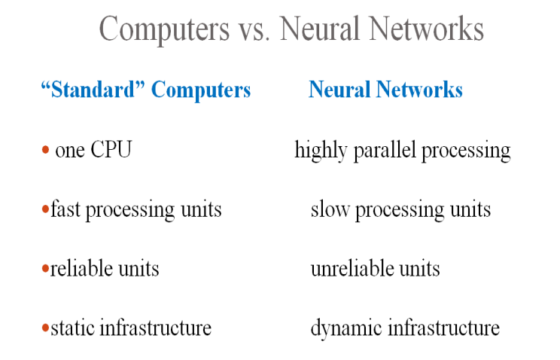

|  |  |  |
| --- | --- | --- |
| Aspect | Traditional Computer | Artificial Neural Network (ANN) |
| Architecture | Von Neumann Architecture, CPU, memory, I/O devices | Inspired by the human brain, layers of interconnected neurons |
| Operations | Deterministic, same input always produces the same output | Non-deterministic, influenced by training factors and randomness |
| Programming | Rule-based, explicit instructions | Learning-based, adjusts weights based on training data |
| Approach | Algorithmic, sequence of well-defined instructions | Model-based, solutions derived from training on data |
| Applications | General-purpose, word processing, scientific calculations | Specialized tasks, image/speech recognition, NLP, predictive analytics |
| Precision | High precision in arithmetic and logical operations | Effective at pattern recognition, unstructured data interpretation |
| Data Handling | Structured data, predefined formats | Unstructured data, learns from examples |
| Memory Management | Hierarchical (RAM, cache, storage) | Often utilizes distributed computing resources (GPUs, TPUs) |
| Performance | Depends on clock speed, CPU cores, and memory efficiency | Improves with more data and better algorithms, benefits from parallelism |
| Scalability | Add more processing power or memory | Add more processing power or memory |

ARTIFICIALNEURALNETWORK-DEFINITION

* An artificial neural network (ANN) may be defined as an information processing model that is inspired by the way biological nervous systems, such as the brain, process information. This model tries to replicate only the most basic functions of the brain.
* The key element of ANN is the novel structure of its information processing system.
* An ANN is composed of a large number of highly interconnected processing elements(neurons) working in union to solve specific problems.

ARCHITECTURE OF A SIMPLE ARTIFICIAL NEURAL NETWORK

* ANN possess a large number of processing elements called nodes/neurons which operate in parallel.
* Neurons are connected with others by connection link.
* Each link is associated with weights which contain information about the input signal.
* Each neuron has an internal state (activation or activity level) of its own which is a function of the inputs that neuron receives.
* The activation signal of a neuron is transmitted to other neurons. Remember, a neuron can send only one signal at a time, which can be transmitted to several other neurons.

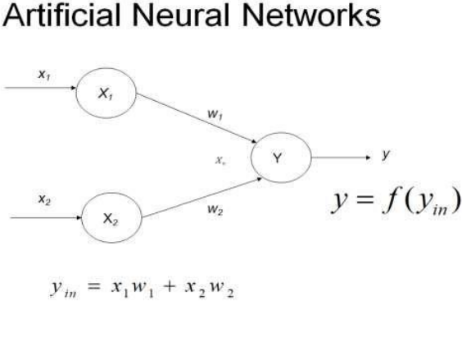

* To depict the basic operation of a neural net, consider a set of neurons, say X1 and X2 , transmitting signals to another neuron, Y.
* Here X1 and X2 are input neurons, which transmit signals, and Y is the output neuron, which receives signals.
* Input neurons X1 and X2 are connected to the output neuron Y, over a weighted interconnection links (w1, and w2) as shown in Figure.
* For the above simple neuron net architecture, the net input has to be calculated in the following way



* where x1 and x2 are the activations of the input neurons X1, and X2, i.e., the output of input signals. The output y of the output neuron Y can be obtained by applying activations over the net input, i.e., the function of the net input

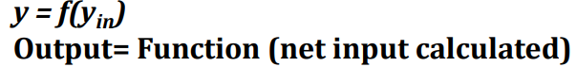

* The function to be applied over the net input is called activation function.

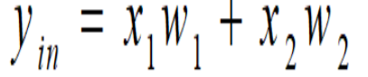

* The calculation of the net input is similar to the calculation of output of a pure linear straight-line equation (y = mx).

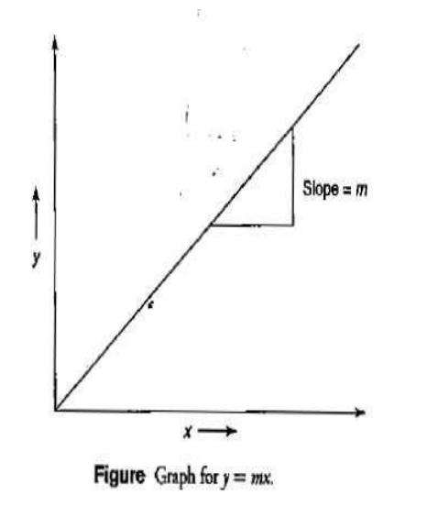

* Here, to obtain the output y, the slope m is directly multiplied with the input signal. This is a linear equation.
* Thus, when slope and input are linearly varied, the output is also linearly varied, as shown in graph.
* This shows that the weight involved in the ANN is equivalent to the slope of the linear straight line.

BIOLOGICAL NEURON NETWORK

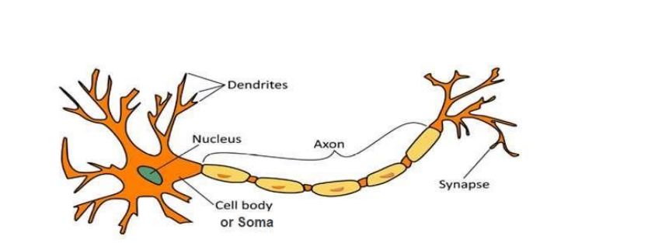

* A nerve cell (neuron) is a special biological cell that processes information.
* According to an estimation, there are huge number of neurons, approximately numerous interconnections, approximately .
* The biological neuron depicted in Figure above consists of 4 main parts:

1. **Dendrites** − They are tree-like branches, responsible for receiving the information from other neurons it is connected to.
2. **Soma** − It is the cell body of the neuron and is responsible for processing of information.
3. **Axon** − It is just like a cable through which neurons send the info.
4. **Synapses** − (bulb-like organ) It is the connection between the axon and other neuron dendrites

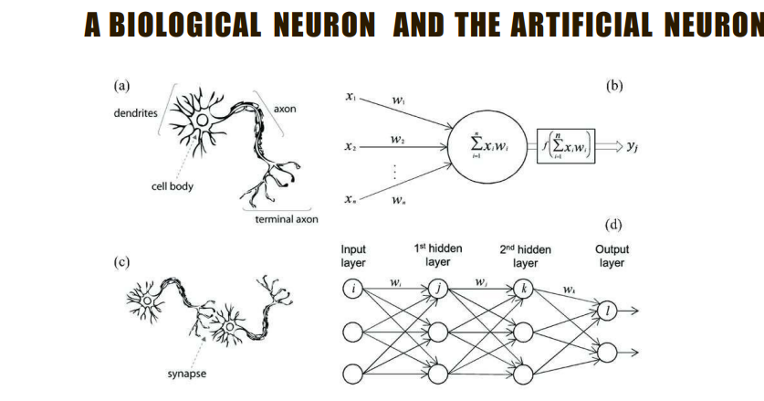

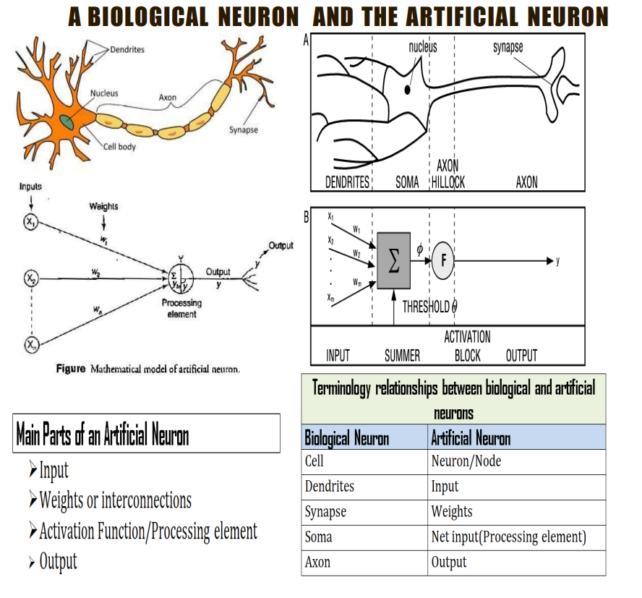

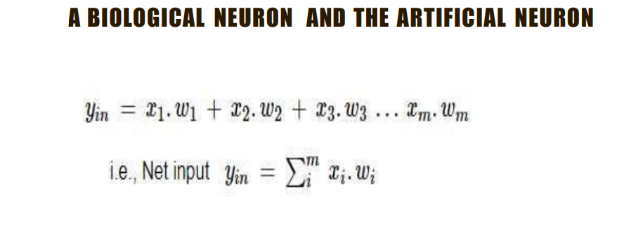

* where i represents the i th processing element.
* The activation function is applied over it to calculate the output.
* The weight represents the strength of synapse connecting the input and the output neurons.
* A positive weight corresponds to an excitatory synapse, and a negative weight corresponds to an inhibitory synapse.

COMPARISON BETWEEN BIOLOGICAL NEURON AND THE ARTIFICIAL NEURON

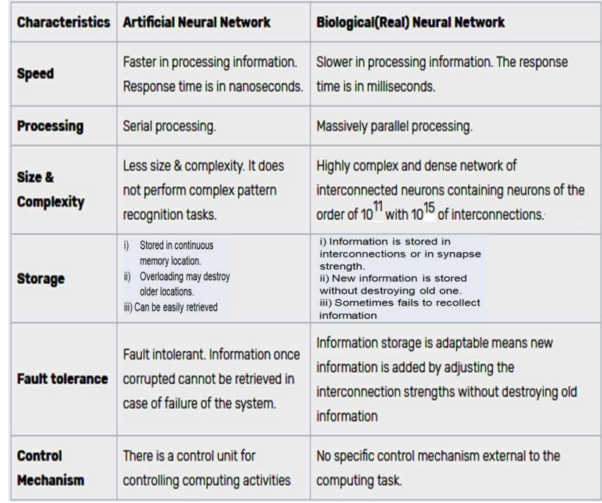

CHARACTERISTICS OF ANN

* 1. It is a neutrally implemented mathematical model.
  2. There exist a large number of highly interconnected processing elements called neurons in an ANN.
  3. The interconnections with their weighted linkages hold the informative knowledge.
  4. The input signals arrive at the processing elements through connections and connecting weights.
  5. The processing elements of the ANN have the ability to learn, recall and generalize from the given data by suitable assignment or adjustment of weights.
  6. The computational power can be demonstrated only by the collective behaviour of neurons, and it should be noted that no single neuron carries specific information.

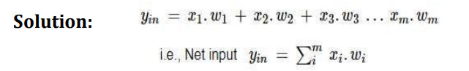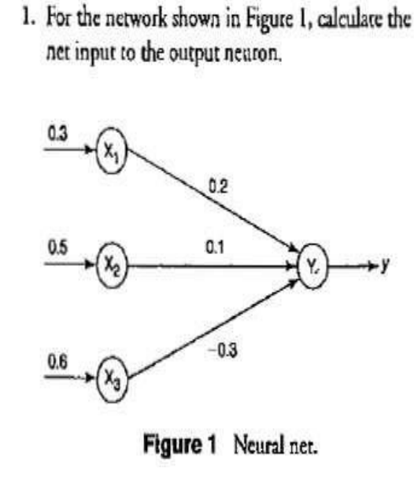

* The given neural net consists of three input neurons and one output neuron.
* The inputs and weights are

[x1, x2 ,x3 ] = [0.3, 0.5, 0.6] [w1 ,w2 ,w3 ] = [0.2,0.1,-0.3] ➢The net input can be calculated as

