

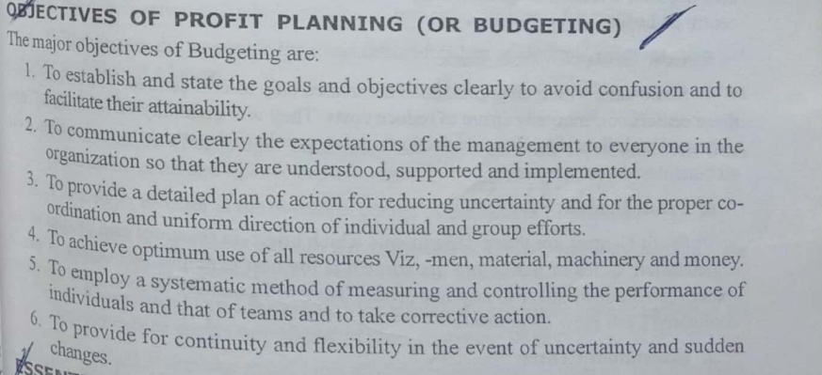

OBJECTIVES OF PROFIT PLANNING (OR BUDGETING)

The major objectives of Budgeting are:

1. To establish and state the goals and objectives clearly to avoid confusion and to facilitate their attainability.

2. To communicate clearly the expectations of the management to everyone in the organization so that they are understood, supported and implemented.

3. To provide a detailed plan of action for reducing uncertainty and for the proper co- ordination and uniform direction of individual and group efforts.

4. To achieve optimum use of all resources Viz, -men, material, machinery and money.

5. To employ a systematic method of measuring and controlling the performance of individuals and that of teams and to take corrective action.

6. To provide for continuity and flexibility in the event of uncertainty and sudden changes.

**Explain 5 differences between estimation and costing**

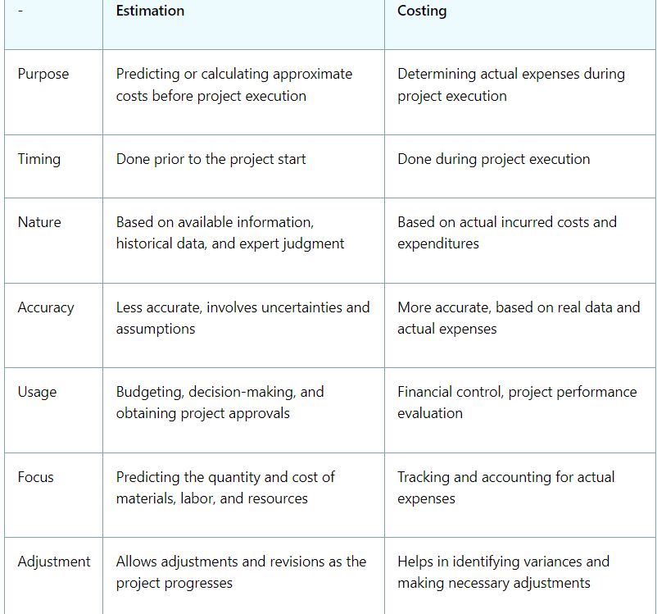



**1. Fixed Budget**

A fixed budget is a budget that remains unchanged irrespective of the level of activity or volume of production. It is based on the assumption that certain costs will remain constant and is typically prepared for a specific period (e.g., a year). It does not account for variations in the business environment or changes in production levels.

**2. Flexible Budget**

A flexible budget, on the other hand, is designed to change in accordance with the level of activity or volume of production. It adjusts to different levels of output and is more dynamic compared to a fixed budget. This type of budget helps in understanding the variations in costs with changes in activity levels and is useful for performance evaluation.

**3. Functional Budgets**

Functional budgets are prepared for various functions or departments within an organization. Each functional budget focuses on a specific area and helps in planning and controlling the costs associated with that particular function. The major functional budgets include:

* **(a) Sales Budget:**
  + The sales budget forecasts the expected sales revenue and is based on the anticipated volume of sales, pricing strategy, and market conditions. It is the starting point for preparing other budgets as it influences production, purchasing, and labor needs.
* **(b) Production Budget:**
  + The production budget outlines the number of units that must be produced to meet sales demands and maintain inventory levels. It takes into account production capacity, planned inventory levels, and the sales budget.
* **(c) Financial Budget:**
  + The financial budget encompasses the financial aspects of the business, including cash flow projections, capital expenditures, and funding requirements. It ensures that the organization has sufficient financial resources to meet its obligations and achieve its objectives.
* **(d) Material Purchase Budget:**
  + The material purchase budget estimates the quantity and cost of raw materials required for production. It is based on the production budget and helps in planning procurement activities, ensuring that materials are available when needed.
* **(e) Labour Budget:**
  + The labor budget forecasts the labor hours and associated costs needed to meet production goals. It considers factors such as labor rates, workforce availability, and production schedules.
* **(f) Selling and Distribution Budget:**
  + The selling and distribution budget estimates the costs associated with selling the products and delivering them to customers. It includes expenses such as advertising, sales commissions, transportation, and warehousing.

**4. Master Budget**

The master budget is a comprehensive and consolidated budget that incorporates all the individual functional budgets. It provides an overall financial plan for the organization and includes budgeted financial statements such as the income statement, balance sheet, and cash flow statement. The master budget serves as a roadmap for the organization’s financial activities and provides a coordinated approach to achieving its goals.