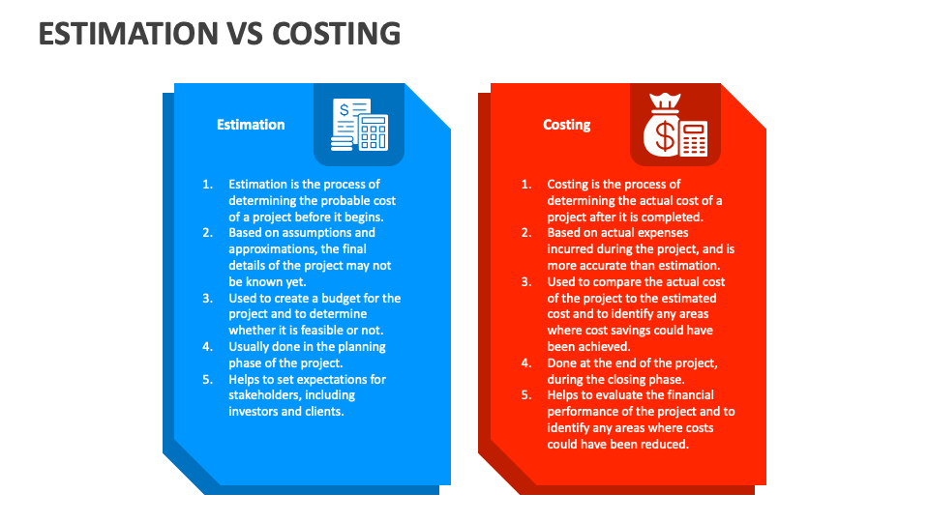

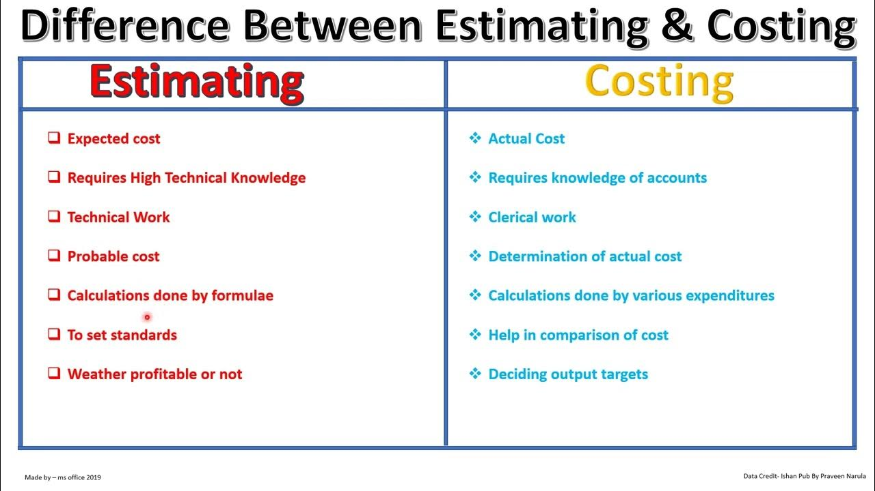

| **Aspect** | **Estimation** | **Costing** |
| --- | --- | --- |
| **Definition** | A rough calculation or judgment of value, quantity, or extent based on incomplete data. | The process of determining the actual cost of producing a product or providing a service based on detailed data. |
| **Purpose** | Used for forecasting, planning, and budgeting. | Used for financial reporting, cost control, and pricing decisions. |
| **Accuracy** | Generally, less accurate due to assumptions and approximations. | More accurate as it is based on actual data and detailed analysis. |
| **Time of Usage** | Typically used before the start of a project or production. | Used during and after the completion of a project or production. |
| **Data Requirement** | Requires less detailed data, often relies on historical data and expert judgment. | Requires detailed and specific data related to actual expenses and resource usage. |
| **Basis** | Based on predictions and expectations. | Based on actual transactions and incurred costs. |
| **Flexibility** | More flexible and adaptable to changes in assumptions and conditions. | Less flexible as it is based on fixed and recorded data. |
| **Risk Involvement** | Higher risk due to potential inaccuracies and unforeseen changes. | Lower risk as it reflects actual performance and costs. |
| **Application Areas** | Used in initial project proposals, feasibility studies, and budget preparation. | Used in cost accounting, financial statements, and post-project analysis. |
| **Scope** | Broader scope with potential variations. | Narrower scope with specific, detailed focus. |
| **Impact on Decision Making** | Provides a general idea for strategic decisions. | Offers precise data for tactical and operational decisions. |