**Dr. Ambedkar Institute of Technology**

[As Auseronous Institution, affiliated to VTU, Belgam and Aided by Government of Karnataka]



Near Jnana Bharathi Campus, Mallathahalli, Bangalore-560056.

DEPARTMENT OF MECHANICAL ENGINEERING

ENGINEERING ECONOMICS 21MET 6053

REPORT ON

**“**World Economy & Indian Economy**”**

Under Guidance of

Dr.SHRINIVAS

Assistant Professor

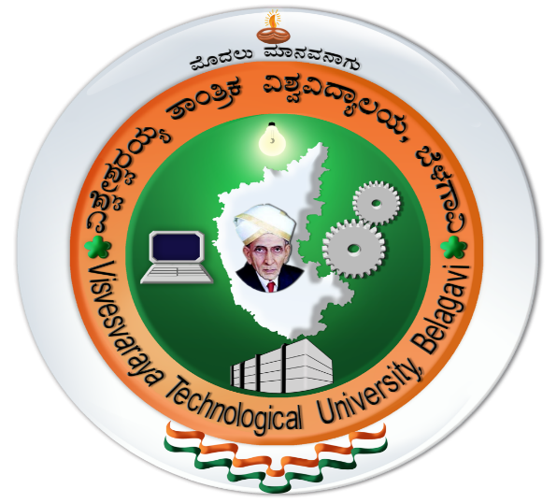

# **Visvesvaraya Technological University**

# 

### 

Submitted By:

GROUP MEMBERS:

|  |  |  |
| --- | --- | --- |
| **SI No:** | **Name** | **USN** |
| **01** | **Hajratali s mogalalli** | **1DA22CS409** |
| **02** | **Abhinav Kumar** | **1DA21IS001** |
| **03** | **BHARATKUMAR N MEDEGAR** | **1DA21CS033** |
| **04** | **Sumith sindhe** | **1DA21AE028** |
| **05** | **Karthik V Desai** | **1DA21CS073** |
| **06** | **PAVAN G B** | **1DA21CS099** |
| **07** | **MANJUNATH GOWDA R** | **1DA21CS084** |
| **08** | **YASHAS B Y** | **1DA21CS169** |
| **09** | **P Bharat Kumar Reddy** | **1DA21IS034** |
| **10** | **Abhishek H.** | **1DA21IS002** |
| **11** | **Mallikarjun** | **1DA21EC077** |