**Introduction**

**Introduction to Apache Kafka**

Apache Kafka is a powerful and widely adopted distributed event streaming platform. Designed for high-throughput, fault-tolerant, and scalable data pipelines, Kafka has become an integral component in modern software architecture. Below is a detailed breakdown of its significance, history, and the purpose of this report.

**Overview of Apache Kafka**

Apache Kafka is an open-source platform that enables the **real-time streaming of events**. Events, in this context, are actions or occurrences like user activity, system logs, or application events. Kafka excels in providing a robust system for collecting, storing, and processing such events.

**Distributed Nature**: Kafka operates as a cluster of servers (brokers) and is designed to be highly scalable. This allows organizations to handle massive volumes of data efficiently.

**Event Streaming Platform**: It supports the publishing, subscribing, storing, and processing of event streams in real-time. These capabilities make it ideal for applications such as log aggregation, event sourcing, and real-time analytics.

**Origins and Current Status**: Kafka was originally developed by LinkedIn to address their growing needs for data processing and later open-sourced in 2011. It is now managed under the Apache Software Foundation, ensuring continuous development and widespread adoption.

In essence, Kafka bridges the gap between data producers and consumers, enabling systems to communicate asynchronously and process data efficiently.

**Importance of Messaging Systems**

Modern software systems are often built as a collection of independent services or applications that need to communicate with each other. This is where **messaging systems** come into play.

**Asynchronous Communication**: Unlike synchronous communication, messaging systems allow producers (senders of data) and consumers (receivers) to operate independently. This decoupling ensures that even if one system is temporarily down, the overall functionality remains unaffected.

**Key Features Kafka Addresses**:

**High Throughput**: Kafka handles millions of events per second, making it ideal for systems with heavy data loads.

**Fault Tolerance**: By replicating data across brokers, Kafka ensures that no messages are lost, even if parts of the system fail.

**Real-Time Processing**: With the ability to process streams in real-time, Kafka is used in applications like monitoring, fraud detection, and user personalization.

**History and Evolution**

Kafka’s journey from a LinkedIn project to a global standard is a testament to its innovation and adaptability.

**Origins at LinkedIn**

Around 2008, LinkedIn faced challenges in managing and processing their growing data needs. Existing solutions lacked the scalability and fault tolerance required.

Kafka was introduced as a distributed log-based message broker to solve this problem.

**Open-Sourcing in 2011**

Recognizing the broader utility of Kafka, LinkedIn contributed it to the open-source community. This decision allowed developers worldwide to adopt and enhance it.

**Growth under Apache Software Foundation**

The Apache Kafka project gained significant momentum, with contributions from companies like Confluent, Uber, and Netflix.

Over the years, Kafka evolved beyond a messaging system to a comprehensive event streaming platform, introducing features like **Kafka Streams** and **Kafka Connect**.

**Current Status**

Kafka is now a critical tool used across industries, including finance, e-commerce, telecommunications, and IoT. Its continuous development ensures it remains a leader in the event streaming space.

**Objectives**

The primary goal of this report is to provide an in-depth understanding of Apache Kafka. Key objectives include:

**Architecture Analysis**:

Explore how Kafka achieves scalability, durability, and fault tolerance.

**Feature Exploration**:

Examine the unique capabilities that set Kafka apart from other messaging systems.

**Use Case Demonstration**:

Highlight real-world scenarios where Kafka is used to solve critical business problems.

**Relevance in Modern Systems**:

Understand Kafka’s role in supporting microservices, real-time analytics, and distributed systems.

**Fundamentals of Apache Kafka**

Apache Kafka is a robust and scalable distributed messaging system designed to handle large volumes of real-time data. This section delves into its core functionalities, fundamental components, and how they work together to provide high-throughput and fault-tolerant messaging.

**What is Apache Kafka?**

Apache Kafka is an **open-source publish-subscribe messaging system** optimized for distributed environments. It enables applications to exchange data asynchronously, making it an essential tool for building real-time data pipelines and streaming applications.

* **Publish-Subscribe System**: Kafka allows multiple producers to publish data to specific topics, and multiple consumers can subscribe to these topics to receive the data. This ensures decoupled communication between systems.
* **Optimized for High Throughput**: Kafka is designed to handle massive amounts of data, often processing millions of events per second.
* **Distributed Architecture**: Kafka operates as a cluster of servers, offering horizontal scalability and resilience against failures.

Kafka’s architecture and design principles make it suitable for applications ranging from real-time analytics to event sourcing and log aggregation.

**Core Concepts of Kafka**

To understand Kafka's functionality, it’s crucial to explore its key components and how they interact:

**1. Topics**

* A **topic** is a logical channel or category to which messages are sent by producers.
* Think of a topic as a folder, where each message (event) is stored sequentially.
* Topics allow consumers to subscribe and read relevant data.
* Topics are **immutable**, meaning once data is written to a topic, it cannot be altered.

**Example**: In an e-commerce application, topics like user-activity or order-events can be used to organize and process user events and order transactions.

**2. Partitions**

* Kafka splits each topic into **partitions**, which are smaller chunks of data stored across different servers (brokers).
* **Purpose**:
  + Enable parallelism: Multiple consumers can read from different partitions simultaneously.
  + Provide scalability: Partitions can be distributed across brokers to handle larger datasets.
* **Data Ordering**: Kafka guarantees ordering within a partition but not across partitions.

**Example**: A topic user-activity can have multiple partitions, such as:

* Partition 0: Logs for user IDs 0–99
* Partition 1: Logs for user IDs 100–199

**3. Producers**

* **Producers** are applications or processes that write data to Kafka topics.
* They define:
  + The topic to which data is written.
  + The partitioning logic to distribute messages across partitions (default or custom partitioners can be used).
* Producers ensure data reliability by waiting for acknowledgments from Kafka brokers before considering a message successfully sent.

**Example**: A web application sending user clicks and events to a Kafka topic for analysis.

**4. Consumers**

* **Consumers** are applications that subscribe to Kafka topics and process the data.
* Kafka allows consumers to:
  + **Pull messages**: Consumers fetch messages at their own pace.
  + Track offsets: Kafka assigns a unique offset to each message, allowing consumers to resume from where they left off in case of a failure.
* Consumers can be part of a **consumer group**, where:
  + Each consumer in the group reads data from a unique set of partitions.
  + Multiple consumers share the workload efficiently.

**Example**: A data analytics system reading events from user-activity to generate reports.

**5. Brokers**

* **Brokers** are Kafka servers that store and manage messages.
* A **Kafka Cluster** consists of multiple brokers working together, providing:
  + **Scalability**: More brokers mean more partitions and greater capacity.
  + **Fault Tolerance**: Data replication ensures that even if one broker fails, the messages are not lost.
* Each broker handles a portion of the topic partitions and ensures data delivery to consumers.

**Example**: In a cluster with three brokers, a topic with three partitions will have one partition assigned to each broker.

**Key Characteristics of Kafka**

1. **Data Integrity**:
   * Kafka ensures that all messages within a partition are stored sequentially and retrieved in the same order.
   * Messages are persisted to disk, ensuring durability.
2. **Message Retention**:
   * Kafka retains messages for a configurable duration, even after consumers have processed them.
   * This allows consumers to re-read messages if needed.
3. **Fault Tolerance**:
   * Kafka replicates partitions across multiple brokers. If one broker fails, another replica takes over seamlessly.
4. **Low Latency**:
   * Kafka’s efficient storage and retrieval mechanisms ensure minimal delays, even with high data loads.

**How Kafka Ensures Data Ordering**

Kafka guarantees that messages are delivered in the same order as they were produced but only within individual partitions. For example:

* A producer sends events 1, 2, and 3 to Partition 0.
* A consumer reading from Partition 0 will always receive the events in the order 1 → 2 → 3.

This characteristic is critical for applications like transaction processing or user activity tracking, where maintaining the sequence of events is essential.

**Kafka Architecture**

Apache Kafka’s architecture is designed to provide scalability, durability, and fault tolerance for real-time data streaming and processing. This section explains how Kafka works, describes its core components, and highlights the mechanisms that enable its performance and reliability.

**How Kafka Works**

At its core, Apache Kafka functions as a **distributed commit log** system. It efficiently handles message production, storage, and consumption in a distributed environment.

1. **Distributed Commit Log**:
   * Kafka stores messages in a structured, append-only log format.
   * Each message is assigned a unique offset, ensuring **sequential storage** within partitions.
   * Messages are stored durably on disk and replicated across multiple brokers to prevent data loss.
2. **Decoupling Producers and Consumers**:
   * Producers write data to Kafka, and consumers independently fetch this data at their convenience.
   * This decoupling ensures that producers and consumers do not need to be active at the same time.
   * Consumers can replay messages by reading from specific offsets, enabling robust fault recovery and analytics.
3. **Real-Time Streaming**:
   * Kafka processes and delivers data in real-time, making it suitable for event-driven architectures and streaming pipelines.

**Key Components of Kafka Architecture**

**1. Zookeeper (or KRaft)**

* **Zookeeper**:
  + Manages metadata about Kafka clusters, including broker states, topic configurations, and partition assignments.
  + Facilitates leader election for partitions, ensuring one broker is responsible for handling writes for a given partition.
* **KRaft (Kafka Raft)**:
  + In newer versions, Zookeeper is being replaced by KRaft, which integrates metadata management directly into Kafka.
  + KRaft simplifies deployment by eliminating the need for an external Zookeeper service.

**Role in Kafka**:

* Maintains the cluster’s health and availability.
* Coordinates updates like adding/removing brokers or topics.

**2. Brokers and Clusters**

* **Brokers**:
  + Kafka servers (brokers) handle all data storage, message distribution, and delivery.
  + Each broker manages a subset of the partitions in a cluster.
* **Cluster**:
  + A Kafka cluster consists of multiple brokers working together to store and distribute data.
  + Fault tolerance is achieved by replicating partitions across brokers.
* **Partition Assignment**:
  + Each partition of a topic is assigned to a leader broker.
  + The leader handles all read/write requests, while follower brokers replicate the data.

**Example**: A topic with 3 partitions in a cluster of 3 brokers:

* Partition 0 → Broker 1 (Leader), Broker 2 (Follower)
* Partition 1 → Broker 2 (Leader), Broker 3 (Follower)
* Partition 2 → Broker 3 (Leader), Broker 1 (Follower)

**3. Producers and Consumers**

* **Producers**:
  + Applications that send messages to Kafka topics.
  + Producers decide which partition to write data to, using:
    - Default partitioning: Round-robin assignment.
    - Custom logic: Based on keys or specific criteria.
* **Consumers**:
  + Applications that subscribe to topics and fetch data for processing.
  + Consumers operate in **consumer groups**:
    - Each consumer group ensures that only one consumer in the group reads data from a particular partition.
    - This allows horizontal scaling of consumption tasks.

**Example**: If a topic has 4 partitions and a consumer group has 2 consumers:

* Consumer 1 → Reads from Partition 0 and Partition 1
* Consumer 2 → Reads from Partition 2 and Partition 3

**4. Replication**

* Kafka ensures fault tolerance through **replication**:
  + Each partition has multiple replicas stored on different brokers.
  + One replica is elected as the leader, while others act as followers.
* If a leader broker fails, one of the followers is automatically promoted to leader.
* The replication factor is configurable for each topic.

**Example**: If a topic’s partition has a replication factor of 3:

* Partition data is stored on three brokers.
* One broker acts as the leader, and the other two serve as backups.

**Visual Diagram**

Below is a conceptual diagram illustrating Kafka’s architecture, including topics, partitions, producers, consumers, brokers, and replication.

**Diagram Description**:

* Producers send messages to specific topics.
* Topics are divided into partitions, distributed across brokers.
* Consumers in consumer groups read data from partitions.
* Replication ensures data redundancy across brokers.

*Let me know if you'd like me to generate an actual visual representation of this architecture.*

**How Kafka Ensures Fault Tolerance and Scalability**

1. **Partitioning and Distribution**:
   * Partitions allow data to be spread across multiple brokers, enabling parallel processing.
   * Consumers can scale horizontally by increasing the number of consumer instances in a group.
2. **Replication**:
   * Guarantees data availability even in the case of broker failures.
   * Configurable replication factor ensures trade-offs between storage and fault tolerance.
3. **Decoupling**:
   * Producers and consumers operate independently, ensuring flexibility in handling message production and consumption.

**Features of Apache Kafka**

Apache Kafka is widely regarded as a robust and efficient distributed messaging system. Its design incorporates key features that make it a preferred choice for handling large-scale, real-time data pipelines. Below is a detailed explanation of Kafka’s primary features:

**1. Scalability**

Kafka is designed to scale horizontally to accommodate growing data and processing demands.

* **Horizontal Scaling**:
  + Kafka can scale by adding more brokers to the cluster.
  + As brokers are added, Kafka redistributes partitions to maintain a balanced load across the cluster.
* **Partitioning**:
  + Topics in Kafka are divided into partitions, allowing parallel processing by multiple consumers.
  + Producers and consumers can also scale independently, ensuring seamless growth as data and workload increase.

**Real-World Application**: For a growing e-commerce platform, Kafka can handle increasing user activity logs and order events by simply expanding the cluster size without significant reconfiguration.

**2. Durability**

Durability ensures that messages are not lost, even in the event of system failures.

* **Message Persistence**:
  + Kafka writes all messages to disk before acknowledging their receipt to producers.
  + Messages are stored in an append-only log format, making disk operations efficient and ensuring message integrity.
* **Replication**:
  + Each partition has replicas across multiple brokers.
  + If the leader broker of a partition fails, a follower broker is promoted to leader, ensuring that data is always available.

**Durability in Practice**: In financial systems, where data loss is unacceptable, Kafka ensures reliable delivery of transactions by persisting messages and replicating data across brokers.

**3. High Throughput**

Kafka is capable of handling **millions of messages per second**, making it suitable for applications with high data ingestion and processing requirements.

* **Efficient Storage**:
  + Kafka optimizes disk usage by batching writes and compressing messages.
* **Asynchronous Processing**:
  + Producers and consumers operate asynchronously, maximizing system performance.
* **Parallelism**:
  + Partitioned topics allow multiple producers and consumers to work simultaneously, further increasing throughput.

**Example Use Case**: In IoT systems, Kafka efficiently ingests sensor data from millions of devices, enabling real-time analytics and monitoring.

**4. Stream Processing**

Kafka goes beyond messaging by providing tools for **real-time data processing**.

* **Kafka Streams API**:
  + A lightweight library that enables developers to build real-time processing applications.
  + Allows transformation, aggregation, and enrichment of data streams.
* **Connect API**:
  + Simplifies integration with external systems like databases and object stores.
* **Integration with Other Frameworks**:
  + Kafka integrates seamlessly with big data tools like Apache Spark, Flink, and Hadoop for advanced analytics and processing.

**Example**: In a ride-sharing application, Kafka Streams can process location data to match riders and drivers in real time while aggregating trip statistics for analysis.

**5. Fault Tolerance**

Kafka is designed to operate reliably even in the presence of failures.

* **Replication**:
  + Kafka replicates each partition across multiple brokers.
  + If a broker fails, another broker takes over as the leader for the affected partitions.
* **Producer Acknowledgment**:
  + Producers can specify acknowledgment levels:
    - **acks=1**: A message is considered delivered once written to the leader partition.
    - **acks=all**: Ensures data is replicated to all followers before acknowledgment, providing maximum reliability.
* **Consumer Offset Management**:
  + Kafka tracks consumer progress using offsets, allowing consumers to resume processing from the last known point in case of failure.

**Example**: In critical systems like banking, Kafka ensures that message delivery and processing are not interrupted even during hardware or network failures.

**Additional Features of Kafka**

* **Message Retention**:
  + Kafka retains messages for a configurable period, even after they are consumed. This allows consumers to reprocess historical data if needed.
* **Exactly-Once Semantics**:
  + With proper configuration, Kafka can ensure exactly-once delivery, which is critical for financial transactions and billing systems.
* **Flexibility**:
  + Kafka supports various use cases, including log aggregation, data integration, and event sourcing.

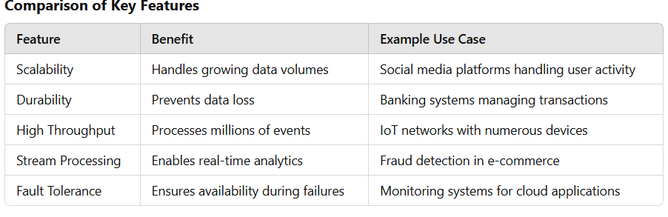

**Use Cases of Apache Kafka**

Apache Kafka’s flexibility and scalability have made it a go-to platform for numerous data-driven applications. Its robust architecture and ability to process large volumes of data in real time allow it to support a wide range of use cases across various industries. Below are some of the most common and impactful use cases:

**1. Real-Time Data Pipelines**

Kafka is frequently used to build **real-time data pipelines** that move data between systems efficiently.

* **How It Works**:
  + Producers write data to Kafka topics in real-time.
  + Kafka stores the data temporarily, ensuring durability.
  + Consumers read the data from topics and forward it to destination systems such as databases, data warehouses, or cloud storage.
* **Applications**:
  + **Log Forwarding**: Transfer application logs to monitoring systems like ELK (Elasticsearch, Logstash, Kibana).
  + **Data Synchronization**: Synchronize data between microservices or between production and analytics databases.
* **Example**:
  + A large e-commerce platform streams clickstream data from its website to a data warehouse for customer behavior analysis.

**2. Event Sourcing**

Kafka serves as a reliable backbone for **event sourcing**, where every change in the state of an application is logged as an immutable event.

* **How It Works**:
  + Events are stored in Kafka topics, forming a sequential log of actions.
  + These logs can be replayed later to reconstruct application states or debug issues.
* **Applications**:
  + **Auditing**: Maintain a history of changes for compliance and troubleshooting.
  + **Replaying Events**: Recover the state of a system after a failure or reconstruct historical states.
* **Example**:
  + In a banking system, Kafka stores every transaction as an event, enabling reconciliation and auditing for compliance with financial regulations.

**3. Log Aggregation**

Kafka simplifies **log aggregation** by collecting logs from distributed systems and centralizing them for analysis and troubleshooting.

* **How It Works**:
  + Logs from various servers, applications, or devices are sent to Kafka.
  + Kafka stores the logs in topics, which are consumed by log analysis tools.
* **Applications**:
  + Centralized logging for microservices architectures.
  + Error tracking and root cause analysis.
* **Example**:
  + A tech company uses Kafka to collect logs from hundreds of microservices, which are then analyzed by Splunk or Elasticsearch for debugging.

**4. Metrics Collection**

Kafka is widely used to collect and monitor **performance metrics** for applications and systems.

* **How It Works**:
  + System metrics like CPU usage, memory consumption, or network latency are published to Kafka topics.
  + Monitoring tools consume these metrics and generate dashboards or alerts.
* **Applications**:
  + Real-time health monitoring of IT infrastructure.
  + Application performance management.
* **Example**:
  + A cloud provider uses Kafka to stream metrics from its servers to a monitoring dashboard like Grafana for real-time performance visualization.

**5. Big Data Integration**

Kafka’s seamless integration with big data tools makes it a cornerstone for **big data pipelines**.

* **How It Works**:
  + Kafka ingests data from various sources and serves as a buffer for downstream processing.
  + Tools like Apache Spark or Hadoop consume this data for advanced analytics or machine learning.
* **Applications**:
  + Real-time analytics for fraud detection or personalized recommendations.
  + Batch processing for business intelligence.
* **Example**:
  + A telecom company streams call detail records into Kafka, which are processed by Spark for customer churn analysis.

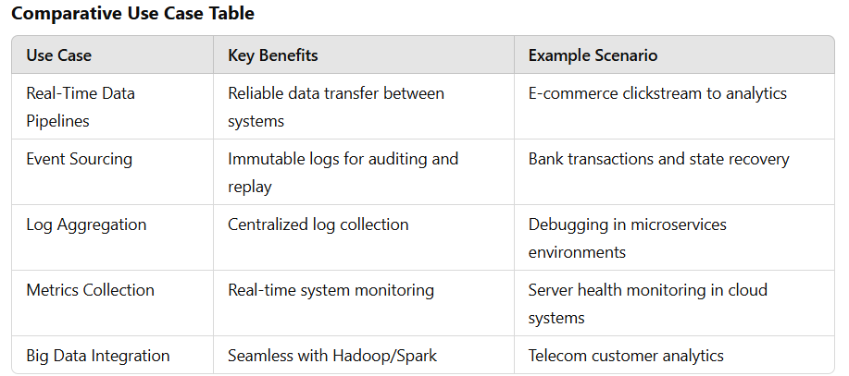

**Industry Use Cases**

1. **Finance**:
   * Real-time fraud detection by streaming transaction data into Kafka and analyzing it with machine learning algorithms.
   * Event sourcing for maintaining audit trails of financial transactions.
2. **Retail**:
   * Collecting and analyzing customer activity on e-commerce platforms for personalized recommendations.
   * Streaming inventory updates across warehouses and stores.
3. **Telecommunications**:
   * Streaming call data records for billing and churn analysis.
   * Monitoring network performance to optimize services.
4. **Healthcare**:
   * Integrating patient data across hospitals for unified electronic medical records.
   * Real-time monitoring of IoT medical devices.
5. **Media and Entertainment**:
   * Streaming video usage analytics to improve recommendation algorithms.
   * Processing social media feeds for content trend analysis.

**6. Kafka vs Other Messaging Systems**

Apache Kafka stands out among messaging systems due to its unique design principles, features, and use cases. Below is a detailed comparison of Kafka with other popular messaging systems: RabbitMQ, ActiveMQ, and AWS Kinesis.

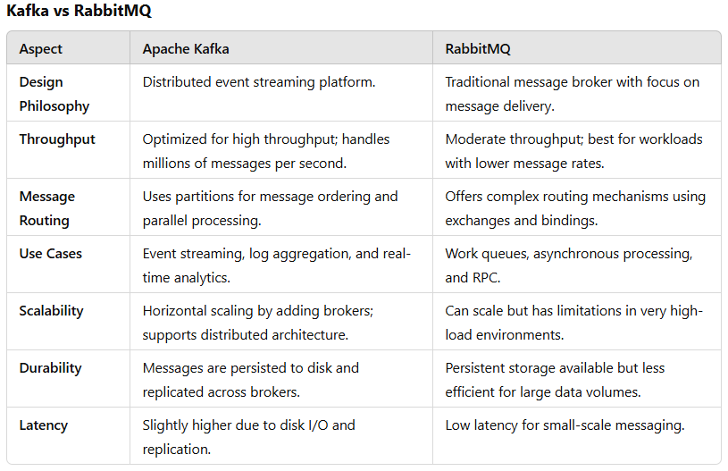

**Conclusion**:

* Kafka is ideal for high-throughput, real-time applications requiring horizontal scalability.
* RabbitMQ excels in scenarios demanding complex routing or lower message volumes with low latency.

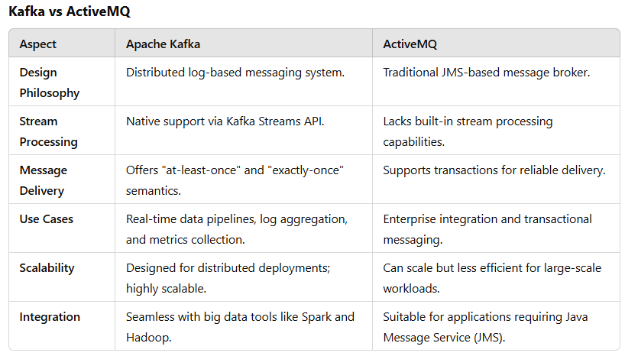

**Conclusion**:

* Kafka’s architecture is more suited for event streaming and large-scale real-time systems.
* ActiveMQ is better for applications requiring transactional messaging or enterprise integration.

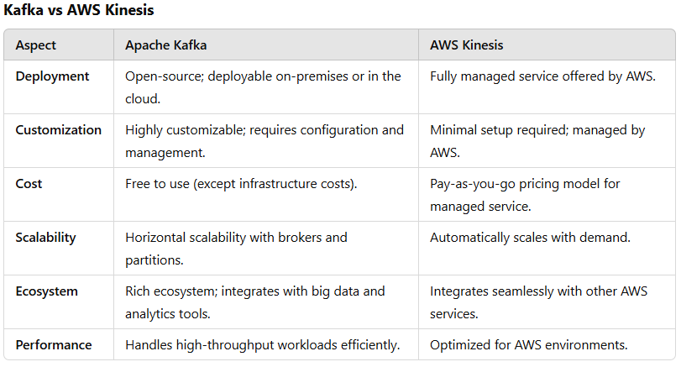

**Conclusion**:

* Kafka offers greater flexibility and control, making it suitable for organizations preferring self-hosted solutions.
* AWS Kinesis is ideal for users seeking a managed service with tight integration into AWS.

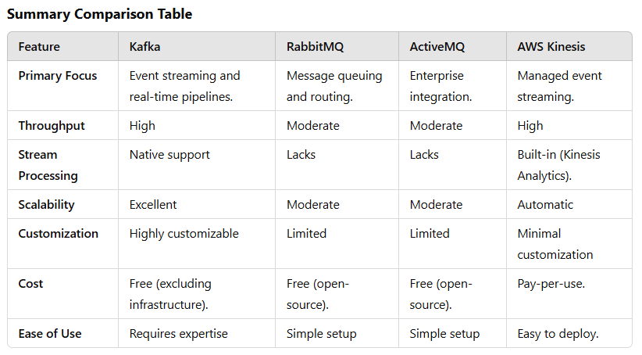

**11. Conclusion**

Apache Kafka has emerged as one of the most important tools in the modern data infrastructure ecosystem. Initially developed by LinkedIn and later open-sourced under the Apache Software Foundation, Kafka’s ability to handle real-time data streams has made it a critical component for businesses and organizations across industries. Its scalable, fault-tolerant, and high-throughput architecture enables the creation of robust data pipelines, event-driven applications, and large-scale data systems that can manage millions of messages per second.

**Recap of Kafka’s Features and Use Cases**

Kafka’s core features—such as its distributed commit log, partitioned topics, and message replication—enable high-throughput, fault-tolerant, and real-time processing of data. Kafka’s architecture is designed to scale horizontally, making it an excellent choice for systems that need to handle large volumes of data with low latency. Its support for stream processing via Kafka Streams also sets it apart from traditional messaging systems, offering organizations a way to process and analyze data in real-time.

Kafka’s use cases are diverse and include building **real-time data pipelines**, **event sourcing**, **log aggregation**, **metrics collection**, and **big data integration**. It is widely used in industries like finance, e-commerce, telecommunications, and healthcare to handle massive streams of data, ensuring businesses can process and respond to information quickly and efficiently. Kafka’s ability to integrate with other big data tools like Apache Spark and Hadoop further enhances its applicability in large-scale data processing and analytics.

**Kafka’s Role in Modern Computing**

In the current digital era, data is being generated at an unprecedented rate. Applications and systems must not only process large volumes of data but also do so in real time. Apache Kafka plays a crucial role in enabling real-time data streaming, empowering businesses to make faster decisions and react to changing conditions instantly. Whether it's streaming customer behavior data to improve user experiences, monitoring server health for proactive maintenance, or analyzing transactional data for fraud detection, Kafka’s reliability and scalability make it the go-to platform for managing real-time data at scale.

Kafka has proven to be a game-changer for building **data pipelines** that connect systems in a loosely coupled, asynchronous manner. This decoupling allows for greater flexibility and resilience in large-scale systems. It supports fault tolerance through data replication and ensures message integrity, even in the event of broker or network failures.

**The Importance of Apache Kafka in Real-Time Data Handling**

Real-time data processing has become a cornerstone of modern computing, and Apache Kafka is at the forefront of this transformation. Kafka’s ability to ingest, store, and stream data in real-time makes it indispensable for organizations that need to act quickly on data. Whether it's streaming user activity data to personalize content, aggregating logs to monitor system health, or integrating data from multiple sources into a unified data warehouse, Kafka provides the infrastructure for continuous, seamless data flow.

In conclusion, Apache Kafka has proven its worth as a high-performance, scalable, and fault-tolerant event streaming platform. Its growing adoption across industries speaks to its capability to support modern applications that rely on real-time data. As the world becomes increasingly connected and data-driven, Kafka's role in managing the flow of information and enabling timely decision-making will continue to be of paramount importance. Its features, flexibility, and robust ecosystem ensure that it remains a critical component in the future of computing, data engineering, and real-time analytics.

4o mini

**You said:**

12. References (1 Page) Include links to: Official Kafka documentation White papers and blogs Books like "Kafka: The Definitive Guide"

**ChatGPT said:**

ChatGPT

**12. References**

1. **Official Kafka Documentation**  
   The official Apache Kafka documentation is the best resource for understanding Kafka's features, installation, configuration, and usage.
   * [Apache Kafka Documentation](https://kafka.apache.org/documentation/)
2. **White Papers and Blogs**
   * **Kafka: The Definitive Guide**  
     This white paper provides an in-depth look at how Kafka works and how to use it effectively in real-world applications.
     + Kafka: The Definitive Guide
   * **Real-Time Data Streaming with Kafka**  
     This blog post discusses the architecture of Kafka and best practices for using it in real-time data processing.
     + Real-Time Data Streaming with Kafka
   * **How Kafka Powers Real-Time Data Pipelines**  
     A detailed article explaining how Kafka is used to build scalable data pipelines.
     + How Kafka Powers Real-Time Data Pipelines
3. **Books**
   * **Kafka: The Definitive Guide** by Neha Narkhede, Gwen Shapira, and Todd Palino  
     This book is a comprehensive guide to understanding and implementing Kafka, covering everything from basic concepts to advanced configurations.
     + Kafka: The Definitive Guide
   * **Kafka Streams in Action** by Bill Bejeck  
     A detailed guide to stream processing with Kafka Streams, including use cases and examples.
     + Kafka Streams in Action
4. **Additional Resources**
   * **Apache Kafka in Action** by Vikash Chhapparia  
     This book is an excellent resource for those wanting to understand Kafka from a practical perspective, with detailed examples and case studies.
     + Apache Kafka in Action
   * **Confluent Blog**  
     Confluent, the company behind Kafka, regularly publishes blogs with tutorials, use cases, and performance tuning tips.
     + Confluent Blog