**Chapter 1**

**Introduction**

* 1. **Introduction**
* The introduction highlights the core problems—traffic congestion, pollution, and time inefficiency—well.
* Consider integrating statistical data to strengthen the argument, e.g., average time spent searching for parking or pollution levels attributed to idling vehicles in congested areas.
* Use subsections for clarity, e.g., **"The Need for Automation"** and **"Environmental and Traffic Concerns."**

**Suggested Revision Example:**

"In India, where the population and vehicular traffic are escalating rapidly, the inefficiency in parking systems exacerbates road congestion and air pollution. Studies show that urban drivers spend an average of X minutes searching for parking, contributing to Y% of CO2 emissions. This project aims to address these issues by designing a comprehensive automated car parking system, ensuring efficient space utilization, reduced manual intervention, and an eco-friendly solution to urban traffic woes."

**1.2 Problem Statement**

* The problem statement is clear but can be condensed and aligned more directly to the objectives.
* Avoid repeating points already covered in the introduction. Instead, focus on summarizing the specific gaps the project addresses.

**Suggested Revision Example:**

"The rapid increase in vehicular population in public spaces has intensified parking challenges, including inefficiency in locating vacant slots, manual dependency, and traffic congestion due to improper parking. Existing systems lack real-time availability indicators, leading to increased pollution and user inconvenience. This project aims to mitigate these challenges by introducing a smart, automated parking solution tailored to Indian urban infrastructure."

**CHAPTER 2**

**2.1 Literature Survey**

The development of a smart automated parking system draws from various research efforts. Below is an overview of significant contributions:

1. **“Detecting Efficient Parking Space Using Smart Parking” by Ajay Zajam**
   * **Methodology:** Utilizes Ultra-High Frequency, Radio Frequency Identification (RFID), and IEEE 802.15.4 Wireless Sensor Networks.
   * **Key Features:** A customized algorithm collects data on the occupancy state of parking spaces and directs drivers to the nearest available parking spot.
   * **Relevance:** Highlights the importance of real-time parking guidance and data integration for enhanced user convenience.
2. **“Smart Parking System for Monitoring Cars and Wrong Parking” by Faris Alshehri**
   * **Methodology:** Employs ultrasonic sensors to detect car park availability.
   * **Key Features:** Includes vacant parking detection, improper parking alerts, a display of available parking lots, and directional indicators for drivers.
   * **Relevance:** Demonstrates how sensor technology can optimize parking efficiency and address challenges like improper parking.
3. **“Advanced CAR Parking System using Arduino” by Hemanth Chaudhary**
   * **Methodology:** Based on Arduino, the system employs authorization cards with vehicle details for user identification.
   * **Key Features:** Only authorized users with valid parking space are granted access via automated gates.
   * **Relevance:** Underlines the importance of security and user authentication in smart parking systems.
4. **“Automatic Parking Lot Mapping for Available Parking Space Detection” by Kairoek Choeychuen**
   * **Methodology:** Proposes a method to estimate parking lot maps for detecting available spaces automatically.
   * **Key Features:** Serves as a Parking Guidance System (PGS) module, aiding drivers in efficiently locating vacant parking slots.
   * **Relevance:** Highlights mapping and detection techniques critical for designing intelligent parking systems.

**2.2 Objectives**

**•Enhance User Convenience:**

Enable seamless and hassle-free parking experiences through real-time guidance and efficient management of parking spaces.

**•Increase Safety:**

Minimize the risks of accidents and vehicle damage by implementing precise and automated parking mechanisms.

**•Reduce Operational Costs:**

Lower dependency on manual labor and streamline operations to achieve cost-effective management.

**•Improve Traffic Flow:**

Reduce congestion and waiting times in parking facilities and surrounding areas by optimizing entry, exit, and slot allocation processes.

**•Optimize Space Utilization and Energy Efficiency:**

Maximize the use of available parking spaces and design the system for minimal energy consumption.

**CHAPTER 3**

**PROPOSED WORK**

**3.1 Methodology**

The proposed automated car parking system uses several integrated components, including sensors, microcontrollers, motors, and a mobile app for efficient parking management. Below is the system description and workflow:

ARDUINO UNO

IR

SENSOR

IR

SENSOR

SERVO

MOTOR

LCD DISPLAY

ESP 8266

MOBILE

APP

POWER

SUPPLY

Fig 3.1 Block diagram of car parking system

**System Overview:**

* The IR sensor at the entrance toll gate detects incoming vehicles.
* If a parking slot is available, the gate opens automatically. If the parking lot is full, the LCD displays a message indicating "Parking Full," and the gate remains closed.
* A mobile app, designed for user interaction, displays real-time updates on parking slot availability. The ESP8266 NodeMCU facilitates communication between sensors and the mobile app through a cloud service.

**Block Diagram:**

Components involved:

* **IR Sensor:** Detects vehicle presence to manage parking space occupancy and monitor availability.
* **LCD Display:** Provides real-time feedback on parking slot availability.
* **Servo Motor:** Controls entry and exit barriers.
* **Arduino Uno:** Serves as the central control unit, coordinating all components.
* **ESP8266 NodeMCU:** Connects the system to the internet, enabling remote access via the mobile app.
* **Power Supply:** Powers all components in the system.

**3.2 Flow Chart**

The flow chart outlines the logical sequence for detecting vehicles, managing parking slots, and communicating with the mobile app.

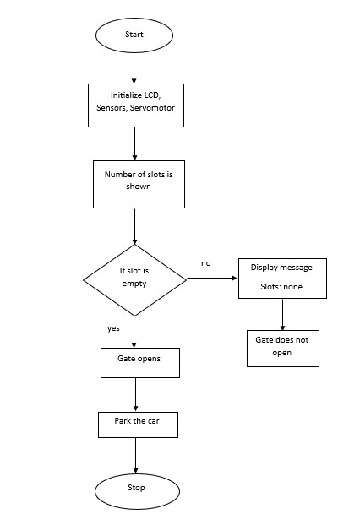

### Fig

### 3.2 Flow chart of car parking system

**3.3 Requirements and Specifications**

**Hardware Requirements:**

1. **Arduino Uno:**
   * **Description:** A microcontroller board for coordinating components.
   * **Specifications:**
     + Voltage: 5V
     + Digital I/O Pins: 14 (6 PWM outputs)
     + Analog Input Pins: 6
     + Clock Speed: 16 MHz

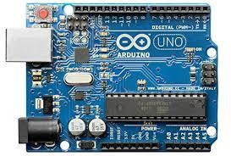

Fig 3.3 Arduino uno board

1. **IR Sensor:**
   * **Description:** Detects vehicles and monitors slot availability.
   * **Specifications:**
     + Voltage: 3.3V to 5V
     + Detection Range: Up to 30 cm
     + Output: Digital

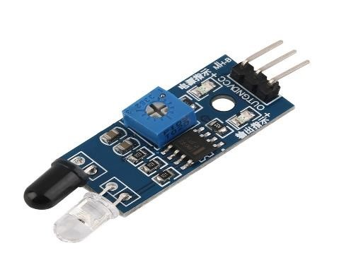

### Fig 3.4 IR Sensor

1. **Servo Motor:**
   * **Description:** Rotates gates for vehicle entry and exit.
   * **Specifications:**
     + Voltage: 4.8V to 6V
     + Torque: 1.8 kg-cm at 4.8V
     + Rotation Range: 0 to 180 degrees

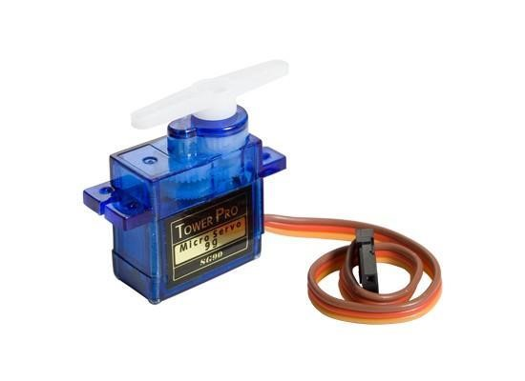

### Fig 3.5 Servo motor

1. **ESP8266 NodeMCU:**
   * **Description:** Wi-Fi module for cloud communication.
   * **Specifications:**
     + Voltage: 3.3V
     + Digital I/O Pins: 11
     + Clock Speed: 80 MHz
     + Wi-Fi: 802.11 b/g/n

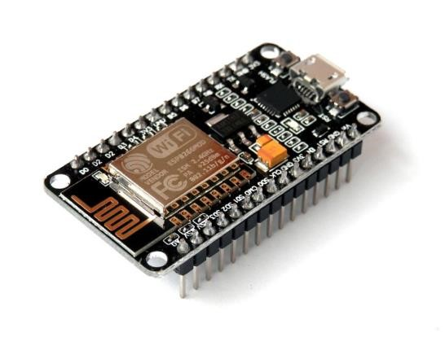

### Fig 3.6 ESP8266

1. **LCD Display (I2C):**
   * **Description:** Displays parking slot availability and system status.
   * **Specifications:**
     + Characters: 16x2
     + Voltage: 4.7V to 5.3V
     + Interface: 4-bit or 8-bit

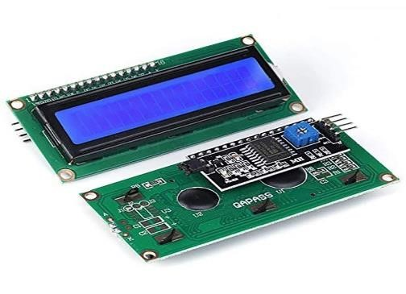

### Fig 3.7 LCD Display

**Software Requirements:**

1. **Arduino IDE:**
   * Description: Used for programming the Arduino Uno and ESP8266.
   * Features:
     + Supports C/C++ language.
     + Includes a library manager for integrating pre-written code.

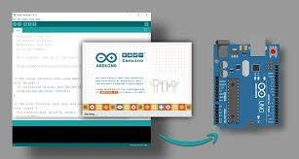

### Fig 3.8 Arduino IDE software

1. **Blynk Application:**
   * Description: Allows users to control and monitor the system via a smartphone.
   * Features:
     + Easy to use with drag-and-drop custom control panels.
     + Remote control capability for managing parking.

**3.4 Implementation**

**Steps for Implementation:**

1. **Define System Requirements:**
   * Use IR sensors to detect vehicles in parking slots.
   * Control entry/exit gates using servo motors.
   * Provide slot availability updates on an LCD display and mobile app.
2. **Hardware Setup:**
   * Install IR sensors at parking slots, entrance, and exit gates.
   * Connect servo motors to control gates.
   * Use ESP8266 NodeMCU for Wi-Fi connectivity.
3. **Develop Software:**
   * Write Arduino code for managing sensors, servo motors, and LCD display.
   * Program NodeMCU to send real-time data to the mobile app.
   * Design the Blynk app interface for users to view and control parking slots.
4. **Testing and Calibration:**
   * Test individual components and their integration.
   * Calibrate sensors for accurate vehicle detection and gate control.
   * Ensure real-time data updates on both the LCD display and mobile app.

**Circuit Diagram:**

* **Setup Details:**
  + The parking area includes two lots, each with two parking slots. IR sensors are attached to analog pins A0, A1, A2, and A3 of the Arduino Uno. Additional IR sensors at the entrance and exit are connected to digital pins 5 and 7.
  + Servo motors, connected to pins 9 and 10, control the gates. The LCD display connects to A4 and A5.
  + ESP8266 manages data transfer, and all components are powered through a 5V supply from the Arduino.

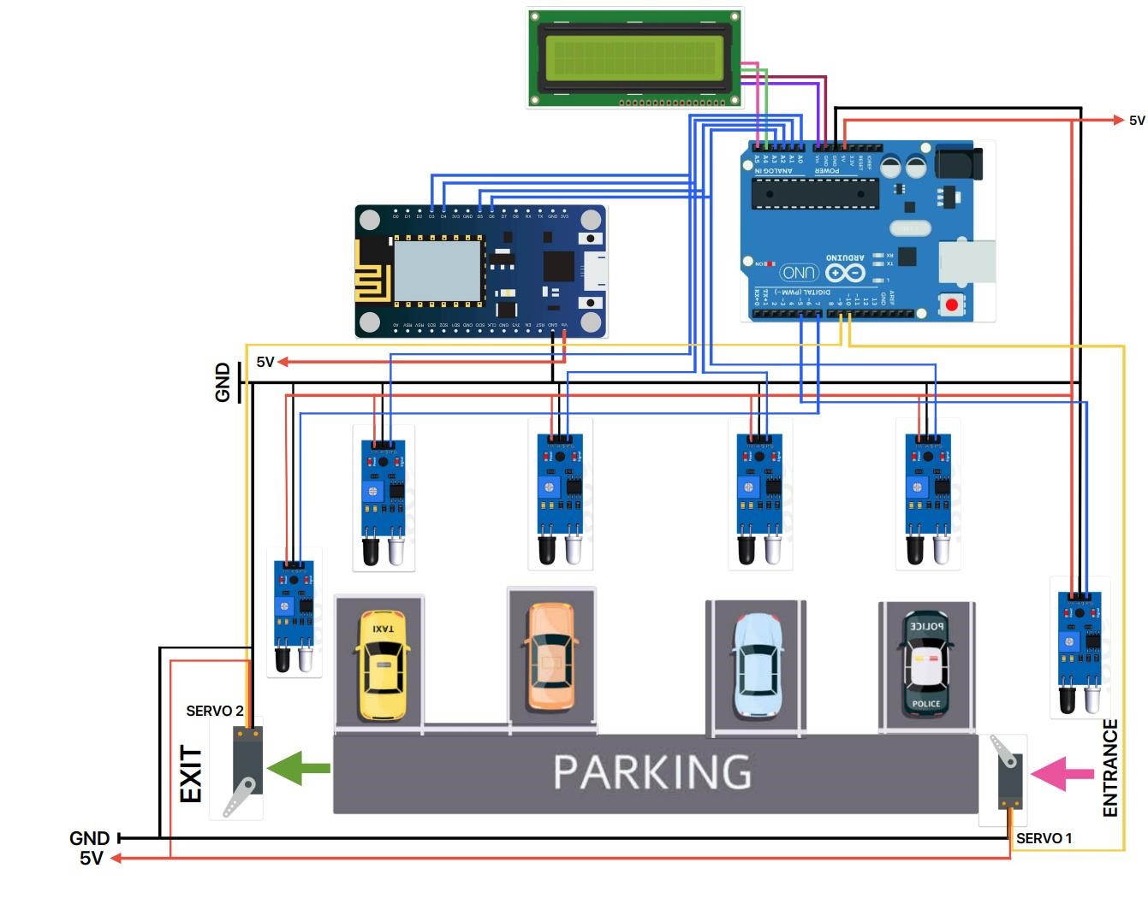

***Fig 3.9 Circuit diagram of Automated car parking system***

**CHAPTER 4**

**RESULTS AND DISCUSSION**

**4.1 Results**

The automated car parking system achieved significant success by efficiently managing parking spaces using modern IoT components. Key achievements include:

* **Accurate Detection:** IR sensors effectively detected vehicle presence with high precision.
* **Reliable Actuation:** Servo motors operated promptly and smoothly in response to sensor inputs, ensuring seamless vehicle movement.
* **User-Friendly Interface:** The Blynk mobile application enabled users to remotely monitor slot availability and control gates with ease.
* **Real-Time Connectivity:** NodeMCU ESP8266 provided stable and robust Wi-Fi connectivity, ensuring real-time updates and communication.
* **On-Site Display:** The LCD display gave clear and immediate updates on parking slot status and gate functionality, enhancing the overall user experience.

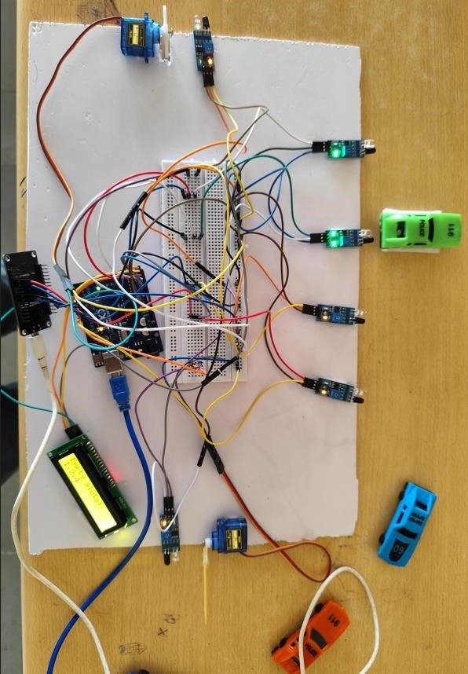The system demonstrated exceptional reliability and scalability, making it adaptable for future expansions. The integration of IR sensors, servo motors, NodeMCU, and the LCD display was seamless, offering an intuitive and convenient parking solution. This project exemplifies the transformative potential of IoT-based systems in creating efficient and user-friendly infrastructure solutions.

**fig 4.1 working model**

**4.2 Applications**

The automated car parking system is versatile and applicable in various environments:

1. **Urban Areas:**
   * **Commercial Buildings:** Ideal for office buildings, shopping malls, and hotels where parking space is limited.
   * **Residential Complexes:** Suitable for high-rise apartments and gated communities.
2. **Transport Hubs:**
   * **Airports:** Helps accommodate large vehicle volumes, streamlining passenger experiences.
   * **Train Stations and Bus Terminals:** Manages commuter parking efficiently.
3. **Hospitals and Medical Facilities:**
   * Ensures convenient and efficient parking for patients, visitors, and staff in high-demand areas.
4. **Entertainment and Sports Venues:**
   * Effectively handles parking during large events, reducing congestion and improving traffic flow.

**4.3 Advantages**

1. **Space Efficiency:**
   * **Maximized Space Utilization:** Automated systems optimize space usage by eliminating the need for driving lanes and ramps.
2. **Time Savings:**
   * **Quick Parking and Retrieval:** Vehicles can be parked and retrieved faster compared to traditional systems.
   * **Reduced Search Time:** Drivers save time by avoiding the need to search for parking slots.
3. **Cost Efficiency:**
   * **Lower Operational Costs:** Automated systems require less maintenance, lighting, and ventilation compared to traditional parking lots.
4. **Environmental Benefits:**
   * **Reduced Emissions:** Minimizing idle time and unnecessary vehicle movement reduces carbon emissions.

**4.4 Disadvantages**

1. **Initial Costs:**
   * Automated parking systems involve significant upfront costs for installation. Balancing initial investment with long-term benefits is essential.
2. **Maintenance Needs:**
   * Regular maintenance and robust security measures are necessary to ensure smooth operations and prevent potential failures.

**CHAPTER 5**

**CONCLUSION AND FUTURE SCOPE**

**5.1 Conclusion**

Automated car parking systems represent a significant advancement in addressing urban parking challenges. Our project demonstrates how these systems leverage modern technology to enhance parking efficiency and optimize space utilization. They are particularly beneficial in high-traffic areas such as hospitals, shopping complexes, and transport hubs, as they reduce operational costs and simplify parking management.

By automating the parking process, the system provides a safer and more streamlined experience for users while contributing to environmental sustainability by reducing emissions and conserving energy. The project illustrates how such systems improve traffic flow, enhance safety, and reduce the dependency on manual parking solutions.

Looking ahead, automated car parking systems will play an essential role in smart city development, responding to the growing demand for efficient and intelligent parking solutions. Adopting these technologies paves the way for more sustainable and user-friendly urban environments, setting a new standard for convenience and accessibility in parking infrastructure.

**5.2 Future Scope**

1. **Integration with Smart Cities:**
   * These systems can be integrated with urban infrastructure, providing real-time parking updates, optimizing traffic flow, and reducing congestion in smart city frameworks.
2. **Enhanced User Experience:**
   * Mobile app integration can offer real-time parking availability, navigation assistance, and payment options, creating a seamless and convenient experience for users.
3. **Advanced Safety Features:**
   * Future iterations can include additional safety measures such as collision detection, fire alarms, and emergency response mechanisms, ensuring secure parking facilities.
4. **Cost-Effective Solutions:**
   * Leveraging cost-efficient technologies like Arduino and ESP8266 can reduce the dependency on expensive hardware and infrastructure, making it accessible for a wider range of parking operators.

**REFERENCES**

* Kabir, A.Z.M. Tahmidul. "Automated Parking System with Fee Management Using Arduino." Department of Electrical and Electronic Engineering, American International University-Bangladesh.
* Smith, Alan G. *Introduction to Arduino*. 2011.
* Alshehri, Faris, Almawgani, A.H.M., Alqahtani, Ayed, and Alqahtani, Abdurahman. "Smart Parking System for Monitoring Cars and Wrong Parking." Department of Electrical Engineering, Najran University, Saudi Arabia.
* Bonde, D.J., Shende, R., Gaikwad, K., Kedari, A., and Bhokre, A. "Automated Car Parking System Commanded by Android Application." *International Conference on Computer Communication and Informatics,* 2014.
* "Vision-Based Automated Parking System." *10th International Conference on Information Science, Signal Processing, and Their Applications (ISSPA),* 2010.
* Chaudhary, H., Bansal, P., and Valarmathi, B. "Advanced Car Parking System Using Arduino." *4th International Conference on Advanced Computing and Communication Systems (ICACCS),* Coimbatore, 2017.
* Khanna, A., and Anand, R. "IoT-Based Smart Parking System." *International Conference on Internet of Things and Applications (IOTA),* Pune, 2016.