1. **Explain the advantages and dis advantages of using robots in industries**
2. Increased Productivity:
   * Robots can operate continuously 24/7 without the need for breaks, meals, or sleep, allowing for constant production. This capability leads to significant increases in productivity, as robots can accomplish more work in less time compared to human workers.
   * Many industries, such as automotive and electronics manufacturing, benefit from robots’ ability to perform repetitive tasks consistently, which reduces downtime and accelerates production timelines.
3. Enhanced Precision and Quality:
   * Robots are programmed to follow exact commands and maintain consistency in every operation, reducing the likelihood of human error. This precision is crucial in industries where quality control is paramount, such as pharmaceuticals and electronics manufacturing.
   * With robots’ high accuracy, there is also a reduction in material waste due to minimized errors, which contributes to cost savings and improves product quality.
4. Improved Safety:
   * In hazardous environments or tasks that pose risks to human health (e.g., handling toxic chemicals, operating in extreme temperatures, or performing heavy lifting), robots can operate in place of human workers, enhancing workplace safety.
   * Robots can take on dangerous tasks, reducing the risk of injuries and accidents in the workplace. This advantage not only safeguards employees but also minimizes costs associated with workplace accidents and insurance.
5. Cost Efficiency in the Long Run:
   * Although the initial investment in robotic systems can be high, robots tend to lower long-term operational costs by performing tasks faster, with fewer errors and minimal need for rework.
   * Reduced labor costs and savings on workplace injury-related expenses can make robotic systems more economical over time, especially in high-volume production settings.
6. Flexibility and Adaptability:
   * Modern robots are often reprogrammable, making them versatile for multiple tasks within an industry. When production needs shift or product designs change, robots can be reconfigured to adapt to new requirements.
   * Robots can handle a variety of tasks in one setting, including assembly, packaging, welding, and inspection. This adaptability can help companies adjust to market demands quickly.
7. Better Data Collection and Analysis:
   * Many industrial robots are equipped with sensors that collect data on performance, efficiency, and production quality. This data is valuable for predictive maintenance, performance optimization, and decision-making, enabling companies to improve overall processes.
   * With data-driven insights, industries can make more informed decisions, optimize workflows, and reduce downtime by performing maintenance only when needed, thanks to predictive analysis.

Disadvantages of Using Robots in Industries

1. High Initial Investment:
   * The upfront costs of purchasing and installing robotic systems can be very high. This includes expenses for the robots themselves, control systems, installation, training, and any modifications to the facility.
   * For small and medium-sized enterprises (SMEs), the capital requirement might be prohibitive, making robotic systems less accessible to businesses with limited budgets.
2. Job Displacement:
   * One of the most significant social impacts of industrial robots is the displacement of manual labor jobs, as robots take over tasks traditionally performed by human workers. This shift can lead to reduced employment opportunities for low-skill jobs, impacting workers and local economies.
   * While robots create new roles in programming, maintenance, and operation, these positions typically require higher skill levels, leaving low-skilled workers vulnerable to job loss.
3. Technical Expertise and Maintenance Costs:
   * Robotic systems require skilled technicians and engineers for programming, troubleshooting, and regular maintenance. The demand for specialized knowledge means industries must invest in training or hire experts, which can be costly.
   * Robots may need periodic repairs, and parts replacements can be expensive. Complex robotic systems with multiple moving parts are particularly susceptible to downtime if not maintained properly.
4. Limited Flexibility in Unstructured Environments:
   * Robots excel in structured, repetitive tasks within controlled environments. However, in dynamic or unstructured settings, they may struggle to adapt due to limited flexibility and inability to make on-the-fly decisions.
   * Tasks requiring human intuition, creativity, or complex decision-making are challenging for robots, which can limit their usefulness in certain roles or industries that deal with constantly changing conditions.
5. Dependence on Technology and Risk of Malfunctions:
   * If there is a power outage, software bug, or hardware malfunction, robots can disrupt production processes, causing delays and potentially leading to costly downtime.
   * Additionally, robots that rely on complex software are vulnerable to cybersecurity threats, such as hacking, which could compromise both data security and operational safety.
6. Impact on Worker Morale:
   * The introduction of robots in a workplace can lead to concerns about job security and fear of being replaced, affecting worker morale. Employees may feel undervalued or fearful of future layoffs, impacting their motivation and productivity.

Discuss the five common robot configurations with sketch

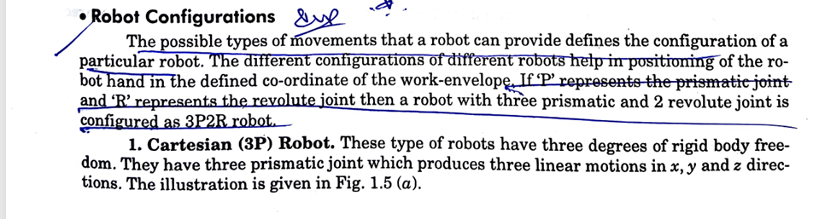

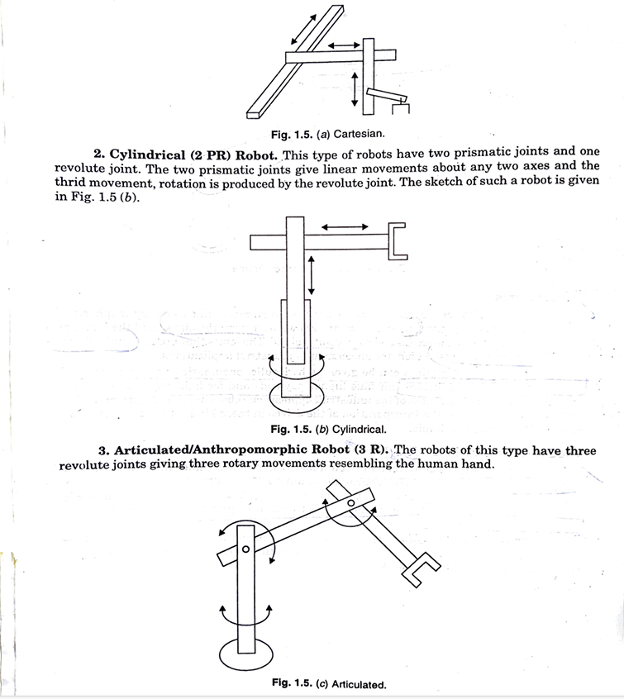

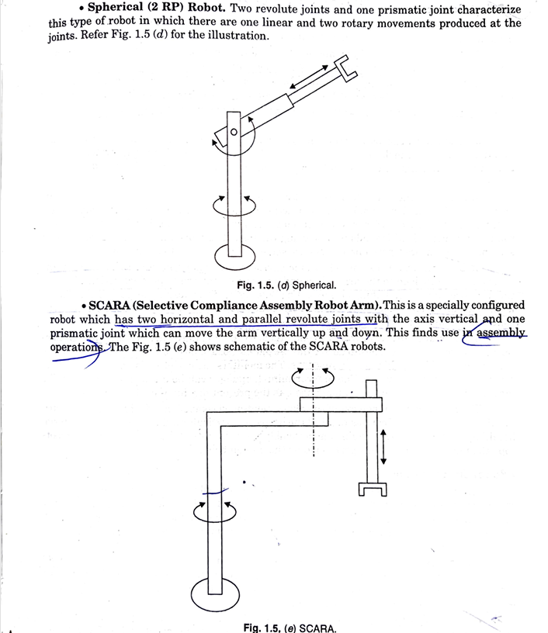

Explain with a sketch hydraulic system of robot

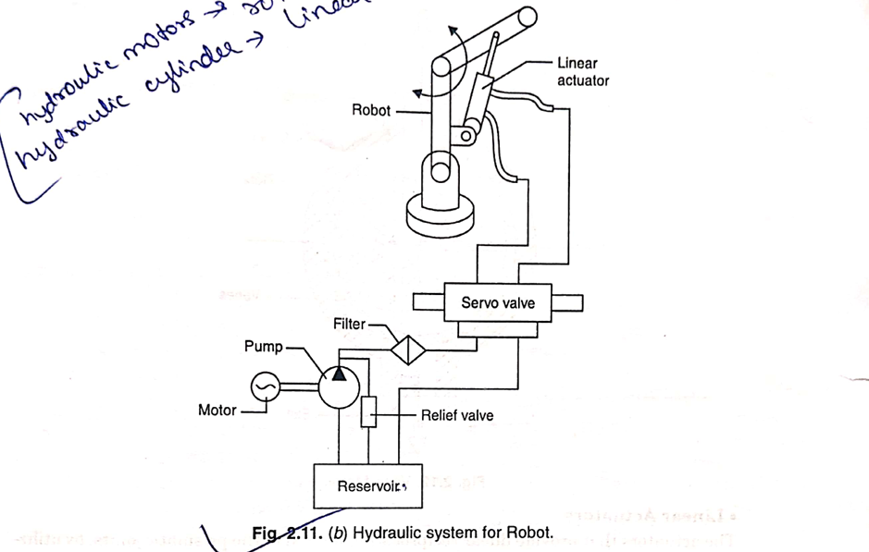

This diagram illustrates a hydraulic system for a robot, using hydraulic components to control the movement of a robotic arm through a linear actuator. Here’s a breakdown of how it functions:

1. Reservoir: This component stores hydraulic fluid. The fluid is essential for transferring energy throughout the system.
2. Pump: Driven by a motor, the pump draws fluid from the reservoir and pressurizes it. This pressure generates the necessary force to move the robotic arm.
3. Motor: The motor powers the pump, helping it circulate hydraulic fluid through the system.
4. Filter: The filter ensures that only clean hydraulic fluid enters the system by removing any impurities, which prevents damage to the system components.
5. Relief Valve: This valve controls the maximum pressure within the system to prevent overload or damage. If the pressure exceeds a certain limit, the valve releases excess fluid back to the reservoir.
6. Servo Valve: This valve regulates the fluid flow to the linear actuator based on control signals. By adjusting the direction and rate of flow, it controls the movement of the actuator and, therefore, the robotic arm.
7. Linear Actuator: Connected to the robotic arm, the actuator converts hydraulic pressure into mechanical motion, allowing the arm to move back and forth in a controlled manner.
8. Robot Arm: This is the actual component that performs tasks. The linear actuator's movement enables the arm to perform various actions, such as lifting, pushing, or positioning.

Annotations on the image:

* Hydraulic Motors: They provide rotational motion.
* Hydraulic Cylinders: They provide linear motion.

In summary, this hydraulic system allows for precise control of the robotic arm's movements, powered by pressurized hydraulic fluid and controlled by various valves and actuators.

Discuss the social impact of robotics on direct labour :

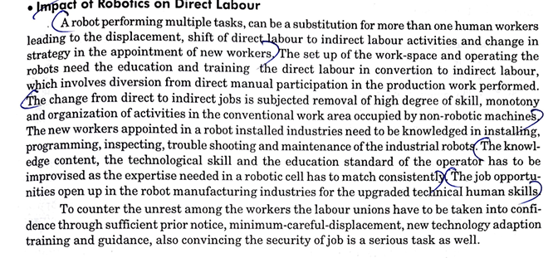

Discuss force analysis of gripper mechanism in detail

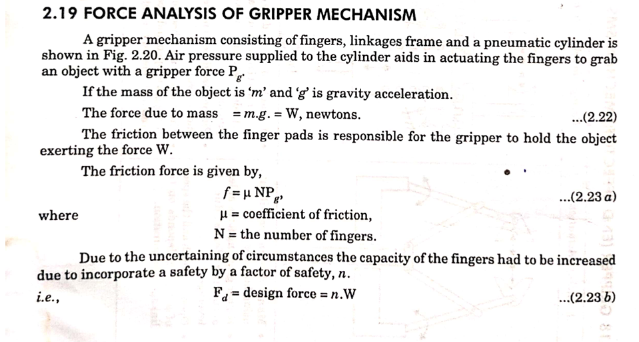

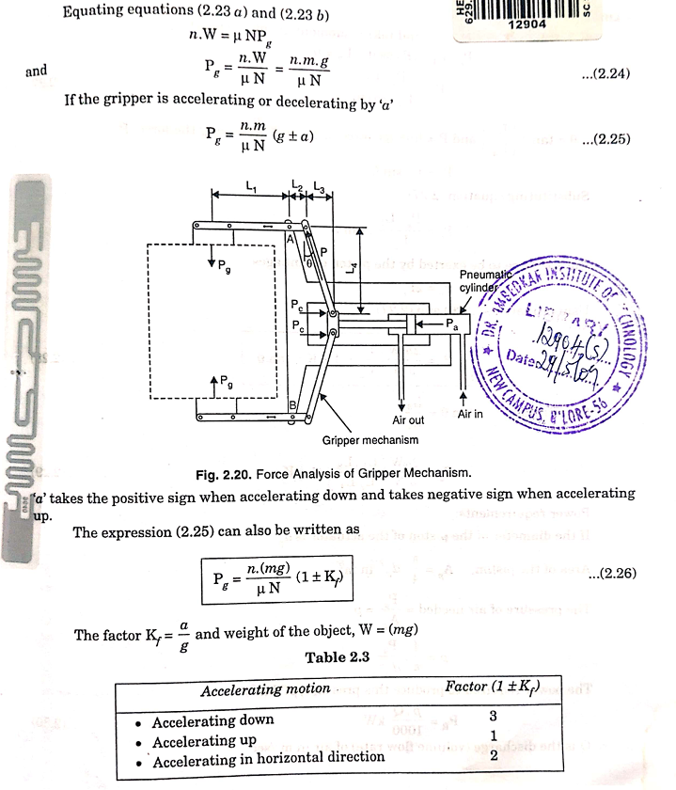

Explain performance parameters and with a figure describe repeatability resolution and accuracy

**1. Accuracy**

Accuracy refers to how close a measurement is to the true value or standard. It’s the degree to which the result of a measurement conforms to the correct value or standard.

**2. Repeatability**

Repeatability is the ability of a measurement system to give consistent results for the same input under the same conditions. It reflects how much the measurements vary when repeated several times. High repeatability means the results are consistently close to each other.

**3. Resolution**

Resolution is the smallest detectable change in the measured quantity that the system can reliably display. A high-resolution system can detect very minute changes in the input.

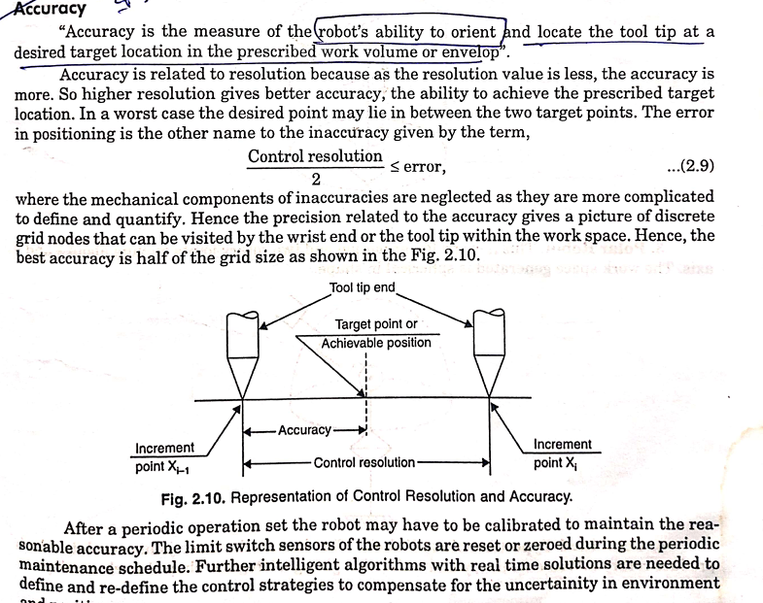

Explain electric drives with a neat sketch

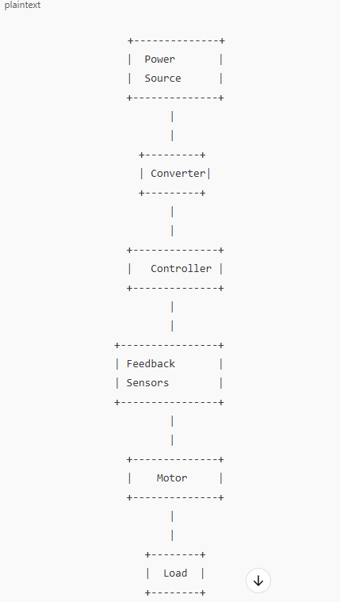

Electric drives are systems that control the motion of electric motors to provide precise movement in various applications, such as industrial machines, robotics, and electric vehicles. They use electrical energy to control speed, position, and torque of an electric motor. Here’s a simple explanation along with a basic sketch.

Key Components of an Electric Drive:

1. Power Source: Supplies the electrical energy, which could be AC or DC power.
2. Converter: Converts AC power to DC or vice versa, depending on the type of motor used. For example, an inverter converts DC to AC for AC motors.
3. Controller: Manages the speed, torque, and position of the motor by controlling the power delivered to it. The controller processes signals from sensors and adjusts motor operation based on input commands.
4. Motor: Converts electrical energy into mechanical energy. Common motors used include DC motors, induction motors, and synchronous motors.
5. Feedback Sensors: Provide real-time data on the motor's speed, position, and current, which is used by the controller to adjust motor performance.
6. Load: The component or machine that the motor drives, such as a conveyor belt, robotic arm, or fan.

Working Principle of Electric Drives:

1. Power Control: The controller receives power from the power source and, using the converter, delivers appropriate power to the motor. This controls the speed and torque according to the requirements.
2. Feedback Mechanism: Feedback sensors monitor the motor's performance and send real-time data (speed, position, etc.) back to the controller.
3. Adjustments: Based on feedback, the controller adjusts the power supply to ensure accurate control over motor operation, optimizing performance as per the system's needs.

Applications

Electric drives are widely used in:

* Industrial machinery (conveyors, presses)
* Robotics (to control precise movements)
* Electric vehicles (for traction control)
* HVAC systems (fans, pumps)

Explain actuators and discuss about pneumatic actuators with a neat sketch

An **actuator** is a device that converts energy into motion. It’s a fundamental component in systems that require controlled movement or positioning. Actuators receive control signals (usually electrical, hydraulic, or pneumatic) and generate a corresponding physical action, often in the form of linear or rotary motion. Common types of actuators include **electrical actuators** (e.g., motors), **hydraulic actuators** (using liquid pressure), and **pneumatic actuators** (using compressed air or gas).

