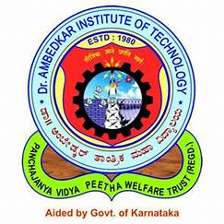 | Dr. Ambedkar Institute of Technology
 | Department of Computer Science & Engineering

Internship status-1

Student’s USN | Student’s Name | Name of Industry/ company where the student is doing the internship | Progress till March 15th 2025 |  |  | Internal guide name / Contact number
Student’s USN | Student’s Name |  | Work Assigned: (Short descriptio n of  work/task s) | Progress Made: (Summary of completed tasks or work done) | Learning Outcome: (Skills  learned or knowledge gained) | Internal guide name / Contact number
1DA21CS028 | Arya N D | Happay VA tech ventures | Gained hands-on experience in API integrations and data mapping. | We were assigned with test accounts. And got replaced with real time clients of Zensar company. | Gained familiarity with API integrations. Understood how expense management company works. | Dr. Suresha D 99001 08794

