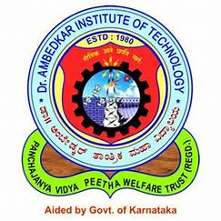 | Dr. Ambedkar Institute of Technology
 | Department of Computer Science & Engineering

Internship status-1

Student's  USN | Student  Name | Name of the industry/  company where the student is doing the internship | Progress till March 15th 2025 * |  |  | Internal guide name/  contact number
Student's  USN | Student  Name |  | Work  Assigned: [Short description of work/tasks] | Progress Made: [Summary of completed tasks or work done | Learning Outcome:  [Skills learned or knowledge gai ned] | Internal guide name/  contact number
 | Karthik M Kundagol |  | Learning HTML, CSS, JavaScript, and Git/GitHub for frontend development. | - Covered HTML and CSS basics and started styling web pages.  - Implemented JavaScript for interactive web elements.  - Learned Git basics and how to manage repositories on GitHub.  - Practiced version control with real-world projects. | - Proficiency in HTML, CSS, and JavaScript for frontend development.  - Understanding of Git/GitHub for version control and collaboration.  - Hands-on experience in building and managing web projects. | Prof Uma K M(+91 99802 59898)
  1DA22CS413
  Take It Smart

