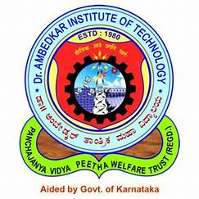 | Dr. Ambedkar Institute of Technology
 | Department of Computer Science & Engineering

Internship status-1

Student's  USN | Student  Name | Name of the industry/c ompany where the student is doing the internship | Progress till March 15th 2025 * |  |  | Internal guide name/c  ontact number
Student's  USN | Student  Name |  | Work  Assigned: [Short description of work/tasks] | Progress Made: [Summary of completed tasks or work done | Learning Outcome:  [Skills learned or knowledge gai ned] | Internal guide name/c  ontact number
 | Hajaratali S Mogallali | Rooman Technology | Learning Python (Basic to Advanced) and Flask. Understanding DevOps, its tools (Docker, Git, GitHub), and basic Linux. | - Covered Python fundamentals and started with advanced concepts.  - Explored Flask and implemented basic web applications.  - Gained theoretical understanding of DevOps and its importance.  - Learned Git basics, how to use GitHub for version control, and Docker containerization.  - Got familiar with Linux commands and system navigation. | - Proficiency in Python and Flask for web development.  - Understanding of DevOps principles and its significance.  - Hands-on experience with Git, GitHub, and Docker.  - Basic command-line operations and system management in Linux. | Prof Uma K M(+91 99802 59898)
  1DA22CS409

