AZ-104 - Practice Test 1
AZ-104 — Azure Administrator · 82 questions

Question 1
You have an Azure subscription that includes a Recovery Services vault named Vault1.
You plan to configure multi-user authorization (MAU) for Vault1.
Which Azure resource must be created before you can enable MAU?
Réponses:
☐ an Azure administrative unit
☐ an Azure managed identity
☑ a resource guard
☐ a custom Azure role
Explication
a resource guard is correct because enabling Multi-User Authorization (MAU) in a Recovery Services vault requires creating a resource guard. A resource guard protects critical operations (such as disabling soft delete or stopping backup) by requiring additional authorization from designated approvers. The resource guard enforces MAU by ensuring operations cannot proceed without explicit approval from specified users or groups.
an Azure administrative unit is incorrect because administrative units are used for grouping Azure AD resources and delegating administrative tasks, not for securing critical Recovery Services vault operations.
an Azure managed identity is incorrect because managed identities are used to securely authenticate services with Azure resources, not for enabling or managing MAU in a Recovery Services vault.
a custom Azure role is incorrect because, while custom roles may provide granular permissions, they are not required to enable MAU. The primary requirement for MAU is the creation of a resource guard.
Reference(s):
- https://learn.microsoft.com/en-us/azure/storage/blobs/encryption-scope-manage?tabs=portal

Question 2
You have an Azure subscription that includes the following public IP address resources:
- IP1 – IPv4, Standard SKU, Regional tier, Static assignment
- IP2 – IPv4, Standard SKU, Global tier, Static assignment
- IP3 – IPv4, Basic SKU, Regional tier, Dynamic assignment
- IP4 – IPv4, Basic SKU, Regional tier, Static assignment
- IP5 – IPv6, Standard SKU, Regional tier, Static assignment
You plan to deploy an Azure Firewall Premium instance named FW1.
Which of these public IP addresses are eligible to be associated with FW1?
Réponses:
☑ IP1 only
☐ IP1 and IP2 only
☐ IP1, IP2, and IP5 only
☐ IP1, IP2, IP4, and IP5 only
Explication
IP1 is correct because it is an IPv4, Standard SKU, Regional tier, Static public IP address. Azure Firewall supports Standard SKU public IP addresses, and Azure Firewall requires a static IPv4 public IP configuration.
IP2 is incorrect because, although it is an IPv4 Standard SKU address with Static assignment, it uses the Global tier. Global-tier public IP addresses are intended for the frontends of cross-region Azure Load Balancers. Azure Firewall is a regional resource and its public IP must therefore use the Regional tier.
IP3 is incorrect because it uses the Basic SKU and Dynamic assignment. Azure Firewall supports Standard SKU public IP addresses; Basic SKU public IP addresses aren't supported. Additionally, Azure Firewall uses static rather than dynamic public IPv4 addresses.
IP4 is incorrect because, although it is an IPv4 Regional address with Static assignment, it uses the Basic SKU. Azure Firewall does not support Basic SKU public IP addresses.
IP5 is incorrect because it is an IPv6 public IP address. Azure Firewall currently does not support IPv6; it operates using IPv4, even when deployed in a dual-stack virtual network.
Therefore, among the listed public IP addresses, only IP1 satisfies all the requirements for association with FW1: IPv4, Standard SKU, Regional tier, and Static assignment.
Reference(s):
- https://learn.microsoft.com/en-us/azure/virtual-network/ip-services/configure-public-ip-firewall
- https://learn.microsoft.com/en-us/azure/virtual-network/ip-services/public-ip-addresses
- https://learn.microsoft.com/en-us/azure/virtual-network/ip-services/ipv6-overview

Question 3
You have an Azure subscription named Sub1 that contains the following resources:
- MG1: Management group
- RG1: Resource group
- VM1: Virtual machine
You create a user account named Admin1.
To which of these resources can you assign Admin1 as a co-administrator?
Réponses:
☐ VM1
☐ MG1
☐ RG1
☑ Sub1
Explication
Sub1 is correct because the Co-administrator role can only be assigned at the subscription level. This role grants the same access as the built-in Owner role but does not allow modifying role assignments within the subscription.
Reference(s):
- https://learn.microsoft.com/en-us/azure/role-based-access-control/rbac-and-directory-admin-roles

Question 4
You have an Azure subscription that contains the following resources:
- ManagementGroup1: Management group
- RG1: Resource group
- 5e7a2c91-4b3d-4f68-9a21-c8d7e3b5f402: Subscription ID
- Tag1: Tag
You are working in Azure Cloud Shell and need to deploy a virtual machine by using an Azure Resource Manager (ARM) template.
You must complete the shown command to perform the deployment.
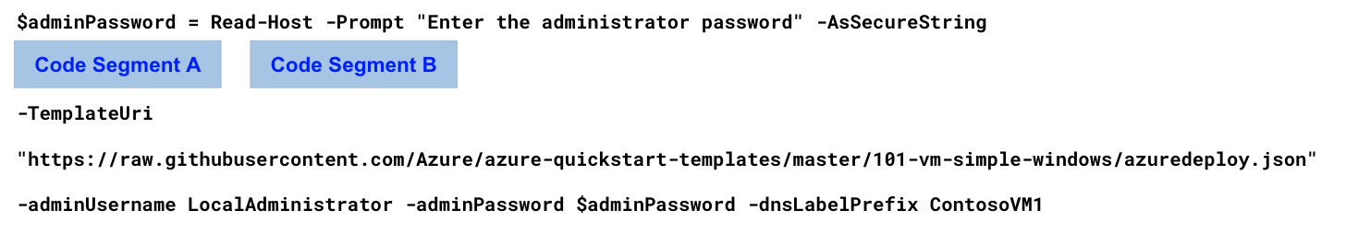
What should you choose for Code Segment A?
Réponses:
☐ New-AzVm
☐ New-AzResource
☐ New-AzTemplateSpec
☑ New-AzResourceGroupDeployment
Explication
New-AzResourceGroupDeployment is correct as we can only deploy the resources via ARM template in powershell when we scope it to a collection in Azure for e.g., a resource group, a subscription or a management group. Although there is no context mentioned in the question, yet among the options, this is the only correct command that can be used during an ARM template deployment.
New-AzVM is incorrect because this command although does create a VM, yet cannot use a template file for the deployment. It uses a VM object with all the parameters you need to define the size, OS and other properties of the new VM.
New-AzResource is incorrect because similar to New-AzVM, this command can be used to create a resource of type VM, but it does not have a parameter where it can take the link of an ARM template to be used for the deployment.
New-AzTemplateSpec is incorrect because creating a templatespec is not going to help in directly creating a VM for you. You would have to manually deploy the VM again in the second step with the templateSpec that you create with this command. Hence this is not the correct answer.
Reference(s):
- https://learn.microsoft.com/en-us/powershell/module/az.compute/new-azvm?view=azps-10.1.0
- https://learn.microsoft.com/en-us/powershell/module/az.resources/new-azresource?view=azps-10.1.0
- https://learn.microsoft.com/en-us/powershell/module/az.resources/new-aztemplatespec?view=azps-10.1.0
- https://learn.microsoft.com/en-us/azure/azure-resource-manager/templates/deploy-powershell

Question 5
You have an Azure subscription that contains the following resources:
- ManagementGroup1: Management group
- RG1: Resource group
- 5e7a2c91-4b3d-4f68-9a21-c8d7e3b5f402: Subscription ID
- Tag1: Tag
You are working in Azure Cloud Shell and need to deploy a virtual machine by using an Azure Resource Manager (ARM) template.
You must complete the shown command to perform the deployment.
What should you choose for Code Segment B?
Réponses:
☐ -Tag Tag1 `
☑ -ResourceGroupName RG1 `
☐ -GroupName ManagementGroup1 `
☐ -Subscription 8c4be1cd-7655-4c66-63ea-a9ee101d8y75 `
Explication
-ResourceGroupName RG1 is correct because we are using New-AzResourceGroupDeployment as the first part, and that command uses the name of the resource group as the mandatory parameter.
-Tag Tag1, -GroupName ManagementGroup1 and -Subscription 8c4be1cd-7655-4c66-63ea-a9ee101d8y75 are incorrect options because these switches (parameters) are not used with the New-AzResourceGroupDeployment command used for deploying resources to a resource group using an ARM template. Hence we cannot choose these options.
Reference(s):
- https://learn.microsoft.com/en-us/azure/azure-resource-manager/templates/deploy-powershell

Question 6
You have an Azure App Service web app named app1.
Autoscaling is configured to scale based on a metric. The configuration defines instance limits with a minimum of 1 instance, a maximum of 5 instances, and a default of 1 instance.
A scale-out rule is configured as follows:
- When the average CPU percentage exceeds 70%, increase the instance count by 1.
You configure the autoscale rule criteria as shown below. The rule evaluates the CPU Percentage metric from the App Service plan metrics, uses a specified aggregation method and time grain, applies a threshold condition over a defined duration, and performs a scale-out action with a cooldown period.
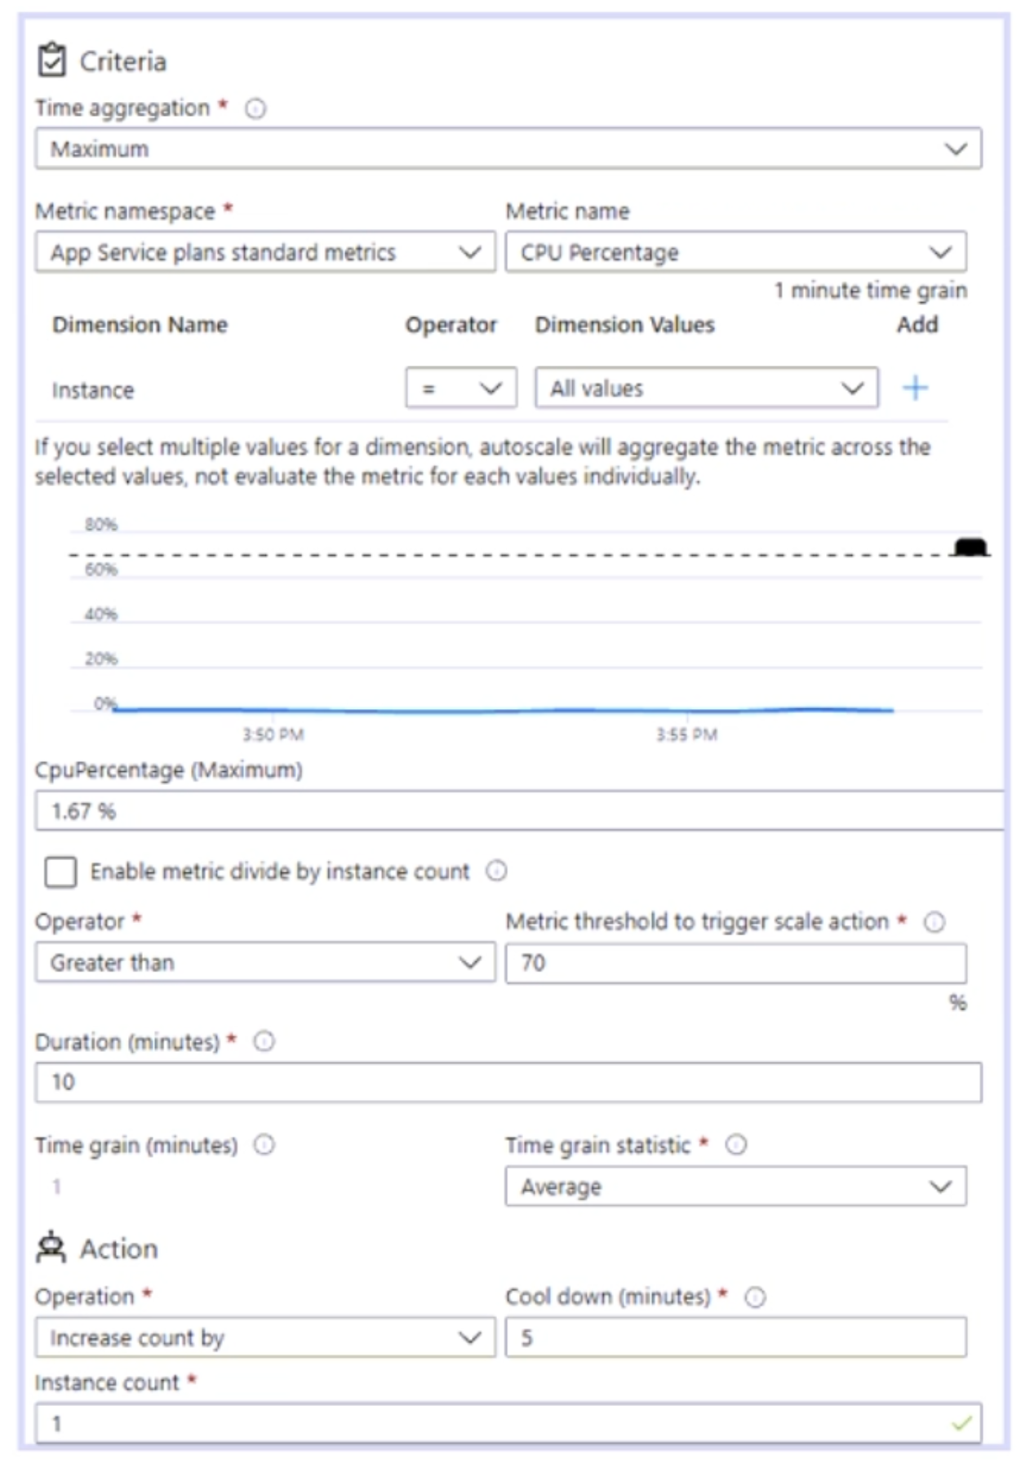
Based on the information presented in the configuration, select the option that correctly completes the following statement:
"After CPU usage has reached 80 percent for 15 minutes, ____________________ will be running."
Réponses:
☐ 1 instance
☑ 2 instances
☐ 3 instances
☐ 4 instances
☐ 5 instances
Explication
2 instances is correct because the default count is 1. So it starts with 1 instance. If the CPU usage remains greater than 70% for more than 10 minutes, it increases the count by 1. And then it does not do any scaling operation for the next 5 minutes. So after 15 minutes, we will have 2 instances running.
Reference(s):
- https://learn.microsoft.com/en-us/azure/azure-monitor/autoscale/autoscale-understanding-settings

Question 7
You have an Azure App Service web app named app1.
Autoscaling is configured to scale based on a metric. The configuration defines instance limits with a minimum of 1 instance, a maximum of 5 instances, and a default of 1 instance.
A scale-out rule is configured as follows:
- When the average CPU percentage exceeds 70%, increase the instance count by 1.
You configure the autoscale rule criteria as shown below. The rule evaluates the CPU Percentage metric from the App Service plan metrics, uses a specified aggregation method and time grain, applies a threshold condition over a defined duration, and performs a scale-out action with a cooldown period.
Based on the information presented in the configuration, select the option that correctly completes the following statement:
"Once the first scale-out instance is created, the minimum time before an additional instance is created will be _______________________."
Réponses:
☐ 1 minute
☑ 5 minutes
☐ 10 minutes
☐ 15 minutes
Explication
5 minutes is correct because 5 minutes is the cool down period. Once this period elapses, the system checks again the metrics of the last 10 minutes. If the CPU usage continues to stay above 70% in those 10 minutes, it will increase the count by 1. And then wait again for 5 minutes.
Reference(s):
- https://learn.microsoft.com/en-us/azure/azure-monitor/autoscale/autoscale-understanding-settings

Question 8
You have an Azure subscription that includes the following resources:
- share1: An Azure file share hosted in storage1
- storage1: An Azure Storage account
- User1: A Microsoft Entra user
You need to assign User1 the Storage File Data SMB Share Contributor role for share1.
What action should you perform first?
Réponses:
☐ Enable identity-based data access for the file shares in storage1.
☐ Update the security configuration for the file shares in storage1.
☐ Set the default authorization method to Microsoft Entra ID in the Azure portal for storage1.
☑ Configure Access control (IAM) for share1.
Explication
Configure Access control (IAM) for share1 is correct as you can add access for a user from Access control for any type of resource in Azure. For share specific role also you need to go to IAM of the share and then add the respective Azure AD user.
Enable identity-based data access for the file shares in storage1 is incorrect because this is needed when you want a hybrid user to access the share. In that case, you enable access to Active Directory, Azure AD DS and Azure AD Kerberos. But in our case, the user is an Azure AD entity so a RBAC role assignment would be the way to go.
Update the security configuration for the file shares in storage1 is incorrect because security profile of a share has nothing to do with how a user authorizes itself against the share. It has other security features which you can configure for each of your shares.
Set the default authorization method to Microsoft Entra ID in the Azure portal for storage1 is incorrect because this option is not enough to allow user to be able to act as contributor for the share in your storage account.
Reference(s):
- https://learn.microsoft.com/en-us/azure/storage/files/storage-files-active-directory-overview
- https://learn.microsoft.com/en-us/azure/storage/files/storage-files-identity-ad-ds-assign-permissions?tabs=azure-portal

Question 9
You have an Azure subscription with offices located in the East US and West US Azure regions.
You plan to create a storage account with the configuration shown below. The configuration specifies the subscription, resource group, region, performance tier, redundancy option, networking settings, data protection options, and encryption settings for the storage account.
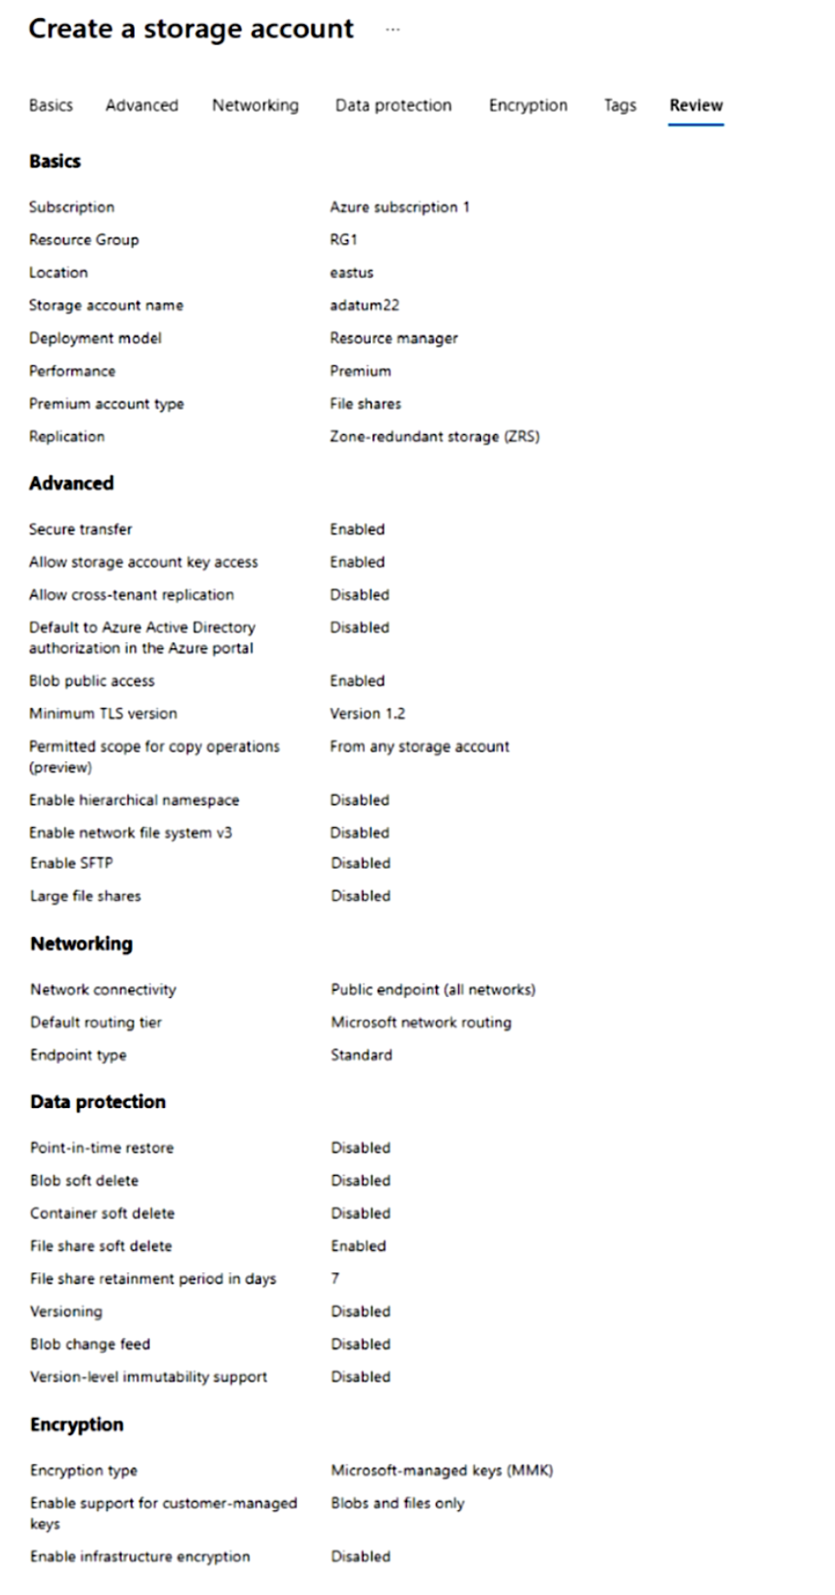
The networking configuration shows that the storage account is accessible through a public endpoint and uses Microsoft network routing. Other settings, such as replication type and file share options, are also defined.
Based on the information presented in the graphic, select the answer choice that completes the following statement correctly.
"To minimize the network costs of accessing adatum22, modify the ____________________ setting."
Réponses:
☑ Default routing tier
☐ Endpoint type
☐ Location
☐ Network connectivity
☐ Performance
Explication
Default routing tier is correct because by default the routing method is set to be through Microsoft global network. But this configuration sometimes increases the network costs if the data you are trying to access is in another region, and in order to reach your system it has to traverse through Microsoft global network to a great extent. In order to minimize this, you can change to Internet routing where it is passed on to the transit ISP at the earliest opportunity.
Endpoint type is incorrect as changing the endpoint type will not have any effect on the network costs of the traffic coming in or going out from the storage account.
Location is incorrect because we do not know as of now where the user, who is trying to access the file share is located. So changing the location will not help.
Network connectivity is incorrect because this defines how you connect to different services in the storage account. If you select Public endpoints then you can access them over the internet otherwise your requests should be coming in from inside the VNet provided VNet integration is already enabled.
Performance is incorrect because this chooses the tier in which your storage account runs. It basically defines the resources available to the services to handle your data and requests. Changing this may have effect on billing cost but it would not affect the networking cost.
Reference(s):
- https://learn.microsoft.com/en-us/azure/storage/common/network-routing-preference

Question 10
You have an Azure subscription with offices located in the East US and West US Azure regions.
You plan to create a storage account with the configuration shown below. The configuration specifies the subscription, resource group, region, performance tier, redundancy option, networking settings, data protection options, and encryption settings for the storage account.
The networking configuration shows that the storage account is accessible through a public endpoint and uses Microsoft network routing. Other settings, such as replication type and file share options, are also defined.
Based on the information presented in the graphic, select the answer choice that completes the following statement correctly.
"After adatum22 is created, you can modify the ___________________________ setting."
Réponses:
☐ Enable infrastructure encryption
☐ Enable support for customer-managed keys
☑ Encryption type
☐ Premium account type
Explication
Encryption Type is correct as we can change this setting even after creation of the storage account. It can be changed to customer-managed keys from Microsoft managed keys or vice-versa.
Enable infrastructure encryption is incorrect because we can only configure this option during the creation of the storage account.
Enable support for customer-managed keys is incorrect because this setting is final once configured during the creation. It cannot be changed later.
Premium account type is incorrect because we can only decide what type of account service we need during its creation. It cannot be extended later to include other services which were excluded before.
Reference(s):
- https://learn.microsoft.com/en-us/azure/storage/common/storage-service-encryption

Question 11
You have an Azure subscription.
You plan to deploy a storage account named storage1 by using an Azure Resource Manager (ARM) template, as shown in the configuration below. The template defines the storage account location, SKU, and kind, along with network access settings. It also configures Blob service–level data protection features, including soft delete, container delete retention, change feed, and blob versioning, each with specified retention periods.
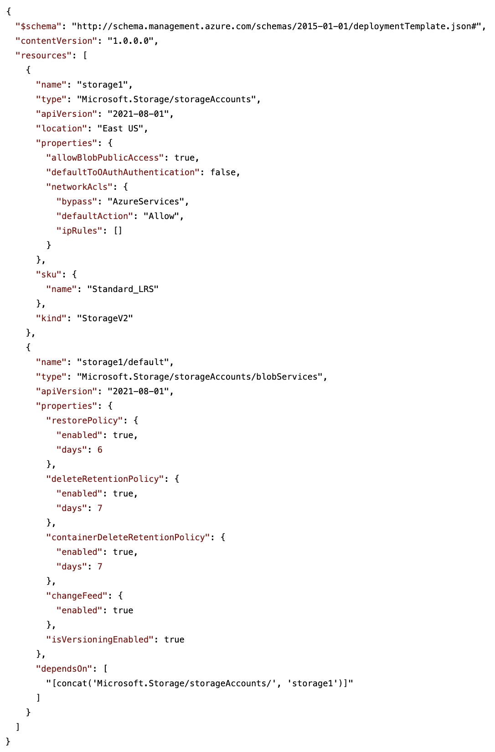
Based on this ARM template configuration, determine whether the following statement is True or False.
`"Changes made to the data in storage1 can be rolled back after seven days"`
Réponses:
☐ True
☑ False
Explication
`False` is correct because rolling back the data means restoring to a point in time. As per the configuration, the max period to which we can restore is 6 days. Hence we cannot roll back the data change done 7 days before.
Reference(s):
- https://learn.microsoft.com/en-us/azure/storage/blobs/versioning-enable?tabs=portal
- https://learn.microsoft.com/en-us/azure/storage/blobs/versioning-overview
- https://learn.microsoft.com/en-us/azure/templates/microsoft.storage/storageaccounts/blobservices?pivots=deployment-language-arm-template#restorepolicyproperties-1

Question 12
You have an Azure subscription.
You plan to deploy a storage account named storage1 by using an Azure Resource Manager (ARM) template, as shown in the configuration below. The template defines the storage account location, SKU, and kind, along with network access settings. It also configures Blob service–level data protection features, including soft delete, container delete retention, change feed, and blob versioning, each with specified retention periods.
Based on this ARM template configuration, determine whether the following statement is True or False.
`"Only users located in the East US Azure region can connect to storage1."`
Réponses:
☐ True
☑ False
Explication
`False` is correct because allowPublicAccess is set to true and there is no ACL for region/IP-based. So everyone on the internet can access the storage account if the person has the access keys.
Reference(s):
- https://learn.microsoft.com/en-us/azure/storage/blobs/versioning-enable?tabs=portal
- https://learn.microsoft.com/en-us/azure/storage/blobs/versioning-overview
- https://learn.microsoft.com/en-us/azure/templates/microsoft.storage/storageaccounts/blobservices?pivots=deployment-language-arm-template#restorepolicyproperties-1

Question 13
You have an Azure subscription.
You plan to deploy a storage account named storage1 by using an Azure Resource Manager (ARM) template, as shown in the configuration below. The template defines the storage account location, SKU, and kind, along with network access settings. It also configures Blob service–level data protection features, including soft delete, container delete retention, change feed, and blob versioning, each with specified retention periods.
Based on this ARM template configuration, determine whether the following statement is True or False.
`"Three copies of storage1 will be maintained in the East US Azure region."`
Réponses:
☑ True
☐ False
Explication
`True` is correct because with LRS type of redundancy you get 3 copies of the data spread in 3 different zones/datacenters of the region.
Reference(s):
- https://learn.microsoft.com/en-us/azure/storage/blobs/versioning-enable?tabs=portal
- https://learn.microsoft.com/en-us/azure/storage/blobs/versioning-overview
- https://learn.microsoft.com/en-us/azure/templates/microsoft.storage/storageaccounts/blobservices?pivots=deployment-language-arm-template#restorepolicyproperties-1

Question 14
An Azure subscription contains a virtual machine called VM1 and an Azure Key Vault named KV1.
You are required to implement disk encryption for VM1 while meeting the following conditions:
- The encryption key must be stored and accessed from KV1.
- Encryption must remain intact if the virtual machine is downloaded from Azure.
- Both the operating system disk and any attached data disks must be encrypted.
Which encryption method should be implemented?
Réponses:
☐ customer-managed keys
☑ Azure Disk Encryption
☐ Confidential disk encryption
☐ encryption at host
Explication
`Azure Disk Encryption` is correct because it supports encrypting both the operating system and data disks of virtual machines using customer-managed keys stored in an Azure Key Vault. It ensures that the encryption persists even if the virtual machine disks are downloaded from Azure, meeting the specified requirements.
`customer-managed keys` is incorrect because while they allow managing encryption keys in Azure Key Vault, they are typically used for server-side encryption at the storage account level, not for encrypting the disks of virtual machines directly.
`Confidential disk encryption` is incorrect because it is designed for confidential computing environments where the data is encrypted in use, but it doesn't meet the requirement to persist encryption when VM disks are downloaded.
`encryption at host` is incorrect because this feature encrypts data stored on the host for VMs but does not encrypt the disks themselves, nor does it persist when the VM is downloaded.
Reference(s):
- https://learn.microsoft.com/en-us/azure/virtual-machines/linux/disk-encryption-overview
- https://learn.microsoft.com/en-us/azure/key-vault/general/customer-managed-keys-overview

Question 15
An Azure environment contains the following virtual machines:
- VM1: IP address 10.0.0.4, deployed in VNET1
- VM2: IP address 172.16.0.4, deployed in VNET2
- VM3: IP address 192.168.0.4, deployed in VNET3
- VM4: IP address 192.168.0.5, deployed in VNET3
The virtual networks VNET1, VNET2, and VNET3 are peered with each other.
A DNS server is running on VM4. This DNS server is authoritative for the contoso.com zone and contains the following records:
- Server1: "A" record with the value 131.107.2.3
- Server2: "A" record with the value 131.107.2.4
Additionally, VNET1 and VNET2 are linked to an Azure private DNS zone named contoso.com, which contains these records:
- Server1: "A" record with the value 131.107.3.3
- Server2: "A" record with the value 131.107.3.4
The virtual networks are configured to use the following DNS servers:
- VNET1: Azure-provided default DNS
- VNET2: Custom DNS server at 192.168.0.5
- VNET3: Custom DNS server at 192.168.0.5
True or False:
`"From VM1, server1.contoso.com resolves to 131.107.3.3."`
Réponses:
☑ True
☐ False
Explication
`True` is correct because VM1 is connected to private DNS zone , where we do see that an A record exists for Server1 which will resolve from server1.contoso.com to 131.107.3.3.
Reference(s):
- https://learn.microsoft.com/en-us/answers/questions/1150496/private-dns-vs-custom-dns-for-one-vnet
- https://learn.microsoft.com/en-us/azure/dns/private-dns-virtual-network-links

Question 16
An Azure environment contains the following virtual machines:
- VM1: IP address 10.0.0.4, deployed in VNET1
- VM2: IP address 172.16.0.4, deployed in VNET2
- VM3: IP address 192.168.0.4, deployed in VNET3
- VM4: IP address 192.168.0.5, deployed in VNET3
The virtual networks VNET1, VNET2, and VNET3 are peered with each other.
A DNS server is running on VM4. This DNS server is authoritative for the contoso.com zone and contains the following records:
- Server1: "A" record with the value 131.107.2.3
- Server2: "A" record with the value 131.107.2.4
Additionally, VNET1 and VNET2 are linked to an Azure private DNS zone named contoso.com, which contains these records:
- Server1: "A" record with the value 131.107.3.3
- Server2: "A" record with the value 131.107.3.4
The virtual networks are configured to use the following DNS servers:
- VNET1: Azure-provided default DNS
- VNET2: Custom DNS server at 192.168.0.5
- VNET3: Custom DNS server at 192.168.0.5
True or False:
`"From VM2, server1.contoso.com resolves to 131.107.3.3."`
Réponses:
☐ True
☑ False
Explication
`False` is correct because VM2 is connected to private DNS zone, but the VNet itself is connected to a custom DNS server where we do see that an A record exists for Server1 which will resolve from server1.contoso.com to 131.107.2.3.
The key point here is that DNS resolution for a VM depends on the DNS server settings configured at the VNet level, not just the private DNS zone links.
- VM2 is in VNET2, and according to the table, VNET2 is configured to use a custom DNS server (192.168.0.5). That IP address belongs to VM4, which is itself authoritative for the `contoso.com` DNS zone (see the table showing Server1 → 131.107.2.3 and Server2 → 131.107.2.4).
- Even though VNET2 is also linked to the Azure private DNS zone `contoso.com` (which contains Server1 → 131.107.3.3 and Server2 → 131.107.3.4), that zone will not be queried by VMs in VNET2. Why? Because Azure Private DNS only applies if the VNet is configured to use the Azure-provided DNS. Since VNET2 is overridden to use the custom DNS server, all queries (like `server1.contoso.com`) go to VM4’s DNS instead.
- Therefore, when VM2 resolves `server1.contoso.com`, it will get the record from VM4’s DNS server (131.107.2.3), not from the private DNS zone (131.107.3.3).
Reference(s):
- https://learn.microsoft.com/en-us/answers/questions/1150496/private-dns-vs-custom-dns-for-one-vnet
- https://learn.microsoft.com/en-us/azure/dns/private-dns-virtual-network-links

Question 17
An Azure environment contains the following virtual machines:
- VM1: IP address 10.0.0.4, deployed in VNET1
- VM2: IP address 172.16.0.4, deployed in VNET2
- VM3: IP address 192.168.0.4, deployed in VNET3
- VM4: IP address 192.168.0.5, deployed in VNET3
The virtual networks VNET1, VNET2, and VNET3 are peered with each other.
A DNS server is running on VM4. This DNS server is authoritative for the contoso.com zone and contains the following records:
- Server1: "A" record with the value 131.107.2.3
- Server2: "A" record with the value 131.107.2.4
Additionally, VNET1 and VNET2 are linked to an Azure private DNS zone named contoso.com, which contains these records:
- Server1: "A" record with the value 131.107.3.3
- Server2: "A" record with the value 131.107.3.4
The virtual networks are configured to use the following DNS servers:
- VNET1: Azure-provided default DNS
- VNET2: Custom DNS server at 192.168.0.5
- VNET3: Custom DNS server at 192.168.0.5
True or False:
`"From VM3, server2.contoso.com resolves to 131.107.2.4."`
Réponses:
☑ True
☐ False
Explication
`True` is correct as VM3 is connected to VNet3 which is connected to the DNS server VM4 and that DNS server does have an existing A record for server2 which will help in resolving server2.contoso.com to 131.107.2.4.
Reference(s):
- https://learn.microsoft.com/en-us/answers/questions/1150496/private-dns-vs-custom-dns-for-one-vnet
- https://learn.microsoft.com/en-us/azure/dns/private-dns-virtual-network-links

Question 18
An Azure subscription contains a storage account named storage1, which includes a blob container called container1.
You need to define a lifecycle management policy for storage1 that automatically moves blobs stored in container1 to the lowest-cost access tier after they have remained unchanged for 90 days.
You are completing the lifecycle management rule shown in the configuration. The rule enables lifecycle management, targets base blobs, applies an action after a specified number of days since modification, and filters the scope of the rule to a specific container.
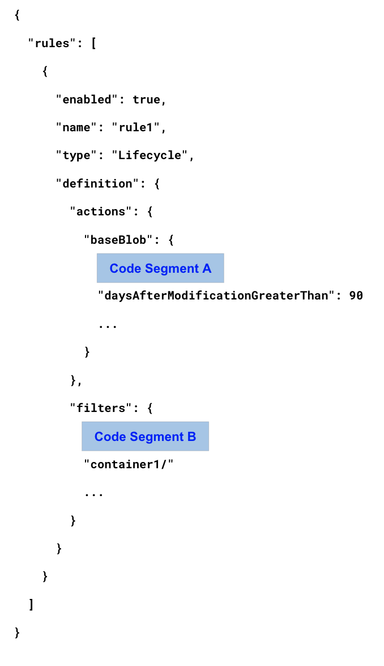
What should you choose for `Code Segment A`?
Réponses:
☐ “enableAutoTierToHotFromCool”: {
☑ “tierToArchive”: {
☐ “tierToCool”: {
Explication
`tierToArchive”: {` is correct because here you define the action you want to take via the policy. As per the requirement we need to move the blobs to the lowest-cost tier which is the Archive tier after 90 days.
Reference(s):
- https://learn.microsoft.com/en-us/azure/storage/blobs/lifecycle-management-policy-configure?tabs=azure-portal

Question 19
An Azure subscription contains a storage account named storage1, which includes a blob container called container1.
You need to define a lifecycle management policy for storage1 that automatically moves blobs stored in container1 to the lowest-cost access tier after they have remained unchanged for 90 days.
You are completing the lifecycle management rule shown in the configuration. The rule enables lifecycle management, targets base blobs, applies an action after a specified number of days since modification, and filters the scope of the rule to a specific container.
What should you choose for `Code Segment B`?
Réponses:
☐ “blobIndexMatch”: [
☐ “blobTypes”: [
☑ “prefixMatch”: [
Explication
`“prefixMatch”: [` is correct because you need to apply the filter which will look for only the blobs in a specified container, container1 in this case. And PrefixMatch does exactly that, because the full name/address of the blob always includes the name of the container they are stored in.
`blobIndexMatch` is incorrect because we do not need to filter on the index of the blobs. We need to apply this policy for all the blobs in the container. Hence we do not use this.
`blobTypes` is incorrect because again we do not need to filter on the type of the blobs. We need to make all the blobs in container1 to move to the archive tier.
Reference(s):
- https://learn.microsoft.com/en-us/azure/storage/blobs/lifecycle-management-policy-configure?tabs=azure-portal

Question 20
An Azure subscription includes the following virtual network configuration:
- VNet1 contains Subnet1, which is associated with NSG1, and is peered with VNet2.
- VNet2 contains Subnet2, which is associated with NSG2, and is peered with VNet1.
The subscription also includes the following virtual machines:
- VM1 is connected to Subnet1.
- VM2 is connected to Subnet2.
In addition, the subscription contains the following Azure App Service web apps:
- WebApp1 uses the Premium pricing tier and has virtual network integration with VNet1.
- WebApp2 uses the Isolated pricing tier and is deployed to Subnet2.
True or False:
`"WebApp1 can communicate with VM2."`
Réponses:
☑ True
☐ False
Explication
`True` is correct because it has VNet integration enabled with VNet1 which in turn is peered with VNet2. And VM2 is deployed under VNet2. So the communication can be established unless there are explicit NSG inbound rules on subnet2 which we do not know of as per the context given in the question.
Reference(s):
- https://learn.microsoft.com/en-us/azure/app-service/configure-vnet-integration-enable
- https://learn.microsoft.com/en-us/azure/app-service/overview-vnet-integration#subnet-requirements

Question 21
An Azure subscription includes the following virtual network configuration:
- VNet1 contains Subnet1, which is associated with NSG1, and is peered with VNet2.
- VNet2 contains Subnet2, which is associated with NSG2, and is peered with VNet1.
The subscription also includes the following virtual machines:
- VM1 is connected to Subnet1.
- VM2 is connected to Subnet2.
In addition, the subscription contains the following Azure App Service web apps:
- WebApp1 uses the Premium pricing tier and has virtual network integration with VNet1.
- WebApp2 uses the Isolated pricing tier and is deployed to Subnet2.
True or False:
`"NSG1 controls inbound traffic to WebApp1."`
Réponses:
☐ True
☑ False
Explication
`False` is correct because VNet integration needs a dedicated subnet and NSG1 is attached to Subnet1. And dedicated subnet means it cannot hold any other resource. But VM1 is already deployed to Subnet1 so NSG1 has no control over the traffic reaching to WebApp1.
Reference(s):
- https://learn.microsoft.com/en-us/azure/app-service/configure-vnet-integration-enable
- https://learn.microsoft.com/en-us/azure/app-service/overview-vnet-integration#subnet-requirements

Question 22
An Azure subscription includes the following virtual network configuration:
- VNet1 contains Subnet1, which is associated with NSG1, and is peered with VNet2.
- VNet2 contains Subnet2, which is associated with NSG2, and is peered with VNet1.
The subscription also includes the following virtual machines:
- VM1 is connected to Subnet1.
- VM2 is connected to Subnet2.
In addition, the subscription contains the following Azure App Service web apps:
- WebApp1 uses the Premium pricing tier and has virtual network integration with VNet1.
- WebApp2 uses the Isolated pricing tier and is deployed to Subnet2.
True or False:
`"WebApp2 can communicate with VM1."`
Réponses:
☑ True
☐ False
Explication
`True` is correct again because of the isolated APP service environment in which VNet integration is enabled by default. Hence WebApp2 can easily talk to VM1.
Reference(s):
- https://learn.microsoft.com/en-us/azure/app-service/configure-vnet-integration-enable
- https://learn.microsoft.com/en-us/azure/app-service/overview-vnet-integration#subnet-requirements

Question 23
Your Azure subscription includes an Azure SQL database named DB1.
You plan to use Azure Monitor to collect performance data for DB1. The solution must allow you to run queries against the collected log data for analysis.
Which destination should you select in the Diagnostic settings of DB1 to meet this requirement?
Réponses:
☐ Archive the logs to an Azure Storage account
☑ Send the logs to a Log Analytics workspace
☐ Stream the logs to an Azure Event Hub
Explication
`Send the logs to a Log Analytics workspace` is correct because Azure Monitor enables querying and analyzing performance data and logs by sending them to a Log Analytics workspace. This allows you to use Kusto Query Language (KQL) to analyze log data and create visualizations in Azure Monitor Workbooks, meeting the requirement to run queries for analyzing log data.
`Archive the logs to an Azure Storage account` is incorrect because it is designed for long-term storage of diagnostic data. While useful for archiving, it doesn't support querying or analyzing log data directly.
`Stream the logs to an Azure Event Hub` is incorrect because it is used for streaming diagnostics data to external systems for real-time processing or integration, not for querying or analyzing log data.
Reference(s):
- https://learn.microsoft.com/en-us/azure/azure-monitor/logs/log-analytics-workspace-overview
- https://learn.microsoft.com/en-us/azure/data-factory/monitor-configure-diagnostics
- https://learn.microsoft.com/en-us/azure/active-directory/reports-monitoring/tutorial-azure-monitor-stream-logs-to-event-hub

Question 24
An Azure subscription named Sub1 contains the following resources:
- RG1: Resource group
- storage1: Storage account
- VNET1: Virtual network
You assign an Azure Policy with these characteristics:
- The policy is applied at the Sub1 scope.
- An exclusion is configured for Sub1/RG1/VNET1.
- The policy definition appends a tag and its value to resources.
- Policy enforcement is enabled.
- The tag name is Tag4, and the tag value is value4.
You then apply tags to the resources as follows:
- Sub1 has the tag Tag1: subscription.
- RG1 has the tag Tag2: IT.
- storage1 has the tag Tag3: value1.
- VNET1 has the tag Tag3: value2.
True or False:
`"RG1 has the Tag2:IT tag assigned only."`
Réponses:
☑ True
☐ False
Explication
`True` is correct. If you look at the policy, only VNET1 is excluded. (sub1/RG1/VNET1 is just the path). So, when you add the tag Tag2: IT to RG1 manually, the policy won't trigger for the resource group because policies are applicable to resources and not on resource group.
Therefore, RG1 will only have the Tag2:IT tag assigned.
Reference(s):
- https://learn.microsoft.com/en-us/azure/azure-resource-manager/management/tag-resources
- https://learn.microsoft.com/en-us/azure/azure-resource-manager/management/tag-policies

Question 25
An Azure subscription named Sub1 contains the following resources:
- RG1: Resource group
- storage1: Storage account
- VNET1: Virtual network
You assign an Azure Policy with these characteristics:
- The policy is applied at the Sub1 scope.
- An exclusion is configured for Sub1/RG1/VNET1.
- The policy definition appends a tag and its value to resources.
- Policy enforcement is enabled.
- The tag name is Tag4, and the tag value is value4.
You then apply tags to the resources as follows:
- Sub1 has the tag Tag1: subscription.
- RG1 has the tag Tag2: IT.
- storage1 has the tag Tag3: value1.
- VNET1 has the tag Tag3: value2.
True or False:
`"Storage1 has the Tag1:subscription, Tag2:IT, Tag3:value1, and Tag4:value4 tags assigned."`
Réponses:
☐ True
☑ False
Explication
`False` is correct as Storage1 has Tag3, which was assigned manually, and Tag4 which is assigned by the policy. So it has only 2 tags and not all.
Reference(s):
- https://learn.microsoft.com/en-us/azure/azure-resource-manager/management/tag-resources
- https://learn.microsoft.com/en-us/azure/azure-resource-manager/management/tag-policies

Question 26
An Azure subscription named Sub1 contains the following resources:
- RG1: Resource group
- storage1: Storage account
- VNET1: Virtual network
You assign an Azure Policy with these characteristics:
- The policy is applied at the Sub1 scope.
- An exclusion is configured for Sub1/RG1/VNET1.
- The policy definition appends a tag and its value to resources.
- Policy enforcement is enabled.
- The tag name is Tag4, and the tag value is value4.
You then apply tags to the resources as follows:
- Sub1 has the tag Tag1: subscription.
- RG1 has the tag Tag2: IT.
- storage1 has the tag Tag3: value1.
- VNET1 has the tag Tag3: value2.
True or False:
`"VNET1 has the Tag2:IT and Tag3:value2 tags assigned only."`
Réponses:
☐ True
☑ False
Explication
`False` is correct because VNet1 originally has Tag3: value2 and there will be no action performed on it via policy because of the exclusion mentioned in the policy definition, so there will not be any addition of a tag. Hence it will just have only one tag.
Reference(s):
- https://learn.microsoft.com/en-us/azure/azure-resource-manager/management/tag-resources
- https://learn.microsoft.com/en-us/azure/azure-resource-manager/management/tag-policies

Question 27
An Azure subscription is associated with a Microsoft Entra tenant that includes two users named User1 and User2.
The subscription contains the following Azure resources:
- RG1: A resource group
- VM1: A virtual machine that is created in RG1
The subscription also has the following alert rules configured:
- Alert1: Scoped to RG1 and triggered by all administrative operations
- Alert2: Scoped to VM1 and triggered by all administrative operations
The users perform these actions:
- User1 creates a new virtual disk and attaches the disk to VM1.
- User2 creates a new resource tag and assigns the tag to both RG1 and VM1.
Which alert rule is triggered by User1?
Réponses:
☐ No alert is triggered
☐ Only Alert1 is triggered
☐ Only Alert2 is triggered
☑ Alert1 and Alert2 are triggered
Explication
`Alert1 and Alert2 are triggered` is correct because these operations are administrative actions. Basically any create/update/delete operation is logged as an admin action in the Activity log which will then trigger these alerts. And the activity by User1 has create operation in RG1 and update operation in VM1.
Reference(s):
- https://learn.microsoft.com/en-us/azure/azure-monitor/essentials/activity-log-schema#administrative-category

Question 28
An Azure subscription is associated with a Microsoft Entra tenant that includes two users named User1 and User2.
The subscription contains the following Azure resources:
- RG1: A resource group
- VM1: A virtual machine that is created in RG1
The subscription also has the following alert rules configured:
- Alert1: Scoped to RG1 and triggered by all administrative operations
- Alert2: Scoped to VM1 and triggered by all administrative operations
The users perform these actions:
- User1 creates a new virtual disk and attaches the disk to VM1.
- User2 creates a new resource tag and assigns the tag to both RG1 and VM1.
Which alert rule is triggered by User2?
Réponses:
☐ No alert is triggered
☐ Only Alert1 is triggered
☐ Only Alert2 is triggered
☑ Alert1 and Alert2 are triggered
Explication
`Alert1 and Alert2 are triggered` is correct because again in this case, assigning the tag is an update operation on the resource itself (RG and VM) as it changes the metadata. So both the alerts will be triggered in this case too.
Reference(s):
- https://learn.microsoft.com/en-us/azure/azure-monitor/alerts/alerts-types#log-alert

Question 29
An Azure subscription contains the following vault resources:
- Backup1: Backup vault
- Recovery1: Recovery Services vault
You then create a storage account that contains these resources:
- cont1: Blob container
- share1: File share
You need to determine where cont1 can be backed up.
To which vault can you back up cont1?
Réponses:
☑ Backup1 only
☐ Recovery1 only
☐ Backup1 or Recovery1
☐ Cannot be backed up to Backup1 or Recovery1
Explication
`Backup1 only` is correct because Azure blob container can only be backed up in Azure Backup vault as it supports Azure blob storage service. Azure Recovery service vault on the other hand does not support Azure Blob storage.
Reference(s):
- https://learn.microsoft.com/en-us/answers/questions/405915/what-is-difference-between-recovery-services-vault

Question 30
An Azure subscription contains the following vault resources:
- Backup1: Backup vault
- Recovery1: Recovery Services vault
You then create a storage account that contains these resources:
- cont1: Blob container
- share1: File share
You need to determine where cont1 can be backed up.
To which vault can you back up share1?
Réponses:
☐ Backup1 only
☑ Recovery1 only
☐ Backup1 or Recovery1
☐ Cannot be backed up to Backup1 or Recovery1
Explication
`Recovery1 only` is correct because Azure file share can only be backed up in Azure RS vault as it supports Azure file share service. Azure Backup vault on the other hand does not support Azure File Share.
Reference(s):
- https://learn.microsoft.com/en-us/answers/questions/405915/what-is-difference-between-recovery-services-vault

Question 31
You have multiple Azure virtual machines deployed in a virtual network named VNet1.
You configure an Azure Storage account as shown below. The networking settings restrict public network access to selected virtual networks and subnets, and VNet1 is explicitly added with a service endpoint enabled on a specific subnet. No additional IP address ranges are configured in the firewall section. The network routing preference is set to use Microsoft network routing, and no private endpoints are configured.
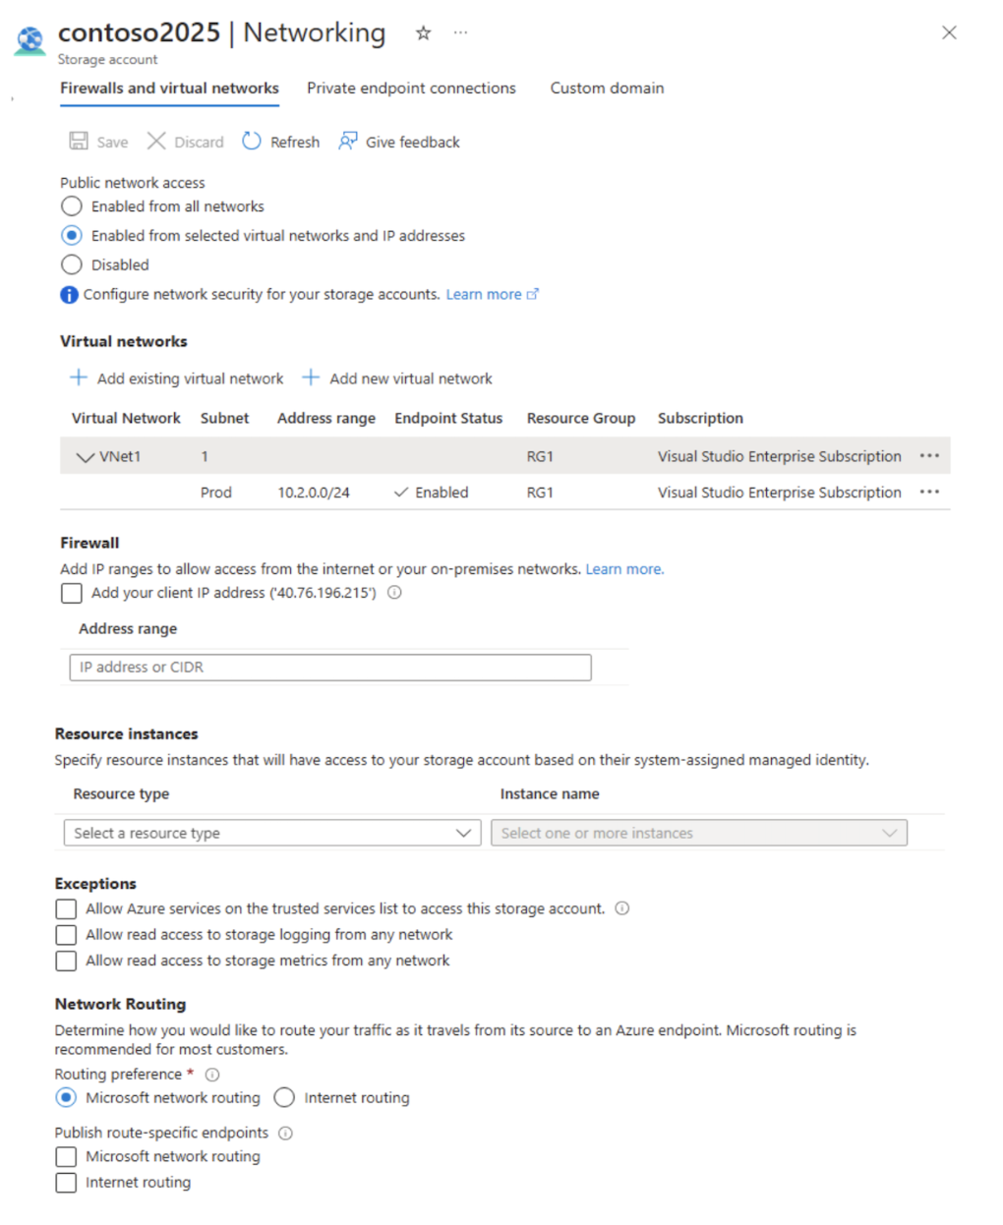
Based on the configuration shown, select the option that correctly completes the following statement:
`"The virtual machines on the 10.2.9.0/24 subnet will have network connectivity to the file shares in the storage account ________________________________."`
Réponses:
☐ always
☐ during a backup
☑ never
Explication
`Never` is correct.
Public network access is set to "Enabled from selected virtual networks and IP addresses." This means that the storage account can only be accessed from specific virtual networks and IP addresses.
Under Virtual networks, VNet1 is listed with a subnet named Prod (10.2.0.0/24) having an "Enabled" endpoint status. This means the storage account permits access only from this specific subnet within VNet1.
The address space of VNet1 is 10.2.0.0/16, but the only associated subnet is 10.2.0.0/24, which includes IP addresses in the range 10.2.0.0 to 10.2.0.255.
The virtual machines on the 10.2.9.0/24 subnet would have IP addresses in the range 10.2.9.0 to 10.2.9.255. This range is outside the defined Prod subnet (10.2.0.0/24).
Since the network connectivity to the storage account is segmented by subnets and not by the entire virtual network, the virtual machines on the 10.2.9.0/24 subnet will not have network connectivity to the file shares in the storage account.
Therefore, the virtual machines on the 10.2.9.0/24 subnet will never have network connectivity to the file shares in the storage account.
Reference(s):
- https://azure.microsoft.com/en-us/blog/azure-backup-now-supports-storage-accounts-secured-with-azure-storage-firewalls-and-virtual-networks

Question 32
You have multiple Azure virtual machines deployed in a virtual network named VNet1.
You configure an Azure Storage account as shown below. The networking settings restrict public network access to selected virtual networks and subnets, and VNet1 is explicitly added with a service endpoint enabled on a specific subnet. No additional IP address ranges are configured in the firewall section. The network routing preference is set to use Microsoft network routing, and no private endpoints are configured.
Based on the configuration shown, select the option that correctly completes the following statement:
`"Azure Backup will be able to back up the unmanaged disks of the virtual machines in the storage account ________________________________."`
Réponses:
☐ always
☐ during a backup
☑ never
Explication
`Never` is the correct answer because if you enable Virtual network in the firewall setting, you need to select the option at the bottom - Allow Azure services on the trusted services list to access this storage account and enable it. Otherwise the access will be limited to the resources in the VNet only.
Reference(s):
- https://azure.microsoft.com/en-us/blog/azure-backup-now-supports-storage-accounts-secured-with-azure-storage-firewalls-and-virtual-networks

Question 33
An Azure subscription includes a storage account named storageaccount1. The storage account has the following lifecycle management rules configured:
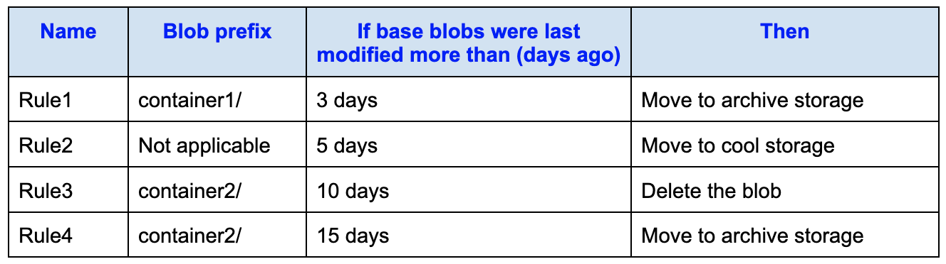
On June 1, you upload the following blobs to storageaccount1:
- File1 is stored in container1 and uses the Hot access tier.
- File2 is stored in container2 and uses the Hot access tier.

True or False:**
`"On June 6, File1 will be stored in the Cool access tier."`
Réponses:
☐ True
☑ False
Explication
`False` is correct because once the file1 is moved to archive after 3 days, the modified date time remains the same. Which means, after 5+ days for Rule 2, it will not be able to move it back to cool tier from archive, as it needs to be rehydrated which cannot be done via a policy.
Reference(s):
- https://learn.microsoft.com/en-us/azure/storage/blobs/archive-rehydrate-overview

Question 34
An Azure subscription includes a storage account named storageaccount1. The storage account has the following lifecycle management rules configured:
On June 1, you upload the following blobs to storageaccount1:
- File1 is stored in container1 and uses the Hot access tier.
- File2 is stored in container2 and uses the Hot access tier.

True or False:**
`"On June 1, File2 will be stored in the Cool access tier."`
Réponses:
☐ True
☑ False
Explication
`False` is correct because Rule3 states that blobs in container2/ older than 10 days will be deleted, and Rule4 moves blobs older than 15 days to archive storage. File2, added on June 1, does not meet the conditions for any lifecycle management rule to trigger. Therefore, it remains in the Hot tier, and no rule moves it to the Cool tier.

Reference(s):**
- https://learn.microsoft.com/en-us/azure/storage/blobs/archive-rehydrate-overview

Question 35
An Azure subscription includes a storage account named storageaccount1. The storage account has the following lifecycle management rules configured:
On June 1, you upload the following blobs to storageaccount1:
- File1 is stored in container1 and uses the Hot access tier.
- File2 is stored in container2 and uses the Hot access tier.

True or False:**
`"On June 16, File2 will be stored in the Archive access tier."`
Réponses:
☐ True
☑ False
Explication
`False` is correct because after 10 days, rule3 deletes the file2 and hence it will not be available to be put to archive tier after 15 days by rule4.
Reference(s):
- https://learn.microsoft.com/en-us/azure/storage/blobs/archive-rehydrate-overview

Question 36
An Azure subscription contains an Azure Storage account named storageaccount1.
You export storageaccount1 as an Azure Resource Manager (ARM) template. The exported template defines the storage account type, location, SKU, encryption settings, access tier, and network access configuration. The network rules allow access by default and include a bypass for Azure services, with no virtual network rules or IP address restrictions specified.
{
"type": "Microsoft.Storage/storageAccount",
"apiVersion": "2019-06-01",
"name": "storageaccount1",
"location": "eastus",
"sku": {
"name": "Standard_LRS",
"tier": "Standard"
},
"kind": "StorageV2",
"properties": {
"networkAcls": {
"bypass": "AzureServices",
"virtualNetworkRules": [],
"ipRules": [],
"defaultAction": "Allow"
},
"supportsHttpsTrafficOnly": true,
"encryption": {
"services": {
"file": {
"keyType": "Account",
"enabled": true
},
"blob": {
"keyType": "Account",
"enabled": true
}
}
},
"keySource": "Microsoft.Storage"
},
"accessTier": "Hot"
}
True or False:
`"A server with the public IP address of 131.107.103.10 can access storageaccount1."`
Réponses:
☑ True
☐ False
Explication
`True` is correct because default action is set to allow for Network ACLs. So any server on the public internet can access the storage account if it has the access keys.

A note about the `bypass` setting in the Network ACL:**
The `bypass` setting is used to allow trusted Azure services to access the storage account even when network rules restrict other traffic. For example, services like Azure Backup, Azure Site Recovery, or Azure Monitor often need access to storage accounts. When the `bypass` value includes `AzureServices`, these trusted services can bypass the firewall restrictions if the `defaultAction` is set to Deny.
In this case:
- The `defaultAction` is set to `Allow`, meaning all IPs (including public IPs) are currently allowed by default.
- The `bypass` setting is irrelevant in this situation because access isn’t restricted to begin with.
- If `defaultAction` were set to `Deny`, then the `bypass: AzureServices` would ensure that trusted Azure services can still reach the storage account — but not general users or applications, even if they are Azure-joined.
Reference(s):
- https://learn.microsoft.com/en-us/azure/storage/blobs/access-tiers-overview
- https://learn.microsoft.com/en-us/azure/well-architected/service-guides/storage-accounts/security

Question 37
An Azure subscription contains an Azure Storage account named storageaccount1.
You export storageaccount1 as an Azure Resource Manager (ARM) template. The exported template defines the storage account type, location, SKU, encryption settings, access tier, and network access configuration. The network rules allow access by default and include a bypass for Azure services, with no virtual network rules or IP address restrictions specified.
{
"type": "Microsoft.Storage/storageAccount",
"apiVersion": "2019-06-01",
"name": "storageaccount1",
"location": "eastus",
"sku": {
"name": "Standard_LRS",
"tier": "Standard"
},
"kind": "StorageV2",
"properties": {
"networkAcls": {
"bypass": "AzureServices",
"virtualNetworkRules": [],
"ipRules": [],
"defaultAction": "Allow"
},
"supportsHttpsTrafficOnly": true,
"encryption": {
"services": {
"file": {
"keyType": "Account",
"enabled": true
},
"blob": {
"keyType": "Account",
"enabled": true
}
}
},
"keySource": "Microsoft.Storage"
},
"accessTier": "Hot"
}
True or False:
`"Individual blobs in storageaccount1 can be set to use the archive tier."`
Réponses:
☑ True
☐ False
Explication
`True` is correct because this storage account is of type StandardV2 which supports blob-level tiering. So individual blob can have different tiers.
Reference(s):
- https://learn.microsoft.com/en-us/azure/storage/blobs/access-tiers-overview
- https://learn.microsoft.com/en-us/azure/well-architected/service-guides/storage-accounts/security

Question 38
An Azure subscription contains an Azure Storage account named storageaccount1.
You export storageaccount1 as an Azure Resource Manager (ARM) template. The exported template defines the storage account type, location, SKU, encryption settings, access tier, and network access configuration. The network rules allow access by default and include a bypass for Azure services, with no virtual network rules or IP address restrictions specified.
{
"type": "Microsoft.Storage/storageAccount",
"apiVersion": "2019-06-01",
"name": "storageaccount1",
"location": "eastus",
"sku": {
"name": "Standard_LRS",
"tier": "Standard"
},
"kind": "StorageV2",
"properties": {
"networkAcls": {
"bypass": "AzureServices",
"virtualNetworkRules": [],
"ipRules": [],
"defaultAction": "Allow"
},
"supportsHttpsTrafficOnly": true,
"encryption": {
"services": {
"file": {
"keyType": "Account",
"enabled": true
},
"blob": {
"keyType": "Account",
"enabled": true
}
}
},
"keySource": "Microsoft.Storage"
},
"accessTier": "Hot"
}
True or False:
`"Global administrators can access a file share hosted in storageaccount1 by using their Microsoft Entra credentials."`
Réponses:
☐ True
☑ False
Explication
`False` is correct because we do not know if the user has been added to the storage account IAM for data access. Simply having the role of Global Admin does not allow the user access to file share data.
Reference(s):
- https://learn.microsoft.com/en-us/azure/storage/blobs/access-tiers-overview
- https://learn.microsoft.com/en-us/azure/well-architected/service-guides/storage-accounts/security

Question 39
You manage a Microsoft Entra tenant.
You need to modify the Default user role permissions to meet the following requirements:
- Standard users must not be able to create new service principals.
- Standard users must be limited to using PowerShell or Microsoft Graph when managing their own Azure resources.
The current Default user role permissions settings are configured as follows:
User permissions
- `Setting 1`: Users can register applications: Yes
- `Setting 2`: Restrict non-admin users from creating tenants: No
- `Setting 3`: Users can create security groups: Yes
Guest user access
- `Setting 4`:Guest user access restrictions: Guest users have limited access to properties and memberships of directory objects
Administration center
- `Setting 5`: Restrict access to Microsoft Entra admin center: No
Session settings
- `Setting 6`: Show keep user signed in: Yes
Based on the requirements and the current configuration, which two settings should you modify?
Réponses (plusieurs réponses possibles)
☑ 1
☐ 2
☐ 3
☐ 4
☑ 5
☐ 6
Explication
`1` is correct because this setting enables the users to register an application in Microsoft Entra from which a service principal can be created. So in order to prevent this, this setting needs to be turned off.
`5` is correct because this setting, if turned on, will not allow non-admin users to access Microsoft Entra admin portal, and hence not allow them to manage their resources from it. So the only way those users can manage their resources are via Powershell, CLI or Microsoft graph API (for Microsoft Entra objects).
Reference(s):
- https://learn.microsoft.com/en-us/azure/active-directory/fundamentals/users-default-permissions

Question 40
An Azure subscription contains a storage account named contoso2024. The storage account includes the following resources:
- cont1: Blob container
- share1: File share
The contoso2024 storage account is configured with the settings shown below. The configuration defines the account kind, performance tier, security and access options, minimum TLS version, copy scope, and the default blob access tier.
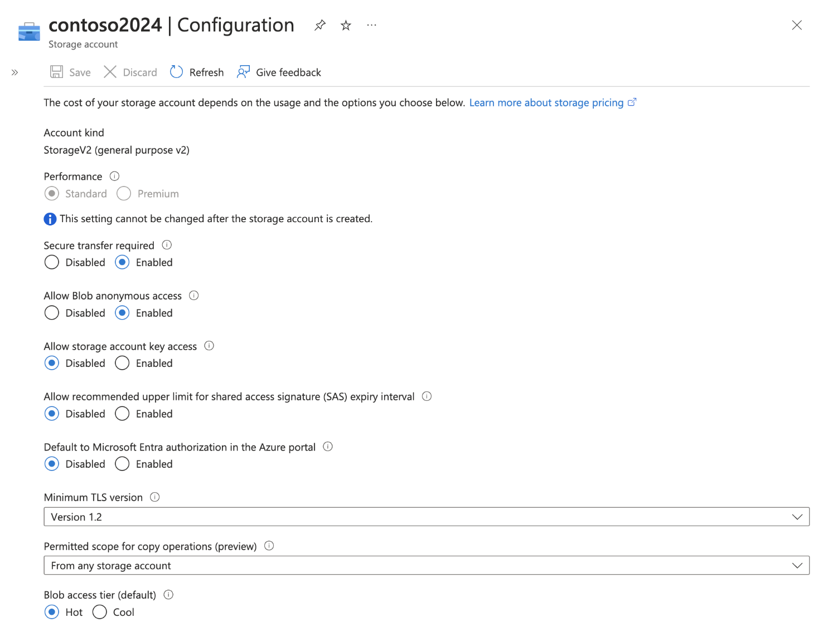
You also have a Microsoft Entra tenant with the following users, each assigned a Shared Access Signature (SAS) token for contoso2024:
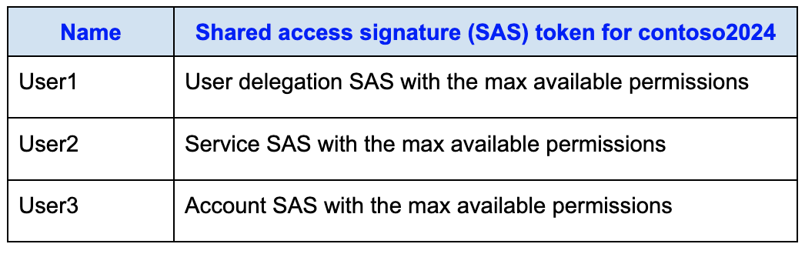
True or False:
`"User1 can access content in cont1."`
Réponses:
☑ True
☐ False
Explication
`True` is correct because User1 has a User Delegation SAS, which does not rely on the storage account keys. In this storage account, the setting Allow storage account key access is disabled, meaning that any SAS signed with the account keys (such as an Account SAS or a Service SAS) cannot be used. However, a User Delegation SAS is signed with a user delegation key that is derived from the user’s Microsoft Entra ID credentials, not from the storage account keys. This makes it valid and usable even when key access is disabled.
The Secure transfer required setting enforces that all connections must use HTTPS, but it is not the determining factor in this scenario because a User Delegation SAS already generates HTTPS URLs by default. Therefore, the reason User1 can access content in cont1 is specifically due to the use of a User Delegation SAS, which remains supported under the current configuration.
Reference(s):
- https://learn.microsoft.com/en-us/rest/api/storageservices/create-user-delegation-sas
- https://learn.microsoft.com/en-us/rest/api/storageservices/create-account-sas
- https://learn.microsoft.com/en-us/rest/api/storageservices/authorize-with-shared-key

Question 41
An Azure subscription contains a storage account named contoso2024. The storage account includes the following resources:
- cont1: Blob container
- share1: File share
The contoso2024 storage account is configured with the settings shown below. The configuration defines the account kind, performance tier, security and access options, minimum TLS version, copy scope, and the default blob access tier.
You also have a Microsoft Entra tenant with the following users, each assigned a Shared Access Signature (SAS) token for contoso2024:
True or False:
`"User2 can access content in cont1."`
Réponses:
☐ True
☑ False
Explication
`False` is correct. User2 cannot access content in cont1 because the storage account contoso2024 has "Allow storage account key access" set to Disabled. This setting prevents any requests that rely on shared key authorization, including those using Service SAS tokens.
Although User2 has a Service SAS token with maximum available permissions, Service SAS tokens are signed using the storage account key. When shared key access is disabled, these SAS tokens become invalid, regardless of their permissions.
Reference(s):
- https://learn.microsoft.com/en-us/azure/storage/common/shared-key-authorization-prevent?tabs=portal#understand-how-disallowing-shared-key-affects-sas-tokens
- https://learn.microsoft.com/en-us/rest/api/storageservices/create-user-delegation-sas
- https://learn.microsoft.com/en-us/rest/api/storageservices/create-account-sas
- https://learn.microsoft.com/en-us/rest/api/storageservices/authorize-with-shared-key

Question 42
An Azure subscription contains a storage account named contoso2024. The storage account includes the following resources:
- cont1: Blob container
- share1: File share
The contoso2024 storage account is configured with the settings shown below. The configuration defines the account kind, performance tier, security and access options, minimum TLS version, copy scope, and the default blob access tier.
You also have a Microsoft Entra tenant with the following users, each assigned a Shared Access Signature (SAS) token for contoso2024:
True or False:
`"User3 can access content in share1."`
Réponses:
☐ True
☑ False
Explication
`False` is correct because because Key access on the storage account is disabled for this storage account. Hence no matter if the user has account-level SAS key, it cannot access the content.
Reference(s):
- https://learn.microsoft.com/en-us/rest/api/storageservices/create-user-delegation-sas
- https://learn.microsoft.com/en-us/rest/api/storageservices/create-account-sas
- https://learn.microsoft.com/en-us/rest/api/storageservices/authorize-with-shared-key

Question 43
An Azure subscription contains 10 virtual machines and the following resources:
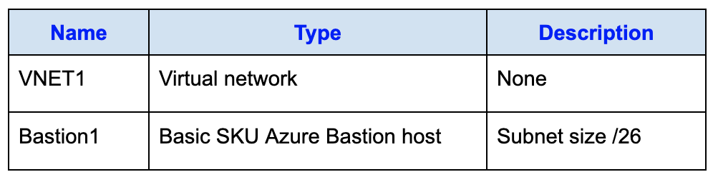
You must ensure that Bastion1 can support 100 simultaneous SSH connections. The solution should require the least possible administrative effort.
What action should you take first?
Réponses:
☐ Configure scaling for the Bastion host.
☑ Upgrade Bastion1 to the standard SKU.
☐ Create and associate a network security group (NSG).
☐ Resize the subnet of Bastion1.
Explication
`Upgrade Bastion1 to the standard SKU` is correct because with Basic SKU, only 2 instances can be created. And each instance supports upto 40 SSH concurrent users. Hence in order to support 10 sessions, we need to upgrade the SKU of the Bastion service to Standard which allows to define the number of instances you need. We need at least 3 instances in this case.
`Configure scaling for the Bastion host` is incorrect because this is only supported in Standard SKU of the Bastion service. Since the service is of type Basic, we first need to upgrade it to Standard.
`Create and associate a network security group (NSG)` is incorrect because an NSG only has rules for Inbound and Outbound traffic. It cannot help in configuring concurrent SSH sessions for Bastion service. For that you need to have multiple instances of the service running parallely,
`Resize the subnet of Bastion1` is incorrect because the size of the subnet does not matter here. For concurrent sessions, users can use the same machine to connect to backend VMs, so subnet does not need to have 100 IP addresses available.
Reference(s):
- https://learn.microsoft.com/en-us/azure/bastion/configuration-settings

Question 44
You have an Azure App Service app named App1 that is currently running two instances.
You configure an autoscale rule as shown below. The rule monitors the Memory Percentage metric across all instances, evaluates the average memory usage at a one-minute time grain, and triggers a scale-out action when the defined threshold is exceeded for a specified duration. When the condition is met, the rule increases the instance count by one and applies a cooldown period before another scale action can occur.
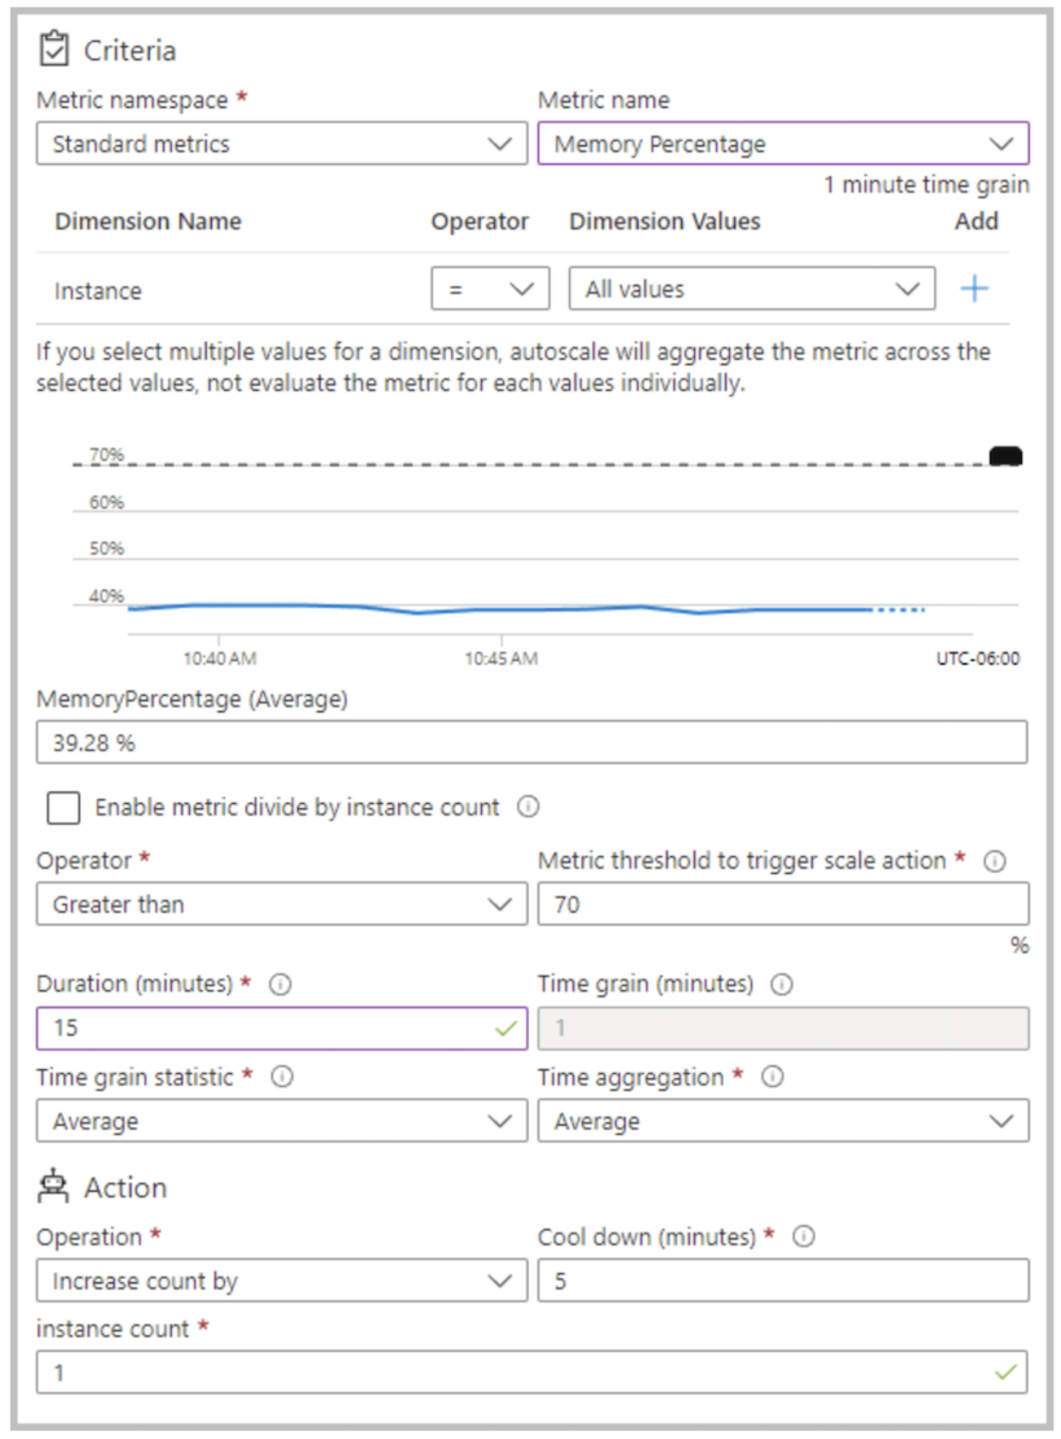
For the Instance limits scale condition, the Maximum number of instances is set to 5.
Over a continuous 30-minute period, App1 uses 80 percent of the available memory.
What is the maximum number of instances that App1 can reach during the 30-minute period?
Réponses:
☐ 2
☐ 3
☐ 4
☑ 5
Explication
`5` is correct because it starts with 2 instances. After the first 15 min, it increases the count by 1 instance. The new count is 3 after 15 minutes. 5 minutes is the cool down period in which no scaling happens. After these 5 minutes, at 20 minutes past the starting point, the scaling happens again since the Memory percentage is still more than 70%. Similarly after 25 min, there will be one more increase in the instance count. Total count at this point is 5. So after the next 5 minutes (making it 30 minutes), it cannot increase the count anymore because the max instance count is set to 5. So the final count will remain 5 after 30 minutes.
Reference(s):
https://learn.microsoft.com/en-us/azure/azure-monitor/autoscale/autoscale-get-started#cool-down-period-effects

Question 45
You have an Azure subscription.
You create an Azure Resource Manager (ARM) template file named deploy.json. The template defines a StorageV2 storage account that uses a Premium_LRS SKU. The resource name is generated dynamically by combining an index value with a unique string, and the template uses a copy loop to deploy multiple instances of the storage account.
{
"$schema": "https://schema.management.azure.com/schemas/2019-04-01/deploymentTemplate.json#",
"contentVersion": "1.0.0.0",
"parameters": {
"location": {
"type": "string",
"defaultValue": "westus"
}
},
"resources": [
{
"apiVersion": "2019-04-01",
"type": "Microsoft.Storage/storageAccounts",
"name": "[concat(copyIndex(), 'storage', uniqueString(resourceGroup().id))]",
"location": "[resourceGroup().location]",
"sku": {
"name": "Premium_LRS"
},
"kind": "StorageV2",
"properties": {},
"copy": {
"name": "storagecopy",
"count": 3
}
}
]
}
You then connect to the subscription and run the following commands.
- New-AZResourceGroup -Name RG1 -Location “centralus”
- New-AZResourceGroupDeployment -ResourceGroupName RG1 -TemplateFile “deploy.json”
True or False:
`"The commands will create four new resources."`
Réponses:
☑ True
☐ False
Explication
`True` is correct because the first command creates a resource group, and the second command creates three storage accounts in the previously created resource group. Hence it total creates 4 resources.
Note: A resource group is also a resource.
Reference(s):
- https://learn.microsoft.com/en-us/azure/azure-resource-manager/management/overview
- https://learn.microsoft.com/en-us/azure/azure-resource-manager/templates/copy-resources#resource-iteration

Question 46
You have an Azure subscription.
You create an Azure Resource Manager (ARM) template file named deploy.json. The template defines a StorageV2 storage account that uses a Premium_LRS SKU. The resource name is generated dynamically by combining an index value with a unique string, and the template uses a copy loop to deploy multiple instances of the storage account.
{
"$schema": "https://schema.management.azure.com/schemas/2019-04-01/deploymentTemplate.json#",
"contentVersion": "1.0.0.0",
"parameters": {
"location": {
"type": "string",
"defaultValue": "westus"
}
},
"resources": [
{
"apiVersion": "2019-04-01",
"type": "Microsoft.Storage/storageAccounts",
"name": "[concat(copyIndex(), 'storage', uniqueString(resourceGroup().id))]",
"location": "[resourceGroup().location]",
"sku": {
"name": "Premium_LRS"
},
"kind": "StorageV2",
"properties": {},
"copy": {
"name": "storagecopy",
"count": 3
}
}
]
}
You then connect to the subscription and run the following commands.
- New-AZResourceGroup -Name RG1 -Location “centralus”
- New-AZResourceGroupDeployment -ResourceGroupName RG1 -TemplateFile “deploy.json”
True or False:
`"The commands will create storage accounts in the West US Azure region."`
Réponses:
☐ True
☑ False
Explication
`False` is correct because the storage accounts are created in the location of the resource group which is Central US.
NOTE: If the `location` value in the template uses:
- `[parameters('location')]`: the resource gets deployed to the location provided in the parameter (`westus` in this case).
- `[resourceGroup().location]`: the resource inherits the region from the resource group, regardless of the parameter.
Reference(s):
- https://learn.microsoft.com/en-us/azure/azure-resource-manager/management/overview
- https://learn.microsoft.com/en-us/azure/azure-resource-manager/templates/copy-resources#resource-iteration

Question 47
You have an Azure subscription.
You create an Azure Resource Manager (ARM) template file named deploy.json. The template defines a StorageV2 storage account that uses a Premium_LRS SKU. The resource name is generated dynamically by combining an index value with a unique string, and the template uses a copy loop to deploy multiple instances of the storage account.
{
"$schema": "https://schema.management.azure.com/schemas/2019-04-01/deploymentTemplate.json#",
"contentVersion": "1.0.0.0",
"parameters": {
"location": {
"type": "string",
"defaultValue": "westus"
}
},
"resources": [
{
"apiVersion": "2019-04-01",
"type": "Microsoft.Storage/storageAccounts",
"name": "[concat(copyIndex(), 'storage', uniqueString(resourceGroup().id))]",
"location": "[resourceGroup().location]",
"sku": {
"name": "Premium_LRS"
},
"kind": "StorageV2",
"properties": {},
"copy": {
"name": "storagecopy",
"count": 3
}
}
]
}
You then connect to the subscription and run the following commands.
- New-AZResourceGroup -Name RG1 -Location “centralus”
- New-AZResourceGroupDeployment -ResourceGroupName RG1 -TemplateFile “deploy.json”
True or False:
`"The first storage account that is created will have a prefix of 0."`
Réponses:
☑ True
☐ False
Explication
`True` is correct because there is a copy loop running in the template which deploys three count of storage account. And the indexing of this loop, like any other programming language, starts with 0.
Reference(s):
- https://learn.microsoft.com/en-us/azure/azure-resource-manager/management/overview
- https://learn.microsoft.com/en-us/azure/azure-resource-manager/templates/copy-resources#resource-iteration

Question 48
You manage a Microsoft Entra tenant.
You need to create a Microsoft 365 group that dynamically includes only users who belong to the finance department and are located in US.
To accomplish this, you must complete the dynamic membership rule shown below. The rule evaluates a user attribute for department membership and combines it with a country-based condition.
What should you choose for `Code Segment A`?
Réponses:
☐ device.managementType
☐ device.organizationalUnit
☑ user.department
☐ user.usageLocation
Explication
`user.department` is correct because the requirement is to create a group that contains members from a specific department, in this case, the finance department. The user.department attribute in dynamic membership rules is used to filter users based on their department property.
Reference(s):
- https://learn.microsoft.com/en-us/entra/identity/users/groups-dynamic-membership

Question 49
You manage a Microsoft Entra tenant.
You need to create a Microsoft 365 group that dynamically includes only users who belong to the finance department and are located in US.
To accomplish this, you must complete the dynamic membership rule shown below. The rule evaluates a user attribute for department membership and combines it with a country-based condition.
What should you choose for `Code Segment B`?
Réponses:
☑ and
☐ or
☐ typeof
Explication
`and` is correct because you want to include users who meet both criteria: being in the finance department and being located in US. Using "and" ensures that both conditions must be true for a user to be included in the dynamic membership.
Reference(s):
- https://learn.microsoft.com/en-us/entra/identity/users/groups-dynamic-membership

Question 50
You manage a Microsoft Entra tenant.
You need to create a Microsoft 365 group that dynamically includes only users who belong to the finance department and are located in US.
To accomplish this, you must complete the dynamic membership rule shown below. The rule evaluates a user attribute for department membership and combines it with a country-based condition.
What should you choose for `Code Segment C`?
Réponses:
☐ -and
☑ -eq
☐ -in
☐ -match
Explication
`-eq` is correct because the goal is to specify a condition where the attribute (in this case, the country) is equal to a specific value, "US". The operator -eq stands for "equals" and is used in dynamic membership rules to match exact attribute values.
Reference(s):
- https://learn.microsoft.com/en-us/entra/identity/users/groups-dynamic-membership

Question 51
You have an Azure subscription that includes a storage account named storageacct1234 and two users named User1 and User2.
You assign User1 the role assignments shown below. The assignments indicate that User1 has a Reader role inherited from the resource group scope and a Storage Blob Data Contributor role assigned directly at the storage account level.
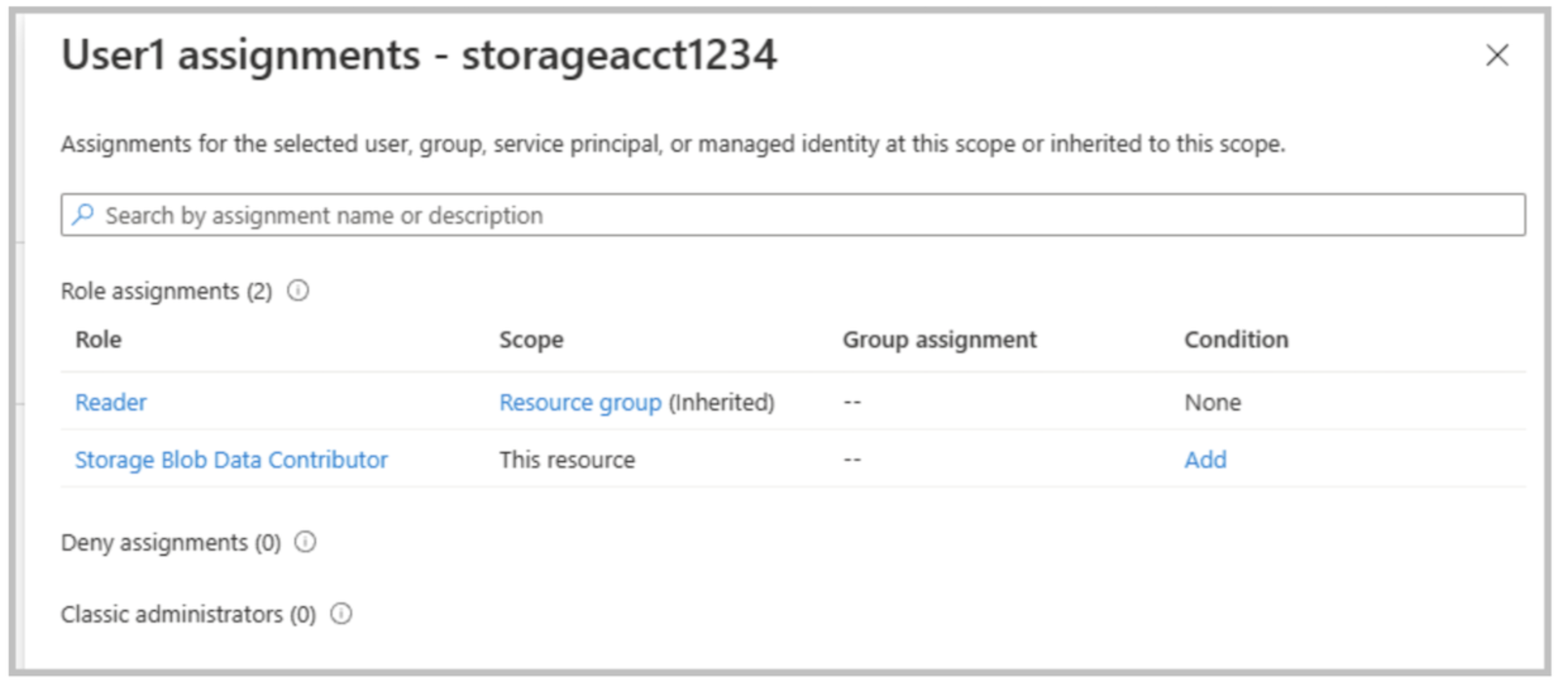
Based on these role assignments, which two actions can User1 perform?
Réponses (plusieurs réponses possibles)
☐ Assign roles to User2 for storageacct1234.
☑ Upload blob data to storageacct1234.
☐ Modify the firewall of storageacct1234.
☑ View blob data in storageacct1234.
☐ View file shares in storageacct1234.
Explication
`Upload blob data to storageacct1234` is correct because the Storage Blob Data Contributor role is a data-plane role that allows read, write, and delete operations on blob containers and blobs within the storage account.
`View blob data in storageacct1234` is correct because the ability to read blob content is granted by the Storage Blob Data Contributor role. The Reader role alone does not provide data access, but it allows viewing the storage account resource itself in the Azure portal.**

`Assign roles to User2 for storageacct1234` is incorrect because assigning RBAC roles requires Owner or User Access Administrator permissions. Neither the Reader role nor the Storage Blob Data Contributor role includes authorization to assign roles.**

`Modify the firewall of storageacct1234` is incorrect because changing networking or firewall settings is a management-plane operation that requires Contributor, Owner, or specific networking permissions. The Reader role is read-only, and the Storage Blob Data Contributor role applies only to blob data access.**

`View file shares in storageacct1234` is incorrect because Azure Files access is controlled by separate data-plane roles such as Storage File Data SMB Share Reader or Storage File Data SMB Share Contributor. The Storage Blob Data Contributor role applies only to blob storage and does not grant access to file shares.
Reference(s):
- https://learn.microsoft.com/en-us/azure/role-based-access-control/built-in-roles#storage-blob-data-contributor
- https://learn.microsoft.com/en-us/azure/role-based-access-control/built-in-roles

Question 52
You have an Azure subscription that includes the following virtual networks:
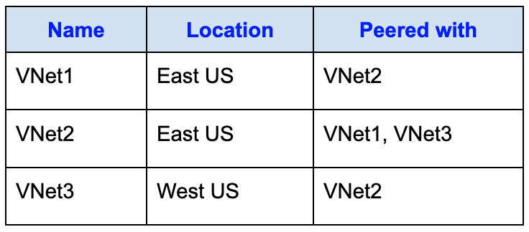
The subscription also contains the following virtual machines:
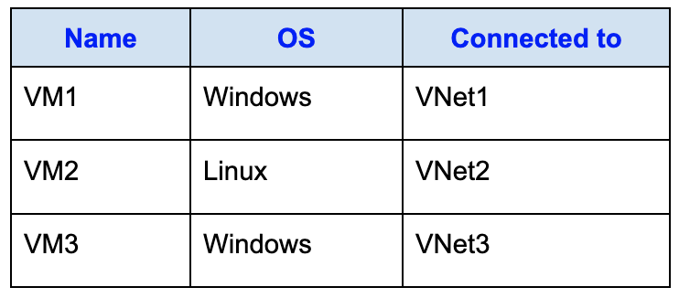
Each virtual machine has only a private IP address assigned.
You then deploy an Azure Bastion resource with the following configuration:
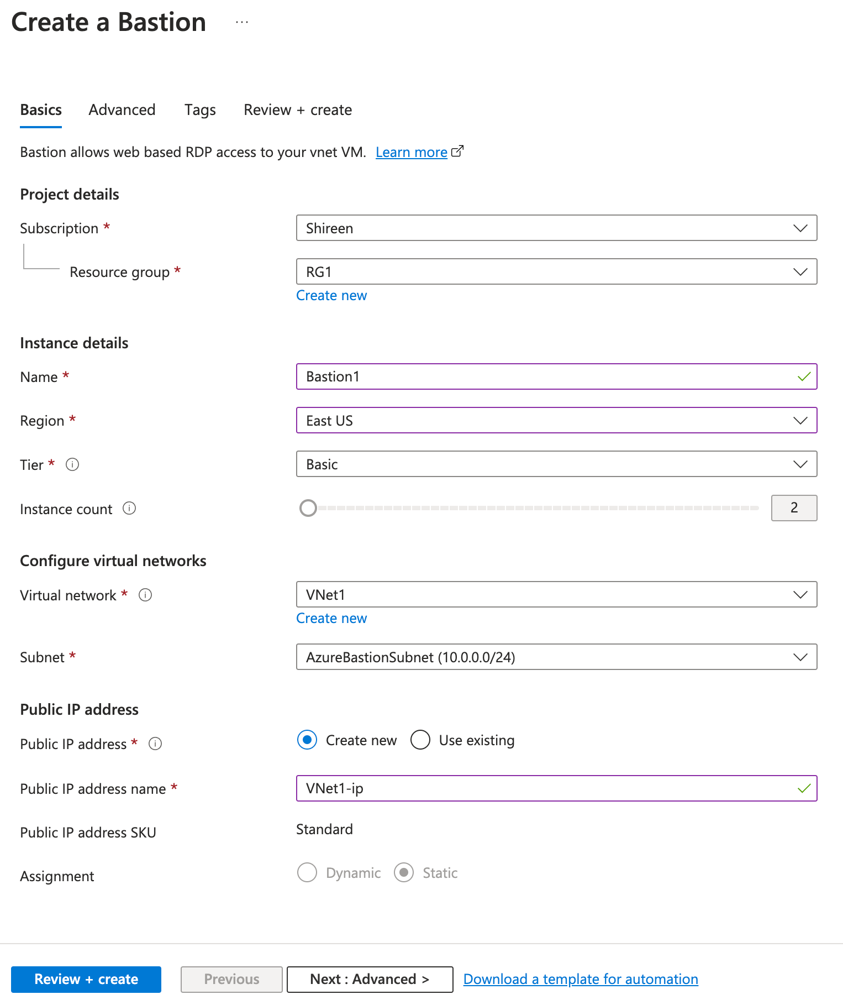
True or False:
`"The Remote Desktop Connection client (mstsc.exe) can be used to connect to VM1 through Bastion1."`
Réponses:
☐ True
☑ False
Explication
`False` is correct. The Remote Desktop Connection client (`mstsc.exe`) cannot be used to connect to VM1 through Bastion1 because Bastion1 is deployed using the Basic SKU, and the Basic SKU does not support native client access. Native client access refers to using external tools such as `mstsc.exe` or SSH from a local terminal, rather than the Azure portal's browser-based Bastion session.
To use `mstsc.exe` for RDP access to a virtual machine through Azure Bastion, you must deploy Azure Bastion with the Standard SKU, and explicitly enable the “Native client support” feature. Since the Bastion instance in this scenario uses the Basic tier, the native client feature is not available, and RDP access is only possible through the Azure portal.
Reference(s):
- https://learn.microsoft.com/en-us/azure/bastion/native-client
- https://learn.microsoft.com/en-us/azure/bastion/configuration-settings#skus
- https://learn.microsoft.com/en-us/azure/bastion/bastion-overview

Question 53
You have an Azure subscription that includes the following virtual networks:
The subscription also contains the following virtual machines:
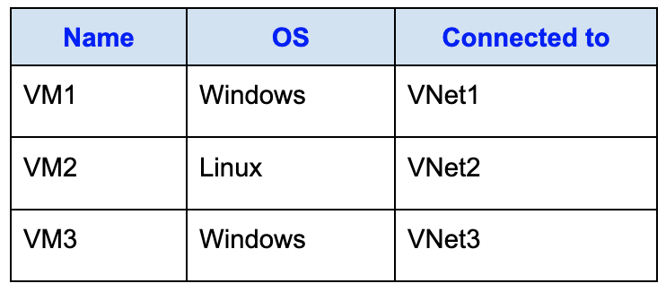
Each virtual machine has only a private IP address assigned.
You then deploy an Azure Bastion resource with the following configuration:
True or False:
`"The Azure portal can use SSH to connect to VM2 through Bastion1."`
Réponses:
☑ True
☐ False
Explication
`True` is correct because Bastion1 is deployed in VNet1 using the Basic SKU, which supports RDP for Windows VMs and SSH for Linux VMs through the Azure portal’s browser-based session. VM2 is a Linux VM located in VNet2, and since VNet2 is directly peered with VNet1, Bastion1 can be used to establish an SSH session from the portal. The Basic SKU limitation only applies to native client support (mstsc.exe or ssh.exe), which requires the Standard SKU. Since the question specifically states “Azure portal”, SSH through the portal is fully supported.
Reference(s):
- https://learn.microsoft.com/en-us/azure/bastion/native-client#deploy-bastion-with-the-native-client-feature
- https://learn.microsoft.com/en-us/azure/bastion/configuration-settings#skus

Question 54
You have an Azure subscription that includes the following virtual networks:
The subscription also contains the following virtual machines:
Each virtual machine has only a private IP address assigned.
You then deploy an Azure Bastion resource with the following configuration:
True or False:
`"The Azure portal can be used to connect to VM3 through Bastion1."`
Réponses:
☐ True
☑ False
Explication
`False` is correct because there is no direct connection between VNet1 in which Bastion1 is and VNet3. Hence the connection from Bastion1 will not be possible to VM3.
Reference(s):
- https://learn.microsoft.com/en-us/azure/bastion/native-client#deploy-bastion-with-the-native-client-feature
- https://learn.microsoft.com/en-us/azure/bastion/configuration-settings#skus

Question 55
You have an Azure subscription that contains an Azure container registry named ShireenReg1.
You enable the Admin user for ShireenReg1.
After enabling the Admin user, you want to sign in directly to the container registry.
Which username can you use to sign in to ShireenReg1?
Réponses:
☐ root
☐ admin
☐ administrator
☑ ShireenReg1
Explication
ShireenReg1 is correct because when you enable the admin user for an Azure container registry, Azure provides the registry name itself as the username. This means you can use the container registry's name (in this case, "ShireenReg1") as the username, along with the admin user access key as the password, to log in.
Reference(s):
- https://learn.microsoft.com/en-us/azure/container-registry/container-registry-authentication?tabs=azure-cli
- https://learn.microsoft.com/en-us/azure/container-registry/container-registry-get-started-azure-cli

Question 56
You have an Azure Storage account named contoso2024 that contains the following resources:
- container1: a blob container that stores File1
- share1: an Azure File share that stores File2
You have the following users and permissions assigned for contoso2024:
- User1: Reader role
- User2: Storage Account Contributor role
- User3: Has an access key for contoso2024
The storage account contoso2024 is configured with secure transfer enabled, public blob access enabled, storage account key access disabled, and Azure Active Directory authorization disabled in the Azure portal.
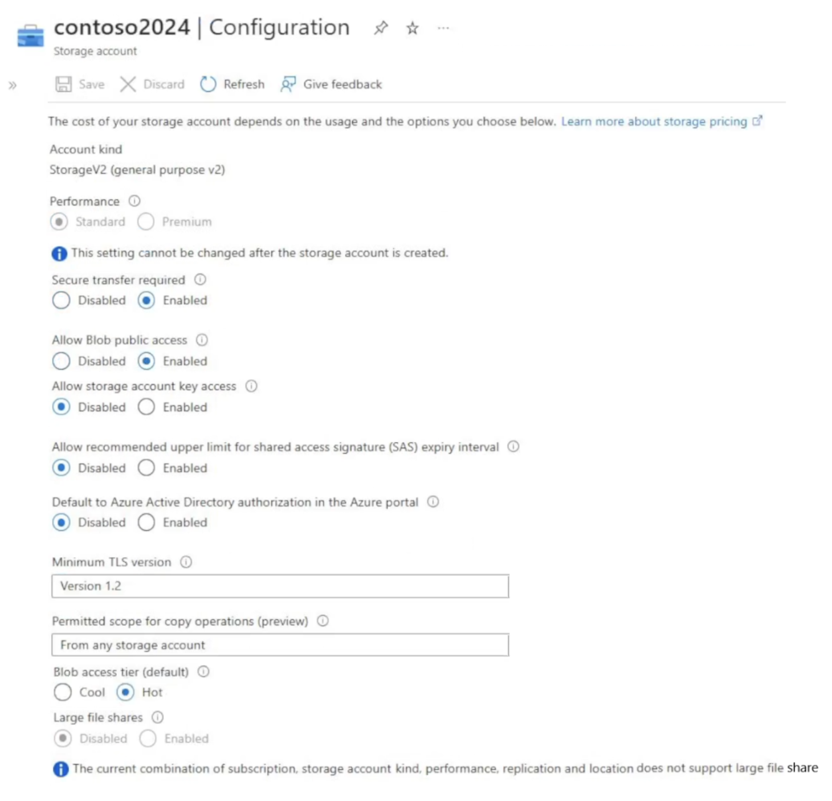
True or False:
`"User1 can read File1."`
Réponses:
☐ True
☑ False
Explication
`False` is correct because Reader role gives you access to read the metadata and configuration of the storage account (on the service-level). It does not give you read access to the content of blob storage. Hence User1 cannot read File1.
Note: While "Allow Blob public access" is enabled at the storage account level, this only means that public access is permitted if the individual container is configured to allow it (such as "container" or "blob" level anonymous access). However, unless the container is explicitly set to public access (which is not indicated in the question), anonymous users cannot access the blob data. In this scenario, User1 has only the Reader role (control plane access) and no data plane permissions, and we have no information that public access is configured on the container. Therefore, User1 cannot read File1.
Reference(s):
- https://learn.microsoft.com/en-us/azure/role-based-access-control/built-in-roles
- https://learn.microsoft.com/en-us/azure/storage/common/storage-account-keys-manage?tabs=azure-portal

Question 57
You have an Azure Storage account named contoso2024 that contains the following resources:
- container1: a blob container that stores File1
- share1: an Azure File share that stores File2
You have the following users and permissions assigned for contoso2024:
- User1: Reader role
- User2: Storage Account Contributor role
- User3: Has an access key for contoso2024
The storage account contoso2024 is configured with secure transfer enabled, public blob access enabled, storage account key access disabled, and Azure Active Directory authorization disabled in the Azure portal.
True or False:
`"User2 can read File2."`
Réponses:
☐ True
☑ False
Explication
`False` is correct because the Storage Account Contributor role has all the permissions to manage a storage account, but not access to it. Along with it, it does not have the access to read data from any of the storage services be it blob or fileshares. But it does have access to Access-keys, from which the data can be read. However in the configuration we see that the Storage Account key access has been disabled. So User2 cannot read file2.
Reference(s):
- https://learn.microsoft.com/en-us/azure/role-based-access-control/built-in-roles
- https://learn.microsoft.com/en-us/azure/storage/common/storage-account-keys-manage?tabs=azure-portal

Question 58
You have an Azure Storage account named contoso2024 that contains the following resources:
- container1: a blob container that stores File1
- share1: an Azure File share that stores File2
You have the following users and permissions assigned for contoso2024:
- User1: Reader role
- User2: Storage Account Contributor role
- User3: Has an access key for contoso2024
The storage account contoso2024 is configured with secure transfer enabled, public blob access enabled, storage account key access disabled, and Azure Active Directory authorization disabled in the Azure portal.
True or False:
`"User3 can read File1 and File2."`
Réponses:
☐ True
☑ False
Explication
`False` is correct because access to Storage account via Access Keys has been disabled. So User3 cannot do anything in the storage account.
Reference(s):
- https://learn.microsoft.com/en-us/azure/role-based-access-control/built-in-roles
- https://learn.microsoft.com/en-us/azure/storage/common/storage-account-keys-manage?tabs=azure-portal

Question 59
You create a virtual machine scale set named Scale1.
During deployment, Scale1 is configured with custom autoscaling settings, as shown in the exhibit. The configuration specifies an initial number of instances, minimum and maximum instance limits, and CPU-based scale-out and scale-in rules. In particular, the scale-out rule increases the instance count when average CPU usage exceeds the defined threshold for a specified duration.
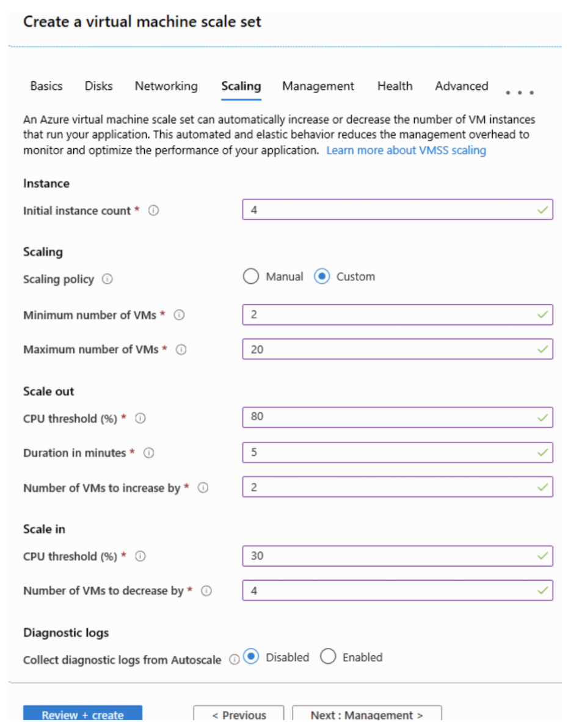
Based on the autoscaling configuration shown in the exhibit, complete the following statement:
`“If Scale1 is utilized at 85 percent for six minutes after it is deployed, Scale1 will be running _______________.”`
Réponses:
☐ 2 virtual machines
☐ 4 virtual machines
☑ 6 virtual machines
☐ 10 virtual machines
☐ 20 virtual machines
Explication
`6 virtual machines` is the correct option because the virtual machine scale set (VMSS) is configured to scale out when CPU utilization exceeds 80% for 5 minutes. In this case:
- The initial number of VMs is 4.
- When the CPU usage crosses 80% for 6 minutes (exceeding the configured threshold of 5 minutes), 2 additional VMs will be added.
- Therefore, the total number of VMs becomes 4 + 2 = 6 VMs.
**Reference(s):

- https://learn.microsoft.com/en-us/azure/virtual-machine-scale-sets/virtual-machine-scale-sets-autoscale-overview
- https://learn.microsoft.com/en-us/azure/azure-monitor/autoscale/autoscale-best-practices
- https://learn.microsoft.com/en-us/azure/azure-monitor/autoscale/autoscale-overview

Question 60
You create a virtual machine scale set named Scale1.
During deployment, Scale1 is configured with custom autoscaling settings, as shown in the exhibit. The configuration specifies an initial number of instances, minimum and maximum instance limits, and CPU-based scale-out and scale-in rules. In particular, the scale-out rule increases the instance count when average CPU usage exceeds the defined threshold for a specified duration.
Based on the autoscaling configuration shown in the exhibit, complete the following statement:
`“If Scale1 is first utilized at 25 percent for six minutes after it is deployed, and then utilized at 50 percent for six minutes, Scale1 will be running _______________.”`
Réponses:
☑ 2 virtual machines
☐ 4 virtual machines
☐ 6 virtual machines
☐ 10 virtual machines
☐ 20 virtual machines
Explication
`2 virtual machines` is the correct answer because the Azure Virtual Machine Scale Set (VMSS) configuration specifies:
- Initial instance count: 4
- Minimum number of VMs: 2
- Scale-in threshold: CPU usage below 30% triggers a reduction of 4 VMs
In the given scenario:
- The CPU utilization drops to 25% and stays at this level for 6 minutes.
- This satisfies the scale-in policy, which reduces the number of VMs by 4.
- However, the minimum VM threshold is set to 2, and a scale set cannot scale below the configured minimum limit.
As a result, Scale1 will be running 2 virtual machines after the scale-in process completes.
Reference(s):
- https://learn.microsoft.com/en-us/azure/virtual-machine-scale-sets/virtual-machine-scale-sets-autoscale-overview
- https://learn.microsoft.com/en-us/azure/azure-monitor/autoscale/autoscale-best-practices
- https://learn.microsoft.com/en-us/azure/azure-monitor/autoscale/autoscale-overview

Question 61
You have an Azure App Service plan configured with autoscaling. In the autoscale configuration, the plan uses metric-based scaling with defined scale-out and scale-in rules. The instance limits specify a minimum, maximum, and default number of instances. Scale-out occurs when CPU usage exceeds a configured threshold, and scale-in occurs when
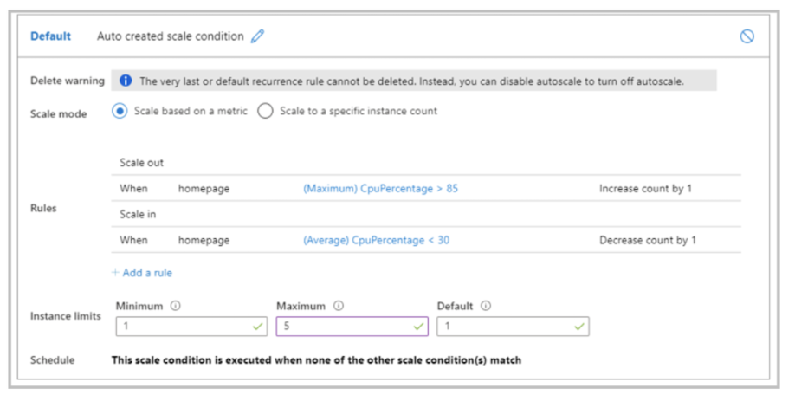
The scale-in settings for the App Service plan are configured as shown in the following exhibit.
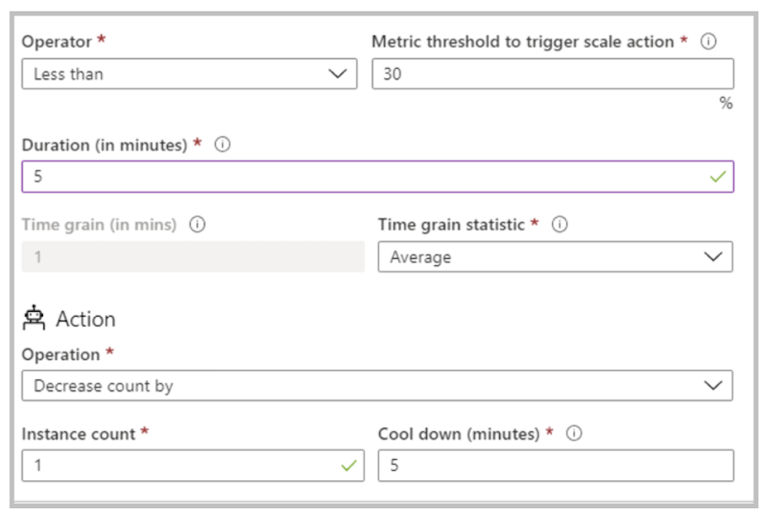
The scale out rule is configured with the same duration and cool down tile as the scale in rule.
Based on the information presented, select the answer choice that completes the following statement correctly.
`“If after deployment CPU usage is 70 percent for one hour and then reaches 90 percent for five minutes, at that time the total number of instances will be ________.”`
Réponses:
☐ 1
☑ 2
☐ 3
☐ 4
☐ 5
Explication
`2` is the correct answer because the scaling conditions are set as follows:
- Scale-out condition: When CPU usage exceeds 85%, the instance count increases by 1.
- Scale-in condition: When CPU usage drops below 30%, the instance count decreases by 1.
- Instance limits: Minimum = 1, Maximum = **5

- Initial State: The default instance count starts at 1.
- First Condition (70% for one hour): This does not trigger a scale-out because it doesn’t exceed the 85% threshold. The instance count remains at 1.
- Second Condition (90% for 5 minutes): This exceeds the 85% threshold, triggering a scale-out by 1 instance.
As a result, after these events, the total number of instances will increase from 1 to 2.
**Reference(s):

- https://learn.microsoft.com/en-us/azure/azure-monitor/autoscale/autoscale-overview
- https://learn.microsoft.com/en-us/azure/azure-monitor/autoscale/autoscale-common-scale-patterns
- https://learn.microsoft.com/en-us/previous-versions/azure/azure-monitor/autoscale/tutorial-autoscale-performance-schedule

Question 62
You have an Azure App Service plan configured with autoscaling. In the autoscale configuration, the plan uses metric-based scaling with defined scale-out and scale-in rules. The instance limits specify a minimum, maximum, and default number of instances. Scale-out occurs when CPU usage exceeds a configured threshold, and scale-in occurs when
The scale-in settings for the App Service plan are configured as shown in the following exhibit.
The scale out rule is configured with the same duration and cool down tile as the scale in rule.
Based on the information presented, select the answer choice that completes the following statement correctly.
`“If after deployment the CPU maintains constant usage of 90 percent for one hour, and then the average CPU usage is below 25 percent for nine minutes, at that point the number of instances will be ___________.”`
Réponses:
☐ 1
☐ 2
☐ 3
☑ 4
☐ 5
Explication
`4` is correct. The App Service Plan starts with 1 instance. When the CPU usage is consistently at 90% for 1 hour, the scale-out rule applies. The rule checks if the maximum CPU percentage exceeds 85% over a 5-minute window, and if it does, it increases the instance count by 1. After scaling out, a 5-minute cooldown period begins before the next evaluation.
Since both the evaluation period and the cooldown duration are set to 5 minutes, the system can scale out every 5 minutes as long as the CPU remains above 85%. Therefore, in 60 minutes, scaling can occur up to 12 times. However, the maximum instance limit is capped at 5, so only 4 scale-out operations can occur before hitting the cap, bringing the instance count from 1 to 5.
Afterward, when the CPU usage drops below 30% and stays there for 9 minutes, the scale-in rule (which evaluates on a 5-minute basis and then applies a 5-minute cooldown) is triggered. Only 1 full scale-in cycle can be completed during that 9-minute low usage period. So, the instance count is reduced by 1, resulting in a final count of 4 instances.
Reference(s):
- https://learn.microsoft.com/en-us/azure/azure-monitor/autoscale/autoscale-overview
- https://learn.microsoft.com/en-us/azure/azure-monitor/autoscale/autoscale-common-scale-patterns
- https://learn.microsoft.com/en-us/previous-versions/azure/azure-monitor/autoscale/tutorial-autoscale-performance-schedule

Question 63
You have a deployment template named Template1 that provisions 10 Azure web apps.
Before deploying Template1, you need to determine which prerequisite resource must be created in advance. The solution should be designed to keep Azure costs as low as possible.
What should you identify?
Réponses:
☐ one Azure Traffic Manager
☐ one Azure Application Gateway
☑ one App Service plan
☐ 10 App Service plans
☐ five Azure Application Gateways
Explication
`one App Service plan` is correct because an App Service Plan allows multiple web apps to run within a single plan, sharing the same resources (e.g., CPU, memory). This approach minimizes Azure costs by avoiding the need for separate App Service Plans for each web app. Instead of provisioning separate infrastructure for each app, a single App Service Plan can host multiple apps, as long as they share similar performance and scaling requirements.
`one Azure Traffic Manager` is incorrect because Azure Traffic Manager is a DNS-based load balancer primarily used for global traffic routing across multiple regions. It is not required to host or run Azure Web Apps.
`one Azure Application Gateway` is incorrect because an Application Gateway is a layer 7 load balancer for web traffic routing and SSL offloading. It is useful for managing incoming web traffic but is not a requirement for deploying Azure Web Apps.
`10 App Service plans` is incorrect because deploying 10 separate App Service Plans for 10 web apps is unnecessary and would significantly increase costs. A single App Service Plan can host multiple web apps efficiently.
`five Azure Application Gateways` is incorrect because, similar to one Azure Application Gateway, five instances would be redundant and cost-inefficient for deploying just 10 web apps.
Reference(s):
- https://learn.microsoft.com/en-us/azure/app-service/overview-hosting-plans
- https://learn.microsoft.com/en-us/azure/app-service/overview

Question 64
You have an Azure subscription that contains the resources shown in the following table.
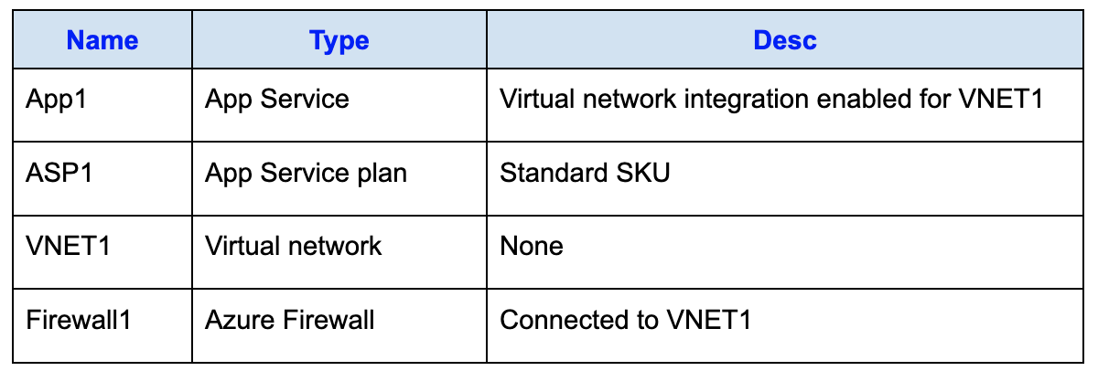
You are required to control and manage outbound traffic originating from VNET1 by using Firewall1.
What should you do first?
Réponses:
☑ Create a route table.
☐ Configure the Hybrid Connection Manager.
☐ Create an Azure Network Watcher.
☐ Upgrade ASP1 to the Premium SKU.
Explication
`Create a route table` is correct because to manage outbound traffic from a virtual network (VNET1) using Azure Firewall (Firewall1), you must first create a route table. The route table is used to define how outbound traffic is directed through the Azure Firewall. Specifically, you configure a user-defined route (UDR) in the route table to ensure that outbound traffic is routed through the Azure Firewall. Without this configuration, the traffic will not pass through the firewall, and you won't be able to control or manage it effectively.
`Configure the Hybrid Connection Manager` is incorrect because Hybrid Connection Manager is used to connect Azure App Services to on-premises resources securely. It is not relevant to managing outbound traffic via Azure Firewall.
`Create an Azure Network Watcher` is incorrect because Azure Network Watcher is used for monitoring and diagnosing network issues, not for managing or directing outbound traffic through an Azure Firewall.
`Upgrade ASP1 to the Premium SKU` is incorrect because upgrading to the Premium SKU of the App Service Plan does not affect the routing of outbound traffic through an Azure Firewall.
Reference(s):
- https://learn.microsoft.com/en-us/azure/app-service/network-secure-outbound-traffic-azure-firewall
- https://docs.microsoft.com/en-us/azure/virtual-network/tutorial-create-route-table-portal
- https://docs.microsoft.com/en-us/azure/network-watcher/network-watcher-monitoring-overview

Question 65
You have an Azure subscription with the following virtual networks:
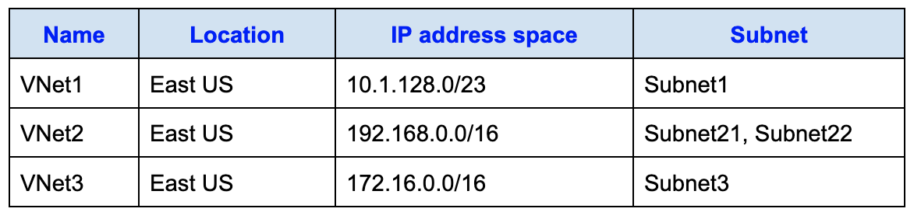
The subnets are configured with the following IP address ranges:
- Subnet1: 10.1.128.0/24
- Subnet21: 192.168.0.0/17
- Subnet22: 192.168.128.0/17
- Subnet3: 172.16.1.0/24
You plan to deploy a container app named app1 in the East US region.
To support this, you need to create a container app environment named env1 with the following conditions:
- Uses its own (and existing) virtual network.
- Uses its own (and new) subnet.
- Is connected to the smallest possible subnet.
To which virtual networks can you connect env1?
Réponses:
☐ VNet1 only
☐ VNet2 only
☑ VNet3 only
☐ VNet1 or VNet2 only
☐ VNet2 or VNet3 only
☐ VNet1, VNet2, or VNet3
Explication
`VNet3 only` is correct because the requirement specifies that the container app environment (env1) must use its own (and new) subnet and must connect to the smallest possible subnet. Additionally, the subnet must be able to accommodate a minimum /23 CIDR range, which requires at least 512 IP addresses.
- VNet1 has an IP address space of /23 (512 IP addresses in total). Subnet1 already occupies /24, which uses 256 addresses, leaving insufficient IP addresses to create a new /23 subnet.
- VNet2 has an IP address space of /16 (65,536 IP addresses). However, it already contains two subnets, each with /17 ranges (32,768 IP addresses each). This allocation exhausts the available IP space, leaving no room for an additional /23 subnet.
- VNet3 also has an IP address space of /16 (65,536 IP addresses). Subnet3, which occupies /24, only consumes 256 addresses, leaving sufficient IP space to create a new /23 subnet.
Reference(s):
- https://www.ipaddressguide.com/cidr
- https://www.calculator.net/ip-subnet-calculator.html?cclass=any&csubnet=17&cip=10.128.1.0&ctype=ipv4&printit=0&x=55&y=24

Question 66
You have an Azure subscription with the following virtual networks:
The subnets are configured with the following IP address ranges:
- Subnet1: 10.1.128.0/24
- Subnet21: 192.168.0.0/17
- Subnet22: 192.168.128.0/17
- Subnet3: 172.16.1.0/24
You plan to deploy a container app named app1 in the East US region.
To support this, you need to create a container app environment named env1 with the following conditions:
- Uses its own (and existing) virtual network.
- Uses its own (and new) subnet.
- Is connected to the smallest possible subnet.
Which subnet mask should you use?
Réponses:
☐ /16
☑ /23
☐ /24
☐ /26
☐ /28
Explication
`/23` is correct because, as per Microsoft's official recommendation, a container app environment requires a dedicated subnet with a minimum address space of /23 when connecting to a virtual network. This allocation ensures sufficient IP addresses (512) for both current and future scaling needs of the container app environment. Additionally, the requirement specifies selecting the smallest possible subnet that meets these prerequisites, and /23 is the optimal choice in this scenario.
Therefore, /23 satisfies both the minimum requirement and the smallest possible subnet criteria for deploying a container app environment in an Azure virtual network.
Reference(s):
- https://www.calculator.net/ip-subnet-calculator.html?cclass=any&csubnet=17&cip=10.128.1.0&ctype=ipv4&printit=0&x=55&y=24
- https://learn.microsoft.com/en-us/azure/container-apps/vnet-custom?tabs=bash&pivots=azure-portal#restrictions

Question 67
Note: This question is part of a series that uses the same overall scenario. Each question in the series proposes a different solution that may or may not satisfy the stated requirement.
You have an application named App1 that runs on two Azure virtual machines, VM1 and VM2. Incoming traffic to App1 is handled through an Azure Load Balancer. The effective network security rules applied to VM2 are shown in the exhibit.
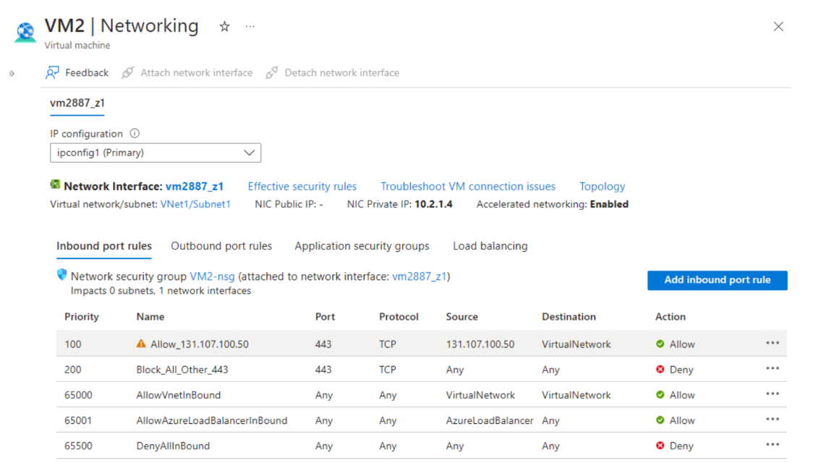
You observe that connection attempts from the IP address 131.107.100.50 to App1 over TCP port 443 are unsuccessful, even though the Load Balancer rules have been confirmed to be correctly configured.
You want to ensure that traffic from 131.107.100.50 can successfully reach App1 on port 443.
Proposed Solution: You remove the inbound network security rule named BlockAllOther443.
Does this solution achieve the stated objective?
Réponses:
☑ Yes
☐ No
Explication
`Yes` is correct because the inbound security rule Block_All_Other_443 (priority 200) denies all TCP 443 traffic from any source to any destination. This rule inadvertently blocks the Azure Load Balancer’s health probe traffic, which also uses TCP 443. Since health probes are required to mark backend VMs as healthy, VM2 is excluded from the load balancer rotation, causing all client traffic (even from 131.107.100.50, which is explicitly allowed by rule 100) to fail. By deleting the overly broad deny rule, the health probe is allowed through via the built-in AllowAzureLoadBalancerInBound rule (priority 65001), restoring VM2’s healthy state. Once the probe succeeds, the client IP 131.107.100.50 can connect successfully because its explicit allow rule (priority 100) is already in place.
Reference(s):
- https://learn.microsoft.com/en-us/azure/load-balancer/manage-rules-how-to

Question 68
Note: This question is part of a series that uses the same overall scenario. Each question in the series proposes a different solution that may or may not satisfy the stated requirement.
You have an application named App1 that runs on two Azure virtual machines, VM1 and VM2. Incoming traffic to App1 is handled through an Azure Load Balancer. The effective network security rules applied to VM2 are shown in the exhibit.
You observe that connection attempts from the IP address 131.107.100.50 to App1 over TCP port 443 are unsuccessful, even though the Load Balancer rules have been confirmed to be correctly configured.
You want to ensure that traffic from 131.107.100.50 can successfully reach App1 on port 443.
Proposed Solution: You create an inbound security rule that allows any traffic from the AzureLoadBalancer source and has a priority of 150.
Does this solution achieve the stated objective?
Réponses:
☑ Yes
☐ No
Explication
`Yes` is correct because adding a new inbound rule at priority 150 that explicitly allows traffic from the AzureLoadBalancer service tag ensures that health probe traffic is not blocked by the existing deny rule at priority 200. With this higher-priority rule in place, the health probe can once again mark VM2 as healthy, enabling the load balancer to forward traffic to it. As in Q1, once the probe succeeds, the existing allow rule at priority 100 for 131.107.100.50 ensures the client connection over TCP 443 is successful.
Reference(s):
- https://learn.microsoft.com/en-us/azure/load-balancer/manage-rules-how-to

Question 69
You have an Azure subscription that contains an Azure Availability Set named WEBPROD-AS-USE2 as shown below.
PS Azure:\> az vm availability-set list -g RG1
[
{
"id": "/subscriptions/8372f433-2dcd-4361-b5ef-5b188fed87d0/resourceGroups/RG1/providers/Microsoft.Compute/availabilitySets/WEBPROD-AS-USE2",
"location": "eastus2",
"name": "WEBPROD-AS-USE2",
"platformFaultDomainCount": 2,
"platformUpdateDomainCount": 10,
"proximityPlacementGroup": null,
"resourceGroup": "RG1",
"sku": {
"capacity": null,
"name": "Aligned",
"tier": null
},
"statuses": null,
"tags": {},
"type": "Microsoft.Compute/availabilitySets",
"virtualMachines": []
}
]You then add 14 virtual machines to WEBPROD-AS-USE2.
Select the answer choice that completes the following statement based on the information presented.
`“When Microsoft carries out planned maintenance in the East US 2 region, the highest number of virtual machines that could be unavailable at the same time will be __________.”`
Réponses:
☑ 2
☐ 7
☐ 10
☐ 14
Explication
`2` is the correct answer here. The Availability Set named WEBPROD-AS-USE2 is configured with 10 update domains, as shown in the exhibit (`"platformUpdateDomainCount": 10`). When Azure performs planned maintenance, only one update domain is rebooted at a time to maintain high availability.
If there are 14 virtual machines in the availability set, Azure distributes them evenly across the 10 update domains. This means:
- 4 update domains will host 2 VMs each.
- 6 update domains will host 1 VM each.
Since maintenance affects only one update domain at a time, the maximum number of VMs that can be offline simultaneously is 2—the worst case being an update domain with 2 VMs.
This behavior ensures that at least 12 out of 14 VMs remain available during any planned maintenance event.
Reference(s.):
- https://learn.microsoft.com/en-us/azure/virtual-machines/availability-set-overview
- https://learn.microsoft.com/en-us/azure/virtual-machines/availability

Question 70
You have an Azure subscription that contains an Azure Availability Set named WEBPROD-AS-USE2 as shown below.
PS Azure:\> az vm availability-set list -g RG1
[
{
"id": "/subscriptions/8372f433-2dcd-4361-b5ef-5b188fed87d0/resourceGroups/RG1/providers/Microsoft.Compute/availabilitySets/WEBPROD-AS-USE2",
"location": "eastus2",
"name": "WEBPROD-AS-USE2",
"platformFaultDomainCount": 2,
"platformUpdateDomainCount": 10,
"proximityPlacementGroup": null,
"resourceGroup": "RG1",
"sku": {
"capacity": null,
"name": "Aligned",
"tier": null
},
"statuses": null,
"tags": {},
"type": "Microsoft.Compute/availabilitySets",
"virtualMachines": []
}
]You then add 14 virtual machines to WEBPROD-AS-USE2.
Select the answer choice that completes the following statement based on the information presented.
`“If a power outage occurs in the Azure datacenter rack hosting WEBPROD-AS-USE2, the maximum number of virtual machines that could become unavailable will be ______.”`
Réponses:
☐ 2
☑ 7
☐ 10
☐ 14
Explication
`7` is the correct. The exhibit shows that the Availability Set WEBPROD-AS-USE2 is configured with:
- `"platformFaultDomainCount": 2`
Fault domains represent physical server racks in the Azure datacenter. Virtual machines in an Availability Set are distributed across the specified number of fault domains to protect against rack-level failures, such as power or network outages.
If the availability set contains 14 virtual machines and is configured with 2 fault domains, Azure will distribute the VMs as evenly as possible across both fault domains:
- One fault domain will host 7 VMs
- The other fault domain will host 7 VMs
If one server rack (i.e., one fault domain) experiences a power failure, all VMs in that fault domain will be unavailable. Hence, a maximum of 7 virtual machines could be offline in such a scenario.
Reference(s.):
- https://learn.microsoft.com/en-us/azure/virtual-machines/availability-set-overview
- https://learn.microsoft.com/en-us/azure/virtual-machines/availability

Question 71
You have an Azure subscription that uses the public IP addresses shown in the following table.
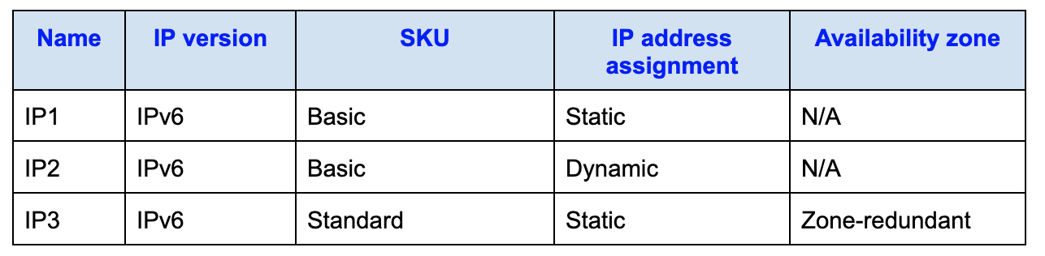
You need to create a public Azure Standard Load Balancer.
Which of the listed public IP addresses can be used for this deployment?
Réponses:
☐ IP2 only
☑ IP3 only
☐ IP1 and IP3 only
☐ IP1, IP2, and IP3
Explication
`IP3 only` is the correct answer here. Azure Standard Load Balancers require a Standard SKU public IP address with a Static assignment. From the table:
- IP3 has IP version IPv6, SKU Standard, Static assignment, and is zone-redundant. All these characteristics make it eligible to be associated with a Standard Load Balancer.
`IP1` is incorrect because it uses the Basic SKU, which is not compatible with Standard Load Balancers.
`IP2` is incorrect because it also uses the Basic SKU and is dynamically assigned, both of which disqualify it for use with a Standard Load Balancer.
Azure Load Balancers follow strict compatibility rules:
- Standard Load Balancers support only Standard SKU public IPs with Static assignments.
- Basic Load Balancers support only Basic SKU public IPs and allow Dynamic assignment, especially for IPv6, but cannot be used with Standard Load Balancers.
Reference(s.):
- https://learn.microsoft.com/en-us/azure/load-balancer/skus#sku-comparison
- https://learn.microsoft.com/en-us/azure/virtual-network/ip-services/ipv6-overview
- https://learn.microsoft.com/en-us/azure/load-balancer/load-balancer-overview
- https://learn.microsoft.com/en-us/azure/virtual-network/ip-services/public-ip-addresses#sku
- https://learn.microsoft.com/en-us/azure/load-balancer/quickstart-load-balancer-standard-public-portal

Question 72
You have an Azure Storage account named storage1 that includes a blob container called container1. The default access tier for storage1 is set to Hot.
You configure lifecycle management rules for storage1 as summarized below:
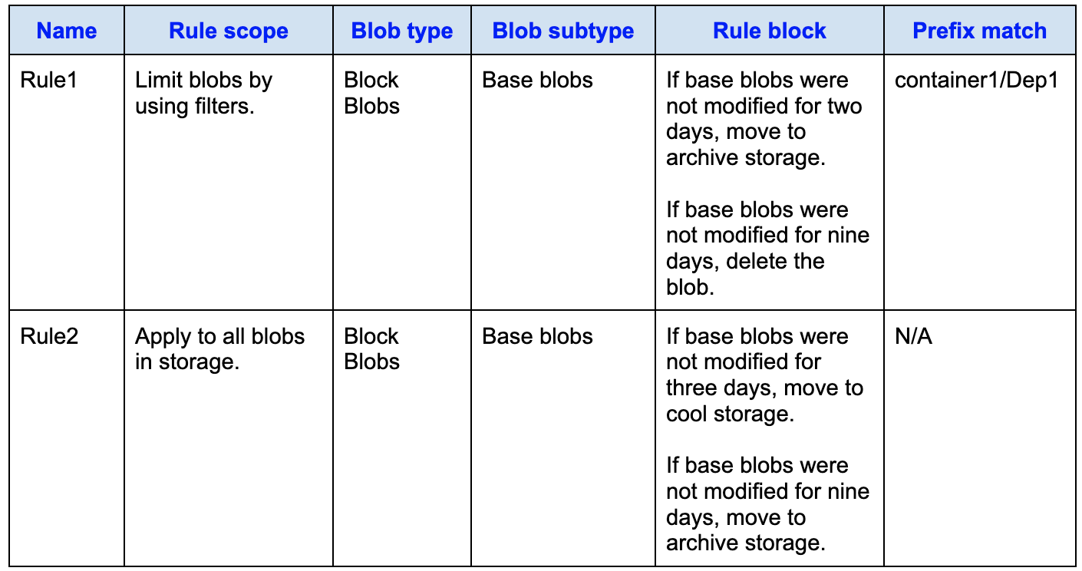
You then carry out the following actions:
- October 1: Upload three files, Dep1File1.docx, File2.docx, and File3.docx, to container1.
- October 2: Edit Dep1File1.docx and File3.docx.
- October 5: Edit File2.docx.
True or False:
`“On October 10, you are able to read Dep1File1.docx without any delay.”`
Réponses:
☐ True
☑ False
Explication
`False` is the correct answer here. According to Rule1, blobs with the prefix `container1/Dep1` are moved to archive storage if they are not modified for two days, and deleted if not modified for nine days. The file Dep1File1.docx falls under this prefix rule, and although it was edited on October 2, it hasn't been modified since.
By October 4, two full days have passed since the last modification, so the blob is moved to the archive tier. On October 10, the file would still be in the archive tier. Reading from archive storage requires rehydration, which is not instantaneous and introduces a delay. Therefore, you cannot read `Dep1File1.docx` without a delay on October 10.
Reference(s.):
- https://learn.microsoft.com/en-us/azure/storage/blobs/lifecycle-management-overview
- https://learn.microsoft.com/en-us/azure/storage/blobs/access-tiers-overview#archive-access-tier

Question 73
You have an Azure Storage account named storage1 that includes a blob container called container1. The default access tier for storage1 is set to Hot.
You configure lifecycle management rules for storage1 as summarized below:
You then carry out the following actions:
- October 1: Upload three files, Dep1File1.docx, File2.docx, and File3.docx, to container1.
- October 2: Edit Dep1File1.docx and File3.docx.
- October 5: Edit File2.docx.
True or False:
`“On October 10, you are able to read File2.docx without any delay.”`
Réponses:
☑ True
☐ False
Explication
`True` is the correct answer here. The blob File2.docx is stored in container1, but it does not match the prefix filter `container1/Dep1` defined in Rule1, so Rule1 does not apply to it. Only Rule2, which applies to all blobs in `storage1`, governs File2.docx.
Rule2 specifies that if base blobs are not modified for three days, they are moved to cool storage, and if not modified for nine days, they are moved to archive. File2.docx was last modified on October 5, and by October 10, only five days have passed since that modification. Therefore, it would have been moved to the cool tier, but not to the archive tier.
Blobs in the cool tier can be accessed without delay (unlike archive tier blobs that require rehydration). Hence, File2.docx can be read on October 10 without a delay.
Reference(s.):
- https://learn.microsoft.com/en-us/azure/storage/blobs/access-tiers-overview
- https://learn.microsoft.com/en-us/azure/storage/blobs/lifecycle-management-overview

Question 74
You have an Azure Storage account named storage1 that includes a blob container called container1. The default access tier for storage1 is set to Hot.
You configure lifecycle management rules for storage1 as summarized below:
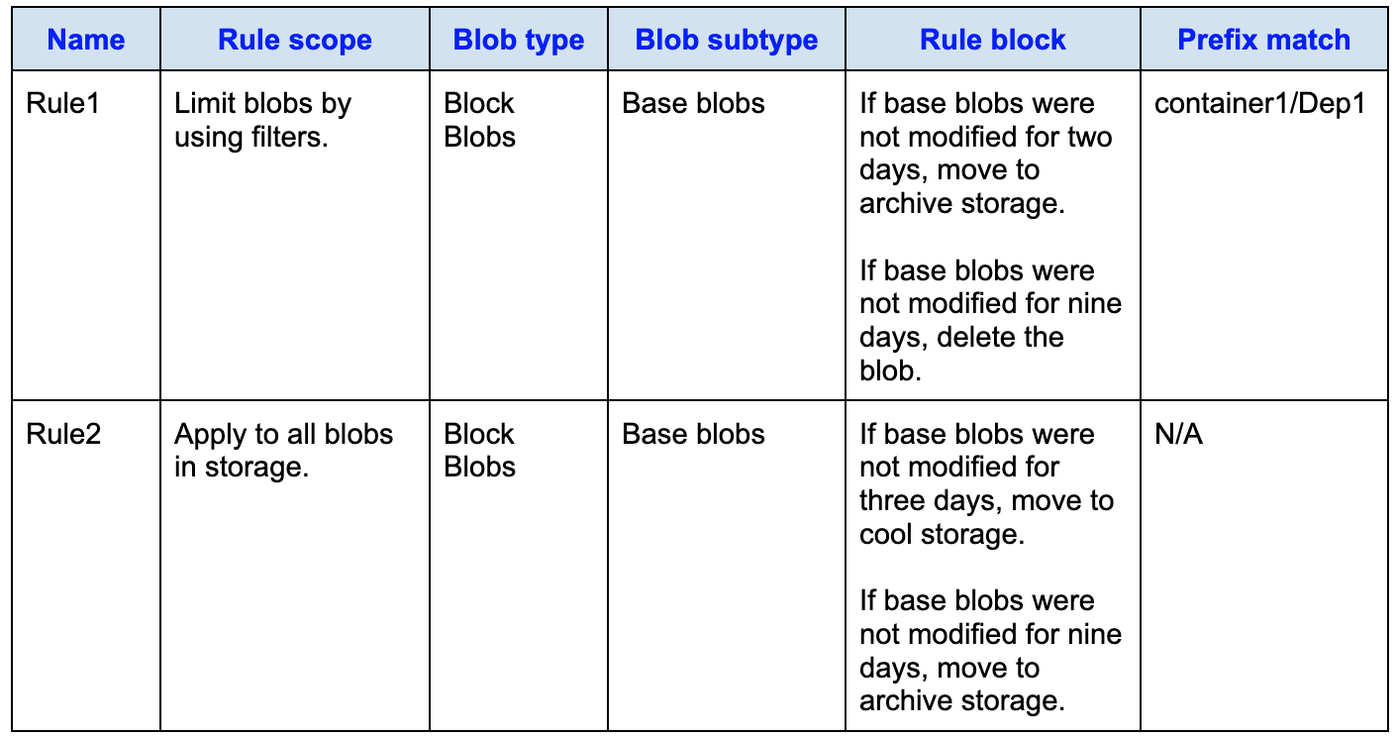
You then carry out the following actions:
- October 1: Upload three files, Dep1File1.docx, File2.docx, and File3.docx, to container1.
- October 2: Edit Dep1File1.docx and File3.docx.
- October 5: Edit File2.docx.
True or False:
`“On October 10, you are able to read File3.docx without any delay.”`
Réponses:
☑ True
☐ False
Explication
`True` is the correct answer here. File3.docx is stored in container1 and does not fall under the prefix filter `container1/Dep1` used in Rule1. Therefore, only Rule2 applies to this file.
Rule2 states that if a base blob is not modified for three days, it moves to cool storage, and after nine days of no modification, it moves to archive storage. File3.docx was last modified on October 2, and by October 10, it has not been modified for eight days.
This means File3.docx would have been moved to cool storage on October 5, but it would not yet be in the archive tier (which would happen on October 11). Since the cool access tier allows immediate read access without delay, File3.docx is readable on October 10 without requiring rehydration.
Reference(s.):
- https://learn.microsoft.com/en-us/azure/storage/blobs/access-tiers-overview
- https://learn.microsoft.com/en-us/azure/storage/blobs/lifecycle-management-overview

Question 75
You have an Azure virtual machine named VM1 that is running Windows Server 2019. You export VM1 as an Azure Resource Manager template named Template1 and store it in the Azure Resource Manager library.
You then plan to use Template1 to deploy a new virtual machine called VM2.
What can you configure during the deployment of VM2?
Réponses:
☐ administrator username
☐ operating system
☑ resource group
☐ virtual machine size
Explication
`resource group` is correct because when deploying a virtual machine from a saved Azure Resource Manager (ARM) template, the deployment process prompts you to select or create a resource group. This is a required part of any ARM deployment as the resource group defines the logical container for the resources created.
`administrator username` is incorrect because although it may appear as a parameter in some templates, a saved template from an existing VM typically contains the username already configured and does not prompt for a new one unless manually modified in the template.
`operating system` is incorrect because the OS is defined in the base image used in the original virtual machine and carried forward in the template. You cannot change the OS during deployment from a saved template without editing the template's image reference.
`virtual machine size` is incorrect because while it can be configured in custom templates, deploying from a saved template does not always expose the size as a parameter unless it was explicitly defined that way in the template configuration. Without modification, the size remains the same as that of the source VM.
Reference(s.):
- https://learn.microsoft.com/en-us/azure/azure-resource-manager/templates/quickstart-create-templates-use-the-portal
- https://learn.microsoft.com/en-us/azure/azure-resource-manager/templates/deploy-powershell
- https://learn.microsoft.com/en-us/azure/azure-resource-manager/templates/template-tutorial-create-first-template

Question 76
You are preparing to enable backup for an Azure virtual machine named VM1.
During the backup setup process, you notice that the Backup Pre-Check reports a Warning status.
Which of the following situations could explain why the pre-check shows a warning?
Réponses:
☐ VM1 has a disk configuration that does not match the expected requirements.
☑ VM1 is missing the most recent version of the Azure VM Agent (WaAppAgent.exe).
☐ VM1 is currently in a stopped state.
☐ The associated Recovery Services vault is not available.
Explication
`VM1 is missing the most recent version of the Azure VM Agent (WaAppAgent.exe)` is the correct answer here. When configuring backup for an Azure virtual machine, Azure performs a Backup Pre-Check to validate whether the VM is properly configured for backup. If the Azure VM Agent is outdated or missing, it may not be able to communicate with the backup service properly, which results in a Warning status in the Backup Pre-Check. The agent is essential for snapshot-based backup and must be up to date for backup extensions to function reliably.
`VM1 has a disk configuration that does not match the expected requirements` is incorrect because that condition typically results in a Failed status, not just a warning. Unmatched or unmanaged disks can prevent backup from proceeding altogether.
`VM1 is currently in a stopped state` is incorrect because a stopped VM can still be backed up, and Azure will handle backup at the storage level. Being stopped does not automatically trigger a warning status in Backup Pre-Check.
`The associated Recovery Services vault is not available` is incorrect because that would lead to a critical error or failed status, not a warning. The vault must be available for any backup operation to proceed.
Reference(s.):
- https://learn.microsoft.com/en-us/azure/backup/backup-azure-vms-troubleshoot
- https://learn.microsoft.com/en-us/azure/backup/backup-azure-arm-vms-prepare#install-the-vm-agent
- https://learn.microsoft.com/en-us/azure/backup/backup-azure-vms-first-look-arm
- https://learn.microsoft.com/en-us/azure/virtual-machines/extensions/agent-windows

Question 77
You have an Azure subscription and you create an Azure Resource Manager (ARM) template named Template.json.
The template defines the creation of a resource group called Marketing in the East US region and contains no parameters, variables, or outputs.
{
"$schema": "https://schema.management.azure.com/schemas/2019-04-01/deploymentTemplate.json#",
"contentVersion": "1.0.0.0",
"parameters": {},
"variables": {},
"resources": [
{
"type": "Microsoft.Resources/resourceGroups",
"apiVersion": "2024-11-01",
"location": "eastus",
"name": "Marketing"
}
],
"outputs": {}
}You now want to deploy Template.json by using Azure Cloud Shell.
Which PowerShell cmdlet should you use to perform this deployment?
Réponses:
☑ New-AzSubscriptionDeployment
☐ New-AzManagementGroupDeployment
☐ New-AzResourceGroupDeployment
☐ New-AzTenantDeployment
Explication
`New-AzSubscriptionDeployment` is the correct answer here. The ARM template defines a resource group creation, but it's not scoped to an existing resource group because it creates the group itself. Therefore, it must be deployed at the subscription level, not the resource group level. The `New-AzSubscriptionDeployment` cmdlet is specifically used to deploy templates that create or manage resource groups.
`New-AzResourceGroupDeployment` is incorrect because this cmdlet is used when deploying resources within a specific, existing resource group. Since the template creates a new resource group (`"type": "Microsoft.Resources/resourceGroups"`), this cmdlet cannot be used—it assumes the resource group already exists.
`New-AzManagementGroupDeployment` is incorrect because it is used for ARM deployments at the management group level, which is not applicable here. The template is not managing resources across management groups.
`New-AzTenantDeployment` is incorrect because it is used to deploy tenant-scoped resources (such as Microsoft Entra tenants or policy definitions at the tenant level). That does not apply in this scenario.
Reference(s.):
- https://learn.microsoft.com/en-us/powershell/module/az.resources/new-azresourcegroupdeployment
- https://learn.microsoft.com/en-us/azure/azure-resource-manager/templates/deploy-to-subscription

Question 78
You have a Microsoft Entra tenant named ironclad.onmicrosoft.com, and a user named Admin1 is assigned the User administrator role. An external partner uses a Microsoft account with the sign-in address user1@outlook.com.
When Admin1 tries to invite this external partner to access the Microsoft Entra tenant, the invitation fails with the error message:
`“Unable to invite user user1@outlook.com - Generic authorization exception”.`
You need to make sure that Admin1 is able to successfully invite the external partner to sign in to the Microsoft Entra tenant.
What action should you take?
Réponses:
☐ From the Custom domain names blade, add a custom domain.
☑ From the Users blade, modify the External collaboration settings.
☐ From the Organizational relationships blade, add an identity provider.
☐ From the Roles and administrators blade, assign the Security administrator role to Admin1.
Explication
`From the Users blade, modify the External collaboration settings` is the correct answer here. The error message “Generic authorization exception” typically occurs when external collaboration is not properly configured to allow guest invitations. In Microsoft Entra ID (formerly Azure AD), external user invitations depend on the External collaboration settings under the Users blade. By enabling guest invites and configuring who can invite external users (like Admin1), you can resolve this error and allow Admin1 to successfully invite the partner user.
`From the Custom domain names blade, add a custom domain` is incorrect because adding a custom domain is unrelated to external collaboration or guest user invitations. It's used for domain branding and user email domains within the tenant.
`From the Organizational relationships blade, add an identity provider` is incorrect because this is typically used for B2B direct connect or federation with another organization, not for inviting an individual Microsoft account user like `user1@outlook.com`.
`From the Roles and administrators blade, assign the Security administrator role to Admin1` is incorrect because the User administrator role already grants the ability to invite guest users—if external collaboration is enabled. The issue isn’t with permissions but with the tenant-wide settings for guest collaboration.
Reference(s.):
- https://learn.microsoft.com/en-us/entra/external-id/user-properties#external-collaboration-settings
- https://learn.microsoft.com/en-us/azure/active-directory/roles/permissions-reference#user-administrator
- https://portal.azure.com/#view/Microsoft_AAD_IAM/DirectoryUserSettingsBladeV2
- https://portal.azure.com/#view/Microsoft_AAD_IAM/AllowlistPolicyBlade

Question 79
You have an Azure subscription named Subscription1 that includes the following resources:
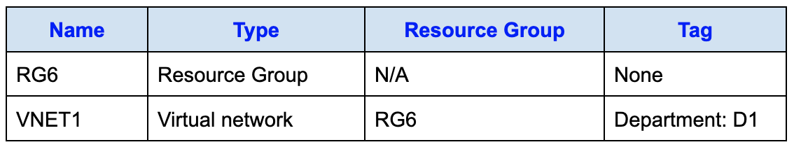
You assign a policy to RG6 as shown in the following table.
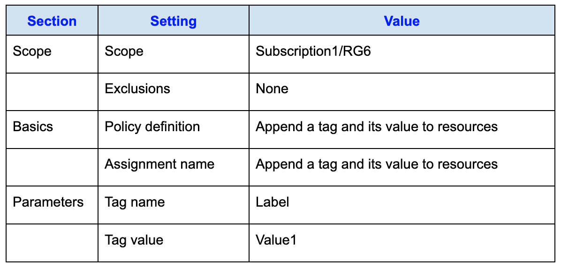
Additionally, the following action is performed:
- The tag RGroup: RG6 is applied directly to the resource group RG6.
After the policy assignment and tag configuration, you deploy a new virtual network named VNET2 into RG6.
Which tag(s) apply to VNET1?
Réponses:
☐ None
☑ Department: D1 only
☐ Department: D1, and RGroup: RG6 only
☐ Department: D1, and Label: Value1 only
☐ Department: D1, RGroup: RG6, and Label: Value1
Explication
`Department: D1 only` is the correct answer here. According to the first table, VNET1 was already deployed in RG6 and has a tag of `Department: D1`. The Azure Policy that appends the `Label: Value1` tag was assigned after the deployment of VNET1 and therefore does not apply retroactively to existing resources. Azure policy with an `Append` effect only enforces the tagging requirement at the time of resource creation or modification, not on existing untouched resources.
The policy will apply to new resources deployed in RG6 after the policy was assigned. VNET1 is unaffected unless it is updated or redeployed.
`None` is incorrect because VNET1 already has a `Department: D1` tag.
`Department: D1, and RGroup: RG6 only` is incorrect because the `RGroup: RG6` tag was applied to the resource group (RG6), but tags from resource groups do not automatically inherit to the resources inside them unless explicitly applied via policy or ARM template.
`Department: D1, and Label: Value1 only` and `Department: D1, RGroup: RG6, and Label: Value1` are both incorrect because the `Label: Value1` tag would only apply to resources created after the policy was assigned.
Reference(s.):
- https://learn.microsoft.com/en-us/azure/governance/policy/concepts/effect-append
- https://learn.microsoft.com/en-us/azure/governance/policy/overview

Question 80
You have an Azure subscription named Subscription1 that includes the following resources:
You assign a policy to RG6 as shown in the following table.
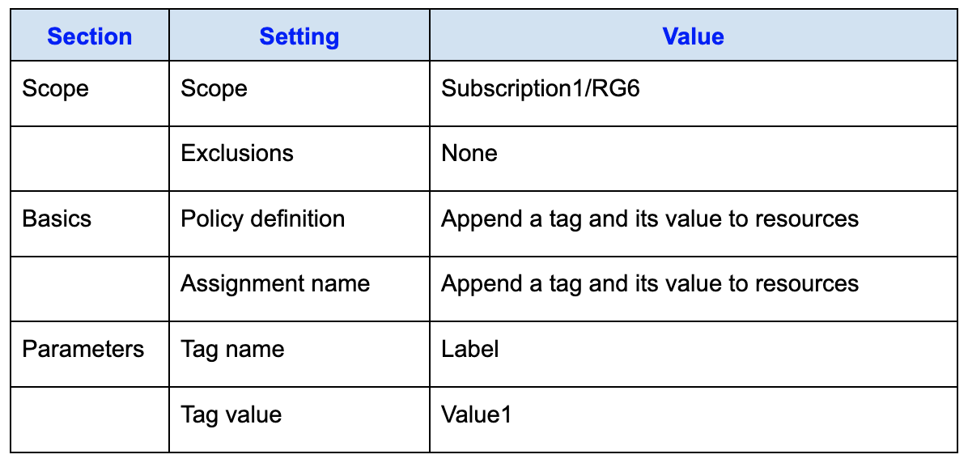
Additionally, the following action is performed:
- The tag RGroup: RG6 is applied directly to the resource group RG6.
After the policy assignment and tag configuration, you deploy a new virtual network named VNET2 into RG6.
Which tag(s) apply to VNET2?
Réponses:
☐ None
☐ RGroup: RG6 only
☑ Label: Value1 only
☐ RGroup: RG6, and Label: Value1
Explication
`Label: Value1 only` is the correct answer here. Azure resources do not automatically inherit tags from their resource group or subscription. While the tag `RGroup: RG6` was manually applied to the resource group RG6, this tag is not automatically passed down to newly created resources within that group.
The only tag that applies to VNET2 is the one enforced through the assigned Azure Policy. The policy uses the Append effect to apply a tag with name `Label` and value `Value1` to all new resources created in RG6. Since VNET2 was deployed after this policy was applied, it receives only the tag defined by the policy.
`None` is incorrect because the policy explicitly appends a tag to any newly created resource in RG6.
`RGroup: RG6 only` is incorrect because tags from the resource group are not automatically inherited by its resources unless explicitly defined by a policy or script.
`RGroup: RG6, and Label: Value1` is incorrect because only the policy-defined tag is applied, and resource group tags are not inherited.
Reference(s.):
- https://learn.microsoft.com/en-us/azure/governance/policy/concepts/effect-append
- https://learn.microsoft.com/en-us/azure/azure-resource-manager/management/tag-resources?tabs=json#tag-inheritance-at-deployment
- https://learn.microsoft.com/en-us/azure/governance/policy/overview

Question 81
You have an Azure subscription that includes a storage account named storage1.
You plan to create a blob container named container1 within storage1.
You must configure customer-managed key (CMK) encryption for container1.
Which encryption key should you select?
Réponses:
☐ An elliptic curve (EC) key that uses only the P-384 curve
☐ An elliptic curve (EC) key that uses only the P-521 curve
☐ An elliptic curve (EC) key that uses either the P-384 or P-521 curve
☐ an RSA key with a key size of 4096 only
☑ an RSA key type with a key size of 2048, 3072, or 4096 only
Explication
`an RSA key type with a key size of 2048, 3072, or 4096 only` is the correct answer because Azure Storage supports customer-managed keys (CMK) for encryption using RSA keys only, and those keys must have a key size of 2048, 3072, or 4096 bits. EC (Elliptic Curve) keys are not supported for encrypting data in Azure Storage with CMK.
`An elliptic curve (EC) key that uses only the P-384 curve` and `An elliptic curve (EC) key that uses either the P-384 or P-521` curve are all incorrect because Azure Storage does not support EC keys for customer-managed encryption.
`an RSA key with a key size of 4096 only` is incorrect because it unnecessarily restricts the valid RSA key sizes. While 4096 is supported, 2048 and 3072 are also valid, and the question does not require the only 4096 constraint.
Reference(s):
- https://learn.microsoft.com/en-us/azure/storage/common/customer-managed-keys-overview
- https://learn.microsoft.com/en-us/azure/key-vault/keys/about-keys#supported-key-types-and-sizes

Question 82
You have an Azure virtual machine called VM1, and Azure Monitor is set up to capture events from the virtual machine.
You need to configure an alert rule that notifies an administrator whenever an error is recorded in the System event log on VM1.
Which resource should be selected as the target when creating this alert rule?
Réponses:
☐ virtual machine extension
☐ virtual machine
☐ metric alert
☑ Azure Log Analytics workspace
Explication
`Azure Log Analytics workspace` is the correct answer because when you want to create an alert based on event logs (such as System event log) collected from a virtual machine, those logs are first sent to a Log Analytics workspace via the Azure Monitor agent or Log Analytics agent.
Once the logs are in the workspace, you can query them using Kusto Query Language (KQL) and create log alert rules based on the results — such as triggering an alert when an error is logged in the System event log of VM1.
`virtual machine` is incorrect because you can only use metric-based alerts directly on VMs, not event log-based queries.
`virtual machine extension` is incorrect because extensions are agents that help collect data but are not targets for alerts.
`metric alert` is incorrect because event logs are not metrics. You need a log-based alert, not a metric-based one.
Reference(s):
- https://learn.microsoft.com/en-us/azure/azure-monitor/alerts/alerts-overview
- https://learn.microsoft.com/en-us/azure/azure-monitor/agents/data-sources-windows-events
- https://learn.microsoft.com/en-us/azure/azure-monitor/agents/data-sources-windows-events

