AZ-104 - Practice Test 2
AZ-104 — Azure Administrator · 76 questions

Question 1
You have an application named App1 that is hosted on an Azure App Service web app named webapp1.
Developers in your organization commit an updated version of App1 to a Git repository named Git1.
The webapp1 App Service has the following deployment slots configured:
- webapp1-prod – Production
- webapp1-test – Staging
You must ensure that the updated version of App1 is validated in a test environment before it is made available to end users.
Which two actions should you take?
Réponses (plusieurs réponses possibles)
☐ Stop the webapp1-prod deployment slot.
☐ Deploy the updated version of App1 directly to webapp1-prod, and then perform testing.
☑ Deploy the updated version of App1 to webapp1-test, and then perform testing.
☐ Stop the webapp1-test deployment slot.
☑ Perform a swap between the deployment slots.
Explication
`Deploy the updated version of App1 to webapp1-test, and then perform testing` is correct because deploying the update to the webapp1-test slot allows you to test the new version of App1 in a staging environment without impacting the production environment. This approach aligns with best practices for deploying updates to staging before production.
`Perform a swap between the deployment slots` is correct because once testing is complete and the update is verified, you can swap webapp1-test with webapp1-prod. Swapping slots allows you to seamlessly promote the tested version to production without downtime, making the update available to users.
`Stop the webapp1-prod deployment slot` is incorrect because stopping the production slot is unnecessary for testing updates in the staging slot.
`Deploy the updated version of App1 directly to webapp1-prod, and then perform testing` is incorrect because deploying directly to production bypasses the staging environment and does not allow testing before making the update available to users.
`Perform a swap between the deployment slots` is incorrect because stopping the staging slot is not required for testing or deploying updates.
Reference(s):
- https://learn.microsoft.com/en-us/azure/app-service/deploy-staging-slots

Question 2
You have an Azure subscription.
You are required to deploy a virtual machine by using an Azure Resource Manager (ARM) template.
To proceed, you must complete the following ARM template configuration.
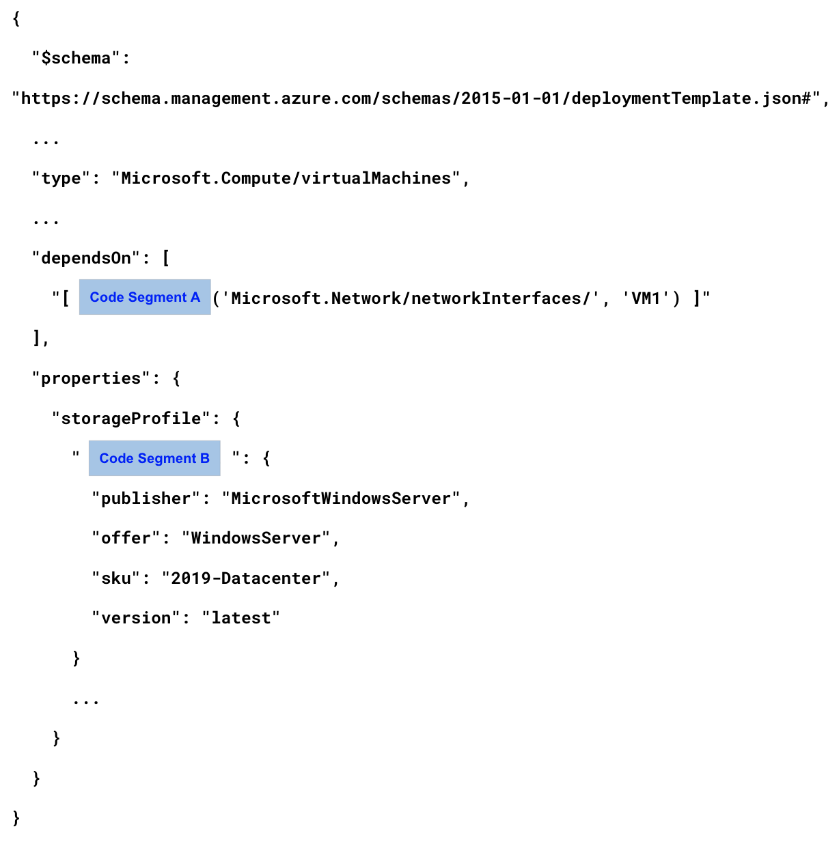
Which value should you choose for `Code Segment A`?
Réponses:
☐ reference
☑ resourceId
☐ Union
Explication
`resourceId` is correct because in Azure Resource Manager (ARM) templates, resourceId is used to reference the unique identifier of an existing resource. In this template, resourceId can generate the ID for the network interface, which is required to establish the dependency on the network interface for VM1.
`reference` is incorrect because it is used to obtain runtime properties of a resource, rather than generating a resource ID within the template.
`Union` is incorrect as it does not apply to this context in ARM templates.
Reference(s):
- https://learn.microsoft.com/en-us/azure/azure-resource-manager/templates/overview

Question 3
You have an Azure subscription.
You are required to deploy a virtual machine by using an Azure Resource Manager (ARM) template.
To proceed, you must complete the following ARM template configuration.
Which value should you choose for `Code Segment B`?
Réponses:
☐ Array
☐ Image
☑ ImageReference
☐ vhd
Explication
`ImageReference` is correct because in an Azure Resource Manager (ARM) template, ImageReference is used within the storageProfile section to specify the image details (such as publisher, offer, SKU, and version) for a virtual machine. This configuration tells Azure which image to use when creating the VM.
`Array` is incorrect as it is not relevant to defining the image configuration for a virtual machine in an ARM template.
`Image` is incorrect because it is not the specific attribute used within storageProfile for defining the VM image. The correct term is ImageReference.
`vhd` is incorrect because vhd is used to specify a virtual hard disk file when using a custom VHD image rather than a platform image.
Reference(s):
- https://learn.microsoft.com/en-us/azure/templates/microsoft.compute/virtualmachines
- https://learn.microsoft.com/en-us/azure/virtual-machines/windows/ps-template

Question 4
You are required to configure an Azure App Service web app named bluerock.azurewebsites.net so that it can host the custom domain www.bluerock.com.
What action should you perform first?
Réponses:
☑ Create a TXT record named asuid that includes the domain verification identifier.
☐ Create a TXT record named www.bluerock.com with a value pointing to bluerock.azurewebsites.net.
☐ Create a CNAME record named asuid that includes the domain verification identifier.
☐ Create A records for www.bluerock.com and asuid.bluerock.com.
Explication
`Create a TXT record named asuid that includes the domain verification identifier` is correct because, to verify a custom domain for an Azure web app, you first need to create a TXT record with the name asuid in the DNS zone of your domain. This TXT record should contain the domain verification ID provided by Azure. This step is essential to prove ownership of the domain before configuring it to point to the Azure web app.
`Create a TXT record named www.bluerock.com with a value pointing to bluerock.azurewebsites.net` is incorrect because a TXT record with this configuration will not verify domain ownership. The asuid TXT record with the verification ID is required for domain verification.
`Create a CNAME record named asuid that includes the domain verification identifier` is incorrect because a TXT record (not a CNAME) is required for domain verification purposes.
`Create A records for www.bluerock.com and asuid.bluerock.com` is incorrect because A records are not used for domain verification. A TXT record with asuid is required for the initial verification step.
Reference(s):
- https://learn.microsoft.com/en-us/azure/app-service/app-service-web-tutorial-custom-domain

Question 5
You are planning to deploy an Azure Container Instance by using the Azure Resource Manager (ARM) template shown.
{
"type": "Microsoft.ContainerInstance/containerGroups",
"apiVersion": "2018-10-01",
"name": "webprod",
"location": "westus",
"properties": {
"containers": [
{
"name": "webprod",
"properties": {
"image": "microsoft/iis:nanoserver",
"ports": [
{
"protocol": "TCP",
"port": 80
}
],
"environmentVariables": [],
"resources": {
"requests": {
"memoryInGB": 1.5,
"cpu": 1
}
}
}
}
],
"restartPolicy": "OnFailure",
"ipAddress": {
"ports": [
{
"protocol": "TCP",
"port": 80
}
],
"ip": "[parameters('IPAddress')]",
"type": "Public"
},
"osType": "Windows"
}
}
Based on the configuration provided, choose the option that correctly completes the following statement:
“Internet users ________________________________________.”
Réponses:
☑ are able to connect to the container instance from any device.
☐ are not able to connect to the container instance.
☐ are only able to connect to the container instance from devices running Windows.
Explication
`are able to connect to the container instance from any device` is correct because the template specifies a public IP address ("type": "Public") and opens TCP port 80, which is a common HTTP port accessible from any internet-enabled device. This configuration allows internet users to connect to the container instance without restrictions on device type.
`are not able to connect to the container instance` is incorrect because the template has a public IP and open port 80, making the container accessible from the internet.
`are only able to connect to the container instance from devices running Windows` is incorrect because there is no configuration in the template that restricts access to specific operating systems.
Reference(s):
- https://learn.microsoft.com/en-us/azure/container-instances
- https://learn.microsoft.com/en-us/azure/container-instances/container-instances-multi-container-group

Question 6
You are planning to deploy an Azure Container Instance by using the Azure Resource Manager (ARM) template shown.
{
"type": "Microsoft.ContainerInstance/containerGroups",
"apiVersion": "2018-10-01",
"name": "webprod",
"location": "westus",
"properties": {
"containers": [
{
"name": "webprod",
"properties": {
"image": "microsoft/iis:nanoserver",
"ports": [
{
"protocol": "TCP",
"port": 80
}
],
"environmentVariables": [],
"resources": {
"requests": {
"memoryInGB": 1.5,
"cpu": 1
}
}
}
}
],
"restartPolicy": "OnFailure",
"ipAddress": {
"ports": [
{
"protocol": "TCP",
"port": 80
}
],
"ip": "[parameters('IPAddress')]",
"type": "Public"
},
"osType": "Windows"
}
}
Based on the configuration provided, choose the option that correctly completes the following statement:
“If Internet Information Services (IIS) running inside the container fails, ____________________.”
Réponses:
☑ the container instance will restart automatically
☐ the container instance will restart only through a manual action
☐ the container instance must be redeployed
Explication
`the container instance will restart automatically` is correct because the template specifies a restart policy of "OnFailure", which means that if the application within the container (in this case, Internet Information Services or IIS) fails, the container instance will automatically restart.
`the container instance will restart only through a manual action` is incorrect because the "OnFailure" restart policy ensures that the container restarts automatically upon a failure.
`the container instance must be redeployed` is incorrect because the container does not need to be redeployed; it will automatically restart based on the defined restart policy.
Reference(s):
- https://learn.microsoft.com/en-us/azure/container-instances/container-instances-restart-policy

Question 7
You have an Azure subscription that includes several virtual machines deployed in the West US Azure region.
You want to use Traffic Analytics in Azure Network Watcher to monitor network traffic for the virtual machines.
Which two resources must you create?
Réponses (plusieurs réponses possibles)
☑ a storage account
☐ a Microsoft Sentinel workspace
☑ a Log Analytics workspace
☐ a Data Collection Rule (DCR) in Azure Monitor
☐ an Azure Monitor workbook
Explication
`a storage account` is correct because Traffic Analytics in Azure Network Watcher requires a storage account to store NSG flow logs. These logs capture information about the traffic to and from virtual machines, which Traffic Analytics uses for analysis.
`a Log Analytics workspace` is correct because Traffic Analytics processes the data collected from NSG flow logs and stores it in a Log Analytics workspace. This workspace allows you to query and analyze the traffic data collected by Traffic Analytics.
`a Microsoft Sentinel workspace` is incorrect because while Microsoft Sentinel can integrate with Log Analytics for security purposes, it is not required specifically for Traffic Analytics in Azure Network Watcher.
`a Data Collection Rule (DCR) in Azure Monitor` is incorrect because DCRs are used for configuring data collection in Azure Monitor but are not required for setting up Traffic Analytics.
`an Azure Monitor workbook` is incorrect because an Azure Monitor workbook provides visualization for data already collected in Azure Monitor or Log Analytics but is not a requirement for enabling Traffic Analytics.
Reference(s):
- https://learn.microsoft.com/en-us/azure/network-watcher/traffic-analytics

Question 8
You have an Azure subscription named Subscription1 in which you create an alert rule named Alert1.
The Alert1 action group is configured as shown in the following exhibit.
ResourceGroupName : default-activitylogalerts
GroupShortName : AG1
Enabled : True
EmailReceivers : {Action1 - EmailAction}
SmsReceivers : {Action1 - SMSAction}
WebhookReceivers : {}
Id : /subscriptions/7c1e9b42-3f6a-4d88-9a21-5e7c4b2f9d10/resourceGroups/default-activitylogalerts/providers/microsoft.insights/actionGroups/ActionGroup1
Name : ActionGroup1
Type : Microsoft.Insights/ActionGroups
Location : Global
Tags : {}The alert condition for Alert1 is evaluated and triggered every minute.
Based on the information presented, select the answer choice that completes the following statement correctly.
“The number of email messages that Alert1 will send in an hour _____.”
Réponses:
☐ 0
☐ 4
☐ 6
☐ 12
☑ 60
Explication
`60` is correct because the alert rule Alert1 is set to trigger every minute. Since there are 60 minutes in an hour, Alert1 will trigger 60 times in one hour. Each time the alert is triggered, it sends an email based on the configured action group.
Reference(s):
- https://learn.microsoft.com/en-us/azure/azure-monitor/alerts/action-groups

Question 9
You have an Azure subscription named Subscription1 in which you create an alert rule named Alert1.
The Alert1 action group is configured as shown in the following exhibit.
ResourceGroupName : default-activitylogalerts
GroupShortName : AG1
Enabled : True
EmailReceivers : {Action1 - EmailAction}
SmsReceivers : {Action1 - SMSAction}
WebhookReceivers : {}
Id : /subscriptions/7c1e9b42-3f6a-4d88-9a21-5e7c4b2f9d10/resourceGroups/default-activitylogalerts/providers/microsoft.insights/actionGroups/ActionGroup1
Name : ActionGroup1
Type : Microsoft.Insights/ActionGroups
Location : Global
Tags : {}The alert condition for Alert1 is evaluated and triggered every minute.
Based on the information presented, select the answer choice that completes the following statement correctly.
“The number of SMS messages that Alert1 will send in an hour is ________.”
Réponses:
☐ 0
☐ 4
☐ 6
☑ 12
☐ 60
Explication
`12` is correct because, although Alert1 is configured to trigger every minute (which would normally result in 60 alerts per hour), Azure imposes a limit of one SMS notification every 5 minutes. Due to this restriction, only 12 SMS messages will be sent per hour (one SMS every 5 minutes).
Reference(s):
- https://learn.microsoft.com/en-us/azure/azure-monitor/alerts/action-groups

Question 10
You have an Azure subscription named Subscription1 that contains the resources shown in the following table.
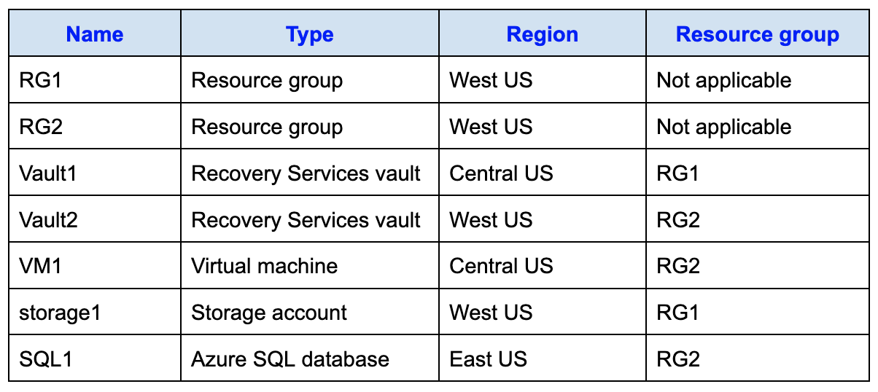
Within storage1, you create a blob container named blob1 and a file share named share1.
Which of the listed resources are eligible to be backed up to `Vault1`?
Réponses:
☑ VM1 only
☐ VM1 and share1 only
☐ VM1 and SQL1 only
☐ VM1, storage1, and SQL1 only
☐ VM1, blob1, share1, and SQL1
Explication
`VM1 only` is correct because a Recovery Services vault can only back up resources that are in the same geographic region as the vault itself. In this case, Vault1 is located in Central US, so it can only protect resources within the Central US region. VM1 is the only resource in Central US and, therefore, the only resource that can be backed up by Vault1.
`VM1 and share1 only` is incorrect because share1 is in West US, which is not the same region as Vault1. Recovery Services vaults cannot back up resources in a different region.
`VM1 and SQL1 only` is incorrect because SQL1 is in East US, which is not the same region as Vault1.
`VM1, storage1, and SQL1 only` and `VM1, blob1, share1, and SQL1` are both incorrect because Vault1 cannot back up blobs or resources located outside of the Central US region.
Reference(s):
- https://learn.microsoft.com/en-us/azure/backup/backup-create-rs-vault
- https://docs.microsoft.com/en-us/azure/backup/backup-afs

Question 11
You have an Azure subscription named Subscription1 that contains the resources shown in the following table.
Within storage1, you create a blob container named blob1 and a file share named share1.
Which of the listed resources are eligible to be backed up to `Vault2`?
Réponses:
☐ storage1 only
☑ share1 only
☐ VM1 and share1 only
☐ blob1 and share1 only
☐ storage1 and SQL1 only
Explication
`share1 only` is correct because Vault2 is a Recovery Services vault located in West US and can only back up resources within the same region. share1 is an Azure file share in storage1 (also located in West US) and is eligible for backup by the Recovery Services vault. Blobs are not supported for backup in a Recovery Services vault, and VM1 is in Central US, so it cannot be backed up by Vault2.
`storage1 only` is incorrect because Recovery Services vaults do not directly back up storage accounts themselves. They can back up Azure file shares within a storage account, but not the storage account as a whole.
`VM1 and share1 only` is incorrect because VM1 is located in Central US, not West US, so it cannot be backed up by Vault2.
`blob1 and share1 only` is incorrect because blobs cannot be backed up by a Recovery Services vault. Only file shares within a storage account are eligible for backup, provided they are in the same region.
`storage1 and SQL1 only` is incorrect because SQL1 is located in East US and cannot be backed up by Vault2 in West US.
Reference(s):
- https://learn.microsoft.com/en-us/azure/backup/backup-create-rs-vault
- https://azure.microsoft.com/en-in/blog/microsoft-azure-block-blob-storage-backup/
- https://docs.microsoft.com/en-us/azure/backup/backup-afs

Question 12
You manage a Recovery Services vault named RSV1. The backup policy configured for RSV1 has the following settings:
- Instant snapshots are retained for 5 days
- Daily backup recovery points are retained for 14 days
RSV1 is configured to perform daily backups of a virtual machine named VM1.
VM1 hosts a static website, and the site content was last updated eight days ago.
You must restore VM1 to its state from eight days ago, and the solution must minimize service downtime.
What should you do first?
Réponses:
☐ Delete VM1.
☑ Restore VM1 by using the Create new restore configuration option.
☐ Deallocate VM1.
☐ Restore VM1 by using the Replace existing restore configuration option.
Explication
`Restore VM1 by using the Create new restore configuration option` is correct because it allows you to recover VM1 to a previous state from eight days ago without affecting the existing VM. This approach minimizes downtime as it creates a new VM instance based on the backup from eight days ago, enabling you to test and verify the restored version separately before making it live if needed.
`Delete VM1` is incorrect because deleting VM1 would not be required to perform the restore operation and would lead to unnecessary downtime and data loss.
`Deallocate VM1` is incorrect because deallocating VM1 is unnecessary for restoring from a backup. This option does not achieve the goal of recovering to a specific point in time.
`Restore VM1 by using the Replace existing restore configuration option` is incorrect because using the replace option would overwrite the current VM, causing downtime while the restore is performed. This does not align with the goal of minimizing downtime.
Reference(s):
https://learn.microsoft.com/en-us/azure/backup/backup-azure-arm-restore-vms

Question 13
You have a Microsoft Entra tenant that includes the following users:
- Admin1 with the User Administrator role
- User1 with the User role
You must complete the following tasks:
- Create a custom attribute named Property1.
- Ensure that Admin1 is able to assign Property1 to User1.
Which two settings should you configure from the Microsoft Entra ID blade?
Réponses (plusieurs réponses possibles)
☑ Custom security attributes
☑ Roles and administrators
☐ External Identities
☐ Administrative units
☐ Application proxy
☐ Microsoft Entra Connect
Explication
`Custom security attributes` is correct because this setting allows you to define attributes like `Property1` within Microsoft Entra ID. These attributes can then be assigned to users, groups, service principals, or managed identities as needed.
`Roles and administrators` is also correct because although Admin1 currently has the User Administrator role—which does not grant the ability to create or assign custom security attributes—this blade is used to assign the appropriate roles. To fulfill the requirement, Admin1 must be granted two additional roles: Attribute Definition Administrator to create `Property1`, and Attribute Assignment Administrator to assign it to User1. These roles must be explicitly assigned through the Roles and administrators section in the Microsoft Entra admin center.
`External Identities` is incorrect because it manages access and collaboration with external users and is not relevant to custom attribute configuration.
`**
Administrative units` is incorrect** because they are used for scoping administrative permissions to subsets of users or devices, not for managing attribute definitions or assignments.
`Application proxy` is incorrect this is unrelated to identity or attribute management; it provides secure remote access to on-premises applications.
`Microsoft Entra Connect` is incorrect because this is used for syncing identities from on-premises directories and has no role in attribute creation or assignment.
Reference(s):
- https://learn.microsoft.com/en-us/entra/fundamentals/whatis

Question 14
You have an Azure subscription.
You plan to create an Azure Storage account with the configuration shown in the following exhibit.
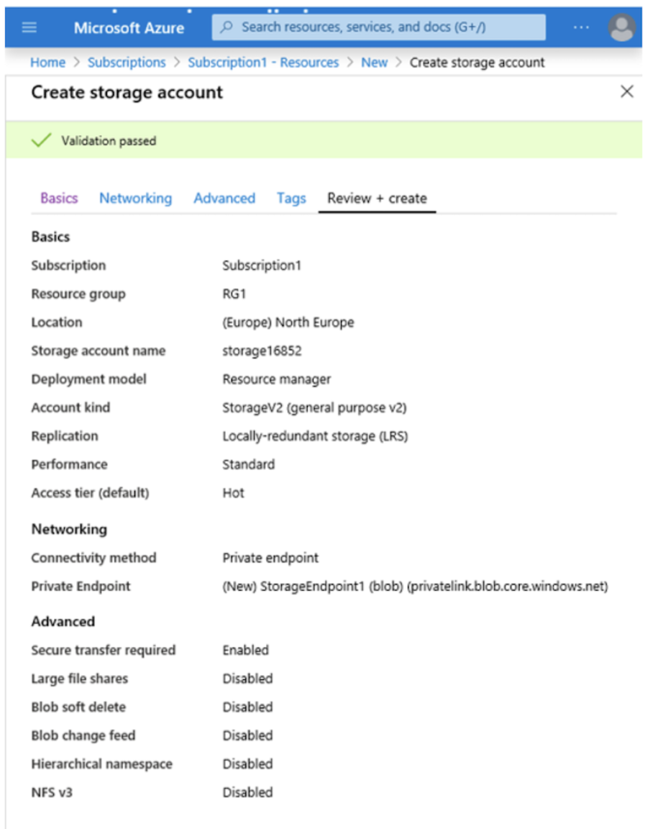
Based on the information presented, select the answer choice that completes the following statement correctly.
“The minimum number of copies of the storage account will be ________.”
Réponses:
☐ 1
☐ 2
☑ 3
☐ 4
Explication
`3` is correct because the storage account is using Locally-redundant storage (LRS), which replicates data three times within a single data center in the selected region. This ensures that there are three copies of the data, providing local redundancy in case of hardware failures.
Reference(s):
- https://learn.microsoft.com/en-us/azure/storage/common/storage-redundancy

Question 15
You have an Azure subscription.
You plan to create an Azure Storage account with the configuration shown in the following exhibit.
Based on the information presented, select the answer choice that completes the following statement correctly.
“To reduce the cost of infrequently accessed data in the storage account, you must modify the ____________________ setting.”
Réponses:
☑ Access tier (default)
☐ Performance
☐ Account kind
☐ Replication
Explication
`Access tier (default)` is correct because changing the access tier to Cool, Cold, or Archive can help reduce the cost of storing data that is infrequently accessed. Switching from Hot to Cool, Cold, or Archive will optimize cost depending on the data access pattern.
`Performance` is incorrect because this setting affects the performance of the storage account (Standard vs. Premium) but does not specifically target cost savings for infrequently accessed data.
`Account kind` is incorrect because changing the account kind to a different type (e.g., StorageV1 to StorageV2) does not directly reduce costs for infrequently accessed data.
`Replication` is incorrect because replication affects data durability and redundancy but does not specifically reduce costs for infrequently accessed data.
Reference(s):
- https://docs.microsoft.com/en-us/azure/storage/blobs/storage-blob-storage-tiers?tabs=azure-portal
- https://docs.microsoft.com/en-us/azure/storage/blobs/storage-blob-performance-tiers
- https://docs.microsoft.com/en-us/azure/storage/common/storage-account-overview?toc=%2fazure%2fstorage%2fblobs%2ftoc.json
- https://azure.microsoft.com/en-us/pricing/details/storage/

Question 16
You are designing an Azure Storage solution and must provision a storage account that satisfies the following design constraints:
- Blob data must be able to use all access tiers, including hot, cool, and archive
- The solution must remain resilient if the primary Azure region becomes unavailable
- The configuration should be as cost-effective as possible
You plan to deploy the storage account by using the Azure CLI command shown below:
How should you complete the following command?
`az storage account create -g RG1 -n storageaccount1 --kind ____ --sku ____`
Réponses:
☐ --kind FileStorage --sku Standard_GRS
☐ --kind Storage --sku Standard_LRS
☐ --kind StorageV2 --sku Standard_RAGRS
☑ --kind StorageV2 --sku Standard_GRS
☐ --kind FileStorge --sku Premium_LRS
Explication
`--kind StorageV2 --sku Standard_GRS` is correct because StorageV2 is the only account kind that supports all three blob storage tiers—Hot, Cool, and Archive. Additionally, the Standard_GRS SKU provides geo-redundancy, which replicates data to a secondary region to ensure resiliency against regional failures, aligning with the requirement for regional fault tolerance.
Reference(s):
- https://learn.microsoft.com/en-us/azure/storage/common/storage-account-overview

Question 17
An Azure subscription contains the following networking resources, all deployed in the East US region:
- VNet1: a virtual network
- Subnet1: a subnet within VNet1
- NIC1: a network interface
You create a user-defined route table named RT1 in the East US region.
Which of the listed resources can RT1 be linked to?
Réponses:
☐ VNet1 only
☑ Subnet1 only
☐ VNet1 and NIC1 only
☐ Subnet1 and NIC1 only
☐ VNet1, Subnet1, and NIC1
Explication
`Subnet1 only` is the correct answer because in Azure, route tables (like RT1) can only be associated with subnets, not with virtual networks (VNet1) or network interfaces (NIC1). When you associate a route table with a subnet, all resources (like virtual machines) within that subnet use the custom routes defined in the route table.
- VNet1 cannot be directly associated with a route table. Instead, route tables are applied at the subnet level within a virtual network.
- NIC1 (network interface) cannot be associated with a route table either.
Reference(s):
- https://learn.microsoft.com/en-us/azure/virtual-network/virtual-networks-udr-overview
- https://learn.microsoft.com/en-us/azure/virtual-network/manage-route-table

Question 18
You are preparing to deploy a containerized workload in Azure.
As part of the solution design, you must identify which Azure service options are capable of automatically adjusting capacity for the container based on demand.
Which Azure service should you recommend?
Réponses:
☐ Azure Container Apps only
☐ Azure Container Instances only
☑ Azure Container Apps or Azure App Service only
☐ Azure Container Instances or Azure App Service only
☐ Azure Container Apps, Azure Container Instances, or Azure App Service
Explication
`Azure Container Apps or Azure App Service only` is the correct answer here. Both Azure Container Apps and Azure App Service provide built-in autoscaling capabilities for containers based on demand, such as HTTP requests or CPU usage. These services can automatically scale out or in depending on the workload.
`Azure Container Instances only` is incorrect because it does not have built-in autoscaling. It allows you to run containers but requires manual scaling.
`Azure Container Apps, Azure Container Instances, or Azure App Service` is incorrect because Azure Container Instances does not support automatic scaling.
Reference(s):
- https://learn.microsoft.com/en-us/azure/container-apps/scale-app?pivots=azure-cli
- https://learn.microsoft.com/en-us/azure/app-service/manage-scale-up

Question 19
Note: This question is part of a series that uses the same overall scenario. Each question in the series proposes a different solution that may or may not satisfy the stated requirement.
An application named App1 is deployed on two Azure virtual machines, VM1 and VM2. Incoming traffic to App1 is distributed by an Azure Load Balancer.
The effective network security rules applied to VM2 are shown in the exhibit.
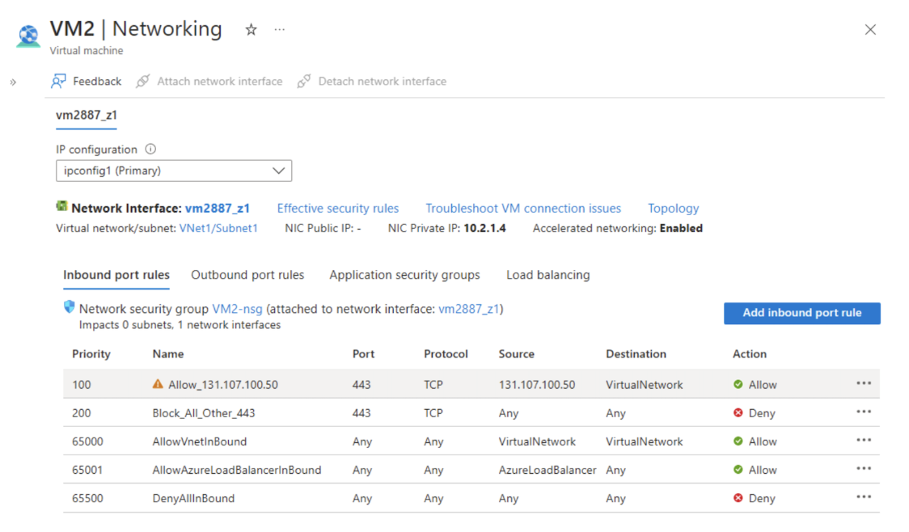
You observe that client connections originating from the IP address 131.107.100.50 fail when attempting to reach App1 over TCP port 443. You verify that the Load Balancer configuration is correct.
Your objective is to ensure that connections from 131.107.100.50 to App1 over TCP port 443 are successfully established.
Proposed solution: You change the priority value of the inbound network security rule named Allow_131.107.100.50.
Does this solution achieve the stated objective?
Réponses:
☐ Yes
☑ No
Explication
`No` is the correct answer because the inbound security rule named Allow_131.107.100.50 already has the highest priority (100), meaning it is the first rule to be evaluated. Since no higher-priority rule is blocking the traffic, modifying the rule's priority will have no effect. Furthermore, the source, destination, protocol, and port settings in the rule already allow traffic from IP `131.107.100.50` over TCP port `443` to the virtual network.
Reference(s):
- https://docs.microsoft.com/en-us/azure/virtual-network/network-security-groups-overview
- https://docs.microsoft.com/en-us/security/benchmark/azure/baselines/load-balancer-security-baseline

Question 20
Note: This question is part of a series that uses the same overall scenario. Each question in the series proposes a different solution that may or may not satisfy the stated requirement.
An application named App1 is deployed on two Azure virtual machines, VM1 and VM2. Incoming traffic to App1 is distributed by an Azure Load Balancer.
The effective network security rules applied to VM2 are shown in the exhibit.
You observe that client connections originating from the IP address 131.107.100.50 fail when attempting to reach App1 over TCP port 443. You verify that the Load Balancer configuration is correct.
Your objective is to ensure that connections from 131.107.100.50 to App1 over TCP port 443 are successfully established.
Proposed solution: You add a new inbound network security rule that explicitly blocks all incoming traffic originating from the IP address 131.107.100.50 and assign the rule a priority value of 64999.
Does this solution achieve the stated objective?
Réponses:
☐ Yes
☑ No
Explication
`No` is correct because creating an inbound security rule that denies all traffic from 131.107.100.50 with a priority of 64999 will block connections from this IP, which is the opposite of the requirement. The goal is to allow connections to App1 from 131.107.100.50 on TCP port 443, not to deny them. Additionally, a deny rule would prevent any successful connection from this IP, making it impossible to establish the required connectivity to App1.
Reference(s):
- https://docs.microsoft.com/en-us/azure/virtual-network/network-security-groups-overview#azure-platform-considerations

Question 21
You are working within an Azure subscription and must deploy an Azure Container Instance named cont1.
The deployment must satisfy the following conditions:
- Ensure that specific configuration parameters are applied to cont1 during the container startup.
- Provide secure values to cont1 during the container startup.
What should you configure for cont1?
Réponses:
☐ a command override
☐ tags
☐ customer-managed keys
☑ environment variables
Explication
`environment variables` is correct because they allow you to set specific configuration parameters and pass secure values (such as sensitive data or credentials) to the container instance cont1 during startup. Environment variables can be securely stored in Azure and referenced in the container, meeting both requirements.
`a command override` is incorrect because it allows you to override the default command for a container but does not handle secure values or configuration parameters needed during startup.
`tags` is incorrect because tags are used for organizing and categorizing resources in Azure but are not used to pass configuration parameters or secure values to containers.
`customer-managed keys` is incorrect because they are related to encryption in Azure and do not provide a mechanism for applying configuration parameters or passing secure values to a container instance at startup.
Reference(s):
https://learn.microsoft.com/en-us/azure/container-instances/container-instances-environment-variables

Question 22
Your Azure environment contains the following virtual machines:
- VM1 and VM2, both deployed in the West Europe region
- VM3 and VM4, both deployed in the North Europe region
A Recovery Services vault is already in place and is currently configured to back up VM1 and VM2.
You now need to enable Recovery Services protection for VM3 and VM4.
What is the first action you should take?
Réponses:
☑ Create a new Recovery Services vault
☐ Provision a new storage account
☐ Set up the required extensions on VM3 and VM4.
☐ Define and configure a new backup policy
Explication
`Create a new Recovery Services vault` is correct because a Recovery Services vault must be in the same region as the virtual machines it protects. Since VM3 and VM4 are in the "North Europe" region, a new Recovery Services vault must be created in that region to back up these virtual machines.
`Provision a new storage account` is incorrect because a storage account is not required for setting up backups through Recovery Services Vaults.
`Set up the required extensions on VM3 and VM4` is incorrect because configuring extensions is not the initial step required to back up these VMs. Extensions are typically configured as part of the backup process.
`Define and configure a new backup policy` is incorrect because a backup policy does not address the requirement of having a Recovery Services vault in the correct region for VM3 and VM4.
Reference(s):
https://docs.microsoft.com/en-us/azure/site-recovery/azure-to-azure-tutorial-enable-replication

Question 23
You are working in an Azure subscription that includes a storage account named storage1.
The following client devices are available:
- Device1 - running Windows 10
- Device2 - running Linux
- Device3 - running macOS
You want to transfer data to storage1 by using the AzCopy utility.
From which of the listed devices can you perform this operation?
Réponses:
☐ Device1 and Device2 only
☐ Device1 only
☐ Device1 and Device3 only
☑ Device1, Device2, and Device3
Explication
`Device1, Device2, and Device3` is correct because AzCopy is a cross-platform command-line utility available for Windows, Linux, and macOS. This means it can be used on all three devices listed in the table to copy data to an Azure storage account.
Reference(s):
https://learn.microsoft.com/en-us/azure/storage/common/storage-use-azcopy-v10?tabs=dnf#download-azcopy

Question 24
You have an Azure subscription and are preparing to move 50 virtual machines from an on-premises VMware vSphere environment into Azure.
As part of the migration setup, you have already created a Recovery Services vault.
What should you do next to continue the migration process?
Réponses:
☐ Define a recovery plan to orchestrate the migration workflow.
☐ Deploy an Open Virtualization Application (OVA) template to vSphere.
☑ Set up an Azure virtual network that will host the migrated virtual machines.
☐ Configure a network extension between the on-premises environment and Azure.
Explication
`Set up an Azure virtual network that will host the migrated virtual machines` is correct because for migrating virtual machines from VMware vSphere to Azure using Azure Site Recovery (ASR), the next step after creating a Recovery Services vault is to configure a virtual network in Azure. This network will act as the target network for the VMs once they are migrated.
`Define a recovery plan to orchestrate the migration workflow` is incorrect because creating a recovery plan is part of the orchestration phase of disaster recovery and is not required as the next step in setting up ASR for migration.
`Deploy an Open Virtualization Application (OVA) template to vSphere` is incorrect because using Azure Site Recovery (ASR) does not require the Azure Migrate appliance or an OVA template. The OVA template is specific to Azure Migrate.
`Configure a network extension between the on-premises environment and Azure` is incorrect as configuring an extended network may be part of the networking requirements, but configuring a virtual network in Azure is the immediate next step.
Reference(s):
- https://learn.microsoft.com/en-us/azure/site-recovery/tutorial-prepare-azure

Question 25
An Azure subscription contains a resource group named RG1.
You intend to deploy a new storage account called storage1 by using infrastructure-as-code. A Bicep file named File1 is available and will be used for this deployment.
To ensure that storage1 is automatically deployed into RG1, you must modify File1 accordingly.
Which property in the Bicep file should you change?
Réponses:
☐ kind
☑ scope
☐ sku
☐ location
Explication
`scope` is correct because setting the scope property is necessary to target a specific resource group, such as RG1, when deploying resources in Bicep. By configuring the scope property, you direct the deployment of storage1 specifically to RG1. This approach is especially useful when deploying resources to a resource group that isn’t the default target in the Bicep file.
`kind` is incorrect because it specifies the type of storage account (e.g., StorageV2, BlobStorage) and does not control the deployment target.
`sku` is incorrect because it defines the storage account’s performance and redundancy (e.g., Standard_LRS, Standard_GRS) but does not determine the deployment target resource group.
`location` is incorrect because it specifies the Azure region for the storage account, but does not target the resource group for deployment.
Reference(s):
- https://learn.microsoft.com/en-us/azure/azure-resource-manager/bicep/deploy-to-resource-group

Question 26
You are working in an Azure subscription called Subscription1.
Within this subscription, you provision an Azure Storage account named contosostorage and then create an Azure Files share called data.
You are writing a script that must access files stored in the data file share.
Which UNC path should the script reference to correctly access those files?
UNC Path to include:
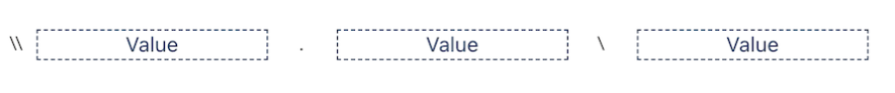
Values to choose from:
- blob
- blob.core.windows.net
- contosostorage
- data
- file
- file.core.windows.net
- portal.azure.com
- subscription1
Réponses:
☑ contosostorage.file.core.windows.net\data
☐ data.file.core.windows.net\contosostorage
☐ contosostorage.blob.core.windows.net\data
☐ data.blob.core.windows.net\contosostorage
☐ file.subscription1\portal.azure.com
☐ blob.data\file.core.windows.net
Explication
contosostorage.file.core.windows.net\data is correct.
The correct UNC path to include in a script that references files from the `data` file share in the `contosostorage` storage account would be:
`\\contosostorage.file.core.windows.net\data`
Here’s why this is correct:
- The correct format for accessing an Azure file share is `\\<storage-account-name>.file.core.windows.net\<file-share-name>`.
- In this case:
- `<storage-account-name>` is `contosostorage`
- `<file-share-name>` is `data`
Thus, `\\contosostorage.file.core.windows.net\data` is the appropriate path.
Reference(s):
- https://docs.microsoft.com/en-us/azure/storage/files/storage-how-to-use-files-windows

Question 27
Your Azure subscription includes two virtual networks with the following characteristics:
- VNet1, deployed in the East US region and peered with VNet2
- VNet2, deployed in the East US region and peered with VNet1
Each virtual network hosts 50 virtual machines.
You are required to deploy Azure Bastion and must ensure that the configuration meets the following criteria:
- Allows automatic scaling of Bastion hosts.
- Supports file upload and download.
- Support the virtual machines on both VNet1 and VNet2.
- Minimize the number of addresses on the Azure Bastion subnet.
You need to configure Azure Bastion.
Which type of Public IP address should you select?
Réponses:
☐ A Basic SKU public IP address that uses dynamic assignment
☐ A Basic SKU public IP address that uses static assignment
☑ A Standard SKU public IP address that uses static assignment
Explication
`A Standard SKU public IP address that uses static assignment` is correct because it is required to support host scaling and advanced features such as file upload and download when implementing Azure Bastion. The Standard SKU is necessary to meet these requirements, and static allocation of the Public IP ensures a consistent IP address for accessing the Bastion host, which is recommended for production environments.
`A Basic SKU public IP address that uses dynamic assignment` is incorrect because the Basic SKU does not support the necessary features like file upload and download or host scaling.
`A Basic SKU public IP address that uses static assignment` is incorrect because, similar to the dynamic allocation, the Basic SKU does not support the advanced features required for this setup.
Reference(s):
- https://learn.microsoft.com/en-us/azure/bastion/bastion-overview
- https://learn.microsoft.com/en-us/azure/bastion/configuration-settings

Question 28
Your Azure subscription includes two virtual networks with the following characteristics:
- VNet1, deployed in the East US region and peered with VNet2
- VNet2, deployed in the East US region and peered with VNet1
Each virtual network hosts 50 virtual machines.
You are required to deploy Azure Bastion and must ensure that the configuration meets the following criteria:
- Allows automatic scaling of Bastion hosts.
- Supports file upload and download.
- Support the virtual machines on both VNet1 and VNet2.
- Minimize the number of addresses on the Azure Bastion subnet.
You need to configure Azure Bastion.
What subnet size should you use?
Réponses:
☐ /24
☑ /26
☐ /28
☐ /29
Explication
`/26` is correct because Azure Bastion requires a dedicated subnet called AzureBastionSubnet, and it is recommended to allocate a subnet with at least a /26 prefix to support scaling and additional features. This size provides sufficient IP addresses for supporting multiple concurrent sessions and scaling requirements.
`/24` is incorrect as it is unnecessarily large for this requirement, leading to wasted IP address space.
`/28` and `/29` are incorrect because these subnet sizes are too small and do not provide enough IP addresses to support scaling and the advanced features of Azure Bastion.
Reference(s):
- https://learn.microsoft.com/en-us/azure/bastion/configuration-settings

Question 29
Your Azure subscription includes the storage accounts described below:
- storage1
- Microsoft Entra authentication: Enabled
- Contains a blob container named container1 with no public access
- storage2
- Microsoft Entra authentication: Enabled
- Contains an Azure Files share named share1
You intend to use AzCopy to transfer a blob directly from container1 in storage1 to share1 in storage2.
To complete this operation, you must choose an appropriate authentication mechanism for AzCopy.
Which authentication method should you use when accessing "storage1"?
Réponses:
☐ OAuth
☐ Anonymous
☐ A storage account access key
☑ A shared access signature (SAS) token
Explication
`A Shared Access Signature (SAS) token` is correct because in this scenario, AzCopy requires a SAS token for copying a blob from a container that has "No public access" set. The SAS token provides limited, scoped permissions, allowing access only to the specific blob container and file share, ensuring secure data transfer between storage resources. This approach adheres to the principle of least privilege by not exposing full access to the storage account.
`OAuth` is incorrect because OAuth cannot be used as the source URL for copying from a blob container to a file share. OAuth is suitable for blob-to-blob copies but not when file shares are involved.
`Anonymous` is incorrect because public access is disabled on the container, so a SAS token or other authentication method is required.
`A Storage Account Access key` is incorrect because it grants broader permissions than necessary, covering the entire storage account, which goes against the principle of least privilege and poses a security risk for this specific transfer.
Reference(s):
- https://docs.microsoft.com/en-us/azure/storage/common/storage-use-azcopy-v10
- https://learn.microsoft.com/en-us/azure/storage/common/storage-ref-azcopy-copy?toc=%2Fazure%2Fstorage%2Fblobs%2Ftoc.json

Question 30
Your Azure subscription includes the storage accounts described below:
- storage1
- Microsoft Entra authentication: Enabled
- Contains a blob container named container1 with no public access
- storage2
- Microsoft Entra authentication: Enabled
- Contains an Azure Files share named share1
You intend to use AzCopy to transfer a blob directly from container1 in storage1 to share1 in storage2.
To complete this operation, you must choose an appropriate authentication mechanism for AzCopy.
Which authentication method should you use when accessing "storage2"?
Réponses:
☐ OAuth
☐ Anonymous
☐ A storage account access key
☑ A shared access signature (SAS) token
Explication
`A shared access signature (SAS) token` is correct because Azure File shares only support SAS as an authentication method for all operations when using AzCopy. This ensures secure access and aligns with the access control requirements for file shares in AzCopy operations.
`OAuth`, `Anonymous`, and `A storage account access key` are incorrect because Azure File shares exclusively support SAS for all types of operations with AzCopy. Therefore, these methods cannot be used in this scenario.
Reference(s):
- https://docs.microsoft.com/en-us/azure/storage/common/storage-use-azcopy-v10
- https://learn.microsoft.com/en-us/azure/storage/common/storage-ref-azcopy-copy?toc=%2Fazure%2Fstorage%2Fblobs%2Ftoc.json

Question 31
You have an Azure subscription that includes a storage account named storage1, which contains a blob container called container1.
You create a blob lifecycle management policy named rule1. The purpose of this rule is to automatically move blobs in container1 to the Cool access tier if they have not been modified for 45 days.
To implement this behavior, you must complete the lifecycle policy definition shown in the exhibit.
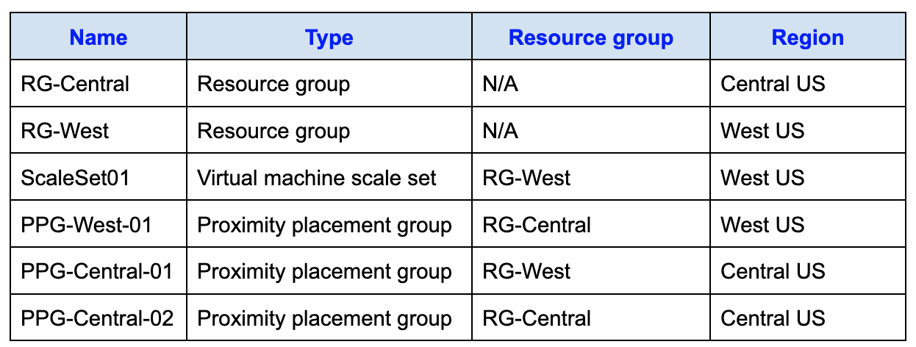
What should you choose for `Code Segment A`?
Réponses:
☐ "daysAfterCreationGreaterThan"
☐ "daysAfterLastAccessTimeGreaterThan"
☑ "daysAfterModificationGreaterThan"
Explication
`daysAfterModificationGreaterThan` is correct because it specifies the condition to move blobs that have not been modified within the specified period (45 days, in this case) to the Cool access tier. This meets the requirement of moving blobs based on the last modification date.
`daysAfterCreationGreaterThan` is incorrect because it moves blobs based on the number of days since creation, not since the last modification or update.
`daysAfterLastAccessTimeGreaterThan` is incorrect because it uses the last access time, which is not the required condition for this scenario. The requirement is based on the last modification date.
Reference(s):
https://learn.microsoft.com/en-us/azure/storage/blobs/lifecycle-management-overview#rule-actions

Question 32
You have an Azure subscription that includes a storage account named storage1, which contains a blob container called container1.
You create a blob lifecycle management policy named rule1. The purpose of this rule is to automatically move blobs in container1 to the Cool access tier if they have not been modified for 45 days.
To implement this behavior, you must complete the lifecycle policy definition shown in the exhibit.
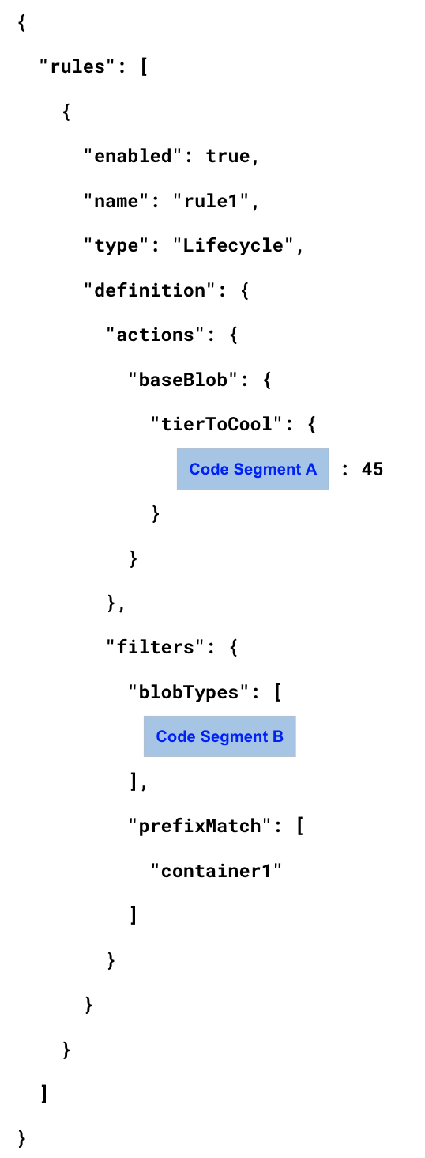
What should you choose for `Code Segment B`?
Réponses:
☐ "AppendBlob"
☑ "Blockblob"
☐ "Pageblob"
Explication
`Blockblob` is correct because block blobs are typically used for storing general-purpose files and are the default choice for most Azure blob storage scenarios, including lifecycle management. Since the requirement involves moving blobs to a different access tier, block blobs are the appropriate selection.
`AppendBlob` is incorrect because append blobs are used for scenarios like logging, where data is continuously appended to the end of the blob. They are not typically managed by lifecycle policies for tiering.
`Pageblob` is incorrect because page blobs are primarily used for Azure Virtual Machine disks and are not suited for lifecycle tiering in this context.
Reference(s):
https://learn.microsoft.com/en-us/azure/storage/blobs/lifecycle-management-overview#rule-filters

Question 33
You are designing an Azure deployment that uses Azure Resource Manager (ARM) templates to provision 50 virtual machines. All virtual machines will be placed in the same availability set.
The goal of the design is to maximize the number of virtual machines that remain online during either Azure platform failures or planned maintenance events.
To achieve this, you are configuring an ARM template that defines an availability set, as shown in the exhibit. The template includes settings for fault domains and update domains.
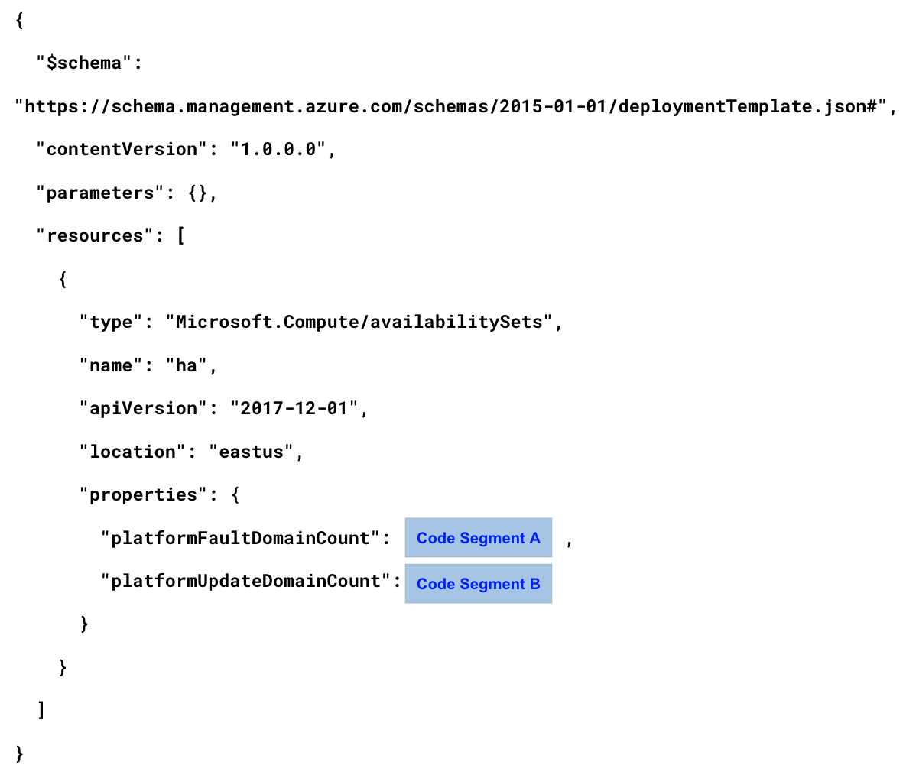
Which value should you specify for the `platformFaultDomainCount` property in the availability set configuration?
Réponses:
☐ 0
☐ 1
☐ 2
☑ 3
Explication
`3` is correct because, in regions that support it, Azure availability sets can be spread across up to 3 fault domains by default. This configuration maximizes availability by distributing virtual machines across more physical racks, thereby increasing the likelihood of VM availability during a fabric failure.
`0`, `1`, and `2` are incorrect because:
- 0 would mean no fault domain distribution, resulting in no fault tolerance.
- 1 would only provide minimal distribution, reducing high availability.
- 2 would offer some availability, but 3 provides the maximum distribution across fault domains, which is preferred when trying to maximize the number of available VMs in case of a failure.
Reference(s):
- https://learn.microsoft.com/en-us/azure/virtual-machines/availability-set-overview
- https://learn.microsoft.com/en-us/azure/virtual-machines/maintenance-and-updates

Question 34
You are designing an Azure deployment that uses Azure Resource Manager (ARM) templates to provision 50 virtual machines. All virtual machines will be placed in the same availability set.
The goal of the design is to maximize the number of virtual machines that remain online during either Azure platform failures or planned maintenance events.
To achieve this, you are configuring an ARM template that defines an availability set, as shown in the exhibit. The template includes settings for fault domains and update domains.
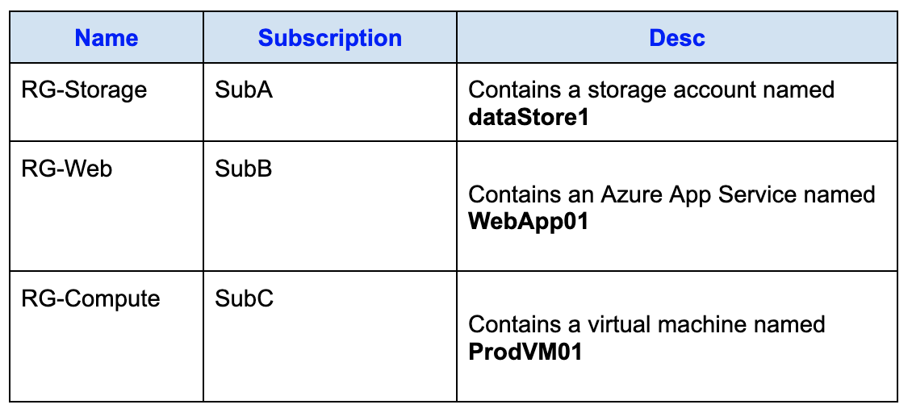
Which value should you specify for the `platformUpdateDomainCount` property in the availability set configuration?
Réponses:
☐ 0
☐ 1
☐ 6
☐ 12
☐ 17
☑ 20
Explication
`20` is correct because Azure Availability Sets support up to 20 update domains by default. Update domains are used to ensure that virtual machines in the same availability set do not go down for maintenance at the same time. By setting the platformUpdateDomainCount to 20, you maximize the distribution of virtual machines across update domains, which helps maintain availability during planned maintenance events.
`0`, `1`, `6`, `12`, and `17` are incorrect because:
- 0 would mean no update domain distribution, resulting in all VMs potentially being impacted by maintenance at the same time.
- 1, 6, 12, and 17 would offer fewer update domains, which would not maximize availability during updates as effectively as using 20.
Reference(s):
- https://learn.microsoft.com/en-us/azure/virtual-machines/maintenance-and-updates
- https://learn.microsoft.com/en-us/azure/virtual-machines/availability-set-overview

Question 35
**Note: This question is part of a series that uses the same overall scenario. Each question in the series proposes a different solution that may or may not satisfy the stated requirement.

You administer a virtual network named VNet1 located in the West US Azure region.
Within VNet1, there are two virtual machines, VM1 and VM2, both running Windows Server.
You are required to analyze and observe all network traffic flowing from VM1 to VM2 over a continuous three-hour window.
Proposed solution: Using Azure Monitor, you configure metrics to track Network In and Network Out traffic.
Does this proposed solution achieve the stated requirement?
Réponses:
☐ Yes
☑ No
Explication
`No` is correct because creating a metric on Network In and Network Out in Azure Monitor will only provide information on the volume of network traffic, not the contents or details of the network traffic. To inspect all network traffic between VM1 and VM2, you would need to use a tool or service that allows for deeper traffic inspection, such as Azure Network Watcher with Packet Capture or a Network Security Group flow log.
Reference(s):
- https://docs.microsoft.com/en-us/azure/azure-monitor/platform/metrics-supported

Question 36
**Note: This question is part of a series that uses the same overall scenario. Each question in the series proposes a different solution that may or may not satisfy the stated requirement.

You administer a virtual network named VNet1 located in the West US Azure region.
Within VNet1, there are two virtual machines, VM1 and VM2, both running Windows Server.
You are required to analyze and observe all network traffic flowing from VM1 to VM2 over a continuous three-hour window.
Proposed solution: Using Azure Network Watcher, you set up a Connection Monitor to track and evaluate the traffic flow between the virtual machines.
Does this proposed solution achieve the stated requirement?
Réponses:
☐ Yes
☑ No
Explication
`No` is correct because Connection Monitor in Azure Network Watcher is primarily used to monitor connectivity status and latency between two endpoints rather than to inspect the content of network traffic. It provides insights into the connection quality, including packet loss and response time, but it does not capture or analyze all network traffic between VM1 and VM2. For inspecting all network traffic, you would need to use Packet Capture in Azure Network Watcher, which allows you to capture network traffic for deeper inspection.
Reference(s):
- https://docs.microsoft.com/en-us/azure/network-watcher/connection-monitor
- https://docs.microsoft.com/en-us/azure/network-watcher/network-watcher-packet-capture-overview

Question 37
**Note: This question is part of a series that uses the same overall scenario. Each question in the series proposes a different solution that may or may not satisfy the stated requirement.

You administer a virtual network named VNet1 located in the West US Azure region.
Within VNet1, there are two virtual machines, VM1 and VM2, both running Windows Server.
You are required to analyze and observe all network traffic flowing from VM1 to VM2 over a continuous three-hour window.
Proposed solution: You use Performance Monitor to configure a Data Collector Set (DCS).
Does this proposed solution achieve the stated requirement?
Réponses:
☐ Yes
☑ No
Explication
`No` is correct because Performance Monitor and creating a Data Collector Set (DCS) on Windows Server allows you to collect performance metrics, such as CPU, memory, and disk usage, but it does not capture or inspect network traffic between VMs. To inspect all network traffic between VM1 and VM2, you would need to use Packet Capture in Azure Network Watcher, which is specifically designed for capturing and analyzing network traffic.
Reference(s):
- https://docs.microsoft.com/en-us/azure/azure-monitor/insights/network-performance-monitor

Question 38
Note: This question is part of a series that uses the same overall scenario. Each question in the series proposes a different solution that may or may not satisfy the stated requirement.
You have a Microsoft Entra tenant named Bluerock.com and an Azure subscription called Subscription1. Within Bluerock.com, there is a security group named Developers. Within Subscription1, there is a resource group named Dev.
You must grant the Developers group permissions that allow them to create Azure Logic Apps within the Dev resource group.
Proposed solution: At the Dev resource group scope, you assign the Logic App Operator role to the Developers group.
Does this solution satisfy the requirement?
Réponses:
☐ Yes
☑ No
Explication
`No` is correct because the Logic App Operator role allows users to perform runtime operations on logic apps, such as triggering, enabling, disabling, and viewing runs and history. However, it does not provide the permissions required to create, update, or delete logic apps. This means that assigning the Logic App Operator role to the Developers group does not fulfill the requirement to allow them to create Azure Logic Apps.
Reference(s):
- https://learn.microsoft.com/en-us/azure/role-based-access-control/built-in-roles#logic-app-operator

Question 39
Note: This question is part of a series that uses the same overall scenario. Each question in the series proposes a different solution that may or may not satisfy the stated requirement.
You have a Microsoft Entra tenant named Bluerock.com and an Azure subscription called Subscription1. Within Bluerock.com, there is a security group named Developers. Within Subscription1, there is a resource group named Dev.
You must grant the Developers group permissions that allow them to create Azure Logic Apps within the Dev resource group.
Proposed solution: At the Subscription1 scope, you grant the Developers group the DevTest Labs User role.
Does this solution satisfy the requirement?
Réponses:
☐ Yes
☑ No
Explication
`No` is correct because the DevTest Labs User role allows users to connect to, start, restart, and shut down virtual machines in Azure DevTest Labs. It does not provide permissions to create Azure Logic Apps. The ability to create Logic Apps requires a role such as Logic App Contributor or Contributor, which explicitly includes permissions for managing logic apps. Therefore, assigning the DevTest Labs User role does not meet the stated requirement.
Reference(s):
- https://learn.microsoft.com/en-us/azure/role-based-access-control/built-in-roles#devtest-labs-user

Question 40
Note: This question is part of a series that uses the same overall scenario. Each question in the series proposes a different solution that may or may not satisfy the stated requirement.
You have a Microsoft Entra tenant named Bluerock.com and an Azure subscription called Subscription1. Within Bluerock.com, there is a security group named Developers. Within Subscription1, there is a resource group named Dev.
You must grant the Developers group permissions that allow them to create Azure Logic Apps within the Dev resource group.
Proposed solution: At the Subscription1 scope, you grant the Developers group the Logic App Contributor role.
Does this solution satisfy the requirement?
Réponses:
☑ Yes
☐ No
Explication
`Yes` is correct because the Logic App Contributor role grants permissions to create and manage Azure Logic Apps within a specified scope, such as a subscription or resource group. This role enables the Developers group to create Azure Logic Apps in the Dev resource group. While the Logic App Contributor role allows for creation and management, it does not permit assigning or modifying access to these Logic Apps, which is not a requirement in this scenario.
- The Logic App Operator role only allows actions such as reading, enabling, or disabling Logic Apps but does not permit their creation or editing, making it insufficient for the stated goal.
- The Logic App Contributor role meets the goal by enabling the necessary level of management without over-provisioning permissions.
Reference(s):
- https://learn.microsoft.com/en-us/azure/role-based-access-control/built-in-roles#logic-app-contributor

Question 41
Note: This question is part of a series that uses the same overall scenario. Each question in the series proposes a different solution that may or may not satisfy the stated requirement.
You have a Microsoft Entra tenant named Bluerock.com and an Azure subscription called Subscription1. Within Bluerock.com, there is a security group named Developers. Within Subscription1, there is a resource group named Dev.
You must grant the Developers group permissions that allow them to create Azure Logic Apps within the Dev resource group.
Proposed solution: At the Subscription1 scope, you grant the Developers group the Logic App Operator role.
Does this solution satisfy the requirement?
Réponses:
☐ Yes
☑ No
Explication
`No` is correct because the Logic App Operator role only provides permissions to read, enable, and disable Azure Logic Apps. It does not grant permissions to create or update Logic Apps. To allow the Developers group to create Azure Logic Apps in the Dev resource group, they need the Logic App Contributor role, which explicitly grants creation and management rights for Logic Apps.
Reference(s):
- https://learn.microsoft.com/en-us/azure/role-based-access-control/built-in-roles#logic-app-operator

Question 42
You manage an Azure Storage account called storage1.
Within storage1, you configure a custom encryption scope named Scope1.
You now need to determine which types of storage data can be protected by applying Scope1.
Which storage types support encryption by using an encryption scope?
Réponses:
☐ file shares only
☑ containers only
☐ file shares and containers only
☐ containers and tables only
☐ file shares, containers, and tables only
☐ file shares, containers, tables, and queues
Explication
`containers only` is correct because encryption scopes in Azure Storage are applicable to Azure Blob Storage and Data Lake Gen2 storage accounts. Since blobs are stored within containers, encryption scopes can be used to encrypt containers, but not other storage types such as file shares, tables, or queues.
Reference(s):
https://learn.microsoft.com/en-us/azure/storage/blobs/encryption-scope-manage?tabs=portal

Question 43
An Azure subscription contains eight virtual machines and the following resources:
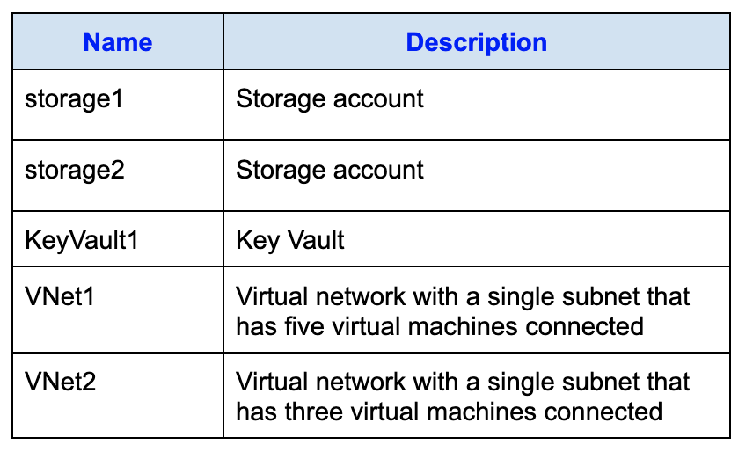
You are required to configure network access for VNet1 while meeting these conditions:
- Virtual machines in VNet1 must be able to communicate with virtual machines in VNet2 over the Microsoft backbone network.
- Virtual machines in VNet1 must be able to securely access storage1, storage2, and Microsoft Entra using the Microsoft backbone.
To satisfy these requirements, you plan to use service endpoints.
What is the minimum number of service endpoints that must be enabled on VNet1?
Réponses:
☑ 1
☐ 2
☐ 3
☐ 5
Explication
`1` is correct because we can use 1 service endpoint for all storage accounts deployed in the same region. Apart from this, the service endpoint is not needed for Microsoft Entra, because VMs accessing Microsoft Entra users (e.g., for user management, authentication, or authorization purposes) relies on Microsoft Entra's authentication and authorization mechanisms, and it doesn't require a service endpoint. Microsoft Entra is a cloud-based identity and access management service that operates independently of a VNet's service endpoints.
Setting up a service endpoint for Microsoft Entra can be advantageous in specific situations, like when VMs require secure access to Microsoft Entra-related APIs. However, it's not mandatory for VMs to connect with Microsoft Entra users or entities.
While it's possible to use two service endpoints for two separate storage accounts, the question asks for the least number of endpoints necessary.
Reference(s):
- https://docs.microsoft.com/en-us/azure/virtual-network/virtual-network-service-endpoints-overview
- https://docs.microsoft.com/en-us/azure/storage/common/storage-network-security
- https://docs.microsoft.com/en-us/azure/key-vault/general/network-security

Question 58
You have an Azure subscription that contains virtual machines running Windows Server, configured as shown in the table below:
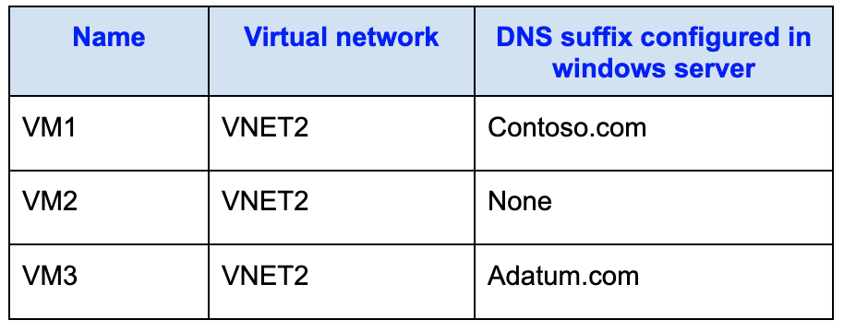
You create the following DNS resources:
- A public Azure DNS zone named adatum.com
- A private Azure DNS zone named contoso.com
You then create a virtual network link between the contoso.com private DNS zone and VNET2, with auto-registration enabled.
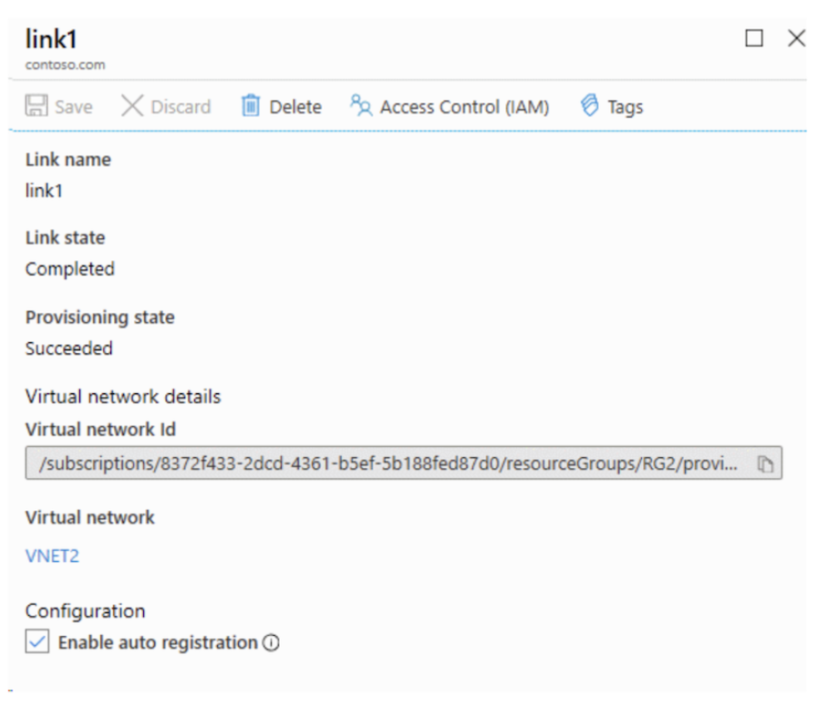
True or False:
`"When VM1 starts, a DNS record for VM1 is created in the contoso.com DNS zone."`
Réponses:
☑ True
☐ False
Explication
`True` is correct because VM1 is in VNET2, and VNET2 is linked to the `contoso.com` private DNS zone with auto-registration enabled. Azure will automatically register the DNS record for VM1 in the `contoso.com` zone. The DNS suffix configured inside the VM (e.g., `contoso.com`) does not affect auto-registration; Azure registers the VM in the zone linked to its VNet, not based on the VM’s internal settings.
**Reference(s):

- https://learn.microsoft.com/en-us/azure/dns/private-dns-overview
- https://learn.microsoft.com/en-us/azure/dns/private-dns-autoregistration
- https://learn.microsoft.com/en-us/azure/virtual-network/virtual-networks-name-resolution-for-vms-and-role-instances?tabs=redhat

Question 59
You have an Azure subscription that contains virtual machines running Windows Server, configured as shown in the table below:
You create the following DNS resources:
- A public Azure DNS zone named adatum.com
- A private Azure DNS zone named contoso.com
You then create a virtual network link between the contoso.com private DNS zone and VNET2, with auto-registration enabled.
True or False:
`"When VM2 starts, a DNS record for VM2 is created in the contoso.com DNS zone."`
Réponses:
☑ True
☐ False
Explication
`True` is correct because VM2 is also in VNET2, which is linked to the `contoso.com` private DNS zone with auto-registration enabled. Azure will register VM2’s DNS record in `contoso.com`, regardless of any DNS suffix configured in the VM's OS. Azure Private DNS zones do not consider the OS-configured DNS suffix; they rely solely on the VNet linkage and auto-registration settings.

Reference(s):**
- https://learn.microsoft.com/en-us/azure/dns/private-dns-overview
- https://learn.microsoft.com/en-us/azure/dns/private-dns-autoregistration
- https://learn.microsoft.com/en-us/azure/virtual-network/virtual-networks-name-resolution-for-vms-and-role-instances?tabs=redhat

Question 60
You have an Azure subscription that contains virtual machines running Windows Server, configured as shown in the table below:
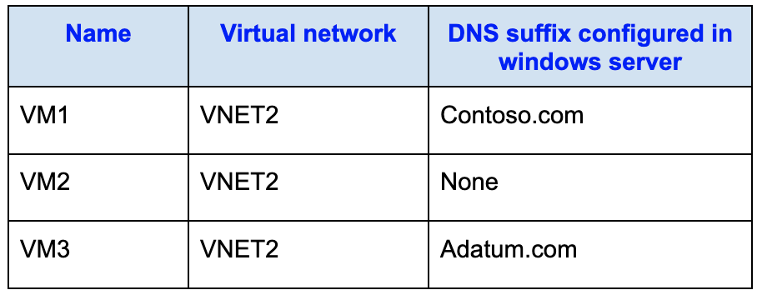
You create the following DNS resources:
- A public Azure DNS zone named adatum.com
- A private Azure DNS zone named contoso.com
You then create a virtual network link between the contoso.com private DNS zone and VNET2, with auto-registration enabled.
True or False:
`"When VM3 starts, a DNS record for VM3 is created in the adatum.com DNS zone."`
Réponses:
☐ True
☑ False
Explication
`False` is correct because VM3 is in VNET2, and VNET2 is linked only to the contoso.com private DNS zone with auto-registration enabled. While VM3 has the DNS suffix adatum.com configured at the OS level, this suffix is ignored for auto-registration purposes. Also, adatum.com is a public Azure DNS zone, and Azure does not support auto-registration into public DNS zones. Therefore, when VM3 is registered through the private DNS zone auto-registration process, its DNS record will be created in contoso.com, not adatum.com.
Reference(s):
- https://learn.microsoft.com/en-us/azure/dns/private-dns-overview
- https://learn.microsoft.com/en-us/azure/dns/private-dns-autoregistration
- https://learn.microsoft.com/en-us/azure/virtual-network/virtual-networks-name-resolution-for-vms-and-role-instances?tabs=redhat

Question 61
You are reviewing alert instances in Azure Monitor.
The alert list displays four total alerts, all with a severity level of Verbose (Severity 4).
There are:
- Two instances of Alert2, each with:
- Alert condition: Fired
- User response: New
- Fired time: 4/29/2022, 2:09 PM
- Two instances of Alert1, each with:
- Alert condition: Fired
- User response: Closed
- Fired time: 4/29/2022, 2:04 PM
Based on the information presented, select the answer choice that completes the following statement correctly.
“For Alert1, User response _______________________.”
Réponses:
☐ cannot be modified
☐ can only be changed back to New
☐ can only be changed to Acknowledged
☑ can be updated to either New or Acknowledged
Explication
`can be updated to either New or Acknowledged` is the correct option because in Azure Monitor, an alert's status can be changed between New, Acknowledged, and Closed at any point based on the current state or requirement. Even if an alert is marked as Closed, it can be reopened and transitioned back to New or Acknowledged. This flexibility allows teams to revisit alerts and reassess their status as conditions change.
Reference(s):
- https://learn.microsoft.com/en-us/azure/azure-monitor/alerts/alerts-overview
- https://learn.microsoft.com/en-us/training/modules/incident-response-with-alerting-on-azure/

Question 62
You are reviewing alert instances in Azure Monitor.
The alert list displays four total alerts, all with a severity level of Verbose (Severity 4).
There are:
- Two instances of Alert2, each with:
- Alert condition: Fired
- User response: New
- Fired time: 4/29/2022, 2:09 PM
- Two instances of Alert1, each with:
- Alert condition: Fired
- User response: Closed
- Fired time: 4/29/2022, 2:04 PM
Based on the information presented, select the answer choice that completes the following statement correctly.
“For Alert2, User response _______________________.”
Réponses:
☐ cannot be modified
☐ can only be changed to Acknowledged
☐ can only be changed to Closed
☑ can be updated to either Acknowledged or Closed
Explication
`can be updated to either Acknowledged or Closed` is the correct option because an Azure alert currently marked as New can transition to either Acknowledged or Closed, depending on how the issue is being managed. Azure Monitor allows flexibility in alert status transitions, enabling teams to track, acknowledge, or resolve alerts effectively.
`cannot be modified` is incorrect because Azure Monitor supports transitions between alert statuses.
`can only be changed to Acknowledged` is incorrect because the alert can also be transitioned to Closed.
`can only be changed to closed` is incorrect because the alert can also be transitioned to Acknowledged.
Reference(s):
- https://learn.microsoft.com/en-us/azure/azure-monitor/alerts/alerts-overview
- https://learn.microsoft.com/en-us/training/modules/incident-response-with-alerting-on-azure

Question 63
You have an Azure subscription that includes a resource group named RG1.
You intend to deploy resources to RG1 by using an Azure Resource Manager (ARM) template named template1. The deployment must meet the following conditions:
- Deploy new resources to RG1.
- All existing resources in RG1 must be deleted before deployment.
You are using the following Azure PowerShell command, which is currently incomplete:
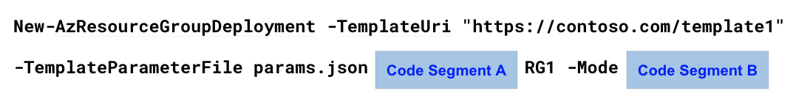
Which value should you choose for `Code Segment A`
Réponses:
☐ -Name
☐ -QueryString
☑ -ResourceGroupName
☐ -Tag
Explication
`-ResourceGroupName` is the correct option because when deploying an Azure Resource Manager (ARM) template to a specific resource group using the New-AzResourceGroupDeployment command, the -ResourceGroupName parameter is used to specify the target resource group where resources will be deployed.
`-Name` is incorrect because this parameter is used to provide a deployment name, not a resource group name.
`-QueryString` is incorrect because it is not a valid parameter for specifying the target resource group in the context of New-AzResourceGroupDeployment.
`-Tag` is incorrect because it is used to assign metadata tags to resources, not to specify the resource group.
Reference(s):
- https://learn.microsoft.com/en-us/powershell/module/az.resources/new-azresourcegroupdeployment
- https://learn.microsoft.com/en-us/azure/azure-resource-manager/templates/deployment-manager-overview

Question 64
You have an Azure subscription that includes a resource group named RG1.
You intend to deploy resources to RG1 by using an Azure Resource Manager (ARM) template named template1. The deployment must meet the following conditions:
- Deploy new resources to RG1.
- All existing resources in RG1 must be deleted before deployment.
You are using the following Azure PowerShell command, which is currently incomplete:
Which value should you choose for `Code Segment B`?
Réponses:
☐ All
☑ Complete
☐ Incremental
Explication
`Complete` is the correct option because the Complete deployment mode ensures that all existing resources in the specified resource group are deleted if they are not defined in the ARM template. This mode is ideal for scenarios where you want to ensure that the resource group exactly matches the template's definition, removing any unnecessary or outdated resources.
`All` is incorrect because it is not a valid mode for the New-AzResourceGroupDeployment command.
`Incremental` is incorrect because, in Incremental mode, only the resources specified in the template are updated or created, and existing resources not mentioned in the template remain unchanged. This does not meet the requirement to remove all existing resources.
Reference(s):
- https://learn.microsoft.com/en-us/azure/azure-resource-manager/templates/deployment-modes
- https://learn.microsoft.com/en-us/powershell/module/az.resources/new-azresourcegroupdeployment

Question 65
You have an Azure subscription that includes a virtual machine named VM1.
VM1 hosts a financial reporting application (App1) that is designed to run as a single active instance only.
At the end of every month, App1 performs intensive processing, which causes CPU utilization on VM1 to spike significantly.
You are required to create an Azure Automation scheduled runbook that temporarily improves the CPU performance of VM1 during this monthly processing window.
Which action should the runbook perform?
Réponses:
☐ Move VM1 into a virtual machine scale set so that compute capacity can scale automatically.
☐ Install the Azure Performance Diagnostics extension on VM1 to analyze CPU bottlenecks.
☑ Change the virtual machine size of VM1 to a SKU that provides more vCPUs and processing power.
☐ Request an increase to the subscription’s vCPU quota to allow additional processors.
☐ Apply a Desired State Configuration (DSC) extension to VM1 to optimize system settings.
Explication
`Change the virtual machine size of VM1 to a SKU that provides more vCPUs and processing power` is correct as we need to add more processing power to the machine, which can be achieved by increasing the size of the VM. This approach allows scaling vertically by assigning more vCPUs or memory resources, ensuring the virtual machine can handle the increased CPU demand at the end of each month when the financial reporting application runs.
`Install the Azure Performance Diagnostics extension on VM1 to analyze CPU bottlenecks` is incorrect as this agent is primarily used for collecting diagnostic logs and performance data from the virtual machine into Azure Monitor. It does not enhance the processing power of the VM, which is the core requirement in this scenario.
`Move VM1 into a virtual machine scale set so that compute capacity can scale automatically` is incorrect because a scale set runs identical instances of a VM to handle increased load horizontally. However, the financial reporting application running on VM1 does not support multiple active instances, rendering this option unsuitable.
`Request an increase to the subscription’s vCPU quota to allow additional processors` is incorrect because increasing the vCPU quota is only necessary when the subscription has exhausted its vCPU limit. In this scenario, we only need to increase the resources of a single virtual machine, not the overall quota for the subscription.
`Apply a Desired State Configuration (DSC) extension to VM1 to optimize system settings` is incorrect as DSC is used to enforce consistent configurations across multiple virtual machines. This approach does not address the requirement to increase the processing power of a single VM for a specific period.
Reference(s):
- https://docs.microsoft.com/en-us/azure/virtual-machines/windows/resize-vm

Question 66
You are working in an Azure subscription and plan to deploy a storage account named storage1 by using an Azure Resource Manager (ARM) template.
The template configuration enables several data protection features for the Blob service, including blob versioning, soft delete, container soft delete, and point-in-time restore with specific retention periods.
{
"$schema": "http://schema.management.azure.com/schemas/2015-01-01/deploymentTemplate.json#",
"contentVersion": "1.0.0.0",
"resources": [
{
"name": "storage1",
"type": "Microsoft.Storage/storageAccounts",
"apiVersion": "2021-08-01",
"location": "East US",
"properties": {
"allowBlobPublicAccess": true,
"defaultToOAuthAuthentication": false,
"networkAcls": {
"bypass": "AzureServices",
"defaultAction": "Allow",
"ipRules": []
}
},
"sku": {
"name": "Standard_LRS"
},
"kind": "StorageV2"
},
{
"name": "storage1/default",
"type": "Microsoft.Storage/storageAccounts/blobServices",
"apiVersion": "2021-08-01",
"properties": {
"restorePolicy": {
"enabled": true,
"days": 6
},
"deleteRetentionPolicy": {
"enabled": true,
"days": 7
},
"containerDeleteRetentionPolicy": {
"enabled": true,
"days": 7
},
"changeFeed": {
"enabled": true
},
"isVersioningEnabled": true
},
"dependsOn": [
"[concat('Microsoft.Storage/storageAccounts/', 'storage1')]"
]
}
]
}
True or False:
`"Changes made to the data in storage1 can be rolled back after seven days"`
Réponses:
☐ True
☑ False
Explication
`False` is the correct answer because the configuration specifies a restorePolicy with the following settings:
- "enabled": true
- "days": 6"
This means the maximum duration for point-in-time recovery of blob data is 6 days. Any changes made beyond this period cannot be rolled back. The statement specifically mentions rolling back data changes after 7 days, which exceeds the configured recovery window.
The deleteRetentionPolicy and containerDeleteRetentionPolicy are both set to 7 days, but these policies only apply to deleted blobs and containers. They do not allow point-in-time recovery of modified data beyond the 6-day limit set in the restore policy.
Reference(s):
- https://learn.microsoft.com/en-us/azure/storage/blobs/anonymous-read-access-configure
- https://learn.microsoft.com/en-us/azure/storage/blobs/versioning-overview
- https://learn.microsoft.com/en-us/azure/storage/blobs/versioning-enable?tabs=portal
- https://learn.microsoft.com/en-us/azure/templates/microsoft.storage/storageaccounts/blobservices?pivots=deployment-language-arm-template#restorepolicyproperties-1

Question 67
You are working in an Azure subscription and plan to deploy a storage account named storage1 by using an Azure Resource Manager (ARM) template.
The template configuration enables several data protection features for the Blob service, including blob versioning, soft delete, container soft delete, and point-in-time restore with specific retention periods.
{
"$schema": "http://schema.management.azure.com/schemas/2015-01-01/deploymentTemplate.json#",
"contentVersion": "1.0.0.0",
"resources": [
{
"name": "storage1",
"type": "Microsoft.Storage/storageAccounts",
"apiVersion": "2021-08-01",
"location": "East US",
"properties": {
"allowBlobPublicAccess": true,
"defaultToOAuthAuthentication": false,
"networkAcls": {
"bypass": "AzureServices",
"defaultAction": "Allow",
"ipRules": []
}
},
"sku": {
"name": "Standard_LRS"
},
"kind": "StorageV2"
},
{
"name": "storage1/default",
"type": "Microsoft.Storage/storageAccounts/blobServices",
"apiVersion": "2021-08-01",
"properties": {
"restorePolicy": {
"enabled": true,
"days": 6
},
"deleteRetentionPolicy": {
"enabled": true,
"days": 7
},
"containerDeleteRetentionPolicy": {
"enabled": true,
"days": 7
},
"changeFeed": {
"enabled": true
},
"isVersioningEnabled": true
},
"dependsOn": [
"[concat('Microsoft.Storage/storageAccounts/', 'storage1')]"
]
}
]
}
True or False:
`"Only users who are geographically located in the East US Azure region are permitted to access storage1."`
Réponses:
☐ True
☑ False
Explication
`False` is the correct answer because there is nothing in the ARM template that restricts network access to the East US region. The `"location": "East US"` property only specifies where the storage account is deployed — it does not limit who can access it. The `networkAcls` configuration explicitly allows all traffic with `"defaultAction": "Allow"` and contains no IP rules or virtual network restrictions. This means users from any region can connect to `storage1` as long as they have valid credentials.
The allowBlobPublicAccess property in the template controls anonymous blob access, not regional access. Since no firewall, IP restrictions, or private endpoint configurations are defined, the account remains globally accessible over the internet.
Reference(s):
- https://learn.microsoft.com/en-us/azure/storage/blobs/anonymous-read-access-configure
- https://learn.microsoft.com/en-us/azure/storage/blobs/versioning-overview
- https://learn.microsoft.com/en-us/azure/storage/blobs/versioning-enable?tabs=portal
- https://learn.microsoft.com/en-us/azure/templates/microsoft.storage/storageaccounts/blobservices?pivots=deployment-language-arm-template#restorepolicyproperties-1

Question 68
You are working in an Azure subscription and plan to deploy a storage account named storage1 by using an Azure Resource Manager (ARM) template.
The template configuration enables several data protection features for the Blob service, including blob versioning, soft delete, container soft delete, and point-in-time restore with specific retention periods.
{
"$schema": "http://schema.management.azure.com/schemas/2015-01-01/deploymentTemplate.json#",
"contentVersion": "1.0.0.0",
"resources": [
{
"name": "storage1",
"type": "Microsoft.Storage/storageAccounts",
"apiVersion": "2021-08-01",
"location": "East US",
"properties": {
"allowBlobPublicAccess": true,
"defaultToOAuthAuthentication": false,
"networkAcls": {
"bypass": "AzureServices",
"defaultAction": "Allow",
"ipRules": []
}
},
"sku": {
"name": "Standard_LRS"
},
"kind": "StorageV2"
},
{
"name": "storage1/default",
"type": "Microsoft.Storage/storageAccounts/blobServices",
"apiVersion": "2021-08-01",
"properties": {
"restorePolicy": {
"enabled": true,
"days": 6
},
"deleteRetentionPolicy": {
"enabled": true,
"days": 7
},
"containerDeleteRetentionPolicy": {
"enabled": true,
"days": 7
},
"changeFeed": {
"enabled": true
},
"isVersioningEnabled": true
},
"dependsOn": [
"[concat('Microsoft.Storage/storageAccounts/', 'storage1')]"
]
}
]
}
True or False:
`"Data in storage1 is replicated across three instances within the East US Azure region."`
Réponses:
☑ True
☐ False
Explication
`True` is the correct answer because the sku property in the ARM template specifies:
- "name": "Standard_LRS"
LRS (Locally Redundant Storage) ensures that three copies of the data are maintained within a single Azure region (East US in this case). These copies are stored synchronously across multiple fault domains and update domains within the same region to provide redundancy against hardware failures.
If regional redundancy was intended (e.g., data being replicated to another region), a different SKU like Geo-Redundant Storage (GRS) or Zone-Redundant Storage (ZRS) would have been specified instead of Standard_LRS.
Reference(s):
- https://learn.microsoft.com/en-us/azure/storage/common/storage-redundancy

Question 69
You have an Azure subscription that includes the following Azure Container Instances (ACI):
- container1: Deployed in East US, running a Windows image
- container2: Deployed in West US, running a Windows image
- container3: Deployed in East US, running a Linux image
A storage account with an Azure file share named storage1 is created in the East US region.
You need to mount storage1 to supported container instances.
Which container instances can successfully mount storage1?
Réponses:
☐ container1 only
☑ container3 only
☐ container1 and container2 only
☐ container1 and container3 only
☐ container1, container2, and container3
Explication
`container3 only` is the correct answer because Azure Container Instances (ACI) supports mounting Azure Files only to Linux-based containers, not to Windows-based ones.
Reference(s):
- https://learn.microsoft.com/en-us/azure/container-instances/container-instances-volume-azure-files#limitations

Question 70
You have an Azure subscription that contains the following resource groups:
- RG1: Region: East US
- RG2: Region: West US
You create the following Azure Resource Manager (ARM) template named deploy.json.
{
"$schema": "https://schema.management.azure.com/schemas/2015-01-01/deploymentTemplate.json#",
"contentVersion": "1.0.0.0",
"parameters": {},
"variables": {},
"resources": [
{
"type": "Microsoft.Resources/resourceGroups",
"apiVersion": "2018-05-01",
"location": "eastus",
"name": "[concat('RG', copyIndex())]",
"copy": {
"name": "copy",
"count": 4
}
}
],
"outputs": {}
}
You deploy the template by running the following cmdlet:
`New-AzSubscriptionDeployment -Location westus -TemplateFile deploy.json`
True or False:
`“The template creates a resource group named RG0 in the East US Azure region.”`
Réponses:
☑ True
☐ False
Explication
`True` is the correct answer here. The ARM template defines a resource group resource type (`Microsoft.Resources/resourceGroups`) and uses a `copy` loop to create 4 resource groups named RG0, RG1, RG2, and RG3. The key detail is the `"location": "eastus"` line inside the resource definition, which specifies that each of these resource groups should be created in the East US Azure region, regardless of the location specified when deploying the template.
The command used to deploy the template is:
New-AzSubscriptionDeployment -Location westus -TemplateFile deploy.json
The `-Location westus` in this context refers to the location of the deployment metadata, not the location of the resources being created. Therefore, the deployment itself is tracked in West US, but the actual resource groups defined in the template are created in East US as specified in the `"location"` property of the resource block.
Hence, RG0 is created in East US, making the statement true.
Reference(s.):
- https://learn.microsoft.com/en-us/azure/azure-resource-manager/templates/deploy-to-subscription

Question 71
You have an Azure subscription that contains the following resource groups:
- RG1: Region: East US
- RG2: Region: West US
You create the following Azure Resource Manager (ARM) template named deploy.json.
{
"$schema": "https://schema.management.azure.com/schemas/2015-01-01/deploymentTemplate.json#",
"contentVersion": "1.0.0.0",
"parameters": {},
"variables": {},
"resources": [
{
"type": "Microsoft.Resources/resourceGroups",
"apiVersion": "2018-05-01",
"location": "eastus",
"name": "[concat('RG', copyIndex())]",
"copy": {
"name": "copy",
"count": 4
}
}
],
"outputs": {}
}
You deploy the template by running the following cmdlet:
`New-AzSubscriptionDeployment -Location westus -TemplateFile deploy.json`
True or False:
`“The template creates four new resource groups.”`
Réponses:
☐ True
☑ False
Explication
`False` is the correct answer here. While the ARM template is intended to create four resource groups (RG0, RG1, RG2, RG3), the table provided in the question shows that RG1 and RG2 already exist in the subscription. Azure Resource Manager (ARM) templates do not overwrite existing resource groups — attempting to create a resource group with a name that already exists will cause that specific deployment iteration to fail, unless the template logic explicitly handles existing resources (which this one does not).
As a result:
- RG0 and RG3 will be created
- RG1 and RG2 will fail to deploy because they already exist.

Reference(s.):**
- https://learn.microsoft.com/en-us/azure/azure-resource-manager/templates/deploy-to-subscription

Question 72
You have an Azure subscription that contains the following resource groups:
- RG1: Region: East US
- RG2: Region: West US
You create the following Azure Resource Manager (ARM) template named deploy.json.
{
"$schema": "https://schema.management.azure.com/schemas/2015-01-01/deploymentTemplate.json#",
"contentVersion": "1.0.0.0",
"parameters": {},
"variables": {},
"resources": [
{
"type": "Microsoft.Resources/resourceGroups",
"apiVersion": "2018-05-01",
"location": "eastus",
"name": "[concat('RG', copyIndex())]",
"copy": {
"name": "copy",
"count": 4
}
}
],
"outputs": {}
}
You deploy the template by running the following cmdlet:
`New-AzSubscriptionDeployment -Location westus -TemplateFile deploy.json`
True or False:
`“The template creates a resource group named RG3 in the West US Azure region.”`
Réponses:
☐ True
☑ False
Explication
`False` is the correct answer here. The ARM template defines the creation of resource groups using the `Microsoft.Resources/resourceGroups` type and specifies the `"location": "eastus"` inside the resource definition. This means all resource groups created by the template, including RG3, are created in the East US region.
While the deployment is executed using the command:
New-AzSubscriptionDeployment -Location westus -TemplateFile deploy.json
the `-Location westus` argument only defines the deployment metadata region, not the region of the resources being deployed. The actual resource group location is explicitly defined in the template as `"eastus"`.
Reference(s.):
- https://learn.microsoft.com/en-us/azure/azure-resource-manager/templates/deploy-to-subscription

Question 73
You are planning to migrate a distributed on-premises application named App1 to Azure.
After the migration is complete:
- App1 will run across nine Azure virtual machines
- The application must remain highly available during planned Azure platform maintenance
You must design the solution so that at least eight virtual machines remain operational whenever Azure performs planned maintenance activities.
Which solution should you implement?
Réponses:
☐ Create a single virtual machine scale set configured with 12 VM instances.
☑ Create a single virtual machine scale set configured with 10 VM instances.
☐ Create one availability set configured with three fault domains and one update domain.
☐ Create one availability set configured with 10 update domains and one fault domain.
Explication
`Create a single virtual machine scale set configured with 10 VM instances` is the correct answer here. Azure Virtual Machine Scale Sets (VMSS) automatically distribute VM instances across fault and update domains to provide high availability. By default, VMSS placement groups are configured with 5 fault domains and 5 update domains, and update domains are updated one at a time during planned Azure maintenance.
With 10 instances spread across 5 update domains, each update domain will host 2 VMs. During a planned update, only one update domain is affected at a time, meaning at most 2 out of 10 VMs are impacted, and at least 8 VMs remain running, which satisfies the requirement.
`Create a single virtual machine scale set configured with 12 VM instances` is incorrect because it exceeds the requirement unnecessarily. While it would also ensure 8 VMs are running during maintenance, it's not optimal in terms of cost and resource efficiency.
`Create one availability set configured with three fault domains and one update domain` is incorrect because a single update domain means all VMs in the set could be impacted at once during planned maintenance, violating the requirement of keeping at least 8 VMs up.
`Create one availability set configured with 10 update domains and one fault domain` is incorrect because, although Azure can support this availability set configuration, it is not the best solution for this scenario. The requirement is to keep at least eight virtual machines operational during planned Azure platform maintenance for an application that runs across nine virtual machines. A single virtual machine scale set with 10 VM instances provides a more suitable and scalable design because Azure distributes the instances across update domains and updates one update domain at a time during planned maintenance. This ensures that at most two VMs are affected at a time and at least eight VMs remain operational.
Reference(s.):
- https://docs.microsoft.com/en-us/azure/virtual-machine-scale-sets/virtual-machine-scale-sets-faq
- https://learn.microsoft.com/en-us/azure/virtual-machine-scale-sets/virtual-machine-scale-sets-use-availability-zones
- https://learn.microsoft.com/en-us/azure/virtual-machines/availability-set-overview

Question 74
You have an Azure subscription that contains the following vaults:
- Recovery1 – Recovery Services vault
- Backup1 – Azure Backup vault
You deploy two virtual machines:
- VM1 – Windows Server, configured with Azure Disk Encryption
- VM2 – Linux, configured with Trusted launch
The following backup policies are configured:
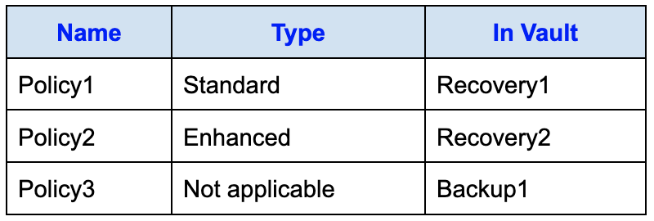
True or False:
`“VM1 can be backed up by using Policy1.”`
Réponses:
☑ True
☐ False
Explication
`True` is the correct answer here. VM1 is a Windows Server virtual machine that uses Azure Disk Encryption and is intended to be backed up using a Recovery Services vault. According to Azure backup support policies, Standard policy types in Recovery Services vaults fully support backing up Windows VMs with Azure Disk Encryption enabled. Policy1, being a Standard policy in the Recovery1 vault, is compatible with this scenario.
There is no limitation that prevents using a Standard policy for encrypted Windows VMs when the vault type is Recovery Services vault. Azure officially supports encrypted disks with both Standard and Enhanced policies for Windows VMs.
Reference(s.):
- https://learn.microsoft.com/en-us/azure/backup/backup-support-matrix
- https://learn.microsoft.com/en-us/azure/backup/backup-azure-vms-introduction

Question 75
You have an Azure subscription that contains the following vaults:
- Recovery1 – Recovery Services vault
- Backup1 – Azure Backup vault
You deploy two virtual machines:
- VM1 – Windows Server, configured with Azure Disk Encryption
- VM2 – Linux, configured with Trusted launch
The following backup policies are configured:
True or False:
`“VM2 can be backed up by using Policy3.”`
Réponses:
☐ True
☑ False
Explication
`False` is the correct answer here. Policy3 is associated with Backup1, which is an Azure Backup vault. However, Azure Backup vaults do not support backup of Azure virtual machines. Instead, Recovery Services vaults are required for backing up Azure VMs, whether the VM is Windows or Linux, and regardless of whether it uses features like Trusted Launch.
Additionally, Policy3 is marked as Not applicable, indicating that it does not contain backup configurations applicable for VM workloads. Azure Backup vaults are designed to support specific workloads such as:
- Azure Disks
- Azure Blobs (in Azure Storage)
- Azure Database for PostgreSQL servers
- Azure Kubernetes Services (AKS)
Since VM2 is a virtual machine, it cannot be backed up using Policy3 in Backup1.
Reference(s.):
- https://learn.microsoft.com/en-us/azure/backup/backup-support-matrix
- https://learn.microsoft.com/en-us/azure/backup/backup-vault-overview
- https://learn.microsoft.com/en-us/azure/backup/backup-azure-vms-introduction

Question 76
You have an Azure subscription that contains the following vaults:
- Recovery1 – Recovery Services vault
- Backup1 – Azure Backup vault
You deploy two virtual machines:
- VM1 – Windows Server, configured with Azure Disk Encryption
- VM2 – Linux, configured with Trusted launch
The following backup policies are configured:
True or False:
`“VM2 can be backed up by using Policy2.”`
Réponses:
☑ True
☐ False
Explication
`True` is the correct answer. Enhanced backup policies are used specifically for protecting Azure virtual machines in Recovery Services vaults, and they support advanced scenarios such as Trusted Launch virtual machines. Since Policy2 is defined as an Enhanced policy, it must be associated with a Recovery Services vault, because Backup vaults do not support VM backup policies of this type.
Even though Recovery2 is not explicitly listed among the available vaults, the presence of an Enhanced policy implicitly indicates that it belongs to a Recovery Services vault. Azure Backup supports protecting Linux virtual machines configured with Trusted Launch when using Enhanced policies in a Recovery Services vault. Therefore, VM2 meets the requirements for being backed up using Policy2.
Reference(s.):
- https://learn.microsoft.com/en-us/azure/backup/backup-support-matrix
- https://learn.microsoft.com/en-us/azure/backup/backup-azure-vms-enhanced-policy?tabs=azure-portal
- https://learn.microsoft.com/en-us/azure/virtual-machines/trusted-launch

Question 77
You are planning to deploy a new Azure App Service application named WebApp1. The configuration must satisfy the following conditions:
- WebApp1 must support validating a custom domain name: app.bluerock.com.
- WebApp1 must be able to automatically scale up to a maximum of eight instances.
- The selected solution should keep costs low and reduce ongoing administrative overhead as much as possible.
Based on these requirements, which App Service pricing plan should you select for WebApp1?
Réponses:
☐ Basic
☐ Free
☐ Shared
☑ Standard
Explication
`Standard` is correct. The Standard App Service plan supports both custom domain name verification and auto-scaling, which are required for WebApp1. It allows binding of a custom domain such as `app.bluerock.com` and supports automatic scaling up to 10 instances, which satisfies the requirement to scale up to eight instances. Additionally, it offers a balance between cost and functionality, minimizing administrative effort while supporting enterprise-grade features.
`Basic` is incorrect because although it supports custom domains, it does not support auto-scaling. The scaling process under the Basic tier is manual, which does not meet the requirement for automatic scaling.
`Free` is incorrect because it does not support custom domain binding or scaling beyond a single instance. It is intended for development or testing scenarios with limited capabilities.
`Shared` is incorrect because it also lacks support for custom domains and does not offer scalability. Like the Free tier, it is meant for lightweight, shared environments with constrained features.
Reference(s.):
- https://learn.microsoft.com/en-us/azure/app-service/overview-hosting-plans
- https://learn.microsoft.com/en-us/azure/app-service/manage-scale-up
- https://azure.microsoft.com/en-us/pricing/details/app-service/windows

Question 78
You are planning to deploy a new Azure App Service application named WebApp1. The configuration must satisfy the following conditions:
- WebApp1 must support validating a custom domain name: app.bluerock.com.
- WebApp1 must be able to automatically scale up to a maximum of eight instances.
- The selected solution should keep costs low and reduce ongoing administrative overhead as much as possible.
Based on these requirements, which record type should you use to verify the domain?
Réponses:
☐ A
☐ AAAA
☐ PTR
☑ TXT
Explication
`TXT` is the correct answer here. To verify a custom domain name like `app.bluerock.com` for an Azure App Service app (such as WebApp1), Azure requires the domain owner to prove ownership by adding a `TXT` record to the domain’s DNS zone. This record contains a unique verification string provided by Azure and is the standard method for verifying custom domains in App Service. It enables the service to confirm that you have administrative control over the domain before allowing it to be associated with the app.
`A` is incorrect because while it maps a domain name to an IPv4 address, it is not used for domain verification. It is generally used for pointing domain names to web servers or hosting environments.
`AAAA` is incorrect because it maps a domain to an IPv6 address and, like the `A` record, is used for routing rather than ownership verification.
`PTR` is incorrect because it is used for reverse DNS lookups (resolving IP addresses to domain names), which is unrelated to domain ownership verification for web apps.
Reference(s.):
- https://learn.microsoft.com/en-us/azure/app-service/app-service-web-tutorial-custom-domain
- https://learn.microsoft.com/en-us/azure/app-service/manage-custom-dns-buy-domain
- https://learn.microsoft.com/en-us/azure/dns/dns-web-sites-custom-domain

Question 79
Your on-premises environment includes the following resource:
- An SMB file share named Share1
Your Azure subscription contains these resources:
- A web app named webapp1
- An Azure virtual network named VNET1
You need to ensure that webapp1 can connect to Share1.
Which Azure resource should you deploy to meet this requirement?
Réponses:
☑ an Azure Virtual Network Gateway
☐ an Azure Application Gateway
☐ a Microsoft Entra Application Proxy
Explication
`an Azure Virtual Network Gateway` is the correct answer here. Since `Share1` is an SMB file share hosted on-premises, and the web app (`webapp1`) is hosted in Azure, you need to establish network-level connectivity between your on-premises network and Azure. This can be accomplished by using an Azure Virtual Network Gateway in combination with either a site-to-site VPN or ExpressRoute connection. Once that private connectivity is established, webapp1 can access resources like the SMB share via VNet Integration, assuming webapp1 is integrated with `VNET1`.
`an Azure Application Gateway` is incorrect because Application Gateway is used for HTTP/HTTPS load balancing and web traffic routing; it does not provide connectivity to on-premises file shares or private networks.
`a Microsoft Entra Application Proxy` is incorrect because Entra Application Proxy is designed to provide secure remote access to on-premises web applications, not file shares like SMB. It works at the application layer, not the network layer.
Reference(s.):
- https://learn.microsoft.com/en-us/azure/vpn-gateway/tutorial-site-to-site-portal
- https://learn.microsoft.com/en-us/azure/app-service/web-sites-integrate-with-vnet
- https://learn.microsoft.com/en-us/azure/vpn-gateway/vpn-gateway-about-vpngateways

Question 80
You are planning to upload the disk files of a virtual machine to a storage account named account1 from your on-premises network. The on-premises environment uses the public IP address range 131.107.1.0/24. These disk files will later be used to provision an Azure virtual machine named VM1, which will be connected to a virtual network called VNet1. The address space of VNet1 is 192.168.0.0/24.
You need to configure account1 to meet the following requirements:
- Allow disk files to be uploaded from the on-premises network.
- Allow the uploaded disks to be attached to VM1 after provisioning.
- Block all other access to the storage account.
Which two actions should you perform?
Réponses (plusieurs réponses possibles)
☐ From the Networking blade of account1, select Allow Azure services on the trusted services list to access this storage account.
☐ From the Service endpoints blade of VNet1, add a service endpoint.
☑ From the Networking blade of account1, add the 131.107.1.0/24 IP address range.
☐ From the Networking blade of account1, add VNet1.
☑ From the Networking blade of account1, select Enabled from selected virtual networks and IP addresses.
Explication
`From the Networking blade of account1, add the 131.107.1.0/24 IP address range` is the correct answer here. Since your on-premises network uses this public IP range, adding it allows connectivity from your location so you can upload the disk files to the Azure storage account. Without adding this IP range, access from your on-premises environment would be denied.
`From the Networking blade of account1, select Enabled from selected virtual networks and IP addresses` is also correct because it activates network-level restrictions and ensures that only the explicitly defined IP ranges and virtual networks have access to the storage account. This setting is necessary to prevent all other access, fulfilling the security requirement.
`From the Networking blade of account1, select Allow Azure services on the trusted services list to access this storage account` is incorrect because this would allow broader Azure services to access the storage account, which violates the requirement to prevent all other access. It provides platform-wide service access beyond your defined IPs and VNets.
`From the Service endpoints blade of VNet1, add a service endpoint` is incorrect because service endpoints do not help in enabling access from on-premises networks. They are intended for traffic routing from Azure virtual networks only.
`From the Networking blade of account1, add VNet1` is incorrect because there is no need to allow VNet1 directly for VM1 to attach the disk during provisioning. Azure handles disk attachment through trusted services internally, and access from the VM at that point is not needed.
Reference(s.):
- https://learn.microsoft.com/en-us/azure/storage/common/storage-network-security
- https://learn.microsoft.com/en-us/azure/virtual-network/virtual-network-service-endpoints-overview
- https://learn.microsoft.com/en-us/azure/storage/common/storage-account-overview

Question 81
You have an Azure subscription with a Microsoft Entra ID P1 license. You need to enable self-service password reset for all users and ensure that, during registration, users are required to answer four security questions.
Which two settings should you use?
Réponses (plusieurs réponses possibles)
☑ Properties
☑ Authentication methods
☐ Registration
☐ Notifications
☐ Customization
☐ On-premises integration
Explication
Properties is the correct answer because this setting allows you to enable Self-Service Password Reset (SSPR) for either a specific group or for all users in the tenant. This directly meets the requirement of enabling SSPR for all users.
Authentication methods is the correct answer because this setting is used to configure how many and which authentication methods users must provide to reset their passwords. It specifically allows you to require users to answer a minimum number of security questions, which fulfills the requirement to answer four questions during registration.
Registration is incorrect because this setting controls whether users are prompted to register their authentication methods for SSPR and MFA, but it does not allow you to enable SSPR itself or configure how many questions must be answered.
Notifications is incorrect because this setting only manages whether users and administrators receive email notifications for password reset events; it does not configure SSPR eligibility or authentication question settings.
Customization is incorrect because this setting is used for UI branding and does not affect SSPR registration or authentication method configuration.
On-premises integration is incorrect because it is used to configure integration with on-premises Active Directory for password writeback, not to manage SSPR enablement or question requirements.
Reference(s.):
- https://learn.microsoft.com/en-us/entra/identity/authentication/concept-sspr-howitworks
- https://learn.microsoft.com/en-us/entra/identity/authentication/howto-sspr-authenticationdata

Question 82
You have an Azure virtual machine named VM1 and an Azure Key Vault named Vault1. You plan to enable Azure Disk Encryption on VM1 and use a key encryption key (KEK) stored in Vault1.
Before configuring disk encryption, you must ensure that Vault1 is properly prepared to support Azure Disk Encryption.
Which two configuration actions must be performed on Vault1 to meet this requirement?
Réponses (plusieurs réponses possibles)
☑ Create a new key.
☐ Select Azure Virtual machines for deployment.
☑ Select Azure Disk Encryption for volume encryption.
☐ Configure a key rotation policy.
☐ Create a new secret.
Explication
`Create a new key` is correct because Azure Disk Encryption with a key encryption key (KEK) requires a key vault key (not a secret) to wrap the encryption key used to encrypt the VM disks.
`Select Azure Disk Encryption for volume encryption` is correct because the key vault must have the “Azure Disk Encryption for volume encryption” permission enabled. This allows the disk encryption process to access the key vault during encryption and decryption operations.
`Select Azure Virtual machines for deployment` is incorrect because this setting is related to deployment credentials for virtual machines, not required for enabling encryption.
`Configure a key rotation policy` is incorrect because although key rotation is good practice for long-term security, it's not required to prepare the key vault for Azure Disk Encryption.
`Create a new secret` is incorrect because secrets are not used in KEK-based encryption. The process uses a key, not a secret, to wrap the encryption key.
Reference(s):
- https://learn.microsoft.com/en-us/azure/virtual-machines/windows/disk-encryption-overview
- https://learn.microsoft.com/en-us/azure/security/fundamentals/encryption-atrest#azure-disk-encryption
- https://learn.microsoft.com/en-us/azure/key-vault/keys/quick-create-portal

Question 83
Your organization purchases a new Azure subscription and creates an ARM template file named deploy.json, as shown in the below exhibit. The template provisions multiple resource groups and applies management locks with different lock levels to specific resource groups by using nested deployments.
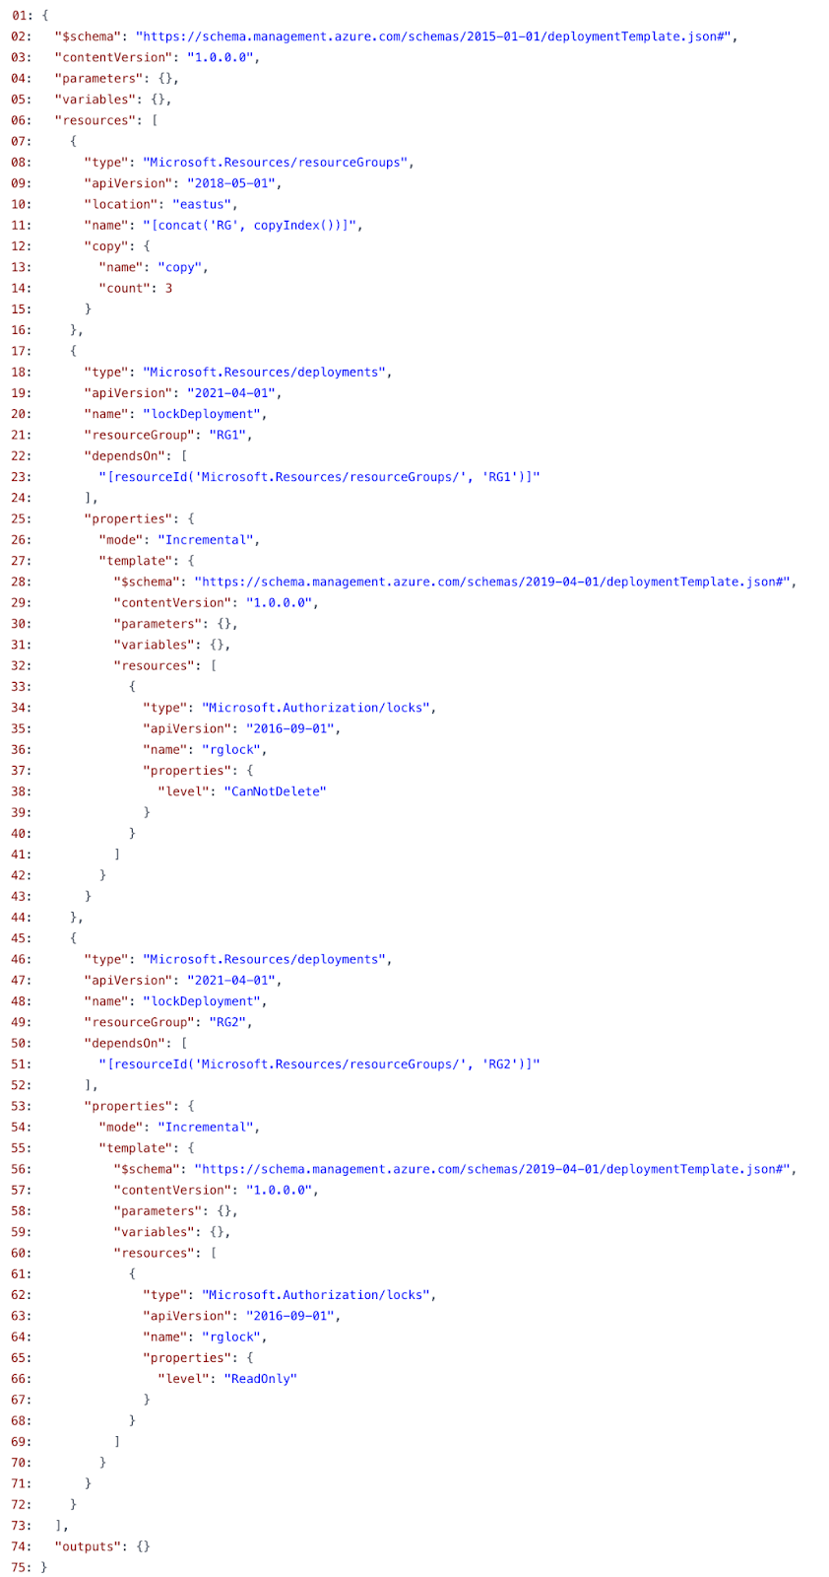
After connecting to the subscription, you run the New-AzDeployment cmdlet with the template file and a deployment location of West US as shown below:
`New-AzDeployment -Location westus -TemplateFile “deploy.json”`
Based on this deployment, determine whether the following statement is True or False:
`"You can deploy a virtual machine to RG1."`
Réponses:
☑ True
☐ False
Explication
`True` is the correct answer because the ARM template (`deploy.json`) uses a `copy` loop to create three resource groups (`RG0`, `RG1`, and `RG2`). After creating the resource groups, it deploys a `CanNotDelete` lock on `RG1` and a `ReadOnly` lock on `RG2`. A CanNotDelete lock only prevents deletion of the resource or resource group—it does not block updates or new resource deployments. Therefore, you can still deploy a virtual machine to RG1.
Reference(s):
- https://learn.microsoft.com/en-us/azure/azure-resource-manager/management/lock-resources
- https://learn.microsoft.com/en-us/azure/azure-resource-manager/templates/template-syntax#copy-loop-for-resources

Question 84
Your organization purchases a new Azure subscription and creates an ARM template file named deploy.json, as shown in the below exhibit. The template provisions multiple resource groups and applies management locks with different lock levels to specific resource groups by using nested deployments.
After connecting to the subscription, you run the New-AzDeployment cmdlet with the template file and a deployment location of West US as shown below:
`New-AzDeployment -Location westus -TemplateFile “deploy.json”`
Based on this deployment, determine whether the following statement is True or False:
`"You can deploy a virtual machine to RG2."`
Réponses:
☐ True
☑ False
Explication
`True` is the correct answer because the ARM template applies a ReadOnly lock to the resource group RG2. A ReadOnly lock prevents any write operations within the resource group, including creating, updating, or deleting resources. Therefore, you cannot deploy a virtual machine or any other resource to RG2 while the lock is in place.
Reference(s):
- https://learn.microsoft.com/en-us/azure/azure-resource-manager/management/lock-resources
- https://learn.microsoft.com/en-us/azure/azure-resource-manager/templates/template-syntax#copy-loop-for-resources

Question 85
Your organization purchases a new Azure subscription and creates an ARM template file named deploy.json, as shown in the below exhibit. The template provisions multiple resource groups and applies management locks with different lock levels to specific resource groups by using nested deployments.
After connecting to the subscription, you run the New-AzDeployment cmdlet with the template file and a deployment location of West US as shown below:
`New-AzDeployment -Location westus -TemplateFile “deploy.json”`
Based on this deployment, determine whether the following statement is True or False:
`"You can manually create a resource group named RG3."`
Réponses:
☑ True
☐ False
Explication
`True` is the correct answer because although the ARM template includes a `copy` loop to create three resource groups named `RG0`, `RG1`, and `RG2`, it does not restrict or block manual creation of additional resource groups outside of the template. Azure allows users to manually create new resource groups such as `RG3` using the portal, CLI, or PowerShell, provided there are no policy restrictions preventing it.
Reference(s):
- https://learn.microsoft.com/en-us/azure/azure-resource-manager/management/manage-resource-groups-portal
- https://learn.microsoft.com/en-us/azure/azure-resource-manager/templates/template-syntax#copy-loop-for-resources

Question 86
You are planning to automate the deployment of a virtual machine scale set that is based on the Windows Server Datacenter image.
As part of the deployment process, you must ensure that all virtual machines created in the scale set automatically have the required web server components installed at provisioning time.
Based on this requirement, determine which two actions you should perform.
Réponses (plusieurs réponses possibles)
☐ Create a new virtual machine scale set in the Azure portal.
☑ Upload a configuration script that installs the required web server components.
☑ Update the `extensionProfile` section of the Azure Resource Manager (ARM) template to run the configuration during provisioning.
☐ Create an Azure Policy to enforce the installation of web server components.
☐ Create an Azure Automation account to manage post-deployment configuration.
Explication
`Upload a configuration script that installs the required web server components` is correct because to automate the installation of web server components (e.g., IIS), you need a PowerShell or DSC (Desired State Configuration) script that defines those installation steps.
`Update the extensionProfile section of the Azure Resource Manager (ARM) template to run the configuration during provisioning` is correct because this section allows you to add VM extensions such as Custom Script Extension or DSC Extension, which execute your uploaded configuration script on each VM instance when the scale set is deployed.
`Create a new virtual machine scale set in the Azure portal` is incorrect for this purpose alone, as it doesn’t inherently ensure web server components are installed unless you use extensions or post-deployment scripts.
`Create an Azure Policy to enforce the installation of web server components` is incorrect because policies are used to enforce resource configurations or compliance—not to deploy software like a web server on VMs.
`Create an Azure Automation account to manage post-deployment configuration` is incorrect because Automation Accounts are used for orchestrating broader tasks like runbooks across Azure, not for provisioning software during VM creation in scale sets.
Reference(s):
- https://learn.microsoft.com/en-us/azure/virtual-machine-scale-sets/tutorial-install-apps-template
- https://learn.microsoft.com/en-us/azure/virtual-machines/extensions/custom-script-windows
- https://learn.microsoft.com/en-us/azure/virtual-machines/extensions/dsc-overview

Question 87
You have an Azure subscription that includes a storage account named storage1. The subscription is associated with a Microsoft Entra tenant named bluerock.com, which is synchronized with an on-premises Active Directory domain. This on-premises domain contains the following security principals:
- User1, which is a user account.
- Computer1, which is a computer account.
In Microsoft Entra tenant, you create a user named User2.
The storage1 account contains an Azure file share named share1 and is configured to use Active Directory–based authentication for Azure Files and has the following configurations.
"kind": "StorageV2",
"properties": {
"azureFilesIdentityBasedAuthentication": {
"directoryServiceOptions": "AD",
"activeDirectoryProperties": {
"domainName": "Bluerock.com",
"netBiosDomainName": "Bluerock.com",
"forestName": "Bluerock.com"
. . .
}
}
True or False:
`“You can assign the Storage File Data SMB Share Contributor role to User1 for Share1.”`
Réponses:
☑ True
☐ False
Explication
`True` is the correct answer because User1 is a user account that exists in the on-premises Active Directory, which is synced to Microsoft Entra ID (Azure AD). Since Azure Files supports identity-based authentication using AD DS, and the configuration shows that the storage account is using the "AD" directoryServiceOptions, you can assign Azure RBAC roles like Storage File Data SMB Share Contributor to an Entra ID user who originates from on-prem AD via synchronization.
This setup enables access control for SMB file shares through Entra ID roles, and User1 qualifies as a principal that can be assigned such roles.
Reference(s):
- https://learn.microsoft.com/en-us/azure/storage/files/storage-files-identity-assign-share-level-permissions?tabs=azure-portal
- https://learn.microsoft.com/en-us/azure/storage/files/storage-files-active-directory-overview
- https://learn.microsoft.com/en-us/azure/storage/files/storage-files-identity-auth-active-directory-enable
- https://learn.microsoft.com/en-us/azure/role-based-access-control/built-in-roles#storage-file-data-smb-share-contributor

Question 88
You have an Azure subscription that includes a storage account named storage1. The subscription is associated with a Microsoft Entra tenant named bluerock.com, which is synchronized with an on-premises Active Directory domain. This on-premises domain contains the following security principals:
- User1, which is a user account.
- Computer1, which is a computer account.
In Microsoft Entra tenant, you create a user named User2.
The storage1 account contains an Azure file share named share1 and is configured to use Active Directory–based authentication for Azure Files and has the following configurations.
"kind": "StorageV2",
"properties": {
"azureFilesIdentityBasedAuthentication": {
"directoryServiceOptions": "AD",
"activeDirectoryProperties": {
"domainName": "Bluerock.com",
"netBiosDomainName": "Bluerock.com",
"forestName": "Bluerock.com"
. . .
}
}
True or False:
`“You can assign the Storage File Data SMB Share Reader role to Computer1 for share1.”`
Réponses:
☐ True
☑ False
Explication
`False` is the correct answer because Computer1 is a computer account from the on-premises Active Directory. Azure role-based access control (Azure RBAC), including roles like Storage File Data SMB Share Reader, can only be assigned to users, groups, service principals, and managed identities in Microsoft Entra ID. Computer accounts are not valid principals for Azure RBAC role assignments.
While the storage account is configured for Active Directory authentication (`directoryServiceOptions: "AD"`), role assignments using Azure RBAC require an Entra ID identity, and Computer1, being a traditional AD computer object, is not eligible.
Reference(s):
- https://learn.microsoft.com/en-us/azure/storage/files/storage-files-identity-assign-share-level-permissions?tabs=azure-portal
- https://learn.microsoft.com/en-us/azure/role-based-access-control/overview
- https://learn.microsoft.com/en-us/azure/storage/files/storage-files-active-directory-overview
- https://learn.microsoft.com/en-us/azure/storage/files/storage-files-identity-auth-active-directory-enable

Question 89
You have an Azure subscription that includes a storage account named storage1. The subscription is associated with a Microsoft Entra tenant named bluerock.com, which is synchronized with an on-premises Active Directory domain. This on-premises domain contains the following security principals:
- User1, which is a user account.
- Computer1, which is a computer account.
In Microsoft Entra tenant, you create a user named User2.
The storage1 account contains an Azure file share named share1 and is configured to use Active Directory–based authentication for Azure Files and has the following configurations.
"kind": "StorageV2",
"properties": {
"azureFilesIdentityBasedAuthentication": {
"directoryServiceOptions": "AD",
"activeDirectoryProperties": {
"domainName": "Bluerock.com",
"netBiosDomainName": "Bluerock.com",
"forestName": "Bluerock.com"
. . .
}
}
True or False:
`"User2 can access share1 over SMB by using identity-based authentication after being assigned the Storage File Data SMB Share Elevated Contributor role."`
Réponses:
☐ True
☑ False
Explication
`False` is the correct answer because User2 is a cloud-only user created directly in Microsoft Entra ID and does not have a corresponding identity in the on-premises Active Directory Domain Services (AD DS) environment.
The storage account storage1 is configured to use on-premises AD DS for Azure Files identity-based authentication, as indicated by `"directoryServiceOptions": "AD"`. When using AD DS authentication with granular share-level Azure RBAC permissions, the corresponding identity must originate from the on-premises AD DS environment and be represented in Microsoft Entra ID.
User2 exists only in Microsoft Entra ID and therefore cannot authenticate to share1 by using the configured AD DS authentication. Assigning the Storage File Data SMB Share Elevated Contributor role does not change the authentication method or provide User2 with an on-premises AD DS identity.
Therefore, User2 cannot access share1 over SMB by using the configured identity-based authentication, even after the role is assigned.
Reference(s):
- https://learn.microsoft.com/en-us/azure/storage/files/storage-files-active-directory-overview
- https://learn.microsoft.com/en-us/azure/storage/files/storage-files-identity-ad-ds-overview
- https://learn.microsoft.com/en-us/azure/role-based-access-control/built-in-roles#storage-file-data-smb-share-elevated-contributor

Question 90
You are planning to create an Azure Storage account named storage1, which will host an Azure file share called share1. The file share must support SMB Multichannel, and the overall configuration should be chosen in a way that keeps costs as low as possible.
How should storage1 be configured to meet these requirements?
Réponses:
☐ Standard performance with locally-redundant storage (LRS)
☑ Premium performance with locally-redundant storage (LRS)
☐ Standard performance with zone-redundant storage (ZRS)
Explication
`Premium performance with locally redundant storage (LRS)` is correct because SMB Multichannel is only supported on Premium File Shares, which use SSD-based storage. These premium shares deliver high throughput and low latency required for parallel SMB connections. Using LRS keeps costs minimal while maintaining adequate redundancy within a single region.
`Standard performance with LRS` and `Standard performance with ZRS` are incorrect because SMB Multichannel is not available on Standard File Shares, regardless of redundancy type. These tiers are optimized for general file storage and lower-cost scenarios, but they lack the performance capabilities and protocol support needed for SMB Multichannel.
Reference(s):
- https://learn.microsoft.com/en-us/azure/storage/files/storage-files-smb-multichannel-performance

