AZ-104 - Practice Test 3
AZ-104 — Azure Administrator · 90 questions

Question 1
You have a Microsoft Entra tenant named apexcore.com.
There are two external partner organizations: ironclad.com and bluerock.com.
Only ironclad.com is configured as a connected organization in Microsoft Entra.
You create an access package as shown in the below exhibit.
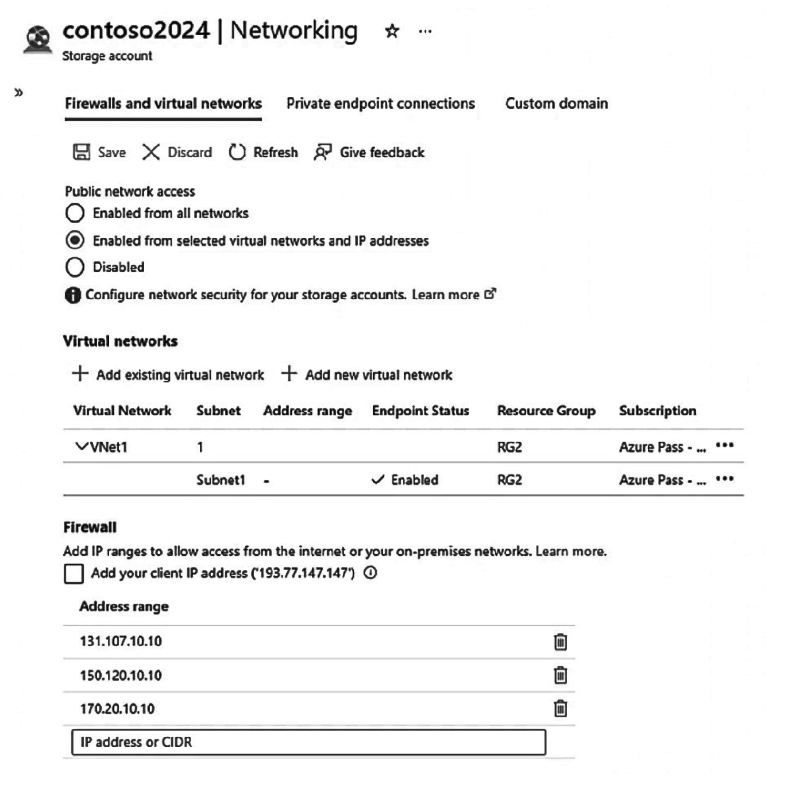
The external user lifecycle settings are configured so that when an external user loses their last access package assignment:
- The user is blocked from signing in.
- The user is removed from the directory after 30 days.
True or False:
`“Users from bluerock.com can be assigned to package1.”`
Réponses:
☐ True
☑ False
Explication
`False` is the correct answer here. The access package package1 is configured to allow access requests from "All configured connected organizations." Based on the information given, only ironclad.com is set up as a connected organization. Since bluerock.com is not configured as a connected organization, users from litwareinc.com are not eligible to be assigned to package1.
Reference(s):
- https://learn.microsoft.com/en-us/azure/active-directory/governance/entitlement-management-access-package-resources#add-a-group-or-team-resource-role
- https://learn.microsoft.com/en-us/azure/active-directory/governance/entitlement-management-external-users

Question 2
You have a Microsoft Entra tenant named apexcore.com.
There are two external partner organizations: ironclad.com and bluerock.com.
Only ironclad.com is configured as a connected organization in Microsoft Entra.
You create an access package as shown in the below exhibit.
The external user lifecycle settings are configured so that when an external user loses their last access package assignment:
- The user is blocked from signing in.
- The user is removed from the directory after 30 days.
True or False:
`“After the 365-day assignment period ends, users from ironclad.com will be removed from Group1.”`
Réponses:
☐ True
☑ False
Explication
`False` is the correct answer. When you assign `ironclad` users to Group1 through an access package, their assignment is set to expire after 365 days. At that point, the users’ access package assignment expires, which means:
- They lose access to Group1 and other resources tied to the package.
- Their membership in Group1 is revoked immediately at expiration.
However, this is not the same as being “removed” from the tenant. The external user lifecycle settings add another step:
- After the assignment expires, external users remain in the tenant directory for an additional 30 days.
- During that time, they cannot access Group1 because their assignment has expired, but their guest account still exists in the directory.
- Only after day 395 (365 + 30) are they actually removed from the directory, which finalizes their removal from all groups.
Reference(s):
- https://learn.microsoft.com/en-us/azure/active-directory/governance/entitlement-management-access-package-resources#add-a-group-or-team-resource-role
- https://learn.microsoft.com/en-us/azure/active-directory/governance/entitlement-management-external-users

Question 3
You have a Microsoft Entra tenant named apexcore.com.
There are two external partner organizations: ironclad.com and bluerock.com.
Only ironclad.com is configured as a connected organization in Microsoft Entra.
You create an access package as shown in the below exhibit.
The external user lifecycle settings are configured so that when an external user loses their last access package assignment:
- The user is blocked from signing in.
- The user is removed from the directory after 30 days.
True or False:
`“Once 395 days have passed, users from ironclad.com will be removed from the apexcore.com tenant.”`
Réponses:
☑ True
☐ False
Explication
`True` is correct because, according to the external user lifecycle settings, after a ironclad.com user loses their last assignment to an access package, they are set to be removed from the apexcore.com tenant after 30 days. Given that the access package assignment expires after 365 days, ironclad.com users will be removed from the apexcore.com tenant 30 days later, totaling 395 days from the start of their assignment.
Reference(s):
- https://learn.microsoft.com/en-us/azure/active-directory/governance/entitlement-management-access-package-resources#add-a-group-or-team-resource-role
- https://learn.microsoft.com/en-us/azure/active-directory/governance/entitlement-management-external-users

Question 4
You have an Azure subscription that includes a resource group named ResGrp1.
ResGrp1 is located in the West Europe region and is used to host temporary resources for a project.
The resource group contains the following resources:
- VM1 is a virtual machine deployed in the North Europe region.
- RGV1 is a Recovery Services vault located in North Europe.
- SQLDB01 is a SQL Server running on an Azure virtual machine in North Europe.
- sa001 is a storage account deployed in West Europe.
The virtual machine SQLDB01 is configured to be backed up to the Recovery Services vault RGV1.
After the project is completed, you attempt to delete ResGrp1 from the Azure portal, but the deletion operation fails.
You need to successfully remove ResGrp1.
What should you do first?
Réponses:
☐ Delete the VM1 virtual machine
☐ Delete the sa001 storage account
☑ Stop the backup of SQLDB01
☐ Stop the VM1 virtual machine
Explication
`Stop the backup of SQLDB01` is correct because the deletion of a resource group that contains a Recovery Services vault with active backup jobs or protected items will fail. In this scenario, SQLDB01 is backed up to RGV1, which means there are active backup items associated with it. To successfully delete ResGrp1, you first need to stop the backup for SQLDB01 and delete any protected items from the Recovery Services vault (RGV1). Once the backup is stopped and protected items are removed, ResGrp1 can be deleted.
`Delete the VM1 virtual machine` is incorrect because deleting VM1 would not impact the active backup configuration associated with SQLDB01 in RGV1. The deletion of the resource group fails due to the active backup in the Recovery Services vault, not because of the presence of VM1.
`Delete the sa001 storage account` is incorrect because deleting the storage account in a different region (West Europe) does not address the active backup in RGV1. The storage account (sa001) is unrelated to the backup process of SQLDB01 and does not prevent the deletion of the resource group.
`Stop the VM1 virtual machine` is incorrect because stopping the virtual machine does not affect the backup status in the Recovery Services vault. The issue lies with the active backup of SQLDB01, not with the state of VM1.
Reference(s):
- https://learn.microsoft.com/en-us/azure/backup/backup-azure-delete-vault

Question 5
You have an Azure subscription that includes two storage accounts named contoso101 and contoso102.
The subscription also contains two virtual machines with the following configurations:
- VM1 is connected to VNet1/Subnet1 and uses a Basic public IP address SKU.
- VM2 is connected to VNet1/Subnet2 and uses a Standard public IP address SKU.
Within VNet1, service endpoints are configured as follows:
- Microsoft.AzureActiveDirectory is enabled on Subnet2.
- Microsoft.Storage is enabled on Subnet1.
A service endpoint policy named Policy1 is created for the Microsoft.Storage service. The policy allows access only to the storage account contoso101. The policy is associated with subnets that have Microsoft.Storage service endpoints enabled.
True or False:
`“VM1 can access contoso102.”`
Réponses:
☐ True
☑ False
Explication
`False` is the correct answer here. According to the information provided, the service endpoint policy is configured to allow access only to the contoso101 storage account through the Microsoft.Storage service endpoint associated with Subnet1 in VNet1. Since VM1 is connected to Subnet1 and the policy only permits access to contoso101, VM1 cannot access contoso102 because it is not included in the endpoint policy.
Reference(s):
- https://learn.microsoft.com/en-us/azure/virtual-network/virtual-network-service-endpoints-overview
- https://learn.microsoft.com/en-us/azure/virtual-network/virtual-network-service-endpoint-policies?tabs=portal

Question 6
You have an Azure subscription that includes two storage accounts named contoso101 and contoso102.
The subscription also contains two virtual machines with the following configurations:
- VM1 is connected to VNet1/Subnet1 and uses a Basic public IP address SKU.
- VM2 is connected to VNet1/Subnet2 and uses a Standard public IP address SKU.
Within VNet1, service endpoints are configured as follows:
- Microsoft.AzureActiveDirectory is enabled on Subnet2.
- Microsoft.Storage is enabled on Subnet1.
A service endpoint policy named Policy1 is created for the Microsoft.Storage service. The policy allows access only to the storage account contoso101. The policy is associated with subnets that have Microsoft.Storage service endpoints enabled.
True or False:
`“VM2 can access contoso101.”`
Réponses:
☑ True
☐ False
Explication
`True` is the correct answer. Service endpoint policies are always scoped to the subnet where they are applied, meaning they only control traffic originating from that specific subnet. In this scenario, the Microsoft.Storage service endpoint and its associated policy are applied to Subnet1, which contains VM1. Subnet2, where VM2 resides, has only an Azure Active Directory service endpoint and no storage endpoint or policy applied. This means the policy on Subnet1 does not restrict VM2’s traffic. By default, subnets in the same virtual network can communicate freely unless explicit network security groups or custom routes block that communication, and no such restrictions are mentioned here.
Because the question also does not state that the storage account firewall is locked down to specific networks, we assume the default configuration of allowing traffic from all networks. Under these conditions, VM2 can still reach contoso101 using the storage account’s public endpoint, bypassing the need for a storage service endpoint or policy. The idea that Subnet1’s policy would block all other subnets even via public endpoints, is a common misconception; Microsoft’s documentation makes clear that service endpoint policies only affect traffic from the subnets to which they are applied. Therefore, the correct choice is that VM2 can indeed access contoso101.
Reference(s);
- https://learn.microsoft.com/en-us/azure/virtual-network/virtual-network-service-endpoint-policies?tabs=portal#restrict-network-access-to-azure-storage-accounts

Question 7
You have an Azure subscription that includes two storage accounts named contoso101 and contoso102.
The subscription also contains two virtual machines with the following configurations:
- VM1 is connected to VNet1/Subnet1 and uses a Basic public IP address SKU.
- VM2 is connected to VNet1/Subnet2 and uses a Standard public IP address SKU.
Within VNet1, service endpoints are configured as follows:
- Microsoft.AzureActiveDirectory is enabled on Subnet2.
- Microsoft.Storage is enabled on Subnet1.
A service endpoint policy named Policy1 is created for the Microsoft.Storage service. The policy allows access only to the storage account contoso101. The policy is associated with subnets that have Microsoft.Storage service endpoints enabled.
True or False:
`“VM2 uses a private IP address to access Microsoft Entra ID.”`
Réponses:
☐ True
☑ False
Explication
`False` is the correct answer here. While there is a service endpoint for Microsoft.AzureActiveDirectory on Subnet2, which VM2 is connected to, this does not mean that VM2 can use a private IP address to access Microsoft Entra ID. Microsoft Entra ID is a global service that is accessible only via public IP addresses. The service endpoint for Microsoft.AzureActiveDirectory allows secure access to Entra ID but does not provide connectivity via private IP addresses; it only restricts access to specific VNets and subnets to enhance security while still using public IPs for the actual connection.
Reference(s):
- https://learn.microsoft.com/en-us/entra/fundamentals/whatis

Question 8
You have an Azure subscription that contains the following resources:
- A virtual network named VNET1, which includes two subnets.
- subnet1 uses the IP address range 10.3.0.0/24.
- subnet2 uses the IP address range 10.4.0.0/24.
- A network security group named NSG1.
- A virtual machine named vm1 that has the private IP address 10.3.0.15 and is deployed in subnet1.
- A virtual machine named vm2 that has the private IP address 10.4.0.16 and is deployed in subnet2.
- A storage account named storage1.
The network security group NSG1 is configured with custom security rules as follows:
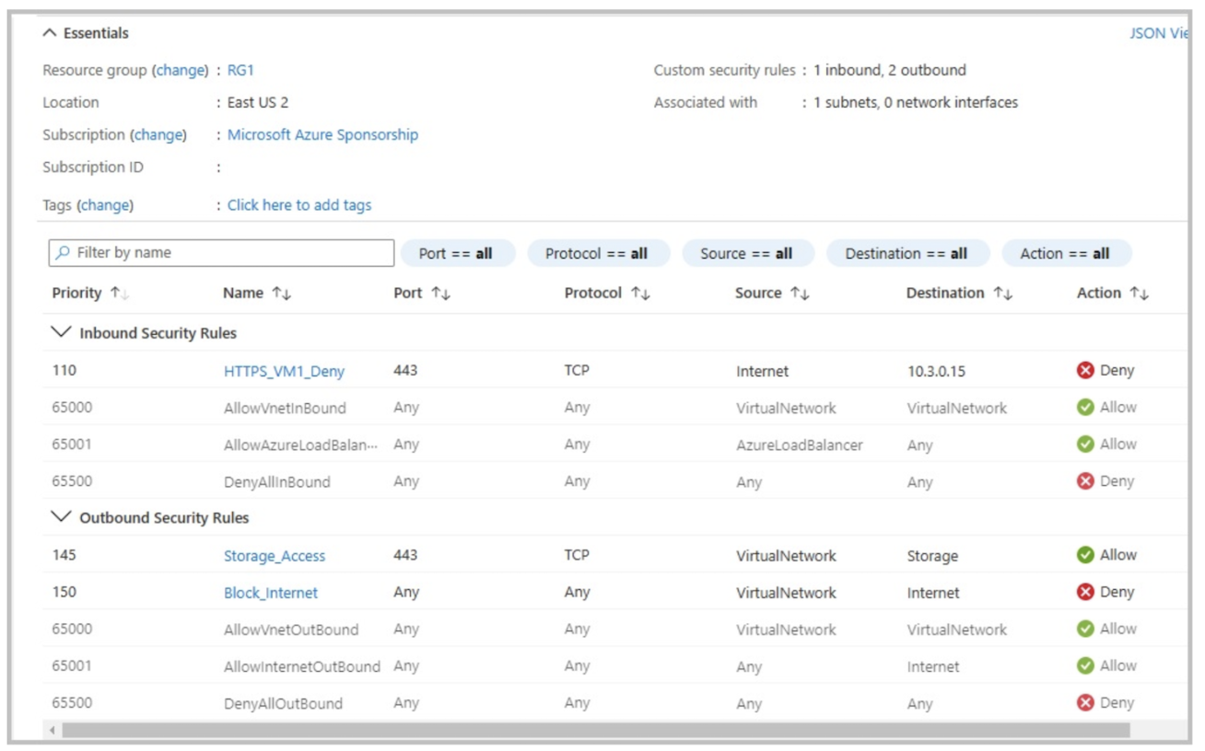
True or False:
`“VM1 can access storage1.”`
Réponses:
☑ True
☐ False
Explication
`True` is the correct answer here. NSG1 has an outbound security rule named Storage_Access configured to allow TCP traffic on port 443 from the virtual network to resources tagged as Storage. This rule enables VM1 to access storage1 on port 443. Additionally, there is no inbound restriction on the Storage endpoint, so VM1 can successfully connect to storage1 as required.
Reference(s):
- https://docs.microsoft.com/en-us/azure/virtual-network/network-security-groups-overview
- https://docs.microsoft.com/en-us/azure/virtual-network/service-tags-overview

Question 9
You have an Azure subscription that contains the following resources:
- A virtual network named VNET1, which includes two subnets.
- subnet1 uses the IP address range 10.3.0.0/24.
- subnet2 uses the IP address range 10.4.0.0/24.
- A network security group named NSG1.
- A virtual machine named vm1 that has the private IP address 10.3.0.15 and is deployed in subnet1.
- A virtual machine named vm2 that has the private IP address 10.4.0.16 and is deployed in subnet2.
- A storage account named storage1.
The network security group NSG1 is configured with custom security rules as follows:
True or False:
`“VM2 can access VM1 by using the HTTPS protocol.”`
Réponses:
☑ True
☐ False
Explication
`True` is the correct answer here. The HTTPS_VM1_Deny rule with priority 110 specifically blocks HTTPS (TCP port 443) traffic only from the Internet to VM1. Since VM2 is within the same virtual network (VNet1), the default VNet-to-VNet communication rule will allow HTTPS traffic between VM2 and VM1. Therefore, VM2 can access VM1 using the HTTPS protocol.
Reference(s):
- https://docs.microsoft.com/en-us/azure/virtual-network/network-security-groups-overview
- https://docs.microsoft.com/en-us/azure/virtual-network/service-tags-overview

Question 10
You have an Azure subscription that contains the following resources:
- A virtual network named VNET1, which includes two subnets.
- subnet1 uses the IP address range 10.3.0.0/24.
- subnet2 uses the IP address range 10.4.0.0/24.
- A network security group named NSG1.
- A virtual machine named vm1 that has the private IP address 10.3.0.15 and is deployed in subnet1.
- A virtual machine named vm2 that has the private IP address 10.4.0.16 and is deployed in subnet2.
- A storage account named storage1.
The network security group NSG1 is configured with custom security rules as follows:
True or False:
`“The NSG1 security rules apply to all virtual machines on VNET1.”`
Réponses:
☐ True
☑ False
Explication
`False` is the correct answer here. NSG1 is attached to a subnet, and by examining the inbound rule, the destination is specified as the private IP of VM1, indicating that NSG1 is likely connected to subnet1. Network Security Group (NSG) rules apply only to the resources within the scope to which the NSG is associated. Therefore, these rules will apply only to the virtual machines in subnet1 and not to all virtual machines on VNET1.
Reference(s):
- https://docs.microsoft.com/en-us/azure/virtual-network/network-security-groups-overview
- https://docs.microsoft.com/en-us/azure/virtual-network/service-tags-overview

Question 11
Note: This question is part of a series that uses the same overall scenario. Each question in the series proposes a different solution that may or may not satisfy the stated requirement.
You have an Azure subscription that contains the virtual machines shown in the following table.
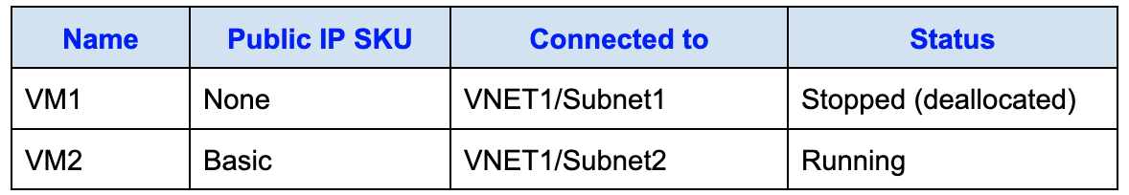
You deploy a load balancer with the following characteristics:
- The load balancer is named LB1.
- It is an internal load balancer.
- It uses the Standard SKU.
- It is deployed in VNET1.
You need to ensure that both VM1 and VM2 can be added to the backend pool of LB1.
Proposed solution: You create a Basic SKU public IP address, associate it with the network interface of VM1, and then start VM1.
Does this solution meet the requirement?
Réponses:
☐ Yes
☑ No
Explication
`No` is the correct answer here. For a Standard SKU load balancer, all virtual machines in the backend pool must be within the same region and connected to the same virtual network (VNET) as the load balancer itself. Additionally, they must either have a Standard SKU public IP address or no public IP address at all. In this scenario, associating a Basic SKU public IP address to VM1 does not meet the requirements for the Standard SKU load balancer. Therefore, this configuration does not allow VM1 and VM2 to be added to the backend pool of LB1.
Reference(s):
- https://learn.microsoft.com/en-us/azure/load-balancer/backend-pool-management#limitations

Question 12
Note: This question is part of a series that uses the same overall scenario. Each question in the series proposes a different solution that may or may not satisfy the stated requirement.
You have an Azure subscription that contains the virtual machines shown in the following table.
You deploy a load balancer with the following characteristics:
- The load balancer is named LB1.
- It is an internal load balancer.
- It uses the Standard SKU.
- It is deployed in VNET1.
You need to ensure that both VM1 and VM2 can be added to the backend pool of LB1.
Proposed solution: You create two public IP addresses using the Standard SKU, and you assign one Standard SKU public IP address to the network interface of each virtual machine.
Does this solution meet the requirement?
Réponses:
☑ Yes
☐ No
Explication
`Yes` is the correct answer here. The load balancer in question has a Standard SKU, which requires any associated virtual machines in the backend pool to either have no public IP or a Standard SKU public IP. In this scenario, by creating Standard SKU public IP addresses and associating them with VM1 and VM2, you meet the requirement for compatibility with the Standard SKU load balancer.
For Standard SKU load balancers, virtual machines added to the backend pool must be within the same virtual network and location. Moreover, it’s important that, if public IPs are present, they are also of the Standard SKU type to ensure compatibility with the Standard SKU load balancer.
Reference(s):
- https://learn.microsoft.com/en-us/azure/load-balancer/backend-pool-management#limitations

Question 13
Note: This question is part of a series that uses the same overall scenario. Each question in the series proposes a different solution that may or may not satisfy the stated requirement.
You have an Azure subscription that contains the virtual machines shown in the following table.
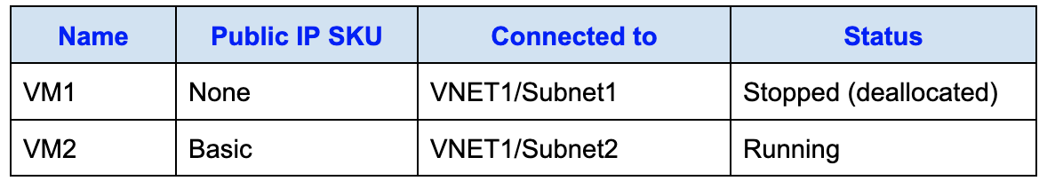
You deploy a load balancer with the following characteristics:
- The load balancer is named LB1.
- It is an internal load balancer.
- It uses the Standard SKU.
- It is deployed in VNET1.
You need to ensure that both VM1 and VM2 can be added to the backend pool of LB1.
Proposed solution: You remove the public IP address association from VM2’s network interface.
Does this solution meet the requirement?
Réponses:
☑ Yes
☐ No
Explication
`Yes` is the correct answer because a Standard Load Balancer can only attach virtual machines that:
- Are in the same location and same virtual network as the Load Balancer.
- Have either a Standard SKU public IP or no public IP.
In this scenario:
- VM1 has no public IP attached, which makes it eligible for the backend pool.
- VM2 has a Basic SKU public IP, which is not compatible with a Standard Load Balancer.
By removing the Basic SKU Public IP from VM2, the virtual machine aligns with the requirements of a Standard Load Balancer and can be added to the backend pool alongside VM1.
Reference(s):
- https://learn.microsoft.com/en-us/azure/load-balancer/load-balancer-standard-overview
- https://learn.microsoft.com/en-us/azure/virtual-network/ip-services/virtual-network-public-ip-addresses
- https://learn.microsoft.com/en-us/azure/load-balancer/quickstart-load-balancer-standard-internal-portal

Question 14
Note: This question is part of a series that uses the same overall scenario. Each question in the series proposes a different solution that may or may not satisfy the stated requirement.
You have an Azure subscription that contains the virtual machines shown in the following table.
You deploy a load balancer with the following characteristics:
- The load balancer is named LB1.
- It is an internal load balancer.
- It uses the Standard SKU.
- It is deployed in VNET1.
You need to ensure that both VM1 and VM2 can be added to the backend pool of LB1.
Proposed solution: You create a Standard SKU public IP address, attach it to VM1’s network interface, and then shut down VM2.
Does this solution meet the requirement?
Réponses:
☐ Yes
☑ No
Explication
`No` is the correct answer here. To add VM1 and VM2 to the backend pool of a Standard SKU internal load balancer, both virtual machines need to be configured to meet the requirements for a Standard SKU load balancer. Specifically, both VMs must have Standard SKU public IP addresses or no public IP at all. VM2 currently has a Basic SKU public IP, which is incompatible with the Standard SKU load balancer.
Reference(s):
- https://learn.microsoft.com/en-us/azure/load-balancer/backend-pool-management#limitations

Question 15
Note: This question is part of a series that uses the same overall scenario. Each question in the series proposes a different solution that may or may not satisfy the stated requirement.
You have an Azure subscription that contains 10 virtual networks, each deployed in its own resource group.
Another administrator intends to create multiple network security groups (NSGs) within the subscription.
You must ensure that every newly created NSG automatically blocks TCP traffic on port 8080 between the virtual networks.
Proposed solution: Assign a built-in Azure Policy definition at the subscription scope.
Does this solution satisfy the requirement?
Réponses:
☐ Yes
☑ No
Explication
`No` is the correct answer here. To meet the specific requirement of automatically blocking TCP port 8080 between virtual networks when an NSG is created, you would need to create a custom Azure policy. Built-in policies provided by Microsoft focus on general compliance and best practices and do not cover specific, custom configurations such as blocking a specific port across all new NSGs. Creating a custom policy allows you to define specific actions, such as blocking or allowing certain ports, tailored to your Azure environment's unique needs.
Reference(s):
- https://docs.microsoft.com/en-us/azure/azure-policy/policy-definition
- https://learn.microsoft.com/en-us/azure/governance/policy/tutorials/create-custom-policy-definition

Question 16
Note: This question is part of a series that uses the same overall scenario. Each question in the series proposes a different solution that may or may not satisfy the stated requirement.
You have an Azure subscription that contains 10 virtual networks, each deployed in its own resource group.
Another administrator intends to create multiple network security groups (NSGs) within the subscription.
You must ensure that every newly created NSG automatically blocks TCP traffic on port 8080 between the virtual networks.
Proposed solution: You create a custom Azure Policy definition and assign it at the subscription level.
Does this solution satisfy the requirement?
Réponses:
☑ Yes
☐ No
Explication
`Yes` is the correct answer here. By configuring a custom policy definition and assigning it to the subscription, you can enforce specific rules on NSGs, such as automatically blocking TCP port 8080 between virtual networks. Custom policies allow you to specify detailed compliance requirements and enforce specific configurations, which in this case include blocking a particular port across newly created NSGs within the subscription.
Reference(s):
- https://docs.microsoft.com/en-us/azure/governance/policy/concepts/definition-structure

Question 17
Note: This question is part of a series that uses the same overall scenario. Each question in the series proposes a different solution that may or may not satisfy the stated requirement.
You have an Azure subscription that contains 10 virtual networks, each deployed in its own resource group.
Another administrator intends to create multiple network security groups (NSGs) within the subscription.
You must ensure that every newly created NSG automatically blocks TCP traffic on port 8080 between the virtual networks.
Proposed solution: You go to the Resource providers blade and unregister the Microsoft.ClassicNetwork provider.
Does this solution satisfy the requirement?
Réponses:
☐ Yes
☑ No
Explication
`No` is the correct answer here. Unregistering the Microsoft.ClassicNetwork provider has no effect on network security groups (NSGs) created in the Azure Resource Manager (ARM) model, as it is associated with the classic deployment model in Azure. The requirement here is to automatically block TCP port 8080 between virtual networks in the ARM model, which cannot be achieved by unregistering a provider. Instead, you would need to implement a custom policy or directly configure NSG rules.
Reference(s):
- https://learn.microsoft.com/en-us/azure/azure-resource-manager/templates/overview

Question 18
Note: This question is part of a series that uses the same overall scenario. Each question in the series proposes a different solution that may or may not satisfy the stated requirement.
You have an Azure subscription that contains 10 virtual networks, each deployed in its own resource group.
Another administrator intends to create multiple network security groups (NSGs) within the subscription.
You must ensure that every newly created NSG automatically blocks TCP traffic on port 8080 between the virtual networks.
Proposed solution: You create a resource lock and apply it at the subscription scope.
Does this solution satisfy the requirement?
Réponses:
☐ Yes
☑ No
Explication
`No` is the correct answer here. A resource lock is used to prevent accidental deletion or modification of Azure resources, but it does not enforce security rules or configurations, such as network access control. Resource locks are intended to protect resources from changes, not to configure their behavior.
To meet the stated goal of automatically blocking TCP port 8080 between virtual networks whenever a network security group (NSG) is created, you should use Azure Policy. You can create a policy definition that audits or enforces the presence of specific inbound or outbound security rules (such as blocking port 8080) in NSGs and assign that policy at the subscription level.
Reference(s.):
- https://learn.microsoft.com/en-us/azure/azure-resource-manager/management/lock-resources
- https://learn.microsoft.com/en-us/azure/governance/policy/overview

Question 19
You have an Azure subscription with the following resources in the same resource group (RG1):
- Vault1: A Recovery Services vault located in the East US region
- VM1: A virtual machine running Windows Server in the East US region
- VM2: A virtual machine running Windows Server in the West US region
On VM1, you configure Azure Backup to protect a folder named Folder1 using a scheduled file-and-folder backup policy. The backup schedule is configured as follows:
- Backup frequency: Daily
- Backup times: 6:00 AM and 10:00 PM
You plan to restore this backup to a different virtual machine and want the data to be recovered on VM2.
What is the first action you must take?
Réponses:
☐ On VM2, install the Windows Server Backup feature.
☐ On VM1, install the Microsoft Azure Recovery Services Agent.
☐ On VM1, install the Windows Server Backup feature.
☑ On VM2, install the Microsoft Azure Recovery Services Agent.
Explication
`On VM2, install the Microsoft Azure Recovery Services Agent` is correct because in order to restore a backup from the Recovery Services vault to a different virtual machine (in this case, VM2), you need to have the Microsoft Azure Recovery Services (MARS) Agent installed on the destination VM. This agent enables the VM to communicate with the Recovery Services vault, allowing it to access and restore backups stored in Azure.
`On VM2, install the Windows Server Backup feature` is incorrect because the Windows Server Backup feature alone does not provide the necessary integration with Azure Recovery Services. The MARS Agent is required to retrieve backups from Azure.
`On VM1, install the Microsoft Azure Recovery Services Agent` is incorrect as the MARS Agent is already installed on VM1 to perform the initial backup. The task here is to restore the backup to VM2.
`On VM1, install the Windows Server Backup feature` is incorrect because this feature does not assist in restoring a backup to another VM. The backup is already configured on VM1, and the requirement is to restore it to VM2, which requires the MARS Agent on VM2.
Reference(s):
- https://learn.microsoft.com/en-us/azure/backup/backup-azure-restore-windows-server

Question 20
You have an Azure subscription named Subscription1 that is shared across multiple departments. The subscription currently includes the following resources:
- storage1 - Azure Storage account
- RG1 - Resource group
- container1 - Blob container
- share1 - Azure file share
Another administrator deploys two new resources, a virtual machine named VM1 and a storage account named storage2, by using a single Azure Resource Manager (ARM) template.
You want to review the ARM template that was used for this deployment.
From which Azure portal blade can you view the template associated with the deployment?
Réponses:
☐ container1
☑ RG1
☐ storage1
☐ VM1
Explication
`RG1` is correct because to view the Azure Resource Manager (ARM) template used for a deployment, you need to access the Resource Group (in this case, `RG1`) where the deployment was made. The Resource Group blade in the Azure portal includes an option to view the deployment history and allows you to access the templates used in those deployments.
`container1` is incorrect because a Blob container does not have deployment information or templates associated with it directly. It is a storage object within a storage account and lacks deployment-level insights.
`storage1` is incorrect as it is the storage account itself, and the ARM template used for deployments would not be accessible from the storage account blade. Templates are accessible through the Resource Group level.
`VM1` is incorrect because while you can see configuration and settings specific to `VM1`, the VM blade does not provide access to the ARM template used in the original deployment. The Resource Group blade is needed for viewing deployment templates.
Reference(s):
- https://learn.microsoft.com/en-us/azure/azure-resource-manager/templates/deployment-history

Question 21
You have a public load balancer that distributes traffic on ports 80 and 443 across three virtual machines named VM1, VM2, and VM3.
You want all Remote Desktop Protocol (RDP) connections to be routed exclusively to VM3.
What configuration should you apply?
Réponses:
☐ Create a separate public load balancer dedicated to VM3
☐ Configure an additional frontend IP configuration
☑ Configure an inbound NAT rule
☐ Configure a load balancing rule
Explication
`Configure an inbound NAT rule` is correct because an inbound NAT rule allows you to direct specific traffic, such as RDP, to a particular virtual machine (VM3 in this case) behind the load balancer. By setting up an inbound NAT rule for port 3389 (RDP), you ensure that all RDP connections go directly to VM3 instead of balancing across all VMs.
`Create a separate public load balancer dedicated to VM3` is incorrect because creating a separate load balancer is unnecessary for directing RDP connections to VM3. An inbound NAT rule is sufficient to achieve this without additional load balancers.
`Configure an additional frontend IP configuration` is incorrect as a frontend IP configuration is used to define the IP address on which the load balancer is accessible. It does not control how RDP traffic is directed to specific VMs.
`Configure a load balancing rule` is incorrect because load balancing rules are intended for distributing traffic across multiple VMs based on specific ports, which is not the goal here. The objective is to direct all RDP traffic to VM3 specifically, not balance it across VMs.
Reference(s):
- https://learn.microsoft.com/en-us/azure/load-balancer/tutorial-load-balancer-port-forwarding-portal

Question 22
You have an Azure subscription that includes several virtual networks deployed across different regions and resource groups.
The virtual networks are configured as follows:
- VNET1 is deployed in the West US region and belongs to resource group RG1.
- VNET2 is deployed in the Central US region and belongs to resource group RG1.
- VNET3 is deployed in the Central US region and belongs to resource group RG2.
- VNET4 is deployed in the West US region and belongs to resource group RG2.
You plan to deploy an Azure Firewall named AF1 in resource group RG1, located in the West US region.
Which virtual networks are valid targets for deploying AF1?
Réponses:
☑ VNET1 only
☐ VNET1 and VNET2 only
☐ VNET1 and VNET4 only
☐ VNET1, VNET2, and VNET4 only
☐ VNET1, VNET2, VNET3, and VNET4
Explication
`VNET1 only` is correct because Azure Firewall can connect to a virtual network within the same region and resource group. In this scenario, AF1 is deployed in RG1 in the West US region. While VNET4 is also in the West US region, it is in a different resource group (RG2), which prevents AF1 from connecting to it. Therefore, VNET1 is the only virtual network eligible for connection to AF1.
Reference(s):
- https://learn.microsoft.com/en-us/azure/firewall/firewall-faq#are-there-any-firewall-resource-group-restrictions

Question 23
You have an Azure subscription that includes the following resources:
- VM1 - a virtual machine
- App1 - an Azure web app
- apexcore.com, which is a Microsoft Entra Domain Services domain
All of these resources are connected to the same virtual network, VNet1.
You plan to deploy an Azure Bastion host named Bastion1 into VNet1.
Which of these resources can be secured by using Bastion1?
Réponses:
☑ VM1 only
☐ apexcore.com only
☐ App1 and apexcore.com only
☐ VM1 and apexcore.com only
☐ VM1, App1, and apexcore.com
Explication
`VM1 only` is correct because Azure Bastion is designed to provide secure and seamless RDP and SSH connectivity to virtual machines within a virtual network. In this scenario, VM1 is the only virtual machine listed in the table, and thus the only resource that can be accessed and protected via Bastion1. Azure Bastion does not support direct connectivity to web apps (such as App1) or to Microsoft Entra Domain Services domains (like apexcore.com).
Reference(s):
- https://learn.microsoft.com/en-us/azure/bastion/bastion-overview

Question 24
You have a Microsoft Entra tenant that is linked to the Azure subscriptions shown in the following table.
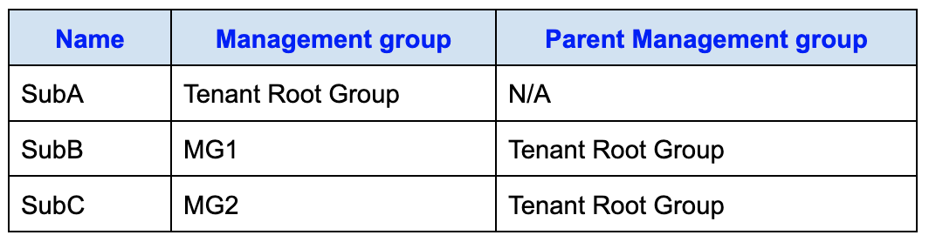
Within these subscriptions, the following resource groups exist:
- RG1 is in SubA and contains a storage account named storage1.
- RG2 is in SubB and contains a web app named App1.
- RG3 is in SubC and contains a virtual machine named VM1.
Role assignments are configured as follows:
- User1 is assigned the Contributor role at the MG2 management group scope.
- User2 is assigned the Storage Account Contributor role scoped specifically to storage1.
- User3 is assigned the User Access Administrator role at the Tenant Root Group scope.
True or False:
`"User1 can resize VM1."`
Réponses:
☑ True
☐ False
Explication
`True` is correct because User1 has the Contributor role assigned at the scope of MG2. Since MG2 is the management group that contains the subscription SubC, which in turn contains the resource group RG3 (where VM1 is located), User1 has Contributor permissions on VM1. The Contributor role provides permissions to manage resources, including resizing virtual machines.
Reference(s):
- https://learn.microsoft.com/en-us/azure/role-based-access-control/built-in-roles

Question 25
You have a Microsoft Entra tenant that is linked to the Azure subscriptions shown in the following table.
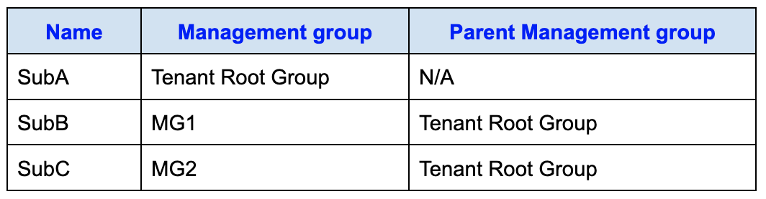
Within these subscriptions, the following resource groups exist:
- RG1 is in SubA and contains a storage account named storage1.
- RG2 is in SubB and contains a web app named App1.
- RG3 is in SubC and contains a virtual machine named VM1.
Role assignments are configured as follows:
- User1 is assigned the Contributor role at the MG2 management group scope.
- User2 is assigned the Storage Account Contributor role scoped specifically to storage1.
- User3 is assigned the User Access Administrator role at the Tenant Root Group scope.
True or False:
`"User2 can create a new storage account in RG1."`
Réponses:
☐ True
☑ False
Explication
`False` is correct because User2’s Storage Account Contributor role is assigned only at the scope of the existing storage account (storage1). Although this role includes permissions to create storage accounts when assigned at the resource group or subscription level, permissions granted at an individual resource scope do not allow the creation of new sibling resources. Since User2 has no role assignment at the RG1 or subscription scope, they cannot create a new storage account in RG1.
Reference(s):
- https://learn.microsoft.com/en-us/azure/role-based-access-control/built-in-roles

Question 26
You have a Microsoft Entra tenant that is linked to the Azure subscriptions shown in the following table.
Within these subscriptions, the following resource groups exist:
- RG1 is in SubA and contains a storage account named storage1.
- RG2 is in SubB and contains a web app named App1.
- RG3 is in SubC and contains a virtual machine named VM1.
Role assignments are configured as follows:
- User1 is assigned the Contributor role at the MG2 management group scope.
- User2 is assigned the Storage Account Contributor role scoped specifically to storage1.
- User3 is assigned the User Access Administrator role at the Tenant Root Group scope.
True or False:
`"User3 can assign User1 the Owner role for RG3."`
Réponses:
☑ True
☐ False
Explication
`True` is correct because User3 has the User Access Administrator role assigned at the scope of the Tenant Root Group. This role grants User3 permission to manage user access to Azure resources at or below the assigned scope. Since the Tenant Root Group is the highest level in the hierarchy, User3 has permission to assign roles, including the Owner role, to any resource within the tenant, including RG3.
Reference(s):
- https://learn.microsoft.com/en-us/azure/role-based-access-control/built-in-roles

Question 27
You have a Microsoft Entra tenant named apexcore.onmicrosoft.com that contains the following users:
- User1 is a member of Group1 and has no directory role assigned.
- User2 is a member of Group2 and has no directory role assigned.
- User3 is a member of Group1 and Group2, and is assigned the User Administrator role.
You enable password reset for apexcore.onmicrosoft.com as below:
- SSPR is enabled for Selected users only.
- The selected group is Group2.
Authentication method settings for password reset are configured with these options:
- Number of methods required to reset: 2
- Enabled methods:
- Mobile phone
- Security questions
- The following methods are not enabled:
- Mobile app notification
- Mobile app code
- Email
- Office phone
- Number of security questions required to register: 5
- Number of security questions required to reset: 3
- A total of 10 security questions are available.
True or False:
`"After User2 answers three security questions correctly, he can reset his password immediately."`
Réponses:
☐ True
☑ False
Explication
`False` is correct because, based on the password reset settings, two methods are required for a successful password reset. Although User2 can use security questions as one of the authentication methods, they would still need to provide a second method (such as a mobile phone verification) to reset their password. Answering only three security questions alone is insufficient as per the configured policy, which mandates two authentication methods.
Reference(s):
- https://learn.microsoft.com/en-us/entra/identity/authentication/tutorial-enable-sspr
- https://learn.microsoft.com/en-us/entra/identity/authentication/passwords-faq

Question 28
You have a Microsoft Entra tenant named apexcore.onmicrosoft.com that contains the following users:
- User1 is a member of Group1 and has no directory role assigned.
- User2 is a member of Group2 and has no directory role assigned.
- User3 is a member of Group1 and Group2, and is assigned the User Administrator role.
You enable password reset for apexcore.onmicrosoft.com as below:
- SSPR is enabled for Selected users only.
- The selected group is Group2.
Authentication method settings for password reset are configured with these options:
- Number of methods required to reset: 2
- Enabled methods:
- Mobile phone
- Security questions
- The following methods are not enabled:
- Mobile app notification
- Mobile app code
- Email
- Office phone
- Number of security questions required to register: 5
- Number of security questions required to reset: 3
- A total of 10 security questions are available.
True or False:
`"If User1 forgets her password, she can reset the password by using the mobile phone app."`
Réponses:
☐ True
☑ False
Explication
`False` is correct because User1 is a member of Group1, and self-service password reset (SSPR) has been enabled only for Group2. Since User1 is not part of Group2, she does not have access to the self-service password reset feature, regardless of the authentication methods configured.
Reference(s):
- https://learn.microsoft.com/en-us/entra/identity/authentication/tutorial-enable-sspr
- https://learn.microsoft.com/en-us/entra/identity/authentication/passwords-faq

Question 29
You have a Microsoft Entra tenant named apexcore.onmicrosoft.com that contains the following users:
- User1 is a member of Group1 and has no directory role assigned.
- User2 is a member of Group2 and has no directory role assigned.
- User3 is a member of Group1 and Group2, and is assigned the User Administrator role.
You enable password reset for apexcore.onmicrosoft.com as below:
- SSPR is enabled for Selected users only.
- The selected group is Group2.
Authentication method settings for password reset are configured with these options:
- Number of methods required to reset: 2
- Enabled methods:
- Mobile phone
- Security questions
- The following methods are not enabled:
- Mobile app notification
- Mobile app code
- Email
- Office phone
- Number of security questions required to register: 5
- Number of security questions required to reset: 3
- A total of 10 security questions are available.
True or False:
`"User3 can add security questions to the password reset process."`
Réponses:
☐ True
☑ False
Explication
`False` is correct because although User3 has the User Administrator role, this role does not include permissions to modify the security questions configured for self-service password reset (SSPR). Only users with the Global Administrator or Authentication Administrator roles have the necessary permissions to modify security questions in the SSPR settings.
Reference(s):
- https://docs.microsoft.com/en-us/azure/active-directory/authentication/quickstart-sspr
- https://docs.microsoft.com/en-us/azure/active-directory/authentication/active-directory-passwords-faq
- https://docs.microsoft.com/en-us/azure/active-directory/authentication/concept-sspr-policy
- https://docs.microsoft.com/en-us/azure/active-directory/authentication/tutorial-enable-sspr
- https://docs.microsoft.com/en-us/azure/active-directory/authentication/howto-sspr-authenticationdata
- https://docs.microsoft.com/en-us/azure/active-directory/roles/permissions-reference#user-administrator

Question 30
You manage a Microsoft Entra tenant that contains approximately 7,000 user accounts.
You create a new user named AdminUsr1.
You must assign the User Administrator administrative role to AdminUsr1.
Which action should you take from the user account properties to complete this task?
Réponses:
☐ From the Licenses blade, assign a new license.
☐ From the Groups blade, invite the user account to a new group.
☑ From the Directory role blade, modify the directory role.
Explication
`From the Directory role blade, modify the directory role` is correct because to assign an administrative role, such as the User Administrator role, to AdminUsr1, you need to navigate to the Directory role blade in the user account properties. From there, you can modify the directory role and assign the appropriate administrative role.
`From the Licenses blade, assign a new license` is incorrect because assigning a license is unrelated to assigning an administrative role. Licenses are used for service access, not role-based access control.
`From the Groups blade, invite the user account to a new group` is incorrect because adding the user to a group does not assign the User Administrator role. Role assignments are handled through the Directory role settings.
Reference(s):
- https://learn.microsoft.com/en-us/entra/fundamentals/how-subscriptions-associated-directory

Question 31
You have the following Azure resources:
- Tenant Root Group - tenant root management group
- MG1 - management group
- Sub1 - subscription
- RG1 - resource group
- VM1 - virtual machine
You want to monitor resource usage and ensure that resources cannot be accidentally deleted.
To which resources can you apply locks?
Réponses:
☐ RG1 and VM1 only
☐ Sub1 and RG1 only
☑ Sub1, RG1, and VM1 only
☐ MG1, Sub1, RG1, and VM1 only
☐ Tenant Root Group, MG1, Sub1, RG1, and VM1
Explication
`Sub1, RG1, and VM1 only` is correct because locks can be applied at the subscription, resource group, and resource (such as a virtual machine) levels to prevent accidental deletion or modification. In this case, Sub1 (the subscription), RG1 (the resource group), and VM1 (the virtual machine) are valid targets for applying locks to track usage and prevent deletion.
`RG1 and VM1 only` is incorrect because locks can also be applied at the subscription level (Sub1), not just at the resource group and resource levels.
`Sub1 and RG1 only` is incorrect because locks can also be applied directly to resources like VM1.
`MG1, Sub1, RG1, and VM1 only` is incorrect because locks cannot be applied to management groups (MG1).
`Tenant Root Group, MG1, Sub1, RG1, and VM1` is incorrect because locks cannot be applied to the Tenant Root Group or management groups.
Reference(s):
- https://learn.microsoft.com/en-us/azure/azure-resource-manager/management/lock-resources?tabs=json

Question 32
You have the following Azure resources:
- Tenant Root Group - tenant root management group
- MG1 - management group
- Sub1 - subscription
- RG1 - resource group
- VM1 - virtual machine
You want to monitor resource usage and ensure that resources cannot be accidentally deleted.
To which resources can you apply tags?
Réponses:
☐ RG1 and VM1 only
☐ Sub1 and RG1 only
☑ Sub1, RG1, and VM1 only
☐ MG1, Sub1, RG1, and VM1 only
☐ Tenant Root Group, MG1, Sub1, RG1, and VM1
Explication
`Sub1, RG1, and VM1 only` is correct because tags can be applied to subscriptions (Sub1), resource groups (RG1), and resources (such as VM1) in Azure. Tags cannot be applied to management groups (MG1) or the Tenant Root Group.
Reference(s):
- https://learn.microsoft.com/en-us/azure/azure-resource-manager/management/tag-resources?tabs=json

Question 33
You are provided with a JSON file that lists several Azure role assignments at different scopes as shown below.
[
{
"RoleAssignmentId": "f1a9c2d4-8b35-4e71-9c2a-6d5e7f8a9012",
"Scope": "/subscriptions/9b2d7f41-6c8e-4a55-b1d9-3e7f2a6c4b10",
"DisplayName": "User1",
"SignInName": "User1@apexcore.onmicrosoft.com",
"RoleDefinitionName": "Owner"
},
{
"RoleAssignmentId": "a7c4e1b2-5d93-4f60-8a1e-2b6c9d7f3e44",
"Scope": "/subscriptions/9b2d7f41-6c8e-4a55-b1d9-3e7f2a6c4b10/resourceGroups/RG2",
"DisplayName": "User2",
"SignInName": "User2@apexcore.onmicrosoft.com",
"RoleDefinitionName": "Owner"
},
{
"RoleAssignmentId": "d3e8f7a1-2c44-4b9e-91fa-5c6d8e2b7a33",
"Scope": "/subscriptions/9b2d7f41-6c8e-4a55-b1d9-3e7f2a6c4b10/resourceGroups/RG1/providers/Microsoft.Compute/virtualMachines/VM1",
"DisplayName": "User3",
"SignInName": "User3@apexcore.onmicrosoft.com",
"RoleDefinitionName": "Owner"
},
{
"RoleAssignmentId": "b6d2a9f8-1e73-4c55-8b0d-9f2e6a4c7d88",
"Scope": "/subscriptions/9b2d7f41-6c8e-4a55-b1d9-3e7f2a6c4b10/resourceGroups/RG1",
"DisplayName": "User4",
"SignInName": "User4@apexcore.onmicrosoft.com",
"RoleDefinitionName": "Contributor"
}
]
Using the details in the role assignment file, choose the option that correctly completes the following statement:
“____________________________ assigned the Owner role for VM1.”
Réponses:
☐ User3 is
☐ User3 and User4 are
☑ User1 and User3 are
☐ User1, User3, and User4 are
☐ User1, User2, User3, and User4 are
Explication
`User1 and User3 are` is correct because in the provided role assignment file, User3 is specifically assigned the Owner role at the scope of VM1 (/subscriptions/.../resourceGroups/RG1/providers/Microsoft.Compute/virtualMachines/VM1).
And User1 is the owner of the subscription, which inherently makes it the owner of VM inside that subscription as well.
Reference(s):
- https://learn.microsoft.com/en-us/azure/role-based-access-control/built-in-roles
- https://learn.microsoft.com/en-us/azure/role-based-access-control/rbac-and-directory-admin-roles

Question 34
You are provided with a JSON file that lists several Azure role assignments at different scopes as shown below.
[
{
"RoleAssignmentId": "f1a9c2d4-8b35-4e71-9c2a-6d5e7f8a9012",
"Scope": "/subscriptions/9b2d7f41-6c8e-4a55-b1d9-3e7f2a6c4b10",
"DisplayName": "User1",
"SignInName": "User1@apexcore.onmicrosoft.com",
"RoleDefinitionName": "Owner"
},
{
"RoleAssignmentId": "a7c4e1b2-5d93-4f60-8a1e-2b6c9d7f3e44",
"Scope": "/subscriptions/9b2d7f41-6c8e-4a55-b1d9-3e7f2a6c4b10/resourceGroups/RG2",
"DisplayName": "User2",
"SignInName": "User2@apexcore.onmicrosoft.com",
"RoleDefinitionName": "Owner"
},
{
"RoleAssignmentId": "d3e8f7a1-2c44-4b9e-91fa-5c6d8e2b7a33",
"Scope": "/subscriptions/9b2d7f41-6c8e-4a55-b1d9-3e7f2a6c4b10/resourceGroups/RG1/providers/Microsoft.Compute/virtualMachines/VM1",
"DisplayName": "User3",
"SignInName": "User3@apexcore.onmicrosoft.com",
"RoleDefinitionName": "Owner"
},
{
"RoleAssignmentId": "b6d2a9f8-1e73-4c55-8b0d-9f2e6a4c7d88",
"Scope": "/subscriptions/9b2d7f41-6c8e-4a55-b1d9-3e7f2a6c4b10/resourceGroups/RG1",
"DisplayName": "User4",
"SignInName": "User4@apexcore.onmicrosoft.com",
"RoleDefinitionName": "Contributor"
}
]
Using the details in the role assignment file, choose the option that correctly completes the following statement:
“____________________________ can create a virtual machine in RG1.”
Réponses:
☑ User1 and User4
☐ User1, User2, and User3
☐ User1, User2, and User4
☐ User1, User3, and User4
☐ User1, User2, User3, and User4
Explication
`User1 and User4` is correct because creating a virtual machine in RG1 requires permissions at the RG1 level or higher within the subscription.
- User1 has the Owner role at the subscription level, which grants full access to manage resources within the entire subscription, including RG1.
- User4 has the Contributor role specifically on RG1, which allows them to manage resources within RG1, including creating and deleting virtual machines. However, as a Contributor, User4 cannot modify Role-Based Access Control (RBAC) settings.
User2 is incorrect because their Owner role is limited to RG2, and they do not have permissions in RG1.
User3 is incorrect because their Owner role applies only to VM1, so they do not have permissions to create new resources in RG1.
Reference(s):
- https://learn.microsoft.com/en-us/azure/role-based-access-control/built-in-roles
- https://learn.microsoft.com/en-us/azure/role-based-access-control/rbac-and-directory-admin-roles

Question 35
You have a Microsoft Entra tenant named bluerock.com that includes the following group hierarchy:
- Group1 is not a member of any other group.
- Group2 is a member of Group1.
- Group3 is a member of Group2.
The tenant also contains the following users and their group memberships:
- User1 is a member of Group1.
- User2 is a member of Group2.
- User3 is a member of Group3.
- User4 is not a member of any group.
You assign the Microsoft Entra ID P2 license directly to Group1 and also directly to User4.
Which users receive the Microsoft Entra ID P2 license as a result of this configuration?
Réponses:
☐ User4 only
☑ User1 and User4 only
☐ User1, User2, and User4 only
☐ User1, User2, User3, and User4
Explication
`User1 and User4 only` is correct because group-based licensing in Microsoft Entra ID does not support nested groups. When a license is assigned to Group1, only the direct members of Group1 receive the license. This means User1 (direct member of Group1) and User4 (who received the license directly) are the only users assigned the Microsoft Entra ID P2 license. User2 and User3 do not receive the license because they are members through nested groups (Group2 and Group3).
Reference(s):
- https://learn.microsoft.com/en-us/entra/identity/users/licensing-group-advanced#limitations-and-known-issues

Question 36
You have several virtual networks in your Azure environment. The peering settings for vNET6 are configured as follows:
- A peering connection Peering1 to vNET1 exists, but its Peering status is Disconnected and Gateway transit is Enabled.
- A peering connection Peering2 to vNET2 exists, but its Peering status is Disconnected and Gateway transit is Disabled.
Based on this configuration, complete the statement:
“Virtual machines hosted in vNET6 are able to communicate with virtual machines hosted in ____________________.”
Réponses:
☑ vNET6 only
☐ vNET6 and vNET1 only
☐ vNET6, vNET1, and vNET2 only
☐ all the virtual networks in the subscription
Explication
`vNET6 only` is correct because the peering status for vNET6 with both vNET1 and vNET2 is mentioned as Disconnected. This means there is no active peering connection between vNET6 and any other virtual network. As a result, hosts on vNET6 can only communicate within vNET6 itself and cannot reach vNET1, vNET2, or any other virtual network in the subscription.
Reference(s):
- https://learn.microsoft.com/en-us/azure/virtual-network/virtual-network-peering-overview

Question 37
You have several virtual networks in your Azure environment. The peering settings for vNET6 are configured as follows:
- A peering connection Peering1 to vNET1 exists, but its Peering status is Disconnected and Gateway transit is Enabled.
- A peering connection Peering2 to vNET2 exists, but its Peering status is Disconnected and Gateway transit is Disabled.
Based on this configuration, complete the statement:
“To change the peering connection between vNET6 and vNET1 to a Connected state, you must first _____________________.”
Réponses:
☐ add a service endpoint
☐ add a subnet
☑ delete peering1
☐ modify the address space
Explication
`delete peering1` is the correct answer because a peering connection in the Disconnected state indicates that the peering relationship is broken or missing from one side. To restore connectivity between vNET6 and vNET1, the disconnected peering must first be deleted and then recreated.
Although Azure now supports modifying the address space of peered virtual networks without deleting the peering, that functionality applies to active peerings that can be synchronized afterward. In this scenario, the issue is the Disconnected peering state itself, not an address-space update.
Reference(s):
- https://learn.microsoft.com/en-us/azure/virtual-network/virtual-network-manage-peering

Question 38
You have an Azure subscription that includes the following resources:
- VM1 - a virtual machine
- VM2 - a virtual machine
- LB1 - a load balancer that uses the Basic SKU
You install the Web Server (IIS) role on both VM1 and VM2. After the installation, you add both virtual machines to the backend pool of LB1.
LB1 is configured as shown below.
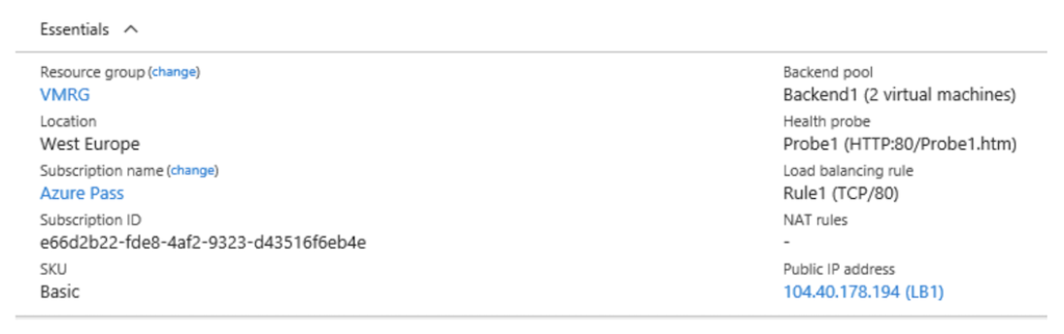
Rule1 is configured as shown below.
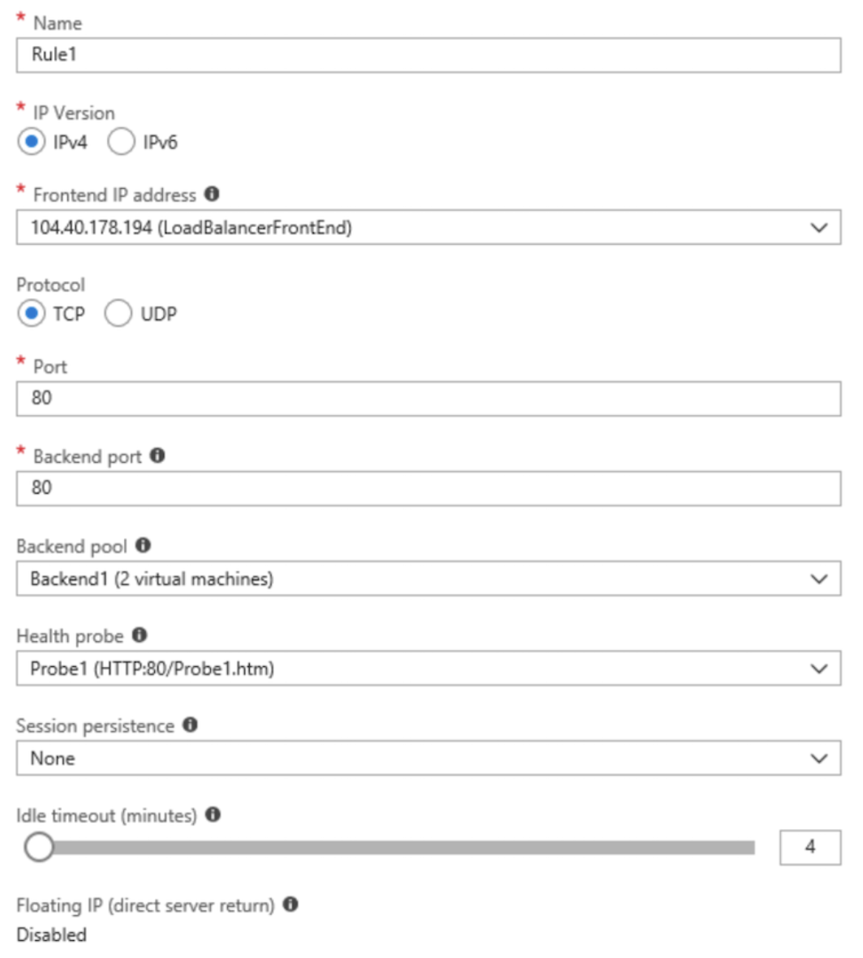
True or False:
`"VM1 is in the same availability set as VM2."`
Réponses:
☑ True
☐ False
Explication
`True` is correct because a Basic SKU load balancer requires that all network interfaces (NICs) connected to it be part of the same availability set. This restriction means that both VM1 and VM2 must be in the same availability set to be added to LB1 (a Basic SKU load balancer). The Basic SKU does not support flexibility across multiple availability sets, enforcing that all associated VMs are within the same availability set.
Reference(s):
- https://learn.microsoft.com/en-us/azure/load-balancer/load-balancer-overview
- https://learn.microsoft.com/en-us/azure/load-balancer/skus

Question 39
You have an Azure subscription that includes the following resources:
- VM1 - a virtual machine
- VM2 - a virtual machine
- LB1 - a load balancer that uses the Basic SKU
You install the Web Server (IIS) role on both VM1 and VM2. After the installation, you add both virtual machines to the backend pool of LB1.
LB1 is configured as shown below.
Rule1 is configured as shown below.
True or False:
`"If Probe1.htm is present on VM1 and VM2, LB1 will balance traffic for TCP port 80 between VM1 and VM2."`
Réponses:
☑ True
☐ False
Explication
`True` is correct because Probe1 is configured as an HTTP probe on port 80, checking for the presence of Probe1.htm on both VM1 and VM2. If Probe1.htm is present on both virtual machines, the health probe will mark both VMs as healthy, enabling LB1 (the Basic SKU load balancer) to balance incoming traffic on TCP port 80 across VM1 and VM2. The load balancer will distribute traffic only to VMs that pass the health probe check, so the presence of Probe1.htm ensures load balancing between the two VMs.
Reference(s):
- https://learn.microsoft.com/en-us/azure/load-balancer/load-balancer-custom-probe-overview

Question 40
You have an Azure subscription that includes the following resources:
- VM1 - a virtual machine
- VM2 - a virtual machine
- LB1 - a load balancer that uses the Basic SKU
You install the Web Server (IIS) role on both VM1 and VM2. After the installation, you add both virtual machines to the backend pool of LB1.
LB1 is configured as shown below.
Rule1 is configured as shown below.
True or False:
`"If you delete Rule1, LB1 will balance all the requests between VM1 and VM2 for all the ports."`
Réponses:
☐ True
☑ False
Explication
`False` is correct because if Rule1 is deleted, LB1 will lack the configuration needed to balance traffic for any ports between VM1 and VM2. Additionally, if all health probes fail for all instances in the backend pool, no new flows will be directed to the backend pool, and the Basic Load Balancer will terminate any existing TCP flows to the backend pool. Therefore, deleting Rule1 would prevent LB1 from balancing any requests across VM1 and VM2.
Reference(s):
- https://learn.microsoft.com/en-us/azure/load-balancer/load-balancer-custom-probe-overview

Question 41
You have an Azure subscription named Subscription1 that contains a virtual machine named VM1.
On VM1, you install and configure the following services:
- A web server
- A DNS server
VM1 has the effective network security rules shown in the following exhibit.
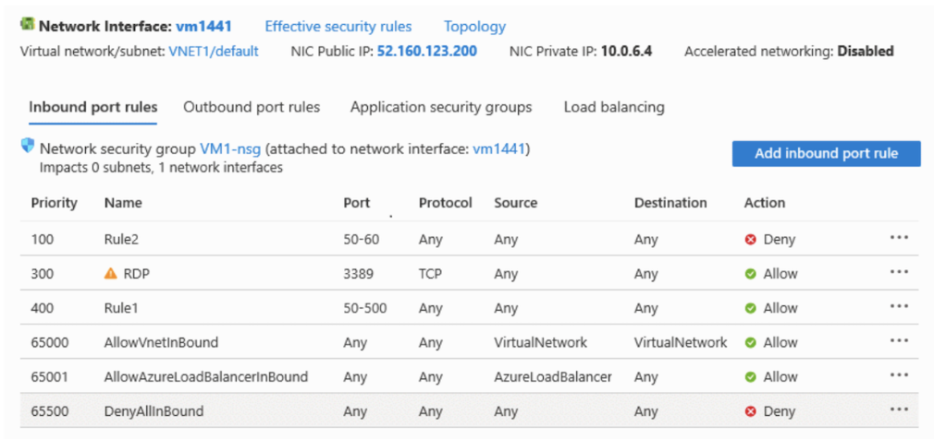
Based on this configuration, select the option that correctly completes the following statement:
“Internet users _________________________________________.”
Réponses:
☐ can connect to only the DNS server on VM1
☑ can connect to only the web server on VM1
☐ can connect to the web server and the DNS server on VM1
☐ cannot connect to the web server and the DNS server on VM1
Explication
`can connect to only the web server on VM1` is correct because the web server uses port 80, which is not blocked by any of the inbound security rules. However, Rule2 (with priority 100) explicitly denies access to ports 50-60 for all protocols, including port 53, which is used by the DNS service. Since port 53 is blocked by Rule2, internet users cannot connect to the DNS server on VM1 but can still connect to the web server.
`Can connect to only the DNS server on VM1` is incorrect because port 53 for DNS is blocked by Rule2.
`Can connect to the web server and the DNS server on VM1` is incorrect because the DNS port (53) is blocked.
`Cannot connect to the web server and the DNS server on VM1` is incorrect because the web server on port 80 is still accessible.
Reference(s):
- https://learn.microsoft.com/en-us/azure/virtual-network/network-security-groups-overview

Question 42
You have an Azure subscription named Subscription1 that contains a virtual machine named VM1.
On VM1, you install and configure the following services:
- A web server
- A DNS server
VM1 has the effective network security rules shown in the following exhibit.
Based on this configuration, select the option that correctly completes the following statement:
“If you delete Rule2, Internet users _________________________________________.”
Réponses:
☐ can connect to only the DNS server on VM1
☐ can connect to only the web server on VM1
☑ can connect to the web server and the DNS server on VM1
☐ cannot connect to the web server and the DNS server on VM1
Explication
`can connect to the web server and the DNS server on VM1` is correct because if Rule2 is deleted, the restriction on ports 50-60 is removed, allowing port 53 (used by DNS) to be accessible. The web server on port 80 is already accessible, as it falls outside the range that was blocked by Rule2. Therefore, with Rule2 deleted, internet users would be able to connect to both the web server (on port 80) and the DNS server (on port 53).
`Can connect to only the DNS server on VM1` is incorrect because port 80 for the web server is also accessible.
`Can connect to only the web server on VM1` is incorrect because port 53 for DNS would also be accessible once Rule2 is deleted.
`Cannot connect to the web server and the DNS server on VM1` is incorrect because deleting Rule2 allows access to both port 80 and port 53.
Reference(s):
- https://learn.microsoft.com/en-us/azure/virtual-network/network-security-groups-overview

Question 43
You have two Azure subscriptions named Subscription1 and Subscription2.
Each subscription is associated with a different Microsoft Entra tenant.
The resources are configured as follows:
- Subscription1
- Contains a virtual network named VNet1
- VNet1 has an address space of 10.0.0.0/16
- VNet1 contains a virtual machine named VM1
- Subscription2
- Contains a virtual network named VNet2
- VNet2 has an address space of 10.10.0.0/24
- VNet2 contains a virtual machine named VM2
You need to establish network connectivity between VNet1 and VNet2.
What should you do first?
Réponses:
☐ Move the virtual machine VM1 from Subscription1 to Subscription2.
☑ Create and configure virtual network gateways for the virtual networks.
☐ Move the virtual network VNet1 into Subscription2.
☐ Change the IP address range assigned to VNet2.
Explication
`Create and configure virtual network gateways for the virtual networks` is correct because to connect VNet1 in Subscription1 to VNet2 in Subscription2, you need to set up VNet-to-VNet connectivity across different subscriptions and tenants. The recommended approach for achieving this connection is to provision virtual network gateways in each virtual network and establish a VPN connection between them. This approach supports cross-subscription and cross-tenant connections.
`Move the virtual machine VM1 from Subscription1 to Subscription2` is incorrect because moving the VM does not address the need to connect the virtual networks across different subscriptions and tenants.
`Move the virtual network VNet1 into Subscription2` is incorrect because moving the entire virtual network to the same subscription is unnecessary when you can achieve connectivity through virtual network gateways.
`Change the IP address range assigned to VNet2` is incorrect because there is no overlapping IP address space that would prevent connectivity; both address spaces are already compatible.
Reference(s):
- https://learn.microsoft.com/en-us/azure/vpn-gateway/vpn-gateway-howto-vnet-vnet-resource-manager-portal

Question 44
You have an Azure subscription and plan to deploy the below Bicep file named File01.bicep.
param location string = resourceGroup().location
resource virtualNetwork 'Microsoft.Network/virtualNetworks@2025-01-01' = {
name: 'VNET1'
location: location
properties: {
addressSpace: {
addressPrefixes: [
'10.0.0.0/16'
]
}
subnets: [
{
name: 'Subnet-1'
properties: {
addressPrefix: '10.0.0.0/24'
}
}
{
name: 'Subnet-2'
properties: {
addressPrefix: '10.0.1.0/24'
}
}
]
}
}
True or False:
`“The virtual network will be named using the same value as the resource group’s location.”`
Réponses:
☐ True
☑ False
Explication
`False` is correct because the name of the virtual network in the provided Bicep file is explicitly set as 'VNET1'. The location parameter is assigned based on the location of the resource group, but this value only determines where the virtual network is deployed, not its name. Therefore, the name of the virtual network will be 'VNET1', regardless of the resource group's location.
Reference(s):
- https://learn.microsoft.com/en-us/azure/azure-resource-manager/bicep/bicep-functions-resourcegroup

Question 45
You have an Azure subscription and plan to deploy the below Bicep file named File01.bicep.
param location string = resourceGroup().location
resource virtualNetwork 'Microsoft.Network/virtualNetworks@2025-01-01' = {
name: 'VNET1'
location: location
properties: {
addressSpace: {
addressPrefixes: [
'10.0.0.0/16'
]
}
subnets: [
{
name: 'Subnet-1'
properties: {
addressPrefix: '10.0.0.0/24'
}
}
{
name: 'Subnet-2'
properties: {
addressPrefix: '10.0.1.0/24'
}
}
]
}
}
True or False:
`“Both subnet objects will be created successfully without any deployment errors.”`
Réponses:
☑ True
☐ False
Explication
`True` is correct because both Subnet-1 and Subnet-2 in the Bicep file have unique address prefixes (10.0.0.0/24 for Subnet-1 and 10.0.1.0/24 for Subnet-2) that fall within the address space of VNET1 (10.0.0.0/16). Since the subnets have non-overlapping address ranges within the virtual network's address space, they will be provisioned successfully.
Reference(s):
- https://learn.microsoft.com/en-us/azure/virtual-network/virtual-network-manage-subnet

Question 46
You have an Azure subscription and plan to deploy the below Bicep file named File01.bicep.
param location string = resourceGroup().location
resource virtualNetwork 'Microsoft.Network/virtualNetworks@2025-01-01' = {
name: 'VNET1'
location: location
properties: {
addressSpace: {
addressPrefixes: [
'10.0.0.0/16'
]
}
subnets: [
{
name: 'Subnet-1'
properties: {
addressPrefix: '10.0.0.0/24'
}
}
{
name: 'Subnet-2'
properties: {
addressPrefix: '10.0.1.0/24'
}
}
]
}
}
True or False:
`“Deploying File1.bicep multiple times will result in a deployment error.”`
Réponses:
☐ True
☑ False
Explication
`False` is correct because deploying File01.bicep more than once will not inherently cause an error, as Azure Resource Manager is designed to perform idempotent deployments. This means that if you deploy the same Bicep file multiple times without changing the parameters, Azure will recognize that the resources already exist and will not attempt to recreate them, avoiding any conflict or error. Any subsequent deployments would simply update the existing resources if there are changes; otherwise, the deployment will succeed without modification.
Reference(s):
- https://learn.microsoft.com/en-us/azure/azure-resource-manager/templates/overview

Question 47
You have an on-premises environment that includes a VPN gateway.
Your Azure subscription contains the following resources:
- vgw1 – a virtual network gateway configured for a site-to-site VPN connection to the on-premises network
- storage1 – a storage account using the Standard performance tier
- Vnet1 – a virtual network with forced tunneling enabled
- VM1 – a virtual machine connected to Vnet1
You must guarantee that any traffic originating from VM1 and destined for storage1 travels only across the Microsoft backbone network, and not through the public internet or the on-premises network.
What configuration should you implement?
Réponses:
☐ Azure Peering Service
☑ service endpoints
☐ Microsoft Entra Application Proxy
☐ Azure Application Gateway
Explication
`service endpoints` is correct because configuring service endpoints for storage1 will ensure that traffic from VM1 to storage1 travels across the Microsoft backbone network. Service endpoints allow private access to Azure services over the Azure backbone network by extending a virtual network's identity to the Azure service. This setup secures the traffic from VM1 to storage1 by keeping it within Microsoft’s network infrastructure.
`Azure Peering Service` is incorrect because it is designed for optimizing internet traffic but does not ensure that traffic stays within the Microsoft backbone for specific resources like storage1.
`Microsoft Entra Application Proxy` is incorrect because it provides secure remote access to on-premises applications, not for managing internal Azure network traffic between resources.
`Azure Application Gateway` is incorrect as it is a layer 7 load balancer for managing HTTP/HTTPS traffic and does not direct traffic over the Microsoft backbone for a virtual machine accessing a storage account.
Reference(s):
- https://learn.microsoft.com/en-us/azure/virtual-network/virtual-network-service-endpoints-overview

Question 48
You have an Azure subscription that includes a storage account named storacc1.
The storacc1 account contains blob data stored in a container named cont1.
You plan to share access to storacc1 by generating a shared access signature (SAS).
The SAS must meet the following requirements:
- Ensure that the SAS can only be used to enumerate and download blobs stored in cont1.
- Use the principle of least privilege.
Which three settings should you enable?
Réponses (plusieurs réponses possibles)
☐ File
☑ Container
☐ Object
☑ Read
☑ List
☐ Filter
Explication
`Container` is correct. This level of access limits the scope to container-level operations, specifically allowing access to cont1 where the blobs are stored.
`Read` and `List` are correct. Enabling Read and List permissions ensures that the SAS can only enumerate and download blobs within container1. Read permission allows downloading the blobs, and List permission allows enumerating the blobs within the container.
Reference(s):
- https://learn.microsoft.com/en-us/rest/api/storageservices/create-user-delegation-sas#specify-the-signed-resource-field
- https://learn.microsoft.com/en-us/rest/api/storageservices/create-user-delegation-sas#specify-permissions

Question 49
You have an Azure Storage account named storage1.
You also have two Azure App Service applications named App1 and App2. Both applications run in Azure container instances and both use managed identities.
You must ensure that both App1 and App2 can read blobs stored in storage1. The solution must meet the following requirements:
- Use the fewest possible secrets.
- Ensure that App2 is allowed to read data from storage1 for only the next 30 days.
What should you configure in storage1 for App1?
Réponses:
☐ Configure storage account access keys.
☐ Enable advanced security settings on the storage account.
☑ Configure role-based access control (RBAC) by using Access control (IAM).
☐ Generate Shared access signatures (SAS)
Explication
`Configure role-based access control (RBAC) by using Access control (IAM)` is correct because Azure Role-Based Access Control (RBAC) enables you to assign the Storage Blob Data Reader role to App1’s managed identity, allowing it to read blobs in storage1 without using secrets like keys or tokens. This meets the requirement to minimize the number of secrets used. RBAC is the most secure and manageable approach for long-term access and works seamlessly with managed identities. While RBAC does not natively support automatic expiration of access after a specific period, that requirement only applies to App2.
`Configure storage account access keys` is incorrect because access keys grant full access to the storage account and must be stored and rotated as secrets, violating the principle of least privilege.
`Enable advanced security settings on the storage account` is incorrect because it enhances storage account protection (e.g., firewalls or encryption), but it is not used to control identity-based read permissions.
`Generate Shared access signatures (SAS)` is incorrect for App1 because it involves generating and managing a token (a secret) and is better suited for time-limited access scenarios. While SAS does support expiration, it requires more overhead compared to RBAC for apps with managed identities.
Reference(s):
- https://learn.microsoft.com/en-us/azure/role-based-access-control/overview
- https://learn.microsoft.com/en-us/azure/azure-resource-manager/managed-applications/publish-managed-identity#granting-access-to-azure-resources

Question 50
You have an Azure Storage account named storage1.
You also have two Azure App Service applications named App1 and App2. Both applications run in Azure container instances and both use managed identities.
You must ensure that both App1 and App2 can read blobs stored in storage1. The solution must meet the following requirements:
- Use the fewest possible secrets.
- Ensure that App2 is allowed to read data from storage1 for only the next 30 days.
What should you configure in storage1 for App2?
Réponses:
☐ Configure storage account access keys.
☐ Enable advanced security settings on the storage account.
☐ Configure role-based access control (RBAC) by using Access control (IAM).
☑ Generate Shared access signatures (SAS).
Explication
`Generate Shared access signatures (SAS)` is correct because it enables time-bound access by allowing you to generate a token that grants App2 read access to blobs in storage1 with an exact expiration, such as 30 days. This satisfies the requirement to limit App2’s access duration. While a SAS token is considered a secret, it’s the most practical built-in option for temporary access enforcement. It avoids the need for manual revocation logic that would be required with IAM-based roles.
`Configure storage account access keys` is incorrect because they provide full control over the storage account and are not time-limited, making them unsuitable for scoped or temporary access.
`Enable advanced security settings on the storage account` is incorrect as it does not control time-limited access and does not apply to managed identity permissions.
`Configure role-based access control (RBAC) by using Access control (IAM)` is incorrect for App2 because RBAC does not natively support automated expiration of permissions. You would need external tooling like scripts or Azure PIM to revoke access after 30 days, which is less direct than a SAS token with an expiration.
Reference(s):
- https://learn.microsoft.com/en-us/azure/storage/common/storage-sas-overview
- https://learn.microsoft.com/en-us/azure/storage/common/authorize-data-access?tabs=blobs

Question 51
You have a Microsoft Entra user named User1 and an Azure Storage account named contoso2026 that uses read-access geo-redundant storage (RA-GRS).
You must meet the following requirements:
- User1 must be able to write blob data to contoso2026.
- The contoso2026 storage account must be able to fail over to its secondary endpoint.
Which two settings should you configure?
Réponses (plusieurs réponses possibles)
☑ Access Control (IAM)
☐ Access Keys
☐ Shared access signature
☑ Redundancy
Explication
`Access Control (IAM)` is correct because to enable User1 to write blob data to contoso2026, you can assign the Storage Blob Data Contributor role to User1 through Access Control (IAM). This role provides the necessary permissions for writing blob data without using account keys or SAS tokens, aligning with best practices for managing access in Azure.
`Redundancy` is correct because to configure contoso2026 to fail over to its secondary endpoint, you need to adjust the Redundancy setting. This setting allows you to manage the geo-redundant failover behavior for the storage account, enabling automatic or manual failover to the secondary region when needed.
`Access Keys` is incorrect because using access keys would not meet the principle of least privilege and would grant full access rather than just write permissions.
`Shared access signature` is incorrect because while it can provide specific permissions, using IAM roles is a more secure and manageable way to provide User1 with write access.
Reference(s):
- https://docs.microsoft.com/en-us/azure/storage/common/storage-redundancy#read-access-geo-redundant-storage
- https://docs.microsoft.com/en-us/azure/storage/common/storage-initiate-account-failover?tabs=azure-portal
- https://docs.microsoft.com/en-us/azure/role-based-access-control/overview
- https://docs.microsoft.com/en-us/azure/storage/common/storage-sas-overview
- https://docs.microsoft.com/en-us/azure/storage/common/storage-account-keys-manage

Question 52
You have the following App Service plans:
- ASP1
- OS: Windows
- Region: West US
- ASP2
- OS: Windows
- Region: Central US
- ASP3
- OS: Linux
- Region: West US
You plan to create the following Azure web apps:
- WebApp1
- Runtime stack: .NET 8 (LTS)
- Location: West US
- WebApp2
- Runtime stack: ASP.NET 4.8
- Location: West US
Which App Service plan can be used to host WebApp1?
Réponses:
☐ ASP1 only
☐ ASP3 only
☐ ASP1 and ASP2 only
☑ ASP1 and ASP3 only
☐ ASP1, ASP2, and ASP3
Explication
`ASP1 and ASP3 only` is correct because WebApp1 requires a .NET 8 (LTS) runtime stack, which is supported on both Windows and Linux platforms. ASP1 is a Windows-based App Service plan in the West US region, which aligns with the requirements for WebApp1. ASP3 is a Linux-based App Service plan, also located in the West US region, which is compatible with .NET 8. Therefore, both ASP1 and ASP3 can host WebApp1.
`ASP1 only` is incorrect because ASP3 can also support .NET 8 (LTS) on Linux.
`ASP3 only` is incorrect because ASP1 also supports .NET 8 (LTS) on Windows.
`ASP1 and ASP2 only` is incorrect because ASP2 is in the Central US region, which does not align with the West US requirement for WebApp1.
`ASP1, ASP2, and ASP3` is incorrect because ASP2 is not in the West US region.
Reference(s):
- https://learn.microsoft.com/en-us/azure/app-service/overview

Question 53
You have the following App Service plans:
- ASP1
- OS: Windows
- Region: West US
- ASP2
- OS: Windows
- Region: Central US
- ASP3
- OS: Linux
- Region: West US
You plan to create the following Azure web apps:
- WebApp1
- Runtime stack: .NET 8 (LTS)
- Location: West US
- WebApp2
- Runtime stack: ASP.NET 4.8
- Location: West US
Which App Service plan can be used to host WebApp2?
Réponses:
☑ ASP1 only
☐ ASP3 only
☐ ASP1 and ASP2 only
☐ ASP1 and ASP3 only
☐ ASP1, ASP2, and ASP3
Explication
`ASP1 only` is correct because WebApp2 requires the ASP.NET 4.8 runtime stack, which is supported only on Windows-based App Service plans. ASP1 is a Windows-based App Service plan in the West US region, matching the requirements for WebApp2.
In the screenshot below, you can see that the Linux option for the Operating System is greyed out when the Runtime stack is selected as ASP.NET 4.8.
`ASP3 only` is incorrect because ASP3 is a Linux-based plan, which does not support the ASP.NET 4.8 runtime stack.
`ASP1 and ASP2 only` is incorrect because, although ASP2 is a Windows-based plan, it is in the Central US region, whereas WebApp2 requires a plan in the West US region.
`ASP1 and ASP3 only` is incorrect because ASP3 does not support ASP.NET 4.8.
`ASP1, ASP2, and ASP3` is incorrect because ASP2 and ASP3 do not meet the requirements for WebApp2 due to either region mismatch or OS incompatibility.
Reference(s):
- https://learn.microsoft.com/en-us/azure/app-service/

Question 54
Your on-premises network hosts an Active Directory Domain Services (AD DS) domain named apexcore.com. The domain includes the following servers:
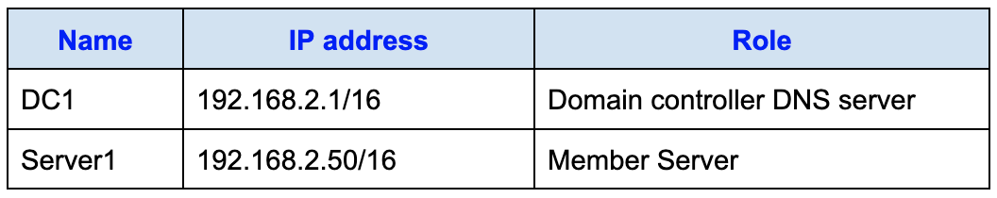
You are planning to migrate the apexcore.com domain to Azure.
You create an Azure virtual network named VNET1 with these configurations:
- Address space: 10.0.0.0/16
- Subnet configuration:
- Subnet name: Subnet1
- IPv4 address range: 10.0.1.0/24
You need to move DC1 into VNET1. The configuration must ensure that all member servers in apexcore.com can continue to resolve Active Directory DNS records correctly.
How should the IP address be configured?
Réponses:
☑ Obtain an IP address automatically.
☐ Use 10.0.1.3
☐ Use 10.0.2.1
☐ Use 192.168.2.1
Explication
`Obtain an IP address automatically` is correct because, out of the options given, this is the most feasible solution. While it's generally best practice to assign a static IP to a Domain Controller (DC) to ensure consistent DNS resolution, obtaining an IP automatically can work as long as DC1 remains active. If DC1 is shut down, it may receive a different IP upon restart, which could disrupt DNS resolution.
`Use 10.0.1.3` is incorrect because the first four IP addresses within a subnet range (like 10.0.1.0/24) are reserved by Azure, making 10.0.1.3 unavailable for assignment.
`Use 10.0.2.1` is incorrect because, although it’s within the overall VNET1 address space, it falls outside of Subnet1’s range (10.0.1.0/24), which would prevent proper network connectivity.
`Use 192.168.2.1` is incorrect as this IP is part of the on-premises network and does not exist within VNET1’s address space, making it unusable in the Azure virtual network.
Reference(s):
- https://learn.microsoft.com/en-us/azure/cloud-adoption-framework/ready/azure-best-practices/dns-for-on-premises-and-azure-resources

Question 55
Your on-premises network hosts an Active Directory Domain Services (AD DS) domain named apexcore.com. The domain includes the following servers:
You are planning to migrate the apexcore.com domain to Azure.
You create an Azure virtual network named VNET1 with these configurations:
- Address space: 10.0.0.0/16
- Subnet configuration:
- Subnet name: Subnet1
- IPv4 address range: 10.0.1.0/24
You need to move DC1 into VNET1. The configuration must ensure that all member servers in apexcore.com can continue to resolve Active Directory DNS records correctly.
How should the Name resolution be configured?
Réponses:
☑ Configure VNET1 to use a custom DNS server.
☐ Configure VNET1 to use the default Azure-provided DNS server.
☐ Create an Azure Private DNS zone named apexcore.com.
☐ Create an Azure public DNS zone named apexcore.com.
Explication
`Configure VNET1 to use a custom DNS server` is correct because to ensure that the member servers in apexcore.com can resolve Active Directory Domain Services (AD DS) DNS names, VNET1 should be configured to use the IP address of DC1 (acting as the DNS server) as a custom DNS server. This configuration will allow resources within VNET1 to resolve DNS queries for apexcore.com using DC1's DNS service, which is essential for Active Directory domain name resolution.
`Configure VNET1 to use the default Azure-provided DNS server` is incorrect because Azure’s default DNS server does not support resolving on-premises or custom domain names like apexcore.com.
`Create an Azure Private DNS zone named apexcore.com` is incorrect because, while a private DNS zone could theoretically support name resolution, it would not integrate seamlessly with AD DS DNS requirements. Using DC1 as the DNS server directly provides better compatibility with AD DS.
`Create an Azure public DNS zone named apexcore.com` is incorrect because a public DNS zone is intended for resolving internet-facing names and is not suitable for internal AD DS name resolution within VNET1.
Reference(s):
- https://learn.microsoft.com/en-us/azure/virtual-network/virtual-networks-name-resolution-for-vms-and-role-instances#name-resolution-that-uses-your-own-dns-server
- https://learn.microsoft.com/en-us/azure/cloud-adoption-framework/ready/azure-best-practices/dns-for-on-premises-and-azure-resources

Question 56
You have an Azure subscription that includes a virtual machine named VM1.
You plan to attach a 1 TB data disk to VM1. The disk must meet the following requirements:
- It must remain available if an entire datacenter becomes unavailable.
- It must deliver the lowest possible latency and the highest performance.
- It must prevent data loss in the event that the host fails.
Which storage type should you choose?
Réponses:
☐ Premium SSD that uses locally-redundant storage (LRS)
☑ Premium SSD that uses zone-redundant storage (ZRS)
☐ Standard SSD that uses locally-redundant storage (LRS)
☐ Standard SSD that uses zone-redundant storage (ZRS)
Explication
`Premium SSD that uses zone-redundant storage (ZRS)` is correct because it provides data resiliency by replicating data across multiple availability zones, ensuring that data remains available in the event of a datacenter outage. Additionally, Premium SSDs offer the lowest latency and highest performance compared to Standard SSDs. The use of ZRS ensures that data is also protected against potential failures within a specific zone, meeting the requirement of no data loss in case of a host or datacenter failure.
`Premium SSD that uses locally-redundant storage (LRS)` is incorrect because while it provides high performance and low latency, LRS only replicates data within a single datacenter, which does not provide resiliency in the event of a datacenter outage.
`Standard SSD that uses locally-redundant storage (LRS)` is incorrect because Standard SSDs do not meet the requirement for the highest performance and low latency, and LRS does not protect against datacenter outages.
`Standard SSD that uses zone-redundant storage (ZRS)` is incorrect because, while ZRS provides data resiliency across zones, Standard SSDs lack the performance and low latency required.
Reference(s):
- https://learn.microsoft.com/en-us/azure/virtual-machines/overview
- https://learn.microsoft.com/en-us/azure/architecture/example-scenario/identity/adds-extend-domain#vm-recommendations

Question 57
You have an Azure subscription that includes a virtual machine named VM1.
You plan to attach a 1 TB data disk to VM1. The disk must meet the following requirements:
- It must remain available if an entire datacenter becomes unavailable.
- It must deliver the lowest possible latency and the highest performance.
- It must prevent data loss in the event that the host fails.
Which host caching would you recommend?
Réponses:
☐ None
☑ Read-only
☐ Read/Write
Explication
`Read-only `is correct because it provides a balance between performance and data durability. Enabling Read-only caching on a Premium SSD with zone-redundant storage (ZRS) allows frequently accessed data to be cached, which enhances read performance without risking significant data loss. In the event of a host failure, data is read from the redundant storage across zones, ensuring data resiliency. Since only read operations are cached, the data stored on disk remains consistent and resilient to host failures, addressing the requirement of no data loss.
Although None caching eliminates any risk of data loss, Read-only caching is acceptable for workloads that prioritize high performance and data resiliency, as it does not impact data integrity during writes.
`None` is incorrect because, while it prevents any risk of data loss, it does not utilize the performance benefits of read caching, which may be desirable for high-performance workloads with Premium SSD storage.
`Read/Write` is incorrect as it caches both read and write operations on the host, which can result in data loss in the event of a host failure. This does not meet the requirement to ensure that no data loss occurs if a host fails.
Reference(s):
- https://learn.microsoft.com/en-us/azure/architecture/example-scenario/identity/adds-extend-domain#vm-recommendations

Question 58
You have an Azure subscription that includes the following resources:
- VNet1 - Virtual network located in West US, in RG2
- VNet2 - Virtual network located in West US, in RG1
- VNet3 - Virtual network located in East US, in RG1
- NSG1 - Network security group located in East US, in RG2
To which subnets can you apply NSG1?
Réponses:
☐ the subnets on VNet1 only
☐ the subnets on VNet2 only
☑ the subnets on VNet3 only
☐ the subnets on VNet2 and VNet3 only
☐ the subnets on VNet1, VNet2, and VNet3
Explication
`the subnets on VNet3 only` is correct because a network security group (NSG) must be in the same region as the virtual network or subnets to which it is applied. NSG1 is in the East US region, and therefore it can only be applied to the subnets within VNet3, as VNet3 is also in the East US region.
Reference(s):
- https://learn.microsoft.com/en-us/azure/virtual-network/network-security-groups-overview
- https://learn.microsoft.com/en-us/azure/security/fundamentals/network-best-practices

Question 59
**Note: This question is part of a series that uses the same overall scenario. Each question in the series proposes a different solution that may or may not satisfy the stated requirement.

You have a Microsoft Entra tenant named ironclad.com and an Azure subscription named Subscription1. The tenant contains a group called Developers. The subscription contains a resource group named Dev.
You need to allow the Developers group to create Azure Logic Apps in the Dev resource group.
Proposed Solution: You assign the Contributor role to the Developers group at the Dev resource group scope.
Does this configuration satisfy the requirement?
Réponses:
☑ Yes
☐ No
Explication
`Yes` is correct because assigning the Contributor role to the Developers group at the Dev resource group level allows the group members to manage all resources within the resource group, including the ability to create Azure Logic Apps. The Contributor role provides full access to manage resources without granting permissions to assign roles or manage access, which fulfills the requirement stated in the question.
Reference(s):
- https://learn.microsoft.com/en-us/azure/role-based-access-control/built-in-roles#contributor

Question 60
**Note: This question is part of a series that uses the same overall scenario. Each question in the series proposes a different solution that may or may not satisfy the stated requirement.

You have a Microsoft Entra tenant named ironclad.com and an Azure subscription named Subscription1. The tenant contains a group called Developers. The subscription contains a resource group named Dev.
You need to allow the Developers group to create Azure Logic Apps in the Dev resource group.
Proposed Solution: On the Dev resource group, you grant the Logic App Contributor role to the Developers group.
Does this configuration satisfy the requirement?
Réponses:
☑ Yes
☐ No
Explication
`Yes` is correct because the Logic App Contributor role provides the necessary permissions to manage Azure Logic Apps within the assigned scope, which includes creating, updating, and deleting logic apps. Assigning this role to the Developers group at the Dev resource group level fulfills the requirement to allow the group to create Azure Logic Apps in the Dev resource group without granting broader permissions.
Reference(s):
- https://learn.microsoft.com/en-us/azure/role-based-access-control/built-in-roles#logic-app-contributor

Question 61
You have an Azure subscription that includes a virtual network named VNet1.
VNet1 uses the IP address space 10.0.0.0/16 and contains the following subnets:
- Subnet0 (IP address range: 10.0.0.0/24)
- Subnet1 (IP address range: 10.0.1.0/24)
- Subnet2 (IP address range: 10.0.2.0/24)
- GatewaySubnet (IP address range: 10.0.254.0/24)
Subnet1 hosts a virtual appliance named VM1, which functions as a router.
You create a route table named RT1.
You need to ensure that all inbound traffic arriving from the VPN gateway into VNet1 is routed through VM1.
You plan to configure RT1 accordingly.
What value should you specify for the address prefix?
Réponses:
☑ 10.0.0.0/16
☐ 10.0.1.0/24
☐ 10.0.254.0/24
Explication
`10.0.0.0/16` is correct because it represents the entire IP address range of VNet1, including all its subnets (Subnet0, Subnet1, Subnet2, and GatewaySubnet). Configuring this address prefix in the route table ensures that all traffic arriving at the VPN gateway and destined for any subnet in VNet1 is routed through the virtual appliance (VM1) in Subnet1.
`10.0.1.0/24` is incorrect because this prefix only applies to Subnet1. Configuring RT1 with this prefix will not ensure that all traffic from the VPN gateway to the other subnets passes through VM1.
`10.0.254.0/24` is incorrect because this prefix refers specifically to the GatewaySubnet. It does not cover the entire VNet, and traffic to other subnets will not be routed through VM1.
Reference(s):
- https://azure.microsoft.com/en-in/solutions/network-appliances/
- https://learn.microsoft.com/en-us/azure/virtual-network/virtual-networks-udr-overview

Question 62
You have an Azure subscription that includes a virtual network named VNet1.
VNet1 uses the IP address space 10.0.0.0/16 and contains the following subnets:
- Subnet0 (IP address range: 10.0.0.0/24)
- Subnet1 (IP address range: 10.0.1.0/24)
- Subnet2 (IP address range: 10.0.2.0/24)
- GatewaySubnet (IP address range: 10.0.254.0/24)
Subnet1 hosts a virtual appliance named VM1, which functions as a router.
You create a route table named RT1.
You need to ensure that all inbound traffic arriving from the VPN gateway into VNet1 is routed through VM1.
You plan to configure RT1 accordingly.
What value should you specify for the next hop type?
Réponses:
☑ Virtual appliance
☐ Virtual network
☐ Virtual network gateway
Explication
`Virtual appliance` is correct because the virtual appliance next-hop type is used when traffic needs to be routed through a specific virtual machine or network virtual appliance (NVA). In this scenario, VM1 in Subnet1 acts as a router for all inbound traffic from the VPN gateway. The routing table RT1 should use the "Virtual appliance" next-hop type to direct traffic to the virtual machine.
`Virtual network` is incorrect because it refers to routing traffic within the virtual network itself, not specifically through a virtual machine or appliance acting as a router.
`Virtual network gateway` is incorrect because it refers to routing traffic to or through an Azure VPN Gateway. In this case, the traffic has already reached the VPN Gateway and needs to be routed through the virtual appliance (VM1).
Reference(s):
- https://learn.microsoft.com/en-us/azure/virtual-network/virtual-networks-udr-overview
- https://azure.microsoft.com/en-in/solutions/network-appliances/

Question 63
You have an Azure subscription that includes a virtual network named VNet1.
VNet1 uses the IP address space 10.0.0.0/16 and contains the following subnets:
- Subnet0 (IP address range: 10.0.0.0/24)
- Subnet1 (IP address range: 10.0.1.0/24)
- Subnet2 (IP address range: 10.0.2.0/24)
- GatewaySubnet (IP address range: 10.0.254.0/24)
Subnet1 hosts a virtual appliance named VM1, which functions as a router.
You create a route table named RT1.
You need to ensure that all inbound traffic arriving from the VPN gateway into VNet1 is routed through VM1.
You plan to configure RT1 accordingly.
Which option should you select for the Assigned to setting?
Réponses:
☑ GatewaySubnet
☐ Subnet0
☐ Subnet1 and Subnet2
Explication
`GatewaySubnet` is correct because the routing table RT1 must be associated with the GatewaySubnet to ensure that all traffic coming from the VPN Gateway is routed through the virtual appliance (VM1) in Subnet1. The GatewaySubnet is a dedicated subnet for VPN Gateway and requires proper routing configuration to direct traffic appropriately.
`Subnet0` is incorrect because associating the route table with Subnet0 would not ensure that traffic from the VPN Gateway is routed through the virtual appliance in Subnet1.
`Subnet1 and Subnet2` is incorrect because associating the route table with these subnets does not target the GatewaySubnet, which is the entry point for VPN traffic. Routing must start from the GatewaySubnet.
Reference(s):
- https://learn.microsoft.com/en-us/azure/virtual-network/virtual-networks-udr-overview
- https://learn.microsoft.com/en-us/azure/vpn-gateway/vpn-gateway-about-vpn-gateway-settings
- https://azure.microsoft.com/en-in/solutions/network-appliances

Question 64
You have a virtual network named VNET1 that includes the following subnets:
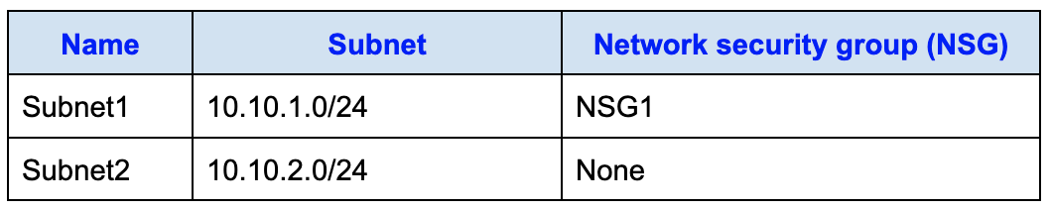
You also have the following Azure virtual machines with the listed network configurations:
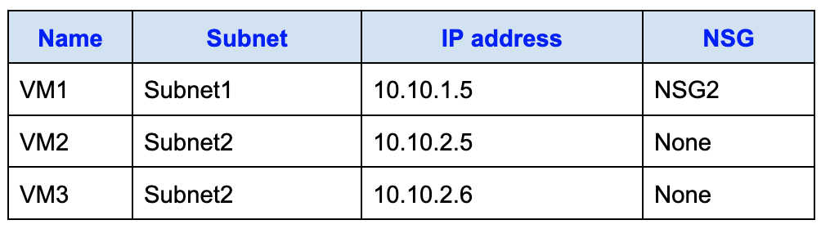
For NSG1, you configure the following inbound security rule:
- Priority: 101
- Source: 10.10.2.0/24
- Destination: 10.10.1.0/24
- Destination port: TCP 1433
- Action: Allow
For NSG2, you configure the following inbound security rule:
- Priority: 125
- Source: 10.10.2.5
- Destination: 10.10.1.5
- Destination port: TCP 1433
- Action: Block
True or False:
`“VM2 can connect to the TCP port 1433 services on VM1.”`
Réponses:
☐ True
☑ False
Explication
`False` is the correct answer because the traffic from VM2 to VM1 on TCP port 1433 must be allowed by both NSGs in the inbound path. For inbound traffic to VM1, Azure evaluates the subnet-level NSG first and then the NIC-level NSG. NSG1 allows TCP 1433 traffic from 10.10.2.0/24 to 10.10.1.0/24, so the traffic is allowed at the subnet level. However, NSG2, which is associated with VM1’s NIC, explicitly blocks TCP 1433 traffic from 10.10.2.5 to 10.10.1.5. Since the traffic is denied at the NIC level, the connection from VM2 to VM1 fails.
Reference(s):
- https://learn.microsoft.com/en-us/azure/virtual-network/network-security-groups-overview
- https://learn.microsoft.com/en-us/azure/virtual-network/network-security-group-how-it-works

Question 65
You have a virtual network named VNET1 that includes the following subnets:
You also have the following Azure virtual machines with the listed network configurations:
For NSG1, you configure the following inbound security rule:
- Priority: 101
- Source: 10.10.2.0/24
- Destination: 10.10.1.0/24
- Destination port: TCP 1433
- Action: Allow
For NSG2, you configure the following inbound security rule:
- Priority: 125
- Source: 10.10.2.5
- Destination: 10.10.1.5
- Destination port: TCP 1433
- Action: Block
True or False:
`“VM1 can connect to the TCP port 1433 services on VM2.”`
Réponses:
☑ True
☐ False
Explication
`True` is the correct answer because there are no Network Security Groups (NSGs) applied to Subnet2, where VM2 resides, or directly to VM2's network interface. NSG1 is applied at Subnet1, allowing traffic from Subnet2 to Subnet1 on TCP port 1433. NSG2 is applied at VM1's network interface, but it explicitly blocks inbound traffic from 10.10.2.5 (VM2) to 10.10.1.5 (VM1) on TCP port 1433. However, the direction of traffic in this question is from VM1 to VM2, not the other way around. Therefore, the NSG rules blocking inbound traffic on VM1 do not apply in this scenario, and the outbound connection from VM1 to VM2 is not blocked.
Reference(s):
- https://learn.microsoft.com/en-us/azure/virtual-network/network-security-groups-overview
- https://learn.microsoft.com/en-us/azure/virtual-network/network-security-group-how-it-works

Question 66
You have a virtual network named VNET1 that includes the following subnets:
You also have the following Azure virtual machines with the listed network configurations:
For NSG1, you configure the following inbound security rule:
- Priority: 101
- Source: 10.10.2.0/24
- Destination: 10.10.1.0/24
- Destination port: TCP 1433
- Action: Allow
For NSG2, you configure the following inbound security rule:
- Priority: 125
- Source: 10.10.2.5
- Destination: 10.10.1.5
- Destination port: TCP 1433
- Action: Block
True or False:
`“VM2 can connect to the TCP port 1433 services on VM3.”`
Réponses:
☑ True
☐ False
Explication
`True` is the correct answer because there are no Network Security Groups (NSGs) applied to Subnet2, where VM3 resides, or directly to VM3's network interface. NSG1, applied to Subnet1, allows traffic from Subnet2 (10.10.2.0/24) to Subnet1 (10.10.1.0/24) on TCP port 1433.
The rule in NSG2 that blocks inbound traffic specifically applies to traffic from VM2 (10.10.2.5) to VM1 (10.10.1.5), but not to VM3 (10.10.2.6). Therefore, VM2 can successfully connect to TCP port 1433 services on VM3 without restriction.
Reference(s):
- https://learn.microsoft.com/en-us/azure/virtual-network/network-security-groups-overview
- https://learn.microsoft.com/en-us/azure/virtual-network/network-security-group-how-it-works

Question 67
You have four Azure virtual machines with the following configurations:
- VM1 – IP address 10.1.0.4, connected to VNET1/Subnet1
- VM2 – IP address 10.1.10.4, connected to VNET1/Subnet2
- VM3 – IP address 172.16.0.4, connected to VNET2/SubnetA
- VM4 – IP address 10.2.0.8, connected to VNET3/SubnetB
A DNS service is installed on VM1.
You configure the DNS server settings on each virtual network to use a custom DNS server with the IP address 10.1.0.4.
You need to ensure that all the virtual machines can resolve DNS names by using the DNS service on VM1.
What action should you take?
Réponses:
☐ Add service endpoints on VNET2 and VNET3.
☑ Configure peering between VNET1, VNET2, and VNET3.
☐ Add service endpoints on VNET1.
☐ Configure a conditional forwarder on VM1.
Explication
`Configure peering between VNET1, VNET2, and VNET3` is the correct option because DNS queries sent to a custom DNS server (VM1 in this case) require network connectivity between the virtual networks. Virtual network peering allows resources in different VNets to communicate seamlessly. Once peering is configured, all DNS traffic can route correctly through VM1.
`Add service endpoints on VNET2 and VNET3` is incorrect because service endpoints are used for secure connections to Azure services like Storage or SQL, not for enabling DNS resolution between VNets.
`Add service endpoints on VNET1` is incorrect for the same reason, as service endpoints don't facilitate cross-VNet DNS resolution.
`Configure a conditional forwarder on VM1` is incorrect because a conditional forwarder directs DNS queries to specific DNS servers based on domain names. However, without VNet peering, the DNS traffic wouldn't route between VNets.
Reference(s):
- https://learn.microsoft.com/en-us/azure/virtual-network/virtual-network-peering-overview
- https://learn.microsoft.com/en-us/azure/virtual-network/virtual-networks-name-resolution-for-vms-and-role-instances
- https://learn.microsoft.com/en-us/azure/virtual-network/virtual-network-service-endpoints-overview
- https://learn.microsoft.com/en-us/azure/dns/private-dns-overview

Question 68
You intend to use Azure Network Watcher to perform the following activity:
- Test and confirm outbound network connectivity from an Azure virtual machine to an external destination.
Which feature should you use for the above task?
Réponses:
☑ Connection troubleshoot
☐ IP flow verify
☐ Next hop
☐ NSG flow logs
☐ Traffic Analytics
Explication
`Connection troubleshoot` is the correct option because it is specifically designed to validate outbound connectivity from an Azure virtual machine (VM) to an external host. This feature checks the end-to-end connection and identifies if the connection succeeds or fails, providing insights into network latency, packet loss, and the point of failure.
`IP flow verify` is incorrect because it checks whether a specific packet is allowed or denied by security rules, but it does not validate the entire outbound connection path.
`Next hop `is incorrect because it shows the next hop a packet will take to reach its destination but does not validate the outbound connection itself.
`NSG flow logs` is incorrect because it provides a record of traffic through network security groups (NSGs) but does not validate outbound connectivity.
`Traffic Analytics` is incorrect because it analyzes traffic patterns and usage but does not validate specific outbound connections.
Reference(s):
- https://learn.microsoft.com/en-us/azure/network-watcher/network-watcher-connectivity-overview
- https://learn.microsoft.com/en-us/azure/network-watcher/network-watcher-overview

Question 69
You intend to use Azure Network Watcher to perform the following activity:
- Determine which security rule is blocking a network packet from reaching an Azure virtual machine.
Which feature should you use for the above task?
Réponses:
☑ IP flow verify
☐ Next hop
☐ Packet capture
☐ Traffic Analytics
Explication
`IP flow verify` is the correct option because this feature in Azure Network Watcher is specifically designed to identify whether a network packet is allowed or denied to or from an Azure virtual machine (VM). It evaluates the effective security rules applied to the VM's network interface and identifies the rule responsible for blocking or allowing the traffic.
`Next hop` is incorrect because it helps determine the route a packet takes to reach its destination but does not identify security rules blocking traffic.
`Packet capture` is incorrect because it captures live packet data for network traffic but does not identify which security rule is affecting the traffic.
`Traffic Analytics` is incorrect because it provides insights into traffic flow patterns and network resource usage, but it does not identify the specific security rule blocking traffic.
Reference(s):
- https://learn.microsoft.com/en-us/azure/network-watcher/network-watcher-ip-flow-verify-overview
- https://learn.microsoft.com/en-us/azure/network-watcher/network-watcher-overview

Question 70
You have an Azure subscription named Subscription1 that includes a virtual network called VNet1, which resides in a resource group named RG1.
A user named User1 has been assigned the following roles at the Subscription1 scope:
- Reader
- Security Admin
- Security Reader
You must ensure that User1 is able to assign the Reader role on VNet1 to other users.
What action should you take?
Réponses:
☐ Remove User1 from the Security Reader and Reader roles at the Subscription1 level, and then assign User1 the Contributor role for Subscription1.
☐ Remove User1 from the Security Reader and Reader roles at the Subscription1 level.
☑ Assign User1 the User Access Administrator role at the VNet1 scope.
☐ Remove User1 from the Security Reader role at the Subscription1 level, and then assign User1 the Contributor role for the RG1 resource group.
Explication
`Assign User1 the User Access Administrator role at the VNet1 scope` is the correct answer because the User Access Administrator role allows a user to manage user access to resources, including assigning RBAC roles such as Reader to other users. While User1 already has the Reader, Security Admin, and Security Reader roles, none of these roles grant the ability to assign RBAC roles to other users. Assigning the User Access Administrator role at the scope of VNet1 ensures that User1 has the necessary permissions to assign roles without granting broader privileges at the subscription or resource group level, adhering to the principle of least privilege.
`Remove User1 from the Security Reader and Reader roles at the Subscription1 level, and then assign User1 the Contributor role for Subscription1` is incorrect because the Contributor role allows managing resources but does not grant role assignment capabilities.
`Remove User1 from the Security Reader and Reader roles at the Subscription1 level` is incorrect because simply removing existing roles does not grant any permissions for role assignment.
`Remove User1 from the Security Reader role at the Subscription1 level, and then assign User1 the Contributor role for the RG1 resource group` is incorrect because the Contributor role at the resource group level (RG1) does not allow assigning roles for VNet1.
Reference(s):
- https://learn.microsoft.com/en-us/azure/role-based-access-control/built-in-roles
- https://learn.microsoft.com/en-us/azure/role-based-access-control/role-definitions
- https://learn.microsoft.com/en-us/azure/role-based-access-control/overview

Question 71
You have an Azure subscription that includes the following resources:
- Ten network security groups (NSGs)
- Ten virtual machines
- One Log Analytics workspace named Workspace1
Each network security group is associated with the network interface of a virtual machine.
You want to configure an Azure Monitor Network Insights alert that triggers when suspicious network traffic is detected.
What action should you perform first?
Réponses:
☐ Deploy Connection Monitor.
☑ Configure NSG flow logs.
☐ Configure data collection endpoints.
☐ Configure a private link.
Explication
`Configure NSG flow logs` is the correct answer because Azure Monitor Network Insights relies on NSG flow logs to analyze and detect suspicious network traffic. NSG flow logs capture detailed information about IP traffic flowing through network security groups, including source and destination IPs, ports, and protocols.
Enabling NSG flow logs is a prerequisite for Azure Monitor to process network traffic data and identify anomalies or suspicious activities. These logs are sent to a Log Analytics workspace (e.g., Workspace1) for further analysis.
`Deploy Connection Monitor` is incorrect because Connection Monitor is used for monitoring network connectivity and performance between Azure resources or between Azure and on-premises resources. It does not directly facilitate alerting based on suspicious network traffic.
`Configure data collection endpoints` is incorrect because data collection endpoints (DCEs) are primarily used for routing Azure Monitor Agent data. They are not directly related to enabling NSG flow logs or configuring Network Insights alerts.
`Configure a private link` is incorrect because private links are used to securely access Azure services over a private IP address. They do not play a role in enabling network traffic analysis or triggering alerts for suspicious traffic.
Reference(s):
- https://learn.microsoft.com/en-us/azure/network-watcher/nsg-flow-logs-overview
- https://learn.microsoft.com/en-us/azure/network-watcher/network-watcher-overview
- https://learn.microsoft.com/en-us/azure/network-watcher/network-insights-overview

Question 72
You have an Azure Storage account named storage1 that has the Blob service properties shown in the following exhibit.
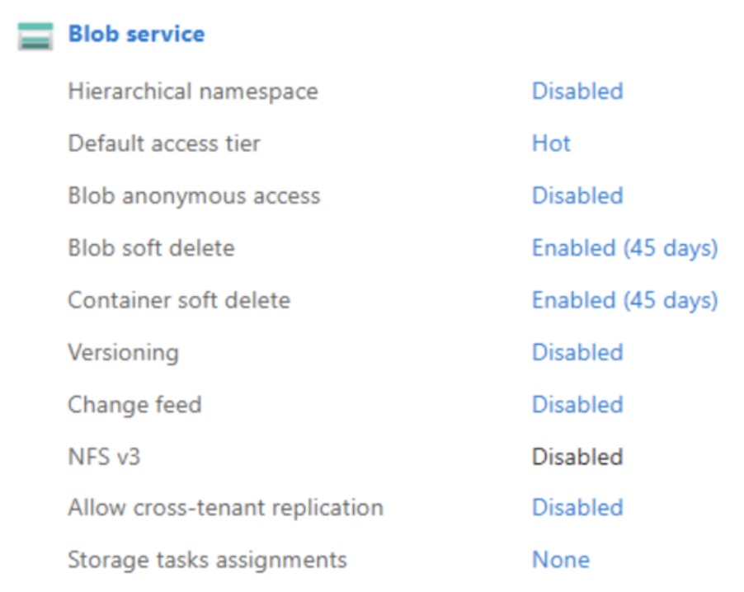
On January 1, the following blobs are uploaded to storage1:
- File1 is stored in the Hot access tier
- File2 is stored in the Cool access tier
- File3 is stored in the Archive access tier
You then perform these actions:
- On January 5, File1 is deleted
- On January 15, File2 is moved to the Archive access tier
- On April 5, File3 is rehydrated
True or False:
`“You are charged an early deletion penalty for File1.”`
Réponses:
☐ True
☑ False
Explication
`False` is the correct answer here. File1 was uploaded to the storage account under the Hot access tier on January 1 and then deleted on January 5. The Hot tier does not have an early deletion penalty, regardless of the deletion time.
For reference, the access tiers and their minimum retention periods for avoiding early deletion charges are as follows:
- Hot: No minimum retention period; early deletion penalty does not apply.
- Cool: 30 days minimum retention period.
- Cold: 90 days minimum retention period.
- Archive: 180 days minimum retention period.
Since File1 was stored in the Hot tier, it incurs no early deletion penalty even if it is deleted within days of upload.
Reference(s.):
- https://learn.microsoft.com/en-us/azure/storage/blobs/access-tiers-overview
- https://learn.microsoft.com/en-us/azure/storage/blobs/access-tiers-overview#early-deletion-charge

Question 73
You have an Azure Storage account named storage1 that has the Blob service properties shown in the following exhibit.
On January 1, the following blobs are uploaded to storage1:
- File1 is stored in the Hot access tier
- File2 is stored in the Cool access tier
- File3 is stored in the Archive access tier
You then perform these actions:
- On January 5, File1 is deleted
- On January 15, File2 is moved to the Archive access tier
- On April 5, File3 is rehydrated
True or False:
`“You are charged an early deletion penalty for File2.”`
Réponses:
☑ True
☐ False
Explication
`True` is the correct answer here. File2 was added on January 1 with the Cool access tier and was moved to the Archive access tier on January 15; just 14 days after it was created. The Cool tier has a minimum retention period of 30 days, meaning that if a blob is deleted, overwritten, or moved to another tier before 30 days, an early deletion penalty applies.
Since File2 was moved from Cool to Archive after 14 days, Azure will apply a prorated early deletion charge for 16 days (i.e., 30 - 14). This charge reflects the unused portion of the required minimum retention period in the Cool tier.
Reference(s.):
- https://learn.microsoft.com/en-us/azure/storage/blobs/access-tiers-overview

Question 74
You have an Azure Storage account named storage1 that has the Blob service properties shown in the following exhibit.
On January 1, the following blobs are uploaded to storage1:
- File1 is stored in the Hot access tier
- File2 is stored in the Cool access tier
- File3 is stored in the Archive access tier
You then perform these actions:
- On January 5, File1 is deleted
- On January 15, File2 is moved to the Archive access tier
- On April 5, File3 is rehydrated
True or False:
`“You are charged an early deletion penalty for File3.”`
Réponses:
☑ True
☐ False
Explication
`True` is the correct answer here. File3 was uploaded on January 1 and placed in the Archive access tier. It was then rehydrated (i.e., restored to an online tier such as Hot or Cool) on April 5, which is 94 days after it was archived.
The Archive tier has a minimum retention period of 180 days. If a blob is rehydrated, deleted, or moved before 180 days, Azure applies a prorated early deletion fee for the remaining days.
In this case, File3 remained in the Archive tier for only 94 days, so an early deletion charge equivalent to 86 days (180 - 94) will be incurred.
Reference(s.):
- https://learn.microsoft.com/en-us/azure/storage/blobs/access-tiers-overview#early-deletion-charge

Question 75
You manage two Azure subscriptions named Subscription1 and Subscription2.
Subscription1 has the following virtual networks:
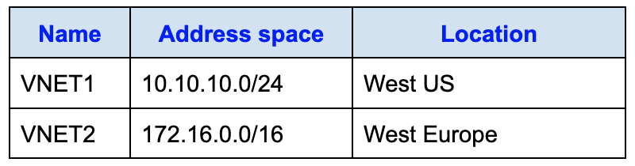
The virtual networks contain the following subnets:
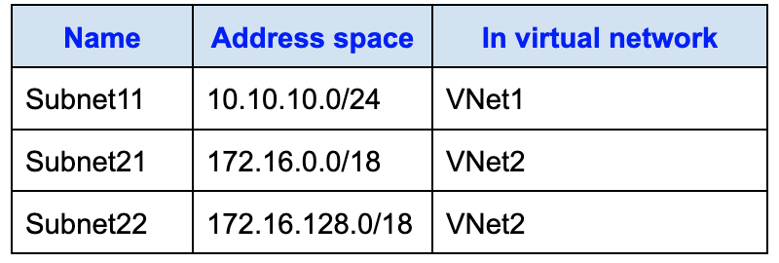
Subscription 2 contains the following virtual network:
- Name: VNETA
- Address space: 10.10.128.0/17
- Location: Canada Central
VNETA contains the following subnets:
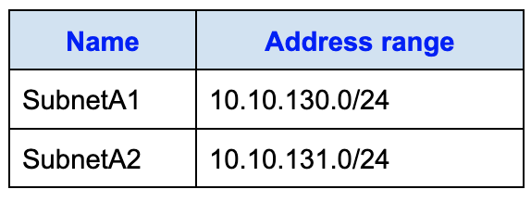
True or False:
`“A Site-to-site connection can be established between VNET1 and VNET2.”`
Réponses:
☐ True
☑ False
Explication
`False` is the correct answer here. A Site-to-Site connection in Azure requires a gateway subnet to be present in each virtual network that participates in the connection. However, in this case, VNet1 uses the entire address space `10.10.10.0/24` for Subnet11, leaving no free IP range available to define a gateway subnet within VNet1.
Since Azure requires a dedicated subnet named `GatewaySubnet` with available IPs in the address space for a VPN gateway to function, and VNet1 does not have any spare address space, you cannot deploy a gateway there.
Because of this, a Site-to-Site connection cannot be established between VNet1 and VNet2, even though their address spaces do not overlap.
Reference(s.):
- https://learn.microsoft.com/en-us/azure/vpn-gateway/vpn-gateway-howto-site-to-site-resource-manager-portal
- https://learn.microsoft.com/en-us/azure/vpn-gateway/vpn-gateway-about-vpngateways
- https://learn.microsoft.com/en-us/azure/vpn-gateway/tutorial-site-to-site-portal

Question 76
You manage two Azure subscriptions named Subscription1 and Subscription2.
Subscription1 has the following virtual networks:
The virtual networks contain the following subnets:
Subscription 2 contains the following virtual network:
- Name: VNETA
- Address space: 10.10.128.0/17
- Location: Canada Central
VNETA contains the following subnets:
True or False:
`“VNET1 and VNET2 can be peered.”`
Réponses:
☑ True
☐ False
Explication
`True` is the correct answer here. Azure virtual network peering supports connections between virtual networks under the following conditions:
- The address spaces of the VNets must not overlap
- The VNets can be in the same or different Azure regions
- The VNets can belong to the same or different subscriptions
In this case:
- VNET1 has an address space of `10.10.10.0/24`
- VNET2 has an address space of `172.16.0.0/16`
These address spaces do not overlap, which satisfies the IP requirement.
Additionally:
- VNET1 is located in West US
- VNET2 is located in West Europe
Azure supports global virtual network peering, which allows peering between virtual networks in different Azure regions.
Therefore, VNET1 and VNET2 can be peered using global VNet peering, and no technical limitation prevents this configuration.
Reference(s.):
- https://learn.microsoft.com/en-us/azure/virtual-network/virtual-network-peering-overview
- https://learn.microsoft.com/en-us/azure/virtual-network/virtual-network-manage-peering

Question 77
You manage two Azure subscriptions named Subscription1 and Subscription2.
Subscription1 has the following virtual networks:
The virtual networks contain the following subnets:
Subscription 2 contains the following virtual network:
- Name: VNETA
- Address space: 10.10.128.0/17
- Location: Canada Central
VNETA contains the following subnets:
True or False:
`“VNET1 and VNETA can be peered.”`
Réponses:
☑ True
☐ False
Explication
`True` is the correct answer here.
Azure allows peering between VNets as long as the following conditions are met:
- No overlapping address ranges
- VNets can be in the same or different subscriptions
- VNets can be in the same or different regions
Since VNET1 and VNETA are in different regions but have non-overlapping IP ranges, they can be peered using global VNet peering.
Reference(s.):
- https://learn.microsoft.com/en-us/azure/virtual-network/virtual-network-peering-overview
- https://learn.microsoft.com/en-us/azure/virtual-network/virtual-network-manage-peering

Question 78
You have an Azure virtual machine named VM1 that is connected to a virtual network called VNet1. VM1 has the following configuration:
- Subnet: 10.0.0.0/24
- Availability set: AVSet
- Network security group (NSG): None
- Private IP address: 10.0.0.4 (dynamic)
- Public IP address: 40.90.219.6 (dynamic)
You deploy a Standard, internet-facing Azure Load Balancer named slb1.
You need to configure slb1 to allow inbound traffic to VM1, and you are permitted to make any required changes to VM1 during the configuration.
Complete the following statement:
“Before creating a backend pool on slb1, you must ____________________.”
Réponses:
☐ Create and assign an NSG to VM1
☑ Remove the public IP address from VM1
☐ Change the private IP address of VM1 to static
Explication
`Remove the public IP address from VM1` is the correct answer here. When using a Standard, Internet-facing Azure Load Balancer, virtual machines that are part of the backend pool should not have individual public IP addresses assigned. Instead, all inbound traffic should be directed to the load balancer’s frontend public IP, and the load balancer will distribute that traffic to the VMs in the backend pool.
In this case, VM1 currently has a dynamic public IP address. For proper configuration with Standard SKU Load Balancer, this dynamic public IP should be removed, and the VM should receive traffic only through the load balancer. The Standard Load Balancer also requires a Standard SKU public IP to be assigned to its frontend configuration—not to the individual VM.
`Create and assign an NSG to VM1` is incorrect because NSGs control traffic flow at the subnet or NIC level but are not required to add a VM to a Standard Load Balancer backend pool. While NSGs can be used for security, they are not relevant to this prerequisite.
`Change the private IP address of VM1 to static` is incorrect in this specific scenario because the VM is being added to a Standard Load Balancer in an Internet-facing configuration. In such cases, the VM’s private IP does not need to be static—only the load balancer’s public IP needs to be static and Standard SKU. The private IP requirement typically applies when the load balancer is internal, not Internet-facing.
Reference(s.):
- https://learn.microsoft.com/en-us/azure/load-balancer/load-balancer-standard-overview
- https://learn.microsoft.com/en-us/azure/load-balancer/quickstart-load-balancer-standard-public-portal
- https://learn.microsoft.com/en-us/azure/load-balancer/load-balancer-troubleshoot#vms-in-backend-pool-need-to-have-no-public-ip-or-use-standard-public-ip-only

Question 79
You have an Azure virtual machine named VM1 that is connected to a virtual network called VNet1. VM1 has the following configuration:
- Subnet: 10.0.0.0/24
- Availability set: AVSet
- Network security group (NSG): None
- Private IP address: 10.0.0.4 (dynamic)
- Public IP address: 40.90.219.6 (dynamic)
You deploy a Standard, internet-facing Azure Load Balancer named slb1.
You need to configure slb1 to allow inbound traffic to VM1, and you are permitted to make any required changes to VM1 during the configuration.
Complete the following statement:
“Before you can connect to VM1 from slb1, you must______________________.”
Réponses:
☑ Create and configure an NSG
☐ Remove the public IP address from VM1
☐ Change the private IP address of VM1 to static
Explication
`Create and configure an NSG` is the correct answer here. In the context of an Internet-facing Standard Load Balancer, after configuring the load balancer and assigning a static, standard public IP to the frontend, you must ensure that traffic is allowed through to the VM. A Network Security Group (NSG) is required to define and permit inbound traffic (such as TCP on port 80 or 443) to the VM or subnet where the VM resides.
By default, no inbound traffic is allowed unless explicitly permitted via an NSG. Without an NSG rule allowing the required traffic, even if the frontend IP and backend pool are configured correctly, the connection to VM1 through slb1 would fail due to traffic being denied at the network layer.
`Remove the public IP address from VM1` is incorrect because this step is only relevant if the VM had a dynamic public IP that conflicted with the Standard Load Balancer setup. Since the public IP has already been properly configured in the prior step, there's no need to remove it again. The focus now is on allowing traffic through to the VM, not modifying its IP configuration.
`Change the private IP address of VM1 to static` is incorrect because this is only required in the context of an internal load balancer or when backend pools rely on consistent internal addressing. For Internet-facing load balancers, private IP settings are not critical for enabling frontend communication. What’s essential is that the NSG allows the traffic to reach the backend VM.
Reference(s.):
- https://learn.microsoft.com/en-us/azure/virtual-network/network-security-groups-overview
- https://learn.microsoft.com/en-us/azure/load-balancer/load-balancer-standard-overview
- https://learn.microsoft.com/en-us/azure/load-balancer/load-balancer-troubleshoot#ensure-nsgs-allow-traffic-to-vms-in-the-backend-pool

Question 80
You have an Azure virtual network named VNet1 that is connected to an on-premises network by using a site-to-site VPN. VNet1 includes a single subnet named Subnet1.
Subnet1 is associated with a network security group (NSG) called NSG1. The subnet hosts a basic internal load balancer named ILB1, which has three Azure virtual machines configured in its backend pool.
You need to collect information about the IP addresses that establish connections to ILB1. The collected data must be available for interactive querying directly from the Azure portal.
Which resource should you create to meet this requirement?
Réponses:
☐ An Azure Event Grid
☑ An Azure Log Analytics workspace
☐ An Azure Storage account
Explication
`An Azure Log Analytics workspace` is the correct answer here. To collect and analyze data about incoming IP addresses connecting to resources like an internal load balancer (ILB1), and to run interactive queries via the Azure portal, the data must be sent to a Log Analytics workspace.
By enabling NSG flow logs on NSG1 (which is associated with Subnet1), you can capture information such as source and destination IP addresses, ports, protocols, and whether traffic was allowed or denied. These logs can be sent to a Log Analytics workspace, where they are indexed and made available for querying using Kusto Query Language (KQL).
`An Azure Event Grid` is incorrect because it is used for event-based messaging and automation—not for storing or querying traffic flow data.
`An Azure Storage account` is incorrect in this context because although NSG flow logs can be stored in a storage account, you cannot run interactive queries on the data from the Azure portal unless the data is also sent to a Log Analytics workspace.
Reference(s.):
- https://learn.microsoft.com/en-us/azure/azure-monitor/logs/quick-create-workspace?tabs=azure-portal
- https://learn.microsoft.com/en-us/azure/azure-monitor/logs/log-analytics-workspace-overview
- https://learn.microsoft.com/en-us/azure/network-watcher/network-watcher-nsg-flow-logging-portal
- https://learn.microsoft.com/en-us/azure/event-grid/overview
- https://learn.microsoft.com/en-us/azure/storage/common/storage-introduction

Question 81
You have an Azure virtual network named VNet1 that is connected to an on-premises network by using a site-to-site VPN. VNet1 includes a single subnet named Subnet1.
Subnet1 is associated with a network security group (NSG) called NSG1. The subnet hosts a basic internal load balancer named ILB1, which has three Azure virtual machines configured in its backend pool.
You need to collect information about the IP addresses that establish connections to ILB1. The collected data must be available for interactive querying directly from the Azure portal.
On which resource should you enable diagnostics?
Réponses:
☐ ILB1
☑ NSG1
☐ The Azure virtual machines
Explication
`NSG1` is the correct answer here. To collect data about the IP addresses that connect to ILB1, you must monitor network traffic, and the correct way to do this in Azure is by enabling NSG flow logs on the Network Security Group (NSG) associated with the subnet or network interface.
In this case:
- NSG1 is associated with Subnet1, which contains ILB1 and its backend virtual machines.
- Enabling diagnostic settings (NSG flow logs) on NSG1 captures detailed flow-level information such as source IP, destination IP, port, protocol, and action (allow/deny).
- The logs can be sent to a Log Analytics workspace, where you can run interactive queries using Kusto Query Language (KQL) directly from the Azure portal.
`ILB1` is incorrect because while you can enable diagnostics on a load balancer, it captures metrics like health probe status and data throughput, not connection-level details like source IP addresses.
`The Azure virtual machines` is incorrect because enabling diagnostics on the VMs focuses on performance and system logs (e.g., CPU, disk, guest OS), but not on the network flow data you need for this scenario.
Reference(s.):
- https://learn.microsoft.com/en-us/azure/network-watcher/network-watcher-nsg-flow-logging-overview
- https://learn.microsoft.com/en-us/azure/network-watcher/network-watcher-nsg-flow-logging-portal

Question 82
You manage an Azure subscription in which you create an Azure Container Registry (ACR) and build a container image locally.
You plan to upload the container image to the Azure Container Registry by using the Azure Command-Line Interface (CLI).
After successfully signing in to the container registry, what should you do next to prepare the image for upload?
Réponses:
☑ Assign a tag to the container image that includes the container registry’s login server name.
☐ Display a list of container images that already exist in the container registry.
☐ Deploy a container group.
☐ Configure a YAML file.
Explication
`Assign a tag to the container image that includes the container registry’s login server name` is the correct answer here. After signing in to an Azure Container Registry (ACR), the next required step to push a container image is to tag the image using the registry’s login server URL. This tag identifies the destination registry and repository for the image. The format typically looks like:
az acr login --name <registryName>
docker tag <localImageName> <registryName>.azurecr.io/<repositoryName>:<tag>
docker push <registryName>.azurecr.io/<repositoryName>:<tag>This step is necessary because Docker uses the tag to determine where the image should be pushed. Without tagging the image with the correct registry address, the `docker push` command will not know the target location.
`Display a list of container images that already exist in the container registry` is incorrect because it does not help in preparing an image for upload.
`Deploy a container group` is incorrect because this step would come after the image is already pushed and available in the container registry.
`Configure a YAML file` is incorrect because YAML files are typically used for defining deployments in Kubernetes or other orchestration platforms, not for pushing container images.
Reference(s.):
- https://learn.microsoft.com/en-us/azure/container-registry/container-registry-get-started-azure-cli
- https://learn.microsoft.com/en-us/azure/container-registry/container-registry-authentication

Question 83
You have an application named App1 that will be deployed on two Azure virtual machines, VM1 and VM2.
You plan to use an Azure Availability Set for App1. The solution must ensure that App1 remains available when Azure performs planned maintenance on the physical hardware hosting VM1 and VM2.
What configuration should you include when creating the Availability Set?
Réponses:
☐ one update domain
☑ two update domains
☐ one fault domain
☐ two fault domains
Explication
`two update domains` is the correct answer here. Update domains in an Availability Set ensure that not all virtual machines are rebooted at the same time during planned maintenance events, such as OS patching or Azure platform updates. By placing VM1 and VM2 in two separate update domains, Azure ensures that only one VM is rebooted at a time, keeping App1 available during maintenance.
This satisfies the requirement to maintain availability of App1 during planned maintenance, which is exactly what update domains are designed to protect against.
`one update domain` is incorrect because placing both VMs in the same update domain would allow both to be rebooted simultaneously during planned maintenance, causing downtime for App1.
`one fault domain` and `two fault domains` are incorrect in this context because fault domains deal with unplanned hardware failures, not planned maintenance. While fault domains enhance resilience to physical failures, they do not ensure availability during platform maintenance activities.
Reference(s.):
- https://learn.microsoft.com/en-us/azure/virtual-machines/availability-set-overview
- https://learn.microsoft.com/en-us/azure/virtual-machines/availability

Question 84
You have an Azure subscription that includes an Azure Storage account named storage1.
The subscription has the following users and group memberships:
- User1 is a member of Group1.
- User2 is a member of Group2.
- User3 is a member of Group1.
You plan to monitor storage1 and configure email notifications for specific monitoring signals.
The notification requirements are as follows:
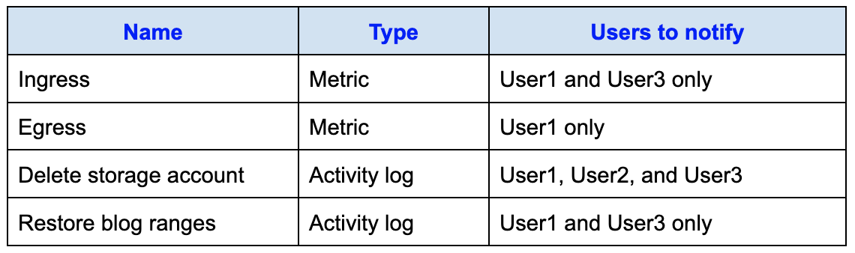
How many Alert rules are required to meet all the monitoring and notification requirements.
Réponses:
☐ 1
☐ 2
☐ 3
☑ 4
Explication
`4` is correct. Four alert rules are required because alert rules are based on unique combinations of signal type (Metric vs. Activity log) and conditions.
Here we have 4 different signals, so each rule will monitor a distinct event.
Reference(s):
- https://learn.microsoft.com/en-us/azure/azure-monitor/alerts/alerts-overview
- https://learn.microsoft.com/en-us/azure/azure-monitor/alerts/action-groups

Question 85
You have an Azure subscription that includes an Azure Storage account named storage1.
The subscription has the following users and group memberships:
- User1 is a member of Group1.
- User2 is a member of Group2.
- User3 is a member of Group1.
You plan to monitor storage1 and configure email notifications for specific monitoring signals.
The notification requirements are as follows:
How many Action groups are required to meet all the monitoring and notification requirements.
Réponses:
☐ 1
☐ 2
☑ 3
☐ 4
Explication
`3` is correct. An Action Group defines who gets notified and how. You need a separate Action Group only when the set of recipients (users) is different. Looking at the notification requirements:
- Ingress: Notifies User1 and User3 - Action Group 1
- Egress: Notifies User1 only - Action Group 2
- Delete storage account: Notifies User1, User2, and User3 - Action Group 3
- Restore blob ranges: Notifies User1 and User3 - Same as Ingress - reuse Action Group 1
So, only three distinct sets of recipients, hence 3 Action Groups are required.
Reference(s):
- https://learn.microsoft.com/en-us/azure/azure-monitor/alerts/action-groups
- https://learn.microsoft.com/en-us/azure/azure-monitor/alerts/alerts-overview

Question 86
You manage two Azure App Service apps named App1 and App2. Each app contains:
- A production deployment slot
- A test deployment slot
The backup settings for the production slots are configured as follows:
- App1
- Backup frequency: Every 1 day
- Schedule start date: January 6, 2024
- Retention period: 0 days
- Keep at least one backup: Yes
- App2
- Backup frequency: Every 1 day
- Schedule start date: January 6, 2024
- Retention period: 30 days
- Keep at least one backup: Yes
Based on this configuration, determine the effect of the backup and retention settings.
True or False:
`“On January 15, 2024, App1 will have only one backup in storage.”`
Réponses:
☐ True
☑ False
Explication
`False` is the correct answer because the backup configuration for App1 specifies a retention period of 0 days with “Keep at least one backup” set to Yes. In Azure App Service, setting the retention to 0 means backups are retained indefinitely unless manually deleted. Additionally, the “keep at least one backup” option ensures that even if retention policies are applied, at least one backup is preserved.
Since App1 is backed up daily starting from January 6, 2024, by January 15, 2024, there would be multiple backups retained unless manually removed. Therefore, App1 would not have only one backup in storage on that date.
Reference(s):
- https://learn.microsoft.com/en-us/azure/app-service/manage-backup
- https://learn.microsoft.com/en-us/cli/azure/webapp/config/backup?view=azure-cli-latest

Question 87
You manage two Azure App Service apps named App1 and App2. Each app contains:
- A production deployment slot
- A test deployment slot
The backup settings for the production slots are configured as follows:
- App1
- Backup frequency: Every 1 day
- Schedule start date: January 6, 2024
- Retention period: 0 days
- Keep at least one backup: Yes
- App2
- Backup frequency: Every 1 day
- Schedule start date: January 6, 2024
- Retention period: 30 days
- Keep at least one backup: Yes
Based on this configuration, determine the effect of the backup and retention settings.
True or False:
`“On February 6, 2024, you can access the backup of the App2 test slot from January 15, 2024.”`
Réponses:
☐ True
☑ False
Explication
`False` is the correct answer because the backup configuration applies only to the production slot of App2, not the test slot. The table provided shows backup settings for the production slots of App1 and App2, and there is no mention of backups being configured for the test slot of App2.
Since Azure App Service does not automatically back up deployment slots other than the production slot unless explicitly configured, no backup of the App2 test slot from January 15, 2024 would exist by February 6, 2024.
Reference(s):
- https://learn.microsoft.com/en-us/azure/app-service/manage-backup
- https://learn.microsoft.com/en-us/azure/app-service/deploy-staging-slots

Question 88
You manage two Azure App Service apps named App1 and App2. Each app contains:
- A production deployment slot
- A test deployment slot
The backup settings for the production slots are configured as follows:
- App1
- Backup frequency: Every 1 day
- Schedule start date: January 6, 2024
- Retention period: 0 days
- Keep at least one backup: Yes
- App2
- Backup frequency: Every 1 day
- Schedule start date: January 6, 2024
- Retention period: 30 days
- Keep at least one backup: Yes
Based on this configuration, determine the effect of the backup and retention settings.
True or False:
`“On January 15, 2024, you can restore the App2 production slot backup from January 6 to the App2 test slot.”`
Réponses:
☑ True
☐ False
Explication
`True` is correct because Azure App Service allows you to restore a backup taken from the production slot to any other slot of the same app, including a test slot. The backup of the App2 production slot from January 6, 2024 would still be available on January 15, 2024 because the retention policy is set to 30 days and the "Keep at least one backup" option is enabled.
This means that the backup from January 6 is retained and can be used to restore not only to the production slot but also to the test slot, assuming the restore operation is initiated within the retention period.
Reference(s):
- https://learn.microsoft.com/en-us/azure/app-service/manage-backup#restore-an-app
- https://learn.microsoft.com/en-us/azure/app-service/web-sites-staged-publishing

Question 89
You are creating an Azure Resource Manager (ARM) template (shown below) that performs the following actions:
- Creates a new resource group.
- Deploys an Azure Storage account into that resource group by using a nested deployment.
{
"$schema": "https://schema.management.azure.com/schemas/2023-04-01/deploymentTemplate.json#",
"contentVersion": "1.0.0.0",
"resources": [
{
"type": "Microsoft.Resources/resourceGroups",
"apiVersion": "2025-11-01",
"location": "eastus",
"name": "RG1"
},
{
"type": "Microsoft.Resources/deployments",
"apiVersion": "2025-11-01",
"name": "storageDeployment",
"resourceGroup": "RG1",
"dependsOn": [
"[resourceId('Microsoft.Resources/resourceGroups/', 'RG1')]"
],
"properties": {
"mode": "Incremental",
"template": {
"$schema": "https://schema.management.azure.com/schemas/2015-01-01/deploymentTemplate.json#",
"contentVersion": "1.0.0.0",
"resources": [
{
"type": "Microsoft.Storage/storageAccounts",
"apiVersion": "2025-05-01",
"name": "storage1",
"location": "eastus",
"kind": "StorageV2",
"sku": {
"name": "Standard_LRS"
}
}
]
}
}
}
]
}
Which PowerShell cmdlet should you run to deploy the template?
Réponses:
☑ New-AzDeployment
☐ New-AzResource
☐ New-AzResourceGroupDeployment
☐ New-AzTenantDeployment
Explication
`New-AzDeployment` is the correct cmdlet to use when your ARM template includes a nested deployment of a resource group, as shown in the image. This cmdlet allows you to deploy resources at the subscription level, which is necessary here because the template first creates a resource group (RG1) and then deploys a storage account into that group.
The nested deployment structure in the ARM template includes:
- A `Microsoft.Resources/resourceGroups` resource to create the resource group.
- A `Microsoft.Resources/deployments` resource that deploys the storage account into the newly created group using a nested template.
Since the deployment targets multiple scopes (subscription and resource group), you must use a subscription-level deployment cmdlet like `New-AzDeployment`.
`New-AzResourceGroupDeployment` is incorrect because it's used to deploy resources within an existing resource group. It cannot be used when your template includes the creation of a new resource group.
`New-AzSubscriptionDeployment` is an alias for `New-AzDeployment`, but the preferred cmdlet name is `New-AzDeployment`, which works consistently across all scopes in newer versions of the Az PowerShell module.
Reference(s):
- https://learn.microsoft.com/en-us/powershell/module/az.resources/new-azdeployment
- https://learn.microsoft.com/en-us/azure/azure-resource-manager/templates/deploy-to-subscription

Question 90
You have an Azure subscription that includes a web app named webapp1.
You want to associate a custom domain, www.apexcore.com, with webapp1.
Before you can complete the custom domain configuration, what is the first action you must take?
Réponses:
☐ Upload a certificate.
☐ Stop webapp1.
☑ Create a DNS record.
☐ Add a connection string.
Explication
`Create a DNS record` is the correct answer because before you can map a custom domain (like `www.apexcore.com`) to an Azure Web App (e.g., `webapp1`), you must prove ownership of the domain. This is done by creating a CNAME or A record in the public DNS zone for the domain, pointing to the web app's default Azure domain (e.g., `webapp1.azurewebsites.net`). This step allows Azure to validate that you control the domain name.
`Upload a certificate` is incorrect because uploading an SSL certificate is only required if you plan to enable HTTPS for the custom domain. It’s not required as the first step in domain assignment.
`Stop webapp1` is incorrect because there's no need to stop the app when adding or validating a custom domain. The app can stay running throughout the process.
`Add a connection string` is incorrect because this relates to configuring access to backend services like databases. It has nothing to do with custom domain configuration.
Reference(s):
- https://learn.microsoft.com/en-us/azure/app-service/app-service-web-tutorial-custom-domain
- https://learn.microsoft.com/en-us/Azure/app-service/app-service-web-tutorial-custom-domain?tabs=root%2Cazurecli

