AZ-104 - Practice Test 4
AZ-104 — Azure Administrator · 88 questions

Question 1
You have an Azure subscription that includes the virtual networks listed below:
- VNet1 in the West US region, peered with VNet2
- VNet2 in the West US region, peered with VNet1 and VNet3
- VNet3 in the East US region, peered with VNet2
The subscription also contains the following virtual machines:
- VM1, connected to VNet1
- VM2, connected to VNet2
- VM3, connected to VNet3
All virtual machines have private IP addresses only.
You deploy an Azure Bastion host named Bastion1 in VNet1.
Which virtual machines can you connect to by using Bastion1?
Réponses:
☐ VM1 only
☑ VM1 and VM2 only
☐ VM1 and VM3 only
☐ VM1, VM2, and VM3
Explication
`VM1 and VM2 only` is the correct answer because Azure Bastion allows connections to virtual machines within the same virtual network or peered virtual networks. Since Bastion1 is deployed in VNet1, it can connect to VM1 (in VNet1) and VM2 (in VNet2), as VNet1 and VNet2 are peered. However, VM3 is in VNet3, which is peered only with VNet2 but not directly with VNet1, preventing Bastion1 from connecting to VM3.
`VM1 only` is incorrect because Bastion1 can also connect to VM2 in VNet2 through the peering with VNet1.
`VM1 and VM3 only` is incorrect because, while VM1 is accessible, VM3 is not reachable via Bastion1 due to the lack of direct peering between VNet1 and VNet3.
`VM1, VM2, and VM3` is incorrect because Bastion1 cannot connect to VM3 since there is no direct peering between VNet1 and VNet3.
Reference(s):
- https://learn.microsoft.com/en-us/azure/bastion/bastion-overview
- https://learn.microsoft.com/en-us/azure/bastion/vnet-peering
- https://learn.microsoft.com/en-us/azure/virtual-network/virtual-network-peering-overview

Question 2
You have an Azure subscription that includes the following resources:
- A virtual network named VNET1 deployed in the East US region
- A public IP address named IP1 deployed in the West Europe region
- A route table named RT1 deployed in the North Europe region
You are required to create a network interface named NIC1. The solution must use only existing resources, and no additional Azure resources can be created as part of the process.
In which Azure region can NIC1 be created?
Réponses:
☑ East US only
☐ East US and West Europe only
☐ East US and North Europe only
☐ East US, West Europe, and North Europe
Explication
`East US only` is the correct answer because network interfaces (NICs) must be created in the same region as the virtual network (VNet) they are associated with. In this case, VNET1 is in the East US region, so NIC1 must also be created in East US to connect to VNET1 without requiring additional resources.
`East US and West Europe only` is incorrect because a NIC must be in the same region as its associated virtual network, and VNET1 is only in East US.
`East US and North Europe only` is incorrect for the same reason. NIC1 cannot be created in North Europe if it needs to connect to VNET1, which is located in East US.
`East US, West Europe, and North Europe` is incorrect because the NIC must be in the same region as the VNet, which is East US in this case.
Reference(s):
- https://learn.microsoft.com/en-us/azure/virtual-network/virtual-network-network-interface

Question 3
You have an Azure subscription that includes three virtual networks: VNet-A, VNet-B, and VNet-C.
The current peering configuration is as follows:
- VNet-A
- Peered with VNet-B -> Status: Connected -> Gateway transit: Disabled
- Peered with VNet-C -> Status: Connected -> Gateway transit: Disabled
- VNet-B
- Peered with VNet-A -> Status: Connected -> Gateway transit: Disabled
- VNet-C
- Peered with VNet-A -> Status: Connected -> Gateway transit: Disabled
Each peering shows a connected status.
Based on the information shown in the exhibits, complete the following statement by selecting the correct option:
“Traffic originating from VNET-A can be routed to __________.”
Réponses:
☐ VNet-B only
☐ VNet-C only
☑ VNet-B and VNet-C
Explication
`VNet-B and VNet-C` is the correct answer because VNet-A has peering connections established with both VNet-B and VNet-C. This setup allows packets from VNet-A to be routed directly to both VNet-B and VNet-C through the peering connections. The peering status is connected, and no additional configurations are needed since the gateway transit is disabled for all peering links, which does not impact routing between the peered networks.
`VNET-B only` is incorrect because packets can also be routed to VNet-C due to the established peering connection between VNet-A and VNet-C.
`VNET-C only` is incorrect because packets can also be routed to VNet-B due to the established peering connection between VNet-A and VNet-B.
Reference(s):
- https://learn.microsoft.com/en-us/azure/virtual-network/virtual-network-peering-overview
- https://docs.microsoft.com/en-us/azure/vpn-gateway/vpn-gateway-peering-gateway-transit

Question 4
You have an Azure subscription that includes three virtual networks: VNet-A, VNet-B, and VNet-C.
The current peering configuration is as follows:
- VNet-A
- Peered with VNet-B -> Status: Connected -> Gateway transit: Disabled
- Peered with VNet-C -> Status: Connected -> Gateway transit: Disabled
- VNet-B
- Peered with VNet-A -> Status: Connected -> Gateway transit: Disabled
- VNet-C
- Peered with VNet-A -> Status: Connected -> Gateway transit: Disabled
Each peering shows a connected status.
Based on the information shown in the exhibits, complete the following statement by selecting the correct option:
“Traffic originating from VNet-B can be routed to __________.”
Réponses:
☑ VNet-A only
☐ VNet-C only
☐ VNet-A and VNet-C
Explication
`VNet-A only` is the correct answer because VNet-B has a direct peering connection with VNet-A, which allows routing of packets between these two virtual networks. Since gateway transit is disabled, VNet-B cannot leverage VNet-A as a transit network to reach other networks, such as VNet-C. This configuration restricts communication to only those virtual networks with direct peering links.
`VNet-C only` is incorrect because there is no direct peering connection between VNet-B and VNet-C, and VNet-B cannot route through VNet-A due to the disabled gateway transit.
`VNet-A and VNet-C` is incorrect because, without gateway transit enabled, VNet-B is restricted to direct communication only with VNet-A.
Reference(s):
- https://learn.microsoft.com/en-us/azure/virtual-network/virtual-network-peering-overview
- https://docs.microsoft.com/en-us/azure/vpn-gateway/vpn-gateway-peering-gateway-transit

Question 5
You have an Azure subscription that includes the following public IP address resources:
- IP1: IPv4, Standard SKU, Regional tier, Static assignment
- IP2: IPv4, Standard SKU, Global tier, Static assignment
- IP3: IPv4, Basic SKU, Regional tier, Dynamic assignment
- IP4: IPv4, Basic SKU, Regional tier, Static assignment
- IP5: IPv6, Basic SKU, Regional tier, Dynamic assignment
You plan to deploy an Azure Bastion host named Bastion1 using the Basic SKU.
Which of the listed public IP addresses can be used for Bastion1?
Réponses:
☑ IP1 only
☐ IP1 and IP2 only
☐ IP3, IP4, and IP5 only
☐ IP1, IP2, IP4, and IP5 only
☐ IP1, IP2, IP3, IP4, and IP5
Explication
`IP1 only` is the correct answer because Azure Bastion requires a Standard Public IP address for both the Basic and Standard SKUs. Additionally, the IP address must be IPv4, have a Regional tier, and use a Static assignment. Among the provided options, IP1 is the only address that satisfies all these conditions, making it suitable for Azure Bastion.
Note: The Microsoft documentation does not explicitly list “Regional tier” as a Bastion requirement. However, in practice, Azure Bastion supports only Regional tier public IPs. Global tier public IPs are intended for cross-region load balancers and cannot be attached to Azure Bastion. This behavior is also confirmed when attempting deployment in the Azure portal, where attaching a Global tier public IP to Bastion results in an error.
- IP2 is incorrect because it has a Global tier, while the requirement is for a Regional tier.
- IP3 is incorrect due to its Basic SKU and Dynamic assignment, both of which are incompatible with Azure Bastion.
- IP4 is incorrect because it also uses the Basic SKU, which does not meet the Standard SKU requirement.
- IP5 is incorrect as it is an IPv6 address, and Azure Bastion supports only IPv4.
Reference(s):
- https://learn.microsoft.com/en-us/azure/bastion/bastion-overview
- https://learn.microsoft.com/en-us/azure/virtual-network/ip-services/configure-public-ip-bastion
- https://learn.microsoft.com/en-us/azure/virtual-network/ip-services/configure-public-ip-bastion

Question 6
You have an Azure subscription.
You plan to deploy a virtual network named VNET1 by using an Azure Resource Manager (ARM) template. The virtual network will be configured to support Azure Bastion.
You are provided with a partially completed ARM template that defines the virtual network, its address space, and two subnets. One subnet definition contains two placeholders that must be completed.
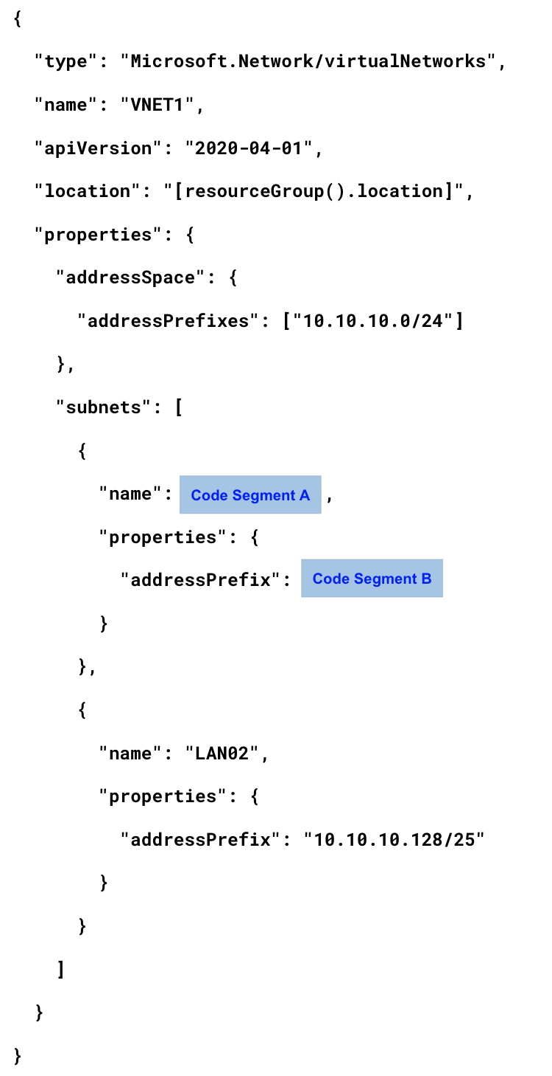
What should you choose for `Code Segment A`?
Réponses:
☑ AzureBastionSubnet
☐ AzureFirewallSubnet
☐ LAN01
☐ RemoteAccessSubnet
Explication
`AzureBastionSubnet` is the correct answer because, to use Azure Bastion, a subnet specifically named AzureBastionSubnet is required. This subnet name is reserved for Azure Bastion deployments and must be configured in the virtual network where Bastion is being deployed.
`AzureFirewallSubnet` is incorrect because this is the reserved subnet name required for Azure Firewall, not Azure Bastion.
`LAN01` is incorrect because it is a generic subnet name and does not meet the specific naming requirement for Azure Bastion.
`RemoteAccessSubnet` is incorrect because it does not align with the required naming convention for Azure Bastion.
Reference(s):
- https://learn.microsoft.com/en-us/azure/bastion/configuration-settings
- https://learn.microsoft.com/en-us/azure/bastion/tutorial-create-host-portal#createhost

Question 7
You have an Azure subscription.
You plan to deploy a virtual network named VNET1 by using an Azure Resource Manager (ARM) template. The virtual network will be configured to support Azure Bastion.
You are provided with a partially completed ARM template that defines the virtual network, its address space, and two subnets. One subnet definition contains two placeholders that must be completed.
What should you choose for `Code Segment B`?
Réponses:
☑ 10.10.10.0/26
☐ 10.10.10.0/28
☐ 10.10.10.0/30
Explication
`10.10.10.0/26` is the correct answer because the AzureBastionSubnet for Azure Bastion requires a subnet prefix of at least /26 to function properly. This prefix size provides a sufficient number of IP addresses for Azure Bastion to manage connections and maintain operational capacity.
`10.10.10.0/28` is incorrect because a /28 subnet does not provide enough IP addresses for Azure Bastion, which requires a minimum of /26.
`10.10.10.0/30` is incorrect because a /30 subnet provides only a very limited number of IP addresses, far below the requirements for Azure Bastion.
Reference(s):
- https://learn.microsoft.com/en-us/azure/bastion/configuration-settings
- https://learn.microsoft.com/en-us/azure/bastion/tutorial-create-host-portal#createhost

Question 8
You have a Windows 11 computer named Device1 and an Azure subscription that includes the following resources:
- A virtual network named VNET1
- A virtual machine named VM1 that runs Windows Server 2022, has no public IP address, and is connected to VNET1
- An Azure Bastion Basic SKU host named Bastion1 that is connected to VNET1
Device1 has both Azure PowerShell and the Azure CLI installed.
You need to establish a Remote Desktop (RDP) connection from Device1 to VM1.
Which three actions should you perform in sequence?
ACTIONS
- From Bastion1, select Native Client Support.
- On Device1, run mstsc.exe.
- Upgrade Bastion1 to the Standard SKU.
- From Bastion1, enable Kerberos authentication.
- From VM1, enable just-in-time (JIT) VM access.
- From Azure CLI on Device1, run az network bastion rdp.
Réponses:
☐ 3-6-1
☐ 3-4-1
☐ 3-2-6
☑ 3-1-6
Explication
`(Action 3) Upgrade Bastion1 to the Standard SKU` – To use the native client feature for Azure Bastion, which allows connecting via a local RDP client (such as mstsc.exe), Bastion1 must be upgraded to the Standard SKU, as this feature is not available with the Basic SKU.
`(Action 1) From Bastion1, select Native Client Support` – After upgrading, enable the native client support option within the Azure Bastion configuration. This feature allows Device1 to connect to VM1 through Bastion using an RDP client.
`(Action 6) From Azure CLI on Device1, run az network bastion rdp` – Use the `az network bastion rdp` command on Device1’s Azure CLI to initiate the RDP connection to VM1 through Bastion1. This command establishes the RDP session without requiring the direct use of `mstsc.exe`.
To connect via RDP, use the following command:
`az network bastion rdp --name "<BastionName>" --resource-group "<ResourceGroupName>" --target-resource-id "<VMResourceId>"`
`(Action 2) On Device1, run mstsc.exe` is not necessary when using the Azure CLI command, as `az network bastion rdp` initiates the connection directly.
`(Action 4) Enable Kerberos authentication` and `(Action 5) Enable just-in-time (JIT) VM access` are not required for this setup.
Reference(s):
- https://learn.microsoft.com/en-us/azure/bastion/bastion-connect-cli
- https://learn.microsoft.com/en-us/azure/bastion/native-client

Question 9
You have an Azure subscription that includes the following resources:
- VMRG – Resource group
- VNet1 – Virtual network
- VNet2 – Virtual network
- VM5 – Virtual machine connected to VNet1
- VM6 – Virtual machine connected to VNet2
You create an Azure private DNS zone named apexcore.com.
You then link the private DNS zone to VNet2 and enable auto-registration for the virtual network link.
The apexcore.com private DNS zone is configured with existing DNS records, as shown in the below exhibit.
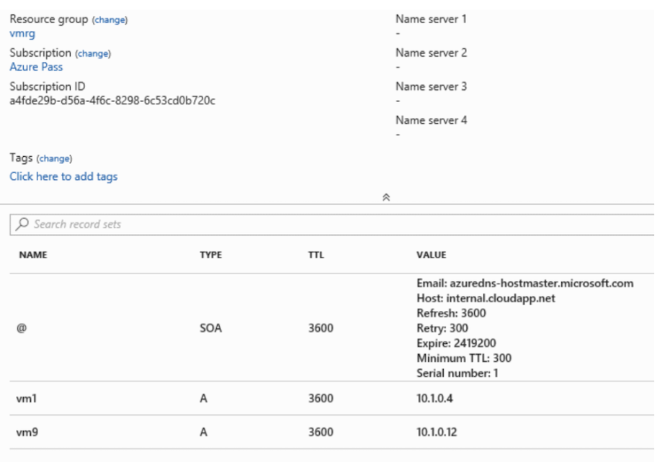
True or False:
`“The A record for VM5 will be registered automatically in the apexcore.com zone.”`
Réponses:
☐ True
☑ False
Explication
`False` is the correct answer. Azure DNS allows for the automatic registration of virtual machines from one designated virtual network linked to a private DNS zone as the registration network. In this case, VNet2 is set as the registration virtual network for the apexcore.com zone. However, VM5 is part of VNet1, not VNet2. Since VM5 does not belong to the registration virtual network, its DNS record will not be automatically registered in the apexcore.com zone.
Reference(s):
- https://learn.microsoft.com/en-us/azure/dns/private-dns-autoregistration
- https://learn.microsoft.com/en-us/azure/dns/private-dns-overview

Question 10
You have an Azure subscription that includes the following resources:
- VMRG – Resource group
- VNet1 – Virtual network
- VNet2 – Virtual network
- VM5 – Virtual machine connected to VNet1
- VM6 – Virtual machine connected to VNet2
You create an Azure private DNS zone named apexcore.com.
You then link the private DNS zone to VNet2 and enable auto-registration for the virtual network link.
The apexcore.com private DNS zone is configured with existing DNS records, as shown in the below exhibit.
True or False:
`“VM5 can resolve VM9.apexcore.com."`
Réponses:
☐ True
☑ False
Explication
`False` is correct. VM5 cannot resolve VM9.apexcore.com because VM5 is connected to VNet1, while VM9 is connected to VNet2. Forward DNS resolution is only supported across virtual networks that are linked to the private DNS zone as resolution virtual networks. In this setup, VNet2 is linked to the apexcore.com private DNS zone, but VNet1 is not linked to this zone nor is it peered with VNet2. Since VNet1 is not configured as a resolution virtual network, VM5 cannot resolve the domain name VM9.apexcore.com.
Reference(s):
- https://learn.microsoft.com/en-us/azure/private-link/private-endpoint-dns
- https://learn.microsoft.com/en-us/azure/dns/private-dns-overview

Question 11
You have an Azure subscription that includes the following resources:
- VMRG – Resource group
- VNet1 – Virtual network
- VNet2 – Virtual network
- VM5 – Virtual machine connected to VNet1
- VM6 – Virtual machine connected to VNet2
You create an Azure private DNS zone named apexcore.com.
You then link the private DNS zone to VNet2 and enable auto-registration for the virtual network link.
The apexcore.com private DNS zone is configured with existing DNS records, as shown in the below exhibit.
True or False:
`“VM6 can resolve VM9.apexcore.com."`
Réponses:
☑ True
☐ False
Explication
`True` is correct. VM6 can resolve VM9.apexcore.com because it belongs to VNet2, which is configured as the registration virtual network for the apexcore.com private DNS zone. Since VNet2 is the registration virtual network, it also serves as the resolution virtual network by default, allowing DNS resolution within this virtual network. An A (Host) record for VM9 exists in the DNS zone, enabling VM6 to successfully resolve the domain name VM9.apexcore.com from within VNet2.
Reference(s):
- https://learn.microsoft.com/en-us/azure/private-link/private-endpoint-dns
- https://learn.microsoft.com/en-us/azure/dns/private-dns-overview

Question 12
You have two Azure virtual machines running Windows Server, configured as shown below:
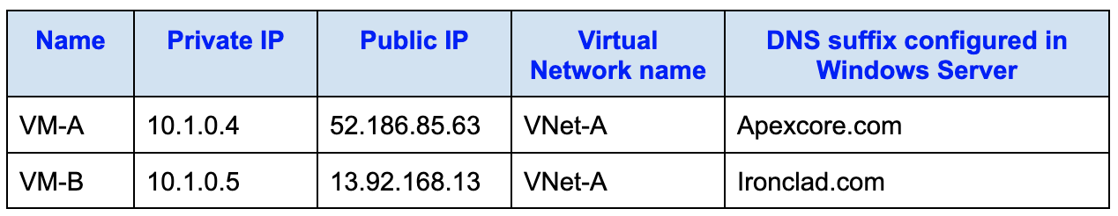
You then create a private Azure DNS zone named apexcore.com and configure the zone to allow automatic DNS registration from VNet-A.
Which A record will be automatically created in the apexcore.com private DNS zone for VM-A?
Réponses:
☐ None
☑ Private IP address only
☐ Public IP address only
☐ Private IP address and public IP address
Explication
`Private IP address only` is the correct answer because when a private Azure DNS zone (such as apexcore.com) is configured for auto-registration in a virtual network (VNet-A), only the private IP addresses of virtual machines in that network are automatically registered in the DNS zone. Public IP addresses are not registered in private DNS zones. Therefore, for VM-A, only the private IP address 10.1.0.4 will be added as an A record in the apexcore.com zone, while the public IP address 52.186.85.63 will not be included.
`None` is incorrect because VM-A is part of VNet-A, and VNet-A is configured for auto-registration in the apexcore.com DNS zone. Therefore, VM1’s private IP address will be registered in the zone.
`Public IP address only` is incorrect because public IP addresses are not registered in private DNS zones. Auto-registration only includes the private IP address.
`Private IP address and public IP address` is incorrect because only the private IP address will be registered in the apexcore.com zone. Public IP addresses are excluded from auto-registration.
Reference(s):
- https://docs.microsoft.com/en-us/azure/dns/private-dns-overview
- https://docs.microsoft.com/en-us/azure/dns/private-dns-scenarios
- https://docs.microsoft.com/en-us/azure/dns/private-dns-scenarios#scenario-split-horizon-functionality

Question 13
You have two Azure virtual machines running Windows Server, configured as shown below:
You then create a private Azure DNS zone named apexcore.com and configure the zone to allow automatic DNS registration from VNet-A.
Which A record will be automatically created in the apexcore.com private DNS zone for VM-B?
Réponses:
☐ None
☑ Private IP address only
☐ Public IP address only
☐ Private IP address and public IP address
Explication
`Private IP address only` is the correct answer because in Azure private DNS zones, DNS records are created based on the Virtual network links to the VNet rather than the DNS suffix configured on the VM itself. Since VNet-A is linked to the adatum.com private DNS zone and auto-registration is enabled, VM-B’s private IP address (10.1.0.5) will be automatically registered in the apexcore.com zone despite its DNS suffix being set to ironclad.com.
`None` is incorrect because the DNS name configured on the VM does not impact auto-registration; as long as the VNet is linked, VM-B’s private IP will be registered.
`Public IP address only` is incorrect because Azure private DNS zones do not register public IP addresses; they register only private IP addresses.
`Private IP address and public IP address` is incorrect because Azure private DNS zones only register private IP addresses, not public ones.
Reference(s):
- https://learn.microsoft.com/en-us/azure/dns/private-dns-autoregistration
- https://docs.microsoft.com/en-us/azure/dns/private-dns-overview
- https://docs.microsoft.com/en-us/azure/dns/private-dns-scenarios
- https://docs.microsoft.com/en-us/azure/dns/private-dns-scenarios#scenario-split-horizon-functionality

Question 14
You have an Azure subscription that includes the container images listed below:
- Image1: Built on Windows Server
- Image2: Built on Linux
You plan to deploy containers by using the following Azure services:
- Azure Container Instances
- Azure Container Apps
- Azure App Service
Based on the supported operating systems for each service, which of the listed Azure services can be used to run Image1?
Réponses:
☐ Azure Container Instances only
☐ Azure Container Apps only
☑ Azure Container Instances and App Services only
☐ Azure Container Apps and App Services only
☐ Azure Container Instances, Azure Container Apps, and App Services
Explication
`Azure Container Instances and App Services only` is the correct answer because Image1 is based on Windows Server, and Azure Container Instances (ACI) and Azure App Service support Windows-based containers. Azure Container Apps, however, only supports Linux-based containers, so it cannot be used to run Image1.
`Azure Container Instances only` is incorrect because Azure App Service also supports Windows-based containers, making it a valid option for running Image1.
`Azure Container Apps only` is incorrect because Azure Container Apps does not support Windows-based containers; it only supports Linux-based containers.
`Azure Container Apps and App Services only` is incorrect because Azure Container Apps does not support Windows-based containers.
`Azure Container Instances, Azure Container Apps, and App Services` is incorrect because Azure Container Apps does not support Windows-based containers, so it cannot be used to run Image1.
Reference(s):
- https://learn.microsoft.com/en-us/azure/container-instances/container-instances-overview
- https://learn.microsoft.com/en-us/azure/container-apps/containers
- https://learn.microsoft.com/en-us/azure/app-service/overview

Question 15
You have an Azure subscription that includes the container images listed below:
- Image1: Built on Windows Server
- Image2: Built on Linux
You plan to deploy containers by using the following Azure services:
- Azure Container Instances
- Azure Container Apps
- Azure App Service
Based on the supported operating systems for each service, which of the listed Azure services can be used to run Image2?
Réponses:
☐ Azure Container Instances only
☐ Azure Container Apps only
☐ Azure Container Instances and App Services only
☐ Azure Container Apps and App Services only
☑ Azure Container Instances, Azure Container Apps, and App Services
Explication
`Azure Container Instances, Azure Container Apps, and App Services` is the correct answer because Image2 is based on Linux, and all three services — Azure Container Instances (ACI), Azure Container Apps, and Azure App Service — support Linux-based containers. Therefore, Image2 can run on any of these services.
`Azure Container Instances only` is incorrect because both Azure Container Apps and Azure App Service also support Linux-based containers, making them valid options for running Image2.
`Azure Container Apps only` is incorrect because Azure Container Instances and Azure App Service can also run Linux-based containers, so this option is too restrictive.
`Azure Container Instances and App Services only` is incorrect because Azure Container Apps also supports Linux-based containers, making it another valid option for Image2.
`Azure Container Apps and App Services only` is incorrect because Azure Container Instances is also capable of running Linux-based containers.
Reference(s):
- https://learn.microsoft.com/en-us/azure/container-instances/container-instances-overview
- https://learn.microsoft.com/en-us/azure/container-apps/containers
- https://learn.microsoft.com/en-us/azure/app-service/overview

Question 16
You have a Microsoft Entra tenant that contains the users listed in the following table, each assigned specific administrative roles.
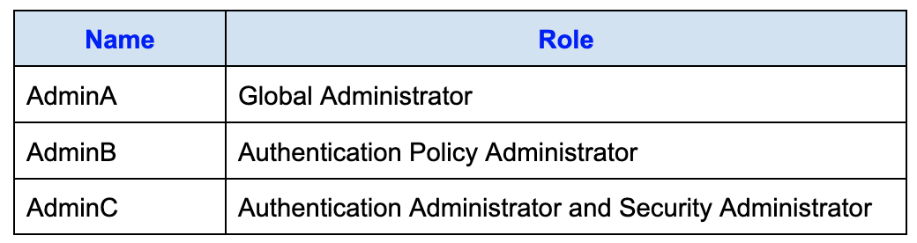
The tenant also contains the groups as shown in the below table, with different group types and membership configurations.
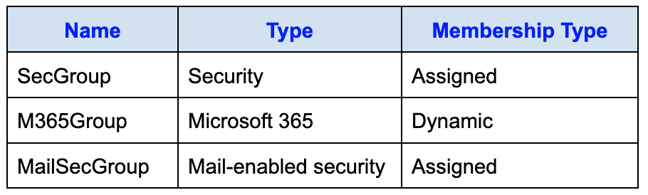
Self-service password reset (SSPR) must be configured for the tenant.
Which of the listed users are permitted to configure SSPR?
Réponses:
☐ AdminA only
☐ AdminB only
☐ AdminC only
☑ AdminA and AdminB only
☐ AdminB and AdminC only
☐ AdminA, AdminB, and AdminC
Explication
`AdminA and AdminB only` is correct because in order to configure Self-Service Password Reset (SSPR) in Microsoft Entra, a user must have at least the Authentication Policy Administrator role. In this case, AdminA is the user with the Global Administrator role and AdminA has Authentication Policy Admin role which grant them the necessary permissions to configure SSPR.
`AdminA only` is the incorrect answer because AdminB (Authentication Policy Administrator) also has the required permissions to configure SSPR.
`AdminB only` is incorrect because AdminA (Global Administrator) also has permissions to configure SSPR, and AdminB cannot be the only one who can configure it.
`AdminC only` is incorrect because neither Authentication Administrator nor Security Administrator roles provide permissions to configure SSPR.
`AdminB and AdminC only` is incorrect because AdminC does not have the required role to configure SSPR. Only AdminA and AdminB have the necessary roles.
`AdminA, AdminB, and AdminC` is incorrect because AdminC does not hold a role that permits configuring SSPR. Only AdminA and AdminB meet the role requirements.
Reference(s):
- https://learn.microsoft.com/en-us/azure/active-directory/authentication/tutorial-enable-sspr
- https://learn.microsoft.com/en-us/entra/identity/role-based-access-control/permissions-reference#authentication-policy-administrator

Question 17
You have a Microsoft Entra tenant that contains the users listed in the following table, each assigned specific administrative roles.
The tenant also contains the groups as shown in the below table, with different group types and membership configurations.
Self-service password reset (SSPR) must be configured for the tenant.
For which group can SSPR be enabled?
Réponses:
☐ SecGroup only
☐ M365Group only
☑ SecGroup or M365Group only
☐ SecGroup or MailSecGroup only
☐ SecGroup, M365Group, or MailSecGroup
Explication
`SecGroup or M365Group only` is the correct answer because Self-Service Password Reset (SSPR) can be enabled for security groups and Microsoft 365 groups. SecGroup is a Security group, and M365Group is a Microsoft 365 group, both of which are supported for SSPR.
`MailSecGrou` is a Mail-enabled security group, which does not support SSPR.
Reference(s):
- https://learn.microsoft.com/en-us/entra/identity/authentication/concept-sspr-howitworks
- https://learn.microsoft.com/en-us/entra/identity/authentication/tutorial-enable-sspr#enable-self-service-password-reset

Question 18
You have an Azure subscription and plan to create an Azure Container Registry named ContReg1.
You must ensure that container images pushed to and pulled from ContReg1 are cryptographically signed and that only trusted images are allowed.
What configuration should you apply to ContReg1 to meet this requirement?
Réponses:
☐ Enable encryption by using a customer-managed key.
☐ Create a connected registry.
☐ Add a token.
☑ Enable content trust.
Explication
`Enable content trust` is the correct answer here. To ensure that you can push and pull signed container images in ContReg1, you need to enable content trust. Content trust ensures that the integrity of the images is maintained by verifying that the images are signed and have not been tampered with. This allows only trusted and signed images to be pushed and pulled from the registry.
`Enable encryption by using a customer-managed key` is incorrect because encryption protects data at rest but does not address image signing.
`Create a connected registry` is incorrect because connected registries are used for geo-replication and scaling deployments but do not address signed images.
`Add a token` is incorrect because tokens are used to manage authentication for accessing the registry, not for image signing.
Reference(s):
- https://learn.microsoft.com/en-us/azure/container-registry/container-registry-content-trust
- https://learn.microsoft.com/en-us/azure/container-registry/container-registry-tasks-overview

Question 19
You provision an Azure Storage account and plan to create 10 blob containers within the account. One of these containers must use a separate encryption key for data that is encrypted at rest.
What action should you take before creating that container?
Réponses:
☐ Rotate the access keys.
☑ Create an encryption scope.
☐ Change the minimum supported TLS version.
☐ Generate a shared access signature (SAS).
Explication
`Create an encryption scope` is the correct answer because to use a different key for encrypting data at rest for a specific blob container, you need to create an encryption scope in Azure Storage. Once created, the encryption scope can be assigned to individual containers, allowing them to use a distinct encryption key.
`Rotate the access keys` is incorrect because rotating access keys changes the authentication keys used to access the storage account but does not provide a way to use a different encryption key for a specific container.
`Change the minimum supported TLS version` is incorrect because modifying the TLS version affects the security protocol for data in transit, not the encryption of data at rest.
`Generate a shared access signature (SAS)` is incorrect because a SAS provides controlled access to the storage account resources but does not influence encryption settings for data at rest.
Reference(s):
- https://learn.microsoft.com/en-us/azure/storage/blobs/encryption-scope-overview
- https://learn.microsoft.com/en-us/azure/storage/blobs/encryption-scope-manage?tabs=portal

Question 20
You have an Azure subscription that contains the storage account shown in the following exhibit.
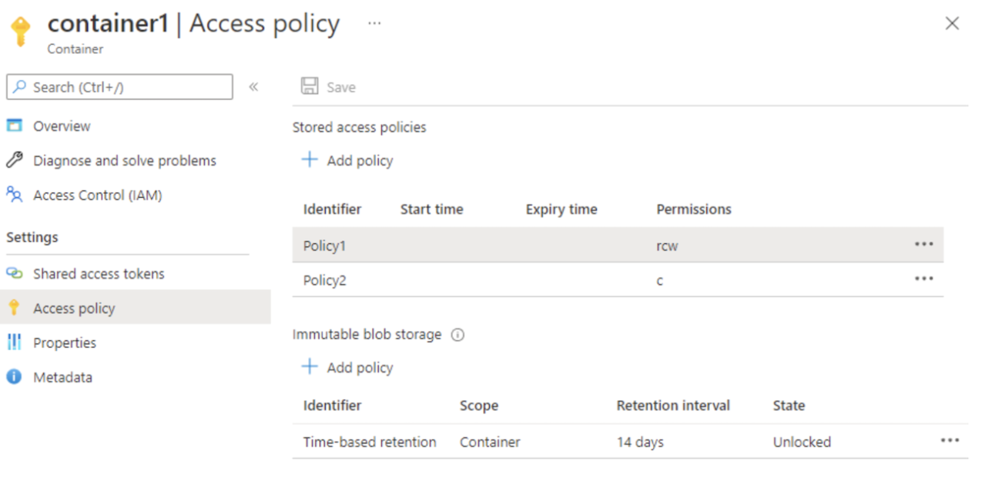
Based on the information provided, select the answer choice that completes the following statement correctly.
“The maximum number of additional stored access policies that can be created for container1 is ________.”
Réponses:
☐ 0
☐ 1
☑ 3
☐ 5
☐ 6
Explication
`3` is the correct answer because Azure Storage accounts support a maximum of 5 stored access policies per container. Since there are already 2 stored access policies (Policy1 and Policy2) defined for container1, you can add 3 more policies to reach the limit of 5.
Reference(s):
- https://learn.microsoft.com/en-us/rest/api/storageservices/define-stored-access-policy

Question 21
You have an Azure subscription that contains the storage account shown in the following exhibit.
Based on the information provided, select the answer choice that completes the following statement correctly.
“The maximum number of additional immutable blob storage policies that can be created for container1 is ________.”
Réponses:
☐ 0
☑ 1
☐ 2
☐ 4
☐ 5
Explication
`1` is the correct answer because Azure Storage accounts support a maximum of 2 immutable blob storage policies per container. Since there is already 1 immutable blob storage policy configured for container1 (with a time-based retention of 14 days), you can add 1 more to reach the maximum limit of 2.
Reference(s):
- https://learn.microsoft.com/en-us/azure/storage/blobs/immutable-storage-overview

Question 22
You have an on-premises server that contains a folder named at D:\DataFolder.
You need to upload all the contents of D:\DataFolder to the public blob container in an Azure Storage account named apexcoredata.
Which command should you run to complete this task?
Réponses:
☐ az storage blob copy start D:\DataFolder https://apexcoredata.blob.core.windows.net/public
☑ azcopy copy D:\DataFolder https://apexcoredata.blob.core.windows.net/public --recursive
☐ azcopy sync D:\DataFolder https://apexcoredata.blob.core.windows.net/public --snapshot
☐ az storage blob copy start-batch D:\DataFolder https://apexcoredata.blob.core.windows.net/public
Explication
`azcopy copy D:\DataFolder https://apexcoredata.blob.core.windows.net/public --recursive` is the correct answer because the `azcopy copy` command is used to upload files from an on-premises folder to an Azure Storage container. The `--recursive` option ensures that all files within D:\Folder1 are copied to the destination container in Azure.
`az storage blob copy start D:\DataFolder https://apexcoredata.blob.core.windows.net/public` is incorrect because `az storage blob copy start` is intended for copying blobs within Azure Storage, not for uploading files from an on-premises location.
`azcopy sync D:\DataFolder https://apexcoredata.blob.core.windows.net/public --snapshot` is incorrect because `azcopy sync` is used to synchronize files between a local folder and a storage container, rather than a direct copy. The `--snapshot` parameter is not relevant for this task.
`az storage blob copy start-batch D:\DataFolder https://apexcoredata.blob.core.windows.net/public` is incorrect because `az storage blob copy start-batch` is designed for batch copying blobs within Azure Storage, not from an on-premises location.
Reference(s):
- https://learn.microsoft.com/en-us/azure/storage/common/storage-use-azcopy-blobs
- https://docs.microsoft.com/en-us/azure/storage/common/storage-ref-azcopy-copy

Question 23
You have an Azure subscription named ProdSub01. In the subscription, you create an Azure file share named fileshare01. You then generate a shared access signature (SAS) named SASKey01 with the following configuration:
- Allowed services: File
- Allowed resource types: Service, Container, Object
- Allowed permissions: Read, Write, List
- Start date/time: September 1, 2018 at 2:00 PM
- End date/time: September 14, 2018 at 2:00 PM
- Allowed IP addresses: 193.77.134.10 – 193.77.134.50
- Allowed protocols: HTTPS only
- Signing key: key1
Based on this configuration, complete the following statement:
`“If on September 2, 2018, you use Microsoft Azure Storage Explorer from a computer with the IP address 193.77.134.1, and connect to the storage account using SASKey01, you __________.”`
Réponses:
☐ will be asked for credentials
☑ will have no access
☐ will have read, write, and list access
☐ will have read-only access
Explication
`will have no access` is the correct answer because, as given, the SAS (Shared Access Signature) restricts access to IP addresses within the range 193.77.134.10 to 193.77.134.50. Although the date of September 2, 2018 is within the permitted time period (2018-09-01 2:00 PM to 2018-09-14 2:00 PM), the IP address 193.77.134.1 does not fall within the specified IP address range, resulting in no access to the storage account.
`will be asked for credentials` is incorrect because SAS tokens provide access based on the permissions and restrictions defined in the token itself, without requiring additional credentials.
`will have read, write, and list access` is incorrect because, while these permissions are specified in the SAS, the IP address restriction prevents any access.
`will have read-only access` is incorrect because the IP address falls outside the permitted range, so access will not be granted regardless of the permissions.
Reference(s):
- https://docs.microsoft.com/en-us/azure/storage/common/storage-sas-overview
- https://docs.microsoft.com/en-us/azure/vs-azure-tools-storage-manage-with-storage-explorer?tabs=windows

Question 24
You have an Azure subscription named ProdSub01. In the subscription, you create an Azure file share named fileshare01. You then generate a shared access signature (SAS) named SASKey01 with the following configuration:
- Allowed services: File
- Allowed resource types: Service, Container, Object
- Allowed permissions: Read, Write, List
- Start date/time: September 1, 2018 at 2:00 PM
- End date/time: September 14, 2018 at 2:00 PM
- Allowed IP addresses: 193.77.134.10 – 193.77.134.50
- Allowed protocols: HTTPS only
- Signing key: key1
Based on this configuration, complete the following statement:
`If on September 10, 2018, you run the net use command on a computer that has an IP address of 193.77.134.50, and you use SASKey01 as the password to connect to fileshare01, you _________________________.”`
Réponses:
☐ will be asked for credentials
☑ will have no access
☐ will have read, write, and list access
☐ will have read-only access
Explication
`will have no access` is the correct answer here because the net use command relies on the SMB (Server Message Block) protocol, which only supports authentication using the Azure Storage account key for access to Azure File Shares. The SAS token cannot be used for authentication in this context, and attempting to use it will result in an error indicating invalid credentials. Therefore, the user will not gain any access to the file share with the net use command when using the SAS token.
`will be asked for credentials` is incorrect because the SAS token is not valid for SMB authentication, so no prompt for credentials will occur in a way that allows access.
`will have read, write, and list access` is incorrect because, without support for SAS authentication, the SMB protocol cannot grant any permissions in this scenario.
`will have read-only access` is incorrect because the net use command with SAS authentication will not provide any access due to the limitations of the SMB protocol, which requires the storage account key.
Reference(s):
- https://learn.microsoft.com/en-us/azure/storage/common/storage-sas-overview
- https://learn.microsoft.com/en-us/azure/storage/storage-explorer/vs-azure-tools-storage-manage-with-storage-explorer?tabs=windows

Question 25
You have an Azure subscription and plan to create a new Azure Storage account. You must configure encryption for the storage account and ensure that the solution meets the following criteria:
- Encryption must use a customer-managed key stored in an Azure Key Vault.
- The key must use the highest supported bit length.
Which type of encryption key should you select?
Réponses:
☐ AES
☐ 3DES
☑ RSA
Explication
`RSA` is the correct answer here because when using customer-managed keys with Azure Storage, the service supports RSA keys for encryption stored in Azure Key Vault. For Azure Storage encryption, RSA keys support the maximum bit length of 4096 bits, which is currently the highest supported bit length in Azure Key Vault for customer-managed keys.
`AES` is incorrect because, while AES is commonly used for encryption, Azure Key Vault only supports RSA for customer-managed keys in this context. AES is not an option for customer-managed keys stored in Azure Key Vault.
`3DES` is incorrect because 3DES (Triple DES) is an older encryption standard and is not supported for customer-managed keys in Azure Key Vault. Azure Key Vault supports RSA keys for customer-managed storage account encryption.
Reference(s):
- https://docs.microsoft.com/en-us/azure/storage/common/storage-service-encryption
- https://learn.microsoft.com/en-us/azure/storage/common/customer-managed-keys-overview
- https://learn.microsoft.com/en-us/azure/key-vault/keys/about-keys

Question 26
You have an Azure subscription and plan to create a new Azure Storage account. You must configure encryption for the storage account and ensure that the solution meets the following criteria:
- Encryption must use a customer-managed key stored in an Azure Key Vault.
- The key must use the highest supported bit length.
Which bit length should you use?
Réponses:
☐ 2048
☐ 3072
☑ 4096
☐ 8192
Explication
`4096` is the correct answer here because, for customer-managed keys stored in Azure Key Vault, the maximum supported bit length for RSA encryption keys is 4096 bits. This is the highest supported bit length in Azure Key Vault for customer-managed keys used for storage account encryption, meeting the requirement for maximum security.
`2048` is incorrect because, although 2048-bit keys are secure, they do not meet the requirement to use the maximum supported bit length.
`3072` is incorrect because, while 3072-bit keys offer stronger encryption than 2048-bit keys, they still do not meet the requirement to use the maximum supported bit length.
`8192` is incorrect because Azure Key Vault does not support RSA keys with an 8192-bit length. The maximum supported bit length for customer-managed RSA keys in Azure Key Vault is 4096 bits.
Reference(s):
- https://docs.microsoft.com/en-us/azure/storage/common/storage-service-encryption
- https://learn.microsoft.com/en-us/azure/storage/common/customer-managed-keys-overview

Question 27
You create an Azure Storage account called apexcorestorage and plan to add an Azure file share named data. Users must be able to map a network drive to the data file share from their home computers running Windows 10.
Which outbound port must be allowed between the users’ computers and the Azure file share?
Réponses:
☐ 80
☐ 443
☑ 445
☐ 3389
Explication
`445` is the correct answer here because SMB (Server Message Block) protocol, which is used to access Azure file shares, operates over port 445. Windows clients need access to port 445 to map a drive to the Azure file share, which allows users to access the data remotely from their home computers.
`80` is incorrect because port 80 is typically used for HTTP traffic, which is not used for SMB file share connections.
`443` is incorrect because port 443 is commonly used for HTTPS traffic, which is not required for SMB file share connections.
`3389` is incorrect because port 3389 is used for Remote Desktop Protocol (RDP) connections, not for mapping file shares.
Reference(s):
- https://docs.microsoft.com/en-us/azure/storage/files/storage-troubleshoot-windows-file-connection

Question 28
You have an Azure web app named webapp1. You also have a virtual network named VNET1 and an Azure virtual machine named VM1 that hosts a MySQL database. VM1 is connected to VNET1.
You must ensure that webapp1 can access the data stored on VM1.
What action should you take?
Réponses:
☑ Connect webapp1 to VNET1.
☐ Set up an internal load balancer.
☐ Configure virtual network peering between VNET1 and another virtual network.
☐ Deploy an Azure Application Gateway.
Explication
`Connect webapp1 to VNET1` is the correct answer because, to enable direct network communication between the Azure web app (webapp1) and the virtual machine (VM1) hosting the MySQL database, the web app needs to be integrated with the same virtual network (VNET1). This integration allows webapp1 to access VM1 over the private network, ensuring secure and seamless connectivity to the database.
`Set up an internal load balancer` is incorrect because a load balancer manages traffic distribution but does not enable direct network connectivity between web apps and VMs.
`Configure virtual network peering between VNET1 and another virtual network` is incorrect because peering with another virtual network does not directly enable webapp1 to access VM1; webapp1 must be connected to VNET1 itself.
`Deploy an Azure Application Gateway` is incorrect because an Application Gateway manages HTTP/S traffic to web applications, not private connectivity between a web app and a VM in a virtual network.
Reference(s):
- https://docs.microsoft.com/en-us/azure/app-service/web-sites-integrate-with-vnet

Question 29
You have an Azure App Service named AppService01 that includes two folders: LogsFolder and TempFolder.
You must configure a daily backup of AppService01, but ensure that TempFolder is excluded from the backup process.
What should you create first to meet this requirement?
Réponses:
☑ An Azure Storage account
☐ A Backup vault
☐ A Recovery Services vault
☐ A resource group
Explication
`An Azure Storage account` is the correct answer because Azure App Service backups require an Azure Storage account to store the backup data. When configuring the backup, you can specify which files and folders to include or exclude, allowing you to exclude TempFolder from the backup of WebApp1.
`A Backup vault` is incorrect because App Service backups do not use Backup vaults. They rely on Azure Storage accounts.
`A Recovery Services vault` is incorrect because Recovery Services vaults are used for Azure Backup and Azure Site Recovery, not for App Service backups.
`A resource group` is incorrect because, while required for organizing resources, it is not specifically needed to configure backups for App Service.
Reference(s):
- https://learn.microsoft.com/en-us/azure/app-service/manage-backup

Question 30
You have an Azure App Service named AppService01 that includes two folders: LogsFolder and TempFolder.
You must configure a daily backup of AppService01, but ensure that TempFolder is excluded from the backup process.
What should you use to exclude TempFolder?
Réponses:
☑ A _backup.filter file
☐ A backup policy
☐ A lock
☐ A WebJob
Explication
`A _backup.filter file` is the correct answer because, in Azure App Service, you can exclude specific files or directories from a backup by creating a _backup.filter file in the root directory of the app. This file allows you to specify any files or directories that should be excluded from the backup, such as TempFolder.
`A backup policy` is incorrect because Azure App Service does not use backup policies to exclude specific directories. It relies on the _backup.filter file.
`A lock` is incorrect because locks are used to prevent accidental modification or deletion of resources, not to control backup contents.
`A WebJob` is incorrect because WebJobs are used to run background tasks in Azure App Service, not to manage backup configurations or exclusions.
Reference(s):
- https://learn.microsoft.com/en-us/azure/app-service/manage-backup

Question 31
You have an Azure subscription that includes the resources listed in the following table.
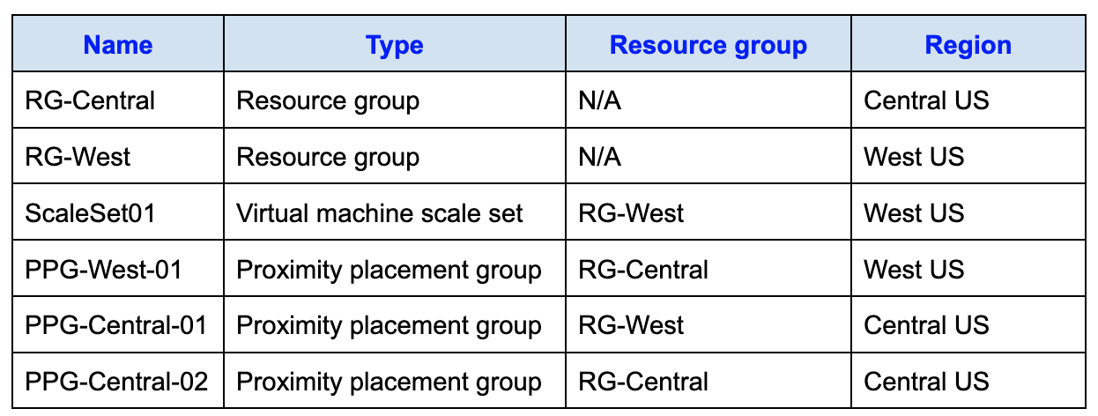
You need to configure a proximity placement group for ScaleSet01.
Which proximity placement groups should you use?
Réponses:
☑ PPG-West-01 only
☐ PPG-West-01 and PPG-Central-02 only
☐ PPG-Central-01 only
☐ PPG-West-01, PPG-Central-01, and PPG-Central-02
Explication
`PPG-West-01 only` is the correct answer because a virtual machine scale set can only use a proximity placement group that is located in the same Azure region. Proximity placement groups are used to ensure that compute resources are placed physically close to each other within an Azure datacenter to minimize latency.
In this scenario, ScaleSet01 is located in the West US region. Among the available proximity placement groups, only PPG-West-01 is also located in West US, making it the only valid option.
It is important to note that the proximity placement group and the virtual machine scale set do not need to be in the same resource group. They only need to exist in the same region.

`PPG-West-01 and PPG-Central-02 only` is incorrect because PPG-Central-02 is located in Central US, which does not match the West US** region of ScaleSet01.
`PPG-Central-01 only` is incorrect because PPG-Central-01 is located in Central US, while ScaleSet01 is located in West US. Proximity placement groups must be in the same region as the compute resources that use them.
`PPG-West-01, PPG-Central-01, and PPG-Central-02` is incorrect because only PPG-West-01 is located in the West US region required by ScaleSet01. The other proximity placement groups are located in Central US and therefore cannot be associated with the scale set.
Reference(s):
- https://azure.microsoft.com/en-us/blog/introducing-proximity-placement-groups/

Question 32
You create an App Service plan named Plan1 and an Azure web app named webapp1. You notice that the option to create a staging slot is currently unavailable.
You need to create a staging slot for Plan1.
What should you do first?
Réponses:
☑ From Plan1, scale up the App Service plan.
☐ From Plan1, scale out the App Service plan.
☐ From webapp1, add a custom domain.
☐ From webapp1, modify the Application settings.
Explication
`From Plan1, scale up the App Service plan` is the correct answer here. To create a staging slot for an Azure App Service plan, it must be in the Standard, Premium, or higher pricing tier. Since staging slots are not available for the Free, Shared, or Basic tiers, the solution here is to scale up Plan1 to a tier that supports deployment slots. This will allow you to create a staging slot for testing or other purposes without affecting the production slot.
`From Plan1, scale out the App Service plan` is incorrect because scaling out increases the number of instances within the same tier but does not change the tier itself. To enable staging slots, you need to change the tier by scaling up.
`From webapp1, add a custom domain` is incorrect because adding a custom domain does not impact the ability to create a staging slot.
`From webapp1, modify the Application settings` is incorrect because modifying application settings does not affect the availability of staging slots, which is determined by the App Service plan tier.
Reference(s):
- https://learn.microsoft.com/en-us/azure/app-service/deploy-staging-slots

Question 33
You have an Azure subscription that includes a virtual machine named VM1, which hosts a line-of-business application that must remain available around the clock. VM1 has a single network interface, one managed disk, and is currently configured with the D4s v3 size.
You plan to apply the following modifications to VM1:
- Resize the virtual machine to D8s v3.
- Attach an additional 500-GB managed disk.
- Install the Puppet Agent virtual machine extension.
- Enable Desired State Configuration (DSC) management.
Which of these changes will result in downtime for VM1?
Réponses:
☐ Adding the Puppet Agent extension.
☐ Attaching a 500-GB managed disk.
☑ Changing the size to D8s v3.
☐ Enabling Desired State Configuration Management.
Explication
`Changing the size to D8s v3` is the correct answer here. Changing the size of a virtual machine in Azure requires it to be deallocated and then re-provisioned, which causes downtime. During the resizing process, VM1 will not be available, resulting in a temporary outage for the line-of-business application.
`Adding the Puppet Agent extension` is incorrect because adding an extension to a virtual machine does not require deallocation, so it does not cause downtime.
`Attaching a 500-GB managed disk` is incorrect because attaching an additional managed disk to a virtual machine can be done while the VM is running, and it does not cause downtime.
`Enabling Desired State Configuration Management` is incorrect because enabling Desired State Configuration (DSC) does not require the virtual machine to be stopped or deallocated, so it does not cause downtime.
Reference(s):
- https://learn.microsoft.com/en-us/azure/virtual-machines/resize-vm
- https://azure.microsoft.com/en-us/blog/resize-virtual-machines

Question 34
You manage an Azure subscription that contains an existing Azure Storage account.
You plan to deploy an Azure Container Instance named sqlcontainer01, which runs a Docker image named mssqlimage01. The image includes a Microsoft SQL Server instance that requires persistent data storage beyond the lifecycle of the container.
You must configure a storage solution that ensures the SQL Server data remains available even if sqlcontainer01 is restarted or redeployed.
Which Azure storage service should you use to provide persistent storage for sqlcontainer01?
Réponses:
☐ Azure Queue storage
☐ Azure Blob storage
☐ Azure Table storage
☑ Azure Files
Explication
`Azure Files` is the correct answer because it provides a fully managed SMB file share that can be mounted by Azure container instances as persistent storage. This is essential for scenarios like running Microsoft SQL Server in a container, where data needs to persist across container restarts. However, it is important to note that volume mounting, including Azure Files, is currently only supported for `Linux-based` Azure container instances. Therefore, this solution assumes that mssqlimage01 is a Linux container image running SQL Server for Linux (which is fully supported).
`Azure Queue storage` is incorrect because it is designed for messaging between application components and does not provide file system-based persistent storage.
`Azure Blob storage` is incorrect because it is used for storing unstructured object data and cannot be mounted as a file system by container instances.
`Azure Table storage` is incorrect because it is a NoSQL key-value store intended for structured data and not suitable for use as a mounted persistent file system.
Reference(s):
- https://learn.microsoft.com/en-us/azure/container-instances/container-instances-volume-azure-files
- https://learn.microsoft.com/en-us/azure/storage/files/storage-files-introduction

Question 35
You have an Azure subscription that includes a virtual network named VNET1 located in the East US 2 region. Two network interfaces, VM1-NI and VM2-NI, are connected to VNET1.
You successfully deploy the following Azure Resource Manager template.
{
"apiVersion": "2017-03-30",
"type": "Microsoft.Compute/virtualMachines",
"name": "VM1",
"zones": "1",
"location": "EastUS2",
"dependsOn": [
"[resourceId('Microsoft.Network/networkInterfaces', 'VM1-NI')]"
],
"properties": {
"hardwareProfile": {
"vmSize": "Standard_A2_v2"
},
"osProfile": {
"computerName": "VM1",
"adminUsername": "AzureAdmin",
"adminPassword": "[parameters('adminPassword')]"
},
"storageProfile": {
"imageReference": "[variables('image')]",
"osDisk": {
"createOption": "FromImage"
}
},
"networkProfile": {
"networkInterfaces": [
{
"id": "[resourceId('Microsoft.Network/networkInterfaces', 'VM1-NI')]"
}
]
}
}
},
{
"apiVersion": "2017-03-30",
"type": "Microsoft.Compute/virtualMachines",
"name": "VM2",
"zones": "2",
"location": "EastUS2",
"dependsOn": [
"[resourceId('Microsoft.Network/networkInterfaces', 'VM2-NI')]"
],
"properties": {
"hardwareProfile": {
"vmSize": "Standard_A2_v2"
},
"osProfile": {
"computerName": "VM2",
"adminUsername": "AzureAdmin",
"adminPassword": "[parameters('adminPassword')]"
},
"storageProfile": {
"imageReference": "[variables('image')]",
"osDisk": {
"createOption": "FromImage"
}
},
"networkProfile": {
"networkInterfaces": [
{
"id": "[resourceId('Microsoft.Network/networkInterfaces', 'VM2-NI')]"
}
]
}
}
}
True or False:
`“VM1 and VM2 can connect to VNET1.”`
Réponses:
☑ True
☐ False
Explication
`True` is the correct answer here. VM1 and VM2 can connect to VNET1 as they both have network interfaces (VM1-NI and VM2-NI) explicitly linked to VNET1 within the same location, "East US 2." This configuration ensures that both virtual machines are part of VNET1 and can communicate within this virtual network.
Reference(s):
- https://learn.microsoft.com/en-us/azure/virtual-network/virtual-network-vnet-plan-design

Question 36
You have an Azure subscription that includes a virtual network named VNET1 located in the East US 2 region. Two network interfaces, VM1-NI and VM2-NI, are connected to VNET1.
You successfully deploy the following Azure Resource Manager template.
{
"apiVersion": "2017-03-30",
"type": "Microsoft.Compute/virtualMachines",
"name": "VM1",
"zones": "1",
"location": "EastUS2",
"dependsOn": [
"[resourceId('Microsoft.Network/networkInterfaces', 'VM1-NI')]"
],
"properties": {
"hardwareProfile": {
"vmSize": "Standard_A2_v2"
},
"osProfile": {
"computerName": "VM1",
"adminUsername": "AzureAdmin",
"adminPassword": "[parameters('adminPassword')]"
},
"storageProfile": {
"imageReference": "[variables('image')]",
"osDisk": {
"createOption": "FromImage"
}
},
"networkProfile": {
"networkInterfaces": [
{
"id": "[resourceId('Microsoft.Network/networkInterfaces', 'VM1-NI')]"
}
]
}
}
},
{
"apiVersion": "2017-03-30",
"type": "Microsoft.Compute/virtualMachines",
"name": "VM2",
"zones": "2",
"location": "EastUS2",
"dependsOn": [
"[resourceId('Microsoft.Network/networkInterfaces', 'VM2-NI')]"
],
"properties": {
"hardwareProfile": {
"vmSize": "Standard_A2_v2"
},
"osProfile": {
"computerName": "VM2",
"adminUsername": "AzureAdmin",
"adminPassword": "[parameters('adminPassword')]"
},
"storageProfile": {
"imageReference": "[variables('image')]",
"osDisk": {
"createOption": "FromImage"
}
},
"networkProfile": {
"networkInterfaces": [
{
"id": "[resourceId('Microsoft.Network/networkInterfaces', 'VM2-NI')]"
}
]
}
}
}
True or False:
`“If an Azure datacenter becomes unavailable, VM1 or VM2 will be available.”`
Réponses:
☑ True
☐ False
Explication
`True` is the correct answer here. In the ARM template, VM1 is assigned to `"zones": "1"` and VM2 to `"zones": "2"`, which places them in separate availability zones within the same Azure region. This configuration ensures that if one datacenter within the region becomes unavailable, the other virtual machine in a different zone remains operational. Azure's availability zones are designed to protect against datacenter-level failures, providing high availability by distributing resources across multiple zones within a region.
Reference(s):
- https://learn.microsoft.com/en-us/azure/reliability/availability-zones-overview?tabs=azure-cli

Question 37
You have an Azure subscription that includes a virtual network named VNET1 located in the East US 2 region. Two network interfaces, VM1-NI and VM2-NI, are connected to VNET1.
You successfully deploy the following Azure Resource Manager template.
{
"apiVersion": "2017-03-30",
"type": "Microsoft.Compute/virtualMachines",
"name": "VM1",
"zones": "1",
"location": "EastUS2",
"dependsOn": [
"[resourceId('Microsoft.Network/networkInterfaces', 'VM1-NI')]"
],
"properties": {
"hardwareProfile": {
"vmSize": "Standard_A2_v2"
},
"osProfile": {
"computerName": "VM1",
"adminUsername": "AzureAdmin",
"adminPassword": "[parameters('adminPassword')]"
},
"storageProfile": {
"imageReference": "[variables('image')]",
"osDisk": {
"createOption": "FromImage"
}
},
"networkProfile": {
"networkInterfaces": [
{
"id": "[resourceId('Microsoft.Network/networkInterfaces', 'VM1-NI')]"
}
]
}
}
},
{
"apiVersion": "2017-03-30",
"type": "Microsoft.Compute/virtualMachines",
"name": "VM2",
"zones": "2",
"location": "EastUS2",
"dependsOn": [
"[resourceId('Microsoft.Network/networkInterfaces', 'VM2-NI')]"
],
"properties": {
"hardwareProfile": {
"vmSize": "Standard_A2_v2"
},
"osProfile": {
"computerName": "VM2",
"adminUsername": "AzureAdmin",
"adminPassword": "[parameters('adminPassword')]"
},
"storageProfile": {
"imageReference": "[variables('image')]",
"osDisk": {
"createOption": "FromImage"
}
},
"networkProfile": {
"networkInterfaces": [
{
"id": "[resourceId('Microsoft.Network/networkInterfaces', 'VM2-NI')]"
}
]
}
}
}
True or False:
`“If the East US 2 region becomes unavailable, VM1 or VM2 will be available.”`
Réponses:
☐ True
☑ False
Explication
`False` is the correct answer here. Although VM1 and VM2 are placed in different availability zones within the East US 2 region, they are still limited to that specific region. If the entire East US 2 region becomes unavailable, both virtual machines will be affected, resulting in downtime for the application hosted on them. Availability zones provide resilience within a region, but they do not protect against a full regional outage.
Reference(s):
- https://learn.microsoft.com/en-us/azure/reliability/availability-zones-overview?tabs=azure-cli

Question 38
You have an Azure subscription in which a virtual machine scale set is deployed with the following scaling configuration:
- Initial instance count: 2
- Scaling policy: Custom
- Minimum number of instances: 1
- Maximumnumber of instances: 10
Scale-out settings:
- CPU Threshold: 75%
- Duration in minutes: 10 minutes
- Number of instances to increase by: 1
Scale-in settings:
- CPU Threshold: 25%
- Number of instances to increase by: 1
Based on the configuration provided, select the answer choice that completes the following statement correctly.
“At 9:00 AM, the virtual machine scale set starts running, and CPU utilization remains at 90 percent for 15 minutes. How many virtual machine instances will be running at 9:15 AM?”
Réponses:
☐ 2
☑ 3
☐ 4
☐ 5
Explication
`3` is the correct answer here. Given that the CPU utilization is 90% for 15 minutes, which is above the scale-out threshold of 75%, the scale set will evaluate this sustained high CPU usage after the 10-minute duration set for scale-out. Since the threshold has been exceeded, the scale set will add 1 instance as specified in the "Number of instances to increase by" setting. Therefore, starting with two instances at 9:00 AM, the scale set will have three instances running by 9:15 AM.
Reference(s):
- https://docs.microsoft.com/en-us/azure/virtual-machine-scale-sets/overview
- https://docs.microsoft.com/en-us/azure/virtual-machine-scale-sets/virtual-machine-scale-sets-autoscale-overview
- https://docs.microsoft.com/en-us/azure/virtual-machine-scale-sets/virtual-machine-scale-sets-autoscale-portal

Question 39
You have an Azure subscription in which a virtual machine scale set is deployed with the following scaling configuration:
- Initial instance count: 2
- Scaling policy: Custom
- Minimum number of instances: 1
- Maximumnumber of instances: 10
Scale-out settings:
- CPU Threshold: 75%
- Duration in minutes: 10 minutes
- Number of instances to increase by: 1
Scale-in settings:
- CPU Threshold: 25%
- Number of instances to increase by: 1
Based on the configuration provided, select the answer choice that completes the following statement correctly.
“At 10:00 AM, the scale set is running five virtual machine instances, and CPU utilization drops below 15 percent for 60 minutes. How many virtual machine instances will be running at 11:00 AM?”
Réponses:
☑ 1
☐ 2
☐ 3
☐ 4
Explication
`1` is the correct answer.
Based on this information, at 11:00 AM, there will be 1 virtual machine instance running.
At 10:00 AM, the scale set has five virtual machine instances running, and CPU utilization falls to less than 15% for 60 minutes, which is below the scale-in CPU threshold of 25%. With the default scale-in duration set to 10 minutes, the scale set will evaluate the CPU utilization every 10 minutes during the 60-minute period and determine that it is below the scale-in threshold.
If the CPU utilization remains below 15% continuously for 60 minutes, the autoscale mechanism will evaluate the conditions every 10 minutes. Each time the condition is met, it will decrease the instance count by 1, subject to the minimum instance limit.​
Assuming the minimum number of instances is set to 1, the scaling would proceed as follows:
- 10:10 AM: Decrease to 4 instances
- 10:20 AM: Decrease to 3 instances
- 10:30 AM: Decrease to 2 instances
- 10:40 AM: Decrease to 1 instance
- 10:50 AM: No further decrease (minimum limit reached)
- 11:00 AM: No change​
Therefore, at 11:00 AM, you will have 1 virtual machine instance running.
Reference(s):
- https://docs.microsoft.com/en-us/azure/virtual-machine-scale-sets/overview
- https://docs.microsoft.com/en-us/azure/virtual-machine-scale-sets/virtual-machine-scale-sets-autoscale-overview
- https://docs.microsoft.com/en-us/azure/virtual-machine-scale-sets/virtual-machine-scale-sets-autoscale-portal

Question 40
You have an Azure subscription and intend to deploy multiple Azure Container Instances, defined as follows:
- Instance1: Windows Server 2019 (Nano Server installation)
- Instance2: Windows Server 2019 (Server Core installation)
- Instance3: Linux
- Instance4: Linux
Which of these instances are eligible to be deployed together within the same container group?
Réponses:
☐ Instance1 only
☐ Instance2 only
☐ Instance1 and Instance2 only
☑ Instance3 and Instance4 only
Explication
`Instance3 and Instance4 only` is correct because Azure Container Instances (ACI) currently supports multi-container groups only for Linux containers. This means you can deploy multiple Linux-based containers (such as Instance3 and Instance4) together within a single container group that shares networking, storage volumes, and lifecycle.
Instance1 and Instance2 are Windows-based containers (Nano Server and Server Core). Azure Container Instances does not support deploying multiple Windows containers in a group. Windows containers can only be deployed as single-container instances. Therefore, even though both are Windows-based, they cannot be combined into a container group.
Instance1 only, Instance2 only, and Instance1 and Instance2 only are incorrect because these configurations would either use Windows containers (unsupported for container groups) or fail to meet the definition of a multi-container group.
Reference(s):
- https://learn.microsoft.com/en-us/azure/container-instances/container-instances-overview
- https://learn.microsoft.com/en-us/azure/container-instances/container-instances-container-groups

Question 41
You have an Azure subscription containing the following storage accounts:
- storage1 - General-purpose v2 (StorageV2), located in Central US
- storage2 - BlobStorage, located in West US
- storage3 - BlockBlobStorage, located in West US
- storage4 - FileStorage, located in East US
You deploy a web application named App1 to the West US region. You must configure a backup solution for App1 while minimizing costs.
Which storage account should you choose as the backup target?
Réponses:
☐ storage1
☑ storage2
☐ storage3
☐ storage4
Explication
`storage2` is the correct answer here. This storage account is of the BlobStorage type and is located in the West US region, the same region as the web app, App1. Azure Backup uses block blobs to store backup data, making BlobStorage an appropriate type for this purpose. Additionally, placing backup data in the same region as the resource being backed up minimizes latency and avoids additional costs associated with cross-region data transfers.
`storage1` is incorrect because it is located in Central US, a different region than the web app’s region (West US). While StorageV2 can also be used for backup, cross-region data transfers can lead to increased latency and additional costs, making it less ideal.
`storage3` is incorrect despite being in the same region as App1 (West US). Although it is of the BlockBlobStorage type, which supports block blobs, it is generally more expensive than BlobStorage or StorageV2, due to its premium performance characteristics. Given the requirement to minimize costs, BlockBlobStorage is not the optimal choice.
`storage4` is incorrect as it is of the FileStorage type, which is intended for Azure File Shares rather than backups. Furthermore, it is located in East US, which is a different region from the web app, leading to potential additional latency and transfer costs.
Reference(s):
- https://learn.microsoft.com/en-us/azure/backup/backup-overview
- https://docs.microsoft.com/en-us/azure/storage/common/storage-account-overview
- https://docs.microsoft.com/en-us/azure/storage/blobs/storage-blobs-introduction
- https://docs.microsoft.com/en-us/azure/storage/blobs/premium-blob-faqs

Question 42
You have an Azure environment that includes a virtual network named VNet1. The virtual machines deployed in VNet1 are configured to allow Remote Desktop access.
Several users will be working from home and must securely connect to these virtual machines over the internet. You are required to implement Point-to-Site (P2S) VPN connectivity so that each user can establish a private connection to the virtual network.
Which three actions should you perform in sequence?
ACTIONS
- Provision a local network gateway resource.
- Configure a public IP address for each virtual machine.
- Create an additional subnet within VNet1.
- Add an IP address pool.
- Deploy a load balancer to VNet1.
- Deploy a VPN gateway for the virtual network.
Réponses:
☐ 1-6-4
☐ 2-4-6
☑ 3-6-4
☐ 4-6-3
☐ 5-6-1
Explication
`(Action 3) Create an additional subnet within VNet1` – A specific subnet is needed for the VPN gateway within VNet1. This subnet is usually named the GatewaySubnet and is required to deploy the VPN gateway for a Point-to-Site (P2S) VPN connection.
`(Action 6) Create a VPN gateway` – After the subnet is created, you need to deploy a VPN gateway in VNet1. The VPN gateway provides the Point-to-Site (P2S) VPN functionality, allowing users to securely connect to the virtual network from a remote location.**

`(Action 4) Add an IP address pool` – Once the VPN gateway is set up, you configure an IP address pool. This pool assigns IP addresses to users who connect through the P2S VPN, ensuring they can connect to resources within VNet1.**

`(Action 1) Provision a local network gateway resource` is incorrect because a local network gateway is used for Site-to-Site (S2S) VPN connections to represent the on-premises VPN device, not for Point-to-Site connections.**

`(Action 2) Configure a public IP address for each virtual machine` is incorrect because with a P2S VPN, users can securely connect to the VMs over the VPN without needing public IPs on each VM, enhancing security.**

`(Action 5) Deploy a load balancer to VNet1` is incorrect because a load balancer is not required for P2S VPN connectivity. It’s typically used for distributing traffic across multiple VMs.
Reference(s):
- https://learn.microsoft.com/en-us/azure/vpn-gateway/vpn-gateway-about-vpngateways

Question 43
You have three Azure storage accounts configured as follows:
- storage1 — General-purpose v2 (StorageV2), Standard performance, Locally-redundant storage (LRS), Cool tier
- storage2 — General-purpose v2 (StorageV2), Standard performance, Read-access geo-redundant storage (RA-GRS), Hot tier
- storage3 — BlobStorage, Premium performance, Locally-redundant storage (LRS), Hot tier
You must identify which storage account can be changed to use zone-redundant storage (ZRS) replication.
Which storage account meets this requirement?
Réponses:
☑ storage1 only
☐ storage2 only
☐ storage3 only
☐ storage2 and storage3
☐ storage1, storage2, and storage3
Explication
`storage1 only` is correct because it is an LRS account that can directly be converted to a ZRS account.
`storage2 only` is incorrect because RA-GRS account cannot be directly converted to ZRS. However, it can be converted to LRS and then finally converted to ZRS. So technically, both Storage1 and Storage2 accounts can be converted to ZRS, but since we do not have "Storage1 and Storage2 only" as an option in the question, we are assuming it to be asking about direct conversion only.
`storage3` is incorrect because BlobStorage accounts are not eligible for ZRS replication, regardless of their performance or replication settings.
`storage2 and storage3 only` is incorrect answer here. Storage2 account is RA-GRS which cannot be converted to ZRS directly. Storage3 being a BlobStorage account is not supported for ZRS replication.
`storage1, storage2, and storage3` are incorrect because only storage1 meets the criteria for direct conversion to ZRS.
Reference(s):
- https://learn.microsoft.com/en-us/azure/storage/common/redundancy-migration?tabs=portal#changing-redundancy-configurationhttps://learn.microsoft.com/en-us/azure/storage/common/storage-redundancy

Question 44
You have a registered DNS domain named apexcore.com. You then create a public Azure DNS zone with the same name (apexcore.com).
You must ensure that any DNS records added to this Azure DNS zone can be successfully resolved by clients on the public internet.
What action should you take?
Réponses:
☐ Update the SOA record in the DNS domain registrar.
☐ Create the SOA record in apexcore.com.
☑ Update the NS records in the DNS domain registrar.
☐ Create NS records in apexcore.com.
Explication
`Update the NS records in the DNS domain registrar` is the correct answer here. To ensure that records created in the apexcore.com Azure DNS zone are resolvable from the internet, you need to update the NS (Name Server) records in your DNS domain registrar. These records should point to the Azure DNS name servers associated with the apexcore.com zone in Azure. This change directs external DNS queries for apexcore.com to Azure DNS, allowing them to be resolved by the public Azure DNS servers.
`Update the SOA record in the DNS domain registrar` is incorrect because the SOA (Start of Authority) record is managed by Azure DNS, and you do not need to modify it in the domain registrar to enable public resolution.
`Create the SOA record in apexcore.com` is incorrect because the SOA record is automatically created and managed by Azure DNS for the zone. No manual action is needed for this record to enable internet resolvability.
`Create NS records in apexcore.com` is incorrect because NS records within the Azure DNS zone are already created automatically. The critical step is to update the NS records at the DNS domain registrar, not within Azure DNS.
Reference(s):
- https://learn.microsoft.com/en-us/azure/dns/dns-delegate-domain-azure-dns

Question 45
You have an Azure subscription that includes a virtual network named VNet1. VNet1 is connected to two separate on-premises datacenters by using two ExpressRoute circuits.
You need to build a dashboard that provides in-depth network metrics and a graphical view of the network topology.
Which Azure service should you use?
Réponses:
☐ Azure Virtual Network Watcher
☑ Azure Monitor Network Insights
☐ a Data Collection Rule (DCR)
☐ Log Analytics
Explication
`Azure Monitor Network Insights` is the correct answer here. Azure Monitor Network Insights provides a comprehensive view of your network’s health and performance. It includes detailed metrics, visualizations, and insights into the network topology, making it ideal for monitoring complex environments like the one described with multiple ExpressRoute circuits.
`Azure Virtual Network Watcher` is incorrect because, while it offers some monitoring and diagnostic tools for network resources, it does not provide an all-encompassing dashboard or a visual representation of network topology as effectively as Network Insights.
`A Data Collection Rule (DCR)` is incorrect because DCRs are primarily used to define data collection and ingestion rules for Azure Monitor. They do not provide a visual representation of network topology or a network-specific dashboard.
`Log Analytics` is incorrect because it is a tool for querying and analyzing logs. While you can use Log Analytics to query network data, it does not provide a pre-built dashboard or topology visualization as Network Insights does.
Reference(s):
- https://learn.microsoft.com/en-us/azure/network-watcher/network-insights-overview
- https://learn.microsoft.com/en-us/azure/network-watcher/network-insights-topology?toc=%2Fazure%2Fazure-monitor%2Ftoc.json&bc=%2Fazure%2Fazure-monitor%2Fbreadcrumb%2Ftoc.json

Question 46
You have an Azure subscription that includes the resources mentioned below:
- A virtual network named VNet1
- A subnet named Subnet1, which is part of VNet1
- Two virtual machines, VM1 and VM2, both deployed to Subnet1
VM1 and VM2 were created from the same deployment template and host line-of-business applications.
You configure a network security group (NSG) as shown in the exhibit.
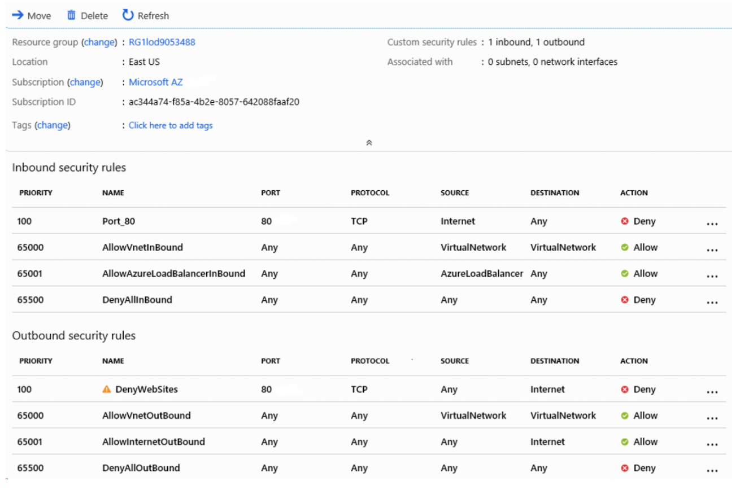
You need to ensure that users on VM1 and VM2 are unable to browse websites on the internet by using TCP port 80.
What should you do?
Réponses:
☐ Modify the DenyWebSites outbound security rule.
☐ Update the Port_80 inbound security rule.
☑ Associate the network security group with Subnet1.
☐ Remove the network security group association from a network interface.
Explication
`Associate the network security group with Subnet1` is the correct answer here. The question specifies the need to prevent users of VM1 and VM2 from accessing websites on the Internet over TCP port 80. In the exhibit, there is an outbound rule, DenyWebSites, configured to block traffic on TCP port 80. However, if you look at the "Associated with" section in the top right corner of the exhibit, it shows "0 subnets, 0 network interfaces", meaning this NSG is not currently associated with any subnet or network interface.
To apply this restriction to VM1 and VM2, which are located in Subnet1, it is necessary to associate the NSG with Subnet1. By doing so, the NSG rules, including the DenyWebSites rule, will take effect, blocking outbound access to websites on TCP port 80 for both VM1 and VM2. Therefore, Associate the NSG to Subnet1 is the correct choice here.
`Modify the DenyWebSites outbound security rule` is incorrect because modifying the rule itself won’t make any difference if the NSG is not associated with Subnet1 or the network interfaces of VM1 and VM2.
`Update the Port_80 inbound security rule` is incorrect because this rule manages inbound traffic on port 80, which is unrelated to the requirement to restrict outbound web access.
`Remove the network security group association from a network interface` is incorrect because there is no existing association to remove, as indicated by the "0 subnets, 0 network interfaces" status.
Reference(s):
- https://learn.microsoft.com/en-us/azure/virtual-network/manage-network-security-group?tabs=network-security-group-portal

Question 47
You have an Azure virtual machine named VM1. You use Azure Backup to create a backup of VM1 called Backup1.
After Backup1 is created, you make the following changes to VM1:
- Change the virtual machine size.
- Copy a file named Budget.xls into a folder named Data.
- Reset the password for the built-in administrator account.
- Attach an additional data disk to the virtual machine.
An administrator then restores VM1 from Backup1 by using the Replace existing restore option.
You need to ensure that all the changes made after the backup are present on VM1 again.
Which action must you perform again?
Réponses:
☐ Attach an additional data disk.
☑ Copy Budget.xls into the Data folder.
☐ Change the size of VM1.
☐ Reset the password for the built-in administrator account.
Explication
`Copy Budget.xls into the Data folder` is correct because the Replace existing restore option restores the virtual machine disks from the selected recovery point. Any changes made to the contents of the disks after Backup1 was created are reverted. Since the Budget.xls file was copied into the Data folder after the backup was taken, it will not exist after the restore and must be copied again.
`Attach an additional data disk` is incorrect because attaching a data disk is a configuration change to the Azure virtual machine resource itself. The Replace existing restore operation primarily restores the VM disks from the backup recovery point and does not necessarily remove VM-level configuration changes such as attached disk references.
`Change the size of VM1` is incorrect because the VM size is a property of the Azure virtual machine resource and is not part of the disk contents restored from the recovery point. Restoring the VM disks does not typically revert the VM size configuration.
`Reset the password for the built-in administrator account` is incorrect because password reset operations are commonly managed through VM extensions and VM resource configuration rather than through the restored disk contents alone. The Replace existing operation does not necessarily revert these VM-level settings.
Reference(s):
- https://docs.microsoft.com/en-us/azure/backup/backup-azure-restore-files-from-vm
- https://docs.microsoft.com/en-us/azure/backup/backup-azure-arm-restore-vms

Question 48
You have an Azure subscription named Subscription1 that contains a resource group with the following characteristics:
- Name: RG1
- Region: West US
- Tags: `"tag1": "value1"`
You assign an Azure Policy named Policy1 at the Subscription1 scope with these settings:
- Exclusions: None
- Policy definition: Append a tag and its value to resources
- Assignment name: Policy1
- Parameters:
- Tag name: tag2
- Tag value: value2
After assigning Policy1, you create a storage account with the following properties:
- Name: storage1
- Region: West US
- Resource group: RG1
- Tags: `"tag3": "value3"`
Which tags are applied to RG1?
Réponses:
☑ "tag1" : "value1" only
☐ "tag2" : "value2" only
☐ "tag1" : "value1" and "tag2" : "value2"
Explication
`"tag1" : "value1" only` is the correct answer here. The policy definition "Append a tag and its value to resources" is configured to apply to resources within Subscription1, not to the resource group RG1 itself. This policy assignment means that any new resources created under Subscription1 will have the specified tag2 : value2 appended if they do not already have this tag. However, it does not apply the tag to the resource group where the resources are created. Therefore, RG1 retains only the original tag, "tag1" : "value1". It should also be noted here that “Subscription” and “Policy1” are created at the initial stage itself and therefore the created policy would apply to the resource group – namely “RG1” within this subscription.
`"tag2" : "value2" only` is incorrect because Policy1 does not add tag2 : value2 to the resource group itself, only to resources created within the scope of Subscription1.
`"tag1" : "value1" and "tag2" : "value2"` is incorrect because, as explained, Policy1 does not alter tags on the resource group RG1 directly. It only affects newly created resources within Subscription1.
Reference(s):
- https://docs.microsoft.com/en-us/azure/azure-resource-manager/management/tag-policies
- https://docs.microsoft.com/en-us/azure/governance/policy/concepts/effects#append

Question 49
You have an Azure subscription named Subscription1 that contains a resource group with the following characteristics:
- Name: RG1
- Region: West US
- Tags: `"tag1": "value1"`
You assign an Azure Policy named Policy1 at the Subscription1 scope with these settings:
- Exclusions: None
- Policy definition: Append a tag and its value to resources
- Assignment name: Policy1
- Parameters:
- Tag name: tag2
- Tag value: value2
After assigning Policy1, you create a storage account with the following properties:
- Name: storage1
- Region: West US
- Resource group: RG1
- Tags: `"tag3": "value3"
`
Which tags are assigned to storage1?
Réponses:
☐ "tag3" : "value3" only
☐ "tag1" : "value1" and "tag3" : "value3" only
☑ "tag2" : "value2" and "tag3" : "value3" only
☐ "tag1" : "value1", "tag2" : "value2", and "tag3" : "value3"
Explication
`"tag2" : "value2" and "tag3" : "value3" only` is the correct answer here. Tags are not inherited automatically from a resource group or subscription to the resources within them. However, in this case, Policy1 was applied to Subscription1 with the definition to append a specific tag to all new resources created in this subscription. The policy was configured with Exclusions: None and parameters Tag name: "tag2" and Tag value: "value2". This means that all resources created after this policy assignment will automatically have "tag2" : "value2" appended.
When storage1 was created in RG1 after the policy was assigned, it had "tag3" : "value3" specified. Since Policy1 was already in effect, "tag2" : "value2" was appended to storage1 due to the policy, resulting in storage1 having the tags "tag2" : "value2" and "tag3" : "value3" only.
`"tag3" : "value3" only` is incorrect because the policy enforces "tag2" : "value2" on all new resources in the subscription.
`"tag1" : "value1" and "tag3" : "value3" only` is incorrect because "tag1" : "value1" is assigned only to RG1 and does not get inherited by resources within the group.
`"tag1" : "value1", "tag2" : "value2", and "tag3" : "value3"` is incorrect because storage1 does not inherit "tag1" : "value1" from RG1.
Reference(s):
- https://docs.microsoft.com/en-us/azure/azure-resource-manager/management/tag-policies
- https://docs.microsoft.com/en-us/azure/governance/policy/concepts/effects#append

Question 50
You have a Microsoft Entra tenant that contains the groups listed below, each with a specific group type and security setting.
- Group1 - Security group (Security enabled: Yes)
- Group2 - Mail-enabled security group (Security enabled: Yes)
- Group3 - Microsoft 365 group (Security enabled: Yes)
- Group4 - Microsoft 365 group (Security enabled: No)
You purchase Microsoft Entra ID P2 licenses and want to assign the licenses by using group-based licensing.
To which groups can you assign a license?
Réponses:
☐ Group1 only
☐ Group1 and Group3 only
☐ Group3 and Group4 only
☑ Group1, Group2, and Group3 only
☐ Group1, Group2, Group3, and Group4
Explication
Group1, Group2, and Group3 only is correct because group-based licensing in Microsoft Entra ID supports security groups (including mail-enabled security groups) and Microsoft 365 groups that have securityEnabled=TRUE.
- Group1 is a security group with security enabled, so it can be used.
- Group2 is a mail-enabled security group, which is still a type of security group, and Microsoft documentation confirms that it is supported for license assignment.
- Group3 is a Microsoft 365 group with security enabled, so it also qualifies.
Group1 only is incorrect because Group3 (a security-enabled Microsoft 365 group) and Group2 (a mail-enabled security group) are also supported.
Group1 and Group3 only is incorrect because Group2 is also eligible for license assignment, as mail-enabled security groups are supported.
Group3 and Group4 only is incorrect because Group4 is a Microsoft 365 group with security disabled, making it ineligible.
Group1, Group2, Group3, and Group4 is incorrect because Group4 is security-disabled and cannot be used for license assignment.
Reference(s):
- https://learn.microsoft.com/en-us/microsoft-365/admin/manage/manage-group-licenses?view=o365-worldwide
- https://learn.microsoft.com/en-us/microsoft-365/admin/create-groups/compare-groups?view=o365-worldwide

Question 51
You have a custom Azure role-based access control (RBAC) role named Role1, defined as shown below.
{
"id": "c47291ab-3f5e-4a11-b9d2-7e6c2f9a8b10",
"properties": {
"roleName": "Role1",
"description": "",
"assignableScopes": [
"/subscriptions/1a2b3c4d-55e6-47f8-9abc-0d1e2f3a4b5c"
],
"permissions": [
{
"actions": [
"Microsoft.Resources/subscriptions/resourceGroups/resources/read",
"Microsoft.Resources/subscriptions/resourceGroups/read",
"Microsoft.Resourcehealth/*",
"Microsoft.Authorization/*/read",
"Microsoft.Compute/*/read",
"Microsoft.Support/*",
"Microsoft.Network/virtualNetworks/read",
"Microsoft.Resources/deployments/*",
"Microsoft.Storage/storageAccounts/read",
"Microsoft.Compute/virtualMachines/start/action",
"Microsoft.Compute/virtualMachines/powerOff/action",
"Microsoft.Compute/virtualMachines/deallocate/action",
"Microsoft.Compute/virtualMachines/restart/action",
"Microsoft.Compute/virtualMachines/*",
"Microsoft.Compute/disks/*",
"Microsoft.Compute/availabilitySets/*",
"Microsoft.Network/virtualNetworks/subnets/join/action",
"Microsoft.Network/virtualNetworks/subnets/read",
"Microsoft.Network/virtualNetworks/subnets/virtualMachines/read",
"Microsoft.Network/networkInterfaces/*",
"Microsoft.Compute/snapshots/*"
],
"notActions": [
"Microsoft.Authorization/*/Delete",
"Microsoft.Authorization/*/Write",
"Microsoft.Authorization/elevateAccess/Action"
]
}
]
}
}
True or False:
`“Users who are assigned Role1 are able to assign Role1 to other users.”`
Réponses:
☐ True
☑ False
Explication
`False` is the correct answer here. The custom role "Role1" includes various permissions under the "actions" section, but the "notActions" section explicitly denies permissions related to **Microsoft.Authorization/*/Delete, Microsoft.Authorization/*/Write, and Microsoft.Authorization/elevateAccess/Action**. These restricted permissions prevent users assigned with "Role1" from performing role assignments or modifications, including the ability to assign "Role1" to other users.
Reference(s):
- https://learn.microsoft.com/en-us/azure/role-based-access-control/built-in-roles

Question 52
You have a custom Azure role-based access control (RBAC) role named Role1, defined as shown below.
{
"id": "c47291ab-3f5e-4a11-b9d2-7e6c2f9a8b10",
"properties": {
"roleName": "Role1",
"description": "",
"assignableScopes": [
"/subscriptions/1a2b3c4d-55e6-47f8-9abc-0d1e2f3a4b5c"
],
"permissions": [
{
"actions": [
"Microsoft.Resources/subscriptions/resourceGroups/resources/read",
"Microsoft.Resources/subscriptions/resourceGroups/read",
"Microsoft.Resourcehealth/*",
"Microsoft.Authorization/*/read",
"Microsoft.Compute/*/read",
"Microsoft.Support/*",
"Microsoft.Network/virtualNetworks/read",
"Microsoft.Resources/deployments/*",
"Microsoft.Storage/storageAccounts/read",
"Microsoft.Compute/virtualMachines/start/action",
"Microsoft.Compute/virtualMachines/powerOff/action",
"Microsoft.Compute/virtualMachines/deallocate/action",
"Microsoft.Compute/virtualMachines/restart/action",
"Microsoft.Compute/virtualMachines/*",
"Microsoft.Compute/disks/*",
"Microsoft.Compute/availabilitySets/*",
"Microsoft.Network/virtualNetworks/subnets/join/action",
"Microsoft.Network/virtualNetworks/subnets/read",
"Microsoft.Network/virtualNetworks/subnets/virtualMachines/read",
"Microsoft.Network/networkInterfaces/*",
"Microsoft.Compute/snapshots/*"
],
"notActions": [
"Microsoft.Authorization/*/Delete",
"Microsoft.Authorization/*/Write",
"Microsoft.Authorization/elevateAccess/Action"
]
}
]
}
}
True or False:
`“Users who are assigned Role1 are able to deploy new virtual machines.”`
Réponses:
☑ True
☐ False
Explication
`True` is the correct answer here.
Although `Microsoft.Compute/virtualMachines/*` alone is not always sufficient to deploy a new virtual machine, Role1 includes all the additional permissions required to create a VM and its associated resources.
The role grants the following key permissions:
- `Microsoft.Compute/virtualMachines/*` – Allows all operations on virtual machines, including creating (`write`), updating, deleting, starting, stopping, restarting, and deallocating VMs.
- `Microsoft.Compute/disks/*` – Allows creation and management of managed disks required by the VM.
- `Microsoft.Network/networkInterfaces/*` – Allows creation and management of network interfaces.
- `Microsoft.Network/virtualNetworks/subnets/join/action` – Allows the network interface to be attached to a subnet.
- `Microsoft.Resources/deployments/*` – Allows ARM template deployments, which are commonly used when deploying virtual machines.
Because Role1 includes permissions for both the virtual machine and its dependent resources, users assigned this role can successfully deploy new virtual machines.
The `notActions` section only prevents users from modifying Azure RBAC role assignments or elevating their own permissions. It does not restrict virtual machine deployment.
Reference(s):
- https://learn.microsoft.com/en-us/azure/role-based-access-control/built-in-roles

Question 53
You have a custom Azure role-based access control (RBAC) role named Role1, defined as shown below.
{
"id": "c47291ab-3f5e-4a11-b9d2-7e6c2f9a8b10",
"properties": {
"roleName": "Role1",
"description": "",
"assignableScopes": [
"/subscriptions/1a2b3c4d-55e6-47f8-9abc-0d1e2f3a4b5c"
],
"permissions": [
{
"actions": [
"Microsoft.Resources/subscriptions/resourceGroups/resources/read",
"Microsoft.Resources/subscriptions/resourceGroups/read",
"Microsoft.Resourcehealth/*",
"Microsoft.Authorization/*/read",
"Microsoft.Compute/*/read",
"Microsoft.Support/*",
"Microsoft.Network/virtualNetworks/read",
"Microsoft.Resources/deployments/*",
"Microsoft.Storage/storageAccounts/read",
"Microsoft.Compute/virtualMachines/start/action",
"Microsoft.Compute/virtualMachines/powerOff/action",
"Microsoft.Compute/virtualMachines/deallocate/action",
"Microsoft.Compute/virtualMachines/restart/action",
"Microsoft.Compute/virtualMachines/*",
"Microsoft.Compute/disks/*",
"Microsoft.Compute/availabilitySets/*",
"Microsoft.Network/virtualNetworks/subnets/join/action",
"Microsoft.Network/virtualNetworks/subnets/read",
"Microsoft.Network/virtualNetworks/subnets/virtualMachines/read",
"Microsoft.Network/networkInterfaces/*",
"Microsoft.Compute/snapshots/*"
],
"notActions": [
"Microsoft.Authorization/*/Delete",
"Microsoft.Authorization/*/Write",
"Microsoft.Authorization/elevateAccess/Action"
]
}
]
}
}
True or False:
`“Users who are assigned Role1 are able to configure a virtual machine to use a static IP address.”`
Réponses:
☑ True
☐ False
Explication
`True` is the correct answer here. The custom role "Role1" includes Microsoft.Network/networkInterfaces/* in the allowed actions, which grants users permissions to manage network interfaces, including the ability to set IP configurations on them. This permission allows users assigned "Role1" to configure settings such as static IP addresses on the network interface associated with a virtual machine.
Reference(s):
- https://learn.microsoft.com/en-us/azure/role-based-access-control/built-in-roles

Question 54
You have an Azure Load Balancer named LB1.
A user named User1 has the following role assignments:
- User Access Administrator assigned at the scope of LB1
- Virtual Machine Contributor assigned at the resource group level that contains LB1 (this assignment is inherited by LB1)
Based on these role assignments and their scopes, select the answer choice that completes the following statement correctly.
`“User 1 can __________________________.”`
Réponses:
☐ delete LB1
☐ create a NAT rule for LB1
☑ assign access permissions to other users for LB1
Explication
`assign access permissions to other users for LB1` is the correct answer here. User1 has been assigned the User Access Administrator role on the specific resource, LB1. The User Access Administrator role allows User1 to manage access for other users on that resource, including assigning roles and permissions. This role provides the capability to delegate access without providing permissions to modify the resource itself.
`delete LB1` is incorrect because User1 does not have the Owner or Contributor role, which are required to delete resources in Azure. The assigned roles of User Access Administrator and Virtual Machine Contributor (at the resource group level) do not provide delete permissions for the Load Balancer.
`create a NAT rule for LB1` is incorrect because configuring or modifying NAT rules on a load balancer requires the Network Contributor or Load Balancer Contributor role. The User Access Administrator role does not allow User1 to configure or modify network settings, and the Virtual Machine Contributor role (inherited at the resource group level) also does not include permissions for network configurations.
Reference(s):
- https://learn.microsoft.com/en-us/azure/role-based-access-control/built-in-roles

Question 55
You have an Azure Load Balancer named LB1.
A user named User1 has the following role assignments:
- User Access Administrator assigned at the scope of LB1
- Virtual Machine Contributor assigned at the resource group level that contains LB1 (this assignment is inherited by LB1)
Based on these role assignments and their scopes, select the answer choice that completes the following statement correctly.
`“User 1 can __________________________ the resource group.”`
Réponses:
☑ delete a virtual machine from
☐ modify the load balancing rules in
☐ deploy an Azure Kubernetes Service (AKS) cluster to
Explication
`delete a virtual machine from` is the correct answer here. User1 has been assigned the Virtual Machine Contributor role at the resource group level (inherited), which grants them permissions to manage virtual machines within that resource group. This includes creating, updating, and deleting virtual machines. Therefore, User1 can delete a virtual machine within the specified resource group. However, this role does not grant permissions to modify load balancing rules or deploy resources unrelated to virtual machines, such as an AKS cluster.
`modify the load balancing rules in` is incorrect because the Virtual Machine Contributor role does not include permissions to modify network settings or load balancing configurations. To modify load balancing rules, User1 would need the Network Contributor or Load Balancer Contributor role, which is not assigned in this scenario.
`deploy an Azure Kubernetes Service (AKS) cluster to` is incorrect because deploying an AKS cluster requires additional permissions beyond those granted by the Virtual Machine Contributor role. Typically, the Contributor role or specific permissions related to AKS deployment would be needed to create and manage AKS clusters in the resource group.
Reference(s):
- https://learn.microsoft.com/en-us/azure/role-based-access-control/built-in-roles

Question 56
You have an Azure subscription that follows the resource hierarchy shown in the diagram, which includes a Tenant Root Group, ManagementGroup1, Subscription1, a resource group named RG1, and a virtual machine named VM1.
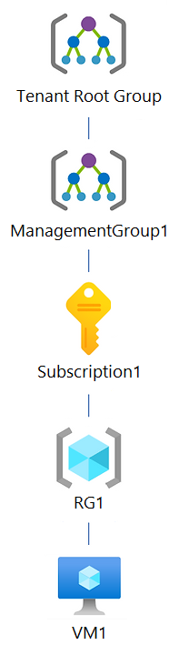
You create an Azure Policy definition named Policy1.
To which Azure resources in this hierarchy can Policy1 be assigned?
Réponses:
☐ Subscription1 and RG1 only
☐ ManagementGroup1 and Subscription1 only
☐ Tenant Root Group, ManagementGroup1, and Subscription1 only
☐ Tenant Root Group, ManagementGroup1, Subscription1, and RG1 only
☑ Tenant Root Group, ManagementGroup1, Subscription1, RG1, and VM1
Explication
`Tenant Root Group, ManagementGroup1, Subscription1, RG1, and VM1` is correct because Azure Policy definitions can be assigned at any level in the Azure hierarchy, including the tenant root group, management groups, subscriptions, resource groups, and individual resource.
It should be noted that policy cannot be applied to an individual resource from the Azure Portal, however, it can be done via Azure CLI or PowerShell.
Since the question dosen't specifically state that the policy should be applied using Azure Portal only, we can safely assume that using CLI/PowerShell, the policy can also be applied to an individual resource (VM1).
Reference(s):
- https://learn.microsoft.com/en-us/azure/governance/policy/concepts/assignment-structure
- https://learn.microsoft.com/en-us/azure/governance/policy/concepts/scope#assignment-scopes
- https://learn.microsoft.com/en-us/azure/azure-resource-manager/management/overview#understand-scope

Question 57
You have an Azure subscription that follows the resource hierarchy shown in the diagram, which includes a Tenant Root Group, ManagementGroup1, Subscription1, a resource group named RG1, and a virtual machine named VM1.
You create an Azure Policy definition named Policy1.
Which Azure resources can you specify as exclusions from Policy1?
Réponses:
☐ VM1 only
☐ RG1 and VM1 only
☐ Subscription1, RG1, and VM1 only
☑ ManagementGroup1, Subscription1, RG1, and VM1 only
☐ Tenant Root Group, ManagementGroup1, Subscription1, RG1, and VM1
Explication
`ManagementGroup1, Subscription1, RG1, and VM1 only` is correct because when assigning a policy, you can exclude resources at any level in the hierarchy, including management groups, subscriptions, resource groups, and individual resources. Exclusions are designed to provide flexibility in policy enforcement by allowing specific resources or groups to be excluded from a policy's scope.
`Tenant Root Group` cannot be excluded from policy assignments. Exclusions are applicable to management groups, subscriptions, resource groups, and individual resources only.
Reference(s):
- https://learn.microsoft.com/en-us/azure/governance/policy/concepts/assignment-structure
- https://learn.microsoft.com/en-us/azure/governance/policy/overview

Question 58
Your Azure environment contains 20 Windows Server virtual machines, an existing network security group called NSG1, and two virtual networks — VNET1 and VNET2 — that are connected through peering.
You intend to deploy an Azure Bastion host using the Basic SKU into VNET1. To ensure the Bastion service is reachable from external networks, you need to update NSG1 to allow incoming traffic from the internet.
When creating the inbound rule in NSG1, which destination port must be allowed?
Réponses:
☐ 22
☑ 443
☐ 3389
☐ 8080
Explication
`443` is correct because Azure Bastion uses HTTPS on port 443 for secure communication from the user's browser to the Azure Bastion host. This allows secure RDP or SSH access to virtual machines in the virtual network without exposing these VMs directly to the internet. When deploying Azure Bastion, an inbound rule must be added to the NSG for port 443 to allow this secure connection from the internet to the Bastion host.
`22` is incorrect because port 22 is used for SSH connections, but with Azure Bastion, the communication is tunneled over port 443 via HTTPS, making SSH directly over port 22 unnecessary.
`3389` is incorrect because port 3389 is used for RDP connections. Azure Bastion tunnels RDP sessions over port 443, eliminating the need to open port 3389 in the NSG.
`8080` is incorrect because port 8080 is not used by Azure Bastion for any connection.
Reference(s):
- https://learn.microsoft.com/en-us/azure/bastion/bastion-overview

Question 59
You have an Azure subscription that includes a user named User1 and a storage account named storage1.
The storage account contains the following resources:
- A blob container named container1
- A file share named folder1
- A table named Table1
User1 is assigned the following roles on storage1:
- Storage Blob Data Reader
- Storage Table Data Contributor
- Storage File Data SMB Share Contributor
A shared access signature (SAS) named SAS1 is created for storage1 with the configuration shown in the exhibit.
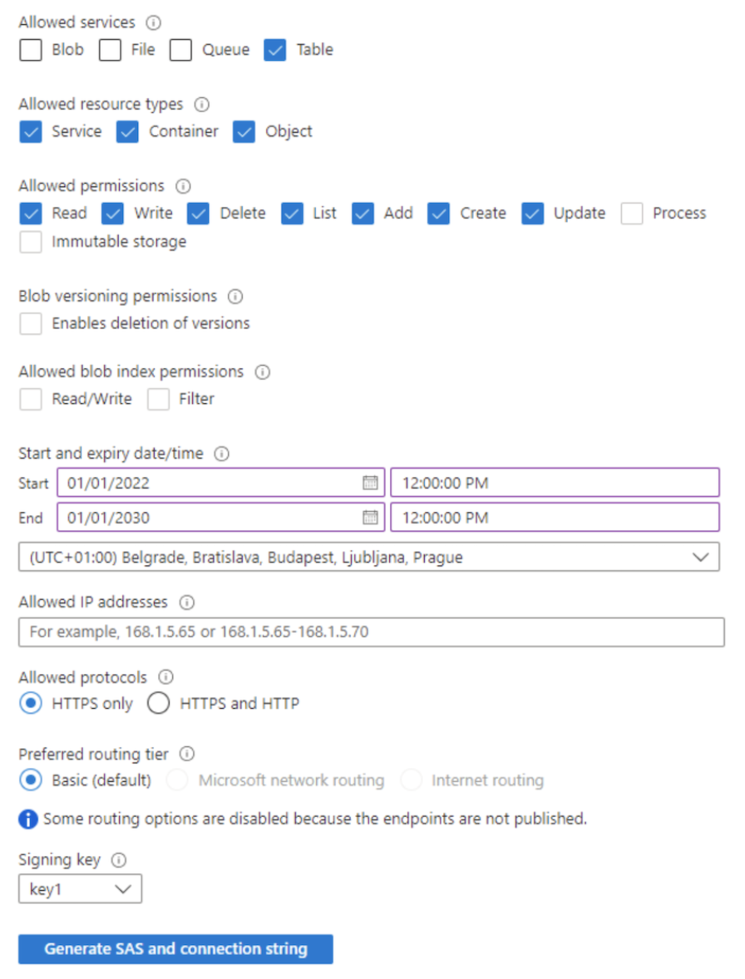
Which of the following resources can User1 write to by using SAS1?
Réponses:
☑ Table1 only
☐ Table1 and container1 only
☐ folder1 and Table1 only
☐ folder1 and container1 only
☐ Table1, folder1, and container1
Explication
`Table1 only` is correct because the SAS policy shown in the exhibit explicitly grants permissions only for the Table service. This means that when connecting to the storage account using SAS1, the scope of access is restricted to Table-based resources, such as Table1. Other services, such as Blob or File (which include container1 and folder1, respectively), are not included in the SAS policy. Therefore, only Table1 is accessible for all permitted operations, including creating, reading, updating, and deleting (CRUD). Other services will not be visible or accessible when connecting using this SAS key.
Reference(s):
https://learn.microsoft.com/en-us/azure/storage/common/storage-configure-connection-string
https://learn.microsoft.com/en-us/azure/storage/common/storage-account-keys-manage?tabs=azure-portal

Question 60
You have an Azure subscription that includes a user named User1 and a storage account named storage1.
The storage account contains the following resources:
- A blob container named container1
- A file share named folder1
- A table named Table1
User1 is assigned the following roles on storage1:
- Storage Blob Data Reader
- Storage Table Data Contributor
- Storage File Data SMB Share Contributor
A shared access signature (SAS) named SAS1 is created for storage1 with the configuration shown in the exhibit.
Which of the following resources can User1 write to by using key1?
Réponses:
☐ Table1 only
☐ Table1 and container1 only
☐ folder1 and Table1 only
☐ folder1 and container1 only
☑ Table1, folder1, and container1
Explication
`Table1, folder1, and container1` is the correct answer because access via `key1` refers to the use of a storage account access key, not a SAS token. Storage account keys act like root-level credentials and grant unrestricted full access to all services and data types in the storage account, including blobs (containers), files (file shares), and tables, regardless of the user's Azure RBAC roles. This means that even though User1 has limited RBAC roles, once they connect using the key, those restrictions are bypassed and they can read/write to all three resources.
Reference(s):
https://learn.microsoft.com/en-us/azure/storage/common/storage-configure-connection-string
https://learn.microsoft.com/en-us/azure/storage/common/storage-sas-overview

Question 61
You have an Azure subscription that includes the storage accounts listed below:
- storage1: StorageV2 with geo-zone-redundant storage (GZRS)
- storage2: BlobStorage with read-access geo-redundant storage (RA-GRS)
- storage3: BlockBlobStorage with zone-redundant storage (ZRS)
You need to determine which of these storage accounts support Azure Blob lifecycle management policies.
Which storage accounts meet this requirement?
Réponses:
☐ storage1 only
☐ storage2 only
☐ storage1 and storage3 only
☐ storage2 and storage3 only
☑ storage1, storage2, and storage3
Explication
`storage1, storage2, and storage3` is correct because all three storage account types—StorageV2, BlobStorage, and BlockBlobStorage—support lifecycle management policies for block blobs and append blobs. These policies enable automated tiering, deletion, and management of blob data to optimize costs and resource usage.
Reference(s):
https://learn.microsoft.com/en-us/azure/storage/blobs/lifecycle-management-overview

Question 62
You have an Azure subscription that includes the storage accounts listed below:
- storage1: StorageV2 with geo-zone-redundant storage (GZRS)
- storage2: BlobStorage with read-access geo-redundant storage (RA-GRS)
- storage3: BlockBlobStorage with zone-redundant storage (ZRS)
You need to determine which of these storage accounts support moving blob data to the Archive access tier.
Which storage accounts satisfy this requirement?
Réponses:
☐ storage1 only
☑ storage2 only
☐ storage1 and storage3 only
☐ storage2 and storage3 only
☐ storage1, storage2, and storage3
Explication
`storage2 only` is correct because only storage accounts configured with LRS (Locally Redundant Storage), GRS (Geo-Redundant Storage), or RA-GRS (Read-Access Geo-Redundant Storage) support moving blob data to the Archive access tier.
`storage1` is incorrect because it is a StorageV2 account configured with GZRS (Geo-Zone-Redundant Storage), which does not support the Archive access tier.
`storage3` is incorrect because it is a BlockBlobStorage account configured with ZRS (Zone-Redundant Storage), which does not support the Archive access tier.
Reference(s):
https://learn.microsoft.com/en-us/azure/storage/blobs/access-tiers-overview

Question 63
You have an Azure Storage account named storage1.
You plan to use AzCopy to transfer data into storage1.
You need to determine which storage services within storage1 support data uploads by using AzCopy.
Which storage services should you identify?
Réponses:
☐ file storage only
☑ blob storage and file storage only
☐ file storage and table storage only
☐ blob storage, table storage, and queue storage only
☐ blob storage, file storage, table storage, and queue storage
Explication
`blob storage and file storage only` is correct because AzCopy supports copying data to Blob storage and File storage, but not Table storage or Queue storage. AzCopy is specifically designed for transferring blob and file data efficiently within and across Azure storage accounts.
Reference(s):
https://learn.microsoft.com/en-us/azure/storage/common/storage-use-azcopy-v10?tabs=dnf

Question 64
An Azure Storage account stores approximately 10,000 blob objects and is accessed by several different users.
You must implement a solution that restricts visibility so that each user can list and access only certain blobs according to their assigned blob index tags.
What component or configuration should you implement to meet this requirement?
Réponses:
☐ a stored access policy
☑ a role assignment condition
☐ just-in-time (JIT) virtual machine access
☐ a shared access signature (SAS)
Explication
`a role assignment condition` is correct because role assignment conditions in Azure can enforce granular access control based on blob index tags. By using conditions in role assignments, you can ensure that users are restricted to viewing only the blobs that match specific index tags. This is an advanced Azure Role-Based Access Control (RBAC) feature designed for fine-grained access control scenarios.
`a stored access policy` is incorrect because stored access policies are used in conjunction with Shared Access Signatures (SAS) to manage shared access over time, but they cannot enforce access based on blob index tags.
`just-in-time (JIT) virtual machine access` is incorrect because JIT VM access is designed to provide temporary access to virtual machines and has no relevance to blob access control or index tags.
`a shared access signature (SAS)` is incorrect because while SAS can provide temporary access to blobs, it cannot enforce blob index tag-based conditions for granular access control.
Reference(s):
- https://learn.microsoft.com/en-us/azure/role-based-access-control/conditions-custom-security-attributes
- https://docs.microsoft.com/en-us/azure/role-based-access-control/conditions-overview
- https://docs.microsoft.com/en-us/azure/storage/blobs/storage-blob-index-how-to
- https://docs.microsoft.com/en-us/azure/security-center/just-in-time-explained

Question 65
In an Azure subscription named Subscription1, there is a resource group named RG1.
Inside RG1, two load balancers are deployed:
- LB1 – configured as an internal load balancer
- LB2 – configured as a public load balancer
You need to grant a user named Admin1 the ability to add and configure a backend address pool for LB1 by using backend resources in RG1. The solution must follow the principle of least privilege.
To enable Admin1 to create and configure a backend address pool for LB1, which Azure RBAC role should be assigned?
Réponses:
☐ Contributor role assigned at the LB1 scope
☐ Network Contributor role assigned at the LB1 scope
☑ Network Contributor role assigned at the RG1 scope
☐ Owner role assigned at the LB1 scope
Explication
`Network Contributor role assigned at the RG1 scope` is correct because adding a backend pool to a load balancer requires permissions not only on the load balancer itself but also on the resources (e.g., virtual machines or virtual machine scale sets) that will be added to the backend pool. The Network Contributor role at the resource group (RG1) level ensures Admin1 has the necessary permissions to manage network resources across RG1, including both the load balancer and the backend pool resources, while still adhering to the principle of least privilege.
`Contributor role assigned at the LB1 scope` is incorrect because this role grants overly broad permissions beyond just managing network resources. It does not align with the principle of least privilege.
`Owner role assigned at the LB1 scope` is incorrect because the Owner role allows full control, including assigning roles, which exceeds the requirements for adding a backend pool.
`Network Contributor role assigned at the LB1 scope` is incorrect because while this role provides permissions to manage the load balancer, it does not include permissions for managing the backend pool's underlying resources (e.g., virtual machines). These additional permissions are required to successfully add resources to the backend pool.
Reference(s):
- https://learn.microsoft.com/en-us/azure/load-balancer/backend-pool-management
- https://learn.microsoft.com/en-us/azure/role-based-access-control/built-in-roles#network-contributor
- https://learn.microsoft.com/en-us/azure/load-balancer/load-balancer-overview

Question 66
In an Azure subscription named Subscription1, there is a resource group named RG1.
Inside RG1, two load balancers are deployed:
- LB1 – configured as an internal load balancer
- LB2 – configured as a public load balancer
You need to grant Admin1 the ability to create a health probe on LB2. The solution must follow the principle of least privilege.
Which Azure RBAC role should assignment be assigned to Admin1 to allow the creation of a health probe on LB2?
Réponses:
☐ Contributor role assigned at the LB2 scope
☑ Network Contributor role assigned at the LB2 scope
☐ Network Contributor role assigned at the RG1 scope
☐ Owner role assigned at the LB2 scope
Explication
`Network Contributor role assigned at the LB2 scope` is correct because it adheres to the principle of least privilege. This role provides sufficient permissions to configure and manage health probes on the specific load balancer without granting unnecessary access to the entire resource group or other unrelated network resources. The Network Contributor role at the resource group level ensures Admin1 has the necessary access to both the load balancer and the related network resources, adhering to the principle of least privilege.
`Network Contributor role assigned at the RG1 scope` is incorrect because assigning this role at the resource group level grants broader permissions than necessary. While it enables the required operations, it goes against the principle of least privilege by providing access to all network resources within the resource group, not just LB2.
`Contributor role assigned at the LB2 scope` is incorrect because it grants excessive permissions, including access to non-network-related tasks, violating the principle of least privilege.
`Owner role assigned at the LB2 scope` is incorrect because the Owner role provides full administrative control, including the ability to assign roles, which far exceeds the permissions needed to add a health probe.
Reference(s):
- https://learn.microsoft.com/en-us/azure/role-based-access-control/built-in-roles#network-contributor
- https://learn.microsoft.com/en-us/azure/load-balancer/load-balancer-overview

Question 67
You have an Azure subscription that includes 10 virtual machines running Windows Server. Each VM hosts a website using IIS, and the Azure Monitor Agent is already installed on all machines.
Your objective is to collect IIS log files from each virtual machine and store them in a Log Analytics workspace.
What should you configure as the initial step?
Réponses:
☐ a private endpoint
☑ Diagnostic settings
☐ a data collection endpoint
☐ VM insights
☐ an Azure Monitor Private Link Scope (AMPLS)
Explication
`Diagnostic settings` is the correct answer because Diagnostic settings in Azure allow you to specify which logs and metrics should be collected from your virtual machines and where they should be sent, such as a Log Analytics workspace. To collect IIS logs from each virtual machine and store them in a Log Analytics workspace, you must configure Diagnostic settings on each virtual machine to enable and route IIS log data appropriately.
`a private endpoint` is incorrect because private endpoints are used to provide private access to Azure services via a private IP address, which is unrelated to configuring IIS log collection.
`a data collection endpoint` is incorrect because a Data Collection Endpoint (DCE) is only needed if Azure Monitor Private Links are in use, which is not specified in this scenario.
`VM insights` is incorrect because VM insights focuses on performance monitoring and dependency mapping for virtual machines. It does not handle IIS log collection and routing to a Log Analytics workspace.
`an Azure Monitor Private Link Scope (AMPLS)` is incorrect because AMPLS enables private access to Azure Monitor resources using Private Links. It is not a requirement for IIS log collection in this context.
Reference(s):
- https://learn.microsoft.com/en-us/azure/azure-monitor/essentials/diagnostic-settings
- https://learn.microsoft.com/en-us/azure/azure-monitor/agents/data-collection-iis

Question 68
You plan to deploy multiple Azure virtual machines running Windows Server 2022 as part of a virtual machine scale set by using an Azure Resource Manager template.
You must ensure that NGINX is installed and available on all virtual machines after the deployment completes.
Which two options should you use?
Réponses (plusieurs réponses possibles)
☑ a Desired State Configuration (DSC) extension
☐ Azure Application Insights
☑ the Publish-AzVMDscConfiguration cmdlet
☐ the New-AzConfigurationAssignment cmdlet
Explication
`a Desired State Configuration (DSC) extension` is the correct answer because the DSC extension allows you to define a desired state configuration for virtual machines in a scale set. This configuration can include installing and configuring software like NGINX on all virtual machines automatically after deployment.
`the Publish-AzVMDscConfiguration cmdlet` is also correct because this cmdlet is used to upload and publish a DSC configuration script to an Azure storage account. This script can then be used by the DSC extension to ensure NGINX is installed and configured on the virtual machines in the scale set.
`Azure Application Insights` is incorrect because Application Insights is a monitoring service used to track application performance and detect issues. It does not install or configure software like NGINX on virtual machines.
`the New-AzConfigurationAssignment cmdlet` is incorrect because this cmdlet is used to assign configurations in Azure Policy for governance, not for installing or configuring software on virtual machines.
Reference(s):
- https://learn.microsoft.com/en-us/azure/virtual-machines/extensions/dsc-overview
- https://learn.microsoft.com/en-us/powershell/module/az.compute/publish-azvmdscconfiguration?view=azps-13.0.0
- https://learn.microsoft.com/en-us/azure/azure-monitor/app/app-insights-overview
- https://learn.microsoft.com/en-us/powershell/module/az.maintenance/new-azconfigurationassignment?view=azps-13.0.0

Question 69
You have a subnet named Subnet1 that hosts several Azure virtual machines. A network security group named NSG1 is associated with Subnet1, and NSG1 currently includes only the default security rules.
You must add a rule to NSG1 that blocks the virtual machines in Subnet1 from accessing the Azure portal. At the same time, the virtual machines must continue to have access to other destinations on the internet.
What value should you configure for the Destination setting in the rule?
Réponses:
☐ Application security group
☐ IP Addresses
☐ Any
☑ Service Tag
Explication
`Service Tag` is the correct answer because Service Tags simplify network security group (NSG) rules by allowing you to reference a group of IP addresses associated with a specific Azure service. In this scenario, to block access to the Azure portal while still allowing access to other internet resources, you would use the AzureCloud service tag as the Destination in your NSG rule. This ensures that traffic specifically destined for the Azure portal is denied without impacting other internet traffic.
`Application security group` is incorrect because Application Security Groups (ASGs) are used to group virtual machines within the same virtual network to simplify NSG management. They cannot be used to target Azure services like the Azure portal.
`IP Addresses` is incorrect because blocking access to the Azure portal using IP addresses would require you to manually identify and maintain the list of Azure portal IP ranges, which is not practical or recommended.
`Any` is incorrect because setting the destination to "Any" would block all internet traffic, including non-Azure-related services, which does not meet the requirement of allowing access to other internet hosts.
Reference(s):
- https://learn.microsoft.com/en-us/azure/virtual-network/service-tags-overview
- https://learn.microsoft.com/en-us/azure/virtual-network/network-security-groups-overview
- https://learn.microsoft.com/en-us/azure/virtual-network/network-security-group-how-it-works

Question 70
You have two Azure virtual machines named VM1 and VM2, and two Recovery Services vaults named RSV1 and RSV2.
Currently, VM2 is protected by backups stored in RSV1.
You want to configure backups for VM2 by using RSV2 instead.
What action should you perform first?
Réponses:
☑ From the RSV1 blade, click Backup items and stop the VM2 backup.
☐ From the RSV2 blade, click Backup. From the Backup blade, select the backup for the virtual machine, and then click Backup.
☐ From the VM2 blade, click Disaster recovery, click Replication settings, and then select RSV2 as the Recovery Services vault.
☐ From the RSV1 blade, click Backup Jobs and export the VM2 job.
Explication
`From the RSV1 blade, click Backup items and stop the VM2 backup` is the correct answer because an Azure virtual machine can only be backed up to one Recovery Services vault at a time. To back up VM2 to a different vault (RSV2), you must first stop the existing backup in RSV1. Once the backup is stopped and the backup data is removed, you can reconfigure the backup for VM2 in RSV2.
`From the RSV2 blade, click Backup. From the Backup blade, select the backup for the virtual machine, and then click Backup` is incorrect because you cannot directly configure VM2 to back up in RSV2 without first stopping the existing backup configuration in RSV1.
`From the VM2 blade, click Disaster recovery, click Replication settings, and then select RSV2 as the Recovery Services vault` is incorrect because Disaster Recovery settings are for replicating a VM to another region, not for configuring backup to a Recovery Services vault.
`From the RSV1 blade, click Backup Jobs and export the VM2 job` is incorrect because exporting backup jobs does not change the Recovery Services vault assigned to the virtual machine.
Reference(s):
- https://learn.microsoft.com/en-us/azure/backup/backup-support-matrix
- https://docs.microsoft.com/en-us/azure/backup/backup-azure-move-recovery-services-vault#must-preserve-previous-backed-up-data
- https://docs.microsoft.com/en-in/azure/backup/backup-azure-vms-first-look-arm

Question 71
You have an Azure subscription named Sub1 with the subscription ID 8f3a1c92-5d47-4b6e-a2f9-71c3d8e5ab40.
You want to create a custom Azure RBAC role named CustomRole1 that meets the following conditions:
- The role can be assigned only at the resource group scope within Sub1.
- The role must not allow users to manage access permissions (RBAC) on the resource groups.
- The role must allow users to view, create, update, and delete resources inside the resource groups.
You are defining the role by using a JSON definition that includes the assignableScopes and permissions sections.
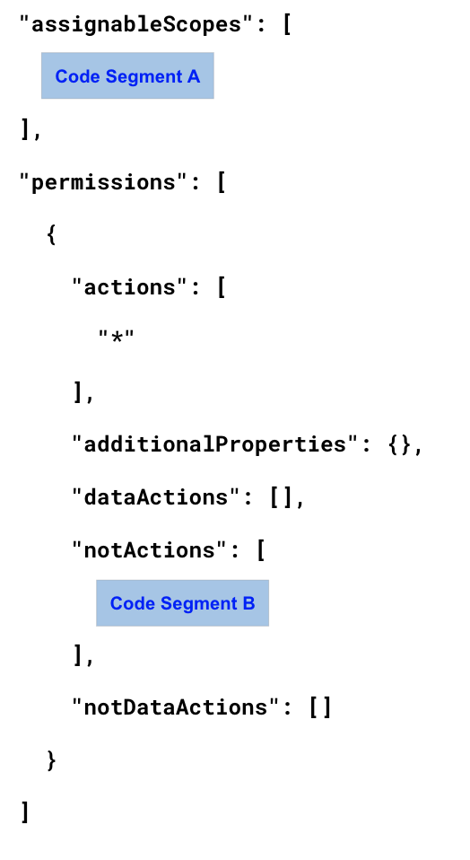
What value should you specify for `Code Segment A` in the definition of CustomRole1?
Réponses:
☐ "/"
☑ "/subscriptions/8f3a1c92-5d47-4b6e-a2f9-71c3d8e5ab40"
☐ "/subscriptions/8f3a1c92-5d47-4b6e-a2f9-71c3d8e5ab40/resourceGroups/"
Explication
`"/subscriptions/8f3a1c92-5d47-4b6e-a2f9-71c3d8e5ab40"` is the correct answer here. The assignableScopes property defines where a custom role can be assigned, and it accepts scopes such as management groups, subscriptions, or specific resource groups. Since Subscription1 has a subscription ID of 8f3a1c92-5d47-4b6e-a2f9-71c3d8e5ab40, and the requirement is to allow assignment of the role only to resource groups within this subscription, the correct assignable scope is the subscription level. This ensures the custom role is available for assignment at the resource group level within that subscription without being overly permissive.
`"/"` is incorrect because the root scope is not supported in custom role definitions. AssignableScopes cannot be set to "/", and attempting to do so will result in a validation error.
`"/subscriptions/8f3a1c92-5d47-4b6e-a2f9-71c3d8e5ab40/resourceGroups"` is incorrect because this is not a valid scope. The string "resourceGroups" is a collection placeholder, and not a valid scope by itself. Using it will result in a validation error such as:
"Validation error: Invalid scope: /subscriptions/<SubscriptionID>/resourceGroups".
Additionally, the question does not reference any specific resource group. It refers broadly to “resource groups” within the subscription, and therefore the assignable scope must be set at the subscription level.
Reference(s.):
- https://docs.microsoft.com/en-us/azure/role-based-access-control/custom-roles
- https://docs.microsoft.com/en-us/azure/role-based-access-control/role-definitions#assignablescopes

Question 72
You have an Azure subscription named Sub1 with the subscription ID 8f3a1c92-5d47-4b6e-a2f9-71c3d8e5ab40.
You want to create a custom Azure RBAC role named CustomRole1 that meets the following conditions:
- The role can be assigned only at the resource group scope within Sub1.
- The role must not allow users to manage access permissions (RBAC) on the resource groups.
- The role must allow users to view, create, update, and delete resources inside the resource groups.
You are defining the role by using a JSON definition that includes the assignableScopes and permissions sections.
What value should you specify for `Code Segment B` in the definition of CustomRole1?
Réponses:
☑ "Microsoft.Authorization/"
☐ "Microsoft.Resources/"
☐ "Microsoft.Security/*"
Explication
`"Microsoft.Authorization/"` is the correct answer here. In the context of custom RBAC role definitions, the "notActions" element (Dropdown 2) is used to explicitly deny certain management operations, even if the `"actions"` list includes a wildcard like `"*"`. In this scenario, the custom role CustomRole1 must allow full access to view, create, modify, and delete resources within resource groups, but it must prevent the user from managing access permissions (i.e., prevent role assignments).
Role assignment and access control operations in Azure are managed through the Microsoft.Authorization namespace. Therefore, to block permission management, you need to specify "Microsoft.Authorization/" in the "notActions" array. This removes the ability to read, create, or delete role assignments, while still allowing other actions.
`"Microsoft.Resources/"` is incorrect because this namespace is used for general resource management tasks like creating and managing resource groups or deployments, not for managing access control. Including it in "notActions" would block legitimate resource operations that the role should be allowed to perform.
`**"Microsoft.Security/*"` is incorrect** because it relates to security center operations such as policy management, security recommendations, and alerts. It is not relevant to access control and does not affect permissions related to RBAC.
Reference(s.):
- https://docs.microsoft.com/en-us/azure/role-based-access-control/custom-roles
- https://docs.microsoft.com/en-us/azure/role-based-access-control/resource-provider-operations#microsoftresources
- https://docs.microsoft.com/en-us/azure/role-based-access-control/resource-provider-operations#microsoftsecurity

Question 73
You have an Azure web app named App1 that uses deployment slots, as shown below:
- webapp1-prod -> Production
- webapp1-test -> Staging
You validate multiple updates to App1 in the webapp1-test slot.
After completing testing, you create a backup of App1.
You then swap the webapp1-test slot with webapp1-prod, after which the application starts showing performance problems.
You must roll back App1 to the earlier, stable version in the shortest possible time.
What action should you take?
Réponses:
☐ Restore App1 from the backup.
☐ Create a clone of App1.
☐ Redeploy the application to App1.
☑ Swap the deployment slots again.
Explication
`Swap the deployment slots again` is the correct answer here. Azure App Service deployment slots allow you to deploy and test changes in a staging slot (in this case, `webapp1-test`) and then swap the staging slot with the production slot (`webapp1-prod`) when ready. When a swap is performed, the content and configuration of the slots are exchanged, allowing for a quick rollback if needed.
Since you already swapped the test slot into production and discovered performance issues, the fastest way to revert is to swap the slots again. This will return the original production version (which is now in the test slot) back to its place, restoring the last working state almost instantly and with zero downtime.
`Restore App1 from the backup` is incorrect because although it can restore the app to a previous state, it is a slower operation and involves data loss risk and manual effort, making it less ideal for quick recovery.
`Create a clone of App1` is incorrect because cloning creates a new app instance, which is not a recovery mechanism and would not affect the current deployment state of App1.
`Redeploy the application to App1` is incorrect because this would require rebuilding and redeploying the application code, which takes more time and may not exactly match the last known good state.
Reference(s.):
- https://learn.microsoft.com/en-us/azure/app-service/deploy-staging-slots

Question 74
You have a pay-as-you-go Azure subscription with the following virtual machines:
- VM1 in resource group RG1, costing 20 euros per day
- VM2 in resource group RG2, costing **30 euros per day

You create the budget shown in the following exhibit.
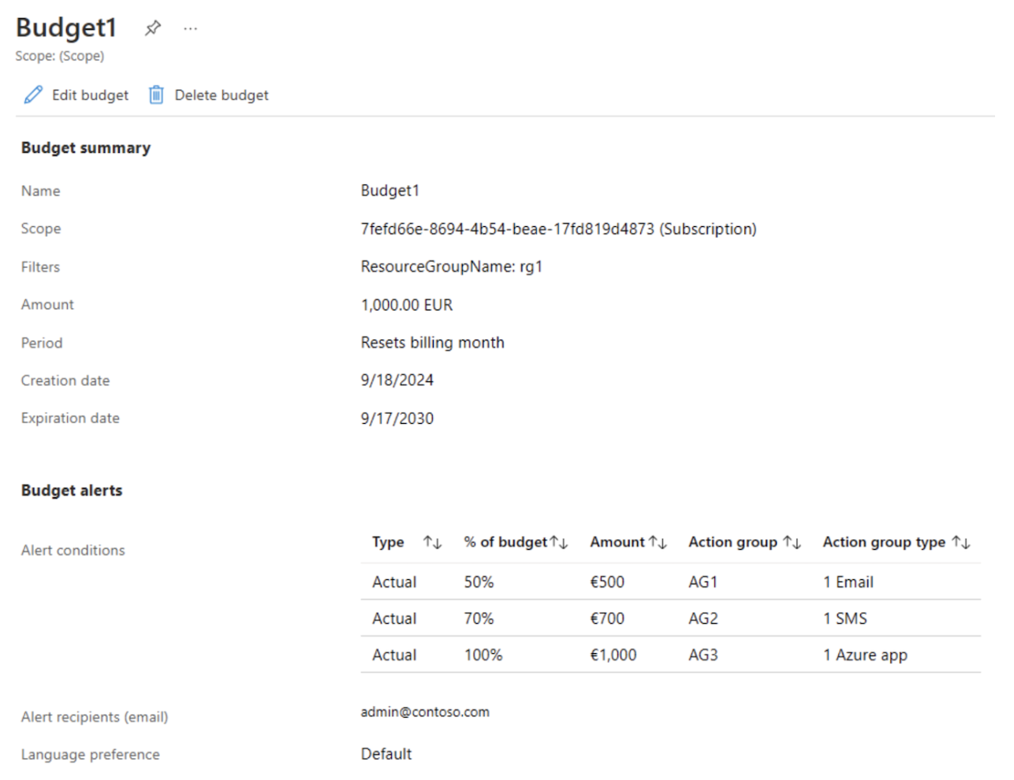
The budget is set up with alert thresholds at 50%, 70%, and 100%, each linked to different action groups.
The action group AG1 contains only the user admin@apexcore.com.
Based on this configuration, complete the following statement:
“When VM1 and VM2 reach the maximum budget limit, ___________________________________.”
Réponses:
☐ Both VM1 and VM2 are automatically shut down.
☑ VM1 and VM2 continue running.
☐ VM1 is stopped, while VM2 continues to run.
Explication
`VM1 and VM2 continue running` is the correct answer here. Azure budgets are a monitoring and alerting tool only. They do not enforce or take automatic action such as shutting down resources. In the case study:
- Budget1 is scoped to Resource Group RG1, which contains VM1.
- VM2, which is in RG2, is not within the scope of the budget and is therefore not tracked or managed by this budget.
- Even when the budget is fully consumed (100%), the configured action groups (AG1, AG2, AG3) only send notifications (via Email, SMS, or Azure app), but do not stop or deallocate any virtual machines.
Therefore, when both VM1 and VM2 reach their maximum cost, they continue to run, and no automatic shutdown occurs.

Reference(s.):**
- https://learn.microsoft.com/en-us/azure/cost-management-billing/costs/tutorial-acm-create-budgets
- https://learn.microsoft.com/en-us/azure/cost-management-billing/manage/cost-management-budget-scenario
- https://learn.microsoft.com/en-us/azure/cost-management-billing/costs/cost-mgt-alerts-monitor-usage-spending

Question 75
You have a pay-as-you-go Azure subscription with the following virtual machines:
- VM1 in resource group RG1, costing 20 euros per day
- VM2 in resource group RG2, costing **30 euros per day

You create the budget shown in the following exhibit.
The budget is set up with alert thresholds at 50%, 70%, and 100%, each linked to different action groups.
The action group AG1 contains only the user admin@apexcore.com.
Based on this configuration, complete the following statement:
“Given the existing usage costs of the virtual machines, _________________________.”
Réponses:
☐ no email notifications will be sent each month
☑ one email notification will be sent each month
☐ two email notifications will be sent each month
☐ three email notifications will be sent each month
Explication
`one email notification will be sent each month` is the correct answer here. This is a common area of confusion, so let's clarify it step by step to avoid misinterpretation.
In the provided scenario:
- VM1 is the only virtual machine within the scope of Budget1 (since VM1 is in RG1, and the budget is scoped to RG1).
- VM1 costs €20 per day, which totals approximately €600 per month.
- The budget thresholds are:
- 50% of €1,000 → triggers Action Group AG1 (configured to send 1 email)
- 70% of €1,000 → triggers AG2 (sends 1 SMS)
- 100% of €1,000 → triggers AG3 (sends 1 Azure app notification)
At €600, only the 50% threshold is crossed, which triggers AG1.
Why it’s not two emails:
You may mistakenly think that:
- One email is sent because AG1 is triggered
- Another email is sent because admin@apexcore.com is listed as an alert recipient
This is not correct.
In Azure Budgets, email alerts are sent only via Action Groups. The person listed (e.g., `admin@apexcore.com`) in the budget configuration is part of the Action Group (AG1) that is associated with the 50% threshold. They are not receiving a second, separate notification outside the Action Group.
So even though the name appears in the recipient list, it does not represent an additional notification beyond what AG1 is configured to send.
Reference(s.):
- https://learn.microsoft.com/en-us/azure/cost-management-billing/costs/tutorial-acm-create-budgets
- https://learn.microsoft.com/en-us/azure/cost-management-billing/manage/cost-management-budget-scenario
- https://learn.microsoft.com/en-us/azure/cost-management-billing/costs/cost-mgt-alerts-monitor-usage-spending

Question 76
You have an Azure subscription that contains the following App Service plans:
- ASP1 runs on Linux and uses the Basic B1 pricing tier.
- ASP2 runs on Windows and uses the Standard S1 pricing tier.
- ASP3 runs on Linux and uses the Premium v3 pricing tier.
You plan to create an additional App Service plan with these settings:
- Name: ASP4
- Operating system: Windows
- Pricing tier: Premium v3
You need to determine which of the App Service plans support rule-based scale-out.
Which App Service plans should you identify?
Réponses:
☐ ASP4 only
☐ ASP2 and ASP4 only
☑ ASP2, ASP3, and ASP4 only
☐ ASP1, ASP2, ASP3, and ASP4
Explication
`ASP2, ASP3, and ASP4 only` is correct. The question asks which App Service plans support rule-based scale out, which refers specifically to autoscale—the ability to automatically increase or decrease the number of instances based on predefined rules, such as CPU usage, memory load, or a schedule.
According to Microsoft documentation:
- Autoscale is not supported in the Basic (B1) pricing tier. While Basic plans support manual scale-out (up to 3 instances), they do not support rule-based scaling.
- Standard (S1) and Premium v3 plans do support autoscale, allowing automatic instance management based on defined rules and schedules.
Therefore, ASP2, ASP3, and ASP4 all support rule-based scale out, while ASP1 does not.
Reference(s.):
- https://learn.microsoft.com/en-us/azure/azure-monitor/autoscale/autoscale-get-started
- https://learn.microsoft.com/en-us/azure/app-service/manage-automatic-scaling?tabs=azure-portal
- https://learn.microsoft.com/en-us/azure/app-service/manage-scale-up
- https://learn.microsoft.com/en-us/azure/azure-monitor/autoscale/autoscale-overview

Question 77
You have an Azure subscription that contains the following App Service plans:
- ASP1 runs on Linux and uses the Basic B1 pricing tier.
- ASP2 runs on Windows and uses the Standard S1 pricing tier.
- ASP3 runs on Linux and uses the Premium v3 pricing tier.
You plan to create an additional App Service plan with these settings:
- Name: ASP4
- Operating system: Windows
- Pricing tier: Premium v3
You need to determine which of the App Service plans support zone redundancy.
Which App Service plans should you identify?
Réponses:
☑ ASP4 only
☐ ASP2 and ASP4 only
☐ ASP2, ASP3, and ASP4 only
☐ ASP1, ASP2, ASP3, and ASP4
Explication
`ASP4 only` is the correct answer here. Azure App Service supports zone redundancy only on the Premium v2 and Premium v3 pricing tiers. This makes ASP3 and ASP4 eligible, since both are using the Premium v3 tier.
But since the correct combination (ASP3 and ASP4 only) is not available among the answer choices, we need to select the best possible correct option from the list.
Among the choices provided:
- `ASP4 only` is the most accurate, because while it omits ASP3, it is the only option that exclusively lists a supported plan.
Therefore, ASP4 only is the best and most appropriate answer based on the available options.
Reference(s.):
- https://learn.microsoft.com/en-us/azure/reliability/reliability-app-service?pivots=free-shared-basic#regions-supported
- https://learn.microsoft.com/en-us/azure/app-service/overview-hosting-plans#premiumv3-pricing-tier

Question 78
You have an Azure subscription with a virtual network named VNet1.
VNet1 includes four subnets named Gateway, Perimeter, NVA, and Production.
The NVA subnet hosts two network virtual appliances (NVAs).
These NVAs are used to inspect network traffic flowing between the Perimeter subnet and the Production subnet.
You need to deploy an Azure Load Balancer in front of the NVAs.
The solution must meet the following conditions:
- The NVAs must operate in an active-active setup with automatic failover.
- Traffic must be load balanced to two different services in the Production subnet, and each service uses a different IP address.
Which three actions should you take?
Réponses (plusieurs réponses possibles)
☑ Add a frontend IP configuration, two backend pools, and a health probe
☐ Add a frontend IP configuration, a backend pool, and a health probe
☐ Deploy a basic load balancer
☑ Deploy a standard load balancer
☐ Add two load balancing rules that have HA Ports enabled and Floating IP disabled
☑ Add two load balancing rules that have HA Ports and Floating IP enabled
Explication
`Add a frontend IP configuration, two backend pools, and a health probe` is correct because the requirement involves load balancing traffic to two services on different IP addresses in the Production subnet. This necessitates two separate backend pools, each associated with one of the services. A frontend IP configuration is needed to receive incoming traffic, and a health probe is essential to determine the availability of the NVAs in the backend pool for failover.
`Deploy a standard load balancer` is correct because only the Standard SKU load balancer supports advanced features like HA Ports, Floating IP, and availability zones, all of which are needed for this high availability active-active NVA setup. The Basic SKU does not support multiple backend pools or advanced configurations required in this scenario.
`Add two load balancing rules that have HA Ports and Floating IP enabled` is correct because:
- HA Ports allows the load balancer to listen on all ports for the services, ensuring full connectivity through the NVAs.
- Floating IP (also known as Direct Server Return) must be enabled for scenarios that involve high availability and active-active NVAs, because it ensures the return path of packets doesn't interfere with source NAT.
`Add a frontend IP configuration, a backend pool, and a health probe` is incorrect because a single backend pool cannot load balance traffic to two distinct IP addresses (services). This setup lacks the isolation needed for managing traffic across both services.
`Deploy a basic load balancer` is incorrect because Basic SKU does not support HA Ports or multiple backend pools, which are essential for this solution.
`Add two load balancing rules that have HA Ports enabled and Floating IP disabled` is incorrect because disabling Floating IP prevents the correct routing behavior necessary for high availability and direct server return, which is needed in an active-active NVA configuration.
Reference(s.):
- https://learn.microsoft.com/en-us/azure/load-balancer/load-balancer-overview
- https://learn.microsoft.com/en-us/azure/load-balancer/load-balancer-ha-ports-overview
- https://learn.microsoft.com/en-us/azure/load-balancer/load-balancer-floating-ip
- https://learn.microsoft.com/en-us/azure/load-balancer/load-balancer-outbound-connections#scenarios-for-floating-ip-enabled
- https://learn.microsoft.com/en-us/azure/load-balancer/load-balancer-multivip-overview

Question 79
You have the following Azure virtual networks configured:
- VNet1
- Address space: 10.11.0.0/16
- Subnet: 10.11.0.0/17
- Resource group Azure region: West US
- VNet2
- Address space: 10.11.0.0/17
- Subnet: 10.11.0.0/25
- Resource group Azure region: West US
- VNet3
- Address space: 10.10.0.0/22
- Subnet: 10.10.1.0/24
- Resource group Azure region: East US
- VNet4
- Address space: 192.168.16.0/22
- Subnet: 192.168.16.0/24
- Resource group Azure region: North Europe
You want to configure virtual network peering for VNet1.
Which of the listed virtual networks can be peered with VNet1?
Réponses:
☐ VNet2 only
☑ VNet3 and VNet4 only
☐ VNet2 and VNet3 only
☐ VNet2, VNet3, and VNet4
Explication
`VNet3 and VNet4 only` is the correct answer here. To peer virtual networks in Azure, one of the main requirements is that the address spaces must not overlap. In the case of VNet1 (10.11.0.0/16):
- VNet2 (10.11.0.0/17) has an address space that overlaps with VNet1. Peering is not allowed in this case due to the overlapping IP ranges, even though it’s in the same region.
- VNet3 (10.10.0.0/22) has a non-overlapping address space and is in a different region (East US), which is still supported via global virtual network peering.
- VNet4 (192.168.16.0/22) also has a non-overlapping address space and is in North Europe, which again supports global VNet peering.
Therefore, only VNet3 and VNet4 can be peered with VNet1.
Reference(s.):
- https://learn.microsoft.com/en-us/azure/virtual-network/virtual-network-peering-overview
- https://learn.microsoft.com/en-us/azure/virtual-network/virtual-network-peering-overview
- https://learn.microsoft.com/en-us/azure/virtual-network/virtual-network-manage-peering

Question 80
You have two Azure subscriptions named Sub1 and Sub2.
In Sub1, there is a virtual machine named VM1 and a storage account named storage1.
The virtual machine VM1 is associated with the following resources:
- Disk1, which is the operating system disk for VM1
- NetInt1, which is the network interface attached to VM1
- VNet1, which is the virtual network that VM1 connects to
You need to move VM1 from Sub1 to Sub2.
Which of the associated resources must you move to Sub2 to complete this task?
Réponses:
☐ VM1, Disk1, and NetInt1 only
☐ VM1, Disk1, and VNet1 only
☐ VM1, Disk1, and storage1 only
☑ VM1, Disk1, NetInt1, and VNet1
Explication
`VM1, Disk1, NetInt1, and VNet1` is the correct answer here. When you move a virtual machine (VM1) to another subscription, all its associated dependent resources must be moved as well. This includes the OS disk (`Disk1`), the network interface (`NetInt1`), and the virtual network (`VNet1`). Azure requires that all dependent resources are part of the move operation to ensure the VM remains functional in the target subscription. If any dependency, like the NIC or virtual network, is left behind, the VM will lose connectivity or fail validation during the move.
Reference(s.):
- https://learn.microsoft.com/en-us/azure/azure-resource-manager/management/move-resource-group-and-subscription#virtual-machines
- https://learn.microsoft.com/en-us/azure/virtual-machines/network-overview

Question 81
You manage two Azure subscriptions: Subscription1 and Subscription2.
In Subscription1, the following resource groups exist:
- RG1 – Region: West Europe – Lock: None
- RG2 – Region: West Europe – Lock: Read-only
The resource group RG1 contains a web application named App1, which is deployed in the West Europe region.
In Subscription2, the following resource groups are configured:
- RG3 – Region: North Europe – Lock: Delete
- RG4 – Region: Central US – Lock: None
True or False:
`“App1 can be moved to RG2.”`
Réponses:
☐ True
☑ False
Explication
`False` is the correct answer because RG2 has a `Read Only` lock applied. When a resource group is locked with `Read Only`, you cannot add or move any resources into it. This type of lock prevents all write operations, including the action of moving a resource (such as App1) into the locked resource group. Even though App1 and RG2 are in the same region and subscription, the lock on RG2 blocks the move.
Reference(s):
- https://learn.microsoft.com/en-us/azure/azure-resource-manager/management/lock-resources?tabs=json
- https://learn.microsoft.com/en-us/azure/azure-resource-manager/management/move-resource-group-and-subscription

Question 82
You manage two Azure subscriptions: Subscription1 and Subscription2.
In Subscription1, the following resource groups exist:
- RG1 – Region: West Europe – Lock: None
- RG2 – Region: West Europe – Lock: Read-only
The resource group RG1 contains a web application named App1, which is deployed in the West Europe region.
In Subscription2, the following resource groups are configured:
- RG3 – Region: North Europe – Lock: Delete
- RG4 – Region: Central US – Lock: None
True or False:
`“App1 can be moved to RG3.”`
Réponses:
☑ True
☐ False
Explication
`True` is the correct answer because Azure allows moving supported resources, such as an App Service web app, between resource groups and even between subscriptions within the same tenant. When a resource is moved between resource groups or subscriptions, the resource itself does not move to another region. Only the Azure Resource Manager metadata changes, and the resource continues to run in its original region.
In this scenario, App1 is deployed in the West Europe region, and moving it to RG3 does not change its location. Even though RG3 is associated with North Europe, resource groups can contain resources from different regions, so this does not prevent the move.
Additionally, if the web app depends on other resources, such as an App Service Plan, those dependent resources must be moved together in the same operation.
The Delete lock on RG3 does not block the move because a delete lock only prevents deletion of the resource group or its resources. It does not prevent adding or moving resources into the resource group.
Therefore, App1 can be moved to RG3, making the statement True.
Reference(s):
- https://learn.microsoft.com/en-us/azure/azure-resource-manager/management/move-support-resources
- https://learn.microsoft.com/en-us/azure/azure-resource-manager/management/lock-resources

Question 83
You manage two Azure subscriptions: Subscription1 and Subscription2.
In Subscription1, the following resource groups exist:
- RG1 – Region: West Europe – Lock: None
- RG2 – Region: West Europe – Lock: Read-only
The resource group RG1 contains a web application named App1, which is deployed in the West Europe region.
In Subscription2, the following resource groups are configured:
- RG3 – Region: North Europe – Lock: Delete
- RG4 – Region: Central US – Lock: None
True or False:
`“App1 can be moved to RG4.”`
Réponses:
☑ True
☐ False
Explication
`True` is the correct answer because App1 can be moved to RG4, which is located in the Central US region, provided that RG4 does not contain any existing App Service resources such as web apps, App Service plans, or TLS/SSL certificates.
Although App1 is in West Europe, moving an app across resource groups or subscriptions does not change the region of the app. The app retains its original region (West Europe) after the move. The metadata such as resource group or subscription may change, but the physical location of the app stays the same.
There is no lock on RG4, so it won’t block the operation.
Reference(s):
- https://learn.microsoft.com/en-us/azure/app-service/manage-move-across-resources
- https://learn.microsoft.com/en-us/azure/azure-resource-manager/management/move-support-resources

Question 84
You have an Azure subscription that contains a virtual machine named VM1.
The virtual machine has two disks attached:
- An operating system disk named Disk1
- A data disk named Disk2
You are required to back up only Disk2 by using Azure Backup.
Which three actions should you perform in sequence?
ACTIONS
- Create a backup policy and configure the backup.
- Create a Recovery Services vault.
- Create an Azure Backup vault.
- Configure a managed identity.
- Delegate permissions for the vault.
Réponses:
☐ 1-3-4
☐ 4-3-1
☑ 3-1-4
☐ 2-1-4
☐ 4-2-1
Explication
`3-1-4` is the correct sequence of actions.
`(Action 3)` Create an Azure Backup vault is correct. For Azure Disk Backup (as opposed to full VM backup), you use an Azure Backup vault, which is a specific vault type designed for backing up individual managed disks. This is different from a Recovery Services vault, which is used for broader scenarios like VM, SQL, and file backups.
`(Action 1)` Create a backup policy and configure the backup is correct. After the vault is created, you define a backup policy that dictates the schedule and retention for the disk backup. You then associate Disk2 with this policy.
`(Action 4)` Configure a managed identity is correct. Azure Disk Backup uses Azure RBAC and managed identities for access. You must configure a user-assigned managed identity with appropriate roles (like `Disk Backup Reader`) to allow the vault to access and back up Disk2.
`(Action 2)` Create a Recovery Services vault is incorrect. This is used for VM-level backup and is not applicable to Azure Disk Backup, which requires a Backup vault.
`(Action 5)` Delegate permissions for the vault is incorrect. Disk Backup uses managed identity and RBAC instead of manual permission delegation. You assign roles to the managed identity instead of explicitly delegating permissions.
Reference(s):
- https://learn.microsoft.com/en-us/azure/backup/backup-managed-disks

Question 85
You have deployed Azure virtual machines across three different Azure regions.
In each region:
- There is one virtual network.
- Each virtual network contains multiple subnets.
- All virtual networks are connected using full-mesh VNet peering.
A user reports that they are unable to connect over TCP port 33000 from a virtual machine in one region to a virtual machine in another region.
Which two options can you use to investigate and troubleshoot this connectivity issue?
Réponses (plusieurs réponses possibles)
☐ Azure Monitor Network Insights
☑ IP flow verify
☐ effective security rules
☐ Azure Virtual Network Manager
☑ Connection troubleshoot
Explication
`IP flow verify` is correct because it allows you to test whether traffic is allowed to or from a virtual machine based on NSG (Network Security Group) rules. It specifically helps in identifying whether a particular port (like 33000) is blocked or allowed, which is essential for troubleshooting connectivity between VMs.
`Connection troubleshoot` is correct because it helps diagnose issues with connectivity between two endpoints. It checks DNS resolution, network latency, and whether TCP connections (like on port 33000) can be established, making it ideal for this scenario involving cross-region VM communication.
`Azure Monitor Network Insights` is incorrect because it gives you a high-level view of the health and topology of your network resources, but it doesn't perform port-level diagnostics or simulate connection attempts.
`effective security rules` is incorrect because it shows the final set of NSG rules applied to a NIC or subnet but doesn't actively test whether a specific port is blocked or allowed. It's useful for analysis, but not direct diagnostics.
`Azure Virtual Network Manager` is incorrect because it's used for centralized network management and policy enforcement across VNets, not for diagnosing connectivity issues like blocked ports.
Reference(s):
- https://learn.microsoft.com/en-us/azure/network-watcher/network-watcher-ip-flow-verify-overview
- https://learn.microsoft.com/en-us/azure/network-watcher/network-watcher-connectivity-overview

Question 86
You have an Azure subscription called Subscription1 that includes two virtual machines named VM1 and VM2, both running Windows Server 2016.
VM1 is protected with Azure Backup, configured to run daily backups without using the Azure Backup agent.
VM1 has been compromised by ransomware that encrypts data.
You need to restore data from the most recent backup of VM1.
To which of the following targets can you perform a file-level recovery for VM1?
Réponses:
☐ VM1 only
☐ VM1 or a new Azure virtual machine only
☐ VM1 and VM2 only
☐ A new Azure virtual machine only
☑ Any Windows computer that has Internet connectivity
Explication
`Any Windows computer that has Internet connectivity` is the correct answer because Azure Backup supports file-level recovery from a VM backup even when the Azure Backup agent is not used. The recovery is performed by downloading and running a script provided by the portal, which mounts the backup snapshot as a virtual drive. This can be done on any supported Windows machine with internet access, allowing files to be copied to any desired location.
Reference(s):
- https://learn.microsoft.com/en-us/azure/backup/backup-azure-restore-files-from-vm
- https://learn.microsoft.com/en-us/azure/backup/backup-azure-vms-introduction

Question 87
You have an Azure subscription called Subscription1 that includes two virtual machines named VM1 and VM2, both running Windows Server 2016.
VM1 is protected with Azure Backup, configured to run daily backups without using the Azure Backup agent.
VM1 has been compromised by ransomware that encrypts data.
You need to restore data from the most recent backup of VM1.
To which location can you restore the backup?
Réponses:
☐ VM1 only
☑ VM1 or a new Azure virtual machine only
☐ VM1 and VM2 only
☐ Any Windows computer that has Internet connectivity
Explication
`VM1 or a new Azure virtual machine only` is the correct answer because when Azure Backup is used to back up a VM without using the Azure Backup agent, it performs a full image-level backup of the virtual machine. In the event of data loss (e.g., ransomware), the entire VM can be restored either to the original VM (VM1) or as a new Azure virtual machine from the latest recovery point. This method does not support file-level recovery to arbitrary machines unless the MARS agent is used, which is not applicable in this scenario.
`VM1 only` is incorrect because Azure Backup allows restoring the VM to a new VM as well, not just to the original one.
`VM1 and VM2 only` is incorrect because Azure Backup does not allow restoring a VM backup to a different existing VM like VM2. Restores are limited to the original VM or a new one.
`Any Windows computer that has Internet connectivity` is incorrect because that type of file-level restore is only supported when using the Azure Backup agent (MARS) or the System Center DPM/MABS, which is not being used in this scenario.
Reference(s):
- https://learn.microsoft.com/en-us/azure/backup/backup-azure-arm-restore-vms
- https://learn.microsoft.com/en-us/azure/backup/backup-support-matrix-iaas
- https://learn.microsoft.com/en-us/azure/backup/backup-azure-vms-introduction

Question 88
You have an Azure subscription that contains the following resources:
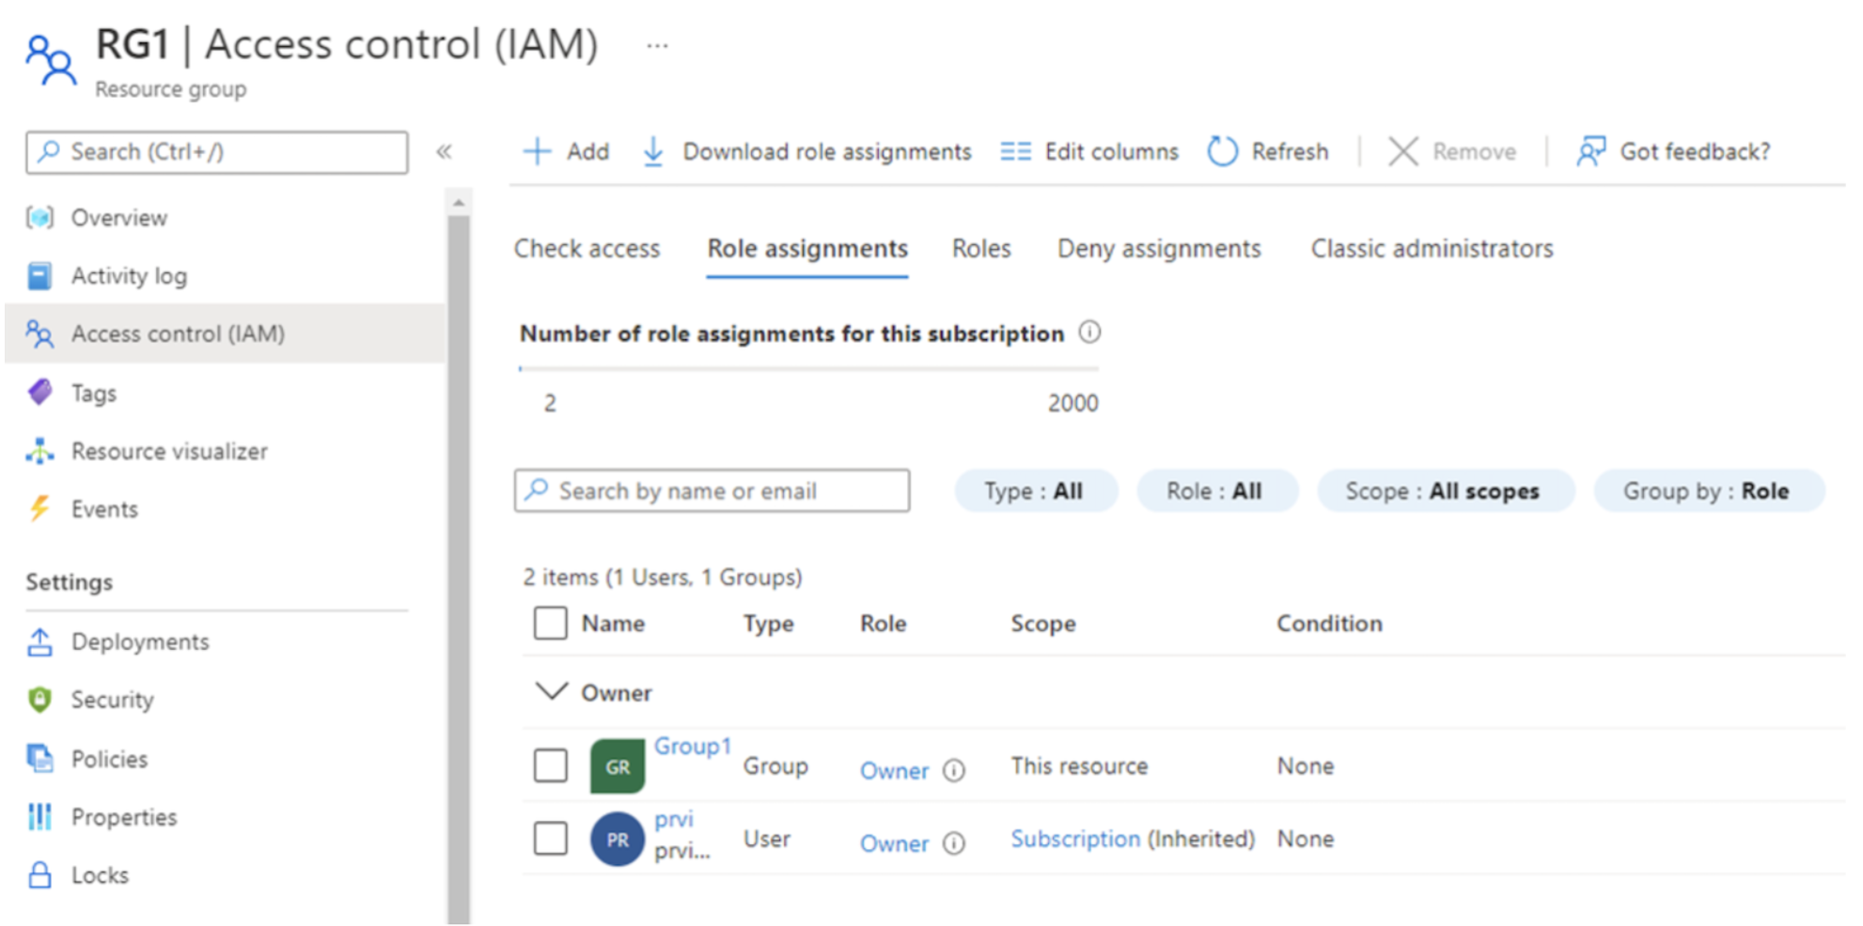
You configure Azure Site Recovery to replicate VM1 from East US to West US.
You then initiate a test failover and choose VNET2 as the destination virtual network.
After the test failover completes, to which subnet in VNET2 will the test instance of VM1 be connected?
Réponses:
☐ RecoverySubnetB
☑ DemoSubnet1
☐ TestSubnet1
☐ RecoverySubnetA
Explication
`DemoSubnet1` is the correct answer because when performing a test failover in Azure Site Recovery and no matching subnet name exists in the target virtual network (VNET2), the test virtual machine is automatically connected to the first subnet in alphabetical order. In this case, the source subnet is `Subnet2`, which does not exist in VNET2. Among the available subnets in VNET2—DemoSubnet1, RecoverySubnetA, RecoverySubnetB, and TestSubnet1—the one that comes first alphabetically is DemoSubnet1, so the test VM is connected there.
`RecoverySubnetA` is incorrect because although it contains “Recovery” in the name, it comes after DemoSubnet1 alphabetically.
`RecoverySubnetB` is incorrect because it is not the first subnet in alphabetical order and does not match the source subnet name.
`TestSubnet1` is incorrect because ASR does not prioritize subnets based on naming conventions like “Test”. It only looks for an exact match or falls back to the first subnet in alphabetical order.
Reference(s):
- https://learn.microsoft.com/en-us/azure/site-recovery/azure-to-azure-network-mapping#specify-a-subnet

