AZ-104 - Practice Test 5
AZ-104 — Azure Administrator · 73 questions

Question 1
You manage an Azure App Service application called PortalApp.
The development team plans to publish updates to PortalApp using Web Deploy. They must be able to authenticate using their Microsoft Entra ID accounts when deploying the application.
The solution must follow the principle of least privilege and avoid granting excessive permissions.
Which action should you take?
Réponses:
☐ Grant the developers the Owner role on the web app.
☐ Set up application-level FTPS credentials.
☐ Configure user-specific FTPS credentials.
☑ Assign the Website Contributor role to the developers.
Explication
`Assign the Website Contributor role to the developers` is the correct answer here. The Website Contributor role provides the necessary permissions to manage the web app, including deploying content, without giving the developers excessive privileges such as those granted by the Owner role. This ensures the solution follows the principle of least privilege.
`Grant the developers the Owner role on the web app` is incorrect because the Owner role gives full control over the resource, including the ability to delete or modify access permissions, which violates the principle of least privilege.
`Set up application-level FTPS credentials` is incorrect because using app-level credentials does not involve using Microsoft Entra credentials and does not follow the principle of least privilege.
`Configure user-specific FTPS credentials` is incorrect because this does not involve using Microsoft Entra credentials and provides too much access for just deploying content.
Reference(s):
- https://learn.microsoft.com/en-us/azure/role-based-access-control/built-in-roles#website-contributor

Question 2
You have an Azure subscription named Sub1 that includes several blob containers, as shown in the following table.

Name In storage account Contains blob**
------- ------------------- ---------------
cont1 storage1 blob1
cont2 storage1 blob2
cont1 storage2 blob3
Each container resides in a specific storage account and contains one blob.
The subscription includes two users named User1 and User2. Both users are assigned the Reader role at the Sub1 subscription scope.
You have defined a condition named `Condition1` with the following logic:
- The condition evaluates to true when the requested action is not a blob read operation
OR
- The container name equals cont1
You have also defined a second condition named `Condition2` with the following logic:
- The condition evaluates to true when the requested action is not a blob write operation
OR
- The blob path matches a pattern that contains the value 2
You then assign roles to the users:
- User1 is assigned the Storage Blob Data Reader role at the Sub1 scope with Condition1 applied.
- User2 is assigned the Storage Blob Data Owner role at the storage1 account scope with Condition2 applied.
True or False:
“User1 can read blob2.”
Réponses:
☐ True
☑ False
Explication
`False` is correct because User1 is assigned the Storage Blob Data Reader role at the Sub1 scope with Condition1, which restricts access to the blobs unless certain conditions are met. Condition1 specifies that User1 can only read blobs within containers named cont1. Since blob2 is in container cont2, User1 cannot read it due to the condition restricting access to containers named cont1.
Reference(s):
- https://learn.microsoft.com/en-us/azure/role-based-access-control/conditions-overview
- https://learn.microsoft.com/en-us/azure/role-based-access-control/conditions-format
- https://learn.microsoft.com/en-us/azure/role-based-access-control/built-in-roles

Question 3
You have an Azure subscription named Sub1 that includes several blob containers, as shown in the following table.

Name In storage account Contains blob**
------- ------------------- ---------------
cont1 storage1 blob1
cont2 storage1 blob2
cont1 storage2 blob3
Each container resides in a specific storage account and contains one blob.
The subscription includes two users named User1 and User2. Both users are assigned the Reader role at the Sub1 subscription scope.
You have defined a condition named `Condition1` with the following logic:
- The condition evaluates to true when the requested action is not a blob read operation
OR
- The container name equals cont1
You have also defined a second condition named `Condition2` with the following logic:
- The condition evaluates to true when the requested action is not a blob write operation
OR
- The blob path matches a pattern that contains the value 2
You then assign roles to the users:
- User1 is assigned the Storage Blob Data Reader role at the Sub1 scope with Condition1 applied.
- User2 is assigned the Storage Blob Data Owner role at the storage1 account scope with Condition2 applied.
True or False:
“User1 can read blob3.”
Réponses:
☑ True
☐ False
Explication
`True` is correct because, based on the conditions set in Condition1, User1 is restricted from reading any blob outside of the cont1 container. Although blob3 is in a different container (cont1 in storage2), the condition will allow User1 to access it. The condition in Condition1 only allows User1 to read blobs from the cont1 container in any storage account in that subscription.
Reference(s):
- https://learn.microsoft.com/en-us/azure/role-based-access-control/conditions-format

Question 4
You have an Azure subscription named Sub1 that includes several blob containers, as shown in the following table.

Name In storage account Contains blob**
------- ------------------- ---------------
cont1 storage1 blob1
cont2 storage1 blob2
cont1 storage2 blob3
Each container resides in a specific storage account and contains one blob.
The subscription includes two users named User1 and User2. Both users are assigned the Reader role at the Sub1 subscription scope.
You have defined a condition named `Condition1` with the following logic:
- The condition evaluates to true when the requested action is not a blob read operation
OR
- The container name equals cont1
You have also defined a second condition named `Condition2` with the following logic:
- The condition evaluates to true when the requested action is not a blob write operation
OR
- The blob path matches a pattern that contains the value 2
You then assign roles to the users:
- User1 is assigned the Storage Blob Data Reader role at the Sub1 scope with Condition1 applied.
- User2 is assigned the Storage Blob Data Owner role at the storage1 account scope with Condition2 applied.
True or False:
“User2 can read blob1.”
Réponses:
☑ True
☐ False
Explication
`True` is correct. User2 is assigned the Storage Blob Data Owner role at the storage1 scope, which includes blob1 and grants permissions to read and write blob data, subject to Condition2.
Condition2 evaluates to true when either the requested action is not a blob write operation or the blob path contains the value `2`. Because reading blob1 is not a write operation, the first clause evaluates to true. Although blob1’s path does not contain `2`, the complete expression evaluates as `true OR false`, which is true.
Therefore, Condition2 permits the read operation, and User2 can read blob1. The blob-path requirement would only restrict write operations, because for a write operation the first clause would evaluate to false.
Reference(s):
- https://learn.microsoft.com/en-us/azure/role-based-access-control/conditions-format

Question 5
You have two Azure virtual machines as shown in the following table. Each virtual machine runs a different operating system, has both private and public IP addresses assigned, and is connected to the same virtual network. One virtual machine has a DNS suffix configured in the operating system, while the other does not.
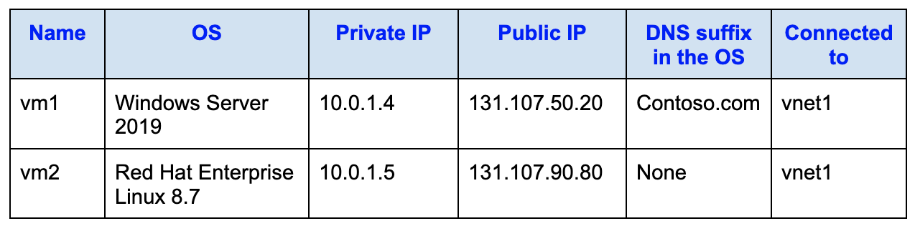
You then create the following Azure DNS resources:
- A public DNS zone named contoso.com
- A private DNS zone named fabrikam.com
You perform the following actions:
- For fabrikam.com, you create a virtual network link to vnet1 and enable automatic registration.
- For contoso.com, you assign the Owner role to both vm1 and vm2.
True of False:
“The DNS A record for vm1 is created in contoso.com and resolves to the IP address 131.107.50.20.”
Réponses:
☐ True
☑ False
Explication
`False` is correct because the contoso.com zone is a public DNS zone, not a private DNS zone. Auto registration for DNS records is supported only for private DNS zones when linked to virtual networks. Since contoso.com is a public DNS zone and auto registration is not enabled for public zones, a DNS A record for vm1 will not be automatically added with its public IP address of 131.107.50.20.
Additionally, the assignment of the Owner role to vm1 and vm2 does not influence DNS auto registration, as that pertains to role-based access control (RBAC) and not DNS management.
Reference(s):
- https://learn.microsoft.com/en-us/azure/dns/private-dns-autoregistration

Question 6
You have two Azure virtual machines as shown in the following table. Each virtual machine runs a different operating system, has both private and public IP addresses assigned, and is connected to the same virtual network. One virtual machine has a DNS suffix configured in the operating system, while the other does not.
You then create the following Azure DNS resources:
- A public DNS zone named contoso.com
- A private DNS zone named fabrikam.com
You perform the following actions:
- For fabrikam.com, you create a virtual network link to vnet1 and enable automatic registration.
- For contoso.com, you assign the Owner role to both vm1 and vm2.
True of False:
“The DNS A record for vm1 is created in fabrikam.com and resolves to the IP address 10.0.1.4.”
Réponses:
☑ True
☐ False
Explication
`True` is correct because fabrikam.com is a private DNS zone, and since auto-registration is enabled for vnet1, the private IP address (10.0.1.4) of vm1 will be automatically added as an A record to the fabrikam.com private DNS zone. Auto-registration is supported for private DNS zones, and linking the virtual network ensures that virtual machines connected to the network can have their private IP addresses automatically registered in the private DNS zone.
Reference(s):
- https://learn.microsoft.com/en-us/azure/dns/private-dns-autoregistration

Question 7
You have two Azure virtual machines as shown in the following table. Each virtual machine runs a different operating system, has both private and public IP addresses assigned, and is connected to the same virtual network. One virtual machine has a DNS suffix configured in the operating system, while the other does not.
You then create the following Azure DNS resources:
- A public DNS zone named contoso.com
- A private DNS zone named fabrikam.com
You perform the following actions:
- For fabrikam.com, you create a virtual network link to vnet1 and enable automatic registration.
- For contoso.com, you assign the Owner role to both vm1 and vm2.
True of False:
“The DNS A record for vm2 is created in fabrikam.com and resolves to the IP address 10.0.1.5.”
Réponses:
☑ True
☐ False
Explication
`True` is correct because fabrikam.com is an Azure Private DNS zone that is linked to vnet1 with automatic registration enabled. When automatic registration is enabled, Azure automatically creates DNS A records for all virtual machines connected to the linked virtual network.
vm2 is connected to vnet1 and has a private IP address of 10.0.1.5, so Azure automatically registers an A record for vm2.fabrikam.com that resolves to the private IP address.
The operating system type of vm2 and the absence of a DNS suffix configured inside the operating system do not affect Azure Private DNS auto-registration, as the registration is handled by the Azure platform.
The public DNS zone contoso.com and the assignment of the Owner role to the virtual machines are not relevant to Private DNS auto-registration and do not influence the creation of records in the fabrikam.com private DNS zone.
Reference(s):
- https://learn.microsoft.com/en-us/azure/dns/private-dns-autoregistration

Question 8
You have two Azure subscriptions named Sub1 and Sub2. Sub1 is in a management group named MG1. Sub2 is in a management group named MG2.
The following resource groups exist in the subscriptions:
Name Subscription
**------ --------------
RG1 Sub1
RG2 Sub2**
The following virtual machines are deployed:
Name Resource group
**------ --------------
VM1 RG1
VM2 RG2
VM3 RG2**
You assign roles to users as shown in the following table.
Name Role Resource
**------ ----------------------------- ----------
User1 Virtual Machine Contributor MG1**
User1 Virtual Machine User Login Sub2
User2 Virtual Machine Contributor MG2
User2 Virtual Machine User Login Sub1
User2 Virtual Machine User Login VM3
True of False:
`"User1 can sign in to VM1."`
Réponses:
☐ True
☑ False
Explication
`False` is correct because User1 does not have the "Virtual Machine User Login" role assigned for VM1 or at the scope of Sub1. While User1 has the "Virtual Machine Contributor" role for management group MG1, which includes Sub1, the "Virtual Machine Contributor" role alone does not grant login permissions. The "Virtual Machine User Login" role is required to allow the user to sign in to the virtual machine, and this role is not assigned to User1 for VM1, Sub1, or RG1.
Reference(s):
- https://learn.microsoft.com/en-us/azure/role-based-access-control/built-in-roles

Question 9
You have two Azure subscriptions named Sub1 and Sub2. Sub1 is in a management group named MG1. Sub2 is in a management group named MG2.
The following resource groups exist in the subscriptions:
Name Subscription
**------ --------------
RG1 Sub1
RG2 Sub2**
The following virtual machines are deployed:
Name Resource group
**------ --------------
VM1 RG1
VM2 RG2
VM3 RG2**
You assign roles to users as shown in the following table.
Name Role Resource
**------ ----------------------------- ----------
User1 Virtual Machine Contributor MG1**
User1 Virtual Machine User Login Sub2
User2 Virtual Machine Contributor MG2
User2 Virtual Machine User Login Sub1
User2 Virtual Machine User Login VM3
True of False:
`"User2 has the ability to administer the disks and disk snapshots associated with VM1."`
Réponses:
☐ True
☑ False
Explication
`False` is correct because User2 has the "Virtual Machine Contributor" role assigned to management group MG2, which includes Sub2, but VM1 is located in Sub1. Therefore, User2 does not have the necessary permissions to manage the disks or disk snapshots for VM1. The "Virtual Machine Contributor" role assigned at MG2 does not apply to resources in Sub1, including VM1. As a result, User2 cannot manage disks or snapshots of VM1.
Reference(s):
- https://learn.microsoft.com/en-us/azure/role-based-access-control/built-in-roles

Question 10
You have two Azure subscriptions named Sub1 and Sub2. Sub1 is in a management group named MG1. Sub2 is in a management group named MG2.
The following resource groups exist in the subscriptions:
Name Subscription
**------ --------------
RG1 Sub1
RG2 Sub2**
The following virtual machines are deployed:
Name Resource group
**------ --------------
VM1 RG1
VM2 RG2
VM3 RG2**
You assign roles to users as shown in the following table.
Name Role Resource
**------ ----------------------------- ----------
User1 Virtual Machine Contributor MG1**
User1 Virtual Machine User Login Sub2
User2 Virtual Machine Contributor MG2
User2 Virtual Machine User Login Sub1
User2 Virtual Machine User Login VM3
True of False:
`"User2 has the ability to administer the disks and disk snapshots associated with VM3."`
Réponses:
☐ True
☑ False
Explication
`False` is correct because the "Virtual Machine Contributor" role allows users to manage virtual machines and attached disks but does not grant permissions to manage disk snapshots. Managing disk snapshots requires specific permissions, such as those granted by the "Disk Snapshot Contributor" role. Since User2 only has the "Virtual Machine Contributor" role, they can manage disks but cannot manage snapshots for VM3.
Reference(s):
- https://learn.microsoft.com/en-us/azure/role-based-access-control/built-in-roles

Question 11
You manage an Azure Storage account named dataarchive01, which contains a blob container called images. This container holds a a large collection of image files.
You plan to deploy an Azure Resource Manager (ARM) template to configure a blob inventory rule named inventoryRule1.
The configuration must ensure that a daily inventory report is generated in CSV format and stored in the images container. The report must include only those blobs whose names start with the prefix “finance”.
You need to complete the configuration of rule1, shown below.
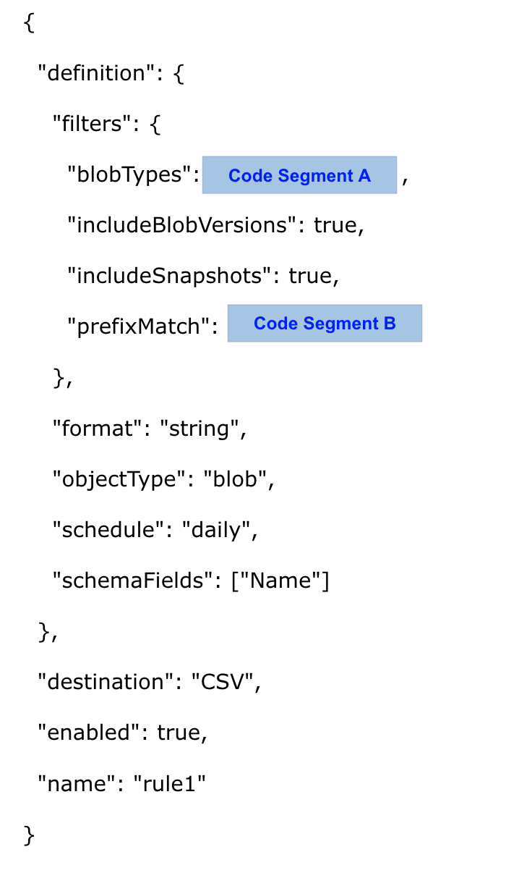
Which value should you choose for Code Segment A?
Réponses:
☐ appendBlob
☑ blockBlob
☐ pageBlob
Explication
`blockBlob` is the correct answer. Block blobs are designed to store large amounts of unstructured data, such as images or backups, which is the use case described here with thousands of image files. Additionally, block blobs are more suitable for use cases where data needs to be frequently accessed, stored, or replaced (such as in a daily CSV file). This fits the requirements for the blob inventory rule where you need to filter blobs whose names start with "finance."
`appendBlob` is incorrect because it is generally used for log data where the need is to continuously append new data. It is not optimized for image storage or daily CSV storage.
`pageBlob` is incorrect because page blobs are typically used for storing virtual hard disks (VHDs) for Azure virtual machines, not for storing images or daily CSV files.
Reference(s):
- https://learn.microsoft.com/en-us/azure/storage/blobs/storage-blobs-introduction
- https://learn.microsoft.com/en-us/rest/api/storageservices/understanding-block-blobs--append-blobs--and-page-blobs

Question 12
You manage an Azure Storage account named dataarchive01, which contains a blob container called images. This container holds a a large collection of image files.
You plan to deploy an Azure Resource Manager (ARM) template to configure a blob inventory rule named inventoryRule1.
The configuration must ensure that a daily inventory report is generated in CSV format and stored in the images container. The report must include only those blobs whose names start with the prefix “finance”.
You need to complete the configuration of rule1, shown below.
Which value should you choose for Code Segment B?
Réponses:
☐ images/*
☑ images/finance
☐ finance
Explication
`images/finance` is the correct answer. According to the documentation, the prefix match string in a blob policy must always start with the container name followed by the desired blob name prefix. In this case, "images" is the container, and "finance" is the required blob prefix, making images/finance the appropriate match string for blobs starting with the word "finance."
`images/*` is incorrect because it would match all blobs within the container and not only those starting with "finance."
`finance` is incorrect because it does not include the container name as required by the blob policy format.
Reference(s):
- https://learn.microsoft.com/en-us/azure/storage/blobs/storage-blob-faq#the-blob-prefix-match-string-didn-t-apply-the-policy-to-the-expected-blobs

Question 13
You manage an Azure Storage account called mediafiles01 that contains a collection of image blobs.
You plan to provision an additional storage account and configure object replication to copy the existing images from mediafiles01 to the new account.
After creating and configuring the destination storage account, you need to determine the appropriate object type that must be created within it to support object replication.
Which object type should you create in the destination storage account?
Réponses:
☑ Container
☐ File share
☐ Table
☐ Queue
Explication
`Container` is the correct answer here. Azure Object Replication is a feature of Azure Blob Storage, and it works at the container level. To replicate blobs from one storage account to another, you must configure object replication policies between source and destination containers. This means that in the new storage account, you must create a container, as it's the fundamental object that holds blobs (such as images in this case). Without a container, the replication policy cannot be configured or function.
`File share` is incorrect because object replication does not support Azure Files. File shares are used in Azure Files, which is a completely separate service from Blob Storage, and is not part of object replication capabilities.
`Table` is incorrect because Azure Table storage is used for NoSQL structured data, and again, object replication only applies to block blobs in containers, not table data.
`Queue` is incorrect because Azure Queue Storage is designed for messaging between application components. It is not related to blob storage or object replication and cannot be used for replicating blob data.
Reference(s):
- https://learn.microsoft.com/en-us/azure/storage/blobs/object-replication-overview
- https://learn.microsoft.com/en-us/azure/storage/blobs/object-replication-configure?tabs=portal
- https://learn.microsoft.com/en-us/azure/storage/queues/storage-queues-introduction
- https://learn.microsoft.com/en-us/azure/storage/files/storage-files-introduction
- https://learn.microsoft.com/en-us/azure/storage/tables/table-storage-overview

Question 14
You manage an Azure Storage account called mediafiles01 that contains a collection of image blobs.
You plan to provision an additional storage account and configure object replication to copy the existing images from mediafiles01 to the new account.
After creating and configuring the destination storage account, you need to determine the appropriate object type that must be created within it to support object replication.
Which account type should you create in the destination storage account?
Réponses:
☐ StorageV2 only
☐ StorageV2 or FileStorage only
☑ StorageV2 or BlobStorage only
☐ StorageV2, BlobStorage, or FileStorage
Explication
`StorageV2 or BlobStorage only` is correct because object replication is supported by both general-purpose v2 storage accounts (StorageV2) and premium block blob storage accounts (BlobStorage). These account types meet the requirements for object replication, allowing replication of blobs between the source and destination accounts.
`StorageV2 only` is incorrect because while StorageV2 supports object replication, premium block blob storage accounts (BlobStorage) also support object replication, and they should not be excluded from the correct answer.
`StorageV2 or FileStorage only `and `StorageV2, BlobStorage, or FileStorage` are incorrect because FileStorage accounts do not support blob storage, which is necessary for object replication.
Reference(s):
- https://learn.microsoft.com/en-us/azure/storage/blobs/object-replication-overview

Question 15
**Note: This question is part of a set of related questions that use the same scenario. Each question proposes a different solution that may or may not satisfy the stated requirement.

You manage an Azure Container Registry named corpRegistry that contains a container image called webappimage.
When you try to deploy an Azure Container Instance using webappimage, the deployment process fails with an error.
You must ensure that a container instance can be deployed successfully using the image stored in corpRegistry.
Proposed solution: `Configure a private endpoint for corpRegistry.`
Does this solution meet the requirement?
Réponses:
☐ Yes
☑ No
Explication
`No` is correct because while a private endpoint connection allows secure access to the container registry over a private network, it does not resolve all potential issues with deploying a container instance. The error might be related to permissions, image availability, or networking configuration rather than the absence of a private endpoint. Other issues like missing Azure Container Instance permissions, registry access policies, or image tags could prevent deployment.
A more appropriate solution would be ensuring that the container instance has the proper permissions to pull images from the registry. This can be done by checking if the container instance has the necessary identities (system-assigned or user-assigned) and permissions to access the container registry.
Reference(s):
- https://learn.microsoft.com/en-us/azure/container-registry/container-registry-private-link

Question 16
**Note: This question is part of a set of related questions that use the same scenario. Each question proposes a different solution that may or may not satisfy the stated requirement.

You manage an Azure Container Registry named corpRegistry that contains a container image called webappimage.
When you try to deploy an Azure Container Instance using webappimage, the deployment process fails with an error.
You must ensure that a container instance can be deployed successfully using the image stored in corpRegistry.
Proposed solution: `Enable the Use dedicated data endpoint setting for corpRegistry.`
Does this solution meet the requirement?
Réponses:
☐ Yes
☑ No
Explication
`No` is correct because selecting "Use dedicated data endpoint" for Registry1 is primarily used to isolate data plane traffic from management plane traffic in a container registry. While it improves network security and performance, it does not directly address issues related to deploying a container instance using an image. The error message could be caused by other factors, such as missing permissions, improper image tags, or incorrect access configurations for the Azure Container Instance. Using a dedicated data endpoint does not resolve these issues.
A more suitable solution would involve verifying the necessary access permissions and configurations to ensure the container instance can pull the image from the registry.
Reference(s):
- https://learn.microsoft.com/en-us/azure/container-registry/container-registry-private-link

Question 17
**Note: This question is part of a set of related questions that use the same scenario. Each question proposes a different solution that may or may not satisfy the stated requirement.

You manage an Azure Container Registry named corpRegistry that contains a container image called webappimage.
When you try to deploy an Azure Container Instance using webappimage, the deployment process fails with an error.
You must ensure that a container instance can be deployed successfully using the image stored in corpRegistry.
Proposed solution: `You assign the AcrPull role to ACR-Tasks-Network for Registry1.`
Does this solution meet the requirement?
Réponses:
☐ Yes
☑ No
Explication
`No` is correct because assigning the AcrPull role to ACR-Tasks-Network does not resolve the error when deploying a container instance. The AcrPull role allows a service or identity to pull images from the container registry, but ACR-Tasks-Network is typically used for managing tasks within the Azure Container Registry (ACR). This role is unrelated to the container instance’s ability to pull images from the registry. The container instance itself or the identity running the container instance should have the AcrPull role assigned for successful image deployment.
A better solution would involve assigning the AcrPull role to the identity or service principal running the container instance, ensuring it has permission to pull images from the registry.
Reference(s):
- https://learn.microsoft.com/en-us/azure/container-registry/container-registry-roles?tabs=azure-cli
- https://learn.microsoft.com/en-us/azure/container-instances/container-instances-managed-identity

Question 18
**Note: This question is part of a set of related questions that use the same scenario. Each question proposes a different solution that may or may not satisfy the stated requirement.

You manage an Azure Container Registry named corpRegistry that contains a container image called webappimage.
When you try to deploy an Azure Container Instance using webappimage, the deployment process fails with an error.
You must ensure that a container instance can be deployed successfully using the image stored in corpRegistry.
Proposed solution: `You set Admin user to Enable for corpRegistry.`
Does this solution meet the requirement?
Réponses:
☑ Yes
☐ No
Explication
`Yes` is correct because enabling the Admin user on the Azure container registry provides credentials (username and password) that can be used to authenticate and pull images from the registry. This can resolve authentication issues when deploying a container instance, as the container instance can use the admin credentials to access the registry and pull image1. This is a quick solution to grant access, especially when other identity-based methods, such as Microsoft Entra, are not configured.
Reference(s):
- https://learn.microsoft.com/en-us/azure/container-registry/container-registry-authentication?tabs=azure-cli
- https://learn.microsoft.com/en-us/azure/container-instances/container-instances-using-azure-container-registry

Question 19
**Note: This question is part of a set of related questions that use the same scenario. Each question proposes a different solution that may or may not satisfy the stated requirement.

You manage an Azure Storage account named datastore01.
A user named UserA must be granted permissions to view (list) the storage account access keys and regenerate those keys when necessary.
Proposed solution: `Assign the Storage Account Encryption Scope Contributor role to UserA at the scope of datastore01.`
Does this solution achieve the objective?
Réponses:
☐ Yes
☑ No
Explication
`No` is correct because the Storage Account Encryption Scope Contributor role does not grant permissions to list or regenerate storage account keys. To enable a user to list and regenerate storage account keys, the user needs to have the Storage Account Key Operator Service Role or Storage Account Contributor role. These roles specifically allow the management of storage account keys, which is not covered by the Storage Account Encryption Scope Contributor role.
Reference(s):
- https://learn.microsoft.com/en-us/azure/role-based-access-control/built-in-roles

Question 20
**Note: This question is part of a set of related questions that use the same scenario. Each question proposes a different solution that may or may not satisfy the stated requirement.

You manage an Azure Storage account named datastore01.
A user named UserA must be granted permissions to view (list) the storage account access keys and regenerate those keys when necessary.
Proposed solution: `You assign the Storage Account Key Operator Service Role to UserA.`
Does this solution achieve the objective?
Réponses:
☑ Yes
☐ No
Explication
`Yes` is correct because the Storage Account Key Operator Service Role grants the necessary permissions to list and regenerate storage account keys without providing broader access to the storage account's data. This role is specifically designed for key management tasks, allowing the user to perform actions related to storage account keys.
Assigning this role to UserA will enable them to list and regenerate the keys for storage1 as required.
Reference(s):
- https://learn.microsoft.com/en-us/azure/role-based-access-control/built-in-roles#storage-account-key-operator-service-role
- https://learn.microsoft.com/en-us/azure/storage/common/storage-account-keys-manage?tabs=azure-portal

Question 21
**Note: This question is part of a set of related questions that use the same scenario. Each question proposes a different solution that may or may not satisfy the stated requirement.

You manage an Azure Storage account named datastore01.
A user named UserA must be granted permissions to view (list) the storage account access keys and regenerate those keys when necessary.
Proposed solution: `You assign the Storage Account Contributor role to UserA.`
Does this solution achieve the objective?
Réponses:
☑ Yes
☐ No
Explication
`Yes` is correct because the Storage Account Contributor role provides the necessary permissions to manage storage accounts, including listing and regenerating storage account keys. This role covers both the management of the storage account itself and the associated keys, which meets the requirement stated in the scenario.
Reference(s):
- https://learn.microsoft.com/en-us/azure/role-based-access-control/built-in-roles

Question 22
**Note: This question is part of a set of related questions that use the same scenario. Each question proposes a different solution that may or may not satisfy the stated requirement.

You manage an Azure Storage account named datastore01.
A user named UserA must be granted permissions to view (list) the storage account access keys and regenerate those keys when necessary.
Proposed solution: `You assign the Reader and Data Access role to UserA.`
Does this solution achieve the objective?
Réponses:
☐ Yes
☑ No
Explication
`No` is correct because the Reader and Data Access role allows a user to view storage account data and metadata but does not provide the necessary permissions to list or regenerate storage account keys. To achieve the goal of allowing UserA to list and regenerate storage account keys, the appropriate role would be the Storage Account Key Operator Service Role or a more privileged role like Contributor.
The Reader and Data Access role is insufficient for key management tasks.
Reference(s):
- https://learn.microsoft.com/en-us/azure/role-based-access-control/built-in-roles#storage-account-key-operator-service-role

Question 23
Note: This question is part of a set of related questions that use the same scenario. Each question proposes a different solution that may or may not satisfy the stated requirement.
You manage an Azure virtual machine named ProdVM01, which was deployed using a custom Azure Resource Manager template called deployVM.json.
You receive an alert stating that ProdVM01 will be affected by a scheduled platform maintenance event.
You must immediately relocate ProdVM01 to another host to avoid the upcoming maintenance impact.
Proposed solution: `From the ProdVM01 Updates blade, select One-time update.`
Does this solution meet the requirement?
Réponses:
☐ Yes
☑ No
Explication
`No` is correct because the One-time update option applies maintenance updates to the virtual machine, but it doesn't guarantee moving the VM to a new host to avoid impending maintenance.
To immediately move the VM to a different host, you would need to Redeploy the virtual machine, which moves it to a new host within the same region.
Reference(s):
- https://learn.microsoft.com/en-us/azure/virtual-machines/maintenance-configurations

Question 24
Note: This question is part of a set of related questions that use the same scenario. Each question proposes a different solution that may or may not satisfy the stated requirement.
You manage an Azure virtual machine named ProdVM01, which was deployed using a custom Azure Resource Manager template called deployVM.json.
You receive an alert stating that ProdVM01 will be affected by a scheduled platform maintenance event.
You must immediately relocate ProdVM01 to another host to avoid the upcoming maintenance impact.
Proposed solution: `From the Overview blade, move ProdVM01 to another subscription`
Does this solution meet the requirement?
Réponses:
☐ Yes
☑ No
Explication
`No` is correct. The Overview blade provides the details of the VM. Moving a VM to another subscription is a logical change and does not affect the underlying physical infrastructure. To move VM1 to a different host to avoid maintenance impacts, you should redeploy the VM instead.
Reference(s):
- https://learn.microsoft.com/en-us/azure/virtual-machines/maintenance-configurations
- https://learn.microsoft.com/en-us/azure/azure-resource-manager/management/move-resource-group-and-subscription

Question 25
Note: This question is part of a set of related questions that use the same scenario. Each question proposes a different solution that may or may not satisfy the stated requirement.
You manage an Azure virtual machine named ProdVM01, which was deployed using a custom Azure Resource Manager template called deployVM.json.
You receive an alert stating that ProdVM01 will be affected by a scheduled platform maintenance event.
You must immediately relocate ProdVM01 to another host to avoid the upcoming maintenance impact.
Proposed solution: `Move the VM to a different resource group from the Overview balde.`
Does this solution meet the requirement?
Réponses:
☐ Yes
☑ No
Explication
`No` is the correct answer here. Moving a virtual machine to a different resource group does not change the physical host on which the VM is running. The operation is a metadata-level move within Azure Resource Manager, and the underlying compute resources (including the physical host) remain unchanged.
Since the goal is to move ProdVM01 to a different host immediately (e.g., to avoid upcoming planned maintenance), simply moving the VM to a different resource group does not meet the requirement.
To move a VM to a different host, you must perform an operation that redeploys the VM, such as using the Redeploy option from the Azure portal or running the `az vm redeploy` command. This action will provision the VM on a new physical host.
Reference(s.):
- https://learn.microsoft.com/en-us/troubleshoot/azure/virtual-machines/windows/redeploy-to-new-node-windows

Question 26
Note: This question is part of a set of related questions that use the same scenario. Each question proposes a different solution that may or may not satisfy the stated requirement.
You manage an Azure virtual machine named ProdVM01, which was deployed using a custom Azure Resource Manager template called deployVM.json.
You receive an alert stating that ProdVM01 will be affected by a scheduled platform maintenance event.
You must immediately relocate ProdVM01 to another host to avoid the upcoming maintenance impact.
Proposed solution: `From the Updates blade, you click Enable.`
Does this solution meet the requirement?
Réponses:
☐ Yes
☑ No
Explication
`No` is the correct answer here. Clicking Enable from the Updates blade typically refers to enabling automatic VM guest patching or maintenance control features, depending on the context. However, this action does not immediately move the VM to a different host.
The goal is to move ProdVM01 to a different physical host immediately to avoid potential impact from scheduled maintenance. The correct action to achieve that is to use the Redeploy option, which reprovisions the virtual machine onto a new physical host in the same region.
Reference(s.):
- https://learn.microsoft.com/en-us/troubleshoot/azure/virtual-machines/windows/redeploy-to-new-node-windows

Question 27
Note: This question is part of a set of related questions that use the same scenario. Each question proposes a different solution that may or may not satisfy the stated requirement.
You manage an Azure virtual machine named ProdVM01, which was deployed using a custom Azure Resource Manager template called deployVM.json.
You receive an alert stating that ProdVM01 will be affected by a scheduled platform maintenance event.
You must immediately relocate ProdVM01 to another host to avoid the upcoming maintenance impact.
Proposed solution: `From the ProdVM01 Redeploy + reapply blade, you click Redeploy.`
Does this solution meet the requirement?
Réponses:
☑ Yes
☐ No
Explication
`Yes` is the correct answer here. Clicking Redeploy from the Redeploy + reapply blade of ProdVM01 moves the virtual machine to a new physical host within the same Azure region. This operation is specifically designed to address issues related to the underlying host, including planned maintenance, host failures, or performance degradation.
When you redeploy a VM:
- The OS and data disks are preserved.
- The VM is moved to a different host.
- The public IP (if static) and other configurations remain unchanged.
Reference(s.):
- https://learn.microsoft.com/en-us/troubleshoot/azure/virtual-machines/windows/redeploy-to-new-node-windows

Question 28
Note: This question is part of a set of related questions that use the same scenario. Each question proposes a different solution that may or may not satisfy the stated requirement.
You manage an Azure virtual machine named ProdVM01, which was deployed using a custom Azure Resource Manager template called deployVM.json.
You receive an alert stating that ProdVM01 will be affected by a scheduled platform maintenance event.
You must immediately relocate ProdVM01 to another host to avoid the upcoming maintenance impact.
Proposed solution: `Move ProdVM01 to another resource group from the RG blade.`
Does this solution meet the requirement?
Réponses:
☐ Yes
☑ No
Explication
`No` is the correct answer here. Moving ProdVM01 to another resource group from the resource group blade is a logical metadata move within Azure Resource Manager. It does not involve changing the physical host on which the virtual machine runs. The VM’s underlying infrastructure—including the compute host—remains the same.
Since the goal is to move ProdVM01 to a different host immediately (to avoid disruption due to planned maintenance), this solution does not meet the requirement. The correct action would be to redeploy the virtual machine using the Redeploy option, which moves the VM to a new physical host.
Reference(s.):
- https://learn.microsoft.com/en-us/troubleshoot/azure/virtual-machines/windows/redeploy-to-new-node-windows

Question 29
You have an Azure subscription that uses Azure Container Instances.
You are working on a computer where the Azure Command-Line Interface (CLI) and Docker are installed.
You build a container image named image1.
You need to create a new Azure container registry and then push image1 to that registry.
Which command should you run to create a new container registry?
Réponses:
☐ az acr build
☑ az acr create
☐ az container create
☐ docker create
Explication
`az acr create` is the correct answer here. This command is used to create a new Azure Container Registry (ACR). Once the container registry is created, you can push your container images (such as image1) to the registry. This satisfies the requirement of provisioning a new Azure Container Registry.
`az acr build` is incorrect because this command is used to build and push a Docker container image to an Azure Container Registry, but it does not provision the registry itself.
`az container create` is incorrect because this command is used to create a container instance, not a container registry.
`docker create` is incorrect because this Docker command is used to create a new container from an image on your local machine, not to provision a container registry in Azure.
Reference(s):
- https://learn.microsoft.com/en-us/cli/azure/acr?view=azure-cli-latest

Question 30
You have an Azure subscription that uses Azure Container Instances.
You are working on a computer where the Azure Command-Line Interface (CLI) and Docker are installed.
You build a container image named image1.
You need to create a new Azure container registry and then push image1 to that registry.
Which command should you run to add image1 to the registry?
Réponses:
☐ az acr create
☐ az container create
☐ docker pull
☑ docker push
Explication
`docker push` is the correct answer here. This command is used to upload (push) your locally built Docker container image, such as image1, to a container registry. Once the Azure Container Registry has been created, you use the docker push command to push the image to the registry.
`az acr create` is incorrect because this command is used to create a new Azure Container Registry, not to upload an image.
`az container create` is incorrect because this command is used to create a container instance in Azure, not to push an image to a registry.
`docker pull` is incorrect because this command is used to download (pull) an image from a registry, not to upload (push) an image.
Reference(s):
- https://learn.microsoft.com/en-us/azure/container-registry/container-registry-get-started-docker-cli?tabs=azure-cli
- https://docs.docker.com/reference/cli/docker/image/push/

Question 31
An Azure subscription includes a container group named Group1. The container group hosts two Azure container instances, as detailed in the following table.
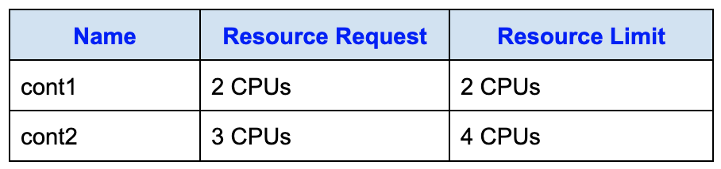
Each container has defined CPU resource requests and limits.
You must ensure that each container cannot consume more CPU resources than it requests, and that cont2 does not negatively affect cont1.
What action should you take?
Réponses:
☐ Increase the CPU resource limit for cont1 to three CPUs.
☐ Increase the CPU resource limit of cont2 to six CPUs.
☑ Remove the CPU resource limits configured on both containers.
☐ Reduce the CPU resource limit of cont2 to two CPUs.
Explication
`Remove the CPU resource limits configured on both containers` is the correct answer. Azure Container Instances allocates CPU resources to a container group based on the sum of the containers’ resource requests. If no resource limit is specified for a container, its maximum CPU usage is equal to its resource request. Therefore, after removing the limits, cont1 cannot use more than its requested 2 CPUs, and cont2 cannot use more than its requested 3 CPUs. This ensures that neither container can consume CPU resources beyond its request and that cont2 cannot use additional shared CPU resources at the expense of cont1.
`Reduce the CPU resource limit of cont2 to two CPUs` is incorrect because a container’s resource limit must be equal to or greater than its resource request. Since cont2 requests 3 CPUs, its limit cannot be reduced to 2 CPUs.
`Increase the CPU resource limit of cont2 to six CPUs` is incorrect because a container’s resource limit cannot exceed the total CPU resources allocated to the container group. The group is allocated 5 CPUs based on the combined requests of cont1 and cont2. Increasing cont2’s limit would also work against the requirement to prevent it from consuming more CPU than it requests.
`Increase the CPU resource limit for cont1 to three CPUs` is incorrect because this would allow cont1 to consume more CPU than its requested 2 CPUs. It would not ensure that each container is restricted to its resource request and could increase resource contention within the group.
Reference(s):
- https://learn.microsoft.com/en-us/azure/container-instances/container-instances-container-groups

Question 32
You are managing a tenant in Microsoft Entra.
You want to ensure that whenever a new Microsoft 365 group is created, the group name automatically follows this format:
<Department><Group name>
Which three actions must you carry out, in the correct order, from the Microsoft Entra admin center to achieve this configuration?
ACTIONS
- Set Add suffix to Attribute.
- Create a group naming policy.
- Set Add prefix to Attribute.
- Set Add suffix to String.
- Set Add prefix to String.
- Set Select type to Department.
- Customize the company branding.
Réponses:
☐ 2-6-3
☑ 2-3-6
☐ 3-2-6
☐ 6-3-2
Explication
`2-3-6` is the correct sequence of actions.
`(Action 2) Create a group naming policy`: You need to create a group naming policy in the Microsoft Entra admin center to enforce a specific naming convention.
`(Action 3) Set Add prefix to Attribute`: In the group naming policy, set Add prefix to Attribute and choose Department as the attribute. This ensures that the department name is added as a prefix to the group name.
`(Action 6) Set Select type to Department`: Finally, ensure that you set Select type to Department to specify that the department attribute should be used when creating the group name.
Reference(s):
- https://learn.microsoft.com/en-us/entra/identity/users/groups-naming-policy

Question 33
You have a Microsoft Entra tenant that is linked to the subscriptions shown in the following table.
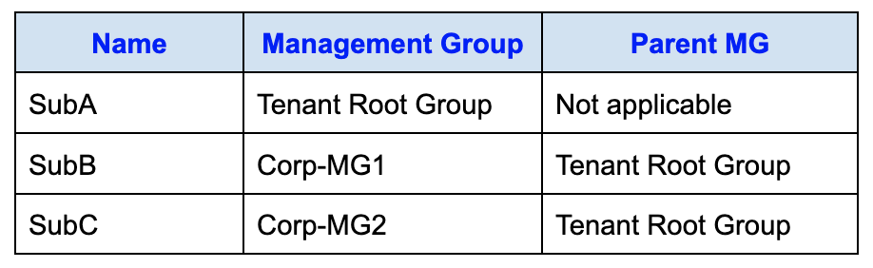
You have the resource groups shown in the following table.
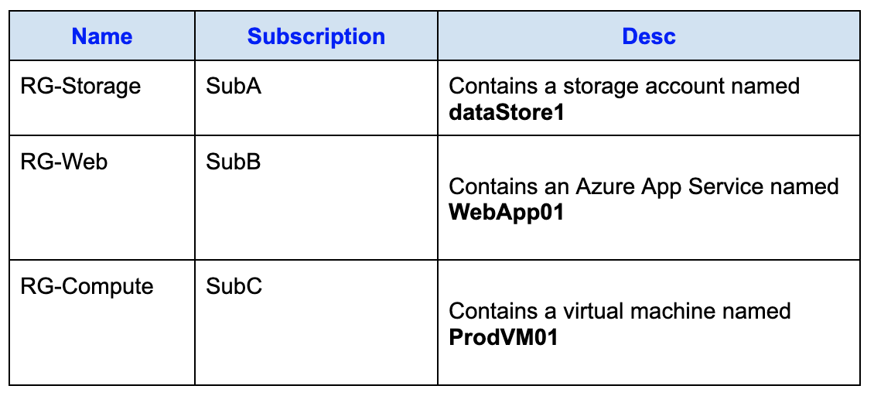
You assign roles to users as shown in the following table.
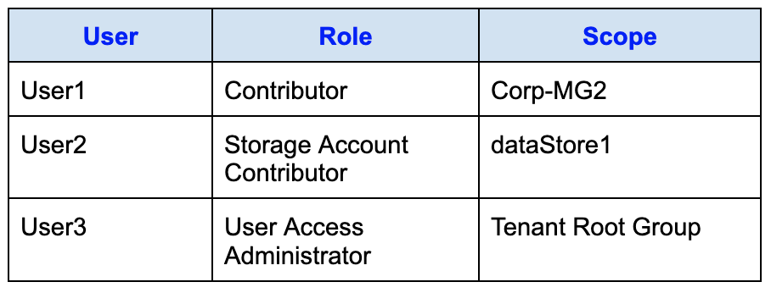
True or False:
`"User1 can resize ProdVM01."`
Réponses:
☑ True
☐ False
Explication
`True` is correct because User1 has the Contributor role assigned at the Corp-MG2 management group level, which includes SubC. Since SubC contains RG-Compute, and RG-Compute has ProdVM01, the Contributor role grants User1 full management rights over all resources within this scope. The Contributor role allows actions such as resizing virtual machines, making User1 capable of resizing ProdVM01.
Reference(s):
- https://learn.microsoft.com/en-us/azure/role-based-access-control/built-in-roles
- https://learn.microsoft.com/en-us/azure/governance/management-groups/overview

Question 34
You have a Microsoft Entra tenant that is linked to the subscriptions shown in the following table.
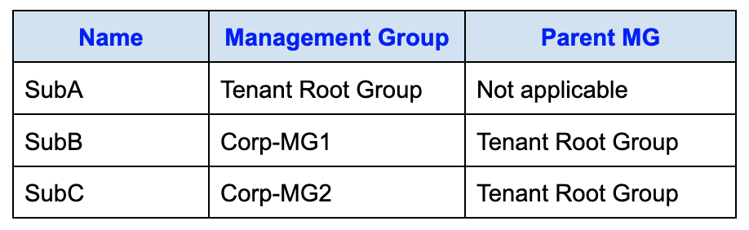
You have the resource groups shown in the following table.
You assign roles to users as shown in the following table.
True or False:
`"User2 can create a new storage account in RG-Storage."`
Réponses:
☐ True
☑ False
Explication
`False` is correct because User2 has the Storage Account Contributor role assigned specifically to dataStore1, not to the entire resource group (RG-Storage). The Storage Account Contributor role allows User2 to manage the specific storage account (dataStore1) but does not provide the ability to create new storage accounts or manage other resources within RG-Storage.
Reference(s):
- https://learn.microsoft.com/en-us/azure/role-based-access-control/built-in-roles#storage-account-contributor

Question 35
You have a Microsoft Entra tenant that is linked to the subscriptions shown in the following table.
You have the resource groups shown in the following table.
You assign roles to users as shown in the following table.
True or False:
`"User3 can assign User1 the Owner role for RG-Compute."`
Réponses:
☑ True
☐ False
Explication
`True` is correct because User3 has the User Access Administrator role assigned at the Tenant Root Group scope. This role allows User3 to manage access and assign roles at any level within the tenant, including management groups, subscriptions, and resource groups. Since RG-Compute is within the tenant, User3 can assign roles such as the Owner role to User1 for RG-Compute.
Reference(s):
- https://learn.microsoft.com/en-us/azure/role-based-access-control/built-in-roles#user-access-administrator
- https://learn.microsoft.com/en-us/azure/governance/management-groups

Question 36
An Azure subscription contains two backup-related services:
- An Azure Backup vault named VaultA
- A Recovery Services vault named VaultB
The subscription includes the following deployed resources:
- VM01 - Virtual machine
- Disk01 - Disk
- WebApp01 - Azure App Service web application
- SQLDB01 - Azure SQL Database
You plan to configure backup protection for these resources.
Which of the listed resources can be backed up using VaultA (the Azure Backup vault)?
Réponses:
☐ WebApp01
☐ SQLDB01
☑ Disk01
☐ VM01
Explication
`Disk01` is correct because Azure managed disks are backed up using Azure Disk Backup, which requires an Azure Backup vault. This allows disks to be backed up independently without backing up the entire virtual machine.
`VM01` could also be backed up, but the backup would include the entire virtual machine, not just the disk. The question specifically focuses on backing up a resource like Disk1.
`WebApp01` (Azure App Service web app) and `SQLDB01` (Azure SQL Database) have different built-in backup features and are not backed up directly using Azure Backup.
Reference(s):
- https://learn.microsoft.com/en-us/azure/backup/backup-overview
https://learn.microsoft.com/en-us/azure/backup/backup-support-matrix

Question 37
An Azure subscription contains two backup-related services:
- An Azure Backup vault named VaultA
- A Recovery Services vault named VaultB
The subscription includes the following deployed resources:
- VM01 - Virtual machine
- Disk01 - Disk
- WebApp01 - Azure App Service web application
- SQLDB01 - Azure SQL Database
You plan to configure backup protection for these resources.
Which of the listed resources can be backed up using VaultB (the Recovery Services vault)?
Réponses:
☐ WebApp01
☐ SQLDB01
☐ Disk01
☑ VM01
Explication
`VM01` is the correct answer because a Recovery Services vault (like VaultB) is used to back up entire virtual machines (VMs) in Azure. Azure Backup supports backing up the operating system, data disks, and attached resources of the VM using a Recovery Services vault.
`Disk01`: While individual disks can be backed up as part of a VM backup, they are not directly backed up independently to a Recovery Services vault.
`WebApp01` (Azure App Service web app) and `SQLDB01` (Azure SQL Database) are not backed up using Azure Backup through a Recovery Services vault. They have their own specific backup mechanisms.
Reference(s):
- https://learn.microsoft.com/en-us/azure/backup/backup-overview
- https://learn.microsoft.com/en-us/azure/backup/backup-support-matrix

Question 38
You have a Microsoft Entra tenant with the following characteristics:
- Tenant name: Default Directory
- License type: Microsoft Entra ID Free
- Primary domain: an onmicrosoft.com domain
The tenant includes these identities:
- UserA - User account
- SecGroup01 - Security group
- M365Group01 - Microsoft 365 group
You purchase a Microsoft Fabric license.
Which of the listed identities can be assigned the Microsoft Fabric license?
Réponses:
☑ UserA only
☐ UserA and SecGroup01 only
☐ UserA and M365Group01 only
☐ UserA, SecGroup01, and M365Group01
Explication
`UserA only` is correct because in a free Microsoft Entra ID tenant, you can only assign licenses to individual users like UserA. Group-based licensing (for SecGroup01 or M365Group01) requires a paid version of Microsoft Entra ID (such as P1 or P2).
`UserA and SecGroup01 only` is incorrect because, in the free version, SecGroup01 (a security group) cannot be assigned licenses.
`UserA and M365Group01 only` is incorrect for the same reason. Group-based licensing (whether it's a security group or a Microsoft 365 group) is not supported in the free tier.
`UserA, SecGroup01, and M365Group01` is incorrect since neither SecGroup01 nor M365Group01 can have licenses assigned in the free tenant.
Reference(s):
- https://learn.microsoft.com/en-us/entra/fundamentals/concept-group-based-licensing

Question 39
You have an Azure subscription that includes the following Microsoft Entra identities:
- UserA - A User
- SecGroup01 - A Security group
- M365Group01 - A Microsoft 365 group
You plan to enable Self-Service Password Reset (SSPR) using the Azure portal.
For which of the listed identities can SSPR be enabled?
Réponses:
☐ UserA only
☐ SecGroup01 only
☐ UserA and SecGroup01 only
☑ SecGroup01 and M365Group01 only
☐ UserA, SecGroup01, and M365Group01
Explication
`SecGroup01 and M365Group01 only` is correct because SSPR can be directly assigned only to a group of users or to ALL users but not to individual users. The setting is then applicable on all the users in that group. You can select individual users in a group if you do not want to enable the setting for all the users in that group.
Reference(s):
- https://learn.microsoft.com/en-us/entra/identity/authentication/tutorial-enable-sspr

Question 40
You have an Azure environment that includes two virtual networks, VNet1 and VNet2, which are configured with virtual network peering.
A Network Virtual Appliance named NetVA1 is deployed in the environment.
You must ensure that all network traffic flowing from VNet1 to VNet2 is routed through NetVA1 so that it can be inspected before reaching its destination.
Which option should you implement to meet this requirement?
Réponses:
☐ Configure a local network gateway.
☑ a route table that has custom routes
☐ Enable a service endpoint.
☐ Configure IP address reservations.
Explication
`A route table that has custom routes` is the correct answer here. To ensure that the traffic from VNet1 to VNet2 is inspected by NetVA1, you need to use a custom route in the route table. You can create a route that forces traffic from VNet1 to pass through the Network Virtual Appliance (NetVA1) for inspection before it reaches VNet2. This is achieved by setting the next hop in the custom route to the IP address of NetVA1.
`Configure a local network gateway` is incorrect because it is used for configuring connections between an Azure virtual network and an on-premises network, not for routing traffic between peered virtual networks.
`Enable a service endpoint` is incorrect because service endpoints provide secure access to Azure services but are not used for routing traffic through a Network Virtual Appliance.
`Configure IP address reservations` is incorrect because IP reservations are used to reserve public IP addresses, and they do not help with routing or traffic inspection between virtual networks.
Reference(s):
- https://learn.microsoft.com/en-us/azure/virtual-network/virtual-networks-udr-overview
- https://learn.microsoft.com/en-us/azure/virtual-network/virtual-network-peering-overview
- https://learn.microsoft.com/en-us/azure/virtual-wan/scenario-route-through-nva

Question 41
An Azure subscription contains several resources distributed across two resource groups, as detailed in the table below. The resources include a container app and multiple Azure Key Vault instances deployed in different regions.
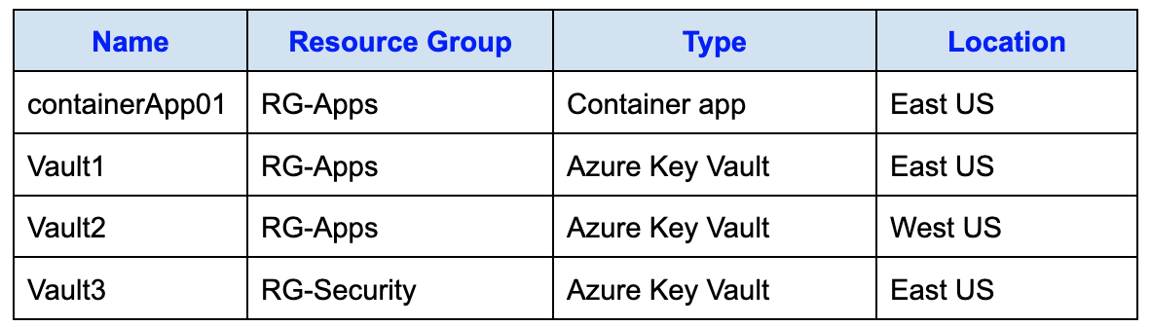
You intend to use an Azure Key Vault to securely supply a secret to containerApp01.
What should you create so that containerApp01 can authenticate and retrieve the secret from the key vault?
Réponses:
☑ A Managed identity
☐ A Private endpoint
☐ A Service principal
☐ A User account
Explication
`A Managed identity` is the correct answer. To securely provide a secret from an Azure Key Vault to containerApp01, you should create a managed identity for containerApp01. Managed identities allow Azure resources to securely access other Azure services (like Key Vault) without needing to manage credentials. Once the managed identity is created, it can be granted the necessary permissions to access the Key Vault and retrieve secrets.
`A Private endpoint` is incorrect because this is used for securing the network access to the Key Vault but does not handle authentication for accessing secrets.
`A Service principal` is incorrect because while service principals can be used to access resources, using a managed identity is a simpler and more secure method for Azure resources.
`A User account` is incorrect because user accounts are not typically used for resource-to-resource access in Azure.
Reference(s):
- https://learn.microsoft.com/en-us/azure/key-vault/general/assign-access-policy?tabs=azure-portal
- https://learn.microsoft.com/en-us/entra/identity/managed-identities-azure-resources/overview

Question 42
An Azure subscription contains several resources distributed across two resource groups, as detailed in the table below. The resources include a container app and multiple Azure Key Vault instances deployed in different regions.
You intend to use an Azure Key Vault to securely supply a secret to containerApp01.
Which Azure Key Vault can be used to supply the secret to containerApp01?
Réponses:
☐ Vault1 only
☐ Vault1 and Vault2 only
☐ Vault1 and Vault3 only
☑ Vault1, Vault2, or Vault3
Explication
`Vault1, Vault2, or Vault3` is correct because there are no Azure-imposed barriers that prevent containerApp01 from accessing Key Vaults located in different regions or resource groups. While it is generally recommended to use a Key Vault in the same region as the resource for performance and latency considerations, the question does not specify best practices, only whether the secret can be used. Therefore, containerApp01 can access all three Key Vaults—Vault1, Vault2, and Vault3—with appropriate permissions.
Reference(s):
- https://learn.microsoft.com/en-us/azure/key-vault/general/disaster-recovery-guidance
- https://learn.microsoft.com/en-us/azure/key-vault/general/best-practices

Question 43
You are working with an Azure subscription.
A user-defined route table named RT1 has been created.
You must add a route to RT1 that requires specifying an IP address for the next hop.
Which next hop option should you choose when configuring the route?
Réponses:
☐ Internet
☐ Virtual network gateway
☐ Virtual network
☑ Virtual appliance
Explication
`Virtual appliance` is the correct answer here. When adding a route to a routing table and specifying a next hop IP address, the correct next hop type is Virtual appliance. A virtual appliance refers to a Network Virtual Appliance (NVA), such as a firewall or load balancer, which inspects or processes network traffic. By choosing Virtual appliance, you can specify the IP address of the NVA that will handle the routed traffic.
`Internet` is incorrect because it routes traffic directly to the public internet without specifying a next hop IP address.
`Virtual network gateway` is incorrect because it is used to route traffic to an Azure VPN gateway for on-premises connectivity.
`Virtual network` is incorrect because it routes traffic within the same virtual network and does not require specifying a next hop IP address.
Reference(s):
- https://learn.microsoft.com/en-us/azure/virtual-network/virtual-networks-udr-overview

Question 44
You are planning to provision an Azure Storage account named storage1.
The storage account must satisfy the following conditions:
- It must be compatible with Azure Data Lake Storage capabilities.
- It should be optimized to reduce costs for data that is accessed infrequently.
- Data must be replicated automatically to another Azure region for resiliency.
Which three options should you configure for storage1?
Réponses (plusieurs réponses possibles)
☑ geo-redundant storage (GRS)
☑ hierarchical namespace
☐ zone-redundant storage (ZRS)
☐ the Hot access tier
☑ the Cool tier
Explication
`geo-redundant storage (GRS)` is correct because the requirement states that data must automatically replicate to a secondary Azure region. GRS provides this replication capability, ensuring redundancy across regions.
`hierarchical namespace` is correct because enabling the hierarchical namespace is necessary to support Azure Data Lake Storage, which uses this feature to organize data in a directory-based structure.
`the Cool tier` is correct because the Cool access tier minimizes costs for infrequently accessed data. This is aligned with the requirement to reduce costs for such data usage scenarios.
`zone-redundant storage (ZRS)` is incorrect because ZRS replicates data only within a single region across availability zones and does not provide cross-region replication, which is a requirement in this scenario.
`the Hot access tier` is incorrect because the Hot tier is optimized for frequently accessed data, which would result in higher costs for infrequently accessed data, contradicting the requirement to minimize costs.
Reference(s):
- https://learn.microsoft.com/en-us/azure/storage/common/storage-account-options
- https://learn.microsoft.com/en-us/azure/storage/blobs/data-lake-storage-introduction

Question 45
You have an Azure subscription named Subscription1 that includes a virtual network called VNet1.
The following users are assigned roles within the subscription:
- User1 is assigned the Owner role.
- User2 is assigned the Security Admin role.
- User3 is assigned the Network Contributor role.
You need to determine which user is permitted to carry out the following task:
“Create a new subnet within VNet1.”
Réponses:
☐ User1 only
☐ User3 only
☑ User1 and User3 only
☐ User2 and User3 only
☐ User1, User2, and User3
Explication
`User1 and User3 only` is correct because the Owner role (User1) has full permissions, including managing resources and configurations like adding a subnet to VNet1. The Network Contributor role (User3) also has sufficient permissions to manage the network, which includes adding subnets.
`User2 and User3 only` is incorrect because although User3 (Network Contributor) has the required permissions, User2 with the Security Admin role does not have permissions to modify or add subnets in a virtual network.
`User1 only` is incorrect because User3 (Network Contributor) also has the required permissions to add a subnet.
`User1, User2, and User3` is incorrect because User2 (Security Admin) does not have permissions to manage network resources like subnets.
Reference(s):
- https://learn.microsoft.com/en-us/azure/role-based-access-control/built-in-roles

Question 46
You have an Azure subscription named Subscription1 that includes a virtual network called VNet1.
The following users are assigned roles within the subscription:
- User1 is assigned the Owner role.
- User2 is assigned the Security Admin role.
- User3 is assigned the Network Contributor role.
You need to determine which user is permitted to carry out the following task:
“Assign a user the Reader role to VNet1”
Réponses:
☑ User1 only
☐ User2 only
☐ User3 only
☐ User1 and User2 only
☐ User2 and User3 only
☐ User1, User2, and User3
Explication
`User1 only` is correct because the Owner role provides full access to manage the VNet and its access, including assigning roles such as the Reader role to VNet1. The Owner role allows complete control over the resource, including RBAC permissions.
`User2 only` is incorrect because the Security Admin role is focused on managing security-related policies and configurations but does not grant the ability to manage access to a VNet.
`User3 only` is incorrect because the Network Contributor role allows management of networking resources, such as creating or modifying VNets and subnets, but does not allow role assignments or access management for the VNet.
`User1 and User2 only` is incorrect because the Security Admin role does not include permissions to manage RBAC for the VNet.
`User2 and User3 only` is incorrect because neither the Security Admin nor the Network Contributor roles allow assigning roles to the VNet.
`User1, User2, and User3` is incorrect because only the Owner role (User1) has the necessary permissions to assign roles to VNet1.
Reference(s):
- https://learn.microsoft.com/en-us/azure/role-based-access-control/built-in-roles

Question 64
An Azure subscription contains a user named User1 along with the following resources:
- RG1, which is a resource group
- networkinterface1, which is a virtual network interface
- NSG1, which is a network security group
The network security group NSG1 is linked to networkinterface1.
User1 has been assigned the following roles related to NSG1:
- Contributor at the NSG1 resource scope
- Reader at the subscription scope (inherited)
- Storage Account Contributor at the resource group scope (inherited)

True of False:**
`"User1 is able to create a storage account within RG1."`
Réponses:
☑ True
☐ False
Explication
`True` is the correct answer because even though the question states that User1 has role assignments on NSG1, the Storage Account Contributor role is assigned at the Resource Group (RG1) level, as shown in the role assignments table. This means User1 inherits the permissions provided by that role for all resources within RG1.
The `Storage Account Contributor` role allows full management of storage accounts, including the ability to create them. Since this role is applied at the RG1 scope, User1 can create storage accounts anywhere within that resource group regardless of their other roles at narrower scopes like NSG1.
The mention of role assignments for NSG1 in the question context simply lists additional roles that User1 has, but those do not restrict or override the broader permissions granted at the resource group level. RBAC in Azure is additive by design, meaning User1’s permissions accumulate across scopes.
**Reference(s):
**https://learn.microsoft.com/en-us/azure/role-based-access-control/built-in-roles
https://learn.microsoft.com/en-us/azure/role-based-access-control/role-assignments-portal
https://learn.microsoft.com/en-us/azure/role-based-access-control/overview

Question 65
An Azure subscription contains a user named User1 along with the following resources:
- RG1, which is a resource group
- networkinterface1, which is a virtual network interface
- NSG1, which is a network security group
The network security group NSG1 is linked to networkinterface1.
User1 has been assigned the following roles related to NSG1:
- Contributor at the NSG1 resource scope
- Reader at the subscription scope (inherited)
- Storage Account Contributor at the resource group scope (inherited)

True of False:**
`"User1 can modify the DNS settings of networkinterface1."`
Réponses:
☐ True
☑ False
Explication
`False` is correct because User1 has the Contributor role assigned only at the NSG1 resource scope, not at the networkinterface1 scope. The Contributor role on NSG1 allows User1 to manage the Network Security Group (NSG1), but it does not extend permissions to manage or modify DNS settings of the associated network interface (networkinterface1).
Additionally, the Reader role at the Subscription level only grants read permissions and does not allow modification of resources. Similarly, the Storage Account Contributor role at the Resource Group (RG1) level is specific to storage accounts and does not provide permissions to modify network interface settings.
Therefore, User1 cannot modify the DNS settings of networkinterface1.
Reference(s):
https://learn.microsoft.com/en-us/azure/role-based-access-control/built-in-roles
https://learn.microsoft.com/en-us/azure/role-based-access-control/overview
https://learn.microsoft.com/en-us/azure/role-based-access-control/role-assignments-portal

Question 66
An Azure subscription contains a user named User1 along with the following resources:
- RG1, which is a resource group
- networkinterface1, which is a virtual network interface
- NSG1, which is a network security group
The network security group NSG1 is linked to networkinterface1.
User1 has been assigned the following roles related to NSG1:
- Contributor at the NSG1 resource scope
- Reader at the subscription scope (inherited)
- Storage Account Contributor at the resource group scope (inherited)

True of False:**
`"User1 can create an inbound security rule to filter inbound traffic to networkinterface1."`
Réponses:
☑ True
☐ False
Explication
`True` is correct because User1 has the Contributor role explicitly assigned to NSG1 (Network Security Group). The Contributor role allows full management permissions over the NSG, including the ability to create, modify, and delete inbound and outbound security rules to control traffic flow.
Since NSG1 is associated with networkinterface1, any inbound security rules configured on NSG1 will apply to networkinterface1. Therefore, User1 has the required permissions to create an inbound security rule to filter inbound traffic to networkinterface1.
**Reference(s):
**https://learn.microsoft.com/en-us/azure/role-based-access-control/built-in-roles
https://learn.microsoft.com/en-us/azure/role-based-access-control/overview
https://learn.microsoft.com/en-us/azure/virtual-network/network-security-groups-overview

Question 67
You configure the custom role shown below.
{
"properties": {
"roleName": "role1",
"description": "",
"roleType": "true",
"assignableScopes": [
"/subscriptions/8f3a91c2-5b47-4d6e-9a21-7c8f0e3b4a6d/"
],
"permissions": [
{
"actions": [
"Microsoft.Authorization/*/read",
"Microsoft.Compute/availabilitySets/*",
"Microsoft.Compute/locations/*",
"Microsoft.Compute/virtualMachines/*",
"Microsoft.Compute/virtualMachineScaleSets/*",
"Microsoft.Compute/disks/write",
"Microsoft.Compute/disks/read",
"Microsoft.Compute/disks/delete",
"Microsoft.Network/locations/*",
"Microsoft.Network/networkInterfaces/*",
"Microsoft.Network/networkSecurityGroups/join/action",
"Microsoft.Network/networkSecurityGroups/read",
"Microsoft.Network/publicIPAddresses/join/action",
"Microsoft.Network/publicIPAddresses/read",
"Microsoft.Network/virtualNetworks/read",
"Microsoft.Network/virtualNetworks/subnets/join/action",
"Microsoft.Resources/deployments/*",
"Microsoft.Resources/subscriptions/resourceGroups/read",
"Microsoft.Support/*"
],
"notActions": [],
"dataActions": [],
"notDataActions": []
}
]
}
}
Based on the information presented, select the answer choice that completes the following statement correctly.
“To ensure that users can sign in to virtual machines that are assigned role1, modify the _____________ section.”
Réponses:
☐ actions
☐ roletype
☐ notActions
☑ dataActions
☐ notDataActions
☐ assignableScopes
Explication
`dataActions` is the correct option because permissions like "Microsoft.Compute/virtualMachines/login/action" or "Microsoft.Compute/virtualMachines/loginAsAdmin/action" are categorized as data plane operations. These permissions determine access to the operational level of the virtual machine, such as signing in or interacting with its data, and should therefore be placed in the dataActions section.
`actions` is incorrect because this section controls management-level (control plane) operations, such as creating, updating, or deleting resources. Signing in to a virtual machine does not fall under this category.
`roletype` is incorrect because it specifies the type of role (e.g., built-in or custom) and does not influence permission assignments.
`notActions` is incorrect because it is used to exclude specific control plane operations from a role rather than granting access.
`notDataActions` is incorrect because it is used to exclude specific data plane operations, not to define permissions for logging into virtual machines.
`assignableScopes` is incorrect because this section only determines where the role can be assigned (e.g., subscription, resource group) and does not directly grant or restrict resource-level permissions.
Reference(s):
https://learn.microsoft.com/en-us/azure/role-based-access-control/custom-roles
https://learn.microsoft.com/en-us/azure/role-based-access-control/built-in-roles#virtual-machine-administrator-login

Question 68
You configure the custom role shown below.
{
"properties": {
"roleName": "role1",
"description": "",
"roleType": "true",
"assignableScopes": [
"/subscriptions/8f3a91c2-5b47-4d6e-9a21-7c8f0e3b4a6d/"
],
"permissions": [
{
"actions": [
"Microsoft.Authorization/*/read",
"Microsoft.Compute/availabilitySets/*",
"Microsoft.Compute/locations/*",
"Microsoft.Compute/virtualMachines/*",
"Microsoft.Compute/virtualMachineScaleSets/*",
"Microsoft.Compute/disks/write",
"Microsoft.Compute/disks/read",
"Microsoft.Compute/disks/delete",
"Microsoft.Network/locations/*",
"Microsoft.Network/networkInterfaces/*",
"Microsoft.Network/networkSecurityGroups/join/action",
"Microsoft.Network/networkSecurityGroups/read",
"Microsoft.Network/publicIPAddresses/join/action",
"Microsoft.Network/publicIPAddresses/read",
"Microsoft.Network/virtualNetworks/read",
"Microsoft.Network/virtualNetworks/subnets/join/action",
"Microsoft.Resources/deployments/*",
"Microsoft.Resources/subscriptions/resourceGroups/read",
"Microsoft.Support/*"
],
"notActions": [],
"dataActions": [],
"notDataActions": []
}
]
}
}
Based on the information presented, select the answer choice that completes the following statement correctly.
“To ensure that role1 can be assigned only to a resource group named RG1, modify the __________________ section.”
Réponses:
☐ actions
☐ roletype
☐ notActions
☐ dataActions
☐ notDataActions
☑ assignableScopes
Explication
`assignableScopes` is the correct option because this section defines where a role can be assigned within Azure. By specifying the resource group scope (e.g., /subscriptions/{subscriptionId}/resourceGroups/RG1) in the assignableScopes section, the custom role role1 can be restricted to be assigned only to RG1.
This ensures that the role cannot be assigned to other subscriptions, resource groups, or resources outside the specified scope.
`actions` is incorrect because it defines control plane permissions for resource management but does not restrict where the role can be assigned.
`roletype` is incorrect because it only specifies whether the role is built-in or custom and does not affect the scope of assignment.
`notActions` is incorrect because it is used to exclude specific actions from the role, not to define assignment scope.
`dataActions` is incorrect because it controls data-level permissions, not role assignment scope.
`notDataActions` is incorrect because it specifies excluded data-level operations and does not define assignment scope.
Reference(s):
https://learn.microsoft.com/en-us/azure/role-based-access-control/built-in-roles#virtual-machine-administrator-login

Question 69
You have an Azure policy as shown in the following exhibit.
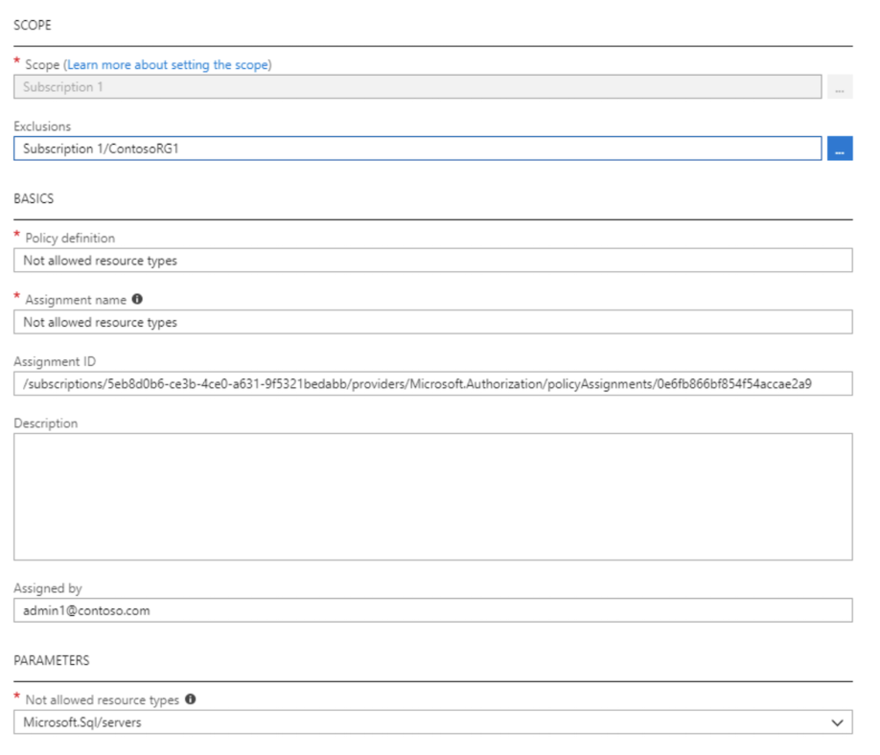
What is the effect of the policy?
Réponses:
☐ You can create Azure SQL servers in any resource group within Subscription 1.
☐ You are prevented from creating Azure SQL servers anywhere in Subscription 1.
☑ You can create Azure SQL servers in ContosoRG1 only.
☐ You are prevented from creating Azure SQL Servers in ContosoRG1 only.
Explication
`You can create Azure SQL servers in ContosoRG1 only` is correct because the policy defines a Not allowed resource types rule for Microsoft.Sql/servers at the Subscription 1 scope. However, the ContosoRG1 resource group is explicitly excluded from this policy. This means that while creating Azure SQL servers is blocked across the entire subscription, ContosoRG1 is exempt from this restriction, allowing Azure SQL servers to be created there.
`You can create Azure SQL servers in any resource group within Subscription 1` is incorrect because the policy explicitly prevents creating Azure SQL servers at the Subscription 1 level, except for the excluded resource group ContosoRG1.
`You are prevented from creating Azure SQL servers anywhere in Subscription 1` is incorrect because the exclusion for ContosoRG1 allows creating Azure SQL servers specifically in that resource group, overriding the subscription-wide restriction.
`You are prevented from creating Azure SQL Servers in ContosoRG1 only` is incorrect because ContosoRG1 is explicitly excluded from the policy, making it the only place where creating Azure SQL servers is permitted.
Reference(s):
https://docs.microsoft.com/en-us/azure/governance/policy/overview#policy-definition

Question 70
You have an Azure subscription with an existing Azure Storage account.
You plan to upload an on-premises virtual machine image to a blob container named vmimages.
Before uploading the image, you must create the required container in the storage account.
To do this, you intend to run an AzCopy command, as shown below.
`https://mystorageaccount.<service>.core.windows.net/vmimages`
Which command should you run?
Réponses:
☐ azcopy sync ‘https://mystorageacount. blob .core.windows.net/vmimages’
☐ azcopy make ‘https://mystorageacount.queue.core.windows.net/vmimages’
☐ azcopy copy ‘https://mystorageacount.table.core.windows.net/vmimages’
☐ azcopy sync ‘https://mystorageacount.dfs.core.windows.net/vmimages’
☑ azcopy make ‘https://mystorageacount.blob.core.windows.net/vmimages’
☐ azcopy copy ‘https://mystorageacount.images.core.windows.net/vmimages’
Explication
`azcopy make ‘https://mystorageaccount.blob.core.windows.net/vmimages’` is correct because the make command in AzCopy is specifically used to create a new container in an Azure Blob Storage account.
- The blob endpoint (blob.core.windows.net) is the correct endpoint for creating containers in Blob Storage.
- The container name vmimages indicates that it is intended for storing blobs, which aligns with the blob endpoint.
- The correct syntax for creating a new blob container using AzCopy is:
azcopy make 'https://<storage-account-name>.blob.core.windows.net/<container-name>'
**azcopy sync ‘https://mystorageaccount.blob.core.windows.net/vmimages’
Sync is used to synchronize data between a source and a destination**, not to create a container.

azcopy make ‘https://mystorageaccount.queue.core.windows.net/vmimages’
The queue** endpoint is for Azure Queue Storage, not Blob Storage.

azcopy copy ‘https://mystorageaccount.table.core.windows.net/vmimages’
The table** endpoint is for Azure Table Storage, not Blob Storage.

azcopy sync ‘https://mystorageaccount.dfs.core.windows.net/vmimages’
The dfs** endpoint is for Azure Data Lake Storage, not Blob Storage.

azcopy copy ‘https://mystorageaccount.images.core.windows.net/vmimages’
The images** endpoint is invalid in Azure Storage.
Reference(s):
https://learn.microsoft.com/en-us/azure/storage/common/storage-ref-azcopy-make

Question 71
You provision an Azure virtual machine named VM1 that runs Windows Server 2019.
The current configuration of VM1 is shown in the below exhibit.
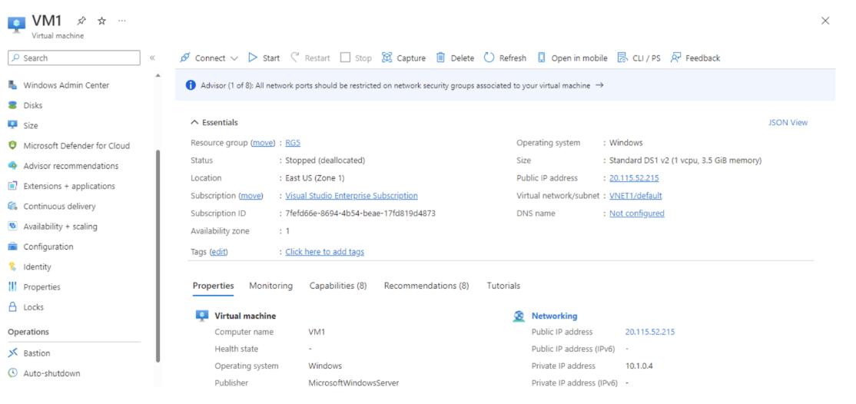
You are required to enable Desired State Configuration (DSC) for VM1.
What is the first action you should take?
Réponses:
☐ Assign a DNS name to VM1.
☐ Establish a connection to VM1.
☑ Power on VM1.
☐ Capture a snapshot of VM1.
Explication
`Power on VM1` is correct because Desired State Configuration (DSC) requires the virtual machine to be in a running state to enable and configure it. In the exhibit, VM1 is currently stopped (deallocated), which means it is not operational. DSC operates by configuring the state of an actively running VM, and it cannot perform any operations on a stopped or deallocated VM.
`Assign a DNS name to VM1` is incorrect because assigning a DNS name is related to external name resolution and not a requirement for enabling DSC.
`Establish a connection to VM1` is incorrect because without starting the VM, you cannot establish a remote connection to perform DSC configuration.
`Capture a snapshot of VM1` is incorrect because snapshots are primarily used for backup or creating new VMs, not for enabling DSC.
Reference(s):
- https://learn.microsoft.com/en-us/azure/automation/automation-dsc-overview
- https://learn.microsoft.com/en-us/azure/virtual-machines/extensions/dsc-overview

Question 72
You have defined a custom security attribute named Attr1 in your Microsoft Entra tenant.
The tenant includes a user account, a security group, and a service principal, as shown below.
- UserA - User
- SecGroup01 - Security group
- AppPrincipal01 - Service principal
You want to apply Attr1 to every identity type that supports custom security attributes.
To which identities can you assign Attr1?
Réponses:
☐ UserA only
☐ SecGroup01 only
☐ UserA and SecGroup01 only
☑ UserA and AppPrincipal01 only
☐ UserA, SecGroup01, and AppPrincipal01
Explication
`UserA and AppPrincipal011 only` is correct because custom security attributes in Microsoft Entra ID can only be assigned to users and service principals (enterprise applications). Security groups are not supported objects for custom security attributes.
Reference(s):
- https://learn.microsoft.com/en-us/entra/fundamentals/custom-security-attributes-overview

Question 73
You have an Azure subscription named Sub1 that contains two users named User1 and User2.
You must assign Azure role-based access control (RBAC) roles to both users so they can perform the following actions within Sub1:
- User1 must view the data in any storage account.
- User2 must assign users the Contributor role for storage accounts.
The assignment must follow the principle of least privilege.
Which RBAC role should you assign to User 1?
Réponses:
☐ Owner
☐ Contributor
☑ Reader and Data Access
☐ Storage Account Contributor
☐ User Access Administrator
Explication
`Reader and Data Access` is the correct role to assign to User1. This role provides read-only access to management operations (like the standard Reader role), but also adds the ability to read the data inside Azure Storage containers and blobs, queues, tables, and files. This aligns perfectly with the requirement that User1 must be able to view the data in any storage account, without allowing write or management capabilities. It also adheres to the principle of least privilege, as it grants exactly what is required and nothing more.
`Owner` is incorrect because it grants full access to manage all resources, including access management permissions. This is far more than what User1 needs just to view storage data, and violates the principle of least privilege.
`Contributor` is incorrect because while it allows full management of resources, it does not grant access to the underlying data in storage accounts (like reading blob contents). So it’s not sufficient for User1's data access requirement, and it overgrants permissions on the management plane.
`Storage Account Contributor` is incorrect because it provides management access to storage accounts (e.g., configuring settings, managing firewalls), but it does not grant data plane access (like reading blobs or files). Therefore, this role does not meet User1’s requirement to view the data inside storage accounts.
`User Access Administrator` is incorrect because it allows managing role assignments, not accessing data. This role is relevant for User2’s requirement, but not for User1. It provides no data access or management access to storage resources, so it is not applicable here.
Reference(s):
- https://learn.microsoft.com/en-us/azure/role-based-access-control/built-in-roles/storage#reader-and-data-access
- https://learn.microsoft.com/en-us/azure/role-based-access-control/built-in-roles#owner
- https://learn.microsoft.com/en-us/azure/role-based-access-control/built-in-roles#contributor
- https://learn.microsoft.com/en-us/azure/role-based-access-control/built-in-roles#storage-account-contributor
- https://learn.microsoft.com/en-us/azure/role-based-access-control/built-in-roles#user-access-administrator

Question 74
You have an Azure subscription named Sub1 that contains two users named User1 and User2.
You must assign Azure role-based access control (RBAC) roles to both users so they can perform the following actions within Sub1:
- User1 must view the data in any storage account.
- User2 must assign users the Contributor role for storage accounts.
The assignment must follow the principle of least privilege.
Which RBAC role should you assign to User 2?
Réponses:
☐ Owner
☐ Contributor
☐ Reader and Data Access
☐ Storage Account Contributor
☑ User Access Administrator
Explication
`User Access Administrator` is the correct role to assign to User2. This role allows a user to manage role assignments in Azure RBAC, including assigning others roles such as Contributor. It does not grant permissions to manage resources directly, making it ideal when the sole requirement is to delegate access control, as is the case here. Since User2 needs to assign users the Contributor role for storage accounts, User Access Administrator provides precisely the needed capability while following the principle of least privilege.
`Owner` is incorrect because although it allows full access to resources and access management, it overgrants permissions by allowing the user to create, delete, and manage any resource, which goes beyond just assigning RBAC roles. This violates the principle of least privilege.
`Contributor` is incorrect because this role allows managing Azure resources, but does not include permission to assign roles to other users. Therefore, it cannot fulfill the requirement to assign the Contributor role to others.
`Reader and Data Access` is incorrect because it only grants read access to Azure resources and data (e.g., in storage accounts), but does not provide any permissions related to role assignments or resource management.
`Storage Account Contributor` is incorrect because it grants permissions to manage storage accounts, including configuration, but it does not allow role assignments. It does not fulfill the need for User2 to assign RBAC roles to others.
Reference(s):
- https://learn.microsoft.com/en-us/azure/role-based-access-control/built-in-roles#user-access-administrator
- https://learn.microsoft.com/en-us/azure/role-based-access-control/built-in-roles#owner
- https://learn.microsoft.com/en-us/azure/role-based-access-control/built-in-roles#contributor
- https://learn.microsoft.com/en-us/azure/role-based-access-control/built-in-roles#reader-and-data-access
- https://learn.microsoft.com/en-us/azure/role-based-access-control/built-in-roles#storage-account-contributor

Question 75
You have an Azure subscription that includes a storage account hosting website content.
You need to ensure that users accessing the website are routed through the Microsoft point-of-presence (POP) that is geographically closest to them.
What configuration should you implement to meet this requirement?
Réponses:
☐ Load balancing
☑ Routing preference
☐ Azure Firewall rules
☐ private endpoints
Explication
`Routing preference` is the correct answer. In Azure Storage, the routing preference setting allows you to specify how user traffic reaches your storage account; either through the Microsoft global network or over the public internet. To ensure that inbound user traffic uses the Microsoft point-of-presence (POP) closest to the user’s location, you should configure the routing preference to use Microsoft network routing (also called "Microsoft edge network"). This ensures that user traffic enters the Microsoft network at the POP closest to the user's location and is routed through Microsoft's backbone to the storage account, optimizing performance and reducing latency.
`Load balancing` is incorrect because while Azure Load Balancer distributes traffic across virtual machines and services, it does not apply to Azure Storage accounts or influence the routing behavior of traffic to them.
`Azure Firewall rules` is incorrect because Azure Firewall is used for controlling and monitoring traffic to/from Azure resources, based on configured rules. It is not responsible for routing user traffic through the Microsoft POPs or determining how traffic enters the Microsoft network.
`Private endpoints` is incorrect because they are used to provide private connectivity to Azure services over a virtual network. While they enhance security by avoiding public internet exposure, they do not control whether traffic is routed through the Microsoft edge network or influence the POP usage.
Reference(s):
- https://learn.microsoft.com/en-us/azure/storage/common/network-routing-preference#microsoft-global-network-versus-internet-routing
- https://learn.microsoft.com/en-us/azure/storage/common/storage-network-security
- https://learn.microsoft.com/en-us/azure/firewall/overview
- https://learn.microsoft.com/en-us/azure/private-link/private-endpoint-overview

Question 76
You have an Azure subscription that includes a storage account named storage1.
You intend to apply role-based access control (RBAC) role assignments to storage1 by using conditional access expressions.
Which services within storage1 allow RBAC role assignments to be configured with conditions?
Réponses:
☐ containers only
☐ file shares only
☐ tables only
☐ queues only
☑ containers and queues only
☐ files shares and tables only
Explication
`containers and queues only` is the correct answer. Azure supports Azure role assignment conditions for Blob Storage containers and Queue Storage. This means you can apply conditional access controls—such as limiting access by IP address, resource tags, or actions—when assigning RBAC roles to these services. This feature enhances fine-grained access control, enabling you to enforce least privilege principles more effectively.
`file shares only` is incorrect because Azure Files currently does not support role assignment conditions. You can assign roles, but not with conditional logic.
`tables only` is incorrect because Azure Table storage does not support RBAC role assignment conditions. Access is typically controlled through account-level keys or Shared Access Signatures (SAS), not conditional RBAC.
`queues only` is incorrect because while queue services support conditional role assignments, selecting this option alone ignores the fact that containers (Blob storage) are also supported.
`containers only` is incorrect for the same reason—it's incomplete. Both containers and queues support conditional role assignments, so the correct answer must include both.
`file shares and tables only` is incorrect because neither of those services supports conditional access using RBAC role assignments.
Reference(s):
- https://learn.microsoft.com/en-us/azure/role-based-access-control/conditions-format#actions
- https://learn.microsoft.com/en-us/azure/storage/blobs/assign-azure-role-data-access?tabs=azure-portal
- https://learn.microsoft.com/en-us/azure/storage/queues/assign-azure-role-data-access?tabs=portal

Question 77
You have an Azure subscription called Sub1 that includes the resource groups, as shown in the table below.
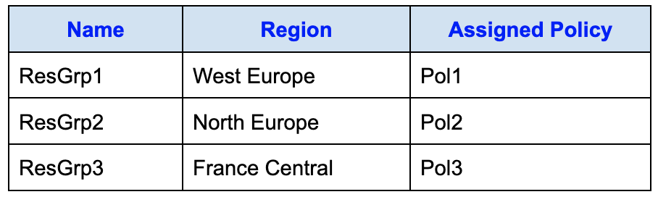
Each resource group is associated with a specific Azure region and has an Azure Policy assigned to it.
A web app named CustomerWeb01 exists in ResGrp1 and is deployed in the West Europe region.
You move CustomerWeb01 to ResGrp2.
What happens as a result of this move?
Réponses:
☐ The App Service plan for CustomerWeb01 moves to North Europe. Pol2 applies to CustomerWeb01.
☐ The App Service plan for CustomerWeb01 remains in West Europe. Pol1 applies to CustomerWeb01.
☑ The App Service plan for CustomerWeb01 remains in West Europe. Pol2 applies to CustomerWeb01.
☐ The App Service plan for CustomerWeb01 moves to North Europe. Pol1 applies to CustomerWeb01.
Explication
`The App Service plan for CustomerWeb01 remains in West Europe. Pol2 applies to CustomerWeb01` is the correct answer here. When you move a resource like a web app to a different resource group, the region of the resource does not change—it stays in the same physical location unless explicitly redeployed. Therefore, CustomerWeb01 and its App Service plan will remain in West Europe.
However, after the move, the policy assigned to the destination resource group (ResGrp2) will now govern CustomerWeb01. Since CustomerWeb01 is now in ResGrp2, Pol2 applies to it.
`The App Service plan for CustomerWeb01 moves to North Europe. Pol2 applies to CustomerWeb01` is incorrect because the App Service plan does not change regions automatically during a resource group move.
`The App Service plan for CustomerWeb01 remains in West Europe. Pol1 applies to CustomerWeb01` is incorrect because although the location remains unchanged, the applied policy comes from the new resource group (ResGrp2), not the original one.
`The App Service plan for CustomerWeb01 moves to North Europe. Pol1 applies to CustomerWeb01` is incorrect for both reasons—the region doesn’t change, and the policy from the original group doesn’t carry over.
Reference(s.):
- https://learn.microsoft.com/en-us/azure/azure-resource-manager/management/move-resource-group-and-subscription
- https://learn.microsoft.com/en-us/azure/governance/policy/overview
- https://learn.microsoft.com/en-us/azure/governance/policy/concepts/definition-structure-basics
- https://learn.microsoft.com/en-us/azure/app-service/app-service-plan-manage

Question 78
Note: This question is part of a set of related questions that use the same scenario. Each question proposes a different solution that may or may not satisfy the stated requirement.
You have three Azure subscriptions named Sub1, Sub2, and Sub3, all associated with a single Microsoft Entra tenant.
The tenant includes a user named User1, a security group named Group1, and a management group named MG1. User1 is a member of Group1.
Both Sub1 and Sub2 are assigned to MG1.
Sub1 contains a resource group named RG1, and RG1 hosts five Azure Functions.
The following role assignments are configured at the MG1 scope:
- Group1 is assigned the Reader role
- User1 is assigned the User Access Administrator role
Additionally:
- User1 is assigned the Virtual Machine Contributor role on Sub1 and Sub2
- User1 is assigned the Contributor role on RG1
True or False:
`“Members of Group1 can view the configuration settings of the Azure Functions.”`
Réponses:
☑ True
☐ False
Explication
`True` is the correct answer here. The members of Group1 can view the configurations of the Azure functions because Group1 has been assigned the Reader role at the management group level (MG1). Since Sub1 and Sub2 are members of MG1, and RG1 (which contains the Azure Functions) is part of Sub1, the Reader role cascades down from MG1 to Sub1 and RG1.
The Reader role allows users to view all resources, including their configurations, but does not permit any modifications. Therefore, even without direct permissions at the resource group or subscription level, Group1 members inherit read-only access and can view the Azure Functions in RG1.
Reference(s.):
- https://learn.microsoft.com/en-us/azure/role-based-access-control/built-in-roles#reader
- https://learn.microsoft.com/en-us/azure/governance/management-groups/overview

Question 79
Note: This question is part of a set of related questions that use the same scenario. Each question proposes a different solution that may or may not satisfy the stated requirement.
You have three Azure subscriptions named Sub1, Sub2, and Sub3, all associated with a single Microsoft Entra tenant.
The tenant includes a user named User1, a security group named Group1, and a management group named MG1. User1 is a member of Group1.
Both Sub1 and Sub2 are assigned to MG1.
Sub1 contains a resource group named RG1, and RG1 hosts five Azure Functions.
The following role assignments are configured at the MG1 scope:
- Group1 is assigned the Reader role
- User1 is assigned the User Access Administrator role
Additionally:
- User1 is assigned the Virtual Machine Contributor role on Sub1 and Sub2
- User1 is assigned the Contributor role on RG1
True or False:
`"User1 can assign the Owner role for RG1."`
Réponses:
☑ True
☐ False
Explication
`True` is the correct answer here. User1 is assigned the User Access Administrator role at the management group (MG1) level. This role grants the ability to manage role assignments (i.e., grant or remove access) on resources within that scope and all its child scopes—including subscriptions and resource groups beneath MG1. Since Sub1 is part of MG1, and RG1 is inside Sub1, the User Access Administrator permission applies to RG1 as well.
While Contributor alone does not allow role assignment, the User Access Administrator role is specifically designed to allow assigning any RBAC role, including Owner, as long as the user has this role at the appropriate level—which User1 does in this case.
Therefore, User1 can assign the Owner role for RG1, even if they are not currently an Owner themselves.
Reference(s.):
- https://learn.microsoft.com/en-us/azure/role-based-access-control/built-in-roles#user-access-administrator
- https://learn.microsoft.com/en-us/azure/role-based-access-control/elevate-access-global-admin
- https://learn.microsoft.com/en-us/azure/role-based-access-control/role-assignments-portal#prerequisites-for-role-assignments
- https://learn.microsoft.com/en-us/azure/role-based-access-control/role-assignments-portal-subscription-admin#prerequisites

Question 80
Note: This question is part of a set of related questions that use the same scenario. Each question proposes a different solution that may or may not satisfy the stated requirement.
You have three Azure subscriptions named Sub1, Sub2, and Sub3, all associated with a single Microsoft Entra tenant.
The tenant includes a user named User1, a security group named Group1, and a management group named MG1. User1 is a member of Group1.
Both Sub1 and Sub2 are assigned to MG1.
Sub1 contains a resource group named RG1, and RG1 hosts five Azure Functions.
The following role assignments are configured at the MG1 scope:
- Group1 is assigned the Reader role
- User1 is assigned the User Access Administrator role
Additionally:
- User1 is assigned the Virtual Machine Contributor role on Sub1 and Sub2
- User1 is assigned the Contributor role on RG1
True or False:
`"User1 can create a new resource group and deploy a virtual machine to the new group."`
Réponses:
☐ True
☑ False
Explication
`False` is the correct answer here. Although User1 has the Virtual Machine Contributor role assigned at the Sub1 and Sub2 subscription levels, and the Contributor role for RG1, they do not have permissions to create a new resource group unless they are granted Owner or Contributor at the subscription level where they want to create that new resource group.
The Virtual Machine Contributor role allows managing virtual machines, but does not grant permissions to create resource groups. Additionally, the Contributor role assigned at RG1 only provides permissions within RG1, not at the subscription level needed to create new resource groups.
Therefore, User1 cannot create a new resource group, and thus, cannot deploy a VM to a new resource group.
Reference(s.):
- https://learn.microsoft.com/en-us/azure/role-based-access-control/built-in-roles#virtual-machine-contributor
- https://learn.microsoft.com/en-us/azure/role-based-access-control/built-in-roles#contributor
- https://learn.microsoft.com/en-us/azure/role-based-access-control/role-assignments-portal#prerequisites-for-role-assignments
- https://learn.microsoft.com/en-us/azure/role-based-access-control/role-assignments-steps

Question 81
You have an Azure subscription named Subscription1 and an on-premises deployment of Microsoft System Center Service Manager.
Within Subscription1, there is a virtual machine named VM1.
You must ensure that Service Manager generates an alert whenever the available memory on VM1 drops below 10 percent.
What should you do first?
Réponses:
☐ Create an automation runbook
☐ Deploy a function app
☑ Deploy the IT Service Management Connector (ITSM)
☐ Create a notification
Explication
`Deploy the IT Service Management Connector (ITSM)` is the correct answer here. The IT Service Management Connector (ITSM) allows you to integrate Azure Monitor with IT service management tools such as System Center Service Manager (SCSM). This connector enables alerts from Azure (e.g., when VM1's available memory drops below a threshold) to automatically generate incidents or alerts within Service Manager.
Before you can generate alerts or trigger incidents in Service Manager based on Azure metrics, you must first deploy and configure the ITSM connector in Azure. Only then can you map Azure alerts (like memory thresholds) to corresponding actions in Service Manager.
`Create an automation runbook` is incorrect because automation runbooks are used for remediating or performing actions based on alerts, not for integrating with Service Manager directly.
`Deploy a function app` is incorrect as it’s generally used for executing custom serverless logic—not necessary in this scenario where a built-in integration exists via ITSM Connector.
`Create a notification` is incorrect because notifications are used to inform users via email or SMS, but not to trigger actions or alerts in Service Manager.
Reference(s.):
- https://learn.microsoft.com/en-us/azure/azure-monitor/alerts/itsmc-overview
- https://learn.microsoft.com/en-in/azure/azure-functions/functions-overview?pivots=programming-language-csharp
- https://learn.microsoft.com/en-us/azure/azure-monitor/alerts/action-groups

Question 82
You have an Azure subscription that includes the following resources, all deployed in the East US region:
- 10 virtual machines
- A key vault named Vault1
- A network security group named NSG1
All virtual machines are protected by using NSG1, which is configured to deny all outbound internet traffic.
You must allow the virtual machines to access Vault1. The solution must follow the principle of least privilege and require minimal ongoing administration.
Which destination should you specify in the outbound security rule for NSG1?
Réponses:
☑ a service tag
☐ an application security group
☐ an IP address range
Explication
`a service tag` is the correct answer here. To allow the virtual machines to access Vault1 (which is an Azure Key Vault resource) while keeping outbound internet access blocked, you should configure the NSG outbound rule to allow traffic only to the AzureKeyVault service tag.
Service tags represent a group of IP address prefixes for specific Azure services and are automatically maintained by Microsoft, which minimizes administrative effort and adheres to the principle of least privilege. By using the `AzureKeyVault` service tag, you allow access only to Key Vault endpoints and nothing else on the internet, satisfying both security and operational requirements.
`an application security group` is incorrect because ASGs are used to group VMs and simplify NSG rules within a virtual network, not for allowing access to Azure services like Key Vault.
`an IP address range` is incorrect because allowing access via public IP ranges to Key Vault would require you to manage and update the ranges manually, which increases administrative overhead and violates the principle of least privilege.
Reference(s.):
- https://learn.microsoft.com/en-us/azure/virtual-network/service-tags-overview
- https://learn.microsoft.com/en-us/azure/key-vault/general/network-security
- https://learn.microsoft.com/en-us/azure/virtual-network/network-security-groups-overview

Question 83
You have an Azure subscription that contains the following virtual machines, all deployed in the same virtual network (VNET1):
- VM-A
- OS: Windows Server
- Subnet: SubnetA
- VM-B
- OS: Windows Server
- Subnet: SubnetB
- VM-C
- OS: Red Hat Enterprise Linux
- Subnet: SubnetC
Each virtual machine’s network interface is configured with the following DNS settings:
- VM-A -> No DNS server configured
- VM-B -> 192.168.10.15
- VM-C -> 192.168.10.15
At the virtual network level, custom DNS settings are configured with the following DNS server:
- 193.77.134.10
All virtual machines can successfully reach both DNS servers (192.168.10.15 and 193.77.134.10).
True or False:
`“VM-A connects to 193.77.134.10 for DNS queries.”`
Réponses:
☑ True
☐ False
Explication
`True` is correct because VM-A does not have a custom DNS server configured at the network interface level. In such cases, Azure virtual machines inherit their DNS server settings from the virtual network (VNET) they are connected to. From the information provided, VNET1 is configured with a single custom DNS server: 193.77.134.10. Therefore, VM-A uses 193.77.134.10 for DNS queries. The DNS server 192.168.10.15 is manually configured only for VM-B and VM-C at their respective NIC level and is not part of the VNET-wide configuration. Since VM-A lacks its own DNS override, it relies solely on the VNET1 configuration.
Reference(s):
- https://learn.microsoft.com/en-us/azure/virtual-network/virtual-networks-name-resolution-for-vms-and-role-instances
- https://learn.microsoft.com/en-us/azure/virtual-network/virtual-networks-faq#can-i-specify-a-custom-dns-server
- https://learn.microsoft.com/en-us/azure/dns/dns-overview

Question 84
You have an Azure subscription that contains the following virtual machines, all deployed in the same virtual network (VNET1):
- VM-A
- OS: Windows Server
- Subnet: SubnetA
- VM-B
- OS: Windows Server
- Subnet: SubnetB
- VM-C
- OS: Red Hat Enterprise Linux
- Subnet: SubnetC
Each virtual machine’s network interface is configured with the following DNS settings:
- VM-A -> No DNS server configured
- VM-B -> 192.168.10.15
- VM-C -> 192.168.10.15
At the virtual network level, custom DNS settings are configured with the following DNS server:
- 193.77.134.10
All virtual machines can successfully reach both DNS servers (192.168.10.15 and 193.77.134.10).
True or False:
`“VM-B connects to 193.77.134.10 for DNS queries”`
Réponses:
☐ True
☑ False
Explication
`False` is the correct answer because VM-B is explicitly configured with a custom DNS server: 192.168.10.15 on its network interface.
When a virtual machine has a DNS server manually set at the NIC level, this custom setting overrides the DNS settings inherited from the virtual network (VNET1).
As a result, VM-B will only use 192.168.10.15 for DNS resolution, and it will not use the secondary DNS server (193.77.134.10) defined at the VNET level unless 193.77.134.10 is manually added as a secondary DNS server on the NIC itself.
Reference(s):
- https://learn.microsoft.com/en-us/azure/virtual-network/virtual-networks-name-resolution-for-vms-and-role-instances
- https://learn.microsoft.com/en-us/azure/virtual-network/virtual-networks-faq#can-i-specify-a-custom-dns-server
- https://learn.microsoft.com/en-us/azure/dns/dns-overview

Question 85
You have an Azure subscription that contains the following virtual machines, all deployed in the same virtual network (VNET1):
- VM-A
- OS: Windows Server
- Subnet: SubnetA
- VM-B
- OS: Windows Server
- Subnet: SubnetB
- VM-C
- OS: Red Hat Enterprise Linux
- Subnet: SubnetC
Each virtual machine’s network interface is configured with the following DNS settings:
- VM-A -> No DNS server configured
- VM-B -> 192.168.10.15
- VM-C -> 192.168.10.15
At the virtual network level, custom DNS settings are configured with the following DNS server:
- 193.77.134.10
All virtual machines can successfully reach both DNS servers (192.168.10.15 and 193.77.134.10).
True or False:
`“VM-C connects to 192.168.10.15 for DNS queries."`
Réponses:
☑ True
☐ False
Explication
`True` is the correct answer because VM-C is explicitly configured with the DNS server 192.168.10.15 on its network interface.
In Azure, when a virtual machine’s NIC is manually configured with a DNS server IP, it overrides the DNS server settings configured at the virtual network level. As a result, VM-C will use 192.168.10.15 for all DNS queries unless that server is unreachable and multiple DNS servers are configured on the NIC (which is not shown in this case).
Therefore, VM-C connects to 192.168.10.15 for DNS resolution.
Reference(s):
- https://learn.microsoft.com/en-us/azure/virtual-network/virtual-networks-name-resolution-for-vms-and-role-instances
- https://learn.microsoft.com/en-us/azure/virtual-network/virtual-networks-faq#can-i-specify-a-custom-dns-server
- https://learn.microsoft.com/en-us/azure/dns/dns-overview

Question 86
You have an Azure subscription that contains the following virtual networks:
- VNet-West (Region: West Europe)
- VNet-Asia (Region: Southeast Asia)
- VNet-US (Region: South Central US)
The subscription also includes the following subnets:
- Subnet-A
- Virtual network: VNet-West
- Service endpoint: None
- Subnet-B
- Virtual network: VNet-Asia
- Service endpoint: Microsoft.Storage
- Subnet-C
- Virtual network: VNet-US
- Service endpoint: Microsoft.Storage
- Subnet-D
- Virtual network: VNet-US
- Service endpoint: None
Additionally, the following storage accounts exist:
- storagewest01
- Region: West Europe
- Kind: StorageV2
- storageus01
- Region: South Central US
- Kind: BlobStorage
- storageasia01
- Region: Southeast Asia
- Kind: StorageV2
You create a service endpoint policy named StoragePolicy01 in the South Central US region. The policy is configured to allow access to all storage accounts in the subscription.
True or False:
`“StoragePolicy01 can be applied to Subnet-C.”`
Réponses:
☑ True
☐ False
Explication
`True` is the correct answer because `Subnet-C` is in VNet-US, which is located in the South Central US region, the same region in which the service endpoint policy (StoragePolicy01) was created.
For a service endpoint policy to be applied to a subnet:
- The subnet must have a matching service endpoint (in this case, `Microsoft.Storage`).
- The subnet and the service endpoint policy must be in the same region.
Since Subnet3 has a `Microsoft.Storage` endpoint enabled and is located in the South Central US region (same as StoragePolicy01), it meets both conditions and therefore Policy1 can be applied to Subnet3.
Reference(s):
- https://learn.microsoft.com/en-us/azure/virtual-network/virtual-network-service-endpoint-policies-overview#limitations
- https://learn.microsoft.com/en-us/azure/virtual-network/virtual-network-service-endpoint-policies-overview
- https://learn.microsoft.com/en-us/azure/virtual-network/virtual-network-service-endpoints-overview

Question 87
You have an Azure subscription that contains the following virtual networks:
- VNet-West (Region: West Europe)
- VNet-Asia (Region: Southeast Asia)
- VNet-US (Region: South Central US)
The subscription also includes the following subnets:
- Subnet-A
- Virtual network: VNet-West
- Service endpoint: None
- Subnet-B
- Virtual network: VNet-Asia
- Service endpoint: Microsoft.Storage
- Subnet-C
- Virtual network: VNet-US
- Service endpoint: Microsoft.Storage
- Subnet-D
- Virtual network: VNet-US
- Service endpoint: None
Additionally, the following storage accounts exist:
- storagewest01
- Region: West Europe
- Kind: StorageV2
- storageus01
- Region: South Central US
- Kind: BlobStorage
- storageasia01
- Region: Southeast Asia
- Kind: StorageV2
You create a service endpoint policy named StoragePolicy01 in the South Central US region. The policy is configured to allow access to all storage accounts in the subscription.
True or False:
`“Only storagewest01 and storageus01 can be accessed from VNet-Asia.”`
Réponses:
☐ True
☑ False
Explication
`False` is the correct answer because Subnet-B in VNet-Asia has the Microsoft.Storage service endpoint enabled, and no service endpoint policy is associated with that subnet. When a subnet has a Storage service endpoint enabled and no endpoint policy restricting access, it can connect to any Azure Storage account that allows access through service endpoints, regardless of the region.
In this scenario:
- VNet-Asia is in Southeast Asia
- Subnet-B has the Microsoft.Storage service endpoint enabled
- No service endpoint policy is applied to Subnet-B
Therefore, Subnet-B can access all storage accounts that permit service endpoint traffic, including:
- storagewest01 (West Europe)
- storageus01 (South Central US)
- storageasia01 (Southeast Asia)
The service endpoint policy StoragePolicy01 does not affect Subnet-B because it is not associated with that subnet.
The statement is incorrect because access is not limited to only storagewest01 and storageus01. The subnet can also access storageasia01.
Reference(s):
- https://learn.microsoft.com/en-us/azure/virtual-network/virtual-network-service-endpoint-policies-overview#limitations
- https://learn.microsoft.com/en-us/azure/virtual-network/virtual-network-service-endpoint-policies-overview
- https://learn.microsoft.com/en-us/azure/virtual-network/virtual-network-service-endpoints-overview

Question 88
You have an Azure subscription that contains the following virtual networks:
- VNet-West (Region: West Europe)
- VNet-Asia (Region: Southeast Asia)
- VNet-US (Region: South Central US)
The subscription also includes the following subnets:
- Subnet-A
- Virtual network: VNet-West
- Service endpoint: None
- Subnet-B
- Virtual network: VNet-Asia
- Service endpoint: Microsoft.Storage
- Subnet-C
- Virtual network: VNet-US
- Service endpoint: Microsoft.Storage
- Subnet-D
- Virtual network: VNet-US
- Service endpoint: None
Additionally, the following storage accounts exist:
- storagewest01
- Region: West Europe
- Kind: StorageV2
- storageus01
- Region: South Central US
- Kind: BlobStorage
- storageasia01
- Region: Southeast Asia
- Kind: StorageV2
You create a service endpoint policy named StoragePolicy01 in the South Central US region. The policy is configured to allow access to all storage accounts in the subscription.
True or False:
`"Only storageus01 can be accessed from VNet-US."`
Réponses:
☐ True
☑ False
Explication
`False` is the correct answer because VNet-US is in the South Central US region, and both Subnet-C and Subnet-D belong to VNet-US. While Subnet-C has a Microsoft.Storage service endpoint and StoragePolicy01 applied, Subnet-D does not have any service endpoint or policy.
Here's what that means:
- Subnet-C can access only storage accounts allowed by StoragePolicy01, which includes storagewest01, storageus01, and storageasia01 (all storage accounts in the subscription), even though it is in South Central US.
- Subnet-D, which has no service endpoint configured, can still access public endpoints of any storage account over the internet if firewall rules and access configurations allow it.
Therefore, it is incorrect to say that only storageus01 can be accessed from VNet-US. In fact, storagewest01, storageus01, and storageasia01 can all potentially be accessed depending on which subnet the traffic originates from and whether it goes through the service endpoint or over the public internet.
Reference(s):
- https://learn.microsoft.com/en-us/azure/virtual-network/virtual-network-service-endpoint-policies-overview#limitations
- https://learn.microsoft.com/en-us/azure/virtual-network/virtual-network-service-endpoint-policies-overview
- https://learn.microsoft.com/en-us/azure/virtual-network/virtual-network-service-endpoints-overview

Question 89
You manage an Azure subscription.
You need to create a custom Azure RBAC role with the following requirements:
- The assigned users must be able to perform all management operations for a virtual network.
- The permissions must adhere to the principle of least privilege, meaning no unnecessary access beyond what is required to manage the virtual network.
Which permissions should you specify in the role definition to meet these requirements?
Réponses:
☑ "Microsoft.Network/virtualNetworks/*"
☐ "Microsoft.Network/virtualNetworks/delete"
☐ "Microsoft.Network/virtualNetworks/write"
Explication
`**"Microsoft.Network/virtualNetworks/*"` is the correct answer because it grants permission to perform all actions** on virtual networks, including read, write, delete, and other operations such as joining subnets or modifying settings. The asterisk `*` is a wildcard that encompasses all actions under the `Microsoft.Network/virtualNetworks` resource provider. This meets the requirement that users must be able to perform all actions on a virtual network.
`"Microsoft.Network/virtualNetworks/delete"` is incorrect because it grants only the ability to delete virtual networks and does not include permissions to read, write, or manage other aspects of the virtual network.
`"Microsoft.Network/virtualNetworks/write"` is incorrect because it only provides write access (e.g., create or update) but not read or delete access, and therefore does not fulfill the requirement of allowing all actions.
Reference(s):
- https://learn.microsoft.com/en-us/azure/role-based-access-control/custom-roles
- https://learn.microsoft.com/en-us/azure/role-based-access-control/resource-provider-operations
- https://learn.microsoft.com/en-us/azure/virtual-network/virtual-networks-overview

Question 90
You manage an Azure subscription.
You need to create a custom Azure RBAC role with the following requirements:
- Users must be able to view the configuration settings of a storage account.
- The permissions must adhere to the principle of least privilege, meaning no unnecessary access beyond what is required to manage the virtual network.
Which permissions should you specify in the role definition to meet these requirements?
Réponses:
☐ "Microsoft.Storage/StorageAccounts/*"
☑ "Microsoft.Storage/StorageAccounts/read"
☐ "Microsoft.Storage/StorageAccounts/blobServices/containers/blob/read"
Explication
`"Microsoft.Storage/storageAccounts/read"` is the correct answer because it grants users read-only access to the configuration and metadata of the storage account (such as properties, settings, keys, and networking configurations), without allowing any modifications or access to the actual data stored in blobs, queues, or files. This fully aligns with the principle of least privilege and the stated requirement to view configuration data only.
`**"Microsoft.Storage/storageAccounts/*"` is incorrect** because it grants all permissions on the storage account, including write and delete operations, which violates the principle of least privilege.
`"Microsoft.Storage/storageAccounts/blobServices/containers/blobs/read"` is incorrect because it only provides read access to blob data, not to the configuration settings of the storage account itself.
Reference(s):
- https://learn.microsoft.com/en-us/azure/role-based-access-control/resource-provider-operations
- https://learn.microsoft.com/en-us/azure/storage/common/storage-account-overview
- https://learn.microsoft.com/en-us/azure/role-based-access-control/custom-roles

