AZ-104 - Practice Test 6
AZ-104 — Azure Administrator · 80 questions

Question 1
An Azure subscription contains three virtual machines. Each VM has an assigned public IP address and is connected to a subnet within VNet1.
The configuration is as follows:
- VM1 – Public IP: 131.107.10.10 – Connected to VNet1/Subnet1
- VM2 – Public IP: 150.120.10.10 – Connected to VNet1/Subnet2
- VM3 – Public IP: 170.20.10.10 – Connected to VNet1/Subnet1
The subscription also contains a storage account named contoso2024, which is configured with network access restrictions as shown in the exhibit.
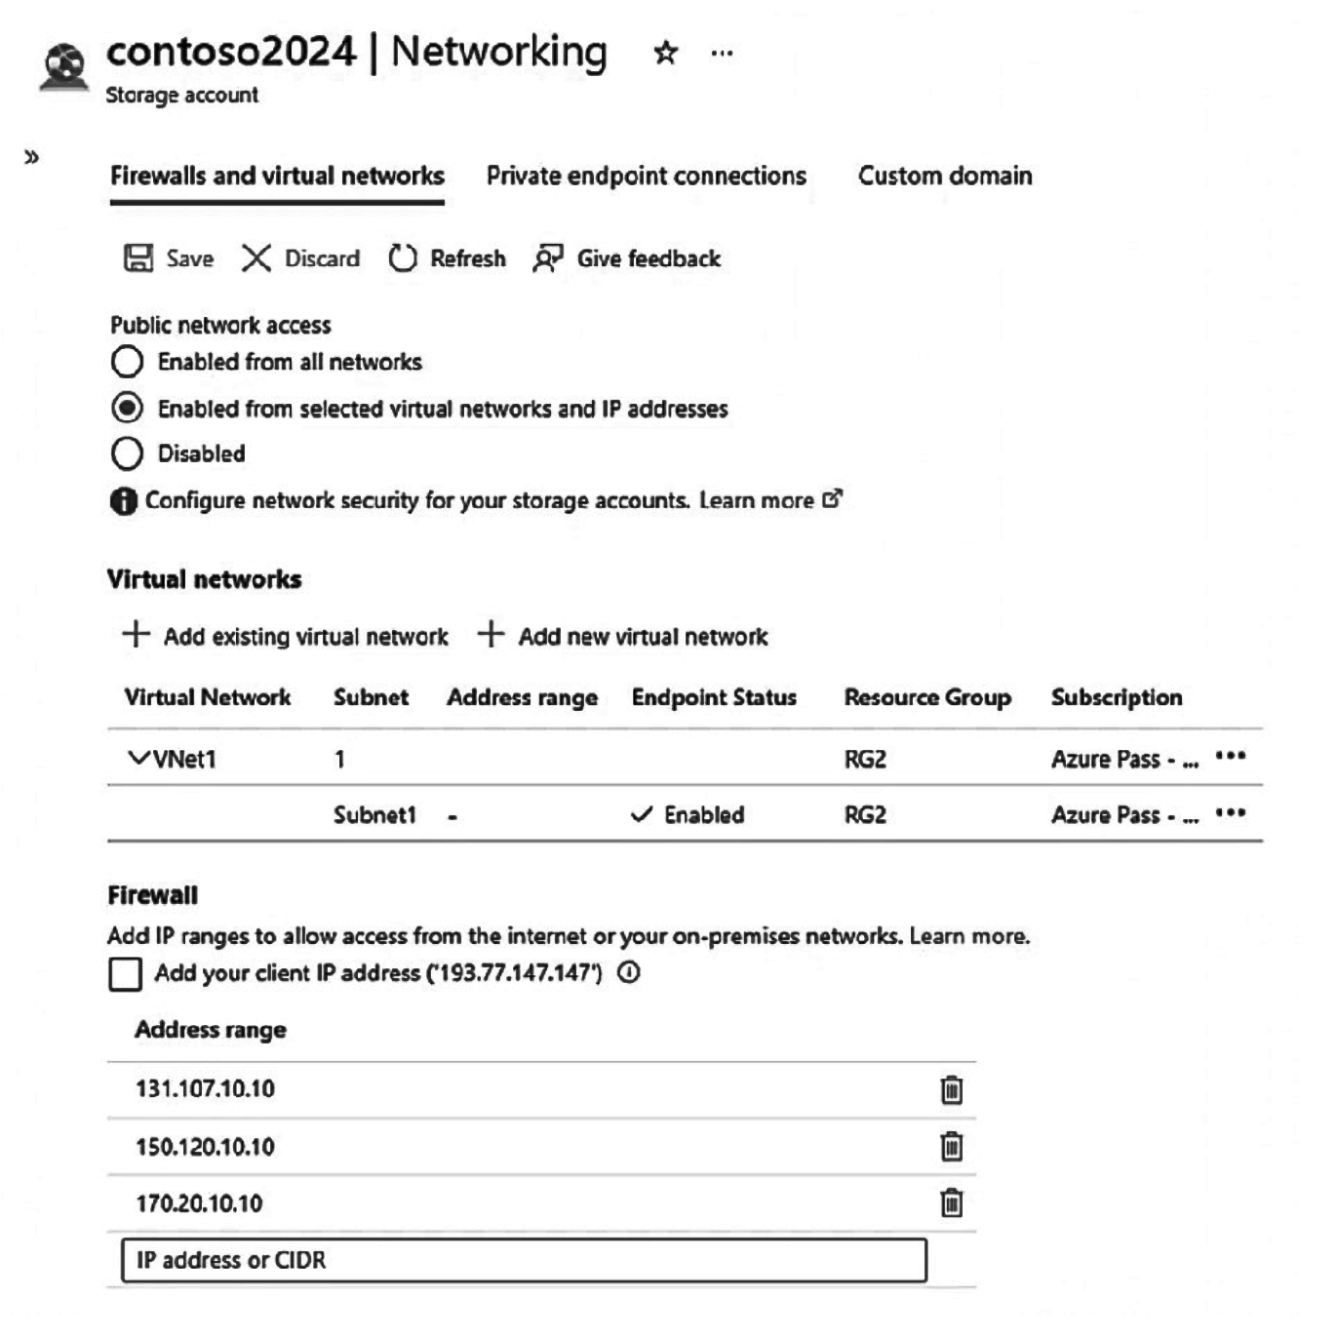
Based on the current firewall and virtual network settings of the storage account, evaluate the following statement.
True or False:
`"VM1 can connect to contoso2024 by using 131.107.10.10."`
Réponses:
☑ True
☐ False
Explication
`True` is correct because VM1 can connect to the contoso2024 storage account using the IP address 131.107.10.10. The storage account's firewall settings allow access from selected IP addresses, and 131.107.10.10, the public IP address of VM1, is explicitly listed as an allowed address. Additionally, VM1 is connected to VNet1/Subnet1, and the storage account is configured to accept traffic from VNet1/Subnet1 as well.
Reference(s):
- https://learn.microsoft.com/en-us/azure/storage/common/storage-network-security?tabs=azure-portal
- https://learn.microsoft.com/en-us/azure/virtual-network/virtual-networks-overview

Question 2
An Azure subscription contains three virtual machines. Each VM has an assigned public IP address and is connected to a subnet within VNet1.
The configuration is as follows:
- VM1 – Public IP: 131.107.10.10 – Connected to VNet1/Subnet1
- VM2 – Public IP: 150.120.10.10 – Connected to VNet1/Subnet2
- VM3 – Public IP: 170.20.10.10 – Connected to VNet1/Subnet1
The subscription also contains a storage account named contoso2024, which is configured with network access restrictions as shown in the exhibit.
Based on the current firewall and virtual network settings of the storage account, evaluate the following statement.
True or False:
`"VM2 can connect to contoso2024 by using 150.120.10.10."`
Réponses:
☑ True
☐ False
Explication
`True` is correct because VM2 has the public IP address 150.120.10.10, which is explicitly listed in the firewall rules of the contoso2024 storage account. While VM2 is connected to VNet1/Subnet2 (a different subnet than Subnet1), the public IP address being listed in the firewall allows VM2 to connect to the storage account, regardless of its subnet within VNet1.
Therefore, VM2 can still connect to contoso2024 using its public IP address.
Reference(s):
- https://learn.microsoft.com/en-us/azure/storage/common/storage-network-security?tabs=azure-portal
- https://learn.microsoft.com/en-us/azure/virtual-network/virtual-networks-overview

Question 3
An Azure subscription contains three virtual machines. Each VM has an assigned public IP address and is connected to a subnet within VNet1.
The configuration is as follows:
- VM1 – Public IP: 131.107.10.10 – Connected to VNet1/Subnet1
- VM2 – Public IP: 150.120.10.10 – Connected to VNet1/Subnet2
- VM3 – Public IP: 170.20.10.10 – Connected to VNet1/Subnet1
The subscription also contains a storage account named contoso2024, which is configured with network access restrictions as shown in the exhibit.
Based on the current firewall and virtual network settings of the storage account, evaluate the following statement.
True or False:
`"VM3 must use its private IP address to connect to contoso2024."`
Réponses:
☐ True
☑ False
Explication
`False` is correct because although VM3 is in VNet1/Subnet1, which is allowed in the storage account’s virtual network rules, the firewall configuration also explicitly permits VM3’s public IP address. This means VM3 is not strictly forced to use its private IP for connectivity. The word “must” makes the statement incorrect: VM3 can connect using its private IP via the service endpoint, but it could also connect using its public IP since that IP is in the firewall allowlist.
Reference(s):
- https://learn.microsoft.com/en-us/azure/storage/common/storage-network-security?tabs=azure-portal
- https://learn.microsoft.com/en-us/azure/virtual-network/virtual-networks-overview

Question 4
You have an Azure App Service plan named AppServicePlanA that is configured with the Standard pricing tier.
You need to configure the plan so that it automatically increases its instance count whenever the web app’s CPU utilization exceeds 80 percent.
Which configuration setting should you enable for AppServicePlanA to achieve this behavior?
Réponses:
☐ Automatic scaling configured in the Scale out settings
☑ Rule-based scaling configured in the Scale out settings
☐ Premium P1 selected under the Scale up (App Service plan) settings
☐ Standard S1 selected under the Scale up (App Service plan) settings
☐ Manual scaling configured in the Scale out settings
Explication
`Rule-based scaling configured in the Scale out settings` is the correct answer here. By selecting Rules Based, you can configure specific conditions for automatic scaling, such as when CPU usage exceeds 80 percent. This allows AppServicePlanA to automatically add more instances when the CPU utilization goes above the defined threshold. In this case, a rule can be created to automatically scale out based on CPU performance, which satisfies the requirement.
`Automatic scaling configured in the Scale out settings` is incorrect because it doesn't allow setting specific scaling conditions, such as CPU thresholds.
`Manual scaling configured in the Scale out settings` is incorrect because it requires manual intervention to scale, which does not meet the requirement of automatic scaling when CPU usage exceeds 80 percent.
`Premium P1 selected under the Scale up (App Service plan) settings` and
`Standard S1 selected under the Scale up (App Service plan) settings` are incorrect because these refer to scaling up (increasing the resources of the plan itself), not scaling out (adding more instances) based on a specific condition like CPU usage.
Reference(s):
- https://learn.microsoft.com/en-us/azure/app-service/manage-scale-up
- https://learn.microsoft.com/en-us/training/modules/scale-apps-app-service/2-autoscale-factors

Question 5
You have an Azure virtual network named VNet1 with the following configuration:
- The IPv4 address space is 172.16.10.0/24
- A subnet named Subnet1 exists within the virtual network
- Subnet1 uses the address range 172.16.10.0/25
Based on this configuration, what is the maximum number of virtual machines that can be deployed and connected to Subnet1?
Réponses:
☐ 24
☐ 25
☑ 123
☐ 128
☐ 251
Explication
`123` is the correct answer. The subnet 172.16.10.0/25 has a total of 128 IP addresses. However, Azure reserves the first four and the last IP address in every subnet for internal use. Therefore, the available IP addresses for virtual machines are:
128 (total IP addresses) - 5 (reserved addresses) = 123 usable IP addresses.
These 123 addresses can be assigned to virtual machines or other resources within the subnet.
- 172.16.10.0/25 means the subnet has 128 total IP addresses (2^7 = 128).
- Azure reserves five IP addresses in each subnet:
- The first IP is the network address.
- The second through fourth IP addresses are reserved for Azure services.
- The last IP address is reserved for the broadcast address.
- Thus, 123 addresses remain available for virtual machines.
Reference(s):
- https://learn.microsoft.com/en-us/azure/virtual-network/virtual-networks-faq

Question 6
Your environment includes an on-premises Active Directory Domain Services (AD DS) domain with the identities listed below:
- User1 is a user account located in OU2.
- User2 is a user account located in OU1.
- Group1 is a global security group that includes User1 and is located in OU1.
You have an Azure subscription that contains a storage account named storage1.
The Azure Files shares in storage1 use AD DS as the identity source, and the default share-level permissions are configured to allow access for all authenticated users and groups.
You create an Azure Files share named share1 and assign the following roles:
- User2 is assigned the Storage File Data SMB Share Reader role.
- Group1 is assigned the Storage File Data SMB Share Contributor role.
You also have a Microsoft Entra tenant that includes a cloud-only user named User3.
Microsoft Entra Connect is configured to synchronize OU1 from the on-premises AD DS domain to the Microsoft Entra tenant.
True or False:
`“User1 is able to access the data stored in share1.”`
Réponses:
☑ True
☐ False
Explication
`True` is the correct answer because User1 can access share1 by using AD DS authentication, even though User1 is not synchronized to Microsoft Entra ID.
The storage account uses AD DS as the identity source, and default share-level permissions are enabled for all authenticated users and groups. For Azure Files with AD DS authentication, Microsoft states that when a default share-level permission is configured, on-premises AD DS identities do not need to be synchronized to Microsoft Entra ID. The identity only needs to authenticate against the AD DS deployment associated with the storage account.
In addition, User1 is a member of Group1 in the on-premises AD DS domain. Group1 is located in OU1, is synchronized to Microsoft Entra ID, and has the Storage File Data SMB Share Contributor role on share1. Microsoft states that for AD DS authentication, non-synchronized users can still access Azure file shares through membership in a synchronized AD DS group. Azure Files reads the group SIDs from the user’s Kerberos ticket and applies the matching RBAC role assignments.
Therefore, User1 can access the data in share1, assuming the applicable NTFS/file-level permissions do not deny access. Azure Files evaluates both share-level permissions and Windows ACLs, and the most restrictive permission applies.
Reference(s):
- https://learn.microsoft.com/en-us/azure/storage/files/storage-files-identity-ad-ds-assign-permissions?tabs=azure-portal
- https://learn.microsoft.com/en-us/azure/storage/files/storage-files-identity-assign-share-level-permissions?tabs=azure-portal
- https://learn.microsoft.com/en-us/azure/storage/files/storage-files-identity-configure-file-level-permissions

Question 7
Your environment includes an on-premises Active Directory Domain Services (AD DS) domain with the identities listed below:
- User1 is a user account located in OU2.
- User2 is a user account located in OU1.
- Group1 is a global security group that includes User1 and is located in OU1.
You have an Azure subscription that contains a storage account named storage1.
The Azure Files shares in storage1 use AD DS as the identity source, and the default share-level permissions are configured to allow access for all authenticated users and groups.
You create an Azure Files share named share1 and assign the following roles:
- User2 is assigned the Storage File Data SMB Share Reader role.
- Group1 is assigned the Storage File Data SMB Share Contributor role.
You also have a Microsoft Entra tenant that includes a cloud-only user named User3.
Microsoft Entra Connect is configured to synchronize OU1 from the on-premises AD DS domain to the Microsoft Entra tenant.
True or False:
`"User2 can access content in share1."`
Réponses:
☑ True
☐ False
Explication
`True` is correct.
User2 can access share1 because User2 is located in OU1, and OU1 is synchronized to Microsoft Entra ID. User2 is also explicitly assigned the Storage File Data SMB Share Reader role on share1, which grants read access at the Azure Files share level.
Additionally, the question states that the default share-level permissions are configured to allow access for all authenticated users and groups. Therefore, even without the explicit RBAC assignment, User2 could still be allowed at the share level if User2 can authenticate against the associated AD DS domain and the default permission grants sufficient access.
However, Azure Files access is controlled by both share-level permissions and NTFS file/directory permissions. Therefore, actual access to the content also depends on the applicable NTFS ACLs. In this question, no restrictive NTFS ACL is mentioned, so User2 can access the content in share1.
Reference(s):
- https://learn.microsoft.com/en-us/azure/storage/files/storage-files-identity-ad-ds-assign-permissions?tabs=azure-portal

Question 8
Your environment includes an on-premises Active Directory Domain Services (AD DS) domain with the identities listed below:
- User1 is a user account located in OU2.
- User2 is a user account located in OU1.
- Group1 is a global security group that includes User1 and is located in OU1.
You have an Azure subscription that contains a storage account named storage1.
The Azure Files shares in storage1 use AD DS as the identity source, and the default share-level permissions are configured to allow access for all authenticated users and groups.
You create an Azure Files share named share1 and assign the following roles:
- User2 is assigned the Storage File Data SMB Share Reader role.
- Group1 is assigned the Storage File Data SMB Share Contributor role.
You also have a Microsoft Entra tenant that includes a cloud-only user named User3.
Microsoft Entra Connect is configured to synchronize OU1 from the on-premises AD DS domain to the Microsoft Entra tenant.
True or False:
`"User3 can access content in share1."`
Réponses:
☐ True
☑ False
Explication
`False` is correct. For AD DS-based Azure Files authentication, Azure Files uses Kerberos through the configured identity source, and Microsoft states that only hybrid identities that exist in both on-premises AD DS and Microsoft Entra ID can be authenticated and authorized for Azure file share access. Also, a storage account can use only one identity source for SMB identity-based authentication, so cloud-only access would require a different identity source such as Microsoft Entra Kerberos, not AD DS.
Reference(s):
- https://learn.microsoft.com/en-us/azure/storage/files/storage-files-identity-ad-ds-assign-permissions?tabs=azure-portal

Question 9
You manage two Azure subscriptions, Sub1 and Sub2. Each subscription is linked to a separate Microsoft Entra tenant.
The environment includes the following virtual networks:
- VNet1 – Located in East US – Associated with Sub1
- VNet2 – Located in East US – Associated with Sub1
- VNet3 – Located in West US – Associated with Sub1
- VNet4 – Located in East US – Associated with Sub2
- VNet5 – Located in Central US – Associated with Sub2
You want to establish virtual network peering from VNet1.
Which of the listed virtual networks are eligible to be peered with VNet1?
Réponses:
☐ VNet2 only
☐ VNet2 and VNet3 only
☐ VNet2 and VNet4 only
☐ VNet2, VNet3, and VNet4 only
☑ VNet2, VNet3, VNet4, and VNet5
Explication
VNet1 can peer with `VNet2, VNet3, VNet4, and VNet5` because global virtual network peering allows you to peer virtual networks across different regions and subscriptions, even when they are linked to different Microsoft Entra tenants.
- VNet2: Same region (East US), same subscription (Sub1).
- VNet3: Different region (West US), same subscription (Sub1).
- VNet4: Same region (East US), different subscription (Sub2).
- VNet5: Different region (Central US), different subscription (Sub2).
With global VNet peering, you can enable communication between virtual networks in different regions and subscriptions, as long as the necessary permissions are configured.
Reference(s):
- https://learn.microsoft.com/en-us/azure/virtual-network/virtual-network-peering-overview

Question 10
You have an Azure subscription that includes a storage account named storage1.
You want to restrict access to storage1 so that it is reachable only from specific networks and from your home office. The approach must require the least amount of ongoing administrative effort.
What is the first configuration change you should make for storage1?
Réponses:
☐ Create a private endpoint for the storage account.
☑ Update the public network access configuration for the storage account.
☐ Configure the storage account to use internet-based routing.
☐ Change the role-based access control (IAM) settings.
Explication
`Update the public network access configuration for the storage account` is the correct answer here. To allow access to storage1 from selected networks and your home office while minimizing administrative effort, you should first modify the Public network access settings. By selecting the option to allow access only from selected virtual networks and IP addresses, you can define specific networks and IP addresses, such as your home office's public IP address, without needing to configure more complex solutions like private endpoints.
`Create a private endpoint for the storage account` is incorrect because private endpoints require additional setup and would only allow access through a private network, not minimizing administrative effort.
`Configure the storage account to use internet-based routing` is incorrect because this would open the storage account to access from the internet, which doesn't fulfill the requirement of limiting access to selected networks and your home office.
`Change the role-based access control (IAM) settings` is incorrect because IAM controls user and group permissions for accessing resources but does not control network access.
Reference(s):
- https://learn.microsoft.com/en-us/azure/storage/common/storage-network-security?tabs=azure-portal
- https://learn.microsoft.com/en-us/azure/storage/common/storage-network-security?tabs=azure-portal#public-network-access

Question 11
An Azure subscription contains three Azure Container Registry (ACR) instances. Each registry is configured with a different pricing tier:
- ContReg1 – Service tier: Premium
- ContReg2 – Service tier: Standard
- ContReg3 – Service tier: Basic
You plan to use Azure Container Registry (ACR) Tasks and also require support for private endpoint connections.
Which of the listed container registries can be used to run ACR Tasks?
Réponses:
☐ ContReg1 only
☐ ContReg1 and ContReg2 only
☑ ContReg1, ContReg2, and ContReg3
Explication
`ContReg1, ContReg2, and ContReg3 `is the correct answer here. ACR Tasks are supported in all service tiers: Basic, Standard, and Premium. While there are performance and feature differences across the tiers (such as the number of concurrent tasks or webhook triggers), ACR Tasks functionality is available in all three tiers, including Basic.
Reference(s):
- https://learn.microsoft.com/en-us/azure/container-registry/container-registry-skus

Question 12
An Azure subscription contains three Azure Container Registry (ACR) instances. Each registry is configured with a different pricing tier:
- ContReg1 – Service tier: Premium
- ContReg2 – Service tier: Standard
- ContReg3 – Service tier: Basic
You plan to use Azure Container Registry (ACR) Tasks and also require support for private endpoint connections.
Which of the container registries can be configured to use private endpoints?
Réponses:
☑ ContReg1 only
☐ ContReg1 and ContReg2 only
☐ ContReg1, ContReg2, and ContReg3
Explication
`ContReg1 only` is the correct answer because only the Premium tier of Azure Container Registry supports private endpoints. ContReg1 is configured with the Premium tier, which allows the use of private endpoints. Standard and Basic tiers, as seen in ContReg2 and ContReg3, do not support private endpoints.
`ContReg1 and ContReg2 only` is incorrect because the Standard tier (used by ContReg2) does not support private endpoints.
`ContReg1, ContReg2, and ContReg3` is incorrect because neither the Standard nor Basic tiers (used by ContReg2 and ContReg3) support private endpoints.
Reference(s):
- https://learn.microsoft.com/en-us/azure/container-registry/container-registry-skus

Question 13
You have an Azure container registry named contoso2023 as shown below.
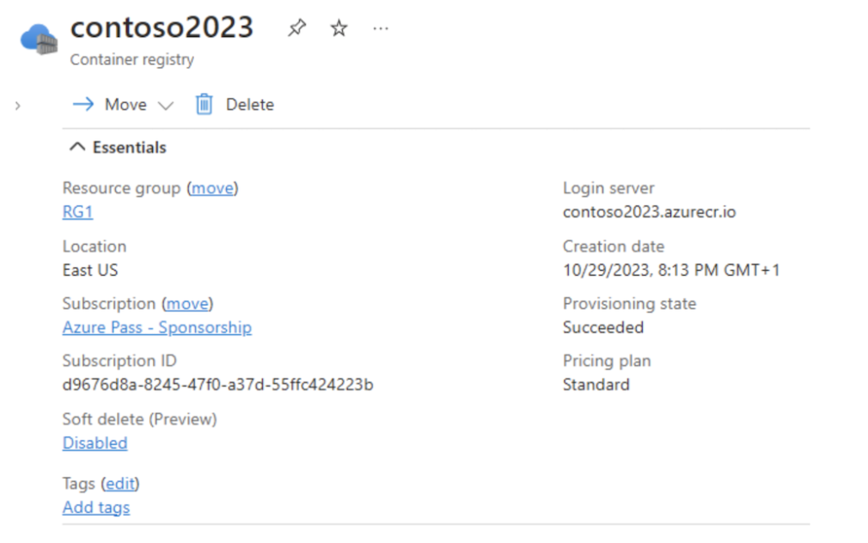
You want to configure contoso2023 so that it uses a dedicated data endpoint for data operations.
Which two configuration settings must you enable or modify on contoso2023 to meet this requirement?
Réponses (plusieurs réponses possibles)
☐ Overview
☑ Properties
☑ Networking
☐ Tasks
☐ Access control (IAM)
☐ Events
Explication
To enable contoso2023 to use a dedicated data endpoint, you need to configure the following two settings:
`Properties`: This is where you can enable and configure the dedicated data endpoint for your Azure container registry. From this blade, you must first change the pricing plan from Standard to Premium. This setting is crucial for routing all data plane operations through a dedicated endpoint.
`Networking`: After the registry is upgraded to Premium, you must go to Networking and enable the dedicated data endpoint setting. Dedicated data endpoints provide registry-specific data endpoint URLs, such as `<registry-name>.<region>.data.azurecr.io`, for data operations.
`Overview`, `Tasks`, `Access control (IAM)`, and `Events` are NOT relevant for enabling or configuring a dedicated data endpoint.
Reference(s):
- https://learn.microsoft.com/en-gb/azure/container-registry/container-registry-firewall-access-rules#enable-dedicated-data-endpoints
- https://learn.microsoft.com/en-us/azure/container-registry/container-registry-private-link

Question 14
You have a Microsoft Entra tenant named contoso.com.
You work with an external organization that uses the domain fabrikam.com.
You plan to invite external users from fabrikam.com into the contoso.com tenant.
You must ensure that invitations can be sent exclusively to users from fabrikam.com and not to users from any other external domains.
What configuration should you perform in the Microsoft Entra admin center?
Réponses:
☐ From Cross-tenant access settings, configure the Tenant restrictions settings.
☐ From Cross-tenant access settings, configure the Microsoft cloud settings.
☐ From External collaboration settings, configure the Guest user access restrictions settings.
☑ From External collaboration settings, configure the Collaboration restrictions settings.
Explication
`From External collaboration settings, configure the Collaboration restrictions settings` is the correct answer. In Microsoft Entra, you can restrict who can be invited as a guest by configuring Collaboration restrictions. By specifying the allowed domains, such as fabrikam.com, you can ensure that invitations can only be sent to users from that domain.
`From Cross-tenant access settings, configure the Tenant restrictions settings` is incorrect because tenant restrictions are used to control which tenants users can access, not to restrict guest invitations.
`From Cross-tenant access settings, configure the Microsoft cloud settings` is incorrect because these settings are used for managing cross-tenant access policies between Microsoft cloud environments, not for restricting guest user invitations.
`From External collaboration settings, configure the Guest user access restrictions settings` is incorrect because this setting controls what guest users can do once they are in your tenant, not who can be invited.
Reference(s):
- https://learn.microsoft.com/en-us/entra/external-id/external-collaboration-settings-configure

Question 15
You have an Azure subscription that includes three virtual machines named VM1, VM2, and VM3. All three virtual machines are deployed in the same availability set called AVSet1.
You want to resize VM1 to a larger virtual machine size. However, the target size is currently not available.
What action should you take first?
Réponses:
☐ Create a proximity placement group and associate it with the virtual machines.
☑ Deallocate VM1.
☐ Convert AvSet1 into a managed availability set.
☐ Power off VM2 and VM3.
Explication
`Deallocate VM1` is the correct answer here. When a specific virtual machine size is unavailable for a VM that is part of an availability set (like AVSet1), the first step is to deallocate the virtual machine. Deallocating the VM releases the hardware allocation, potentially freeing up capacity for the new VM size. Once the VM is deallocated, you can attempt to resize it.
`Create a proximity placement group and associate it with the virtual machines` is incorrect because proximity placement groups are used to ensure low-latency placement of VMs but have no direct impact on resizing availability.
`Convert AVSet1 into a managed availability set` is incorrect because the availability set is already managed by default when using managed disks, and this action wouldn't resolve the size availability issue.
`Power off VM2 and VM3` is incorrect because shutting down the other VMs in the availability set does not affect the resizing of VM1.
Reference(s):
- https://learn.microsoft.com/en-us/azure/virtual-machines/sizes/resize-vm?tabs=portal

Question 16
An Azure subscription contains the following resources:
- VM1 – Virtual machine
- VNet1 – Virtual network
- NIC1 – Network interface
- LB1 – Load balancer
- VPN1 – Virtual network gateway
You create a new public IP address named IP1.
Which two of the listed resources can be linked to IP1?
Réponses (plusieurs réponses possibles)
☐ VM1
☑ LB1
☑ NIC1
☐ VPN1
☐ VNet1
Explication
`LB1 (Load balancer)` and `NIC1 (Network interface) `are the correct answers. Public IP addresses can be associated with a load balancer or a network interface to enable external communication with resources like virtual machines or services behind the load balancer.
- LB1: A public IP can be associated with a load balancer to distribute incoming traffic across multiple backend resources, such as virtual machines.
- NIC1: A public IP can also be associated with a network interface, allowing a virtual machine to have direct access to the internet.
`VM1` is incorrect because public IP addresses are associated with network interfaces (like NIC1) rather than directly with virtual machines.
`VPN1` is incorrect because virtual network gateways use their own public IPs but are not directly associated with manually created public IPs.
`VNet1` is incorrect because virtual networks themselves do not have public IP addresses directly associated with them.
Reference(s):
- https://learn.microsoft.com/en-us/azure/virtual-network/ip-services/public-ip-addresses
- https://learn.microsoft.com/en-us/azure/load-balancer/load-balancer-overview

Question 17
You have an Azure subscription with two virtual networks, VNet1 and VNet2, that are peered with each other.
VNet1 includes a VPN gateway that is configured to use static routing.
The on-premises network has a VPN connection that uses the VPN gateway of VNet1.
You need to enable users from the on-premises network to access a virtual machine hosted in VNet2. The solution must be cost-effective.
Which connectivity approach should you implement?
Réponses:
☐ Deploy Azure Firewall and route traffic through its private IP address
☑ Use service chaining together with user-defined routes (UDRs)
☐ Deploy an Azure Application Gateway
☐ Provision an ExpressRoute circuit connected to VNet2
Explication
`Use service chaining together with user-defined routes (UDRs)` is the correct answer. By using service chaining and configuring user-defined routes (UDRs), you can route traffic from the on-premises network, through the VPN gateway on VNet1, to VNet2. This setup leverages the existing peering between VNet1 and VNet2 without requiring additional costly infrastructure like Azure Firewall or ExpressRoute, thereby minimizing costs. UDRs will ensure that the traffic is directed through the correct paths.
`Deploy Azure Firewall and route traffic through its private IP address` is incorrect because while it could provide routing and security, it is more costly than using UDRs and is not necessary for this scenario.
`Deploy an Azure Application Gateway` is incorrect because this is primarily used for managing and load balancing web traffic, not for routing network traffic between VNets or from on-premises networks.
`Provision an ExpressRoute circuit connected to VNet2` is incorrect because ExpressRoute is a high-cost solution that provides private connectivity between on-premises and Azure, which is not required since you already have a VPN gateway in place for the on-premises connection.
Reference(s):
- https://learn.microsoft.com/en-us/azure/virtual-network/virtual-networks-udr-overview
- https://learn.microsoft.com/en-us/azure/virtual-network/virtual-network-peering-overview

Question 18
You have an Azure subscription that contains a storage account named storage1.
You want to make sure that the access keys for storage1 are rotated automatically.
Which configuration should you set up?
Réponses:
☐ Configure a backup vault
☐ Configure redundancy settings for storage1
☐ Configure lifecycle management for storage1
☑ Configure an Azure Key Vault
☐ Configure a Recovery Services vault
Explication
`Configure an Azure Key Vault` is the correct answer. To ensure that the access keys for storage1 rotate automatically, you should store the keys in Azure Key Vault and enable key rotation policies. Key Vault allows for the secure storage of secrets, including storage account access keys, and provides the ability to configure automatic key rotation.
`Configure a backup vault` and `Configure a Recovery Services vault` are incorrect because these are used for backing up data and managing disaster recovery, not for rotating access keys.
`Configure redundancy settings for storage1` is incorrect because this deals with the replication of storage data across different locations for high availability, not key management.
`Configure lifecycle management for storage1` is incorrect because this manages data retention policies, not access key rotation.
Reference(s):
- https://learn.microsoft.com/en-us/azure/key-vault/general/overview
- https://learn.microsoft.com/en-us/azure/storage/common/storage-account-keys-manage?tabs=azure-portal

Question 19
You have an Azure subscription that includes a storage account named storage1, which stores blob data.
You must assign a role to a user named User1 so that the user can access the blob data in storage1. The role assignment must support Azure role assignment conditions.
Which two roles are suitable for assigning to User1?
Réponses (plusieurs réponses possibles)
☐ Owner
☐ Storage Account Contributor
☐ Storage Account Backup Contributor
☑ Storage Blob Data Contributor
☑ Storage Blob Data Owner
☐ Storage Blob Delegator
Explication
`Storage Blob Data Contributor` is the correct answer because this role allows the user to read, write, and delete blob data within a storage account. This role supports conditions, which can help control access based on specific criteria like time, IP address, or other factors.
`Storage Blob Data Owner` is the correct answer because this role grants full control over blob data, including setting access policies and modifying blob content. It also supports conditions for access.
`Owner` is incorrect because while this role gives full administrative access to the storage account, it does not allow direct blob data access, nor does it support conditions for blob-level data access.
`Storage Account Contributor` is incorrect because it grants management access to the storage account but does not provide direct access to blob data.
`Storage Account Backup Contributor` is incorrect because this role is designed for backup and recovery operations but doesn't provide direct access to blob data.
`Storage Blob Delegator` is incorrect because this role is used to delegate access through OAuth 2.0 on behalf of a user or service and is not intended for direct blob data access.
Reference(s):
- https://learn.microsoft.com/en-us/azure/role-based-access-control/built-in-roles#storage-blob-data-contributor
- https://learn.microsoft.com/en-us/azure/role-based-access-control/built-in-roles#storage-blob-data-owner

Question 20
You have a Microsoft Entra tenant.
You plan to import a large number of user accounts at once.
You must ensure that newly imported users are automatically added to a specific group based on the value of their department attribute. The solution should require minimal ongoing administrative effort.
Which two actions should you take?
Réponses (plusieurs réponses possibles)
☐ Create groups that use the Assigned membership type.
☐ Create an Azure Resource Manager (ARM) template.
☑ Create groups that use the Dynamic User membership type.
☐ Write a PowerShell script that parses an import file.
☐ Create an XML file that contains user information and the appropriate attributes.
☑ Create a CSV file that contains user information and the appropriate attributes.
Explication
`Create groups that use the Dynamic User membership type` is the correct answer because dynamic membership rules allow users to be automatically added to groups based on specific attributes, such as department. This minimizes administrative effort since the users will be automatically placed into the correct group based on their department attribute without manual intervention.
`Create a CSV file that contains user information and the appropriate attributes` is the correct answer because CSV is the supported format for bulk importing users into Microsoft Entra. The CSV file will contain the necessary user information, including department attributes, which are used to assign users to the appropriate dynamic groups.
`Create groups that use the Assigned membership type` is incorrect because assigned groups require manual assignment of users, which does not minimize administrative effort.
`Create an Azure Resource Manager (ARM) template` is incorrect because ARM templates are used to deploy Azure resources, not for user or group management.
`Write a PowerShell script that parses an import file` is incorrect because while it can be used, it would increase administrative effort, which is against the goal of minimizing effort.
`Create an XML file that contains user information and the appropriate attributes` is incorrect because CSV is the recommended format for bulk user import, not XML.
Reference(s):
- https://learn.microsoft.com/en-us/entra/identity/users/groups-dynamic-membership
- https://learn.microsoft.com/en-us/entra/identity/users/groups-bulk-import-members

Question 21
You have an Azure subscription that contains an Azure Container Registry named RegistryProd01, which is currently configured with the Standard pricing tier.
You need to enable support for geo-replication for RegistryProd01.
What is the first step you should perform on RegistryProd01 to meet this requirement?
Réponses:
☐ Enable the admin user for the registry.
☐ Create a scope map for the registry.
☐ Configure an automation task.
☐ Define a cache rule.
☑ Change the registry to a higher SKU tier.
Explication
`Change the registry to a higher SKU tier` is the correct answer here. Geo-replication in Azure Container Registry is only supported in the Premium SKU. Since RegistryProd01 is currently using the Standard SKU, the first step to enable geo-replication is to upgrade the SKU to Premium. Once the SKU is upgraded, you can configure geo-replication across multiple regions.
`Enable the admin user for the registry` is incorrect because this is related to authentication and does not enable geo-replication.
`Create a scope map for the registry` is incorrect because scope maps are used for defining permissions for tokens, not for geo-replication.
`Configure an automation task` is incorrect because automation tasks are used for building and pushing images, not for geo-replication.
`Define a cache rule` is incorrect because cache rules are unrelated to geo-replication.
Reference(s):
- https://learn.microsoft.com/en-us/azure/container-registry/container-registry-geo-replication
- https://learn.microsoft.com/en-us/azure/container-registry/container-registry-skus

Question 22
You have an Azure subscription that includes a storage account named storage1 which contains a blob used to store images.
Access to storage1 is provided to clients by using a shared access signature (SAS).
You want users to see a warning whenever they create a SAS with an expiration period longer than seven days.
What configuration should you apply to the storage account?
Réponses:
☐ Enable a read-only resource lock on the storage account.
☐ Create and configure an alert rule.
☐ Add a lifecycle management policy.
☑ Set Allow recommended upper limit for shared access signature (SAS) expiry interval to Enabled.
Explication
`Set Allow recommended upper limit for shared access signature (SAS) expiry interval to Enabled` is the correct answer. By enabling this setting, Azure will enforce a recommended upper limit for SAS token expiry (in this case, seven days). Users will receive a warning if they try to create a SAS token that exceeds the defined limit, helping to maintain secure access practices.
`Enable a read-only resource lock on the storage account` is incorrect because locks are used to prevent modification or deletion of resources, not for configuring SAS expiry limits.
`Create and configure an alert rule` is incorrect because alert rules are used for monitoring and alerting on events, but do not directly enforce or warn about SAS expiry time.
`Add a lifecycle management policy` is incorrect because lifecycle management is used to manage blob storage tiers and deletion policies, not SAS expiry intervals.
Reference(s):
- https://learn.microsoft.com/en-us/azure/storage/common/storage-sas-overview

Question 23
You have an Azure subscription linked to a hybrid Microsoft Entra tenant. The tenant includes the users listed below:
- User1: Not enabled for on-premises synchronization
- User2: Enabled for on-premises synchronization
You create the following Azure Files shares:
- share1 in storage account contoso2025
- share2 in storage account contoso2025
- share3 in storage account contoso2026
You configure identity-based access for contoso2025 by enabling Active Directory Domain Services (AD DS) as the identity source and setting the default share-level permissions to allow access for all authenticated users and groups.
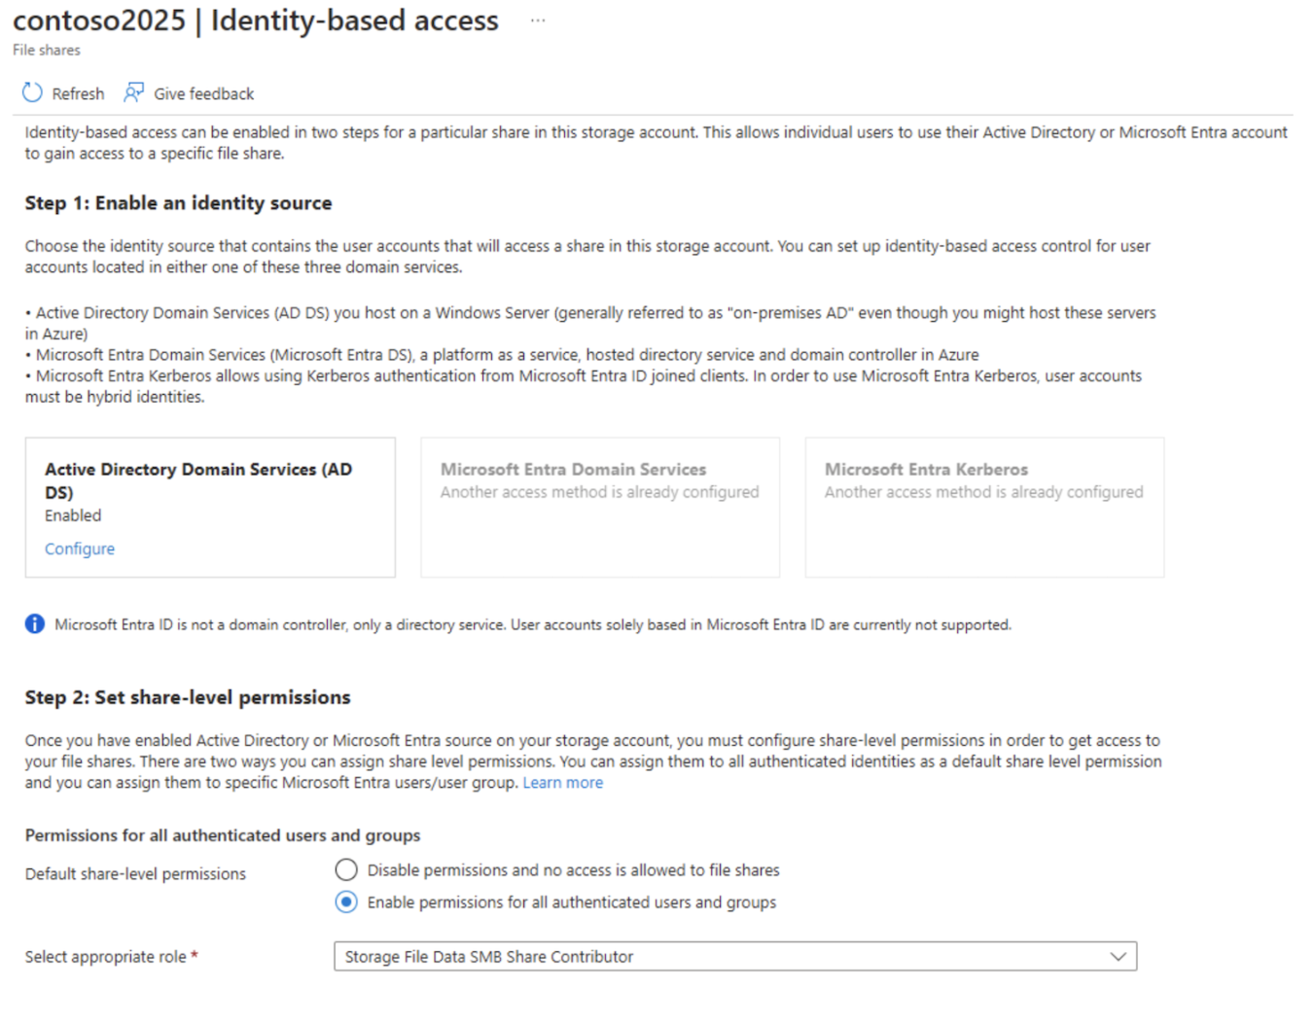
True or False:
`"User1 can access the content in share1."`
Réponses:
☐ True
☑ False
Explication
`False` is correct because User1 does not have on-premises synchronization enabled, as indicated. According to the identity-based access configuration shown in the exhibit, only users synchronized from on-premises AD DS or those with hybrid identities can access the file shares. User1 is not synced from an on-premises AD DS environment and is therefore not eligible for access to share1, despite the permissions being enabled for authenticated users.
Reference(s):
- https://learn.microsoft.com/en-us/azure/storage/files/storage-files-identity-auth-active-directory-enable

Question 24
You have an Azure subscription linked to a hybrid Microsoft Entra tenant. The tenant includes the users listed below:
- User1: Not enabled for on-premises synchronization
- User2: Enabled for on-premises synchronization
You create the following Azure Files shares:
- share1 in storage account contoso2025
- share2 in storage account contoso2025
- share3 in storage account contoso2026
You configure identity-based access for contoso2025 by enabling Active Directory Domain Services (AD DS) as the identity source and setting the default share-level permissions to allow access for all authenticated users and groups.
True or False:
`"User2 can access the content in share2."`
Réponses:
☑ True
☐ False
Explication
`True` is correct because User2 has on-premises sync enabled, as indicated, and the identity-based access configuration for contoso2025 (which contains share2) is set to allow permissions for authenticated users and groups. Since User2 is synchronized from on-premises AD DS, they are eligible to access the content in share2.
Reference(s):
- https://learn.microsoft.com/en-us/azure/storage/files/storage-files-identity-auth-active-directory-enable

Question 25
You have an Azure subscription linked to a hybrid Microsoft Entra tenant. The tenant includes the users listed below:
- User1: Not enabled for on-premises synchronization
- User2: Enabled for on-premises synchronization
You create the following Azure Files shares:
- share1 in storage account contoso2025
- share2 in storage account contoso2025
- share3 in storage account contoso2026
You configure identity-based access for contoso2025 by enabling Active Directory Domain Services (AD DS) as the identity source and setting the default share-level permissions to allow access for all authenticated users and groups.
True or False:
`"User2 can access the content in share3."`
Réponses:
☐ True
☑ False
Explication
`False` is correct because share3 is part of the contoso2026 storage account, which is not configured for identity-based access (according to the provided information and exhibit, only contoso2025 has identity-based access enabled). Since User2 is synced and can access shares in contoso2025, they would not have access to share3 in contoso2026 unless identity-based access is configured similarly for contoso2026.
Reference(s):
- https://learn.microsoft.com/en-us/azure/storage/files/storage-files-identity-auth-active-directory-enable

Question 26
A Microsoft Entra tenant contains the following users:
- User1
- Member of: Group1
- Assigned license: Microsoft Entra ID P2
- User2
- Member of: Group2
- Assigned license: None
- User3
- Member of: No groups
- Assigned license: Microsoft Entra ID P2
- User4
- Member of: No groups
- Assigned license: None
The tenant also contains the following groups and group relationships:
- Group1
- Member of: No groups
- Assigned license: None
- Group2
- Member of: Group3
- Assigned license: Microsoft Entra ID P2
- Group3
- Member of: Group4
- Assigned license: None
- Group4
- Member of: No groups
- Assigned license: Microsoft Entra ID P2
Based on the tenant configuration shown above, which `users` are eligible to be deleted from Microsoft Entra ID?
Réponses:
☐ User4 only
☐ User3 and User4 only
☐ User2 and User4 only
☑ User1, User2, User3, and User4
Explication
`User1, User2, User3, and User4` can all be deleted. In Microsoft Entra ID, users can be deleted regardless of whether they have licenses assigned directly or through group membership. When a user is deleted, any licenses assigned to them will be freed for reassignment.
Reference(s):
- https://learn.microsoft.com/en-us/entra/fundamentals/how-to-create-delete-users

Question 27
A Microsoft Entra tenant contains the following users:
- User1
- Member of: Group1
- Assigned license: Microsoft Entra ID P2
- User2
- Member of: Group2
- Assigned license: None
- User3
- Member of: No groups
- Assigned license: Microsoft Entra ID P2
- User4
- Member of: No groups
- Assigned license: None
The tenant also contains the following groups and group relationships:
- Group1
- Member of: No groups
- Assigned license: None
- Group2
- Member of: Group3
- Assigned license: Microsoft Entra ID P2
- Group3
- Member of: Group4
- Assigned license: None
- Group4
- Member of: No groups
- Assigned license: Microsoft Entra ID P2
Based on the tenant configuration shown above, which `groups` are eligible to be deleted from Microsoft Entra ID?
Réponses:
☐ Group1 only
☐ Group4 only
☑ Group1 and Group3 only
☐ Group1, Group2, Group3, and Group4
Explication
`Group1 and Group3 only` is the correct answer because both groups do not have any licenses directly assigned to them. According to Microsoft Entra documentation, a group cannot be deleted if it has licenses directly assigned. Group1 and Group3 meet the criteria for deletion: Group1 has no assigned license, and Group3 is only a member of another group but does not itself have any license directly assigned.
`Group4 only` is incorrect because Group4 has a Microsoft Entra ID P2 license assigned directly, which prevents it from being deleted until the license is removed.
`Group1 only` is incorrect because while Group1 can be deleted, Group3 can also be deleted, so this answer is incomplete.
`Group1, Group2, Group3, and Group4` is incorrect because Group2 and Group4 both have licenses directly assigned, which disqualifies them from deletion until those licenses are removed.
Reference(s):
- https://learn.microsoft.com/en-us/entra/fundamentals/how-to-create-delete-users
- https://learn.microsoft.com/en-us/entra/fundamentals/licensing-groups-resolve-problems#when-a-licensed-group-is-deleted

Question 28
You have an Azure subscription named ProdSubscription that contains the following resources:
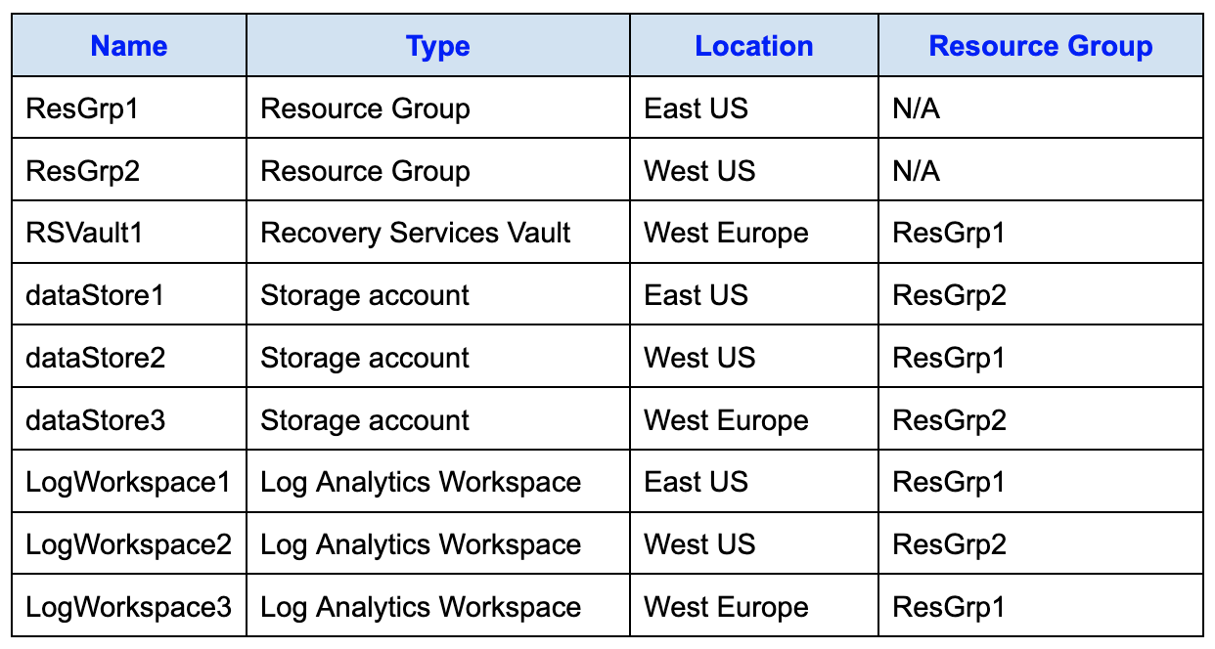
You plan to configure Azure Backup reports for RSVault1.
While configuring diagnostic settings for the AzureBackupReports log category, you must choose a storage account as the destination.
Which `storage accounts` are eligible to store the Azure Backup reports for RSVault1?
Réponses:
☐ dataStore1 only
☐ dataStore2 only
☑ dataStore3 only
☐ dataStore1, dataStore2, and dataStore3
Explication
`dataStore3 only` is correct because Azure Backup requires that the storage account used for diagnostic settings (like Azure Backup reports) be in the same region as the Recovery Services vault (RSVault1). Since RSVault1 is in the West Europe region, only dataStore3, located in West Europe, meets this requirement.
`dataStore1 only` is incorrect because dataStore1 is in the East US region, which does not match the West Europe region of Vault1.
`dataStore2 only` is incorrect because dataStore2 is in the West US region, which also does not match the West Europe region of Vault1.
`dataStore1, dataStore2, and dataStore3` is incorrect because only dataStore3 is in the same region as Vault1. dataStore1 and dataStore2 are in East US and West US, respectively, and therefore cannot be used.
Reference(s):
- https://learn.microsoft.com/en-us/azure/backup/backup-azure-files?tabs=backup-center
- https://docs.microsoft.com/en-us/azure/backup/backup-create-rs-vault

Question 29
You have an Azure subscription named ProdSubscription that contains the following resources:
You plan to configure Azure Backup reports for RSVault1.
While configuring diagnostic settings for the AzureBackupReports log category, you must choose a storage account as the destination.
Which `Log Analytics workspaces` can you use for the Azure Backup reports of RSVault1?
Réponses:
☐ LogWorkspace1 only
☐ LogWorkspace2 only
☐ LogWorkspace3 only
☑ LogWorkspace1, LogWorkspace2, and LogWorkspace3
Explication
`LogWorkspace1, LogWorkspace2, and LogWorkspace3` is correct because, as per the documentation, the location of the Log Analytics workspace does not need to match the location of the Recovery Services vault. Therefore, all three workspaces LogWorkspace1, LogWorkspace2, and LogWorkspace3, can be used to store the Azure Backup reports for Vault1.
Reference(s):
- https://learn.microsoft.com/en-us/azure/backup/configure-reports?tabs=recovery-services-vaults#1-create-a-log-analytics-workspace-or-use-an-existing-one

Question 30
You have an on-premises network and an Azure subscription that includes three peered virtual networks named VNET1, VNET2, and VNET3. All three virtual networks are connected to the on-premises network.
The subscription contains the following virtual machines:
- VM1 and VM2, located in West US and connected to VNET1
- VM3, located in West US and connected to VNET2
- VM4, located in Central US and connected to VNET3
You want to monitor network connectivity between the virtual machines and the on-premises network by using Connection Monitor.
What is the minimum number of Connection Monitor instances that you must deploy?
Réponses:
☐ 1
☑ 2
☐ 3
☐ 4
Explication
`2` is correct because Azure Network Watcher's Connection Monitor requires that the source virtual machine and the Connection Monitor instance reside in the same Azure region. In the table:
- VM1, VM2, and VM3 are in the West US region.
- VM4 is in the Central US region.
You will need:
- One Connection Monitor in West US to monitor VM1, VM2, and VM3's connectivity to the on-premises network.
- One Connection Monitor in Central US to monitor VM4’s connectivity to the on-premises network.
You cannot use a single connection monitor to monitor VMs across regions, hence two are required.
Reference(s):
- https://learn.microsoft.com/en-us/azure/network-watcher/connection-monitor-overview

Question 31
An Azure subscription contains two virtual machines with the following configurations:
- VM1
- Operating system: Windows Server 2019
- Connected to: Subnet1
- VM2
- Operating system: Windows Server 2019
- Connected to: Subnet2
Both VM1 and VM2 have public IP addresses, and inbound Remote Desktop (RDP) access is enabled on each virtual machine.
Subnet1 and Subnet2 belong to the same virtual network named VNET1.
The subscription contains two network security groups (NSGs):
- NSG1 contains only the default security rules.
- NSG2 contains the default rules and an additional inbound rule with the following configuration:
- Priority: 100
- Name: Rule1
- Protocol: TCP
- Port: 3389
- Source: Any
- Destination: Any
- Action: Allow
NSG1 is associated with Subnet1, and NSG2 is associated with the network interface of VM2.
True or False:
`“You can connect to VM1 from the internet using Remote Desktop.”`
Réponses:
☐ True
☑ False
Explication
`False` is correct because VM1 is associated with NSG1, which only has the default rules. By default, NSGs deny inbound traffic from the internet unless there is an explicit rule to allow it. Since NSG1 does not have any custom rule allowing inbound Remote Desktop Protocol (RDP) traffic on port 3389 from the internet, VM1 cannot be accessed via RDP from the internet.
Reference(s):
- https://learn.microsoft.com/en-us/azure/virtual-network/network-security-groups-overview

Question 32
An Azure subscription contains two virtual machines with the following configurations:
- VM1
- Operating system: Windows Server 2019
- Connected to: Subnet1
- VM2
- Operating system: Windows Server 2019
- Connected to: Subnet2
Both VM1 and VM2 have public IP addresses, and inbound Remote Desktop (RDP) access is enabled on each virtual machine.
Subnet1 and Subnet2 belong to the same virtual network named VNET1.
The subscription contains two network security groups (NSGs):
- NSG1 contains only the default security rules.
- NSG2 contains the default rules and an additional inbound rule with the following configuration:
- Priority: 100
- Name: Rule1
- Protocol: TCP
- Port: 3389
- Source: Any
- Destination: Any
- Action: Allow
NSG1 is associated with Subnet1, and NSG2 is associated with the network interface of VM2.
True or False:
`“From the internet, you can connect to VM2 by using Remote Desktop.”`
Réponses:
☑ True
☐ False
Explication
`True` is correct because NSG2, which is associated with VM2’s network interface, has a custom rule (Rule1) that allows inbound traffic on port 3389 (TCP) from any source. This rule enables Remote Desktop Protocol (RDP) connections from the internet to VM2.
Reference(s):
- https://learn.microsoft.com/en-us/azure/virtual-network/network-security-groups

Question 33
An Azure subscription contains two virtual machines with the following configurations:
- VM1
- Operating system: Windows Server 2019
- Connected to: Subnet1
- VM2
- Operating system: Windows Server 2019
- Connected to: Subnet2
Both VM1 and VM2 have public IP addresses, and inbound Remote Desktop (RDP) access is enabled on each virtual machine.
Subnet1 and Subnet2 belong to the same virtual network named VNET1.
The subscription contains two network security groups (NSGs):
- NSG1 contains only the default security rules.
- NSG2 contains the default rules and an additional inbound rule with the following configuration:
- Priority: 100
- Name: Rule1
- Protocol: TCP
- Port: 3389
- Source: Any
- Destination: Any
- Action: Allow
NSG1 is associated with Subnet1, and NSG2 is associated with the network interface of VM2.
True or False:
`“From VM1, you can connect to VM2 by using Remote Desktop.”`
Réponses:
☑ True
☐ False
Explication
`True` is correct because VM1 is in Subnet1 and VM2 is in Subnet2, both of which are part of the same virtual network, VNET1. Azure automatically routes traffic between subnets within the same virtual network, allowing connectivity between VMs across subnets by default. Additionally, NSG2, which is associated with VM2's network interface, has a custom rule (Rule1) that permits inbound RDP traffic on port 3389 from any source, which includes VM1.
Reference(s):
- https://learn.microsoft.com/en-us/azure/virtual-network/virtual-networks-udr-overview
- https://learn.microsoft.com/en-us/azure/virtual-network/tutorial-create-route-table-powershell
- https://learn.microsoft.com/en-us/azure/virtual-network/virtual-networks-overview

Question 34
You have an Azure virtual network named VNet1, as shown in the exhibit.
VNet1 has an address space of 10.2.0.0/16, and currently no devices are connected to it.
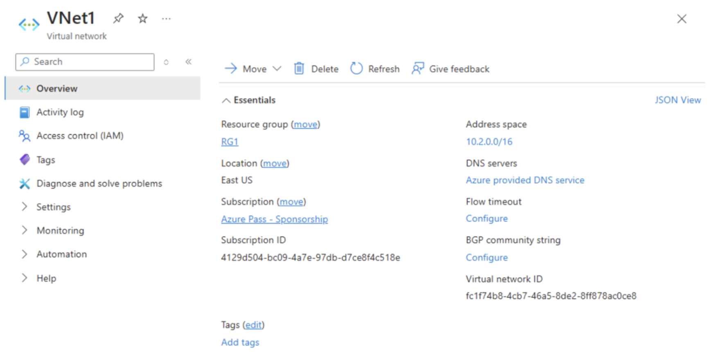
You plan to create a virtual network peering between VNet1 and another virtual network named VNet2. VNet2 also uses the address space 10.2.0.0/16.
You need to establish the peering between the two virtual networks.
What action should you perform first?
Réponses:
☐ Add a gateway subnet to VNet1.
☐ Create a subnet on VNet1 and VNet2.
☑ Modify the address space of VNet1.
☐ Configure a service endpoint on VNet2.
Explication
`Modify the address space of VNet1` is correct because the address spaces of two virtual networks being peered must not overlap. In this case, both VNet1 and VNet2 have the address space 10.2.0.0/16, which causes an overlap and prevents peering. To enable peering, you would first need to modify the address space of VNet1 to a non-overlapping range.
`Add a gateway subnet to VNet1` is incorrect because a gateway subnet is only required for VPN Gateway connections, not for simple VNet peering.
`Create a subnet on VNet1 and VNet2` is incorrect because the presence of subnets is not a requirement for VNet peering. The issue here is the overlapping address space, which must be resolved first.
`Configure a service endpoint on VNet2` is incorrect because service endpoints are used to secure access to Azure services and are not related to VNet peering configuration.
Reference(s):
- https://learn.microsoft.com/en-us/azure/virtual-network/virtual-network-manage-peering

Question 35
You have an Azure subscription named ProductionSub.
You are designing a multi-tier application with the following architecture:
- Web tier
- Internet-facing: Yes
- Number of virtual machines: 10
- Application/Business tier
- Internet-facing: No
- Number of virtual machines: 100
- Database tier (SQL Server)
- Internet-facing: No
- Number of virtual machines: 5
`You must recommend a networking solution that ensures traffic from the web tier to the application tier is evenly distributed across all virtual machines in the application tier.`
Which Azure resource should you recommend to meet this requirement?
Réponses:
☐ an application gateway that uses the Standard tier
☐ an application gateway that uses the WAF tier
☑ an internal load balancer
☐ a network security group (NSG)
☐ a public load balancer
Explication
`An internal load balancer` is correct because an internal load balancer in Azure is designed to distribute network traffic within a virtual network (VNet) across virtual machines (VMs) without exposing them to the internet. In this scenario, it can be used to balance the load between the front-end web servers and the business logic tier, ensuring that traffic spreads equally across the VMs in the business logic tier. Since the business logic tier is not accessible from the internet, an internal load balancer is the appropriate solution.
`An application gateway that uses the Standard tier `is incorrect because an application gateway is primarily designed for web traffic (HTTP/HTTPS) and is typically used in internet-facing scenarios or for application layer load balancing, which is not specified here.
`An application gateway that uses the WAF tier` is incorrect for the same reason as above. Additionally, the WAF tier is designed to protect applications from web vulnerabilities, which is unnecessary for internal load balancing between tiers in this setup.
`A network security group (NSG)` is incorrect because NSGs are used for filtering network traffic based on security rules and do not provide load balancing capabilities.
`A public load balancer` is incorrect because it is used to distribute traffic from the internet to VMs within a VNet. Since the business logic tier is not accessible from the internet, a public load balancer is not suitable.
Reference(s):
- https://learn.microsoft.com/en-us/azure/load-balancer/load-balancer-overview

Question 36
You have an Azure subscription named ProductionSub.
You are designing a multi-tier application with the following architecture:
- Web tier
- Internet-facing: Yes
- Number of virtual machines: 10
- Application/Business tier
- Internet-facing: No
- Number of virtual machines: 100
- Database tier (SQL Server)
- Internet-facing: No
- Number of virtual machines: 5
`You must recommend a networking solution that protects the web tier from SQL injection attacks originating from the internet.`
Which Azure resource should you recommend to meet this requirement?
Réponses:
☐ an application gateway that uses the Standard tier
☑ an application gateway that uses the WAF tier
☐ an internal load balancer
☐ a network security group (NSG)
☐ a public load balancer
Explication
`An application gateway that uses the WAF tier` is correct because the Web Application Firewall (WAF) tier of Azure Application Gateway provides built-in protection against common web vulnerabilities, including SQL injection attacks. By placing an application gateway with WAF in front of the web servers, you can protect them from SQL injection and other security threats.
`An application gateway that uses the Standard tier` is incorrect because the Standard tier does not include WAF functionality, which is required to protect against SQL injection.
`An internal load balancer` is incorrect because load balancers are used to distribute network traffic and do not offer protection against SQL injection or other web vulnerabilities.
`A network security group (NSG)` is incorrect because NSGs control access through rules but do not provide protection against specific types of attacks like SQL injection.
`A public load balancer` is incorrect because, like an internal load balancer, it only distributes traffic and does not protect against web vulnerabilities.
Reference(s):
- https://learn.microsoft.com/en-us/azure/web-application-firewall/ag/ag-overview

Question 37
You have a virtual network named VNet1 with an address space of 10.2.0.0/16 and a single subnet configured as 10.2.0.0/24.
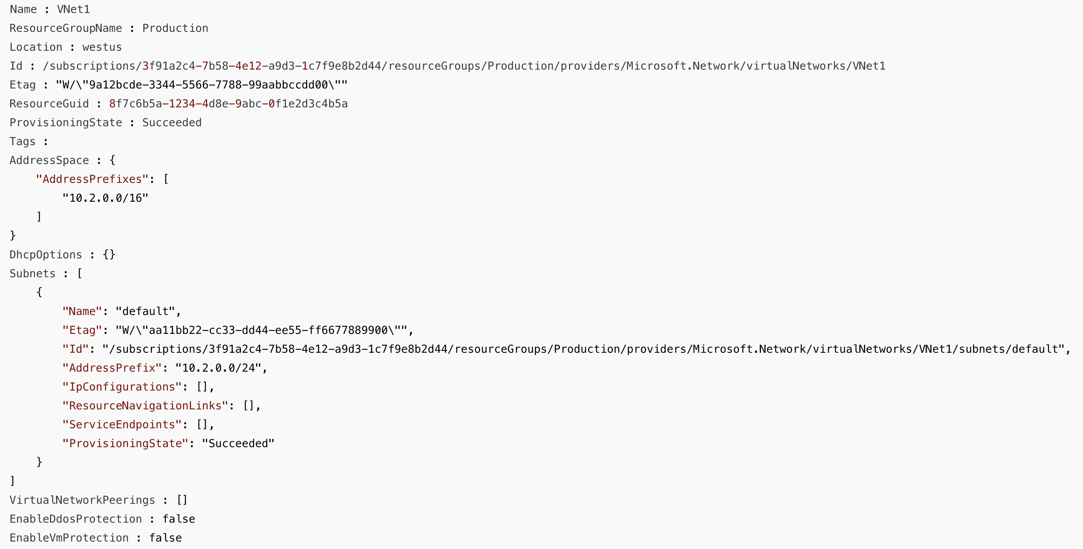
You plan to deploy a virtual machine in VNet1 and assign it an IP address from the 192.168.1.0/24 address range.
Before the virtual machine can receive an IP address from 192.168.1.0/24, what must you do first?
Réponses:
☐ add a network interface
☐ add a subnet
☑ add an address space
☐ delete a subnet
☐ delete an address space
Explication
`Add an address space` is correct because the existing address space of VNet1 is configured as 10.2.0.0/16. To allow virtual machines on VNet1 to receive an IP address from 192.168.1.0/24, you must first add this new address space to VNet1. Azure virtual networks support multiple address spaces, but they must be added explicitly.
`Add a network interface` is incorrect because a network interface allows a VM to connect to a subnet but does not affect the IP range available within the virtual network.
`Add a subnet `is incorrect because adding a new subnet would require an available address space in the 192.168.1.0/24 range, which is not currently defined within VNet1.
`Delete a subnet` is incorrect because deleting a subnet will not allow adding the desired IP range.
`Delete an address space` is incorrect because the action required is to add a new address space, not remove an existing one.
Reference(s):
- https://learn.microsoft.com/en-us/azure/virtual-network/ip-services/virtual-networks-static-private-ip-arm-pportal

Question 38
You have a virtual network named VNet1 with an address space of 10.2.0.0/16 and a single subnet configured as 10.2.0.0/24.
Based on the current address space and subnet configuration, a virtual machine deployed in VNet1 must be assigned an IP address from the 10.2.1.0/24 range.
What must you do before the virtual machine can receive an IP address from this range?
Réponses:
☐ add a network interface
☑ add a subnet
☐ add an address space
☐ delete a subnet
☐ delete an address space
Explication
`Add a subnet` is correct because the current address space for VNet1 is 10.2.0.0/16, which already includes the 10.2.1.0/24 range. However, there is only one existing subnet (default) configured with the 10.2.0.0/24 address prefix. To assign IP addresses from 10.2.1.0/24, you would need to create a new subnet using this address range within the existing address space.
`Add a network interface` is incorrect because a network interface allows a VM to connect to a subnet but does not create a new address range or subnet.
`Add an address space` is incorrect because 10.2.1.0/24 is already part of the existing 10.2.0.0/16 address space, so adding a new address space is unnecessary.
`Delete a subnet` is incorrect because removing an existing subnet does not help in assigning a new IP range.
`Delete an address space` is incorrect because deleting an address space would reduce the IP range available, which is not required here.
Reference(s):
- https://docs.microsoft.com/en-us/microsoft-365/solutions/cloud-architecture-models?view=o365-worldwide
- https://docs.microsoft.com/en-us/azure/virtual-network/virtual-networks-static-private-ip-arm-pportal

Question 39
An Azure subscription is associated with a Microsoft Entra tenant named contoso.com. The tenant is synchronized with an on-premises Active Directory domain.
The domain includes the following users and assigned roles:
- SecAdmin1 – Role: Security Administrator
- BillAdmin1 – Role: Billing Administrator
- User1 – Role: Reports Reader
Self-service password reset (SSPR) is enabled for all users and configured with the following settings:
- Two authentication methods are required to reset a password.
- Available authentication methods are Mobile phone and Security questions.
- Users must register three security questions.
- Users must correctly answer three security questions during password reset.
The following security questions are configured:
- What is your favorite food?
- In what city was your first job?
- What was the name of your first pet?
True or False:
`“During a self-service password reset, SecAdmin1 must answer the security question ‘In what city was your first job?’”`
Réponses:
☐ True
☑ False
Explication
`False` is correct because, although self-service password reset (SSPR) is enabled for all users, the regular SSPR policy does not apply to users in administrative roles, such as Security Administrator. Administrators must go through a two-gate policy to reset their password, which differs from the standard SSPR process configured for non-admin users. Since SecAdmin1 is in an administrative role, they are excluded from using security questions and instead must follow the enhanced SSPR process that applies to Microsoft Entra ID administrators. Additionally, SSPR is enabled by default for admin roles.
Reference(s):
- https://learn.microsoft.com/en-us/entra/identity/authentication/concept-sspr-deploy
- https://learn.microsoft.com/en-us/entra/identity/authentication/concept-sspr-policy#administrator-password-policy-differences
- https://docs.microsoft.com/en-us/azure/active-directory/authentication/concept-sspr-policy#administrator-reset-policy-differences

Question 40
An Azure subscription is associated with a Microsoft Entra tenant named contoso.com. The tenant is synchronized with an on-premises Active Directory domain.
The domain includes the following users and assigned roles:
- SecAdmin1 – Role: Security Administrator
- BillAdmin1 – Role: Billing Administrator
- User1 – Role: Reports Reader
Self-service password reset (SSPR) is enabled for all users and configured with the following settings:
- Two authentication methods are required to reset a password.
- Available authentication methods are Mobile phone and Security questions.
- Users must register three security questions.
- Users must correctly answer three security questions during password reset.
The following security questions are configured:
- What is your favorite food?
- In what city was your first job?
- What was the name of your first pet?
True or False:
`“During a self-service password reset, BillAdmin1 must answer the security question ‘What is your favorite food?’”`
Réponses:
☐ True
☑ False
Explication
`False` is correct because BillAdmin1 has been assigned the Billing Administrator role, which falls under the category of administrative roles in Microsoft Entra. By default, Azure applies a two-gate password reset policy for all administrator accounts. This two-gate policy requires two pieces of authentication data, such as an email address, authenticator app, or phone number, and does not permit the use of security questions for administrators. Therefore, BillAdmin1 would not be prompted to answer a security question, such as "What is your favorite food?" during the password reset process.
Reference(s):
- https://learn.microsoft.com/en-us/entra/identity/authentication/concept-sspr-deploy
- https://learn.microsoft.com/en-us/entra/identity/authentication/concept-sspr-policy#administrator-password-policy-differences
- https://docs.microsoft.com/en-us/azure/active-directory/authentication/concept-sspr-policy#administrator-reset-policy-differences

Question 41
An Azure subscription is associated with a Microsoft Entra tenant named contoso.com. The tenant is synchronized with an on-premises Active Directory domain.
The domain includes the following users and assigned roles:
- SecAdmin1 – Role: Security Administrator
- BillAdmin1 – Role: Billing Administrator
- User1 – Role: Reports Reader
Self-service password reset (SSPR) is enabled for all users and configured with the following settings:
- Two authentication methods are required to reset a password.
- Available authentication methods are Mobile phone and Security questions.
- Users must register three security questions.
- Users must correctly answer three security questions during password reset.
The following security questions are configured:
- What is your favorite food?
- In what city was your first job?
- What was the name of your first pet?
True or False:
`“During a self-service password reset, User1 must answer the security question ‘What was the name of your first pet?’”`
Réponses:
☑ True
☐ False
Explication
`True` is correct because User1 has the Reports Reader role, which is not an administrative role in Microsoft Entra. As a standard user, User1 will follow the regular self-service password reset (SSPR) policy that applies to non-admin users. Since security questions are enabled as an authentication method for SSPR, User1 can be prompted to answer questions like "What was the name of your first pet?" as part of the password reset process.
Reference(s):
- https://learn.microsoft.com/en-us/entra/identity/authentication/concept-sspr-deploy
- https://learn.microsoft.com/en-us/entra/identity/authentication/concept-sspr-policy#administrator-password-policy-differences
- https://docs.microsoft.com/en-us/azure/active-directory/authentication/concept-sspr-policy#administrator-reset-policy-differences

Question 42
You have an Azure subscription that contains the following resources:
- VM1 – Virtual machine
- storage1 – Storage account
- Workspace1 – Log Analytics workspace
- DB1 – Azure SQL database
You plan to create a data collection rule named DCR1 in Azure Monitor.
Which of the listed resources can you configure as data sources in DCR1?
Réponses:
☑ VM1 only
☐ VM1 and storage1 only
☐ VM1, storage1, and DB1 only
☐ VM1, storage1, Workspace1, and DB1
Explication
`VM1 only` is the correct answer because Azure Monitor data collection rules (DCRs) can only collect data from specific resources, primarily virtual machines, as data sources. In this case, VM1 is a virtual machine and is eligible to be set as a data source in DCR1.
`VM1 and storage1 only` is incorrect because storage accounts, like storage1, cannot be used directly as data sources for data collection rules in Azure Monitor.
`VM1, storage1, and DB1 only` is incorrect because DB1 (an Azure SQL database) and storage1 are not supported as data sources for data collection rules in Azure Monitor.
`VM1, storage1, Workspace1, and DB1` is incorrect because Workspace1 (a Log Analytics workspace), storage1, and DB1 cannot be used as data sources in a data collection rule. Only VM1 is valid.
Reference(s):
- https://learn.microsoft.com/en-us/azure/azure-monitor/essentials/data-collection-rule-overview
- https://learn.microsoft.com/en-us/azure/azure-monitor/agents/data-sources-windows-events

Question 43
You have an Azure subscription that contains the following resources:
- VM1 – Virtual machine
- storage1 – Storage account
- Workspace1 – Log Analytics workspace
- DB1 – Azure SQL database
You plan to create a data collection rule named DCR1 in Azure Monitor.
Which of the listed resources can you set as destinations in DCR1?
Réponses:
☐ storage1 only
☑ Workspace1 only
☐ Workspace1 and storage1 only
☐ Workspace1, storage1, and DB1 only
Explication
`Workspace1 only` is the correct answer. In Azure Monitor, a Data Collection Rule (DCR) defines how data is collected from sources and where it is sent. The valid destinations for a DCR are Log Analytics workspaces, which store monitoring data for query and analysis, and are the standard supported target for the Azure Monitor Agent. Other destinations such as Azure Storage accounts or Event Hubs can be used with diagnostic settings, but they are not supported destinations when configuring a DCR directly. Similarly, Azure SQL databases are not valid targets for monitoring data.
In the given scenario, this means that only Workspace1 can be set as a destination in DCR1. Storage1 and DB1 are not valid choices for a DCR destination, as the DCR framework is designed to work with Log Analytics workspaces for centralized monitoring and analytics.
Reference(s):
- https://learn.microsoft.com/en-us/azure/azure-monitor/essentials/data-collection-rule-structure#valid-destinations

Question 44
You have an Azure Linux virtual machine that is protected by Azure Backup.
Two files were deleted from the virtual machine one week ago.
You need to restore the deleted files to an on-premises computer in the shortest possible time.
Which four actions should you perform in sequence?
ACTIONS
- From the Azure portal, click Restore VM from the vault.
- Mount a VHD.
- From the Azure portal, click File Recovery from the vault.
- Copy the files by using AZCopy.
- Select a restore point that contains the deleted files.
- Copy the files by using File Explorer.
- Download and run the script to mount a drive on the local computer.
Réponses:
☐ 2-3-5-7
☐ 1-5-2-6
☑ 3-5-7-6
☐ 6-4-7-2
☐ 4-5-1-3
☐ 2-4-7-3
Explication
3-5-7-6 is the correct sequence of actions.
(Action 3) From the Azure portal, click File Recovery from the vault – To begin the file recovery process, navigate to the File Recovery option in the vault associated with the backup.
(Action 5) Select a restore point that contains the deleted files – Choose a restore point from a date prior to the deletion of the files to ensure they are available in the backup.
(Action 7) Download and run the script to mount a drive on the local computer – This step mounts the backup as a drive on the local computer, allowing access to the files in the backup.
(Action 6) Copy the files by using File Explorer – Using File Explorer provides a straightforward way to restore the files to an on-premises Windows Server computer quickly.
(Action 2) Mount a VHD is not applicable in this context, as the File Recovery option does not involve VHDs directly for individual file restoration.
(Action 4) Copy the files by using AZCopy is unnecessary as File Explorer is sufficient once the drive is mounted. Also, File explorer will be faster than AzCopy.
(Action 3) From the Azure portal, click Restore VM from the vault would initiate a full VM restore, which is not required for individual file recovery.
Reference(s):
- https://docs.microsoft.com/en-us/azure/backup/backup-azure-restore-files-from-vm
- https://docs.microsoft.com/en-us/azure/storage/common/storage-use-azcopy

Question 45
You configure a Recovery Services vault backup policy named Policy1 with the following settings:
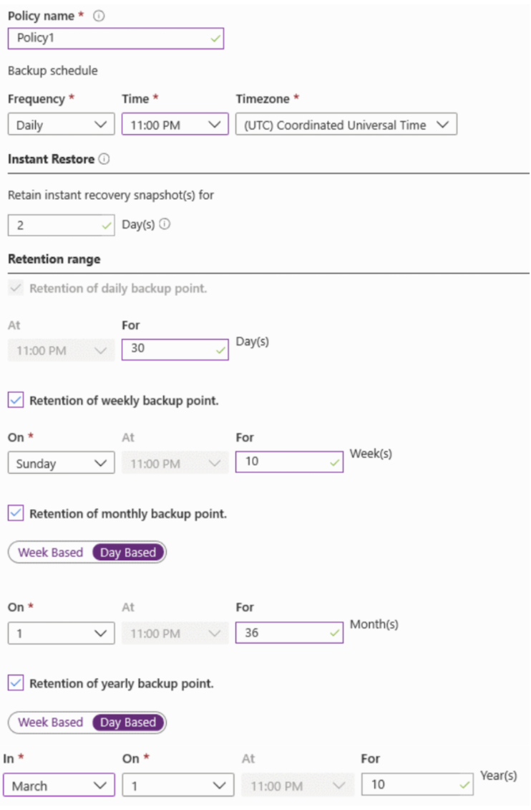
Based on the information provided, select the answer choice that completes the following statement correctly.
“The backup that occurs on Sunday, March 1, will be retained for ___________.”
Réponses:
☐ 30 days
☐ 10 weeks
☐ 36 months
☑ 10 years
Explication
`10 years` is the correct answer because the backup policy specifies retention of yearly backup points. Since the backup occurring on Sunday, March 1, aligns with the yearly retention schedule (March 1), it will be retained for the maximum period defined under the yearly backup retention, which is 10 years.
`30 days` is incorrect because this retention applies only to daily backup points, not yearly backups.
`10 weeks` is incorrect because this retention applies to weekly backup points, not yearly backups.
`36 months` is incorrect because this retention applies to monthly backup points, not yearly backups.
Reference(s):
- https://learn.microsoft.com/en-us/azure/backup/backup-azure-vms-introduction
- https://learn.microsoft.com/en-us/azure/backup/backup-azure-recovery-services-vault-overview

Question 46
You configure a Recovery Services vault backup policy named Policy1 with the following settings:
Based on the information provided, select the answer choice that completes the following statement correctly.
“The backup that occurs on Sunday, November 1, will be retained for _____________.”
Réponses:
☐ 30 days
☐ 10 weeks
☑ 36 months
☐ 10 years
Explication
`36 months` is the correct answer because the backup that occurs on Sunday, November 1, aligns with both the weekly and monthly retention schedules. Given that the monthly backup point retention is set to 36 months and the weekly retention is 10 weeks, Azure’s retention policy dictates that the backup will be retained for the longest period in case of overlap. Therefore, this backup will be retained for 36 months.
`10 weeks` is incorrect because, although the backup aligns with the weekly retention schedule, the 36-month retention period for the monthly backup point takes precedence due to Azure’s policy of selecting the longest retention period.
`10 years` is incorrect because yearly retention is not applicable for this backup, as it is not taken on March 1.
`30 days` is incorrect because this applies only to daily backup points, which are irrelevant for this specific backup.
Reference(s):
- https://learn.microsoft.com/en-us/purview/retention?view=o365-worldwide&tabs=table-overriden
- https://learn.microsoft.com/en-us/azure/backup/backup-azure-recovery-services-vault-overview

Question 47
You purchase a new Azure subscription named Subscription1.
Within Subscription1, you deploy a virtual machine named VM1. VM1 is currently not protected by Azure Backup.
You need to configure Azure Backup for VM1. The backups must run daily at 01:00 and be retained for a period of 30 days.
Where should the backups be stored?
Réponses:
☐ A blob container
☐ A file share
☑ A Recovery Services vault
☐ A storage account
Explication
`A Recovery Services vault` is the correct answer because Azure Backup requires a Recovery Services vault to store backup data for virtual machines. The Recovery Services vault provides backup management and retention policies, allowing backups of VM1 to be created at the specified time (01:00) and retained for 30 days.
`A blob container` is incorrect because blob containers in Azure Storage accounts are not directly used for Azure VM backups. Azure Backup does not store VM backups in blob containers.
`A file share` is incorrect because Azure file shares are meant for file-level storage and sharing, not for storing VM backups using Azure Backup.
`A storage account` is incorrect because, although storage accounts are part of the Azure storage infrastructure, VM backups using Azure Backup require a Recovery Services vault rather than a generic storage account.
Reference(s):
- https://learn.microsoft.com/en-us/azure/backup/backup-overview
- https://learn.microsoft.com/en-us/azure/backup/backup-azure-vms-first-look-arm

Question 48
You purchase a new Azure subscription named Subscription1.
Within Subscription1, you deploy a virtual machine named VM1. VM1 is currently not protected by Azure Backup.
You need to configure Azure Backup for VM1. The backups must run daily at 01:00 and be retained for a period of 30 days.
Which object should you use to configure backup protection for VM1?
Réponses:
☑ A backup policy
☐ A batch job
☐ A batch schedule
☐ A recovery plan
Explication
`A backup policy` is the correct answer because Azure Backup uses backup policies to define the schedule and retention settings for protecting resources, such as virtual machines. To configure the protection for VM1, you would create a backup policy that specifies the backup time (01:00) and the retention period (30 days).
`A batch job` is incorrect because batch jobs are typically used in Azure Batch to execute large-scale parallel and high-performance computing tasks, not for configuring backups.
`A batch schedule` is incorrect because it is not related to Azure Backup. Batch schedules are relevant in the context of Azure Batch, not for VM backup configuration.
`A recovery plan` is incorrect because recovery plans are used in Azure Site Recovery for orchestrating failover and recovery of applications, not for scheduling and managing backups.
Reference(s):
- https://learn.microsoft.com/en-us/azure/backup/backup-azure-vms-introduction
- https://learn.microsoft.com/en-us/azure/backup/backup-azure-vms-first-look-arm

Question 49
You manage an Azure subscription that contains several virtual machines connected to a virtual network named CorpVNet.
You plan to enable Azure Monitor and use VM Insights to monitor the virtual machines.
You must ensure that all communication between the virtual machines and Azure Monitor occurs only through CorpVNet, without using the public internet.
What should you create first to meet this requirement?
Réponses:
☐ a private endpoint
☑ an Azure Monitor Private Link Scope (AMPLS)
☐ a data collection rule (DCR)
☐ a Log Analytics workspace
Explication
`an Azure Monitor Private Link Scope (AMPLS)` is the correct answer because to ensure that virtual machines only communicate with Azure Monitor through the specified virtual network (CorpVNet), you need to set up a private link connection. An Azure Monitor Private Link Scope (AMPLS) allows you to create a private endpoint that enables secure communication between your virtual machines and Azure Monitor over the virtual network.
`a private endpoint` is incorrect because, while it is part of the setup, it must be associated with an AMPLS to connect the virtual machines to Azure Monitor privately. AMPLS is the primary requirement for establishing private connectivity.
`a data collection rule (DCR)` is incorrect because DCRs are used to define which data to collect from resources for Azure Monitor but do not control network connectivity or enable private communication with Azure Monitor.
`a Log Analytics workspace` is incorrect because, while required for Azure Monitor for VM Insights, it does not enable private connectivity with Azure Monitor. The AMPLS is necessary to restrict communication through CorpVNet.
Reference(s):
- https://learn.microsoft.com/en-us/azure/azure-monitor/logs/private-link-security#advantages

Question 50
You have an Azure subscription and plan to deploy a virtual machine by using an Azure Resource Manager (ARM) template.
The virtual machine must be created with multiple data disks.
You need to complete the template shown in the below.
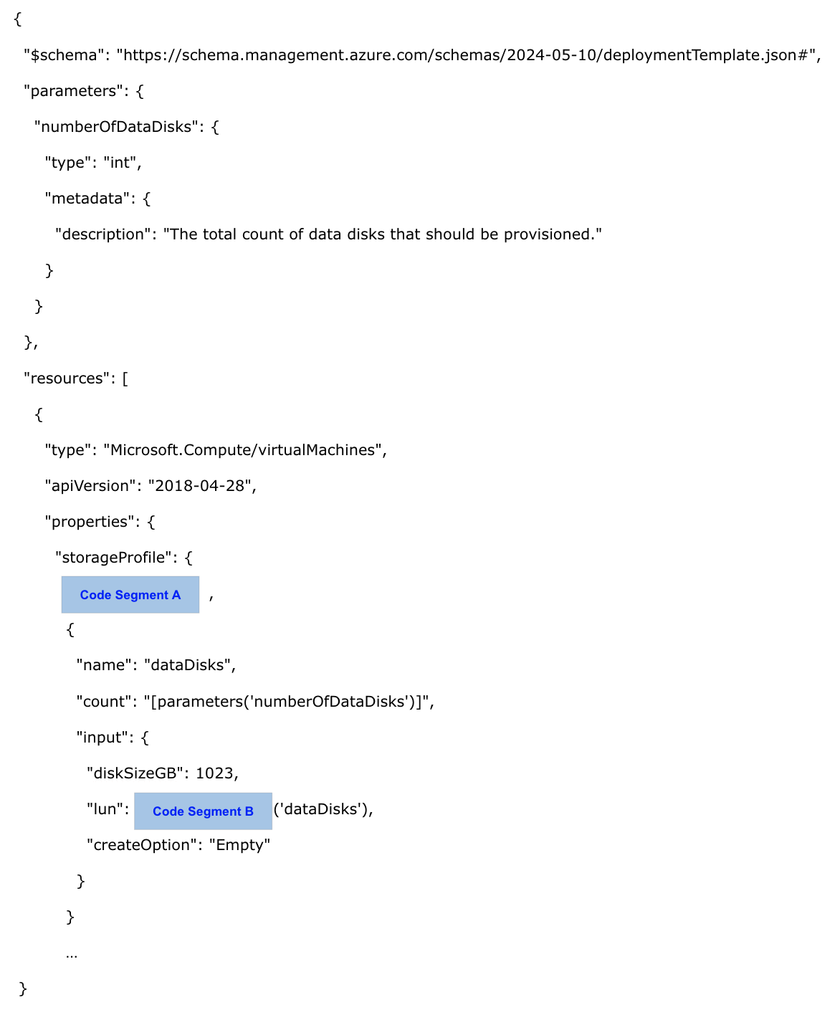
What should you choose for Code Segment A?
Réponses:
☑ "copy":[
☐ "copyIndex":[
☐ "dependsOn":[
Explication
`"copy":[` is correct because the "copy" property is used in ARM templates to define an array of resources or properties that need to be created multiple times. In this case, the data disks need to be created dynamically based on the value of the numberOfDataDisks parameter. Using "copy":[ allows iterating over the required number of disks and defining their properties in the ARM template.
`"copyIndex":[` is incorrect because "copyIndex" is a function used within the "copy" property to get the current iteration index. It cannot replace the "copy" property itself.
`"dependsOn":[` is incorrect because "dependsOn" is used to specify dependencies between resources in an ARM template to ensure that certain resources are created before others. It does not help in defining multiple instances of a resource or property.
Reference(s):
- https://learn.microsoft.com/en-us/azure/azure-resource-manager/templates/copy-resources

Question 51
You have an Azure subscription and plan to deploy a virtual machine by using an Azure Resource Manager (ARM) template.
The virtual machine must be created with multiple data disks.
You need to complete the template shown in the below.
What should you choose for Code Segment B?
Réponses:
☐ "[copy
☑ "[copyIndex
☐ "[dependsOn
Explication
`"[copyIndex"` is correct because the copyIndex() function is used to generate a unique index for each iteration of the copy property in an ARM template. This is particularly useful when you need to create multiple instances of a resource or property, as in this case, where each data disk is assigned a unique Logical Unit Number (LUN). By using "[copyIndex]", the LUN property dynamically assigns a unique index to each data disk being created.
`"[copy"` is incorrect because "copy" is a property used to define the array creation logic in an ARM template. It cannot be used directly as a value in this context.
`"[dependsOn"` is incorrect because "dependsOn" is used to specify dependencies between resources in an ARM template. It does not apply to the dynamic generation of unique indices for resources.
Reference(s):
- https://learn.microsoft.com/en-us/azure/azure-resource-manager/templates/copy-resources

Question 52
You have an Azure subscription that contains the following resources:
- A virtual machine named VM1, located in East US
- A storage account named storage1, located in West US
You must ensure that all data transfers between VM1 and storage1 occur entirely over the Azure private network and do not traverse the public internet.
What should you configure for storage1 to meet this requirement?
Réponses:
☐ a shared access signature (SAS)
☐ data protection
☑ a private endpoint
☐ Public network access in the Firewalls and virtual networks settings
Explication
`a private endpoint` is correct because configuring a private endpoint for storage1 ensures that data transfers between VM1 and storage1 occur entirely within the Azure virtual network. A private endpoint maps the storage account to a private IP address in the virtual network, preventing traffic from traversing the internet and providing a secure connection.
`a shared access signature (SAS)` is incorrect because an SAS provides granular access to resources in a storage account but does not ensure that the data transfer stays within the Azure virtual network.
`data protection` is incorrect because it relates to enabling recovery options and configuring soft delete features for protecting data but does not control the network path used for data transfer.
`Public network access in the Firewalls and virtual networks settings` is incorrect because disabling public network access would block all internet-based traffic but does not ensure that traffic is routed privately within Azure.
Reference(s):
- https://learn.microsoft.com/en-us/azure/private-link/private-endpoint-overview
- https://learn.microsoft.com/en-us/azure/storage/common/storage-private-endpoints

Question 53
You are configuring Microsoft Entra ID–based authentication for an Azure Storage account named storage1.
You must ensure that users who are members of a security group named Group1 can upload files to the storage account by using the Azure portal.
The access configuration must follow the principle of least privilege, granting only the minimum permissions required to perform the upload operation.
Which two roles should you assign to Group1 to meet these requirements?
Réponses (plusieurs réponses possibles)
☑ Reader
☐ Storage Blob Data Reader
☑ Storage Blob Data Contributor
☐ Storage Account Contributor
☐ Contributor
Explication
`Reader` is correct because it grants management-plane read access to the storage account. Although this role does not allow users to upload files, it enables them to discover and navigate the storage account and its containers in the Azure portal. When using Microsoft Entra ID based authentication through the Azure portal, this role is required so users can access the storage account interface without being granted administrative permissions.
`Storage Blob Data Contributor` is correct because it grants the data-plane permissions required to read, write, modify, and delete blob data. This is the role that actually allows members of Group1 to upload files to blob storage.
`Storage Blob Data Reader` is incorrect because it only grants read access to blob data. Users can view blobs but cannot upload, modify, or delete them.
`Storage Account Contributor` is incorrect because it grants management permissions over the storage account, such as configuring storage account settings. These administrative permissions are unnecessary for uploading files and violate the principle of least privilege.
`Contributor` is incorrect because it provides broad management access to Azure resources, including the storage account. This exceeds the permissions required for uploading files and does not follow the principle of least privilege.
Reference(s):
- https://learn.microsoft.com/en-us/azure/role-based-access-control/built-in-roles#storage-blob-data-contributor
- https://learn.microsoft.com/en-us/azure/role-based-access-control/built-in-roles#reader

Question 54
You manage an Azure Storage account named datastore01.
The account includes a blob container named archivecontainer.
You must ensure that any new blobs uploaded to archivecontainer cannot be altered or deleted for a period of one year after they are created.
Which configuration should you apply to meet this requirement?
Réponses:
☐ The Access control (IAM) settings
☑ An access policy
☐ The access level
☐ The access tier
Explication
`An access policy` is the correct answer because immutable storage in Azure Blob Storage is configured using immutability policies (such as time-based retention or legal hold), which are set at the container level. Although technically this is not the same as a "stored access policy" used with SAS tokens, the term "access policy" here refers to the immutability policy configuration under the container’s "Access policy" settings in the Azure portal. By configuring a time-based retention policy under these settings, you can ensure that any new blobs added to the container cannot be modified or deleted for one year, thereby satisfying the requirement for data immutability.
`The Access control (IAM) settings` is incorrect because IAM controls role-based access to storage resources, defining who can read, write, or manage resources, but it does not enforce data immutability or retention policies.
`The access level` is incorrect because it defines whether the container and blobs can be publicly accessed (e.g., private, blob, or container level), but it has no impact on the ability to modify or retain content.
`The access tier` is incorrect because it specifies the performance and cost model of the blob data (Hot, Cool, Cold, or Archive). It does not prevent modifications or define retention behavior.
Reference(s):
- https://learn.microsoft.com/en-us/azure/storage/blobs/immutable-storage-overview
- https://docs.microsoft.com/en-us/azure/storage/blobs/immutable-time-based-retention-policy-overview

Question 55
You have an Azure subscription named ProdSub1 that contains the following resources:
- RegGrp1 – A resource group
- Action1 – An action group configured to send an email notification to admin1@apexcore.com
The subscription includes an alert rule with the following configuration:
- Name: Alert1
- Scope: All resource groups in ProdSub1, including any resource groups created in the future
- Condition: All administrative operations
- Action: Action1
The subscription also includes an alert processing rule with the following settings:
- Name: Rule1
- Scope: ProdSub1
- Rule type: Suppress notifications
- Schedule:
- Start: September 10, 2024
- End: September 13, 2024
True or False:
`"If you create a resource group in ProdSub1 on September 11, 2024, Alert1 is listed in the Azure portal."`
Réponses:
☑ True
☐ False
Explication
`True` is correct because Alert1 has a scope that includes all resource groups in ProdSub1. It also includes all future resources. This means that any resource group created in ProdSub1, regardless of when it's created, will fall under the scope of Alert1. So, if a new resource group is created in ProdSub1 on September 11, 2024, Alert1 would be listed in the Azure portal for that resource group.
Reference(s):
- https://docs.microsoft.com/en-us/azure/azure-monitor/alerts/alerts-overview
- https://docs.microsoft.com/en-us/azure/azure-monitor/alerts/alerts-create
- https://docs.microsoft.com/en-us/azure/azure-monitor/platform/action-groups
- https://docs.microsoft.com/en-us/azure/azure-monitor/platform/alerts-action-rules

Question 56
You have an Azure subscription named ProdSub1 that contains the following resources:
- RegGrp1 – A resource group
- Action1 – An action group configured to send an email notification to admin1@apexcore.com
The subscription includes an alert rule with the following configuration:
- Name: Alert1
- Scope: All resource groups in ProdSub1, including any resource groups created in the future
- Condition: All administrative operations
- Action: Action1
The subscription also includes an alert processing rule with the following settings:
- Name: Rule1
- Scope: ProdSub1
- Rule type: Suppress notifications
- Schedule:
- Start: September 10, 2024
- End: September 13, 2024
True or False:
`"If you create a resource group in ProdSub1 on September 12, 2024, an email message is sent to admin1@apexcore.com."`
Réponses:
☐ True
☑ False
Explication
`False` is correct because, although Alert1 is configured to send an email to admin1@apexcore.com for all administrative operations, there is an alert processing rule (Rule1) in place that suppresses notifications between September 10, 2024 and September 13, 2024. Therefore, despite a new resource group being created in ProdSub1 on September 12, 2024, which is an administrative operation, the suppress rule will prevent the email notification from being sent to admin1@apexcore.com.
Reference(s):
- https://docs.microsoft.com/en-us/azure/azure-monitor/alerts/alerts-overview
- https://docs.microsoft.com/en-us/azure/azure-monitor/platform/action-groups
- https://docs.microsoft.com/en-us/azure/azure-monitor/platform/alerts-action-rules

Question 57
You have an Azure subscription named ProdSub1 that contains the following resources:
- RegGrp1 – A resource group
- Action1 – An action group configured to send an email notification to admin1@apexcore.com
The subscription includes an alert rule with the following configuration:
- Name: Alert1
- Scope: All resource groups in ProdSub1, including any resource groups created in the future
- Condition: All administrative operations
- Action: Action1
The subscription also includes an alert processing rule with the following settings:
- Name: Rule1
- Scope: ProdSub1
- Rule type: Suppress notifications
- Schedule:
- Start: September 10, 2024
- End: September 13, 2024
True or False:
`“If you add a tag to RG1 on September 15, 2022, an email message is sent to admin1@apexcore.com.”`
Réponses:
☑ True
☐ False
Explication
`True` is the correct answer because the alert rule, Alert1, is set to monitor all administrative operations, and adding a tag to a resource is considered an administrative operation in Azure. Since the alert applies to all resource groups in ProdSub1, including future resources, and the suppression rule (which suppresses notifications) only applies between September 10, 2024, and September 13, 2024, the action group linked to Alert1 will trigger an email to admin1@apexcore.com when the tag is added on September 15, 2024.
Reference(s):
- https://learn.microsoft.com/en-us/azure/azure-monitor/alerts/alerts-overview
- https://learn.microsoft.com/en-us/azure/azure-monitor/alerts/action-groups

Question 58
You have an Azure subscription that contains a virtual machine named VM1.
You need to configure backups for VM1. The solution must ensure that the backup data is stored across three availability zones within the primary Azure region.
Which three actions should you perform in sequence?
ACTIONS
- Configure a replication policy.
- Create a Recovery Services vault.
- Set the vault replication type to Zone-redundant storage (ZRS).
- Set the vault replication type to Locally-redundant storage (LRS).
- Create a backup policy for VM1 and enable backup for the virtual machine.
Réponses:
☐ 2-5-3
☑ 2-3-5
☐ 5-3-2
☐ 3-5-2
Explication
`(Action 2) Create a Recovery Services vault` is the first step because the Recovery Services vault is where backup data is stored, and it supports multiple types of replication, including zone-redundant storage (ZRS) which is necessary for availability across three zones.
`(Action 3) Set the vault replication type to Zone-redundant storage (ZRS)` is the second step. After creating the vault, you must configure it to use zone-redundant storage, ensuring that the backups are replicated across three availability zones for higher availability.
`(Action 5) Create a backup policy for VM1 and enable backup for the virtual machine` is the final step. After the vault is created and configured, you need to create a backup policy and link it to VM1 to manage backup schedules and retention.
`(Action 1) Configure a replication policy` is incorrect because the backup replication type (ZRS) is set as part of the vault configuration, not a separate policy.
`(Action 4) Set the vault replication type to Locally-redundant storage (LRS)` is incorrect because LRS only replicates within a single data center, not across multiple availability zones, and thus does not meet the requirement of storing backups across three zones.
Reference(s):
- https://learn.microsoft.com/en-us/azure/backup/backup-create-recovery-services-vault
- https://learn.microsoft.com/en-us/azure/backup/quick-backup-vm-portal

Question 59
You have a Microsoft Entra tenant named adatum.com.
The tenant contains the following security groups:
- Group1
- Type: Security
- Member of: None
- Group2
- Type: Security
- Member of: Group1
The tenant also contains the following users:
- User1
- Member of: Group1
- User2
- Member of: Group2
You assign a Microsoft Entra ID P2 license to Group1.
The license is configured so that the Microsoft Entra ID P2 service plan is enabled.
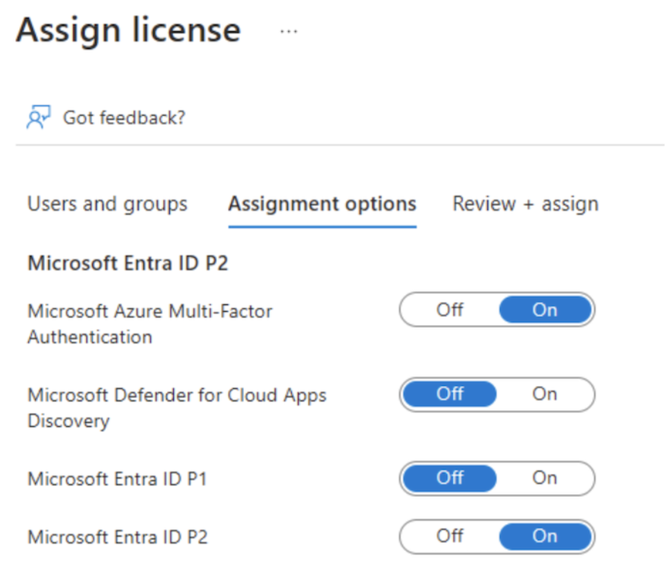
Group2 is not directly assigned any licenses.
True or False:
`“You can remove the Microsoft Entra ID P2 license from User1.”`
Réponses:
☐ True
☑ False
Explication
`False` is correct because User1 received the Microsoft Entra ID P2 license through group-based licensing via Group1. Licenses assigned through a group cannot be removed directly from an individual user. To revoke the license from User1, you must either remove User1 from Group1 or unassign the license from Group1 entirely.
Group-based licensing enforces inheritance, meaning individual license removal is not possible for users who inherit their license through a group assignment.
**Reference(s):
**https://learn.microsoft.com/en-us/entra/fundamentals/concept-group-based-licensing

Question 60
You have a Microsoft Entra tenant named adatum.com.
The tenant contains the following security groups:
- Group1
- Type: Security
- Member of: None
- Group2
- Type: Security
- Member of: Group1
The tenant also contains the following users:
- User1
- Member of: Group1
- User2
- Member of: Group2
You assign a Microsoft Entra ID P2 license to Group1.
The license is configured so that the Microsoft Entra ID P2 service plan is enabled.
Group2 is not directly assigned any licenses.
True or False:
`“User2 is assigned the Microsoft Entra ID P2 license.”`
Réponses:
☐ True
☑ False
Explication
`False` is the correct answer because Microsoft Entra group-based licensing does not support nested group inheritance. In this scenario, although Group1 has been assigned the Microsoft Entra ID P2 license, User2 is only a member of Group2, which is a child of Group1. Because nested groups are not supported for license propagation, User2 will not receive the license via Group1 unless Group2 is directly licensed or the license is directly assigned to User2.
**Reference(s):
**https://learn.microsoft.com/en-us/entra/fundamentals/concept-group-based-licensing
https://learn.microsoft.com/en-gb/entra/identity/users/licensing-group-advanced

Question 61
You have a Microsoft Entra tenant named adatum.com.
The tenant contains the following security groups:
- Group1
- Type: Security
- Member of: None
- Group2
- Type: Security
- Member of: Group1
The tenant also contains the following users:
- User1
- Member of: Group1
- User2
- Member of: Group2
You assign a Microsoft Entra ID P2 license to Group1.
The license is configured so that the Microsoft Entra ID P2 service plan is enabled.
Group2 is not directly assigned any licenses.
True or False:
`“You can assign User1 the Microsoft Defender for Cloud Apps Discovery license.”`
Réponses:
☐ True
☑ False
Explication
`False` is the correct answer because when a license is assigned to a group, the licensing options are inherited by all members of the group, and individual users cannot modify or enable specific license features that were disabled at the group level.
- User1 is a member of Group1, which has the Microsoft Entra ID P2 license assigned.
- If specific features within the license, such as Microsoft Defender for Cloud Apps Discovery, were disabled when assigning the license to Group1, they remain disabled for all members.
- License settings inherited from a group cannot be modified at the user level.
- Group-based licensing controls all assigned features.
- Microsoft Entra ID group-based licensing ensures that individual users cannot override settings configured at the group level.
- If an admin wants to enable a feature, the change must be made at the group level, not for individual users.
- User-level modifications are restricted.
- Since User1’s license is inherited from Group1, they cannot be manually assigned the Microsoft Defender for Cloud Apps Discovery license unless Group1’s settings are updated to enable it.
Reference(s):
https://docs.microsoft.com/en-us/azure/active-directory/fundamentals/active-directory-licensing-whatis-azure-portal
https://docs.microsoft.com/en-us/cloud-app-security/manage-admins

Question 62
You have an Azure subscription named Subscription1 that has the following vCPU quotas in the West US region:
- Standard BS Family vCPUs: 20 (0 currently used)
- Standard D Family vCPUs: 20 (0 currently used)
- Total Regional vCPUs: 20 (0 currently used)
The subscription currently contains the following virtual machines deployed in West US:
- VM1
- Size: Standard_B2ms
- vCPUs: 2
- Status: Running
- VM2
- Size: Standard_B16ms
- vCPUs: 16
- Status: Stopped (Deallocated)
You now plan to deploy the following additional virtual machines:
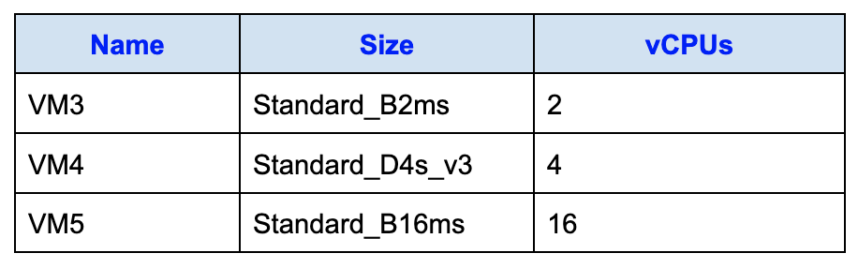
True or False:
`“You can deploy VM3 to West US.”`
Réponses:
☑ True
☐ False
Explication
`True` is correct. In this scenario, VM1 is running and uses 2 vCPUs. VM2 is in a Stopped (Deallocated) state, but it still counts against the vCPU quota because Azure reserves resources for any provisioned (even if deallocated) VM. This brings the current vCPU usage to:
- VM1: 2 vCPUs
- VM2: 16 vCPUs
- Total usage: 18 out of 20 vCPUs (under the Total Regional vCPU quota)
VM3 requires 2 vCPUs, which would increase total usage to exactly 20, matching the quota but not exceeding it. Therefore, the deployment is allowed.
Additionally, the Standard BS Family vCPU quota is 20. VM2 (Standard_B16ms) is a B-series VM, so it counts toward this quota too, alongside VM1. Current usage is therefore 18 vCPUs (VM1's 2 + VM2's 16). Adding VM3 (2 vCPUs from the same family) brings it to exactly 20, which is also allowed.
Reference(s):
https://learn.microsoft.com/en-us/azure/virtual-machines/quotas?tabs=cli
https://learn.microsoft.com/en-us/azure/azure-resource-manager/management/azure-subscription-service-limits

Question 63
You have an Azure subscription named Subscription1 that has the following vCPU quotas in the West US region:
- Standard BS Family vCPUs: 20 (0 currently used)
- Standard D Family vCPUs: 20 (0 currently used)
- Total Regional vCPUs: 20 (0 currently used)
The subscription currently contains the following virtual machines deployed in West US:
- VM1
- Size: Standard_B2ms
- vCPUs: 2
- Status: Running
- VM2
- Size: Standard_B16ms
- vCPUs: 16
- Status: Stopped (Deallocated)
You now plan to deploy the following additional virtual machines:
True or False:
`“You can deploy VM4 to West US.”`
Réponses:
☐ True
☑ False
Explication
`False` is correct as the Total Regional vCPUs quota in West US is capped at 20 vCPUs. This quota represents the maximum total vCPUs across all VM sizes, regardless of whether a virtual machine is running or stopped (deallocated).
In the current scenario:
- VM1 is consuming 2 vCPUs (Running).
- VM2 is Stopped (Deallocated) but still counts towards the total regional vCPU quota with 16 vCPUs reserved.
This results in:
2 vCPUs (VM1) + 16 vCPUs (VM2) = 18 vCPUs
This leaves only 2 vCPUs available under the regional quota.
VM4 requires 4 vCPUs, which would bring the total to:
2 vCPUs (VM1) + 16 vCPUs (VM2) + 4 vCPUs (VM4) = 22 vCPUs
This exceeds the total regional vCPU quota of 20 vCPUs, making the deployment of VM4 impossible under the current quota limits.
Reference(s):
https://learn.microsoft.com/en-us/azure/virtual-machines/quotas?tabs=cli
https://learn.microsoft.com/en-us/azure/azure-resource-manager/management/azure-subscription-service-limits

Question 64
You have an Azure subscription named Subscription1 that has the following vCPU quotas in the West US region:
- Standard BS Family vCPUs: 20 (0 currently used)
- Standard D Family vCPUs: 20 (0 currently used)
- Total Regional vCPUs: 20 (0 currently used)
The subscription currently contains the following virtual machines deployed in West US:
- VM1
- Size: Standard_B2ms
- vCPUs: 2
- Status: Running
- VM2
- Size: Standard_B16ms
- vCPUs: 16
- Status: Stopped (Deallocated)
You now plan to deploy the following additional virtual machines:
True or False:
`“You can deploy VM5 to West US.”`
Réponses:
☐ True
☑ False
Explication
`False` is correct because the Total Regional vCPU quota in the West US region is 20 vCPUs. This quota accounts for all allocated and deallocated virtual machines in the region.
The current vCPU usage is as follows:
- VM1: 2 vCPUs (Running)
- VM2: 16 vCPUs (Stopped/Deallocated)
Even though VM2 is deallocated, its 16 vCPUs still count toward the regional vCPU quota because Azure reserves these resources for the VM.
This means the total vCPU usage stands at:
2 vCPUs (VM1) + 16 vCPUs (VM2) = 18 vCPUs
VM5 requires 16 vCPUs. Adding these would result in:
2 vCPUs (VM1) + 16 vCPUs (VM2) + 16 vCPUs (VM5) = 34 vCPUs
This far exceeds the 20 vCPU quota for the West US region, making it impossible to deploy VM5 without increasing the quota or deallocating other virtual machines.
Reference(s):
https://learn.microsoft.com/en-us/azure/virtual-machines/quotas?tabs=cli
https://learn.microsoft.com/en-us/azure/azure-resource-manager/management/azure-subscription-service-limits

Question 65
You manage a Microsoft Entra tenant named ironclad.com.
The tenant contains the following groups:
- Group1
- Group type: Security
- Membership type: Dynamic user
- Rule: Users where city starts with “m”
- Group2
- Group type: Microsoft 365
- Membership type: Dynamic user
- Rule: Users whose department is not “human resources”
- Group3
- Group type: Microsoft 365
- Membership type: Assigned
- No dynamic rule configured
You then create two users with the following attributes:
- User1
- City: Montreal
- Department: Human resources
- Microsoft 365 license assigned: Yes
- User2
- City: Melbourne
- Department: Marketing
- Microsoft 365 license assigned: No
Based on the configured dynamic membership rules and user properties, which group or groups does User1 belong to?
Réponses:
☑ Group1 only
☐ Group2 only
☐ Group3 only
☐ Group1 and Group2 only
☐ Group1 and Group3 only
☐ Group1, Group2, and Group3
Explication
`Group1 only` is correct because User1 meets the dynamic membership rule for Group1 but does not meet the membership criteria for Group2 or Group3.
- Group1 (Dynamic user): The rule specifies that users whose city starts with "m" are added to this group.
- User1's city is Montreal, which starts with "M." Therefore, User1 is a member of Group1.
- Group2 (Dynamic user): The rule excludes users whose department is "human resources."
- User1's department is "Human resources," so User1 is excluded from Group2.
- Group3 (Assigned membership): Membership is manually assigned.
- User1 is not manually assigned to Group3, so User1 is not a member of Group3.
Therefore, User1 is only a member of Group1.
**Reference(s):
**https://learn.microsoft.com/en-us/entra/identity/users/groups-dynamic-membership
https://learn.microsoft.com/en-us/entra/identity/users/groups-create-rule

Question 66
You manage a Microsoft Entra tenant named ironclad.com.
The tenant contains the following groups:
- Group1
- Group type: Security
- Membership type: Dynamic user
- Rule: Users where city starts with “m”
- Group2
- Group type: Microsoft 365
- Membership type: Dynamic user
- Rule: Users whose department is not “human resources”
- Group3
- Group type: Microsoft 365
- Membership type: Assigned
- No dynamic rule configured
You then create two users with the following attributes:
- User1
- City: Montreal
- Department: Human resources
- Microsoft 365 license assigned: Yes
- User2
- City: Melbourne
- Department: Marketing
- Microsoft 365 license assigned: No
Based on the configured dynamic membership rules and user properties, which group or groups does `User2` belong to?
Réponses:
☐ Group1 only
☐ Group2 only
☐ Group3 only
☑ Group1 and Group2 only
☐ Group1 and Group3 only
☐ Group2 and Group3 only
Explication
`Group1 and Group2 only` is correct because User2 meets the membership rules for both Group1 and Group2 based on their city and department attributes.
- Group1 (Dynamic user): The membership rule specifies that users are added if their city starts with "m".
- User2's city is Melbourne, which starts with "M". Therefore, User2 satisfies the rule for Group1.
- Group2 (Dynamic user): The membership rule specifies that users whose department is not "human resources" are included.
- User2's department is Marketing, which satisfies the notIn ["human resources"] rule. Therefore, User2 is included in Group2.
- Group3 (Assigned membership): Membership is manually assigned.
- User2 has not been manually added to Group3, so they are not a member of Group3.
Additionally, the Microsoft 365 license does not impact group membership. Licenses are only for accessing services and do not affect dynamic or assigned group memberships.
Therefore, User2 is a member of Group1 and Group2 only.
Reference(s):
https://learn.microsoft.com/en-us/entra/identity/users/groups-dynamic-membership
https://learn.microsoft.com/en-us/entra/identity/users/groups-create-rule

Question 67
You have an Azure subscription that contains a virtual machine running Windows 10.
You need to join the virtual machine to an Active Directory domain by using the below Azure Resource Manager (ARM) template.
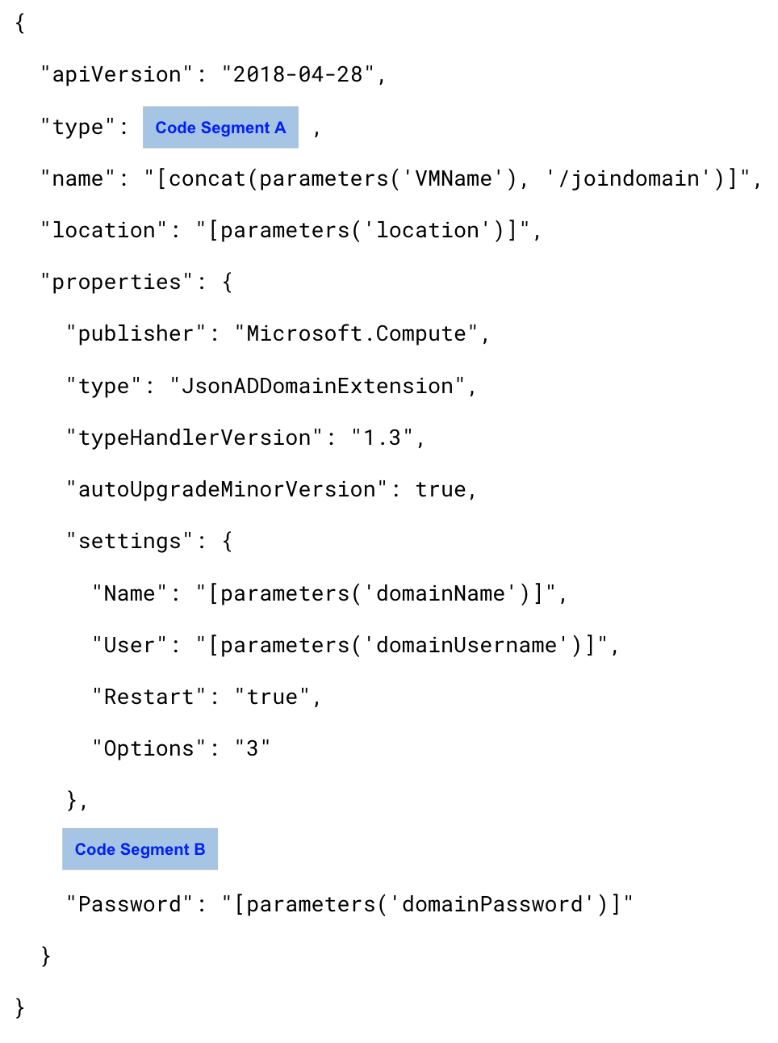
Which value should you choose for `Code Segment A`?
Réponses:
☐ "Extensions",
☐ "Microsoft.Compute/VirtualMachines",
☑ "Microsoft.Compute/virtualMachines/extensions",
Explication
`"Microsoft.Compute/virtualMachines/extensions"` is correct because. This namespace specifies that the resource being managed is an extension applied to an Azure virtual machine.
`"Extensions"` is incorrect because it is not a valid Azure Resource Manager resource type.
`"Microsoft.Compute/VirtualMachines"` is incorrect because it refers to virtual machines themselves, not their extensions.
Reference(s):
- https://learn.microsoft.com/en-us/azure/virtual-machines/extensions/overview
- https://learn.microsoft.com/en-us/azure/templates/microsoft.compute/virtualmachines/extensions
- https://learn.microsoft.com/en-us/azure/virtual-machines/extensions/dsc-template#domain-join

Question 68
You have an Azure subscription that contains a virtual machine running Windows 10.
You need to join the virtual machine to an Active Directory domain by using the below Azure Resource Manager (ARM) template.
Which value should you choose for `Code Segment B`?
Réponses:
☑ "ProtectedSettings": {
☐ "Settings": {
☐ "Statuses": {
Explication
`"ProtectedSettings": {` is correct because in an Azure Resource Manager (ARM) template, sensitive information like passwords or secrets, such as the domainPassword, should always be placed in the ProtectedSettings section. This ensures that the sensitive values are securely encrypted and not exposed in plaintext when viewed or logged.
`"Settings": {` is incorrect because it is used for general configuration settings and does not handle sensitive information securely.
`"Statuses": {` is incorrect because it is used to report the status of an extension deployment, not for passing configuration parameters.
Reference(s):
- https://learn.microsoft.com/en-us/azure/virtual-machines/extensions/domain-join
- https://learn.microsoft.com/en-us/azure/templates/microsoft.compute/virtualmachines/extensions
- https://learn.microsoft.com/en-us/azure/virtual-machines/extensions/dsc-template#domain-join

Question 69
You have an Azure subscription that hosts several resources accessed by users from two locations:
- Users working from home connect to Azure by using a point-to-site (P2S) VPN.
- Users at customer locations connect to Azure by using site-to-site (S2S) VPNs.
There is a line-of-business application named App1 that runs on multiple Azure virtual machines.
All the virtual machines run Windows Server 2016.
You must ensure that incoming connections to App1 are evenly distributed across all the virtual machines.
Which two Azure services can you use to meet this requirement?
Réponses (plusieurs réponses possibles)
☑ an internal load balancer
☐ a public load balancer
☐ an Azure Content Delivery Network (CDN)
☐ Traffic Manager
☑ an Azure Application Gateway
Explication
`an internal load balancer` is the correct answer because it distributes incoming traffic evenly across virtual machines within the same virtual network. Internal Load Balancers are used when applications are accessed only internally and do not require public internet exposure. This matches the scenario where users are connecting through VPNs, either point-to-site or site-to-site, and need internal routing of traffic to backend virtual machines hosting App1.
`an Azure Application Gateway` is also correct because it is a layer-7 (application layer) load balancer that can intelligently route traffic based on HTTP/HTTPS requests. It is suitable for web applications like App1, providing features such as URL-based routing, SSL termination, and session affinity, ensuring optimized and secure delivery of requests to the virtual machines hosting App1.
`a public load balancer` is incorrect because it distributes incoming traffic from public IP addresses. In this scenario, the application is accessed internally through VPN connections rather than from the public internet.
`an Azure Content Delivery Network (CDN)` is incorrect because CDN is designed to cache and deliver static content like images, videos, and scripts globally. It does not handle traffic distribution to backend virtual machines for business applications like App1.
`Traffic Manager` is incorrect because it operates at the DNS level and is used to direct users to different endpoints based on rules like geographic location or endpoint health. It does not distribute traffic across virtual machines within the same virtual network.
Reference(s):
- https://learn.microsoft.com/en-us/azure/load-balancer/load-balancer-overview
- https://learn.microsoft.com/en-us/azure/application-gateway/overview
- https://learn.microsoft.com/en-us/azure/cdn/cdn-overview
- https://learn.microsoft.com/en-us/azure/traffic-manager/traffic-manager-overview

Question 70
You have an Azure subscription that includes a user named User1.
You must grant User1 permissions to:
- Create and manage virtual machines
- Create and manage virtual networks
The permissions assigned must follow the principle of least privilege.
Which role-based access control (RBAC) role should you assign to User1?
Réponses:
☐ Owner
☐ Virtual Machine Contributor
☑ Contributor
☐ Virtual Machine Administrator Login
Explication
`Contributor` is the correct answer because this role grants full access to manage all Azure resources, including virtual machines and virtual networks, but does not allow access to assign roles in Azure RBAC. This aligns with the requirement to deploy virtual machines and manage virtual networks while following the principle of least privilege, as the role does not grant unnecessary permissions such as role assignment.
`Owner` is incorrect because the Owner role has full access to all resources, including the ability to assign roles in RBAC. This exceeds the principle of least privilege since User1 does not require role assignment capabilities.
`Virtual Machine Contributor` is incorrect because this role grants permissions only for managing virtual machines, but it does not include the ability to manage virtual networks, which is explicitly required in the scenario.
`Virtual Machine Administrator Login` is incorrect because this role only allows a user to log in to virtual machines with administrator privileges. It does not provide permissions to deploy virtual machines or manage virtual networks.
Reference(s):
- https://learn.microsoft.com/en-us/azure/role-based-access-control/built-in-roles
- https://learn.microsoft.com/en-us/azure/role-based-access-control/role-definitions
- https://learn.microsoft.com/en-us/azure/role-based-access-control/overview

Question 71
You have an Azure subscription that includes the following resources:
- VNET1: A virtual network in resource group RG1
- VM1: A virtual machine in resource group RG1
A Not allowed resource types Azure Policy is assigned to RG1 with enforcement enabled. The policy blocks the following resource types:
- Microsoft.Network/virtualNetworks
- Microsoft.Compute/virtualMachines
You need to deploy a new virtual machine named VM2 in RG1 and connect it to VNET1.
What action must you take first?
Réponses:
☑ Remove Microsoft.Compute/virtualMachines from the policy.
☐ Add a subnet to VNET1.
☐ Remove Microsoft.Network/virtualNetworks from the policy.
☐ Create an Azure Resource Manager template.
Explication
`Remove Microsoft.Compute/virtualMachines from the policy` is the correct answer. The Not allowed resource types policy assigned to RG1 explicitly prevents the creation of resources with type `Microsoft.Compute/virtualMachines`, which includes any virtual machines. Since the goal is to create a new VM named VM2 in RG1, this policy must first be adjusted to allow VM creation. Otherwise, any deployment attempt for a VM (whether through portal, script, or ARM template) will be blocked due to the policy enforcement.
`Add a subnet to VNET1` is incorrect because the presence or absence of a subnet does not address the core issue. Even if VNET1 had a valid subnet, the policy blocks VM creation entirely in RG1, making this step irrelevant at this point.
`Remove Microsoft.Network/virtualNetworks from the policy` is incorrect because there is no requirement to create a new virtual network—VNET1 already exists and is intended to be used. The VM can be connected to an existing VNet as long as the policy allows VM creation. Removing this restriction isn't necessary to create the VM.
`Create an Azure Resource Manager template` is incorrect because using an ARM template will still fail if the policy prohibits creating the specified resource types. Azure Policy enforcement blocks resource creation regardless of the method used—portal, CLI, PowerShell, or ARM templates.
Reference(s):
- https://learn.microsoft.com/en-us/azure/templates/microsoft.compute/virtualmachines?pivots=deployment-language-bicep
- https://learn.microsoft.com/en-us/azure/governance/policy/concepts/definition-structure#policy-rule
- https://learn.microsoft.com/en-us/azure/governance/policy/concepts/effects#deny
- https://learn.microsoft.com/en-us/azure/governance/policy/samples/not-allowed-resource-types
- https://learn.microsoft.com/en-us/azure/virtual-machines/overview
- https://learn.microsoft.com/en-us/azure/virtual-network/virtual-networks-overview

Question 72
An Azure subscription contains two resource groups with the following configurations:
Resource group settings
- RG1
- Resource group lock: None
- RG2
- Resource group lock name: Lock
- Lock type: Delete
Resources in RG1
- Storage1
- Type: Storage account
- Lock name: Lock1
- Lock type: Delete
- VNET1
- Type: Virtual network
- Lock name: Lock2
- Lock type: Read-only
- IP1
- Type: Public IP address
- Lock: None
Resources in RG2
- Storage2
- Type: Storage account
- Lock name: Lock1
- Lock type: Delete
- VNET2
- Type: Virtual network
- Lock name: Lock2
- Lock type: Read-only
- IP2
- Type: Public IP address
- Lock: None
Which resources can be moved from RG1 to RG2?
Réponses:
☐ None
☐ IP1 only
☐ IP1 and storage1 only
☐ IP1 and VNET1 only
☑ IP1, VNET1, and storage1
Explication
`IP1, VNET1, and storage1` is correct. Azure resource locks such as Read-only and Delete are designed to prevent deletion or modification of resources, but they do not block move operations. A Delete lock on a resource (such as storage1) or the target resource group (like RG2) does not prevent resources from being moved into or out of that group. Similarly, a Read-only lock (as applied to VNET1) restricts modifications but still permits the resource to be moved. IP1 has no lock, so it is fully eligible for movement. Since none of the listed locks prohibit the act of moving resources, all three resources — IP1, VNET1, and storage1 — can be moved from RG1 to RG2.
Resources created in RG1 (used name storage1shireen instead of storage1)
Lock on RG1: None
Locks on storage account and virtual network in RG1
Lock on RG2: Delete
Resources created in RG2 (used name storage2shireen instead of storage1)
Locks on RG2 and virtual network and storage account in RG2
Attempting to move IP1, VNet1, and storage1shireen to RG2

Sucessfully moved IP1, VNet1, and storage1shireen to RG2**
Resources in RG1 after resource movement
Resources in RG2 after resource movement

Reference(s):
- https://docs.microsoft.com/en-us/azure/azure-resource-manager/management/lock-resources

Question 73
An Azure subscription contains two resource groups with the following configurations:
Resource group settings
- RG1
- Resource group lock: None
- RG2
- Resource group lock name: Lock
- Lock type: Delete
Resources in RG1
- Storage1
- Type: Storage account
- Lock name: Lock1
- Lock type: Delete
- VNET1
- Type: Virtual network
- Lock name: Lock2
- Lock type: Read-only
- IP1
- Type: Public IP address
- Lock: None
Resources in RG2
- Storage2
- Type: Storage account
- Lock name: Lock1
- Lock type: Delete
- VNET2
- Type: Virtual network
- Lock name: Lock2
- Lock type: Read-only
- IP2
- Type: Public IP address
- Lock: None
Which resources can be moved from RG2 to RG1?
Réponses:
☐ None
☐ IP2 only
☐ IP2 and storage2 only
☐ IP2 and VNET2 only
☑ IP2, VNET2, and storage2
Explication
`IP2, VNET2, and storage2` is correct as Locks are designed for any update or removal. In this case, we want to move only, we are not deleting, and we are not changing anything in the resource.
In the previous question, we were able to move all resources from RG1 to RG2. Similarly, we will be able to move IP2, VNET2, and storage2 from RG2 to RG1.
Attempting to move resources from RG2 to RG1
After successful movement, RG2 resources
After successful movement, RG1 resources
Reference(s):
- https://docs.microsoft.com/en-us/azure/azure-resource-manager/management/lock-resources

Question 84
You have a Microsoft Entra tenant that has the ironclad.onmicrosoft.com domain name.
You have a domain name of ironclad.com registered at a third-party registrar.
You need to ensure that you can create Microsoft Entra users that have names containing a suffix of @ironclad.com.
Which three actions should you perform in sequence?
ACTIONS
- Verify the domain.
- Add a record to the public ironclad.com DNS zone.
- Create an Azure DNS zone.
- Configure company branding.
- Add a Microsoft Entra tenant.
- Add a custom domain name.
Réponses:
☐ 2-3-6
☑ 6-2-1
☐ 3-2-6
☐ 6-1-2
Explication
`6-2-1` is the CORRECT sequence of actions.
`(Action 6)` Add a custom domain name is correct. You begin by adding `ironclad.com` as a custom domain in your Microsoft Entra tenant. This tells Entra ID that you want to use this domain for user principal names (UPNs) and email addresses.
`(Action 2)` Add a record to the public ironclad.com DNS zone is correct. To prove ownership of the domain, Microsoft Entra ID provides a TXT or MX record that must be added to the public DNS zone where the domain (`ironclad.com`) is hosted. This is required for verification.
`(Action 1)` Verify the domain is correct. After adding the DNS record, you return to Microsoft Entra ID and complete the verification process. Once verified, the domain can be used to create users with UPNs like `user@ironclad.com`.
`(Action 3)` Create an Azure DNS zone is incorrect. Not required unless you're hosting DNS within Azure, which is not needed for verifying a third-party registered domain.
`(Action 4)` Configure company branding is incorrect. Not required to use a custom domain for user accounts.
`(Action 5)` Add a Microsoft Entra tenant is incorrect. Already provided in the question, so not needed.
Reference(s):
- https://learn.microsoft.com/en-us/azure/dns/dns-web-sites-custom-domain
- https://learn.microsoft.com/en-us/entra/fundamentals/add-custom-domain

Question 85
A Microsoft Entra hybrid environment contains the following user accounts:
- User1
- User type: Member
- On-premises synchronization enabled: No
- User2
- User type: Member
- On-premises synchronization enabled: Yes
- User3
- User type: Guest
- On-premises synchronization enabled: No
You need to modify the `JobTitle` attribute for these users.
For which users can the attribute be updated directly within Microsoft Entra ID?
Réponses:
☐ User1 only
☐ User1 and User2 only
☑ User1 and User3 only
☐ User1, User2, and User3
Explication
`User1 and User3 only` is the correct answer because their accounts are cloud-only (User1 is a member with no on-premises sync, and User3 is a guest user). This means their attributes—including JobTitle—can be modified directly in Microsoft Entra ID.
User2 is synchronized from on-premises Active Directory, so their attributes must be modified in the on-premises directory. Microsoft Entra ID does not allow attribute modification for synced users from the cloud interface.
Reference(s):
- https://learn.microsoft.com/en-us/entra/fundamentals/how-to-manage-user-profile-info

Question 86
A Microsoft Entra hybrid environment contains the following user accounts:
- User1
- User type: Member
- On-premises synchronization enabled: No
- User2
- User type: Member
- On-premises synchronization enabled: Yes
- User3
- User type: Guest
- On-premises synchronization enabled: No
You need to modify the `UsageLocation` attribute for these users.
For which users can the attribute be updated directly within Microsoft Entra ID?
Réponses:
☐ User1 only
☐ User1 and User2 only
☐ User1 and User3 only
☑ User1, User2, and User3
Explication
User1, User2, and User3 is the correct answer because the UsageLocation attribute is always stored and managed in Microsoft Entra ID, regardless of whether the user is cloud-only (User1 and User3) or synced from on-premises Active Directory (User2). This attribute is required for assigning Microsoft 365 licenses and can be directly edited from the Microsoft Entra portal or using PowerShell for all types of users.
Reference(s):
- https://learn.microsoft.com/en-us/entra/fundamentals/how-to-manage-user-profile-info

Question 87
An Azure subscription contains the following users:
- User1 – Member of Group1
- User2 – Member of Group2
- User3 – Member of Group3
The groups are configured as follows:
- Group1 – Type: Security
- Group2 – Type: Security
- Group3 – Type: Microsoft 365
All three groups are enabled for Microsoft Entra role assignments.
You also have a resource group named RG1. The access control (IAM) configuration for RG1 is shown in the exhibit.
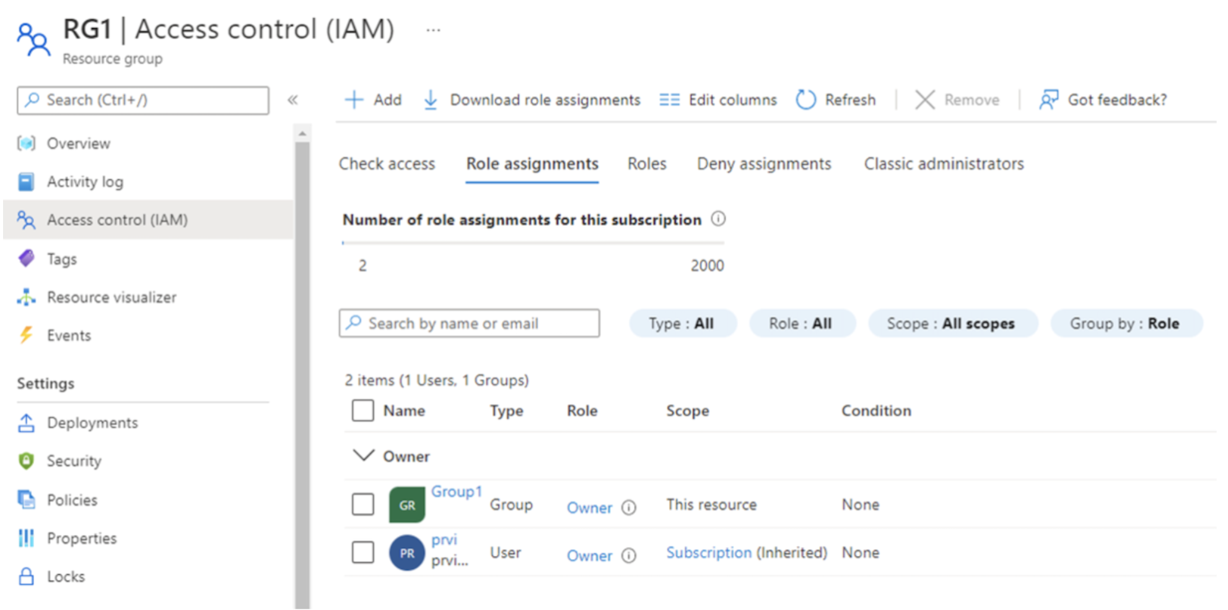
True or False:
`"You can assign User2 the Owner role for RG1 by adding Group2 as a member of Group1."`
Réponses:
☑ True
☐ False
Explication
`True` is CORRECT because nesting is supported for groups that can be assigned a role.
In the screenshots pasted below, TestGroup is the Owner of the RG. And TestGroup3 is another group with a user User1, we want to be added as Owner of RG. So, as you can see, I can add TestGroup3 as the member of TestGroup. And this gives User1 the owner access of the RG.
Reference(s):
- https://learn.microsoft.com/en-us/entra/identity/role-based-access-control/groups-concept#how-are-role-assignable-groups-protected

Question 88
An Azure subscription contains the following users:
- User1 – Member of Group1
- User2 – Member of Group2
- User3 – Member of Group3
The groups are configured as follows:
- Group1 – Type: Security
- Group2 – Type: Security
- Group3 – Type: Microsoft 365
All three groups are enabled for Microsoft Entra role assignments.
You also have a resource group named RG1. The access control (IAM) configuration for RG1 is shown in the exhibit.
True or False:
`"You can assign User3 the Owner role for RG1 by adding Group3 as a member of Group1."`
Réponses:
☐ True
☑ False
Explication
`False` is the correct answer because Azure role assignments do not support nested groups when the nested group is a Microsoft 365 group. In this scenario, Group3 is a Microsoft 365 group, and even though Group1 is assigned the Owner role for RG1, adding Group3 as a member of Group1 will not grant the Owner role to User3. This is because Microsoft Entra ID (Azure AD) does not support nested group evaluation for Microsoft 365 groups in role assignments.
Reference(s):
- https://learn.microsoft.com/en-us/entra/identity/role-based-access-control/groups-concept#limitations-of-using-groups-in-azure-ad-roles
- https://learn.microsoft.com/en-us/entra/identity/users/directory-service-limits-restrictions

Question 89
An Azure subscription contains the following users:
- User1 – Member of Group1
- User2 – Member of Group2
- User3 – Member of Group3
The groups are configured as follows:
- Group1 – Type: Security
- Group2 – Type: Security
- Group3 – Type: Microsoft 365
All three groups are enabled for Microsoft Entra role assignments.
You also have a resource group named RG1. The access control (IAM) configuration for RG1 is shown in the exhibit.
True or False:
`"You can assign User3 the Owner role for RG1 by assigning the Owner role to Group3 for RG1."`
Réponses:
☑ True
☐ False
Explication
`True` is the correct answer because Group3 is configured to allow Microsoft Entra roles to be assigned to it (`Microsoft Entra roles can be assigned to the group: Yes`). This makes the group eligible for role-based access control (RBAC) assignments, such as assigning the Owner role for a specific resource group like RG1. Even though Group3 is a Microsoft 365 group, direct role assignments (not nested) are supported when the group is configured for role assignments. As a result, User3, a direct member of Group3, will inherit the Owner role for RG1.
Reference(s):
- https://learn.microsoft.com/en-us/entra/identity/role-based-access-control/groups-concept#assign-azure-ad-roles-to-groups
- https://learn.microsoft.com/en-us/entra/identity/users/directory-service-limits-restrictions

Question 90
You have an Azure subscription that contains 100 virtual machines.
You need to quickly identify virtual machines that are underutilized and could be moved to a lower-cost service tier.
Which Azure portal blade should you use?
Réponses:
☐ Monitor
☑ Advisor
☐ Metrics
☐ Customer insights
Explication
`Advisor` is the correct answer because Azure Advisor provides personalized recommendations to optimize your Azure resources for cost, performance, security, and more. Specifically, it includes cost recommendations to help identify underutilized virtual machines that can be resized to a lower-cost SKU, thereby reducing unnecessary spend.
`Monitor` is incorrect because although it provides telemetry data and performance metrics, it doesn't offer built-in cost optimization recommendations.
`Metrics` is incorrect because it shows raw performance counters and charts but doesn't interpret or recommend changes based on utilization.
`Customer insights` is incorrect because it's related to customer data analytics (like Dynamics 365), and not relevant for Azure resource management or optimization.
Reference(s):
- https://learn.microsoft.com/en-us/azure/advisor/advisor-cost-recommendations
- https://learn.microsoft.com/en-us/azure/advisor/advisor-overview

