Codit
A versatile text editor / IDE aimed at the
Perl programming language

User manual

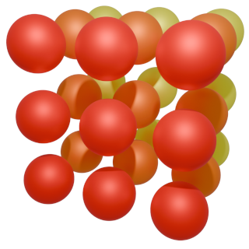

Version
0.19

Hans Jeuken
March 28, 2025

Table of Contents
1. Introduction 4
2. Installation 5
2.1 Installing on Linux and BSD 6
2.2 Installing on Windows 6
2.3 Installing on other operating systems 6
2.4 Updating from previous versions 7
3. Running Codit 7
4. Using Codit 8
4.1 The menu system 8
4.1.1 Codit 8
4.1.2 File 8
4.1.3 Edit 9
4.1.4 Bookmarks 9
4.1.5 Tools 9
4.1.6 View 10
4.2 The tool bar 10
4.3 The status bar 10
4.4 The document list 10
4.5 Document tabs 11
4.6 Indenting lines and selections 11
4.7 Commenting lines and selections 11
5. Settings 11
5.1 Editing settings 12
5.2 Colors settings 12
5.3 GUI settings 12
5.4 Highlighting panel 13
5.5 Plugins panel 13
6. Plugins 13
6.1 Backups 13
6.2 Bookmarks 14
6.3 Colors 14
6.4 Console 14
6.5 Exporter 15
6.5.1 Export to HTML 15
6.5.2 Export to PNG 15
6.6 FileBrowser 16
6.7 Git 17
6.8 Icons 18
6.9 PerlSubs 18
6.10 PodViewer 18
6.11 SearchReplace 19
6.12 Sessions 19
6.13 Snippets 19
6.14 SplitView 20
6.15 Writing your own plugin 20
6.16 Third party plugins 20
7. Keyboard shortcuts 21
7.1 Handling documents 21
7.2 Navigating text 21
7.3 Selecting text 21
7.4 Modifying text 21
7.5 Help, settings and such 22
8. Troubleshooting 23
8.1 General troubleshooting 23
8.2 No icons 23
8.3 Session will not load 23
8.4 Report a bug 23
9. License 24
10. Disclaimer 24

1. Introduction
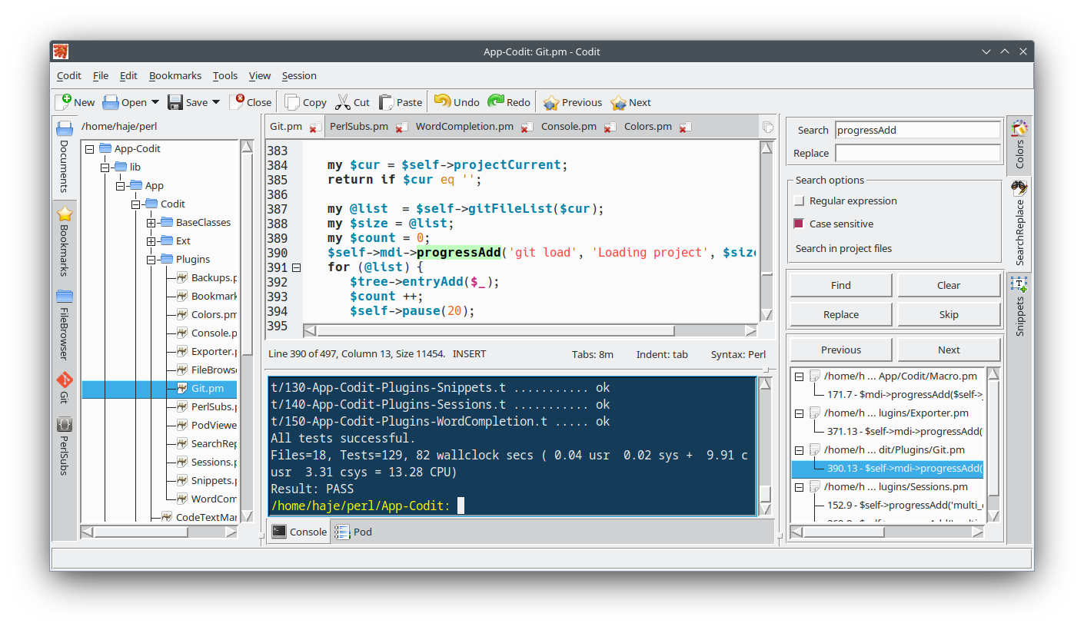
Codit is a versatile text editor / integrated development environment aimed at the Perl programming language.
It is written in Perl/Tk and based on the Tk::AppWindow application framework.
It uses the Tk::CodeText text widget for editing.
Codit has been under development for about one year now. It has gone quite some miles on our systems and can be considered beta software as of version 0.10.
It features a multi document interface that can hold an unlimited number of documents, navigable through the tab bar at the top and a document list in the left side panel.
It has a plugin system designed to invite users to write their own plugins.
It is fully configurable through a configuration window, allowing you to set defaults for editing, the graphical user interface, syntax highlighting and (un)loading plugins.
Tk::CodeText offers syntax highlighting and code folding in plenty formats and languages. It has and advanced word based undo/redo stack that keeps track of selections and save points. It does auto indent, auto brackets, auto complete, bookmarks, comment, uncomment, indent and unindent. Tab size and indent style are fully user configurable.
Enjoy playing!

2. Installation
Codit can simply be installed through CPAN:
sudo perl -MCPAN -e “install App::Codit”
Alternatively you can manually download the package from here:
https://github.com/haje61/App-Codit
After unpacking you do the following:
perl Makefile.PL
make
make test
sudo make install
Of corse first you have to install all dependencies. After make you can do any of the following for visual inspection:
perl -Mblib t/030-App-Codit-CoditTagsEditor.t show
perl -Mblib t/040-App-Codit.t show
perl -Mblib t/050-App-Codit-Plugins-Backups.t show
perl -Mblib t/060-App-Codit-Plugins-Bookmarks.t show
perl -Mblib t/070-App-Codit-Plugins-Colors.t show
perl -Mblib t/075-App-Codit-Plugins-Console.t show
perl -Mblib t/078-App-Codit-Plugins-Exporter.t show
perl -Mblib t/080-App-Codit-Plugins-FileBrowser.t show
perl -Mblib t/085-App-Codit-Plugins-Icons.t show
perl -Mblib t/090-App-Codit-Plugins-Git.t show
perl -Mblib t/100-App-Codit-Plugins-PerlSubs.t show
perl -Mblib t/110-App-Codit-Plugins-PodViewer.t show
perl -Mblib t/120-App-Codit-Plugins-SearchReplace.t show
perl -Mblib t/140-App-Codit-Plugins-Sessions.t show
perl -Mblib t/150-App-Codit-Plugins-SplitView.t show
perl -Mblib bin/codit

2.1 Installing on Linux and BSD
We strongly recommend you also install the Perl modules:
Tk::GtkSettings
Run the following commands each time you login;
tkgtk
xrdb .Xdefaults
This will make the look and feel of all your Tk applications conform to your desktop settings and helps Codit locate the correct icon library.
The screenshots in this manual are taken from a KDE/Plasma desktop with the classic Breeze theme and the Oxygen icon library.
Image::LibRSVG
This will allow you to load vector graphics based icon themes like Breeze. We did not include it as a prerequisite since it does not respond well to unattended install. It requires the gnome library librsvg-2 and its development files to be installed.

2.2 Installing on Windows
Codit is built on Tk. The package on CPAN does not compile beyond Perl version 5.32. A specially crafted tar ball can be found on the Github pages of Strawberry Perl. Download and extract it. Go with the cmd shell into it’s main folder and do the following:
- perl Makefile.PL
- gmake
- gmake test
- gmake install
Please also make sure you have an icon library installed. Preferably the Oxygen theme. We found a suitable one here. Extract the file and rename the folder png to Oxygen. Create a folder Icons in C:\ProgramData and move the Oxygen folder into it.
Downloading it from the Oxygen github repository gives all kinds of problems on Windows.
You can install any other icon theme. However, you then need to start Codit with the -icontheme command line option. SVG based icon themes do not work on Windows.

2.3 Installing on other operating systems
We only test on Windows and Linux. Your milage may vary.

2.4 Updating from previous versions
As of version 0.15 the plugin WordCompletion has been removed. All functionality has been moved to the Tk::CodeText text widget.
If you upgrade from earlier versions than 0.15 it is still present on your system.
Do not load this plugin. It will interfere. Best remove the WordCompletion.pm from the App/Codit/Plugins folder in the perl install dir. You may need sudo priviliges for that.

3. Running Codit
You can launch Codit from the command line as follows:
codit [options] [files]
The following command line options are available:
- -c or -config
Specifies the configfolder to use. If the path does not exist it will be created.
- -h or -help
Displays a help message on the command line and exits.
- -i or -iconpath
Point to the folders where your icon libraries are located.*
- -t or -icontheme
Icon theme to load.
- -np or -noplugins
Launch without any plugins loaded. This supersedes the -plugins option.
- -p or -plugins
Launch with only these plugins .*
- -s or -session
Loads a session at launch. The plugin Sessions must be loaded for this to work.
- -y or -syntax
Specify the default syntax to use for syntax highlighting. Codit will determine the syntax of documents by their extension. This options comes in handy when the file you are loading does not have an extension.
- -v or -version
Displays the version number on the command line and exits.

* You can specify a list of items by separating them with a ‘:’.

4. Using Codit

4.1 The menu system
The main menu learns us a lot about the functionalities of Codit. Let’s go through it.

4.1.1 Codit
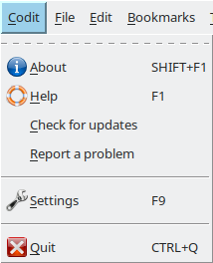
About opens a dialog box with the Codit logo and some information.
Help opens this manual in your default document viewer.
Settings launches the settings dialog. See chapter 5, Settings.
Quit checks for unsaved documents and exits Codit.

4.1.2 File
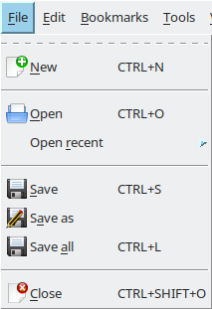
The file menu with all its keyboard shortcuts.
Whenever a file is closed it will be added to the recent documents menu. Whenever a file is opened it will be removed from the recent documents menu.
The Save and Close options work on the currently selected file.

4.1.3 Edit
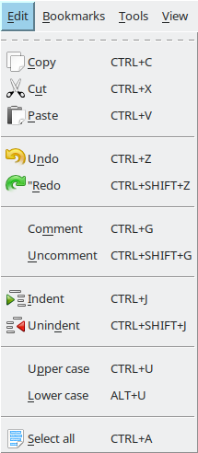
Rules for commenting and uncommenting are derived from the syntax definition in the current document. If no syntax is selected these commands do nothing.
Commenting, un-commenting, indenting and un-indenting work on single lines and selected blocks of text.
Upper case and Lower case work on a selection or if there is no selection on the character at the insert cursor.

4.1.4 Bookmarks
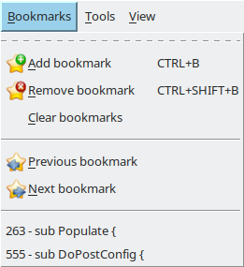
The bookmark tools in this menu only work inside the current selected document. When you select Previous bookmark, the cursor moves backward to the first bookmark it finds. When you select Next bookmark, the cursor moves forward to the first bookmark it finds.

4.1.5 Tools
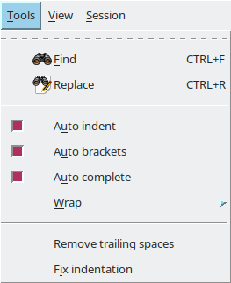
All options in this menu affect only the current selected document.
Auto indent will use the indent style of the current line to generate the same indentation on the nest line when enter is pressed. Auto brackets automatically produces the counterpart of the ‘{‘, ‘[‘, ‘(‘ and the string characters ‘ and “ when you are typing along. Wrap can be set to char, word or none.
Remove trailing spaces removes all spaces and tabs at the end of each line. If a selection exists it operates only on the selection.
Fix indentation pops a dialog asking for the number of spaces per tab. It then attempts to reformat the indentation taking the indent style into account. If a selection exists it operates only on the selection.

4.1.6 View
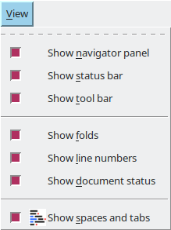
The options toolbar, statusbar, navigator panel, and tool panel show or hide the corresponding panels on the interface.
The options folds, line numbers and document status show or hide the corresponding panels on the current selected document. Other documents are not affected.
Show spaces and tabs activates a macro that highlights leading and trailing spaces and tabs. It updates after you make an edit.

4.2 The tool bar
The toolbar gives you quick access to commands like opening, saving and closing files, cut, copy and past, undo and redo. You can hide it through the View menu or in the settings dialog.

4.3 The status bar
The status bar is probably the most boring feature of Codit, or maybe not. It displays information about the last action taken. Small help texts appear when hoovering over toolbar and side panel items. It displays a progress bar when the Sessions plugin loads a session. That’s it.

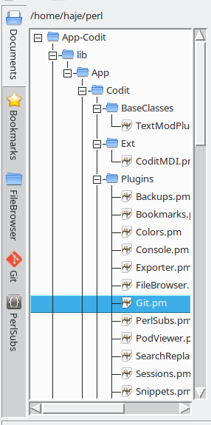
4.4 The document list
The document list displays all open documents in alphanumerical order.
First it displays all un-tracked entries. An entry is un-tracked when it is a newly created document that does not yet exists as a file.
Second it displays all folders containing open files.
Last it displays all open files.
The label in the top of the list shows the folder that all open files have in common.
Right clicking the document lists pops a menu with several options.

4.5 Document tabs

The document tab bar can hold an infinite number of open documents. You can move the tabs that are visible by dragging them left or right. When more documents are open than will fit in the More button is displayed. When you click it a list of available documents pops up. If you select one it will be shown as the first document in the document bar.

4.6 Indenting lines and selections
Indenting and un-indenting is done on the line where the insert cursor is or on a selection of text if a selection exists. You can specify the indent style in the settings dialog or in the status bar of the text widget.
If you set Indent style to tab, indentation is done using tabs. If you set it to a number indentation is done using that amount of spaces. You can use the keyboard shortcut CTRL+J for indenting and CTRL+SHIFT+J for unindenting.

4.7 Commenting lines and selections
Rules for commenting and uncommenting are derived from the syntax definition in the current document. If no syntax is selected commenting and uncommenting do not work. You can use the keyboard shortcut CTRL+G for commenting and CTRL+SHIFT+G for uncommenting.

5. Settings
You can launch the settings dialog by pressing F9 or through the menu:
Codit→Settings
It can occur that the Apply button is grayed out. This happens if one of the settings that is currently loaded is not valid. This happens especially with icon sizes after changing the icon library of your desktop. You can look for entries colored in red and modify them.
You can reset some options to their factory defaults by clearing out their entry. After you hit Apply you have to restart Codit to see the changes.

5.1 Editing settings
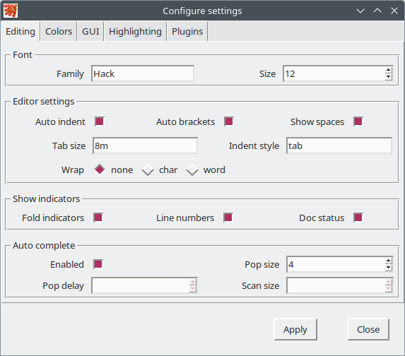
These are the settings for the text widget.
You may reset the Font, Tab size and Indent style fields to their factory defaults.
Tab sizes are measured in millimeters (m), centimeters (c), inches (i) or pixels (p).
If you set Indent style to tab, indentation is done using tabs. If you set it to a number indentation is done using that amount of spaces.
When you hit Apply all currently open documents will be updated.

5.2 Colors settings
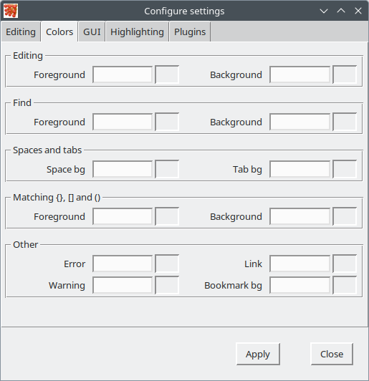
You can reset all colors back to their factory settings.
All color options have sound factory defaults for a light colored desktop theme.
The factory defaults for the Editing colors are dependent on the current desktop theme.

5.3 GUI settings
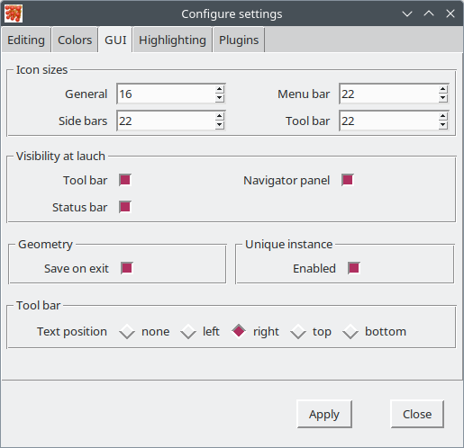
You may reset all icon sizes to their factory defaults by clearing out their entry.
If you set Save on exit Codit will remember it’s window position and size and will launch next time at the same position and size.
When you enable Unique instance only one instance of codit is used for opening files on the command line.
When you hit Apply the interface of Codit is updated.

5.4 Highlighting panel
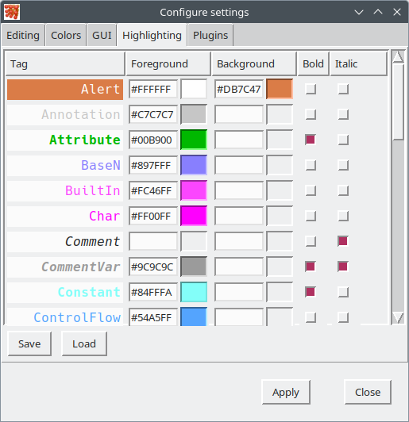
The Highlighting panel allows you to set foreground, background and font options for all highlight attributes.
After you hit apply the highlight tags in all open documents are updated.
You can save and load a highlight theme.

5.5 Plugins panel
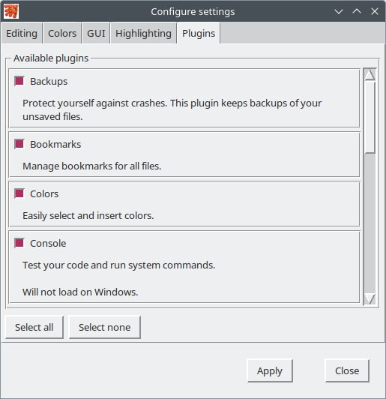
The plugins panel allows you to load and unload plugins.
There is no need to hit the Apply button. The moment you click a checkbox the plugin is loaded or unloaded.
See also the next chapter, Plugins.

6. Plugins
Plugins add functionality to Codit at the command of the user. They can be loaded or unloaded by you through the settings dialog. This way you can leave out functionality you do not want.
The following plugins are at your disposal.

6.1 Backups
The Backups plugin protects you against crashes of all kinds. It silently does it’s job in the background and only reports when it finds an existing backup of a file you open. It keeps backups of all unsaved files. Whenever a file is saved or closed the backup is removed. It keeps the backups in the configuration folder, it does not pollute your working folders.

6.2 Bookmarks
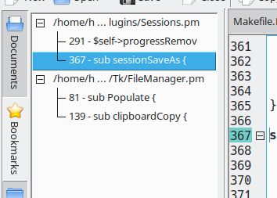

The bookmarks menu only covers bookmarks within the selected document. The bookmarks plugin covers the bookmarks in all open files. I creates a bookmarks list in the navigator panel and a previous and next button in the toolbar. Previous and next refer to the previously and next selected bookmarks.

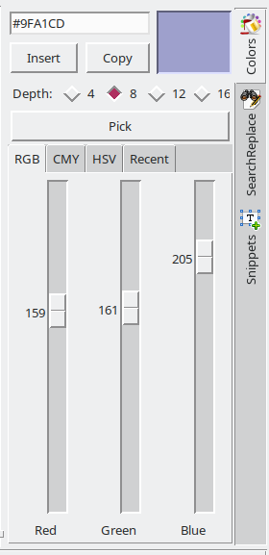
6.3 Colors
The Colors plugin lets you choose a color and insert it’s hex value into your document.
You can select a color in RGB, CMY and HSV space. Whenever you select a color it is added to the Recent tab.
It allows you to specify color depths 4, 8, 12 and 16 bits per color.
You can pick a color from any place on the screen with the pick button. This does not work on Windows.
When a selection exists and the selection contains a valid color code the color is displayed in the indicator.

6.4 Console
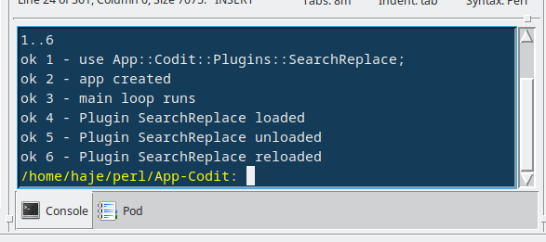
The Console plugin allows you to run system commands and tests inside Codit. It works a bit as a standard command console.
If a command produces errors, the output is scanned for document names and line numbers. Clickable links are created that bring you directly to the place where the error occured.

The command console has three keybindings:
- <CTRL+U>, Toggle buffering on or off.
- <CTRL-W>, Clear the screen.
- <CTRL+Z>, Kill the currently running process.
This plugin does not load on Windows.
You can select text in the console window and copy it to the clipboard.

6.5 Exporter
Plugin Exporter allows you to export the current selected document to HTML or PNG. You will find two entries for this in the File menu:

6.5.1 Export to HTML
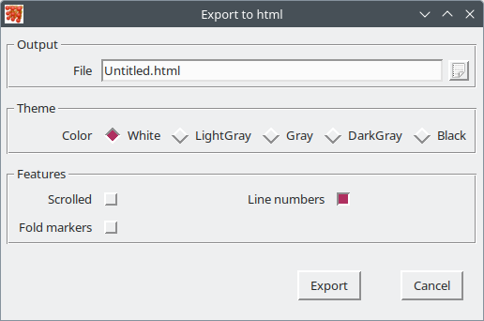
Exporting to html is done using the standard facilities available in Syntax::Kamelon. We are looking to extend that in future versions.
A form will pop up where you can set:
- Output file
A default file is suggested. Change it if you like.
- Theme
Pick one of the available themes.
- Line numbers
Tick this if you want line numbers displayed in the left column.
- Fold markers
Tick this if you want fold markers displayed in the left column.
- Scrolled pane
Tick this if you want the content to appear in a scrollable pane.

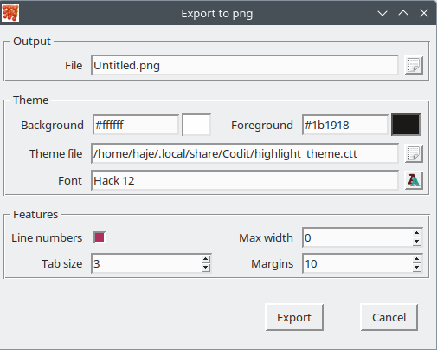
6.5.2 Export to PNG
A form will pop up. All your changes except for Output file are saved. You can set:
- Output file
A default file is suggested. Change it if you like.
- Background
Background color of your image. By default the background color of the Tk::CodeText widget is set.
- Foreground
Default color of the text in your image. By default the foreground color of the Tk::CodeText widget is set.
- Theme file
Select the Tk::CodeText theme file (extension '.ctt') to use for syntax highlighting. By default the theme file used in the Tk::CodeText widget is set. You can create your custom theme file through Menu->Codit->Settings and select the highlighting panel.
- Font
Set the font used to draw text in your image. By default the font of the Tk::CodeText widget is set.
- Line numbers
Tick this if you want line numbers displayed in the left column.
- Tab size
Set the size of tabs in characters.
- Max width
If set to 0 the image will grow in width whenever needed. Otherwise it will wrap text when the max width (in pixels) has been reached.
- Margins
Set the top, left, bottom and right margins around your image.
Beware! Exporting to PNG is painstakingly slow.

6.6 FileBrowser
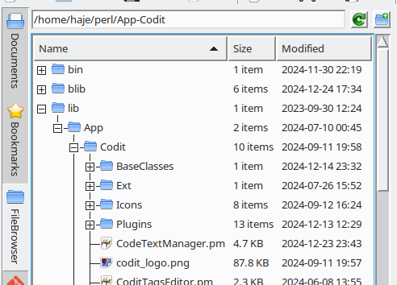
The FileBrowser plugin lets you browse and manage your harddrive and.
Double clicking a file will open it in Codit if it is a text file. Otherwise it will open in the appropriate application of your desktop.
Clicking the right mouse button will open a context menu with options for opening, copy, cut, paste and delete selected files.
All columns are sortable and sizable. If you left-click the header it will give you options to display hidden files (that start with a ‘.’), Sort case dependant or not and directories first.
The following keyboard shortcuts are available when the file list has the focus:
CTRL+C Copy selected files to the file clipboard.
CTRL+X Copy selected files to the file clipboard. Delete them after paste.
CTRL+V Paste files in the file clipboard into the main folder.
CTRL+F Pops/hides the filter entry.
CTRL+P Pops a window with information about selected files and folders.
SHIFT+DELETE Delete selected files and folders. A confirm dialog will pop.
Right-clicking the file browser panel pops a context menu with most if these options.

6.7 Git
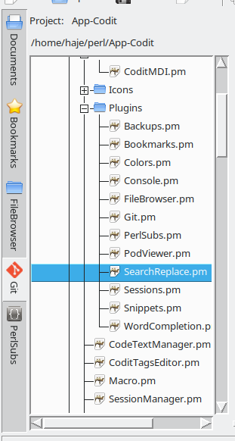
This plugin will only load if the git executable is installed.
It adds a document list to the navigation panel with the git icon.
When a file is opened it will check if it belongs to a git repository. If it does it will add the repository to the top menu list. If you select a repository from that list all documents in that repository are loaded in the file list.
Selecting a document in the list will open it if it is not yet opened and select it.
When a file is closed it will check if there are any remaining documents in it's repository are opened. If none are open it will unselect the repository and remove it from the top menu list.
It has a context menu that pops with the right mouse button. You can quickly open all files in the repository, or remove the current selected file from the repository. And you can collapse and expand the list.

6.8 Icons
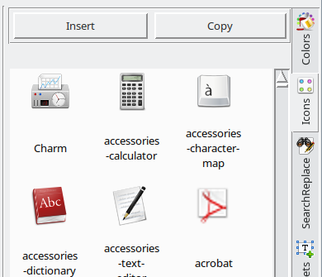
The Icons plugin lets you choose an icon from the iconlibrary and insert it's name into your document.
If a selection exists and it's content matches the name of an icon, the icon will be selected.

6.9 PerlSubs
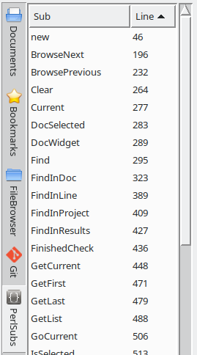
PerlSubs scans the current selected document for lines that begin with ‘sub someName‘ and displays it in a list with the line number. The list is refreshed after an edit.
When you click on and item in the list, the insert cursor is moved to that line and it is scrolled into visibility.
Both colums are sizable and sortable.

6.10 PodViewer
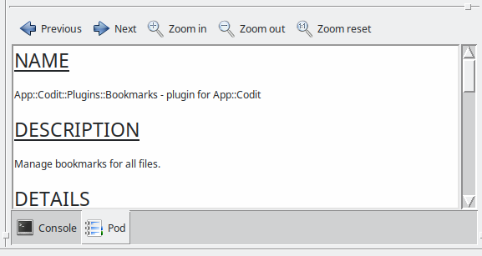
PodViewer adds a ‘Pod’ button to the toolbar. When you click it the frame of the current selected document will split and the bottom half will show the pod documentation in your document. The viewer is refreshed after you make an edit.

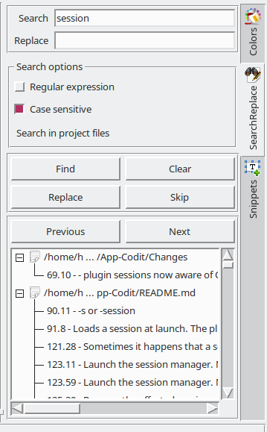
6.11 SearchReplace

This plugin allows you to do a search and replace across multiple or just one file.
After filling out the search and replace fields you first click Find. The list box will fill with the search results.
When you click Replace the first item in the list is replaced and then removed from the list.
You can skip replaces by pressing Skip.
When searching with a regular expression you can include the captures in the replace string with ‘$1’, ‘$2’, etcetera.
Clear removes all search results.

6.12 Sessions
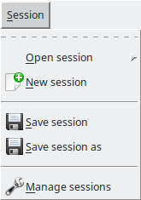
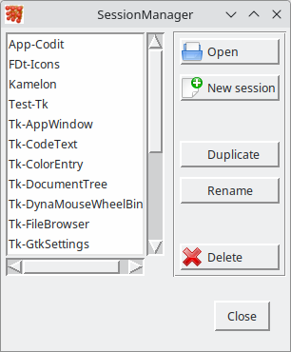
The sessions plugin allows you to save a collection of documents as a session. It adds an item Session to the menu bar.
When re-opening the session the documents are loaded in the exact order as they were when the session was closed. Also the syntax option, tab size, indent style and insert cursor position are saved.
The session manager allows you to keep all your sessions orderly.

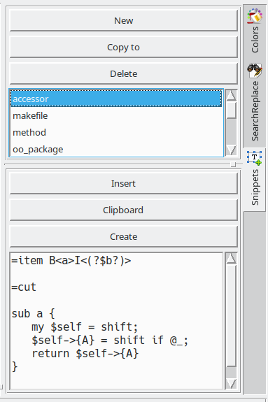
6.13 Snippets
Snippets are shorts pieces of code that you find yourself writing over and over again.
The top side of the panel allows you to manage your collection of snippets.
The bottom side allows you to:
- edit the snippet
- insert a selected snippet into your document,
- copy the snippet to the clipboard
- create a new document based on the snippet. A file dialog is launched and the snippet is saved to the selected file name. Then it is opened in a new tab.

6.14 SplitView
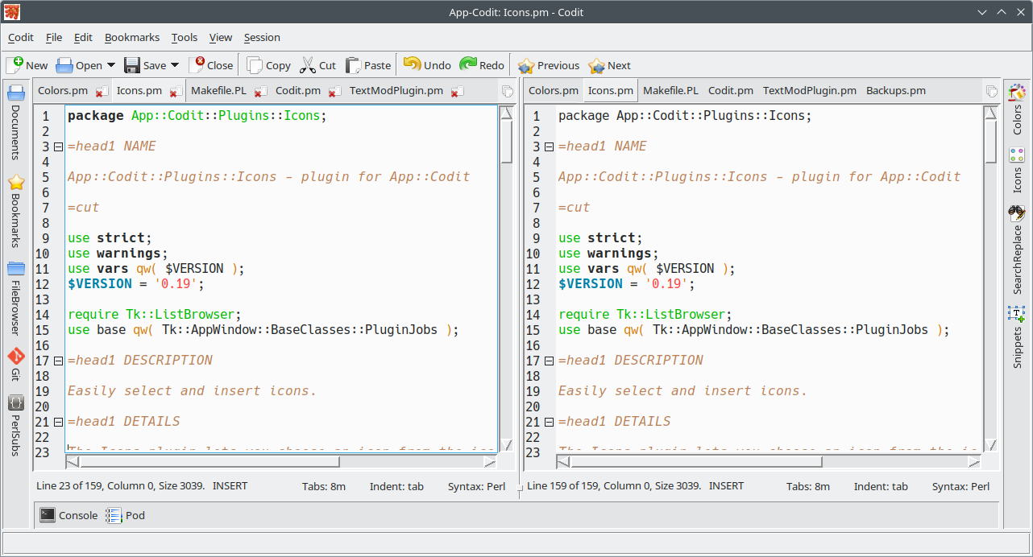
This plugin creates a secondary document interface that holds all the documents in the primary one in a read only state.
You can create a horizontal or a vertical split through the View menu.
Whenever a document is opened or closed in the primary interface it is also opened or closed in the secondary interface.

6.15 Writing your own plugin
The plugins system of Codit is part of the Tk::AppWindow application framework. Here are some places to get started:
- The plugins cookbook.
- The plugins base class.
- Plugins base class with background jobs.

6.16 Third party plugins
Other users (you?) may have uploaded their plugin to CPAN. You can always do a search here.

7. Keyboard shortcuts

7.1 Handling documents
CTRL+N Create a new document.
CTRL+O Open a document.
CTRL+SHIFT+O Close current document.
CTRL+S Save current document when modified.
CTRL+L Save all open documents when modified.

7.2 Navigating text
CTRL+B Add bookmark.
CTRL+SHIFT+B Remove bookmark.
END Go to end of current line.
HOME Go to begin of current line.
CTRL+END Go to end of current document.
CTRL+HOME Go to begin of current document.

7.3 Selecting text
CTRL+A Select all.
SHIFT+DOWN Increase or decrease selection by one line downward.
SHIFT+END Increase or decrease from insert cursor position to the end of the line.
SHIFT+HOME Increase or decrease from insert cursor position to the start of the line.
SHIFT+LEFT Increase or decrease selection by one character to the left.
SHIFT+PGDOWN Increase or decrease selection by screen size downward.
SHIFT+PGUP Increase or decrease selection by screen size upward.
SHIFT+RIGHT Increase or decrease selection by one character to the right.
SHIFT+UP Increase or decrease selection by one line upward.

7.4 Modifying text
CTRL+C Copy selection to clipboard.
CTRL+X Move selection to clipboard.
CTRL+V Paste clipboard into document.
CTRL+G Comment line or selection.
CTRL+SHIFT+G Uncomment line or selection.
CTRL+J Indent line or selection.
CTRL+SHIFT+G Unindent line or selection.
CTRL+I Set character at insert cursor or selection to upper case.
CTRL+SHIFT+I Set character at insert cursor or selection to lower case.
CTRL+Z Undo.
CTRL+SHIFT+Z Redo.

7.5 Help, settings and such
CTRL+Q Quit.
F1 Help.
SHIFT+F1 About.
F9 Settings.

8. Troubleshooting
Just hoping you never need this

8.1 General troubleshooting
If you encounter problems and error messages using Codit, here are some general troubleshooting steps:
- Use the -config command line option to point to a new, preferably fresh settingsfolder.
- Use the -noplugins command line option to launch Codit without any plugins loaded.
- Use the -plugins command line option to launch Codit with only the plugins loaded you specify here.

8.2 No icons
If Codit launches without any icons do one or more of the following:
- Check if your icon theme is based on scalable vectors. Install Icons::LibRSVG if so. See Chapter 2, Installation.
- Locate where your icons are located on your system and use the -iconpath command line option to point there.
- Select an icon library by using the -icontheme command line option.

8.3 Session will not load
Sometimes it happens that a session file gets corrupted. You solve it like this:
- Launch the session manager. Session→Manage sessions.
- Remove the affected session.
- Rebuild it from scratch.
Sorry, that is all we have to offer.

8.4 Report a bug
If all fails you are welcome to open a ticket here: https://github.com/haje61/App-Codit/issues.

9. License
Codit is published under the same license as Perl itself.

10. Disclaimer
We have done our best to make Codit an excellent Perl/IDE. However, you use it at your own risk and expense. If it breaks, you own both parts.
This document may be incomplete and may contain errors. We apologize.

