

تكليف ويب

**عمل الطالبة/**

**مثاني طة عبدالله**

**المهندس/ اسامة**

**JavaScript Challenges (strings, arrays, and date/time)**

**1. Check for Anagrams: Write a function that takes two strings as input and returns true if the two strings are anagrams (meaning they contain the same letters in a different order).**

**2. Slice an Array: Write a function that takes an array and two indices as input and returns a new array that contains the elements between the two indices.**

**3. Split a String into Words: Write a function that takes a string as input and returns an array of the words in that string.**

**4. Calculate the Age Based on a Date of Birth: Write a function that takes a date of birth as input and returns the age of the person as of today.**

**5. Check if a String is a Valid Email Address: Write a function that takes a string as input and returns true if the string is a valid email address.**

**6. Replace All Occurrences of a Substring in a String: Write a function that takes a string, a substring, and a replacement string as input, and returns the same string with all occurrences of the substring replaced with the replacement string.**

**7. Find the Second Smallest Value in an Array: Write a function that takes an array of numbers as input and returns the second smallest value in that array.**

**8. Find the Difference Between Two Arrays: Write a function that takes two arrays as input and returns an array that contains the elements that are in the first array but not in the second array.**

**9. Format a Time Duration: Write a function that takes a time duration (in seconds) as input and returns a formatted string in the format of "X hours, Y minutes, Z seconds".**

**10. Convert a String to CamelCase: Write a function that takes a string as input and returns the same string in CamelCase (meaning each word is capitalized except for the first word).**

Answer :

1. Check for Anagrams

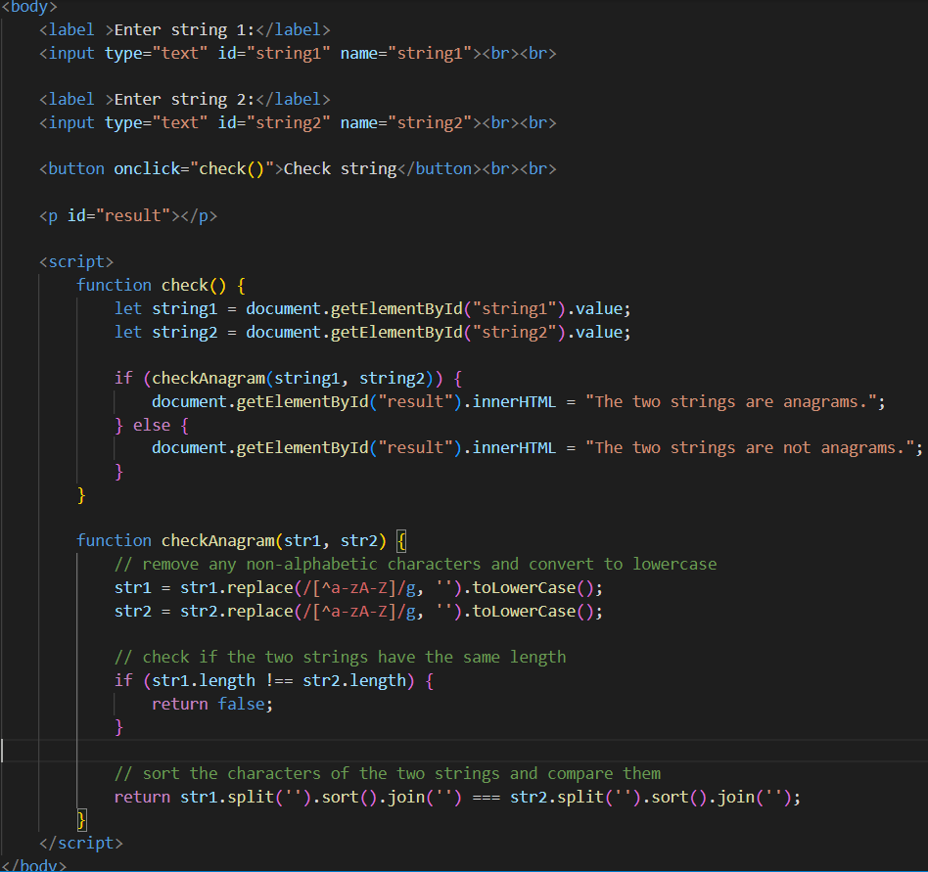

2. Slice an Array:

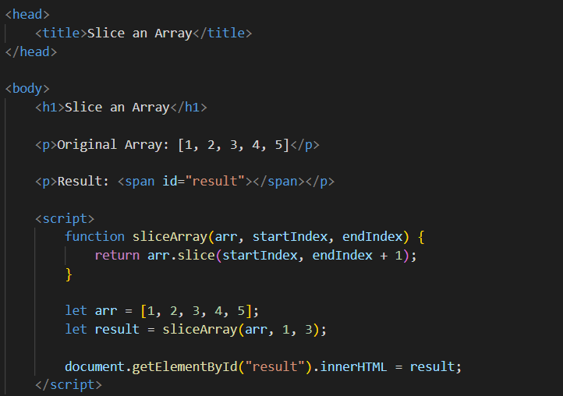

3. Split a String into Words

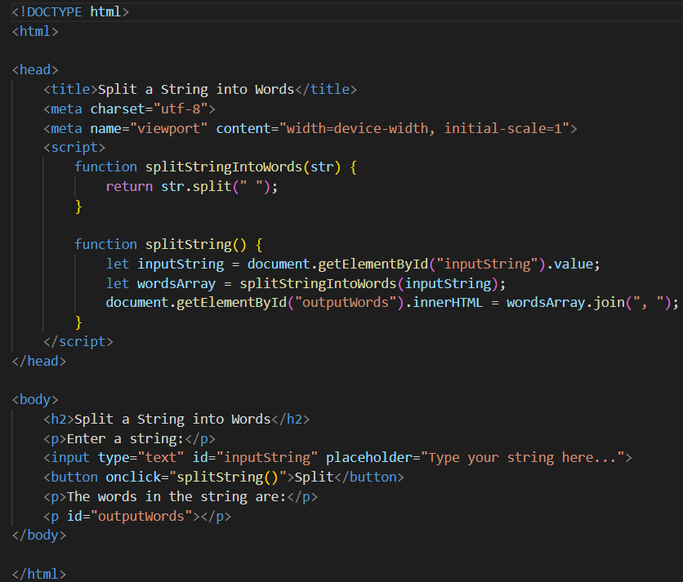

4. Calculate the Age Based on a Date of Birth:

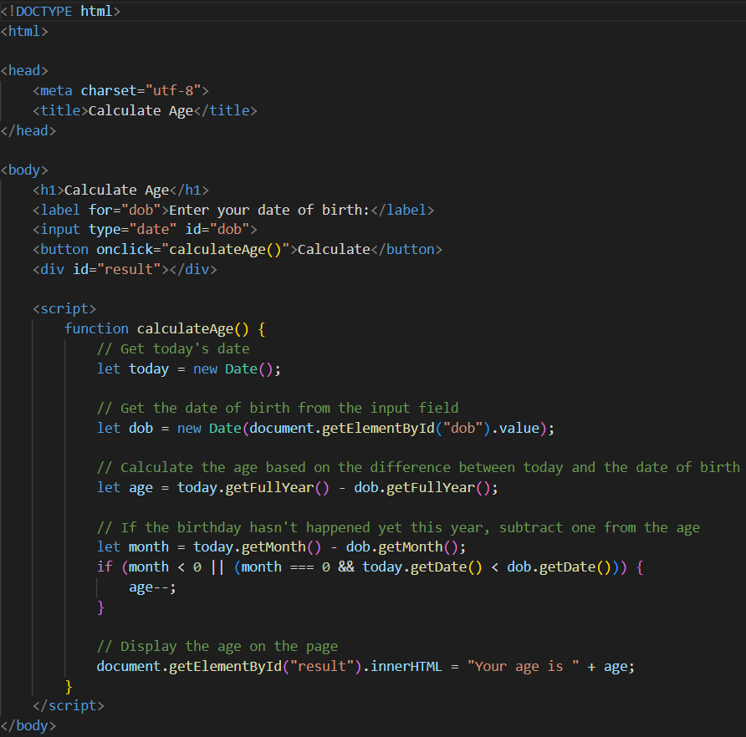

5. Check if a String is a Valid Email Address:

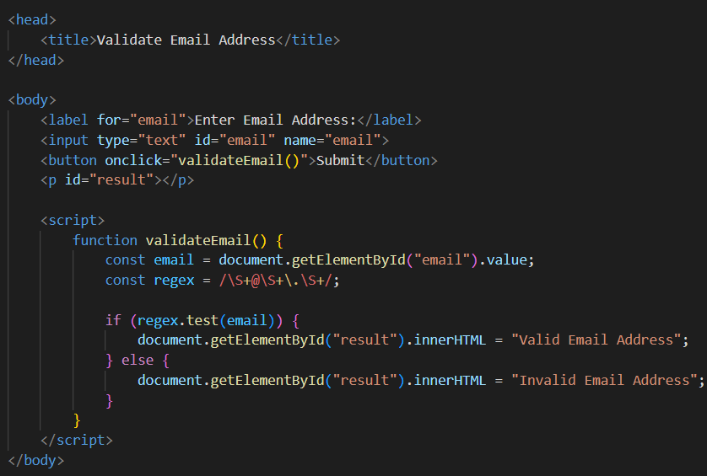

6. Replace All Occurrences of a Substring in a String:

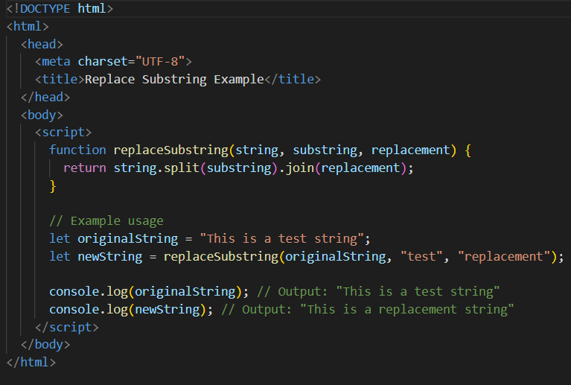

7. Find the Second Smallest Value in an Array:

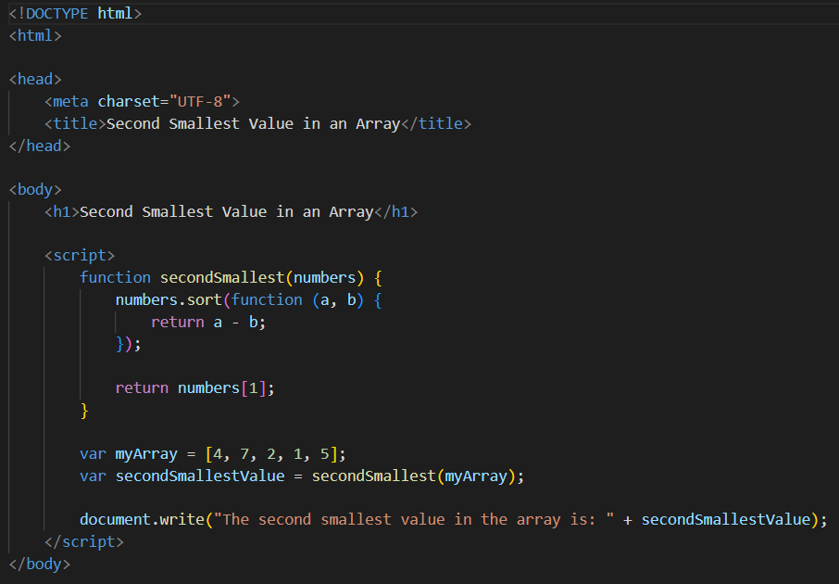

8. Find the Difference Between Two Arrays:

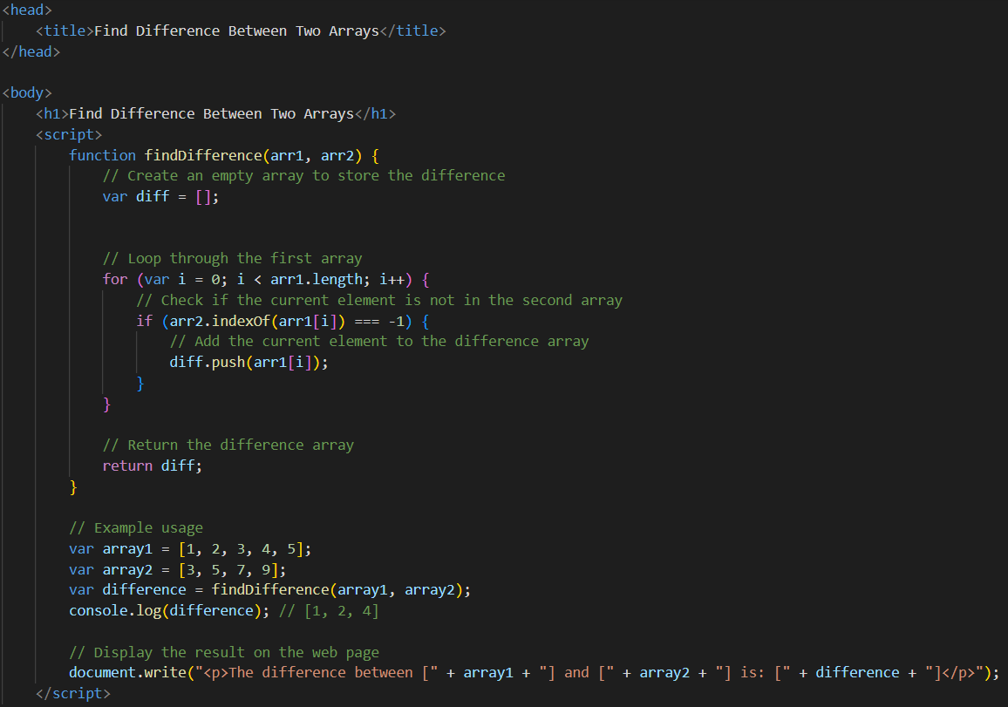

9. Format a Time Duration:

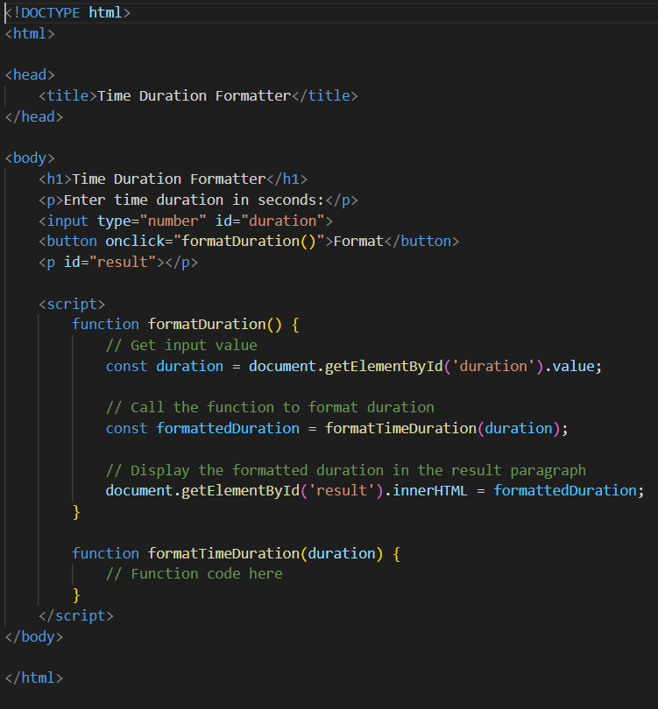

10. Convert a String to CamelCase:

