P4
!pip install -q gensim transformers torch

import gensim.downloader as api
from transformers import pipeline

word_vectors = api.load("glove-wiki-gigaword-100")

generator = pipeline(
"text-generation",
model="gpt2"
)

prompt = "Explain machine learning in healthcare"

def enrich_prompt(prompt):

enriched_words = []

for word in prompt.split():

enriched_words.append(word)

if word in word_vectors:

similar_words = word_vectors.most_similar(
word,
topn=2
)

enriched_words.append(similar_words[0][0])
enriched_words.append(similar_words[1][0])

return " ".join(enriched_words)

enriched_prompt = enrich_prompt(prompt)

original_output = generator(
prompt,
max_length=100
)[0]["generated_text"]

enriched_output = generator(
enriched_prompt,
max_length=100
)[0]["generated_text"]

print("Original Prompt:")
print(prompt)

print("\nEnriched Prompt:")
print(enriched_prompt)

print("\nOutput (Original):")
print(original_output)

print("\nOutput (Enriched):")
print(enriched_output)

print("\nComparison:")
print("Original length:", len(original_output.split()))
print("Enriched length:", len(enriched_output.split()))

print("Insight: Enriched prompt may provide more context but can also introduce noise.")

P6

!pip install -q transformers torch

from transformers import pipeline

sentiment_pipeline = pipeline(
"sentiment-analysis"
)

def analyze_sentiment(text):

result = sentiment_pipeline(text)

return result[0]

while True:

text = input(
"Enter a sentence for sentiment analysis (or 'exit' to quit): "
)

if text.lower() == "exit":
break

sentiment_result = analyze_sentiment(text)

print(
f"Sentiment: {sentiment_result['label']} "
f"(Confidence: {sentiment_result['score']:.2f})\n"
)

P7
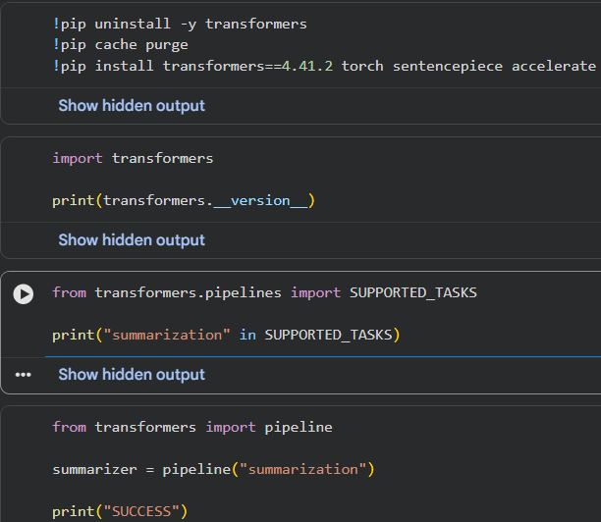
from transformers import pipeline

summarizer = pipeline(
"summarization",
model="facebook/bart-large-cnn"
)

def summarize_text(text):

summary = summarizer(
text,
max_length=130,
min_length=50,
do_sample=False
)

return summary[0]["summary_text"]

long_text = """
Artificial Intelligence (AI) is a rapidly advancing field that aims to create machines capable of human-like thinking.
AI is used in various industries, from healthcare to finance, improving efficiency and accuracy. Machine learning,
a subset of AI, enables computers to learn from data and make predictions without being explicitly programmed.
With deep learning, neural networks can process vast amounts of information and recognize patterns, leading
to advancements in self-driving cars, natural language processing, and medical diagnostics.
"""

summary = summarize_text(long_text)

print("Original Text:")
print(long_text)

print("\nSummarized Text:")
print(summary)

P9
!pip install wikipedia-api pydantic

from pydantic import BaseModel
from typing import List, Optional
import wikipediaapi

class InstitutionDetails(BaseModel):
founder: Optional[str]
founded: Optional[str]
branches: Optional[List[str]]
number_of_employees: Optional[int]
summary: Optional[str]

def fetch_institution_details(institution_name: str) -> InstitutionDetails:

user_agent = "MyJupyterNotebook/1.0 (contact: myemail@example.com)"
wiki_wiki = wikipediaapi.Wikipedia(user_agent=user_agent, language='en')

page = wiki_wiki.page(institution_name)

if not page.exists():
raise ValueError(f"The page for '{institution_name}' does not exist.")

founder = None
founded = None
branches = []
number_of_employees = None

summary = page.summary[:500]

infobox = page.text.split('\n')

for line in infobox:
if 'Founder' in line:
founder = line.split(':')[-1].strip()

elif 'Founded' in line:
founded = line.split(':')[-1].strip()

elif 'Branches' in line:
branches = [branch.strip() for branch in line.split(':')[-1].split(',')]

elif 'Number of employees' in line:
try:
number_of_employees = int(
line.split(':')[-1].strip().replace(',', '')
)
except ValueError:
number_of_employees = None

return InstitutionDetails(
founder=founder,
founded=founded,
branches=branches if branches else None,
number_of_employees=number_of_employees,
summary=summary
)

from IPython.display import display
import ipywidgets as widgets

def display_institution_details(details: InstitutionDetails):
print(f"Founder: {details.founder or 'N/A'}")
print(f"Founded: {details.founded or 'N/A'}")
print(f"Branches: {', '.join(details.branches) if details.branches else 'N/A'}")
print(f"Number of Employees: {details.number_of_employees or 'N/A'}")
print(f"Summary: {details.summary or 'N/A'}")

def on_button_click(b):
institution_name = text_box.value
try:
details = fetch_institution_details(institution_name)
display_institution_details(details)
except ValueError as e:
print(e)

text_box = widgets.Text(
value="",
placeholder="Enter the institution name",
description="Institution:",
disabled=False
)

button = widgets.Button(
description="Fetch Details",
disabled=False,
button_style="",
tooltip="Click to fetch institution details",
icon="search"
)

button.on_click(on_button_click)

display(text_box, button)

