パターン認識 プログラミング課題
理工学群工学システム学類３年
渡部祐也
201611212

1. k-meansについて
本課題では、k-means法について取り組んだ。
1. 1． 実行結果
実行結果を以下の図１，２に示す。同ファイル中のプログラム（k-means）の出力結果をgnuplotによって描画した。出力例は./k-means/ans.datに記録されている。

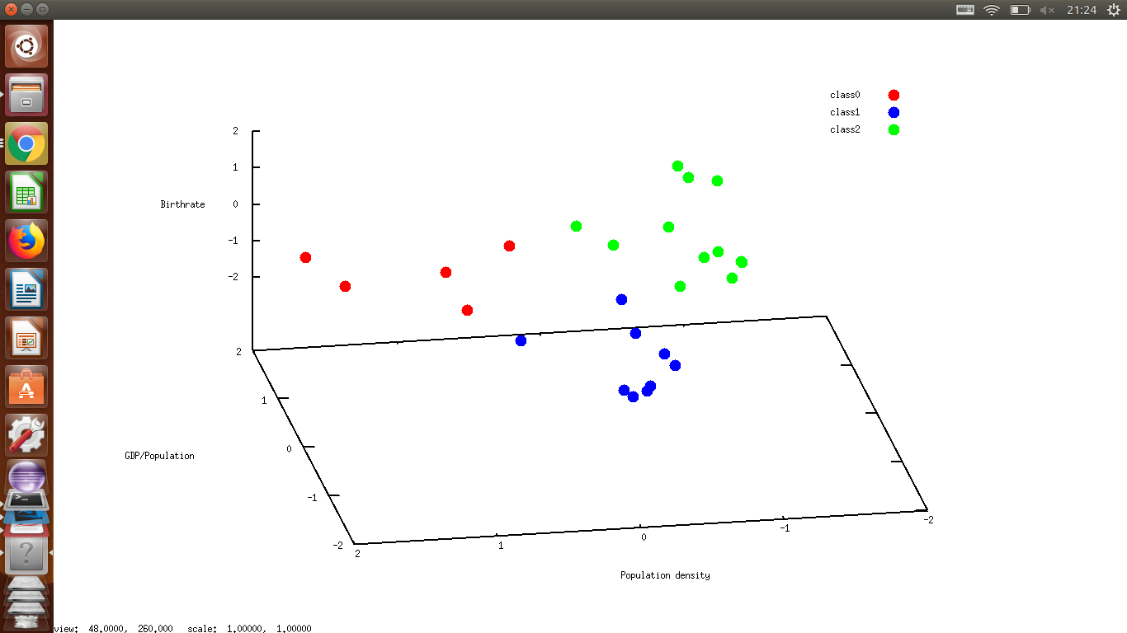
図 1: クラス数K=3
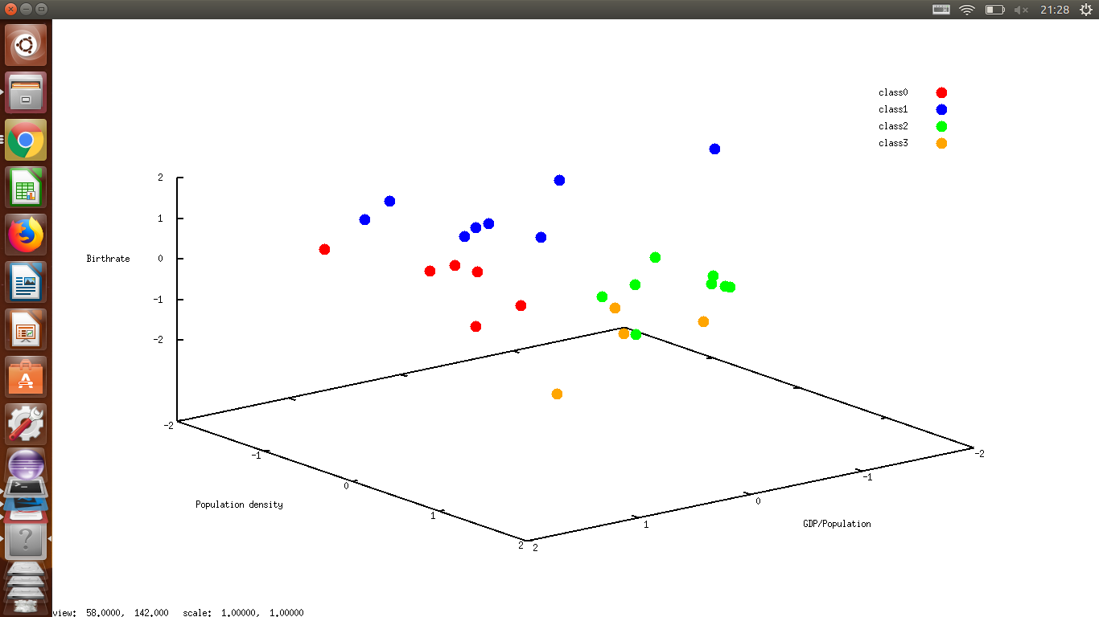
図 2: クラス数K=4
2. Neural Netについて
使用したソースコードは./NeuralNet/NeuralNet.cである。入力は画像(./NeuralNet/img2内のもの)、出力は年齢(./NeuralNet/giin.csvにある)である。隠れ層一つの全結合ニューラルネットを用いた。誤差関数は自乗誤差、最適化の手法は確率的最急勾配法、活性化関数はReLUである。
jpegファイルの読み込みのため、ライブラリとして、libJPEGを用いた。実行形式のファイルはNN.outである。

2. 1. 実行結果
実行結果を以下に示す(長くなります)。

--------------------------------Sample:0-------------------------------------
sample :0, epoch 0 ,train_overall_err:208.600782 || test_overall_err:94.050431
sample :0, epoch 1 ,train_overall_err:65.027603 || test_overall_err:56.302419
sample :0, epoch 2 ,train_overall_err:53.698696 || test_overall_err:52.211303
sample :0, epoch 3 ,train_overall_err:52.865450 || test_overall_err:51.560079
sample :0, epoch 4 ,train_overall_err:52.801720 || test_overall_err:51.414008
sample :0, epoch 5 ,train_overall_err:52.792445 || test_overall_err:51.373118
sample :0, epoch 6 ,train_overall_err:52.786712 || test_overall_err:51.358286
sample :0, epoch 7 ,train_overall_err:52.781131 || test_overall_err:51.350303
sample :0, epoch 8 ,train_overall_err:52.775535 || test_overall_err:51.344151
sample :0, epoch 9 ,train_overall_err:52.769932 || test_overall_err:51.338493
sample :0, epoch 10 ,train_overall_err:52.764330 || test_overall_err:51.332970
sample :0, epoch 11 ,train_overall_err:52.758729 || test_overall_err:51.327486
sample :0, epoch 12 ,train_overall_err:52.753131 || test_overall_err:51.322015
sample :0, epoch 13 ,train_overall_err:52.747535 || test_overall_err:51.316549
sample :0, epoch 14 ,train_overall_err:52.741943 || test_overall_err:51.311087
sample :0, epoch 15 ,train_overall_err:52.736352 || test_overall_err:51.305628
sample :0, epoch 16 ,train_overall_err:52.730765 || test_overall_err:51.300173
sample :0, epoch 17 ,train_overall_err:52.725181 || test_overall_err:51.294720
sample :0, epoch 18 ,train_overall_err:52.719599 || test_overall_err:51.289271
sample :0, epoch 19 ,train_overall_err:52.714019 || test_overall_err:51.283825
sample :0, epoch 20 ,train_overall_err:52.708443 || test_overall_err:51.278382
sample :0, epoch 21 ,train_overall_err:52.702869 || test_overall_err:51.272942
sample :0, epoch 22 ,train_overall_err:52.697298 || test_overall_err:51.267505
sample :0, epoch 23 ,train_overall_err:52.691730 || test_overall_err:51.262072
sample :0, epoch 24 ,train_overall_err:52.686164 || test_overall_err:51.256641
sample :0, epoch 25 ,train_overall_err:52.680601 || test_overall_err:51.251213
sample :0, epoch 26 ,train_overall_err:52.675041 || test_overall_err:51.245789
sample :0, epoch 27 ,train_overall_err:52.669483 || test_overall_err:51.240367
sample :0, epoch 28 ,train_overall_err:52.663928 || test_overall_err:51.234949
sample :0, epoch 29 ,train_overall_err:52.658376 || test_overall_err:51.229534
--------------------------------Sample:1-------------------------------------
sample :1, epoch 0 ,train_overall_err:427.072277 || test_overall_err:104.819130
sample :1, epoch 1 ,train_overall_err:72.769838 || test_overall_err:49.203944
sample :1, epoch 2 ,train_overall_err:55.099047 || test_overall_err:46.200260
sample :1, epoch 3 ,train_overall_err:54.183962 || test_overall_err:45.951282
sample :1, epoch 4 ,train_overall_err:54.111808 || test_overall_err:45.912625
sample :1, epoch 5 ,train_overall_err:54.098413 || test_overall_err:45.901977
sample :1, epoch 6 ,train_overall_err:54.092192 || test_overall_err:45.896467
sample :1, epoch 7 ,train_overall_err:54.087243 || test_overall_err:45.891995
sample :1, epoch 8 ,train_overall_err:54.082550 || test_overall_err:45.887738
sample :1, epoch 9 ,train_overall_err:54.077911 || test_overall_err:45.883526
sample :1, epoch 10 ,train_overall_err:54.073285 || test_overall_err:45.879326
sample :1, epoch 11 ,train_overall_err:54.068663 || test_overall_err:45.875129
sample :1, epoch 12 ,train_overall_err:54.064043 || test_overall_err:45.870935
sample :1, epoch 13 ,train_overall_err:54.059426 || test_overall_err:45.866742
sample :1, epoch 14 ,train_overall_err:54.054810 || test_overall_err:45.862551
sample :1, epoch 15 ,train_overall_err:54.050196 || test_overall_err:45.858361
sample :1, epoch 16 ,train_overall_err:54.045584 || test_overall_err:45.854174
sample :1, epoch 17 ,train_overall_err:54.040974 || test_overall_err:45.849988
sample :1, epoch 18 ,train_overall_err:54.036366 || test_overall_err:45.845803
sample :1, epoch 19 ,train_overall_err:54.031760 || test_overall_err:45.841621
sample :1, epoch 20 ,train_overall_err:54.027155 || test_overall_err:45.837440
sample :1, epoch 21 ,train_overall_err:54.022553 || test_overall_err:45.833261
sample :1, epoch 22 ,train_overall_err:54.017952 || test_overall_err:45.829083
sample :1, epoch 23 ,train_overall_err:54.013353 || test_overall_err:45.824907
sample :1, epoch 24 ,train_overall_err:54.008756 || test_overall_err:45.820733
sample :1, epoch 25 ,train_overall_err:54.004161 || test_overall_err:45.816561
sample :1, epoch 26 ,train_overall_err:53.999567 || test_overall_err:45.812390
sample :1, epoch 27 ,train_overall_err:53.994976 || test_overall_err:45.808221
sample :1, epoch 28 ,train_overall_err:53.990386 || test_overall_err:45.804053
sample :1, epoch 29 ,train_overall_err:53.985798 || test_overall_err:45.799888
--------------------------------Sample:2-------------------------------------
sample :2, epoch 0 ,train_overall_err:377.784292 || test_overall_err:94.815577
sample :2, epoch 1 ,train_overall_err:66.047222 || test_overall_err:56.568362
sample :2, epoch 2 ,train_overall_err:52.867277 || test_overall_err:55.757388
sample :2, epoch 3 ,train_overall_err:52.335473 || test_overall_err:55.848808
sample :2, epoch 4 ,train_overall_err:52.306541 || test_overall_err:55.871642
sample :2, epoch 5 ,train_overall_err:52.300440 || test_overall_err:55.872067
sample :2, epoch 6 ,train_overall_err:52.295959 || test_overall_err:55.867816
sample :2, epoch 7 ,train_overall_err:52.291687 || test_overall_err:55.862650
sample :2, epoch 8 ,train_overall_err:52.287455 || test_overall_err:55.857309
sample :2, epoch 9 ,train_overall_err:52.283230 || test_overall_err:55.851934
sample :2, epoch 10 ,train_overall_err:52.279009 || test_overall_err:55.846556
sample :2, epoch 11 ,train_overall_err:52.274790 || test_overall_err:55.841178
sample :2, epoch 12 ,train_overall_err:52.270573 || test_overall_err:55.835803
sample :2, epoch 13 ,train_overall_err:52.266358 || test_overall_err:55.830429
sample :2, epoch 14 ,train_overall_err:52.262144 || test_overall_err:55.825058
sample :2, epoch 15 ,train_overall_err:52.257932 || test_overall_err:55.819688
sample :2, epoch 16 ,train_overall_err:52.253722 || test_overall_err:55.814321
sample :2, epoch 17 ,train_overall_err:52.249513 || test_overall_err:55.808956
sample :2, epoch 18 ,train_overall_err:52.245307 || test_overall_err:55.803594
sample :2, epoch 19 ,train_overall_err:52.241102 || test_overall_err:55.798233
sample :2, epoch 20 ,train_overall_err:52.236899 || test_overall_err:55.792875
sample :2, epoch 21 ,train_overall_err:52.232698 || test_overall_err:55.787519
sample :2, epoch 22 ,train_overall_err:52.228498 || test_overall_err:55.782165
sample :2, epoch 23 ,train_overall_err:52.224300 || test_overall_err:55.776813
sample :2, epoch 24 ,train_overall_err:52.220104 || test_overall_err:55.771463
sample :2, epoch 25 ,train_overall_err:52.215910 || test_overall_err:55.766115
sample :2, epoch 26 ,train_overall_err:52.211717 || test_overall_err:55.760770
sample :2, epoch 27 ,train_overall_err:52.207527 || test_overall_err:55.755427
sample :2, epoch 28 ,train_overall_err:52.203338 || test_overall_err:55.750086
sample :2, epoch 29 ,train_overall_err:52.199150 || test_overall_err:55.744747
--------------------------------Sample:3-------------------------------------
sample :3, epoch 0 ,train_overall_err:176.757768 || test_overall_err:73.526314
sample :3, epoch 1 ,train_overall_err:63.093388 || test_overall_err:50.584904
sample :3, epoch 2 ,train_overall_err:53.877670 || test_overall_err:49.111631
sample :3, epoch 3 ,train_overall_err:53.148473 || test_overall_err:49.069748
sample :3, epoch 4 ,train_overall_err:53.079046 || test_overall_err:49.083004
sample :3, epoch 5 ,train_overall_err:53.064826 || test_overall_err:49.086536
sample :3, epoch 6 ,train_overall_err:53.056426 || test_overall_err:49.085618
sample :3, epoch 7 ,train_overall_err:53.048932 || test_overall_err:49.083363
sample :3, epoch 8 ,train_overall_err:53.041638 || test_overall_err:49.080737
sample :3, epoch 9 ,train_overall_err:53.034398 || test_overall_err:49.078013
sample :3, epoch 10 ,train_overall_err:53.027174 || test_overall_err:49.075263
sample :3, epoch 11 ,train_overall_err:53.019959 || test_overall_err:49.072508
sample :3, epoch 12 ,train_overall_err:53.012748 || test_overall_err:49.069754
sample :3, epoch 13 ,train_overall_err:53.005542 || test_overall_err:49.067001
sample :3, epoch 14 ,train_overall_err:52.998340 || test_overall_err:49.064251
sample :3, epoch 15 ,train_overall_err:52.991143 || test_overall_err:49.061503
sample :3, epoch 16 ,train_overall_err:52.983949 || test_overall_err:49.058758
sample :3, epoch 17 ,train_overall_err:52.976760 || test_overall_err:49.056015
sample :3, epoch 18 ,train_overall_err:52.969575 || test_overall_err:49.053275
sample :3, epoch 19 ,train_overall_err:52.962394 || test_overall_err:49.050537
sample :3, epoch 20 ,train_overall_err:52.955217 || test_overall_err:49.047802
sample :3, epoch 21 ,train_overall_err:52.948044 || test_overall_err:49.045069
sample :3, epoch 22 ,train_overall_err:52.940875 || test_overall_err:49.042338
sample :3, epoch 23 ,train_overall_err:52.933710 || test_overall_err:49.039610
sample :3, epoch 24 ,train_overall_err:52.926550 || test_overall_err:49.036884
sample :3, epoch 25 ,train_overall_err:52.919394 || test_overall_err:49.034161
sample :3, epoch 26 ,train_overall_err:52.912241 || test_overall_err:49.031440
sample :3, epoch 27 ,train_overall_err:52.905093 || test_overall_err:49.028722
sample :3, epoch 28 ,train_overall_err:52.897949 || test_overall_err:49.026006
sample :3, epoch 29 ,train_overall_err:52.890809 || test_overall_err:49.023293
--------------------------------Sample:4-------------------------------------
sample :4, epoch 0 ,train_overall_err:323.490303 || test_overall_err:101.379969
sample :4, epoch 1 ,train_overall_err:66.959629 || test_overall_err:62.158116
sample :4, epoch 2 ,train_overall_err:52.241530 || test_overall_err:60.556454
sample :4, epoch 3 ,train_overall_err:51.340803 || test_overall_err:60.557881
sample :4, epoch 4 ,train_overall_err:51.257091 || test_overall_err:60.572444
sample :4, epoch 5 ,train_overall_err:51.240995 || test_overall_err:60.572912
sample :4, epoch 6 ,train_overall_err:51.234274 || test_overall_err:60.569411
sample :4, epoch 7 ,train_overall_err:51.229356 || test_overall_err:60.564991
sample :4, epoch 8 ,train_overall_err:51.224828 || test_overall_err:60.560365
sample :4, epoch 9 ,train_overall_err:51.220386 || test_overall_err:60.555695
sample :4, epoch 10 ,train_overall_err:51.215965 || test_overall_err:60.551017
sample :4, epoch 11 ,train_overall_err:51.211549 || test_overall_err:60.546339
sample :4, epoch 12 ,train_overall_err:51.207137 || test_overall_err:60.541663
sample :4, epoch 13 ,train_overall_err:51.202727 || test_overall_err:60.536989
sample :4, epoch 14 ,train_overall_err:51.198319 || test_overall_err:60.532317
sample :4, epoch 15 ,train_overall_err:51.193912 || test_overall_err:60.527647
sample :4, epoch 16 ,train_overall_err:51.189508 || test_overall_err:60.522980
sample :4, epoch 17 ,train_overall_err:51.185105 || test_overall_err:60.518314
sample :4, epoch 18 ,train_overall_err:51.180704 || test_overall_err:60.513651
sample :4, epoch 19 ,train_overall_err:51.176305 || test_overall_err:60.508989
sample :4, epoch 20 ,train_overall_err:51.171908 || test_overall_err:60.504330
sample :4, epoch 21 ,train_overall_err:51.167512 || test_overall_err:60.499673
sample :4, epoch 22 ,train_overall_err:51.163119 || test_overall_err:60.495018
sample :4, epoch 23 ,train_overall_err:51.158727 || test_overall_err:60.490366
sample :4, epoch 24 ,train_overall_err:51.154338 || test_overall_err:60.485715
sample :4, epoch 25 ,train_overall_err:51.149950 || test_overall_err:60.481067
sample :4, epoch 26 ,train_overall_err:51.145563 || test_overall_err:60.476420
sample :4, epoch 27 ,train_overall_err:51.141179 || test_overall_err:60.471776
sample :4, epoch 28 ,train_overall_err:51.136797 || test_overall_err:60.467134
sample :4, epoch 29 ,train_overall_err:51.132416 || test_overall_err:60.462494
--------------------------------Result--------------------------------------
test set 0 : test_err 51.229534
test set 1 : test_err 45.799888
test set 2 : test_err 55.744747
test set 3 : test_err 49.023293
test set 4 : test_err 60.462494
average test err : 52.451991

