

Muhammad Talha
2330-0141
BS AI

Lab 12

Question no 01

Code

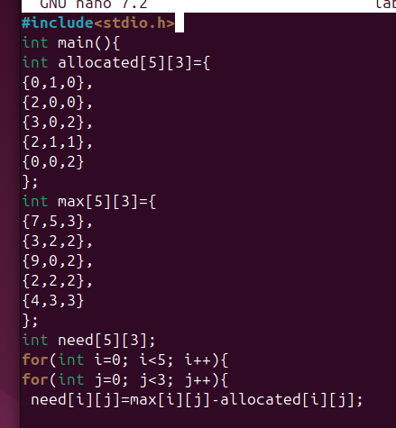
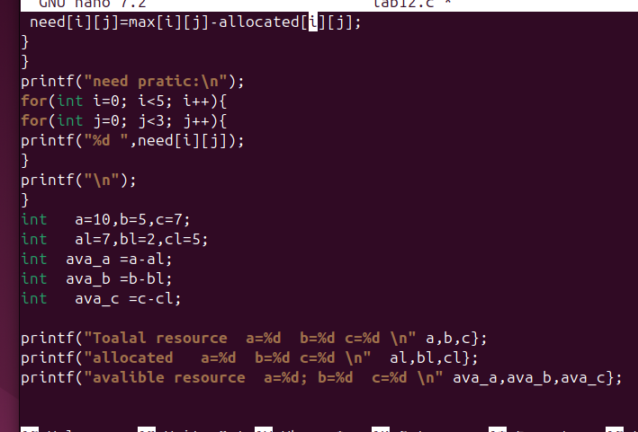

Output

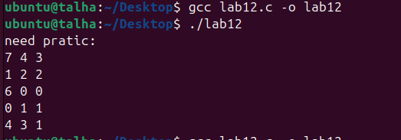

Explantion

Banker's Algorithm Implementation

🔹 Step 1: Define Total Resources
Specify the total number of resources available in the system for each resource type (e.g., A, B, C).

🔹 Step 2: Define the Allocation Matrix
Create a matrix to represent how many resources of each type are currently allocated to each process.

🔹 Step 3: Define the Maximum Demand Matrix
Specify the maximum number of resources each process may need to complete its execution.

🔹 Step 4: Calculate the Need Matrix
For each process, subtract the allocated resources from the maximum demand to find out how many more resources it still needs.

🔹 Step 5: Calculate Total Allocated Resources
Sum all currently allocated resources to find out how much of each resource is already in use.

🔹 Step 6: Calculate Available Resources
Subtract the total allocated resources from the total system resources to determine how many are still available.

🔹 Step 7: Check for a Safe Sequence (Optional - Full Algorithm)
Use the Banker's safety algorithm to check if the system is in a safe state and find the safe sequence of process execution.

