

Muhammad Talha
2330-0141
BS AI

Lab 11

Question no 01

Write a program to pass a message between a parent and child process using POSIX message queues.
Use fork() to create a single child process.
1. Use mq_open() to create the queue
2. Use fork() to split into parent and child
3. Child: use mq_send() to send a message
4. Parent: use mq_receive() to read it
5. Both: use mq_close() to close the queue
6. Parent: use mq_unlink() to remove the queue

Code

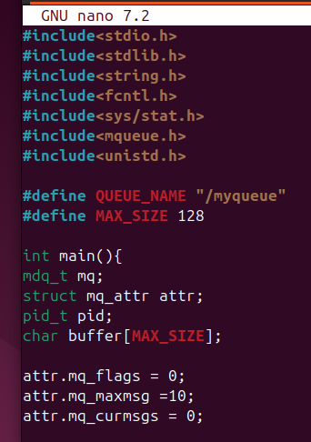
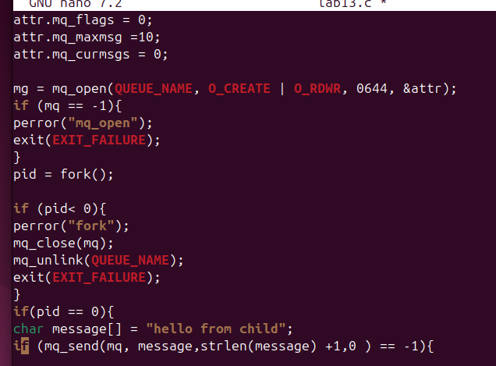
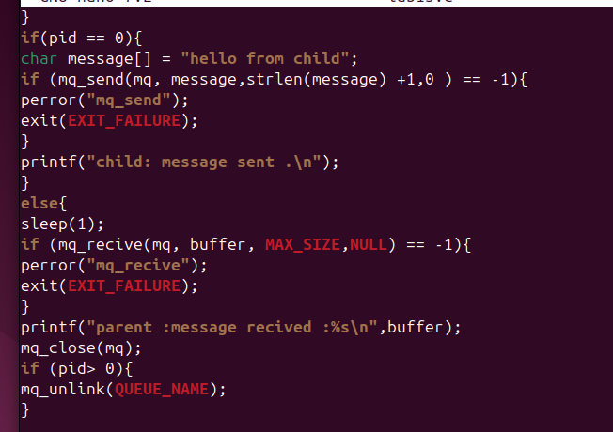

Output

