Two Stream Plasma Instability
Henry Johnson
Dispersion Relation
We start by finding the 1D dispersion relation for cold, two-stream plasma. We let the variable $i$ go from 1 to 2 for each beam in the two-stream plasma. We assume the densities are equal, $n_{1}=n_{2}=\frac{n_{0}}{2}$. We assume the background velocities are equal and opposite, $u_{1}=-u_{2}=u_{0}$. The equilibrium electric field is zero because the uniform distribution of charge does not produce a net electric field. Additionally, we assume a collisionless plasma, where the collision frequency is small compared to the characteristic plasma frequency. We also assume there is no magnetic field.
Continuity:
$$∂_{t}n_{i}+∇⋅\left(n_{i}u_{i}\right)=∂_{t}n_{i}+∂_{x}n_{i}u_{i}=0$$
Momentum:
$$∂_{t}u_{i} +\left(u_{i}⋅∇\right)u_{i}=∂_{t}u_{i} +u_{i}∂_{x}u_{i}=-\frac{e}{m}E$$
Poisson’s:
$$∇⋅E=∂_{x}E=\frac{e}{ϵ_{0}}(n_{1}+n_{2}-n_{0})$$
Linearize and add small perturbations:
$$n_{i}=n_{i}^{0}+n_{i}^{1}$$
$$u_{i}=u_{i}^{0}+u_{i}^{1}$$
$$E=E^{1}$$
Linearized equations:
$$∂_{t}\left(n^{0}+n^{1}\right)+∂_{x}\left[\left(n^{0}+n^{1}\right)\left(u^{0}+u^{1}\right)\right]=∂_{t}n^{1}+u^{0}∂_{x}n^{1}+ n^{0}∂_{x}u^{1}=0$$
$$∂_{t}\left(u^{0}+u^{1}\right)+\left(u^{0}+u^{1}\right)∂_{x}\left(u^{0}+u^{1}\right)=∂_{t}u^{1}+u^{0}∂u^{1}=-\frac{e}{m}E^{1}$$
$$∂_{x}E^{1}=\frac{e}{ϵ_{0}}(\left(n_{1}^{0}+n_{1}^{1}\right)+\left(n_{2}^{0}+n_{2}^{1}\right)-n_{0})$$
We then simplify for the first order equation to get $∂_{x}E^{1}=\frac{e}{ϵ_{0}}(n_{1}^{1}+n_{2}^{1})$

We assume solutions are in the form of $u \sim e^{i(k⋅x-ωt)}$ and $n \sim e^{i(kx-ωt)}$ to get
$$\left(-iω+iku_{i}^{0}\right)n_{i}^{1}+ikn_{i}^{0}u_{i}^{1}=0$$
$$\left(-iω+iku_{i}^{0}\right)u_{i}^{1}=-\frac{e}{m}E^{1}⇒u_{i}^{1}=-\frac{\frac{eE^{1}}{m}}{-iω+iku_{i}^{0}}$$
We plug this back into the continuity equation.
$$\left(-iω+iku_{i}^{0}\right)n_{i}^{1}+ikn_{i}^{0}\left(-\frac{\frac{eE^{1}}{m}}{-iω+iku_{i}^{0}}\right)=0⇒n_{i}^{1}=\frac{ien_{i}^{0}k}{m}⋅\frac{E^{1}}{{\left(ω-ku_{i}^{0}\right)}^{2}}$$
Substituting this back into Poisson’s equation yields
$$ikE^{1}=\frac{e}{ϵ_{0}}\left(n_{1}^{1}+n_{2}^{1}\right)=\frac{e}{ϵ_{0}}\left(\frac{ien_{1}^{0}k}{m}⋅\frac{E^{1}}{{\left(ω-ku_{1}^{0}\right)}^{2}}+\frac{ien_{2}^{0}k}{m}⋅\frac{E^{1}}{{\left(ω-ku_{2}^{0}\right)}^{2}}\right)⇒$$
$$1=\frac{ω_{p}^{2}}{{\left(ω-ku_{1}^{0}\right)}^{2}}+\frac{ω_{p}^{2}}{{\left(ω-ku_{2}^{0}\right)}^{2}}=\frac{ω_{p}^{2}}{{\left(ω-ku_{0}\right)}^{2}}+\frac{ω_{p}^{2}}{{\left(ω+ku_{0}\right)}^{2}}$$
This gives us the dispersion relation
$$1-\frac{ω_{p}^{2}}{{\left(ω-ku_{0}\right)}^{2}}-\frac{ω_{p}^{2}}{{\left(ω+ku_{0}\right)}^{2}}=0$$
We define $\overline{ω}=\frac{ω}{ω_{p}}$ and $\overline{k}=\frac{ku_{0}}{ω_{p}}$, and substitute into the equation to get
$$1-\frac{ω_{p}^{2}}{{\left(\left\{{\overline{ω}ω}_{p}\right\}-\{{\overline{k}ω}_{p}\}\right)}^{2}}-\frac{ω_{p}^{2}}{{\left(\left\{{\overline{ω}ω}_{p}\right\}+\{{\overline{k}ω}_{p}\}\right)}^{2}}=1-\frac{ω_{p}^{2}}{{ω_{p}^{2}\left(\overline{ω}-\overline{k}\right)}^{2}}-\frac{ω_{p}^{2}}{{ω_{p}^{2}\left(\overline{ω}+\overline{k}\right)}^{2}}=0$$
This yields the normalized dispersion relation

 | $$1-\frac{1}{{\left(\overline{ω}-\overline{k}\right)}^{2}}-\frac{1}{{\left(\overline{ω}+\overline{k}\right)}^{2}}=0$$ | (1)

We want to find where instability occurs in the plasma. To do this, we break the equation into $\overline{ω}=ω_{r}+iγ$. Instability occurs when $γ≠0$. To find these values, we run a Python code where we vary wavelength $(\overline{k})$ and plot $γ$.
Finding the Real and Imaginary parts of $\overline{ω}$
Finding the analytical solution:
$$1-\frac{1}{{\left(\overline{ω}-\overline{k}\right)}^{2}}+\frac{1}{{\left(\overline{ω}+\overline{k}\right)}^{2}}=1-\frac{2\left({\overline{ω}}^{2}+{\overline{k}}^{2}\right)}{{\left({\overline{ω}}^{2}-{\overline{k}}^{2}\right)}^{2}}=0⇒{\left({\overline{ω}}^{2}-{\overline{k}}^{2}\right)}^{2}=2\left({\overline{ω}}^{2}+{\overline{k}}^{2}\right)⇒$$
$${\overline{ω}}^{4}-2{{\overline{ω}}^{2}\overline{k}}^{2}+{\overline{k}}^{4}=2{\overline{ω}}^{2}+2{\overline{k}}^{2}$$
We then substitute $X={\overline{ω}}^{2}$ to get
$$X^{2}+\left(2-2{\overline{k}}^{2}\right)X+\left({\overline{k}}^{4}-2{\overline{k}}^{2}\right)=0$$
We can then plug this into the quadratic formula and simplify (not shown) to get
$${\overline{ω}}^{2}={\overline{k}}^{2}+1±\sqrt{1+4{\overline{k}}^{2}}$$
Instability occurs when ${\overline{ω}}^{2}<0→\overline{ω}=iγ$, so we take the sign to be negative, and we solve for $γ$.
$${\overline{ω}}^{2}=-γ^{2}={\overline{k}}^{2}+1-\sqrt{1+4{\overline{k}}^{2}}⇒$$

 | $$γ=\sqrt{\sqrt{1+4{\overline{k}}^{2}}-{\overline{k}}^{2}-1}$$ | (2)

To find where the bounds should be, we set $γ$ equal to zero and find $\overline{k}$.
$$0=\sqrt{1+4{\overline{k}}^{2}}-{\overline{k}}^{2}-1⇒{\overline{k}}^{2}+1=\sqrt{1+4{\overline{k}}^{2}}⇒{\overline{k}}^{4}+2{\overline{k}}^{2}+1=1+4{\overline{k}}^{2}⇒$$
$${\overline{k}}^{4}-2{\overline{k}}^{2}={\overline{k}}^{2}\left({\overline{k}}^{2}-2\right)=0$$
This gives us the zeros of $\overline{k}=0,±\sqrt{2}$. We set $\overline{k}$ to be greater than or equal to zero, so we expect to see a range of $\overline{k}∈\left[0,\sqrt{2}\right]$.
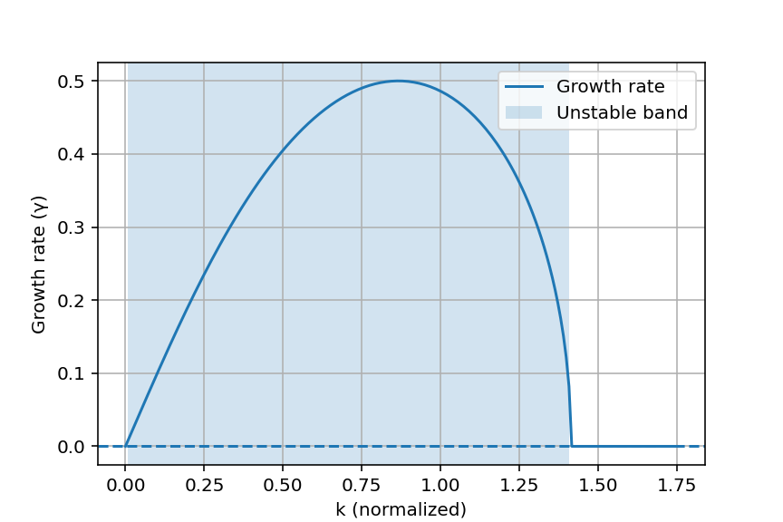
Figure 1. This graph shows the instable region of the growth rate, where gamma is greater than 0.

From the two streams of plasmas, the charged particles can interact to form a tiny electric field perturbation (a wave). The graph shows three different regions: For small k (long wavelengths), $γ≈0$. This is because the perturbation produced isn’t large enough to interfere with the streams, and there isn’t efficient energy transfer. For medium k, we have a bump in $γ$. This occurs because particles can stay in phase with a wave for long enough to transfer energy, thus reinforcing the perturbation. For large k, $γ≈0$. This happens because the wave oscillates too rapidly for particles to respond, and the energy transfer cancels out, resulting in a stable wave.

We also want to solve analytically for $ω_{r}$, which we can define as $\overline{ω}=ω_{r}$ and solve for $ω_{r}$.
$${\overline{ω}}^{2}=ω_{r}^{2}={\overline{k}}^{2}+1+\sqrt{1+4{\overline{k}}^{2}}⇒$$
 | $$ω_{r}=\sqrt{{\overline{k}}^{2}+1+\sqrt{1+4{\overline{k}}^{2}}}$$ | (3)

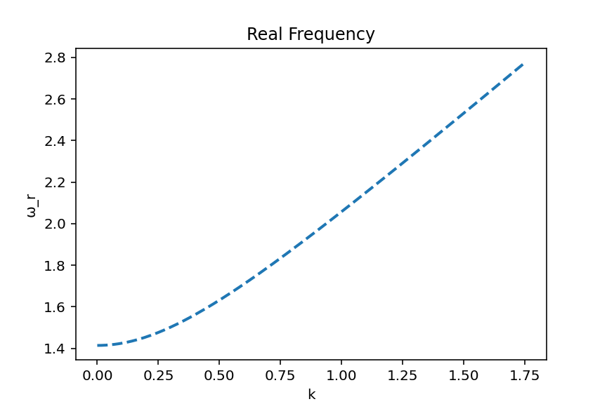
Figure 2. This plot shows the real frequency for the two-beam plasma.

Varying Background Velocity
We also want to look at what changes to the range of instability are made when we change the initial velocity $u_{0}$. To do this, we look at the range of
$$\overline{k}=\frac{ku_{0}}{ω_{p}}∈\left[{\overline{k}}_{min},{\overline{k}}_{max}\right]⇒$$
 | $$k∈\left[\frac{{\overline{k}}_{min}ω_{p}}{u_{0}},\frac{{\overline{k}}_{max}ω_{p}}{u_{0}}\right]$$ | (4)

This indicates that by scanning through different initial velocities, the plot of the growth rate should maintain the same shape and amplitude but will be horizontally stretched or compressed depending on whether $\frac{u_{0}^{'}}{u_{0}}>1$ or $\frac{u_{0}^{'}}{u_{0}}<1$.

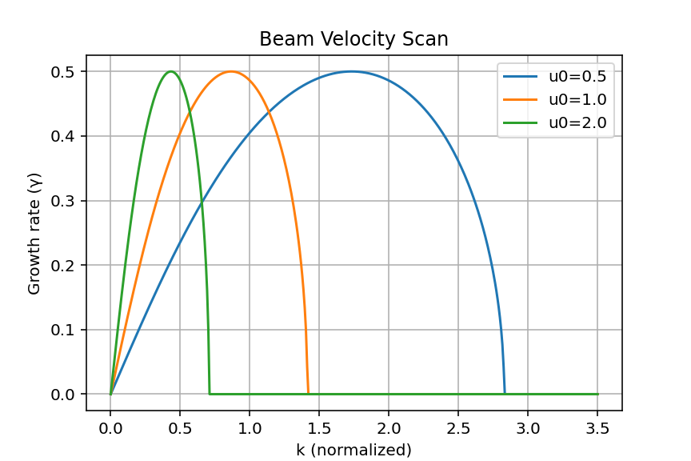
Figure 3. This graph shows how different velocities affect the values for the growth rate.

This is confirmed by the graph, as when we double the background velocity, the width of the instable band is halved, but the amplitude remains the same. Similarly, when we halve the background velocity, the width of the instable band is doubled.

Varying Plasma Density
We now want to look at what changes if we remove the assumption that the densities of the two plasmas are the same ($n_{1}≠n_{2}$). We start with the same formulas for $u_{i}^{1}$ and $n_{i}^{1}$.
$$u_{i}^{1}=-\frac{\frac{eE^{1}}{m}}{-iω+iku_{i}^{0}}, n_{i}^{1}=\frac{ien_{i}^{0}k}{m}⋅\frac{E^{1}}{{\left(ω-ku_{i}^{0}\right)}^{2}}$$
We then plug this into Poisson’s Equation to get:
$$ikE^{1}=\frac{e}{ϵ_{0}}\left(n_{1}^{1}+n_{2}^{1}\right)=\frac{e}{ϵ_{0}}\left(\frac{ien_{1}^{0}k}{m}⋅\frac{E^{1}}{{\left(ω-ku_{1}^{0}\right)}^{2}}+\frac{ien_{2}^{0}k}{m}⋅\frac{E^{1}}{{\left(ω-ku_{2}^{0}\right)}^{2}}\right)⇒$$
$$1=\frac{e^{2}n_{1}^{0}}{{mϵ}_{0}}⋅\frac{1}{{\left(ω-ku_{1}^{0}\right)}^{2}}+\frac{e^{2}n_{2}^{0}}{{mϵ}_{0}}⋅\frac{1}{{\left(ω-ku_{2}^{0}\right)}^{2}}$$
If we introduce a factor $α=\frac{n_{2}^{0}}{n_{1}^{0}}=\frac{ω_{p2}^{2}}{ω_{p1}^{2}}$ and assume that $u_{1}^{0}=-u_{2}^{0}=u_{0}$, we get the equation:
$$1=\frac{ω_{p1}^{2}}{{\left(ω-ku_{0}\right)}^{2}}+\frac{{αω}_{p1}^{2}}{{\left(ω+ku_{0}\right)}^{2}}$$
If we introduce the same normalization factors $\overline{ω}=\frac{ω}{ω_{p1}}$ and $\overline{k}=\frac{ku_{0}}{ω_{p1}}$, we get
 | $$1-\frac{1}{{\left(\overline{ω}-\overline{k}\right)}^{2}}-\frac{α}{{\left(\overline{ω}+\overline{k}\right)}^{2}}=0$$ | (5)

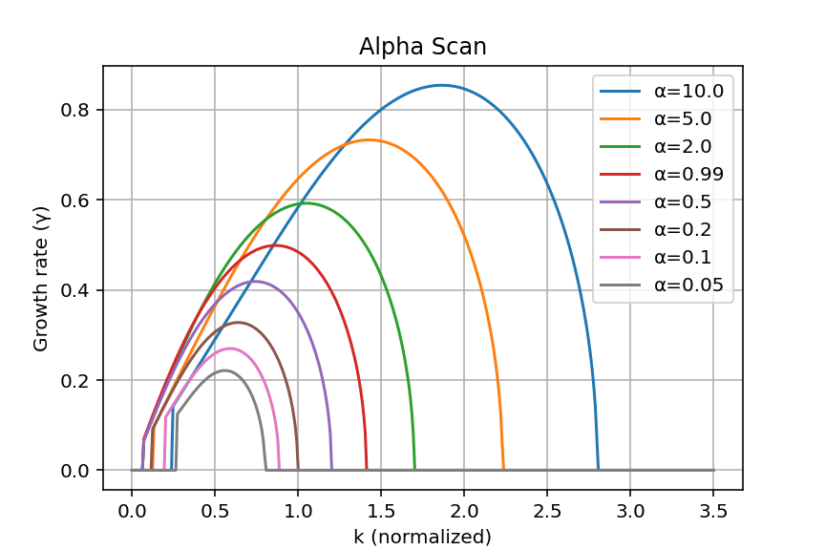
Figure 4. This plot shows the way different densities of plasmas affect the instability growth rate.

Exploration of Small $α$ Values
Next, we want to explore small $α$ values. We start by plotting the same graph with only very small $α$ values.
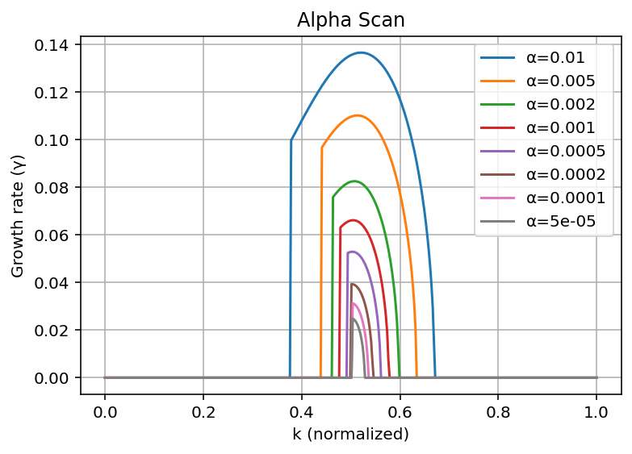
Figure 5. This plot shows how very small alpha values have peaks at about k =.5

If we assume that $α≪1$, we see that instability will occur near $\overline{k}≈\frac{1}{2}$. We introduce small differences of $\overline{k}=\frac{1}{2}-ϵ$ and $\overline{ω}=-\overline{k}+δ$. By plugging the $\overline{ω}$ value into the dispersion relation, we get
$$1-\frac{1}{{\left(-2\overline{k}+δ\right)}^{2}}-\frac{α}{δ^{2}}=0$$
Since $δ$ is small, we can approximate this and plug our $\overline{k}$ value into the equation to get
$$\frac{1}{{\left(-2\overline{k}+δ\right)}^{2}}≈\frac{1}{{\left(2\overline{k}\right)}^{2}}≈1+4ϵ$$
The original equation then simplifies to
$$1-\frac{1}{{\left(-2\overline{k}+δ\right)}^{2}}-\frac{α}{δ^{2}}=0≈1-\left(1+4ϵ\right)-\frac{α}{δ^{2}}⇒δ^{2}=-\frac{α}{4ϵ}$$
Since $δ$ and $ϵ$ are on the same order, we can make the assumption $δ \sim ϵ$, yielding
$$δ^{2}=\frac{α}{4δ}⇒δ \sim - α^{\frac{1}{3}}$$
And because $δ=iγ$, we can find a formula for the magnitude of these two quantities
 | $$γ_{max} \sim α^{1/3}$$ | (6)

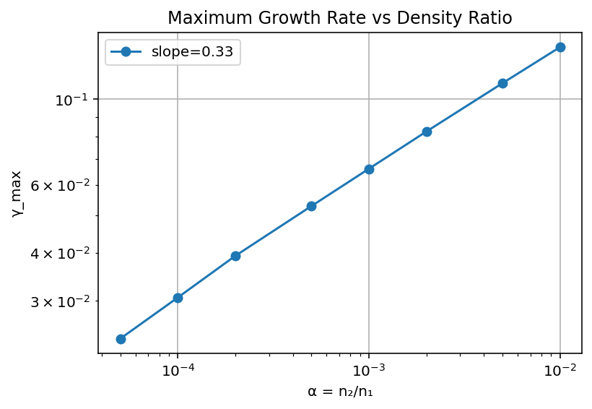
Figure 6. This plot shows the relationship between maximum growth rate and density ratio.

