PROFESSIONAL PROFILE

* Creative award holder 1998, from the creative Arab students’ conference, for developing simulation application for the control lab experiments.
* Senior level in Supply Chain with in-house training, consultancy, and coaching experience.
* Digitized multiple operations, inventory control cycle, control tower platform for orders & shipments management to ensure visibility and alerts, production work-load distribution for multiple units, supplier and customer profiles with scorecard, behavior, claims and meetings, multiple ERP’s setup.
* Project management skills in operational projects, Costing & BoM Audit, Lean 6-Sigma, Digitalization.
* Data-based decision making: Descriptive, Predictive and Prescriptive. Qualitative and Quantitative
* Developed multiple event-driven systems, using power automate and coding
* Managing full cycle of ERP setup, from AS-IS situation, gap-analysis, process design and reengineering, dashboard building, regular and alerts reporting
* Developing chat bot systems using WhatsApp API, and JavaScript voice recognition
* Developed mobile app, including server interaction, attached flyer of my mobile-workforce project
* Active member at [stackoverflow](https://stackoverflow.com/users/2441637/hasan-a-yousef) since 2014

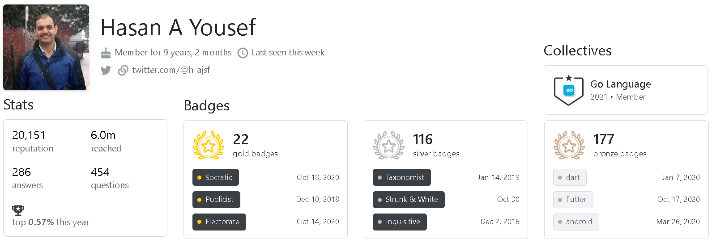

WORK EXPERIENCE

MOST RECENT; LAST 13 YEARS (SAUDI ARABIA)

* + *Supply Chain Manager* – Aujan Industrial Supplies and Services, Dammam, Oct 2019 to Oct 2021
  + *VP of Supply Chain, IT and Projects* – United Arab Float Glass Co, Yanbu, Aug 2018 to Aug 2019
  + *Supply Chain Manager* – BASF Construction Chemicals, Dammam, May 2017 to Aug 2018
  + *Supply Chain and ERP Manager* – Bischof + Klein Company, Dammam, Jan 2014 to May 2017
  + *Senior Supply Chain Planner* – Nalco Saudi, (US based), Dammam, Nov 2009 to Nov 2014

PREVIOUSE 10 YEARS (KUWAIT AND JORDAN)

* + *Purchase and Production Manager*– H.Abul Wood Working Factory, Kuwait, Nov 2007 to Nov 2009
  + *Production Planning & Control Engineer*– RISCO/COOLEX, Kuwait, Feb 2004 to Nov 2007
  + *Operations Engineer* – Petra Engineering and Industries Co, Amman, Oct 1998 to Feb 2004

PROFESSIONAL EDUCATION

* BSc of Industrial Engineering, University of Jordan, Amman – Jordan – Sept 1993 to June 1998
* Certified Supply Chain Manager, GS1 Saudi Arabia + ISCEA OH, USA, 2014
* Project Management Professional (PMP) workshop, PMI # 1974871, Saudi Arabia, 2011

HIGHLIGHS AND KEY ACHIEVEMENTS

* Established Supply Chain department (in more than a company), with governance system, procedures, and workflows, covering all Supply Chain drivers: Demand & Supply Planning, Forecasting, Sourcing, Contracting, Purchasing, Material & Inventory Management, Warehousing, Logistics & Transportation Management, Customer Service, Production, IT/ERP, Import and Export Trade Compliance, …
* Saved more 1M$ in a yearly basis, and 3M$+ of cash and working capital

SCOPE OF WORK, OPERATIONAL ACHIEVEMENTS & ACTIVITIES

* Full Source-to-pay (S2P) process starting from finding, negotiating with, and contracting the supplier of goods, and ending with supplier performance continuous review, passing through the full planning cycle and restrictions, trade compliance, logistics, freight, Operation, and final payment for those goods, considering working capital and revenue recognition management.
* Lead digital transformation processes along with setting business rules with sales and production teams to create synergy, avoid surprises and reduce conflicts
* Digitized workload capacity calculation for each workstation to achieve planning balancing and improve the 5M resources (Men, Material, Machines, Methods, and Money) utilization
* Designed full procurement process cycle: Requirement definition, Tendering and sourcing, Evaluation and selection, Contract risk, Contract awarding, Contract management and Procurement planning, to achieve the best 5R’s (Right-Quantity, -Quality, -Price and -Place) embracing the 4R’s (Responsiveness, Reliability, Resilience - and – Relationships)
* Digitalized Inventory Control system considering modern techniques (MRP, EOQ, ABC, JIT, RoP, FIFO/FEFO, Min-Max, VMI, Consignment, Drop Shipping, Pull/Push) and all restrictions and uncertainties including Product-mix, Shelf live, Space availability, MoQ, MoV, Lead time, ...
* Designed warehouse operation, layout, Item Master, Method Statement for loading/keeping/handling/offloading processes for each SKU (more than 10,000 SKUs)
* Senior level of Leadership, Scope Management, Coaching, Developing and Training, Projects Management, Governance and Control, Resources and Capabilities Utilization, Compliance, Risk Managements, Digitalization and developing sustainable solutions with cross functional collaboration harmony and synergy.
* Working experience with FMCG, retail and manufacturing businesses, B2B and B2C, O&G, Plastics, Glass, Wood, HVAC, safety, and PPE, with top international companies (US and Germany based).