**Other researches, their metrics:**

**Intelligent_Traffic_Routing_Algorithm_fo:**

In this study, 3 equations are used to control packet congestion.

1 **packet set**:

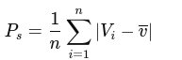

This equation calculates the average variation between the actual congestion and the predicted congestion, where *Vi* represents the actual congestion, and *v‾* is the predicted congestion.

2 **Traffic speed**:

Although this is referred to as "traffic speed," it actually measures the intensity of the variance between actual and predicted congestion.

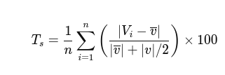

3 **congestion index**:

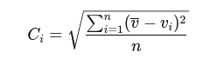

The higher the congestion index, the greater the likelihood of congestion occurring.

**link_utilization.pdf:**

States that this is the most used metric, but does not show an equation. But it uses this as a metric.

**Packet_loss.pdf**:

Uses packet loss as a metric. The equation for this is:

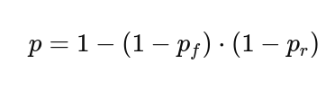

Pf and Pr represent the probabilities of successfully receiving the packet in the forward and reverse directions, respectively. By subtracting each probability from 1, we get the probability of a failure in each direction (i.e., the probability that the packet is not received). Multiplying these probabilities gives the chance that both directions succeed. Finally, subtracting this product from 1 yields the probability that at least one direction fails, resulting in an unsuccessful transmission. If both directions are successful (Pf and Pr are 1), then the equation becomes 1 - (1 - 1)(1 - 1) = 1 - 0 = 1, indicating a 100% success rate**.**

**P-4 based:**

**Link utalization:**

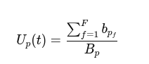

This metric represents the utilization of a network port *p* at time *t*. Here, *bpf* is the bandwidth allocated to flow *f* on port *p*, and *Bp* is the total capacity of port *p*.

**Demand rate**:



This metric calculates the demand rate for a specific flow *f* over a time interval *τ* where *Rxf(t)*is the total received bytes from flow *f* at time *t .*

**Cost rate**



Represents the cost associated with allocating bandwidth to a flow *f*, where *bf* is the allocated bandwidth and *C* is the cost per unit of bandwidth.