1) You’ll find prostate MRI data of 3 patients in this folder.

<https://drive.google.com/drive/folders/1bLjKHSv5pL_UOmgPvt2juzv35NO97ZrO?usp=sharing>

PM – is the prostate mask, T2 and ADC are the MRI sequences

2) You should be able to view these images with 3D Slicer or ITK Snap – both are free to download open source software. I have created a small tutorial that can help you.

<https://www.youtube.com/watch?v=qDFXod306gM>

2) You’ll need to familiarize yourself with simpleITK and openCV libraries in Python. Some useful tutorials below:

<https://theaisummer.com/medical-image-python/>

<https://www.coursera.org/projects/image-processing-with-python>

**Assignment**: A) Load an image and segmentation into Python. Overlay the segmented mask onto image so as to display only the region of interest. Print these images.

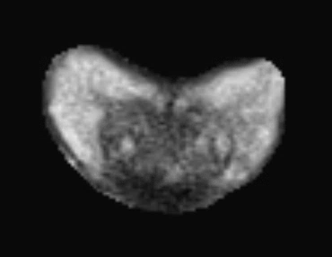

Original Image
  
 (a) Original Image (b) Mask overlaid to display only the prostate

B) Overlay an outline of the mask on the original image and save it as a PNG. Sample result below.