**SWE 574 Software Development Practice, Spring 2015**

**Instructor: Suzan Üsküdarlı**

**Project Timeout**

**Requirement Specification Document**

**Revision 2.0**

**23.05.2015**

**By Team Timeout**

|  |  |
| --- | --- |
| Ali Haluk Seven | 2013719111 |
| Hakan Keçelioğlu | 2012719132 |
| Morteza Bandidarian | 2013719015 |
| Münevver Calayır | 2012719021 |
| Oğuz Çam | 2013719039 |
| Sezgi Seret | 2013719108 |
| Tuncay Altınpulluk | 2013719006 |

# Revision History

|  |  |  |
| --- | --- | --- |
| **Revision** | **Date** | **Explanation** |
| 1.0 | 08.03.2015 | Initial requirement document |
| 2.0 | 23.05.2015 | Final requirement document |

# Table of Contents

Revision History 2

Table of Contents 3

1. Introduction 4

2. Requirements List 4

3. Overall Use Case Diagram 6

4. Use Case Details 7

4.1. Actors 7

4.2. Use Cases Descriptions 7

5. Non-functional Requirements 9

6. Glossary 9

7. Initial Structure 10

References 11

# Introduction

The purpose of this project is to develop a web and mobile application for members of the CMPE Community to create and organize content and connect with each other in meaningful ways. It aims to create information paths that can be utilized for more effective and enjoyable collective action. This application will enable participants to create interest groups or events and invite people on the system. Others who are interested in such interest groups can subscribe and interact about interest. In scope of this project, there will be a mobile and web interface for your project.

This Requirement Specification Document is prepared according to arranged meetings and customer's needs. This document aims to be base for preparing design document and gives an idea about the project to all participants, business analysts, architects and developers who will work for the project.

This document consists of functional and non-functional requirement list, use case diagrams with descriptions for each actors and glossary

# Requirements List

|  |  |  |
| --- | --- | --- |
| **No** | **Requirement** | **Use CASE (s)** |
| 1 | To let users identify themselves by entering email address and password, in order to access the contents of the website. Alternatively, external login options can be supplied to the user (like Facebook or Google login). | Sign in |
| 2 | To create users by entering user’s name(s), last name, email address, password, and role in the Boğaziçi University (student, alumni, staff, assistant, and professor xxxxxx). To set a reasonable minimum length for the user password. The users will be held in the pending mode until an admin approves them. | Sign up |
| 3 | To let the users enter their first name, last name, phone number, address, birth date, about, interest, gender, language (not in the sign up page, but later.) | Update account |
| 4 | To let the users deactivate their accounts. | Deactivate account |
| 5 | To let the admin approve the signed up pending user. | Approve user |
| 6 | To let the users create events in the web page or mobile application. The events must have title, description, start date/time (now for default) and finish date/time. The events may have location information. The user may enter tags starting with “#” in the title or description. | Create event |
| 7 | To let the users create groups in the web page or mobile application. The groups must have title and description. The user may enter tags starting with “#” in the title or description. | Create group |
| 8 | To let the admin define new admins. | Define new admins |
| 9 | To let the user set the privacy of the events or groups. The privacy types are, public for all, public for my role, public for specified role(s) or user(s). | Set privacy |
| 10 | To let the users access the old events, which the user has joined or created. | View archive |
| 11 | To let the users update the events or groups. | Update event/group |
| 12 | To let the users delete the events or groups. | Delete event/group |
| 13 | To let the users insert comments to the group or event page. | Insert comments |
| 14 | To let the users update comments to the group or event page. | Update comments |
| 15 | To let the users delete comments to the group or event page. | Delete comments |
| 16 | To let the users subscribe to events and groups. | Subscribe event/group |
| 17 | To let the users unsubscribe to events and groups. | Unsubscribe event/group |
| 18 | To let the users search other members. | Search members |
| 19 | To let the users search groups or events. The search must be from the tags (If there are no tags, from the description or content). The semantic tagging technique must be used during the search. | Search events/groups |
| 20 | To let the users invite other users to a group. | Invite user to group |
| 21 | To let the users invite other users to an event. | Invite user to event |
| 22 | The system will notify the users about the upcoming events and interesting groups | Event and group recommendation |
| 23 | To let the admin reject the signed up pending user. | Reject user |
| 24 | To let the admin see the pending users from the Pending Users page | Pending users |
| 25 | To let the user activate his/her deactivated account | Activate account |

# Overall Use Case Diagram

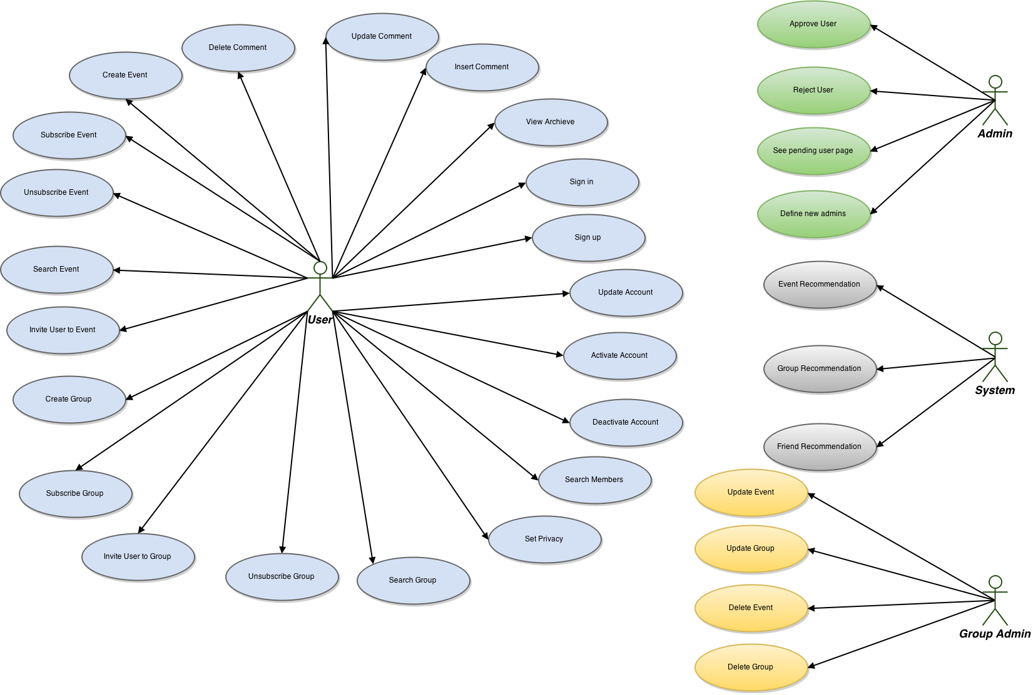

**Figure 1: Timeout Project Overall Use Case Diagram**

# Use Case Details

# 4.1. Actors

|  |  |
| --- | --- |
| **Actor** | **description** |
| User | User uses web or mobile application to create or organize content and connect with other users in meaningful ways such as in the events or in the groups. |
| Admin | A type of user with administrative privileges such as defining new admins, approving user, rejecting user and seeing pending user page. |
| System | A type of actor, which notifies the users about the upcoming events and interesting groups, in the application. |
| Group Admin | A type of user who has the ability to manage group activities such as update event, update group, delete event or delete group. |

# 4.2. Use Cases Descriptions

|  |  |  |
| --- | --- | --- |
| **Actors** | **Use Case** | **Description** |
| User | Sign in | User will be able to sign into the system with an e-mail address and a password so that he/she can access the contents of the website. |
| User | Sign up | A new user will register by creating a username, a last name, an e-mail address, a role and a password so that the system can remember his/her personal information. Also user is able to sign up using the website with his/her Facebook account so that he/she doesn't have to create new credentials. |
| User | Update Account | User can update his/her account details so that he/she can change any inaccurate information such as name, surname, gender, password, contact info, languages, department, faculty, education level, etc. except email address. |
| User | Deactivate account | User can deactivate his/her account and hide his/her information on the system. This deactivation should be in two ways, temporary or permanent. |
| User | Activate account | User can activate his/her account on the system when his/her account is deactivated. |
| Admin | Approve user | User's membership is approved in a reasonable time after the registration. Information about his/her status is emailed as soon as he/she is approved or rejected. In addition to this, an admin has the ability to approve membership of new members. If he/she reject or approve the membership, the user will be informed about the situation with an email. |
| User | Create event | A user can create an event with a specific event date. In order to determine who will be invited to the event, there will be choices such as Choose role, Choose interest group, All members and My friends. |
| User | Create group | User can create group with providing a group name, description and privacy setting such as public or private. He/she can also invite, remove or change status of the members (group admin). He/she can inform all members of the group by sending notification. In addition to this, when a user wants to join the group he/she created, he/she will see pending requests and he/she or other group admins (who he/she defined) can accept or reject pending requests. And accepting or rejecting requests will be shown as a notification. |
| User | Set privacy | User can set privacy of his/her events or groups as public or private and modify it later. His/her events or groups are visible to specific group of people according to his/her privacy setting. |
| User | View archive | User can view a list of his/her recent posts. He/she can view all past event with a descending order. |
| User (Group admin) | Update event/group | User (student, lecturer, staff, etc.) is able to update created events/groups (content, subject, time, etc.) by himself/herself so there is no worry when a mistake in event/group is observed. |
| User (Group admin) | Delete event/group | User is able to delete created event or group by himself/herself, so no one can see it anymore. |
| User | Insert comments | User is able to comment on events or groups, so others can see what is in his/her mind about the topic. |
| User | Update comments | User is able to update his/her comments on events or groups, so others can see what is in his/her mind about the topic. |
| User | Delete comments | User is able to delete his/her comment on events or groups, so others cannot see what he/she commented earlier. |
| User | Subscribe event/group | User is able to subscribe to an event/group by clicking the related button, so others can know which event he/she join; so he/she can receive the actions on that group on his/her homepage. |
| Admin | Define new admins | Admin can define new admins to the system, so they can act as an admin on the system. |
| User | Unsubscribe event/group | User is able to stop subscribing any events or groups by choosing the related event/group and clicking unsubscribe button. So that, he/she will no longer get information about these events/groups. |
| User | Search members | User can find people that he/she know or want to know by entering their name, surname or email address. So that, he/she can request to add them to his/her friend list. After that user accepts the request, they should be in friend list of each other’s. |
| User | Search events/groups | User can search events/groups with some tags or some words to see if related words are mentioned in the events/groups. So that, he/she can subscribe that group or event. |
| User | Invite user to group | User can invite any other user to the group he has already created, with clicking "Invite button" in the group page. In that case, the invited person can see a notification in his homepage, and click the accept button, and he/she become a member of the group. |
| User | Invite user to event | User can press the Invite button in the event page, and invite his/her friend to the event. Then the invited person can see a notification in his/her homepage, and click the accept button, and he/she become a member of the event. |
| System | Event and group recommendation | System finds the online users. Then for each user, finds the tags that the user searched before. Gets the semantic results of the tags. Then, checks if there are events, whose ending time is approaching (like %30 of its live life has passed) and related with these tags. Then, sends a notification to the users about the event. In addition to this, system finds the online users. Then for each user, finds the tags that the user searched before. Gets the semantic results of the tags. Then, checks if there are new groups related with these tags. Then, sends a notification to the users about the group. |

# Non-functional Requirements

* Application should work on any environment.
* This application will be specific to the CMPE department at Boğaziçi University.
* There will be a mobile and web interface for the project.
* The server side will be developed with Java.
* MySQL should be used to store data.
* Java should be used as programming language.
* Any development environment or framework can be used.
* All actions of users should be logged to Google cloud log, where log records are in date and time order.

# Glossary

This glossary aims to give short description about timeout project.

|  |  |
| --- | --- |
| **Term** | **Description** |
| User | User uses web or mobile application to create or organize content and connect with other users in meaningful ways such as in the events or in the groups. |
| Admin | A type of user with administrative privileges such as defining new admins, approving user, rejecting user and seeing pending user page. |
| System | A type of actor, which notifies the users about the upcoming events and interesting groups, in the application. |
| Event | An activity |
| Group | Interest group |
| Tag | Tag helps to describe an item and allows it to be found again by browsing or searching. |
| Account | A user's account allows a user to authenticate to the system. |
| Rejected User | If an admin rejects a user, the user cannot use the system. |
| Approved User | If an admin approves a user, the user can use the system. |
| Pending User | Pending user is a user who signed up and waiting to be approved. An admin has also right to reject the user. |
| Comment | Comments let people comment on content on the web or mobile application. |

# Initial Structure

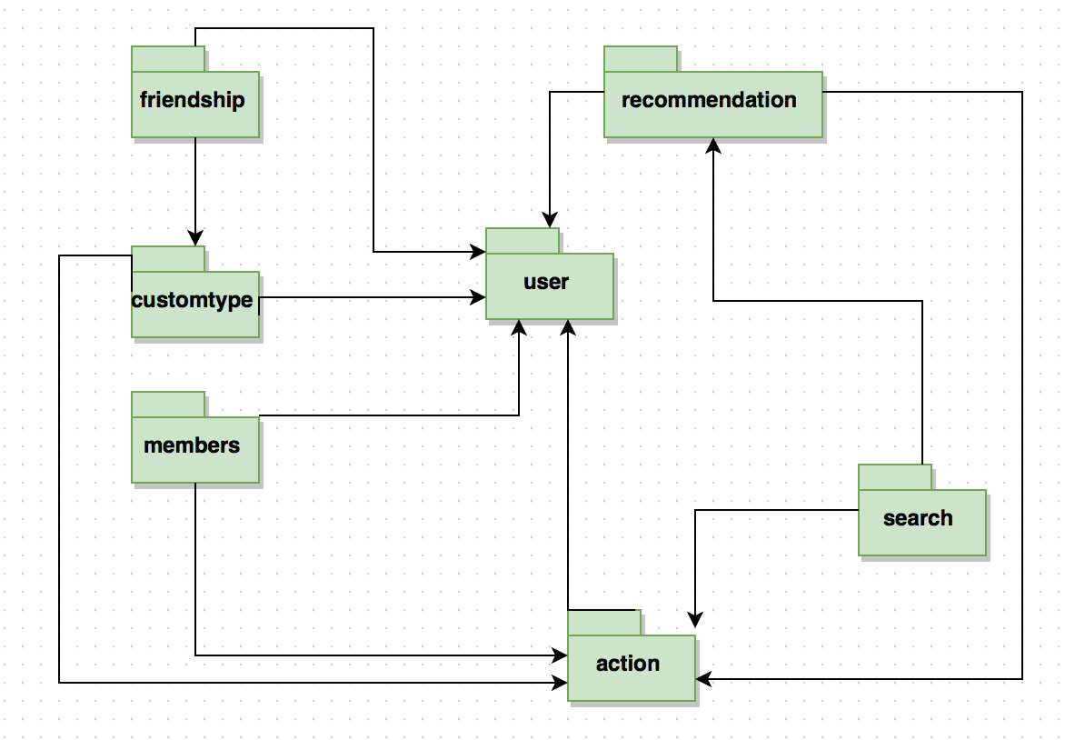

**Figure 2: Initial package architecture**

# References

* Project Definition Paper shared by the customer
* Project Description <https://piazza.com/class/i5y1z7imxas7bf?cid=8>
* Diagram Tool <https://www.draw.io>
* Bennett, McRobb, Farmer, Object Oriented Systems Analysis and Design Using UML, McGraw-Hill, 2010, 4th Edition.