CSE4057 - Information Systems Security Project 2

150117060 Ahmet Hakan Şimşek

150116062 Muhammed Bera Koç

150119740 Senanur Güvercinoğlu

In this project we have built on previous term project, added the project additional security.

To run client we need to run server, by running server, server creates its own public and private RSA key pairs and store them.

To log in to program user need to enter previously registered username and password or if new registration is in process then program creates new user with password that is saved in data.json file

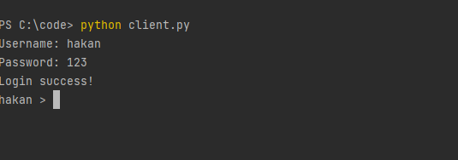

After users logged in to program, then they are in public chat where anyone’s message is seen by everyone. Also after log in, each user creates its own public private RSA key pairs and sends their public key to server to as certificate. In certificate authorithy(server) every users’ public key is store as encrypted with servers public key which mean they are only by decrypted with server itself

In public chat we did not used any crytology

But users can be get in peer to peer private chat by using “@PM ” with name prefix and handshake phase starts

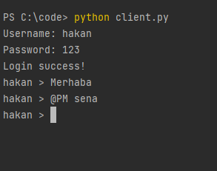

And user send its public key with nonce to requested user by message as follows

If user press y(yes) then, it gets requester’s(hakan) public key by verifying from certificate authority(server) which is encrypted with server’s private key.

When requested user press y(yes), user sends its public key and sends nonce, AES key, IV, HMAC encrypted with pair’s public key which can only be decrypted with pair’s private key.

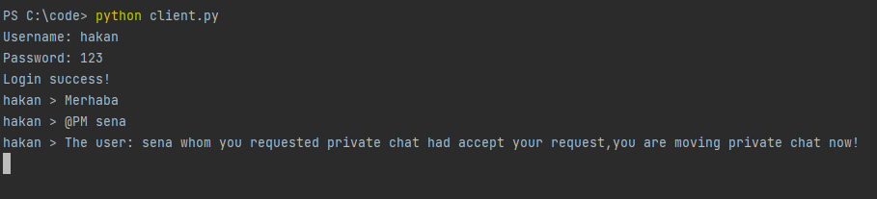

After AES key is distributed to other side with RSA encryption, then they can send messages each other by using AES encryption and those messages sent with AES are not seen by anyone else. Also messages are hashed with message authentication code(HMAC) to provide integrity.

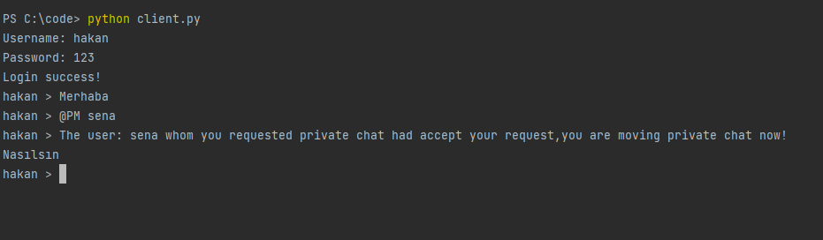

Other users cannot see anymore sena and hakan’s private chat

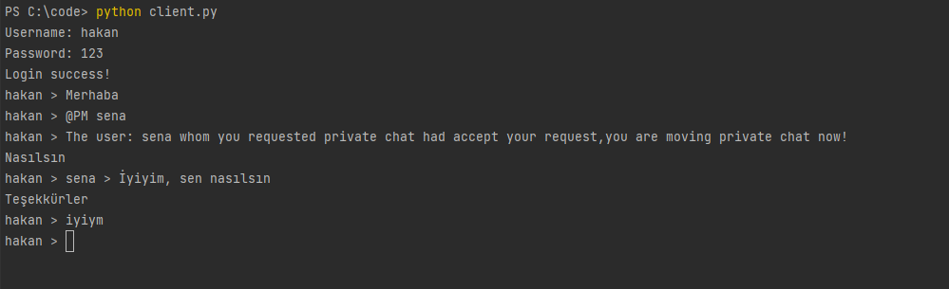

While they are messaging in private chat their encrypted messages and message authentication code(MAC) logged as follows



While these things happening other users cannot see anything.

Then if one of user writes “PMEXIT” then they return to public chat and all logged in users can send message to each other without encryption.

These is the general way of work of this program.

Security hole

* If any encryption key is known then all messages sent over that key can be seen easily
* Solution to this problem is key update mechanism, to prevent decrypt all other messages, we need to use key update mechanism by using these technique each message encrypted with different key and one key only decrypt one message.