**Java**

**Prerequisites:**

-None

**Installation:**

**1.**Search for “install java jdk” on google.

**2.** Choose the first link. You should go to the oracle site. The direct link is <http://www.oracle.com/technetwork/java/javase/downloads/index.html>

**3.**Select the Java Platform JDK Link.

**4.**Accept the license agreement.

**5.**Choose the Java Install for your Operating System. If you are windows 64 bit operating system, choose the Windows x64 java. If you are using windows and do not know if you are using 64-bit or 32-bit, you can visit <https://support.microsoft.com/en-ae/help/15056/windows-7-32-64-bit-faq>.

**6.**Wait for the download to complete. Double click the file from the downloads folder. Java Installer would launch up. Click Continue.

**7.**Click install on the next screen.

**8.**Have a coffee and wait for the installation to complete. When the installation is complete, you would see the screen below:

**9.**First you should add java to your path

**1.**Right click on my computer. Click on properties.

**2.** Click on advanced system settings.

**3.** Click on Environment Variables.

**4.** Click on new.

**5.** Copy the java path up to bin folder.

**6.** Paste this path in variable value and write path in variable name. Click ok.

**7.** Click ok.

**8.** Click ok.

**Check:**

-If you are on Windows : Open the Command Prompt window by

-Click the Start button

-Select All Programs -> Accessories > Command Prompt.

-Or use Ctrl + Esc, and type in cmd and launch up command.

-If you are on Mac or other OS, launch up Terminal.

-cmd + space -> Type terminal -> Press enter

-Type in the command “java –version” as shown in the screen. If it does not work, go to the trouble shooting section.

**Eclipse**

**Prerequisites**

-Java JDK 12

**Installation**

Search google for “download eclipse” and choose the first result.[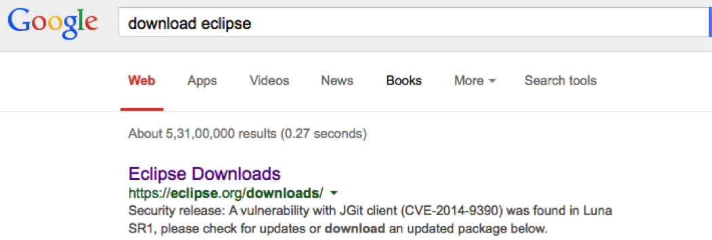](https://github.com/in28minutes/getting-started-in-5-steps/blob/master/images/google-search-download-eclipse.png) [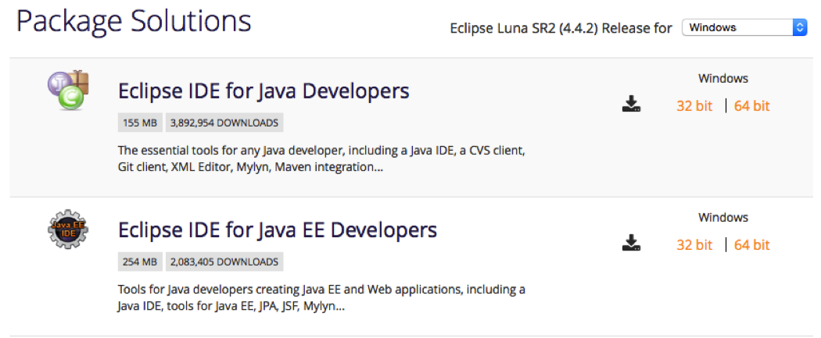](https://github.com/in28minutes/getting-started-in-5-steps/blob/master/images/eclipse-choose-installation.png)

-Click download.

-Wait for the download to complete.

-Open exe file.

-Choose eclipse ide for java developers.

-Set your download directory.

-Click install button.

-Accept terms.

-Set your work space directory.

-Open project folder on eclipse ide.

-Click run button.