Operating System Project 2: Report

First of all, our program splits the return value of path command delimeter as ‘:’ .After that, setup function work which takes input and load into args and determine value of background. After setup function it check if input starts with ‘myshell:’ if it start with shell: then it will delete it, if it is not start with myshell: it works as well.After checking ‘myshell’ our program checks for part B if input is in part B format, if it goes into that part fork itself and wait for user to enter input. If input is not in part B findPath function work to find path of specific function if it find path then execForProcess function work.In that function it forks itself and works for part A.

In part a, first we fork the process and load the appropriate variables to execv function and it work itself. If input includes & we understand that this process is background process which means we are not going to wait for that process, if input does not contain & we are going to wait for that process. Basicly it works like that.
While doing part A hardest part for me is tracing for child process.While in debug mode we can trace only for parent process we cannot trace child processes and forming queue in c a bit complicated for me compare to other languages.

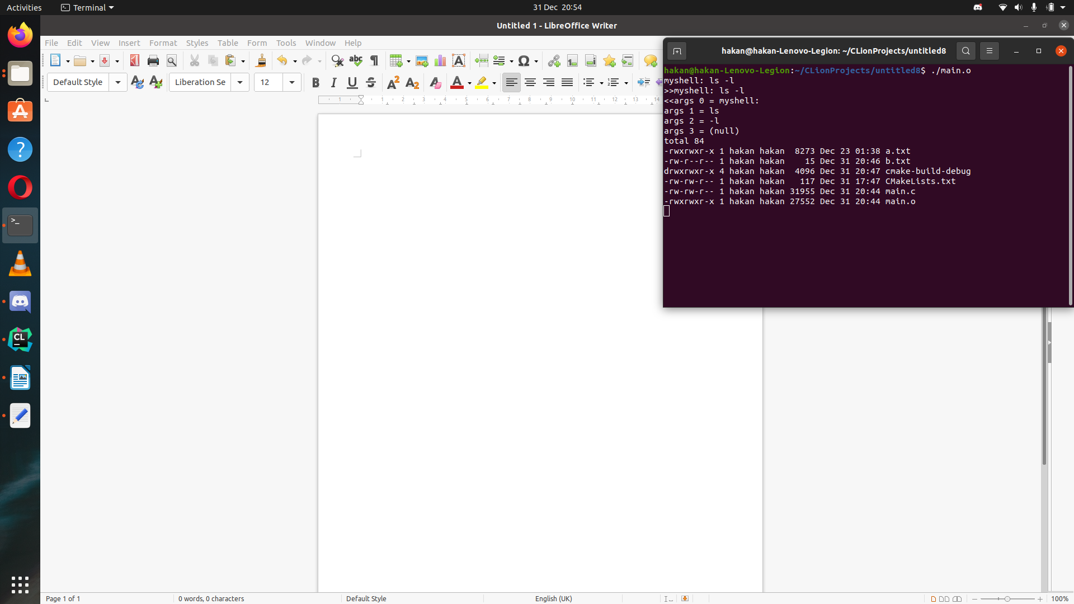

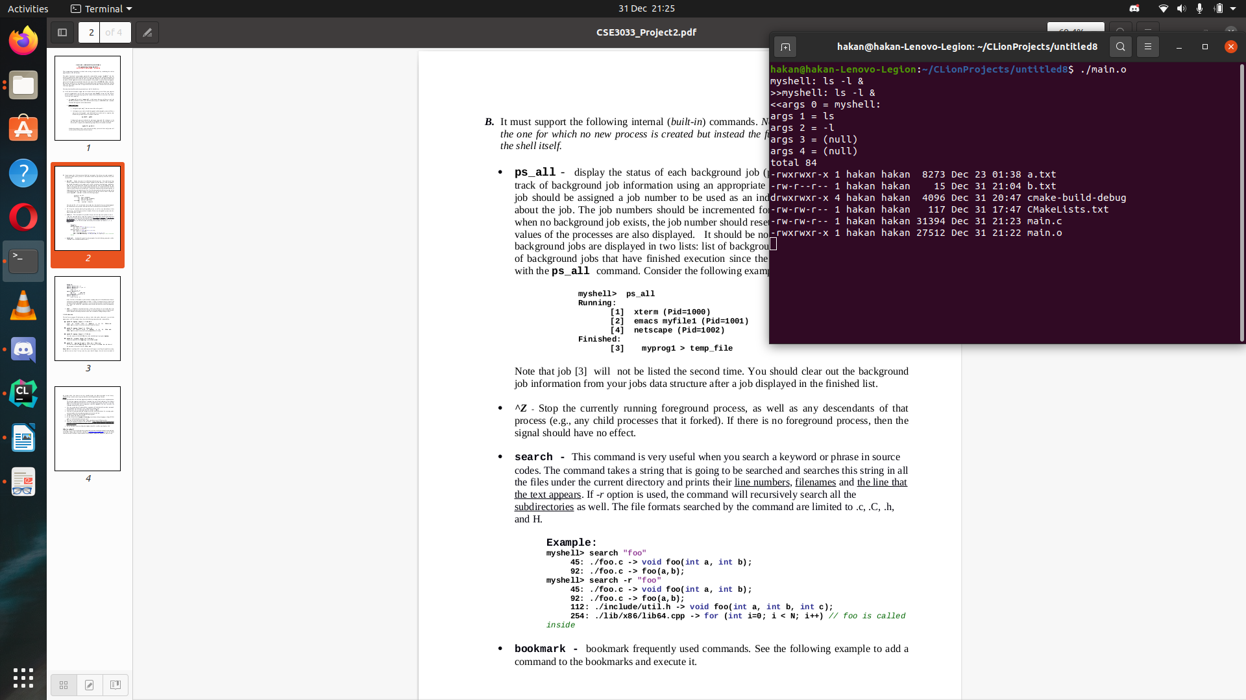
In ps_all part first update the background queue if processes are finished or not and locate them appropriately and then it prints first running processes after terminated processes.

When I put sleep in background process block it is seen processes are in running part

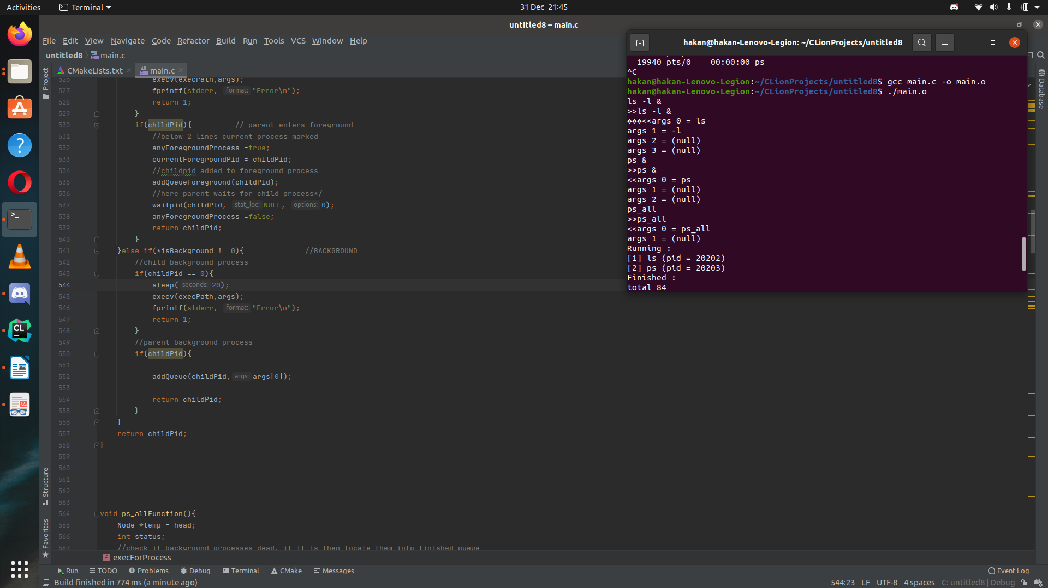
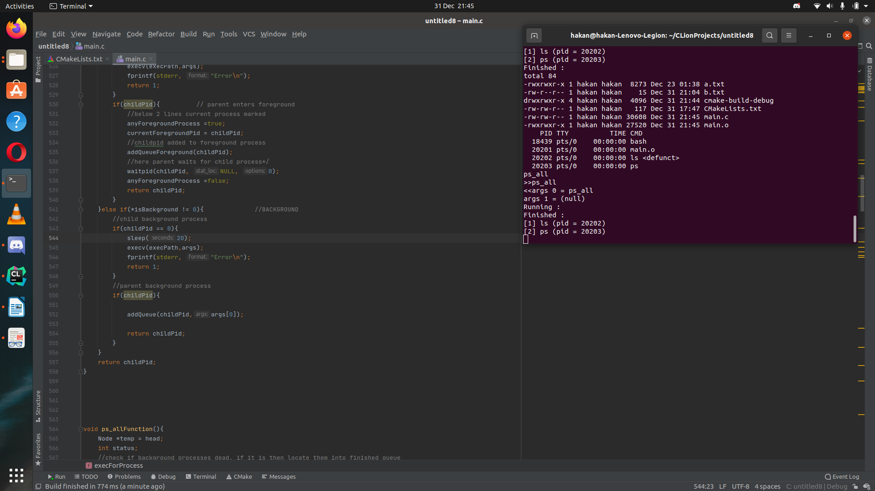
After executing given parts when we write ps_all now they are in finished queue

Part B –

Search –
In this this section we’ve asked to create a simple pattern matching algorithm with an optional recursive functionality. In order to do this we took the input args, made sure that our first argument matches with “search” string and after that we checked if the recursive functionality (-r) is enabled, then we took the search string and called our recursive search function with appropriate inputs.
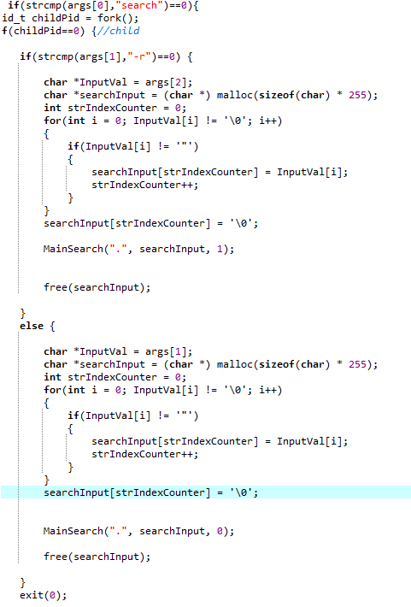
The image above shows the argument parsing steps.

“MainSearch” function has 3 inputs; current directory as string, text to search as string and Recursive Option as integer.
“Current Directory” is a neccessary argument in order to acchieve recursive functionality. It comes with stack like manner so that we can simply create a list of the folders we want to search recursively in the current directory, simply modify current directory as it now represents the new folder directory, call the MainSearch function with same inputs except the “Current Directory” which modified to show new directory, pop back, repeat this process for every other listed folder directories.
“Tex To Search” is -as it describes itself- text to search in files.
“Recursive option” is simply a boolean value for recursive functionality.
In the function, we list the files in the current directory, store them in an array , search the text user wants to search in all of the files in the array. Then, if recursive function enabled, list the folders in the current directory, store them in an array, modify the current directory string as it described argument description above, call MainSearch function with the modifed arguments, pop back, repeat this process for all of the folders in the array.

Bookmark-
In this section of the program, we take the arguments, make sure that our first argument matches with the string “bookmark” and if so, we check for other arguments.
If second argument starts with a quote mark we deduct that the user is trying to store some commands, so we just take the string that is up until the second quote mark without including the first and last quote marks, store them in our global command array.
If second argument starts with a – symbol, we deduct that the user is trying to perform an action. In order to determine the action, we continue the read the input,
If the second character of the argument is a ‘l’ character, we list the contents of the array.
If the second character of the argument is either ‘d’ or ‘i’, we read the last argument which is a number, and store it so that we can use it later.
If the argument is d, or simply the delete command, we simply delete the corresponding index of the array by using previously saved number input as index.
If the argument is i, or simply the execute command, we simply execute the corresponding index of the array by using previously saved number input as index.

^Z –
In this part, we’ve asked to handle the ^Z signal. Since it’s a built-in functionality, we simply just register our handler function by using built-in “signal(SIGTSTP, z_sig_handler);” function. First parameter is built-in identifier, it simply refers that the function we want to override is control-z signal. The second parameter is a function pointer, we simply put here our override function name so that when the signal occurs (control z or ^z) this override function is called. Then when the signal occurs, we simply kill foreground processes (and its children) if there is any.

Exit –
We first check if there are any background processes, if the answer is yes we notify the user about the situation and wait for confirmation. It user confirm the termination, we terminate, if not, we just simply return.

Part C:
We were supposed to modify input output and error redirection in part c. at the start this part shouldn’t be reachable from parent so we needed a child parent discriminator, we usedchildpid=fork() and if(childpid==0) statements to achieve this. We also needed to string where we should read the content so our function checkInputOutputChoise takes a char array called as pString. After finding the location we started coding the inside of funtions. We find the locations where <,>,>>,2>,2>> symbols are read them, we assumed what is after them is file locations, and set location varibale for that. The hardest part for me was the flags, I didn’t even know they are a must. I checked the manual page of it so learned the ones a needed. I used O_RDONLY for the input part and used O_WRONLY for output and error parts. If we are supposed to append on output anderror I used O_APPEND and used O_TRUNC if we are not needed. There aresome other I used to regulate the access I gathered them inside CREATE_FLAGS, which includes S_IRUSR|S_IWUSR|S_IRGRP|S_IROTH. Then I opened the files and saved then fpread, fpwrite, fperr. One other point was the new string args, if we send redirection part to exec part it would raise an error, so I created a funciton to solve that, This funtion is shiftString, it takes to paramaters, one string and other is int, it is the location of letter/char that supposed to be deleted. After taking this input we left the string one by one inside a for loop. And the last part is the error checking and real redirectioning part, in this part I firstly checked the return value of fpread,fpwrite and fperr if they raised an error, after that I used dup2 function to change child’s input output or error reading writing locations, if that’s worked well too, I closed files by close function.
In the end we had our string is reorganized and our child redirected.

--bonus part
In the bonus part we needed to use up and down arrow keys, so we needled with terminal settings. In order to achieve that we first included <termios.h> library, which have the few things we needed.
After including library we changed old terminal settings in order to make reading arrow keys possible, we achieved that by new.c_cflag= ~ECHO; , after achieving that we rearranged the setup funciton. We used getch() function to get the values of pressed button letter by letter. If char is backspace or delete buttons we delete the last char on the line by making it line[last]=’\0’; and decrementing the value by minus 2. if char is normal letter we add it to line and if char is ‘\n’ we save the line and break the loop.
We also save this lines in a struct called as inputLines, if up or down arrow keys are pressed we move the currentLine item to currentLine->before for currentLine->next. After doing that we copy the line content of new currentLine into line(which is local variable). And prints the new line into screen.
Important thing is there is few errors at bonus part, since we didn’t have time to fix all problems. we used \r to rewrite the line over and over and it can give some erros, so we suggest you to use only up and down arrows as long as it is needed and don’t use the backspace and escape keys if it is started showing circumstantial errors, we suggest you to restart the program.

Also, be sure use run this on terminal on full screen.
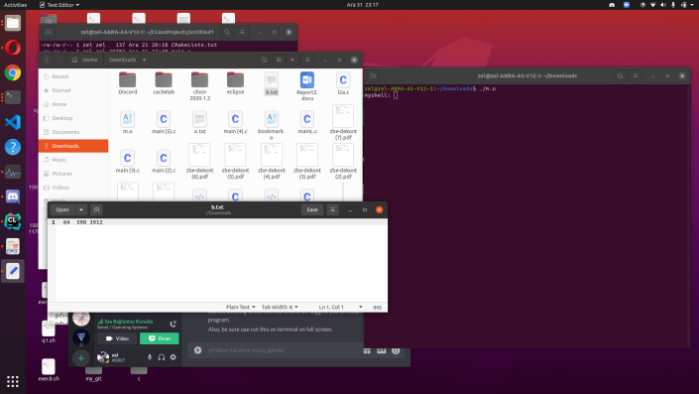before
after