

MIDDLE EAST TECHNICAL UNIVERSITY

EE568

Selected Topics on Electrical Machines

PROJECT 3

PM MOTOR COMPARISON ANALYSIS

Hakan POLAT 2031243

# Introduction

# Question 1

In this part, it is asked to analyse a PMSM with NdFeB N42 magnet. The constant parameters are given below:

* Number of phases: 3
* Number of poles: 4
* Motor Axial Length: 100 mm
* Air-gap clearance: 1 mm
* Magnet to Pole Pitch Ratio: 0.8
* Magnet Type: NdFeB N42 grade (ur=1.05), radial shaped
* Rotor Diameter: 100 mm
* Magnet Radial Thickness: 4 mm

1. In this part it is assumed that the stator is solid. It is asked to draw the equivalent circuit of a single pole-pair.

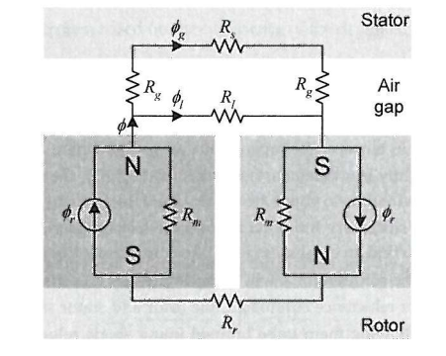

Figure 1: Equivalent magnetic circuit for a single pole pair in PMSM

In Fig. 1 the equivalent magnetic circuit is presented. The mangets are modeled as current sources. Similarly, the same circuit can be modeled with MMF sources. If we assume infinite stator-rotor core permeability and neglect the leakage flux the model can be reduced.

The reduced magnetic model for a single pole pair is given in Fig. 2.

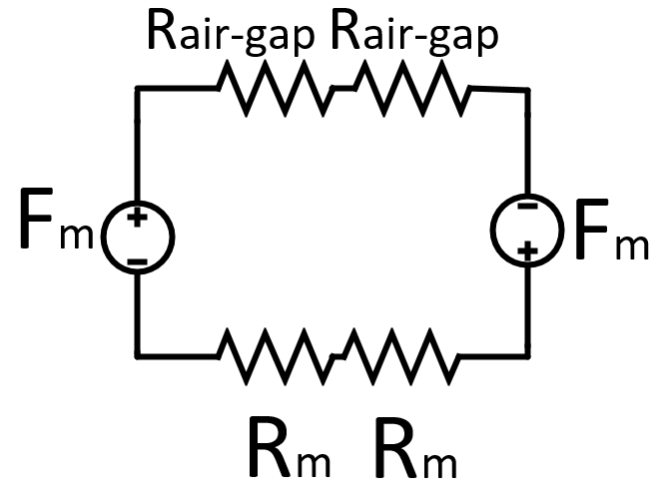

Figure 2: Equivalent reduced magnetic circuit of a single pole pair in PMSM.

Fm is the MMF generated by a single magnet. The Rm is the reluctance of the magnet. Rairgap

is the airgap reluctance.

$$F_{m}=\frac{B_{r}l_{m}}{{1.05µ}_{0}A_{m}}$$

$$2R_{airgap}+2R_{m}=2(\frac{l_{gap}}{µ_{0}A_{m}}+\frac{l_{m}}{{1.05µ}_{0}A_{m}})$$

Br is the maximum magnetic field density supplied by the magnet. Then the operating magnetic field density Bop can be calculated as below.

$$B_{op}=\frac{B_{r}}{1+\frac{1.05l}{l_{m}}}$$

Br of a N42 magnet is between 1280-1320 mT. In our calculation 1300mT is taken. By putting the initially given values Bop= 1.02T. In Fig. 3, the B-H curve of N42 magnet is present. The load line is also shown.

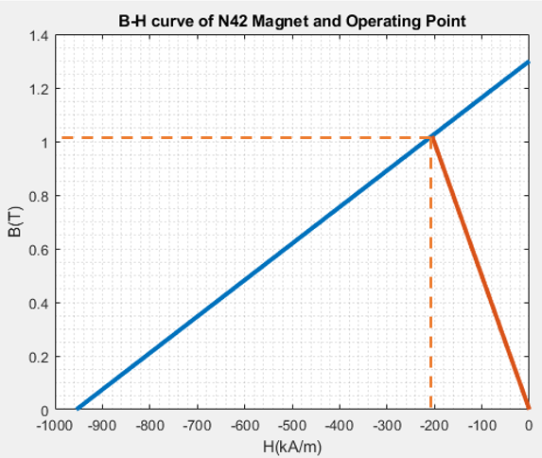

Figure 3: B-H curve of N42 (blue) and the load line(red).

1. Magnetic loading is defined as average airgap flux density over a pole and can be formulated as;

$$B_{load}=\frac{pAB_{op}}{πDL}$$

The only unknown is the magnet area. However, the magnet to load pitch ratio is given as 0.8. Hence, specific magnetic loading can be found as;

$$B_{load}={0.8B}_{op}=0.8 T$$

1. The FEA model was created in COMSOL environment. The geometry is presented in Fig. 4.

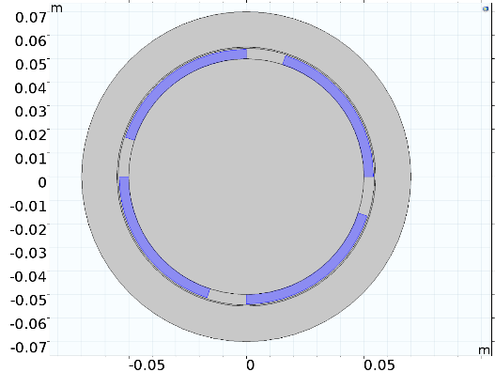

Figure 4: Motor model in COMSOL

The airgap flux density is presented in Fig. 5. The waveform in Fig. 5 is the absolute value of B distribution over a single pole. After 0.8 the B should be negative however in COMSOL I couldn’t find a way to plot the true waveform.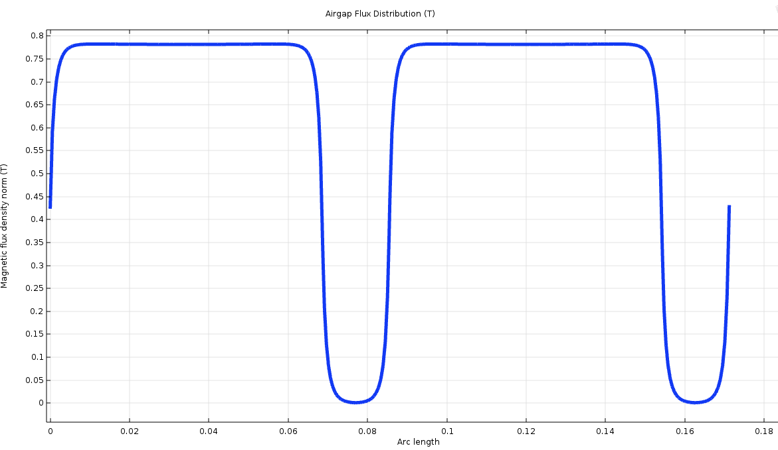

Figure 5: Airgap flux density distribution.

Compared to analytical results the maximum airgap flux density is found to be 0.78. There is a 2.5% error between the FEA and analytical solution. This is due to non ideality of the core material. During analytical analysis the permeability was taken as infinite however, in COMSOL the core material is selected to be iron having a relative permeability of 3000. Moreover, the leakage flux was also neglected however in FEA model leakage is also present.

# Question 2

1. In this part a suitable number of slot will be selected. The simplest choice is choosing 12 which results in a concentric winding design and hence the q=1. Moreover, the winding factor kw=1. This choice may result in higher 3rd and 5th order harmonics. An advantage of choosing 12 slots is also the ease of manufacturing.
2. The radius of required cable can be calculated from the maximum current density and the rated current.

$$5\frac{A}{mm^{2}}=\frac{2.5A}{2πr}$$

D=0.8mm is the rounded diameter of the required cable. Using the AWG table given in <https://en.wikipedia.org/wiki/American_wire_gauge> the cable is selected as AWG 20.

1. Using the rule of thumb given for Do/Di we can find the outer diameter. Inner diameter is 105mm so for a 4 pole machine choose Do=200mm. It is assumed that half of the diameter is slot and half is teeth.

Hence slot width can be calculated as

$$\frac{105π}{2*12}=13.74mm$$

Slot diameter d=0.5 gives the maximum torque. Using d=0.5 gives slot outer 210mm diameter of the outer diameter of the slot. This is not valid since the outer diameter is selected as 200mm. At this point we have 2 options. One is to increase the slot ratio the other one is to increase the outer diameter. I choose to increase the outer diameter. So the slot height can be found as 52.5mm. Now we need to redefine the outer diameter of the machine.

The average airgap flux density was calculated as 0.8T. In order not to saturate the core the stator yoke is selected as 1.1T. Stacking factor is taken as 1. Then;

$$1.1=\frac{\frac{4}{π}*0.8*D_{airgap}*l}{2k_{stacking}lh}=\frac{106*l}{l*2*h}$$

“h” is calculated as 48mm. Therefore the outer diameter is 210+2h=306mm.

The number of turns can be calculated as ;

$$N=\frac{13.74*52.5*0.6}{A_{AWG20}}=835 turns$$

1. The electrical loading can be calculated as

$$\frac{NIQ}{Dπ}=\frac{835*2.5*12}{105*π}=75\frac{A}{m}$$

The typical electrical for PMSM is given between 35-65 . The value found is 75 which is higher. A solution would be to increase d. This also reduces the outer diameter. However, at this point 75 will be used.

1. The average tangential stress can be calculated as;

$$α_{t}=\frac{I_{rms}\cos\left(ϕ\right)B_{peak}}{1.41}=\frac{75*0.8*\frac{4}{π}}{1.41}=54176 Pa$$

$$T=α_{t}r_{rotor}\left(2πr_{rotor}l\right)=97 Nm$$

The rotation speed is 1500 rpm. So angular velocity is 100π.

$$P=Tω=97*100*3.14=30.4kW$$

# Question 3:

In this part the stator outer diameter is fixed to 160mm. Rectangular slot is assumed.

1. For maximum torque output d=0.5 (for rectangular slow). Therefore, slot inner diameter should be 80mm.

At this point, it is important note that in the previous design d was again 0.5. Therefore, the operating flux density and hence magnetic loading does not change. Lets calculate the outer diameter.

$$h=\frac{\frac{4}{π}*0.8*D_{airgap}}{2*1.1}=\frac{\frac{4}{π}*0.8*80}{2.2}=37mm$$

Therefore the outer diameter is 2*37mm+160mm=234mm.

The slot height is (160-80)/2=40mm.

If we divide both the airgap and the magnet height the rotor diameter can be calculated as

$$D_{rotor}=160mm-5mm=155mm$$

The magnetic loading stays the same since the operating B is the same.

Again AWG 20 is used. So the number of turns can be calculated as,

$$N=\frac{f_{fill}*h_{slot}*w_slot}{A_{AWG20}}=\frac{0.6*40*10.47}{0.518}=485 turns$$

Then the electrical loading can be calculated as;

$$\frac{NIQ}{Dπ}=\frac{435*2.5*12}{80*π}=51\frac{A}{m}$$

The tangential stress can be calculated as;

$$α_{t}=\frac{I_{rms}\cos\left(ϕ\right)B_{peak}}{1.41}=\frac{51*0.8*\frac{4}{π}}{1.41}=36842 Pa$$