**Problem 1.**

Euro 2012 stats TEAM.csv file contains statistics of the teams that attended Europen Cup 2012. Using this data do the following tasks:

a) Find the teams that have lowest and highest number of yellow cards. Note that more than one country can have the same maximum number or minimum number of yellow cards.

b) Find the team that has the best shooting accuracy.

Your output should look like:

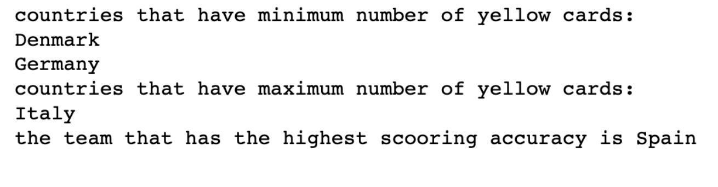

**Problem 2**

The csv file AutoSurvey.csv contains a sample of data about vehicles owned, whether they were purchased new or used, and other types of data. The data file looks like the figure below.

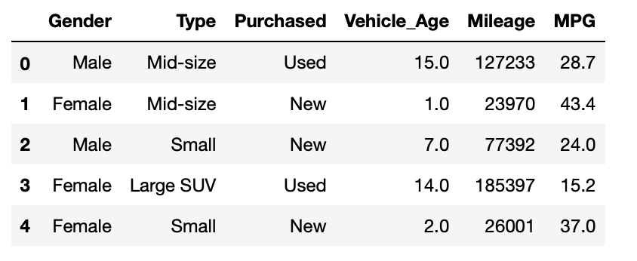

Your function should take this file as an input and do the following operations:

1. Print average mileage for each car type. Average of mileages should be grouped into columns  as New and Used, as shown below

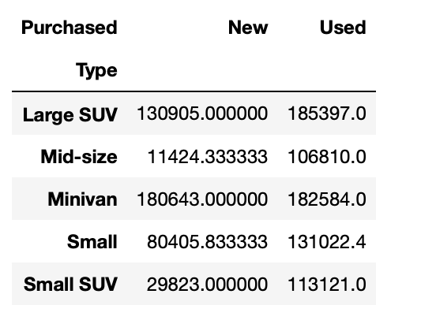

1. For each car type find the difference between maximum and minimum Vehichle Age

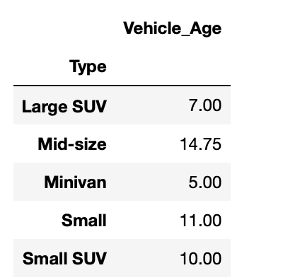

**Problem 3**

**You can use Numpy or PANDAS**

You are given “BreadBasket_DMS.csv” file that contains sales informations of a bakery. The colums are: Date,Time,Transaction and Item. Transaction can be thought as the order id.

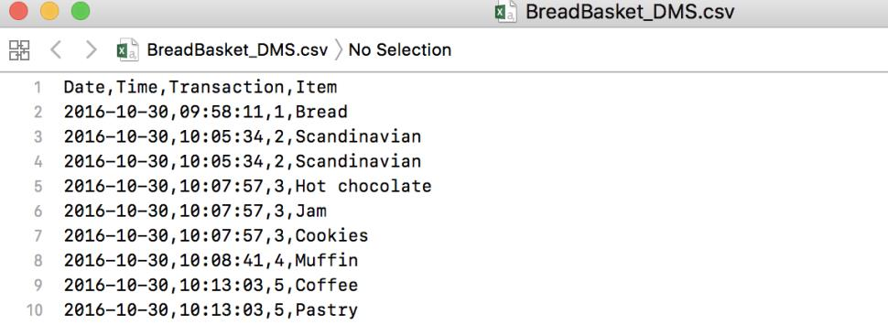

Write a function that takes this file as an input and to the following:

1. a)  Print the number of unique items
2. b)  Print how many times each item was sold.
3. c)  How many transactions contain Coffee. Note that you may have more than one coffee in one

transaction.

Your output should look like below:

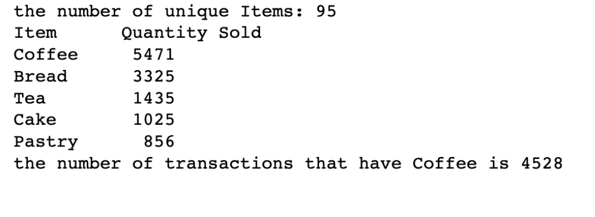

4) print a table showing the monthly sales quantity of coffee and Tea.

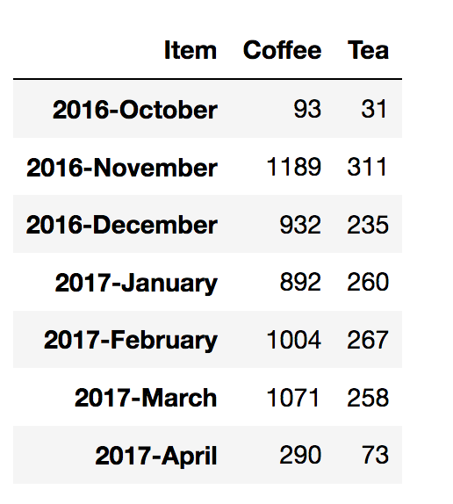

**Problem 4**

This problem is based on a subset of the 311 service requests from NYC Open Data. You are given 311-service-requests.csv file. Use this file as the input do the following analysis.

1. Find average completion time in hours for top-10 most frequent complaints. Also calculate how many data points you have for each complaint types. Do this analysis only for closed complaints.

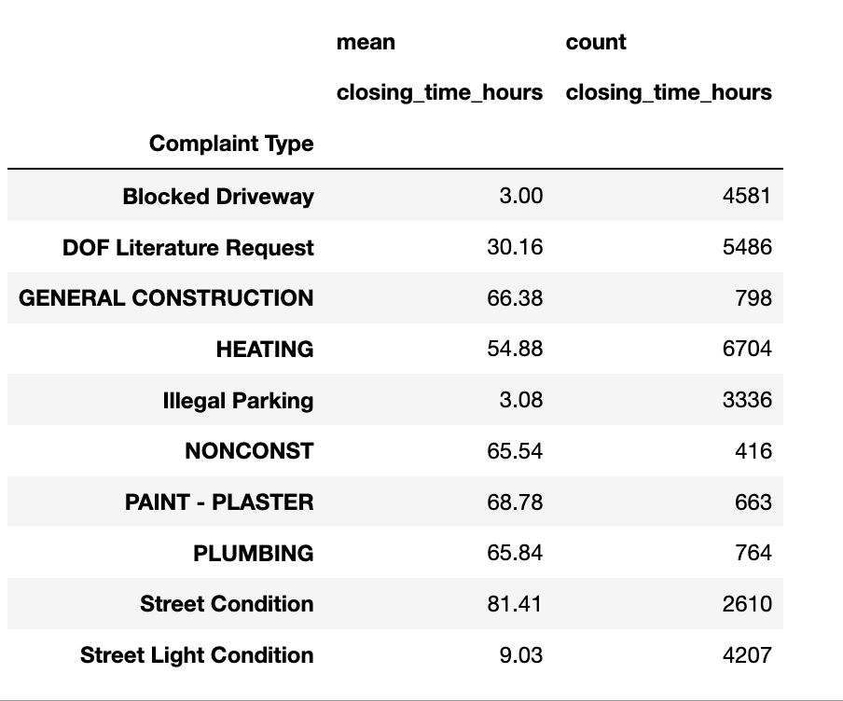

1. Find the day that has the highest number of complaints. Print the result in the following format.

'October-24-Thursday'

1. Produce a table for the number complaint type in each day of the week. Do this analysis only for the top-10 most frequent complaints. 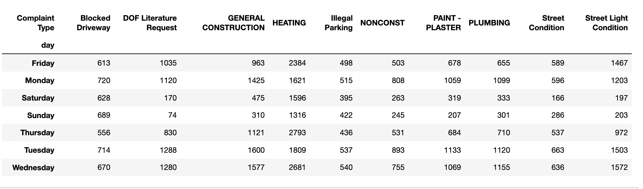
2. Find the percentages for the status of Complaints. Do this analysis only for the top-10 most frequent complaints.

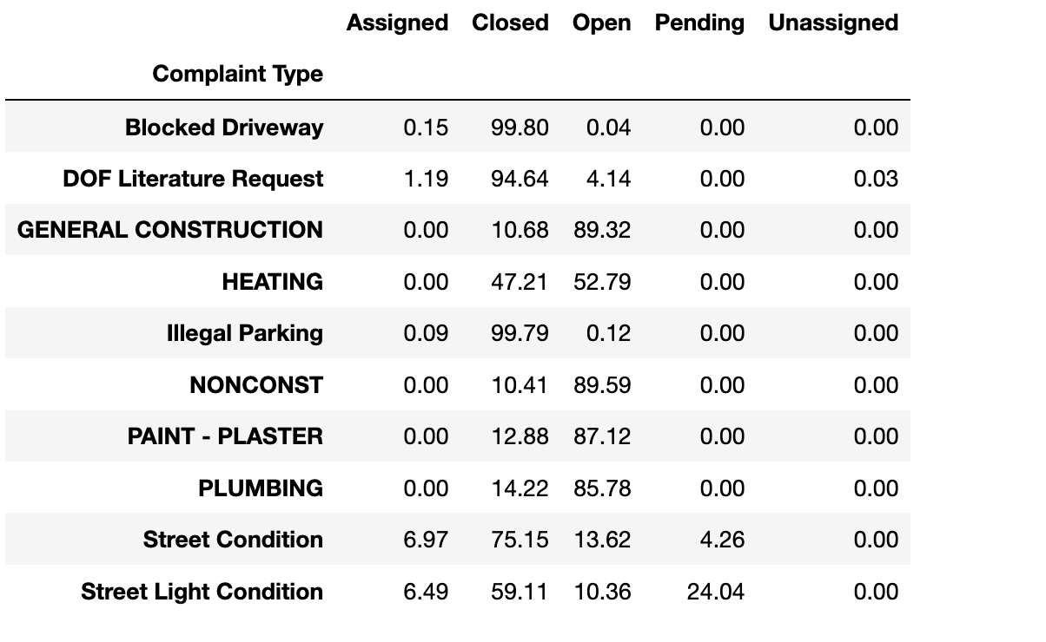

**Problem 5**