Project Proposal — TürkResearcher
A Multi-Agent LLM Research Assistant for Turkish Academic Literature

Student: Hakan Sabuniş, Yusuf Ünlü
Istanbul Medipol University
Track 1 — Novel Idea

1. Problem & Motivation
- English-speaking researchers have grounded LLM tools (Elicit, Consensus.app, scite.ai); the Turkish academic ecosystem has none.
- Turkey publishes 600+ active peer-reviewed journals on DergiPark and tens of thousands of theses on YÖK Ulusal Tez Merkezi every year.
- All of that Turkish-language scholarly output is invisible to current LLM-based research assistants. TürkResearcher fills exactly this gap.

2. System Architecture
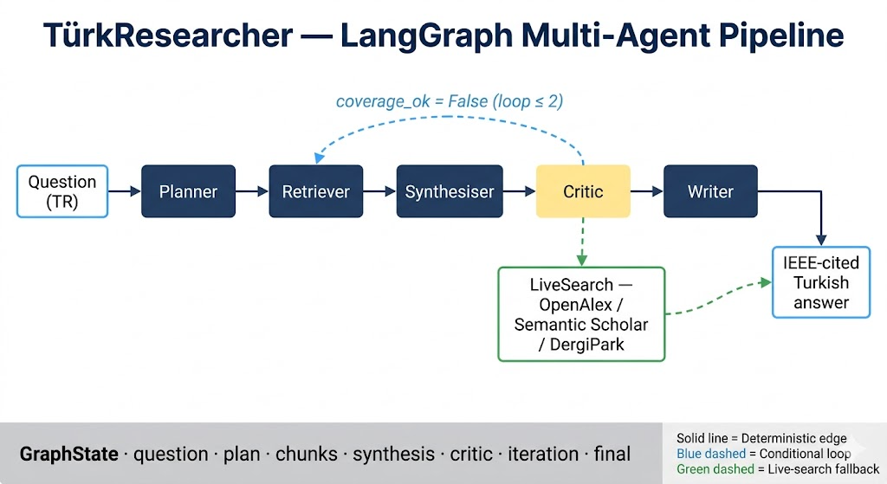
Figure 1. LangGraph state machine. Solid arrows are deterministic; dashed arrows are conditional.
- Six-node directed graph orchestrated by LangGraph; typed Pydantic state; five LLM-using agents plus one optional live-search node.
- Critic conditionally loops back to Retriever (max 2 iterations), then falls through to LiveSearch or directly to Writer.
- Every LLM node uses schema-enforced output through OpenAI function calling — DeepSeek does not support the newer json_schema response format.

3. Component Specifications

3.1 Embedding layer
Property | Value | Rationale
Model | paraphrase-multilingual-mpnet-base-v2 | 768-dim multilingual sentence transformer; XLM-RoBERTa backbone with strong Turkish coverage
Document representation | Title concatenated with abstract | Title-aware indexing adds a strong lexical signal that abstract-only embeddings miss
Normalisation | L2 | Required for cosine similarity to be a valid metric
Inference | CPU at query time | Local agent runs without GPU; ~50 ms/query
Alternatives considered and rejected: BERTurk-base (NER-tuned, weak as sentence encoder), distiluse-multilingual (smaller but lower retrieval quality), custom SimCSE fine-tune (deferred to future work).

3.2 Vector indexing
Property | Value | Rationale
Backend | ChromaDB persistent client | Python-native, persistent on disk, mature LangChain integration
Index | HNSW (M=16, ef_construction=200) | Sub-second similarity search on 10⁵+ vectors
Distance | Cosine | Standard for L2-normalised sentence embeddings
Identifier | Thesis: YÖK ID; article: prefixed | Globally unique; supports source-aware filtering
Metadata fields | 13 (author, advisor, location, year, subject, PDF URL, …) | Sufficient to construct IEEE citations without re-querying parquet

3.3 LLM integration layer
Property | Value
Model | DeepSeek deepseek-chat
Transport | OpenAI-compatible REST (LangChain ChatOpenAI with overridden base URL)
Structured output | function_calling (json_schema unsupported by DeepSeek)
Per-agent temperature | Critic 0.0 · Planner 0.1 · Synthesiser 0.2 · Writer 0.3

3.4 Retrieval strategy
- Multi-query: original question plus each planner sub-question (4–6 queries per turn).
- Per query, top-k=6 chunks by cosine similarity; deduplicated globally on thesis identifier with max-score retention; truncated to top-24 for the synthesiser.
- ChromaDB cosine distance is converted to a [0, 1] similarity score for downstream interpretability.

3.5 Citation subsystem
- The writer emits inline numeric markers; the IEEE reference list is built deterministically by the system from chunk metadata, not by the LLM.
- Each citation includes the public YÖK detail page URL (tez.yok.gov.tr/UlusalTezMerkezi/...), where the abstract, full metadata, and the PDF (for open-access theses) are retrievable.
- A safety pass strips any inline marker that exceeds the available chunk count — no hallucinated references can leak into the final answer.

4. Data Pipeline
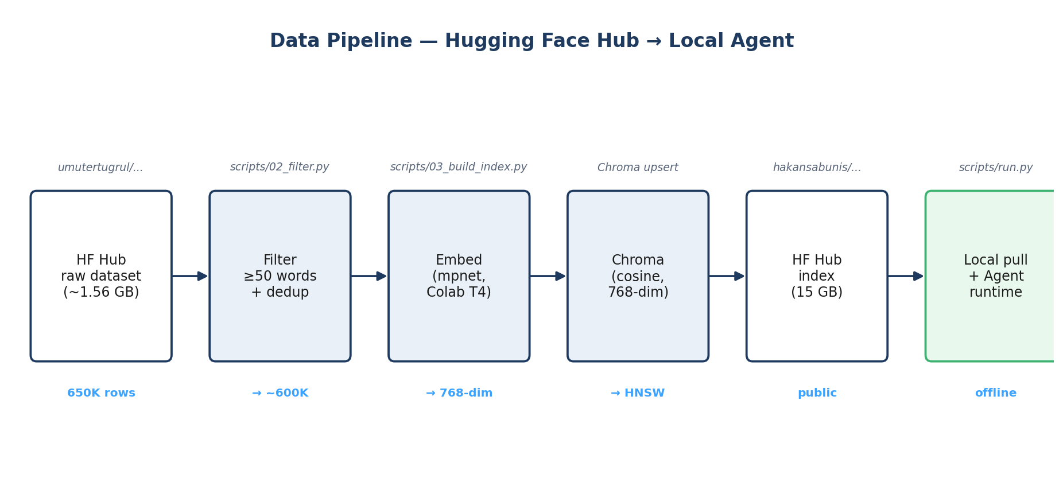
Figure 2. Data pipeline from Hugging Face Hub upstream to local agent runtime.
- Source: umutertugrul/turkish-academic-theses-dataset (650K bilingual abstracts, CC-BY-4.0).
- Filters: abstract ≥ 50 words, non-empty Turkish title, deduplication on thesis identifier — yields ~500-600K records.
- The prebuilt index is published as a public Hugging Face dataset so the runtime can be reproduced in three commands without rebuilding the index.

5. Evaluation Framework
- 30-question Turkish benchmark spanning 10 categories: computer science, education, health, engineering, social sciences, business, agriculture, linguistics, law, multi-domain.
Metric | Range | Captures
Citation accuracy | 0–1 | Whether cited chunks support the surrounding claim
Faithfulness | 0–1 | Whether every claim is grounded in retrieved context
Coverage | 0–1 | Fraction of planner sub-questions substantively addressed
Holistic | 1–5 | Overall academic quality (structure, register, reasoning)
- Mechanical metrics also captured: end-to-end latency, retrieved-chunk count, max cosine similarity, critic iteration count.
- Per-category breakdown surfaces domains where the corpus is strong vs weak — honest error analysis instead of a blended single number.

6. Reproducibility & Deployment
- Code released under MIT licence on GitHub.
- Prebuilt Chroma index published as a public Hugging Face dataset.
- Three-step runtime: install pinned requirements, pull the prebuilt index, run the agent CLI with a Turkish question.

7. Timeline
Phase | Weeks | Output
Data pipeline (fetch, filter, embed, index, push) | 1–2 | Indexed Chroma collection on HF Hub
Multi-agent system implementation | 3 | Runnable agent CLI
Evaluation framework (benchmark, judge, summary) | 4 | Quantitative results table
Academic report (IEEE) and class presentation | 5 | PDF and slide deck

8. Expected Deliverables
- GitHub repository under MIT licence with reproducible pipeline and full evaluation harness.
- Public Hugging Face dataset hosting the prebuilt vector index.
- IEEE-format academic report (2–6 pages): abstract, introduction, related work, methodology, experiments, discussion / error analysis, conclusion.
- 10–15 minute class presentation with a live demo.

